A multidisciplinary approach to identify priority areas for the conservation of a vulnerable family of fishes in Spanish Marine National Parks

Miquel Planas, Cristina Piñeiro-Corbeira, Carmen Bouza, Inés Castejón-Silvo, Manuel Vera, Marcos Regueira, Verónica Ochoa, Ignacio Bárbara, Jorge Terrados, Alexandro Chamorro, Rodolfo Barreiro, Jorge Hernández-Urcera, Irene Alejo, Miguel Nombela, Manuel Enrique García, Belén G. Pardo, Viviana Peña, Pilar Díaz, Javier Cremades, Beatriz Morales-Nin
Department of Ecology and Marine Resources, Instituto de Investigaciones Marinas (IIM-CSIC), Eduardo Cabello 6, 36208 Vigo (Spain). e-mail: mplanas@iim.csic.es

Supplementary material

Table S1. PNIA - Mean values ​​of the textural and compositional parameters of sediment along transects TR1 – TR10 (Spring and summer 2016 surveys in Cíes Archipelago).). MS - Moderately sorted; PS - Poorly sorted. n - Number of samples analyzed.
Season | Transect | n | CaCO₃  % | Gravel  % | Sand  % | Mud  % | Mean (µm) |  | Sorting |  | Skewness
Spring | 1 | 2 | 45.0 | 13.4 | 86.5 | 0.2 | 803 | coarse sand | 0.77 | MS | 0.05
Spring | 2 | 5 | 58.5 | 13.1 | 86.5 | 0.3 | 791 | coarse sand | 1.10 | PS | -0.21
Spring | 3 | 15 | 79.0 | 11.5 | 84.8 | 3.7 | 790 | coarse sand | 1.11 | PS | -0.11
Spring | 4 | 8 | 62.1 | 13.5 | 86.4 | 0.1 | 797 | coarse sand | 0.95 | MS | -0.11
Spring | 5 | 7 | 56.2 | 12.0 | 65.7 | 22.3 | 276 | medium sand | 2.32 | PS | -0.01
Spring | 6 | 3 | 48.0 | 3.8 | 96.2 | 0.0 | 283 | medium sand | 0.83 | MS | -0.28
Spring | 7 | 6 | 28.8 | 7.3 | 92.7 | 0.1 | 374 | medium sand | 0.95 | MS | -0.36
Spring | 8 | 4 | 70.7 | 7.9 | 92.3 | 0.0 | 860 | coarse sand | 0.64 | MS | -0.10
Spring | 9 | 2 | 80.1 | 8.6 | 91.0 | 0.5 | 683 | coarse sand | 1.06 | PS | 0.06
Summer | 3 | 4 | 80.7 | 1.3 | 98.6 | 0.1 | 382 | medium sand | 0.69 | MS | -0.11
Summer | 4 | 9 | 38.4 | 11.2 | 88.7 | 0.2 | 701 | coarse sand | 0.89 | MS | -0.22
Summer | 6 | 4 | 48.6 | 7.2 | 91.2 | 1.6 | 395 | medium sand | 1.1 | PS | -0.21
Summer | 8 | 3 | 71.7 | 1.1 | 98.5 | 0.3 | 372 | medium sand | 0.87 | MS | -0.05
Summer | 10 | 4 | 47.8 | 5.3 | 94.6 | 0.1 | 462 | medium sand | 0.83 | MS | -0.29
Mean |  |  | 58.3 | 8.4 | 89.5 | 2.1 | 569 | coarse sand | 1.01 | PS | -0.14

Table S2. PNIA - Mean values ​​of the textural and compositional parameters of sediment along transects with presence of syngnathids (Spring and summer 2016 surveys in Cíes Archipelago). MS - Moderately sorted; PS - Poorly sorted. n - Number of samples analyzed.
Season | Transect | n | CaCO₃  % | Gravel  % | Sand  % | Mud  % | Mean (µm) |  | Sorting |  | Skewness
Spring | 2 | 1 | 47.0 | 16.6 | 83.0 | 0.1 | 679 | coarse sand | 1.41 | MS | -0.41
Spring | 3 | 6 | 79.0 | 10.2 | 89.8 | 0.0 | 835 | coarse sand | 0.91 | MS | -0.16
Spring | 5 | 1 | 19.8 | 1.8 | 98.2 | - | 413 | medium sand | 0.57 | MS | 0.01
Spring | 6 | 1 | 54.0 | 5.9 | 94.1 | - | 285 | medium sand | 0.94 | MS | -0.39
Summer | 3 | 1 | 80.4 | 0.1 | 99.8 | - | 204 | medium sand | 0.45 | MS | -0.03
Summer | 4 | 2 | 39.1 | 10.4 | 89.6 | - | 808 | coarse sand | 0.63 | MS | -0.20
Summer | 10 | 2 | 39.2 | 6.8 | 93.2 | 0.1 | 516 | coarse sand | 0.77 | MS | -0.41
Mean |  |  | 51.2 | 7.4 | 92.5 | 0.1 | 534 | coarse sand | 0.8 | MS | -0.2

Table S3. PNIA - Macroalgal species with medium-high abundances in transects TR1 to TR10 (spring and summer 2016). B, R and G – Brown, red and green algae, respectively. FO – Frequency of occurrence (%).
 | Transect | TR1 | TR2 | TR3 | TR4 | TR5 | TR6 | TR7 | TR8 | TR9 | TR10 | FO
 | Species (Total=55) | n=7 | n=20 | n=31 | n=29 | n=30 | n=35 | n=12 | n=38 | n=31 | n=22 | FO
B | Cutleria multifida phase Aglaozonia |  |  | + |  | + | + |  |  |  |  | 30
B | Carpodesmia tamariscifolia |  |  | + |  | + |  |  |  |  | + | 30
B | Carpomitra costrata |  |  |  |  |  | + |  | + | + |  | 30
B | Cladostephus spongiosus |  | + | + |  | + |  |  | + | + | + | 60
B | Colpomenia peregrina |  |  | + | + | + | + |  |  |  | + | 50
B | Cutleria adspersa |  |  |  |  |  | + |  |  | + |  | 20
B | Cutleria multifida |  |  | + |  | + |  |  |  |  |  | 20
B | Dictyopteris lucida |  |  |  |  |  | + |  | + | + |  | 30
B | Dictyopteris polypodoides |  |  | + | + | + | + |  | + |  |  | 50
B | Dictyota dichotoma | + | + | + | + | + | + | + | + | + | + | 100
B | Halidrys siliquosa |  |  |  |  |  |  | + | + | + | + | 40
B | Halopteris filicina |  |  |  | + |  |  |  | + | + |  | 30
B | Halopteris scoparia |  | + | + |  |  |  |  |  |  |  | 20
B | Laminaria ochroleuca |  |  | + | + |  | + |  | + | + |  | 50
B | Padina pavonica |  | + | + | + | + | + | + | + |  | + | 80
B | Phyllariopsis brevipes subsp pseudopurpurascens |  |  |  |  |  |  |  | + |  |  | 10
B | Phyllariopsis purpurascens |  |  |  |  |  | + |  | + | + |  | 30
B | Saccorhiza polyschides | + | + | + | + | + | + |  | + | + | + | 90
B | Sargassum muticum |  |  | + | + | + | + |  |  |  | + | 50
B | Taonia atomaria |  |  | + | + | + | + | + |  | + |  | 60
B | Treptacantha baccata |  | + | + | + | + | + | + | + |  | + | 80
B | Treptacantha nodicaulis |  |  |  | + | + |  |  |  |  | + | 30
B | Treptacantha usneoides |  | + | + | + | + | + |  | + |  | + | 70
B | Undaria pinnatifida |  |  | + | + | + | + |  | + |  | + | 60
B | Zanardinia typus |  |  |  |  |  |  |  | + |  |  | 10
R | Asparagopsis armata phase Falkenbergia rufolanosa | + | + | + | + | + | + | + | + | + |  | 90
R | Acrosorium ciliolatum |  |  |  |  | + |  |  |  |  | + | 20
R | Ahnfeltia plicata |  |  |  |  |  |  |  |  | + |  | 10
R | Asparagopsis armata | + | + | + | + | + | + | + | + | + | + | 100
R | Bonnemaisonia asparagoides | + |  |  |  |  |  |  |  | + |  | 20
R | Chondracanthus (acicularis/teedei) |  |  | + | + | + | + |  |  | + |  | 50
R | Chondria (coerulescens/scintillans) |  |  | + | + | + | + |  | + | + |  | 60
R | Corallina/Ellisolandia/Jania spp. |  | + | + | + | + | + | + | + | + |  | 80
R | Cruoria pellita |  |  |  |  |  |  |  | + | + |  | 20
R | Dasysiphonia japonica |  |  | + |  | + |  |  |  |  |  | 20
R | Dilsea carnosa |  |  |  |  |  |  |  | + | + |  | 20
R | Gelidium corneum |  |  |  |  |  | + |  | + |  |  | 20
R | Gelidium spinosum |  | + |  |  | + |  |  |  |  | + | 30
R | Gracilaria (gracilis/multipartita) |  | + | + | + | + | + |  | + |  | + | 70
R | Kallymenia (reniformis/crouaniorum) |  |  |  | + |  | + | + | + | + |  | 50
R | Lithophyllum (incrustans/hibernicum) |  | + | + | + | + | + | + | + | + |  | 80
R | Mesophyllum expansum | + | + | + | + |  |  | + | + | + |  | 70
 | Transect | TR1 | TR2 | TR3 | TR4 | TR5 | TR6 | TR7 | TR8 | TR9 | TR10 | FO
 | Species (Total=55) | n=7 | n=20 | n=31 | n=29 | n=30 | n=35 | n=12 | n=38 | n=31 | n=22 | FO
R | Peyssonnelia (coriacea/dubyi/immersa) |  |  | + | + | + | + |  | + | + | + | 70
R | Phymatolithon (calcareum/lusitanicum) |  | + |  | + |  |  |  |  |  |  | 20
R | Plocamium cartilagineum |  | + |  | + | + | + |  | + | + | + | 70
R | Plocamium raphelisianum |  |  |  |  |  |  |  | + | + |  | 20
R | Pterosiphonia complanata |  |  |  |  |  | + |  | + |  |  | 20
R | Scinaia interrupta |  | + |  |  |  | + |  | + |  |  | 30
R | Sphaerococcus coronopifolius |  |  |  |  |  |  |  | + |  |  | 10
R | Stenogramme interrupta |  | + | + | + | + | + |  |  |  |  | 50
G | Codium adhaerens |  |  |  |  |  |  |  | + | + |  | 20
G | Codium fragile |  |  | + |  | + | + |  | + | + | + | 60
G | Codium tomentosum |  | + | + | + |  | + |  | + | + | + | 70
G | Codium vermilara | + |  | + | + |  | + | + | + | + | + | 80
G | Ulva (rigida/australis) |  | + | + | + | + | + |  | + | + | + | 80

Table S4. PNIA - Variable sites for the haplotypes detected in Syngnathus acus and Hippocampus guttulatus respect to reference sequences AF356040 and AF192664, respectively. Dots denote identical sites.

 | 11
 | 2555789900 |  |  |  | 33445
 | 148566766834 |  |  |  | 77684
 | 057589023731 |  |  |  | 36956
S_acus_AF356040 | CTTAGCCCAACC |  |  | AF192664 | GGATG
Cytb_SA01 | ....A....G.. |  |  | Cytb_HG01 | AAG.T
Cytb_SA02 | .....T.T...T |  |  | Cytb_HG02 | AA.GT
Cytb_SA07 | .......T..TT |  |  | Cytb_HG03 | AA..T
Cytb_SA10 | ...G.T.TT..T
Cytb_SA11 | .....TTT...T
Cytb_SA13 | ............
Cytb_SA14 | ....A.......
Cytb_SA16 | ..C.........
Cytb_SA17 | TC...T.T...T

Table S5. PNAC - Variable sites for the haplotypes detected in Syngnathus abaster respect to the reference sequence AF356040. Dots denote identical sites.
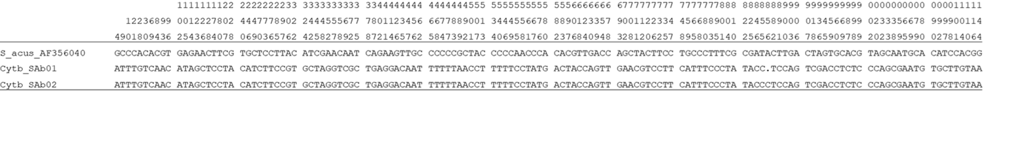

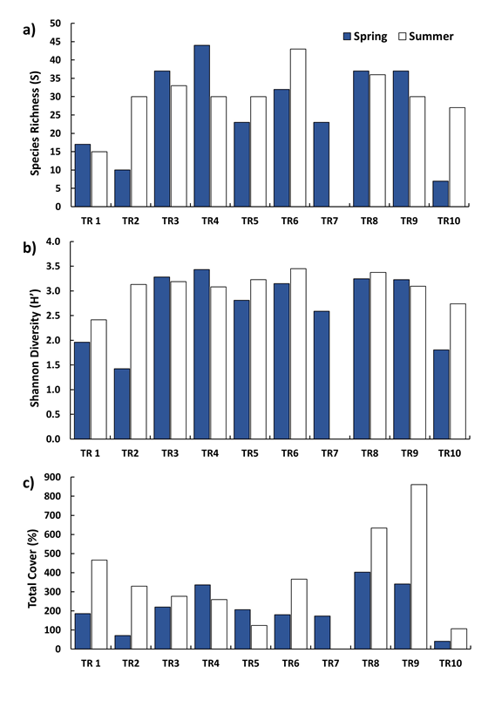
Figure S1. PNIA - Total cover (%), diversity (H’) and species richness (S) of seaweeds in transects TR1 – TR10 surveyed in Cíes Archipelago in spring and summer 2016.

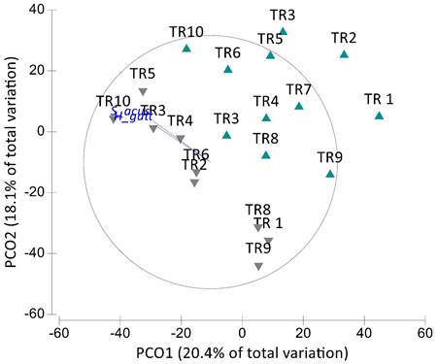
Figure S2. PNIA - Principal coordinates ordination of samples for Transect x Season pairwise combinations of seaweed assemblage in Cíes Archipelago on spring (green) and summer (grey). Overlay vectors are syngnathids whose abundance has a Spearman correlation >0.65 with any axis.

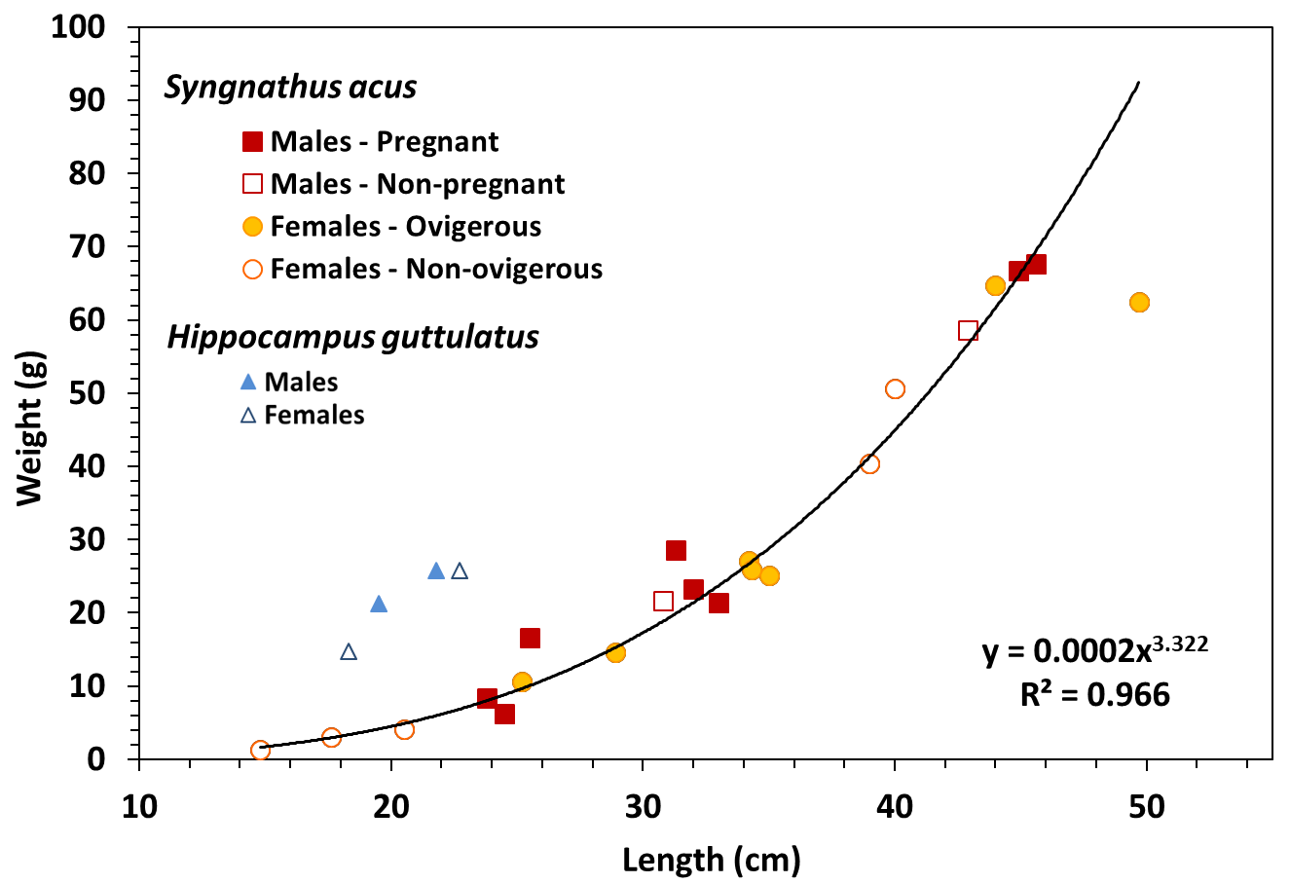
Figure S3. PNIA - Length-weight relationships in S. acus and H. guttulatus from 2016 surveys in Cíes Archipelago. Regression equation provided for S. acus.

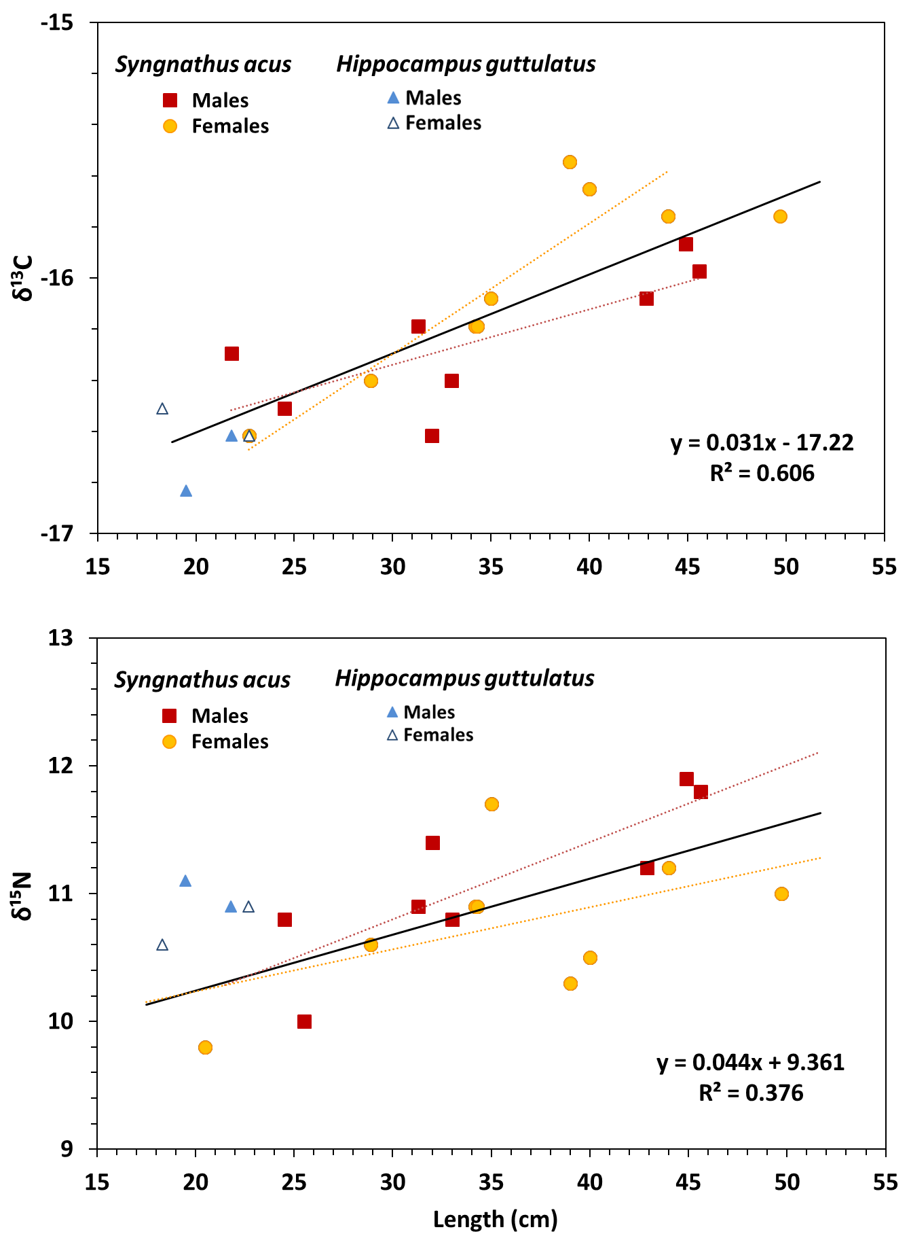
Figure S4. PNIA - Stable isotopes-length relationships in S. acus and H. guttulatus from 2016 surveys in Cíes Archipelago. Dotted lines: Regression lines for S. acus males (red) and females (yellow). Regression equation provided for all S. acus specimens (continuous line).

