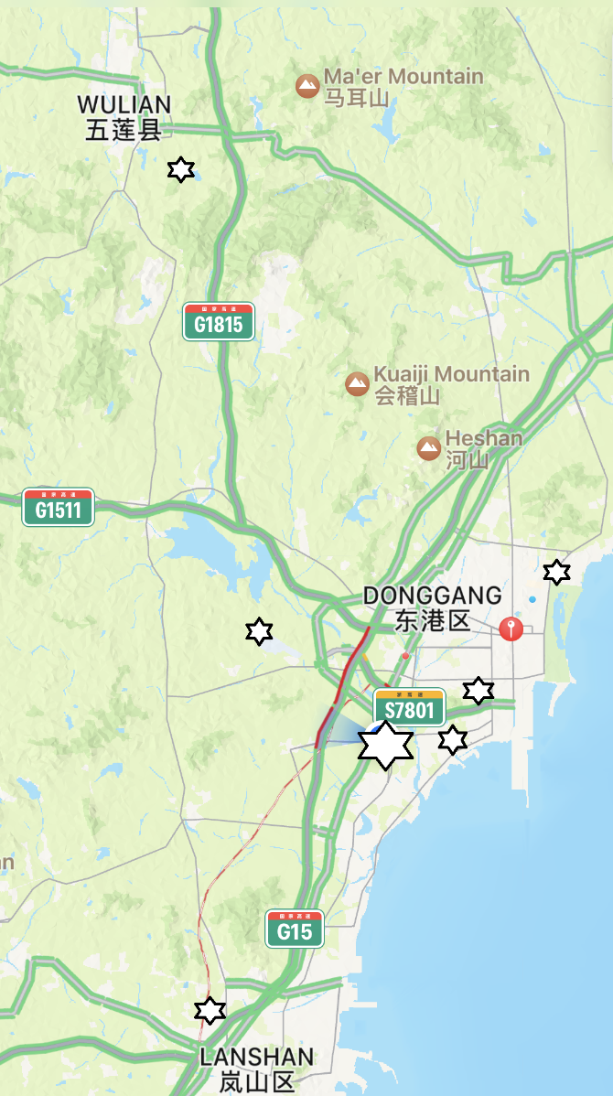

Supplementary Figure 1. Map of Rizhao showing the locations of the sites from which the soil samples were collected (stars). Stars indicate sites from which toxic Bacillus thuringiensis was isolated.

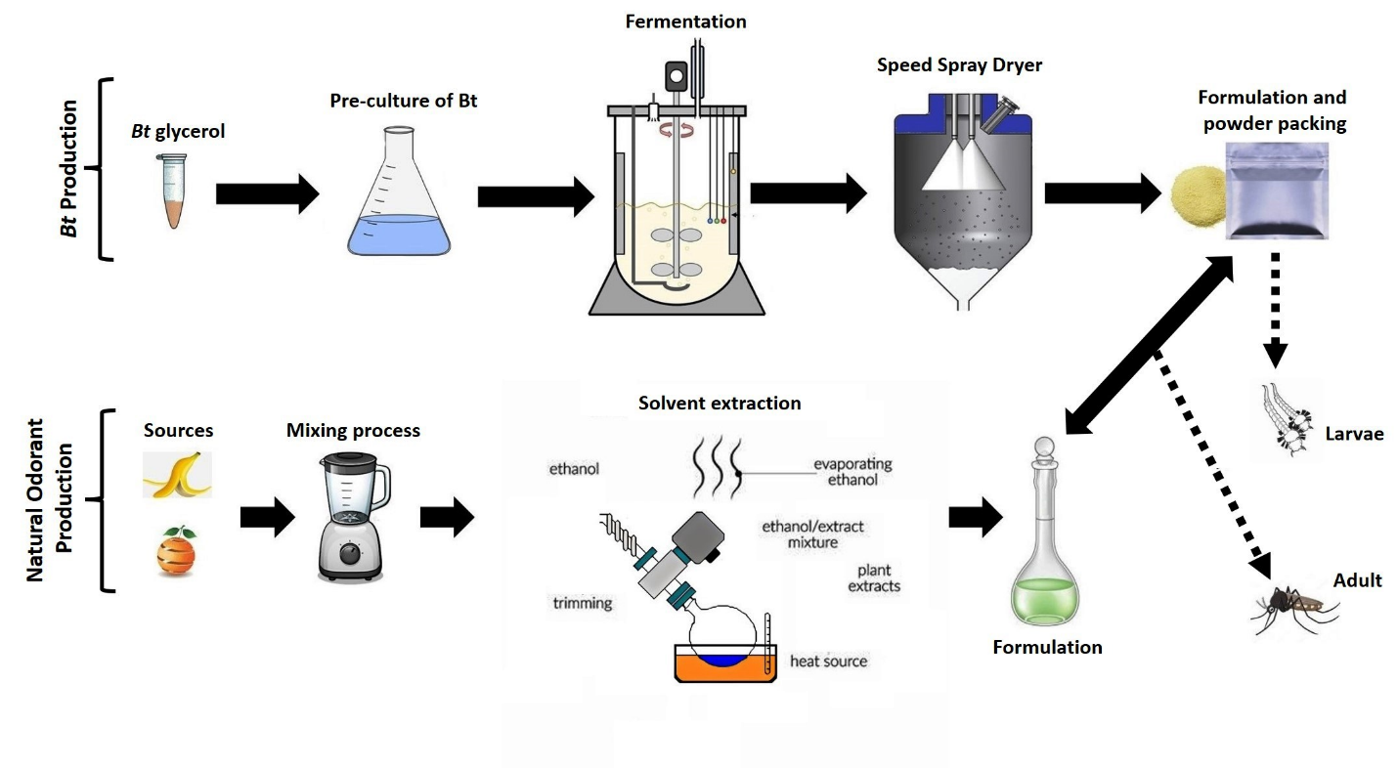
Supplementary Figure 2. Schematic representation of the B. thuringiensis and natural odorant production to the control of larvae and adult mosquitoes.

A
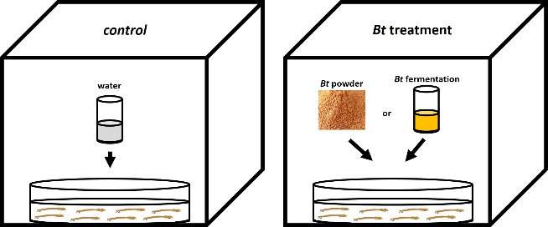
B
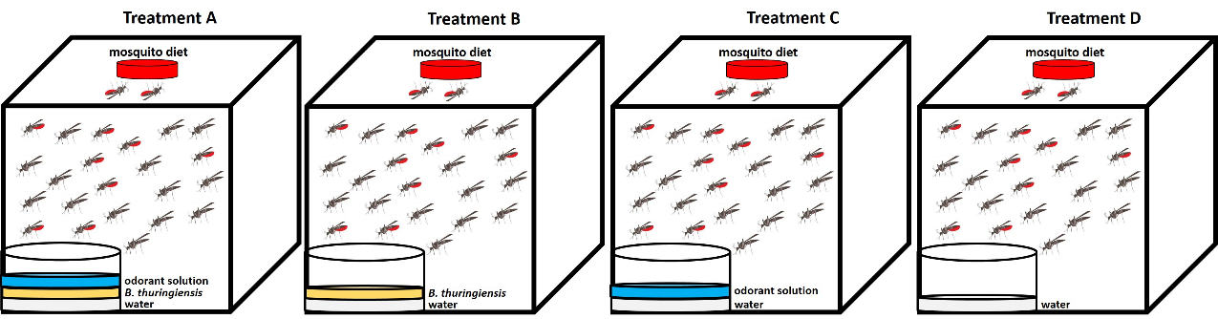
Supplementary Figure 3. Schematic representation of the evaluation of biological activity of B. thuringiensis against larvae (A) and adult (B) mosquitoes under controlled conditions.

