Supplemental information

Nicotinamide enhances osteoblast differentiation through the activation of mitochondrial antioxidant defense system
Heein Yoon¹, Seung Gwa Park¹, Hyun-Jung Kim¹, Hye-Rim Shin¹, Woo-Jin Kim¹, Ki-Tae Kim¹, Young-Dan Cho², Jae-I Moon,¹ Min-Sang Park¹, and Hyun-Mo Ryoo^{1,*}
¹ Department of Molecular Genetics & Dental Pharmacology, School of Dentistry and Dental Research Institute, Seoul National University, Seoul, South Korea
² Department of Periodontology, School of Dentistry and Dental Research Institute, Seoul National University and Soul National University Dental Hospital, Seoul, South Korea
*Correspondence: hmryoo@snu.ac.kr

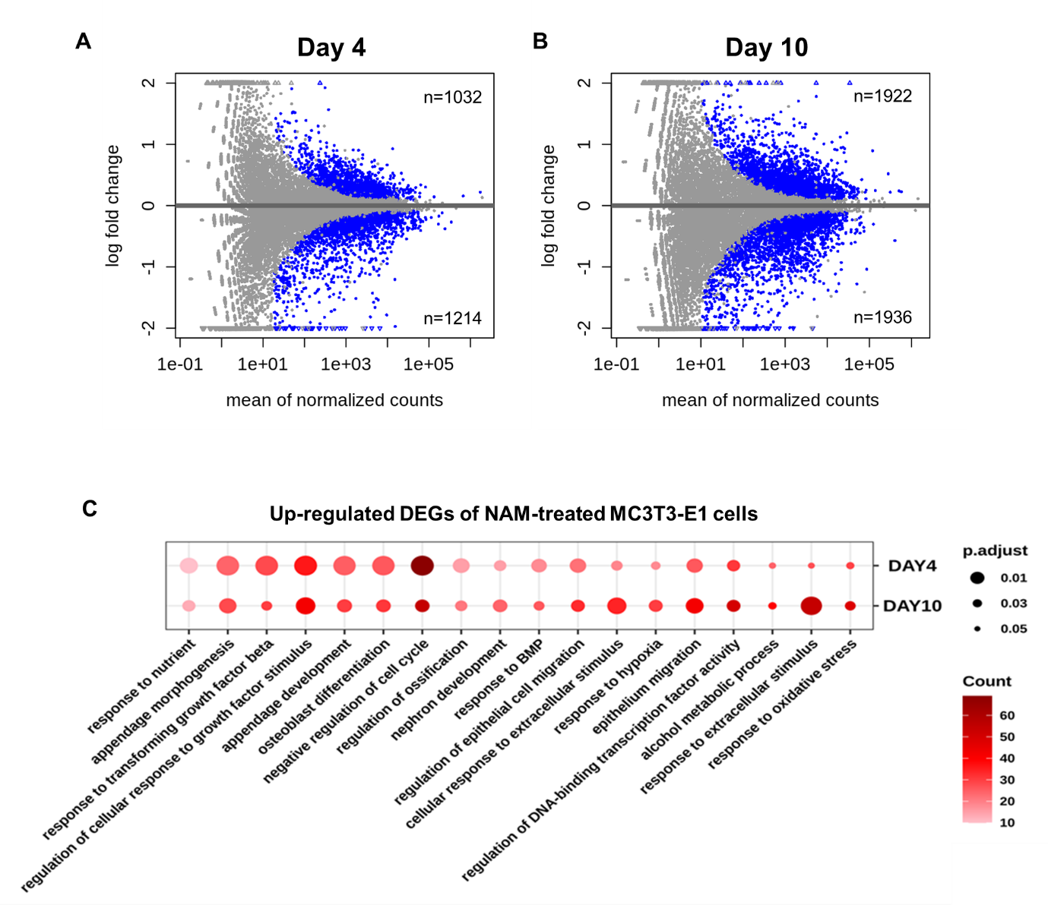

Supplementary Figure 1. RNA-seq analysis on the DEGs regulated by NAM treatment for 4 or 10 days in MC3T3-E1 cells. Related to Figure 1.
(A-B) The differential expression of genes by NAM were visualized using MA plots.
(C-D) GO analysis was performed using upregulated and downregulated DEGs by NAM on day 4 and 10. GO terms were selected and sorted based on enrichment score.

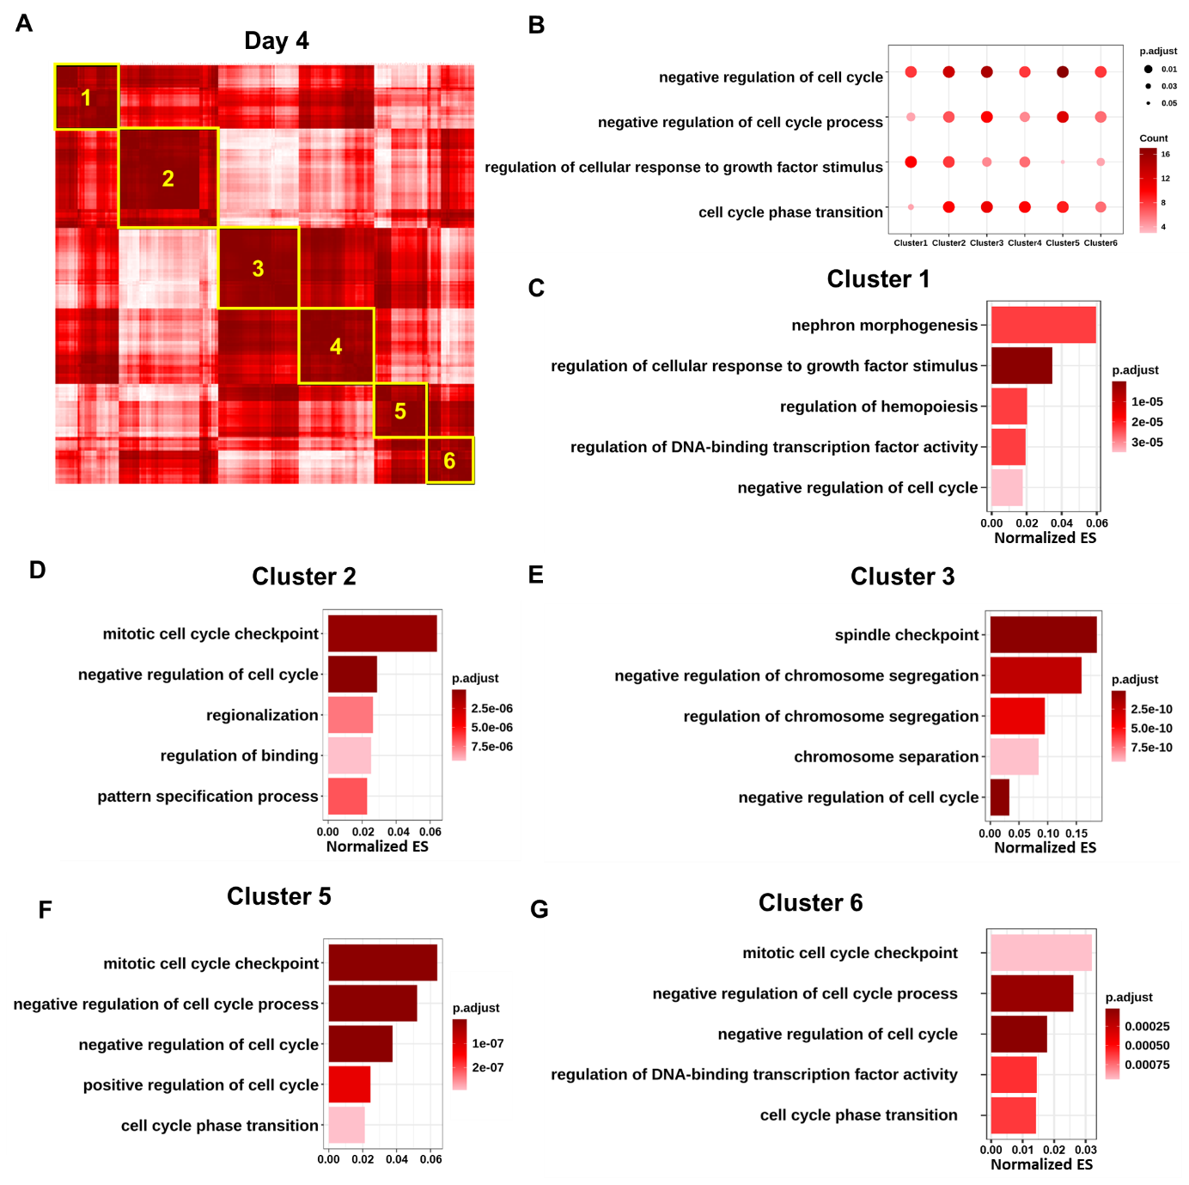
Supplementary Figure 2. Correlation analysis of DEGs upregulated by NAM on day 4. Related to Figure 1.
(A) Correlation analysis of upregulated genes by NAM on day 4. A normalized correlation matrix was performed to show correlation among GO terms.
(B) GO analysis was performed with genes included in each cluster. GO terms commonly included in all clusters are indicated.
(C-G) GO analysis of genes enriched in each cluster are displayed.

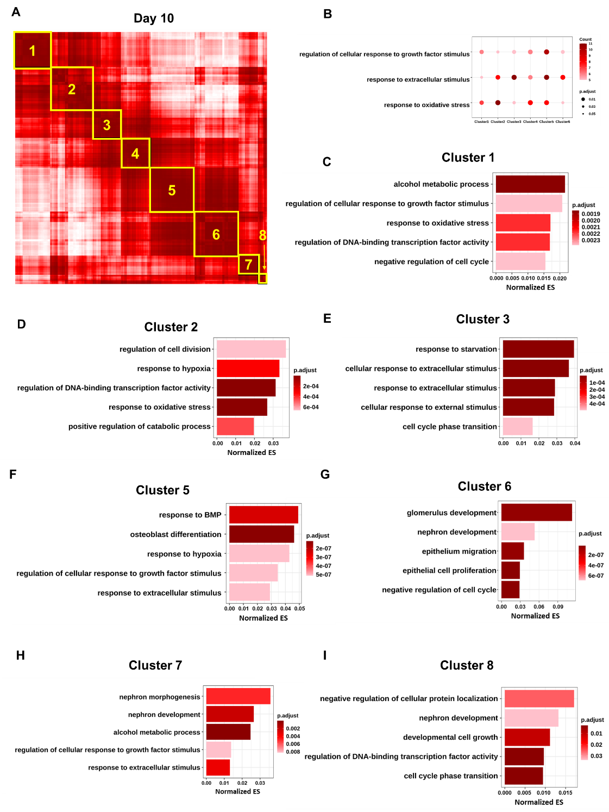

Supplementary Figure 3. Correlation analysis of DEGs upregulated by NAM on day 10. Related to Figure 2.
(A) Correlation analysis of upregulated genes by NAM on day 10. A normalized correlation matrix was performed to show correlation among GO terms.
(B) GO analysis was performed with genes included in each cluster. GO terms commonly included in all clusters are indicated.
(C-I) GO analysis of genes enriched in each cluster are displayed.

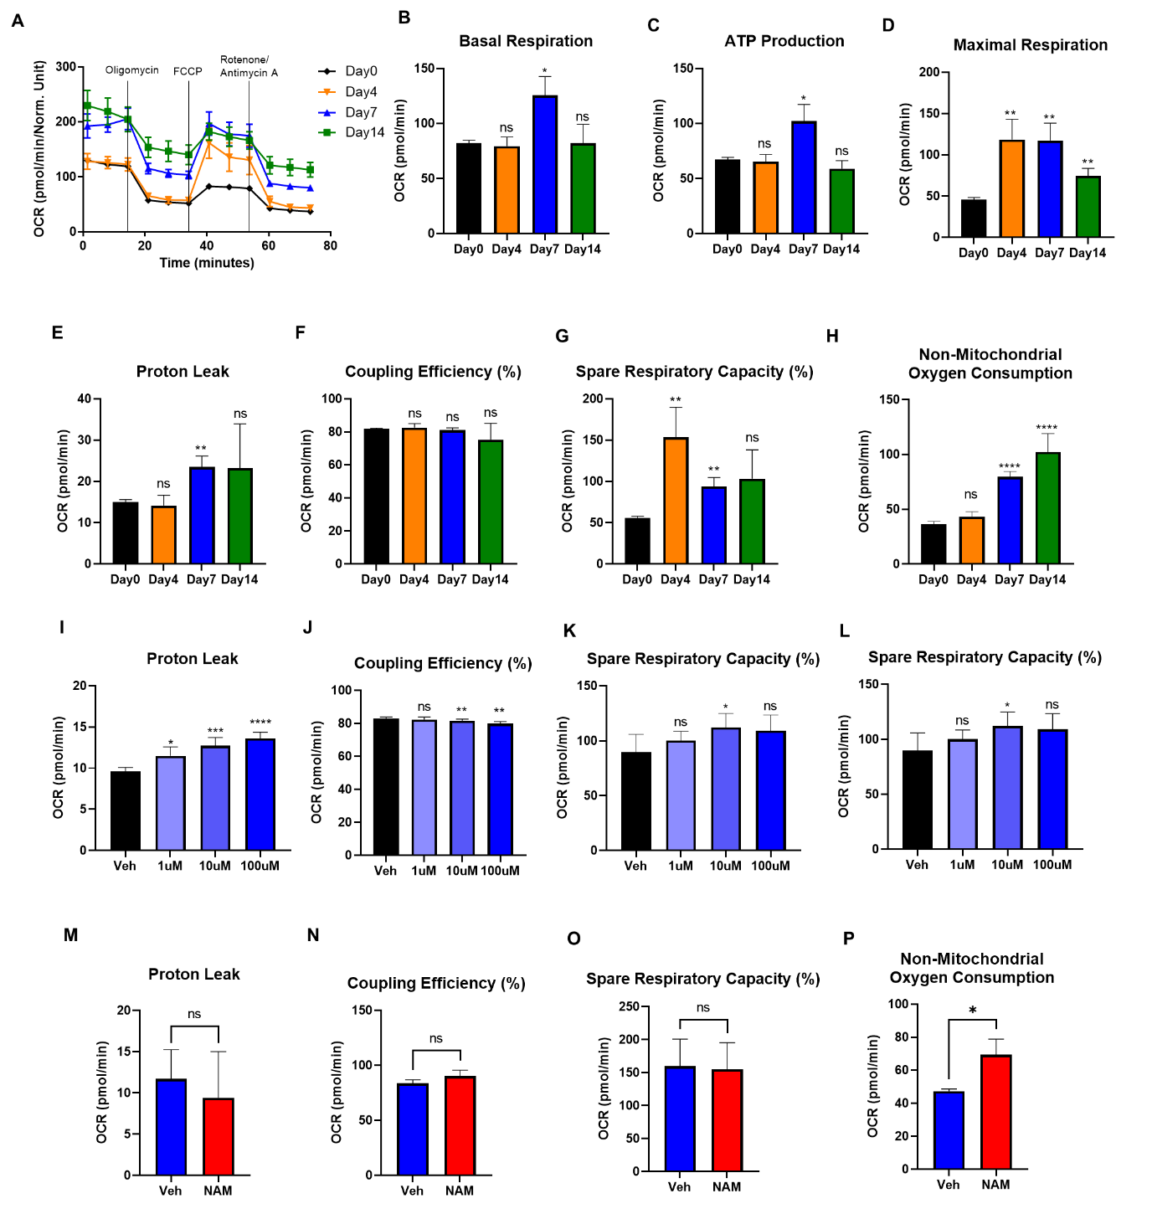
Supplementary Figure 4. The measurement of mitochondrial respiration using XF96 Extracellular Flux Analyzer. Related to Figure 4.
(A-H) MC3T3-E1 cells were cultivated in osteogenic medium for indicated days and the Oxygen Consumption Rate (OCR) was measured with an XF96 Extracellular Flux Analyzer (n≥3). The summary of curved OCR plot (A) was calculated and displayed with bar plots (B-H).
(I-L) MC3T3-E1 cells were cultured with indicated concentrations of NAM in growth medium for 1d and OCR was measured. (M-P) MC3T3-E1 cells were cultured with 10 μM of NAM in osteogenic medium for 7 days.

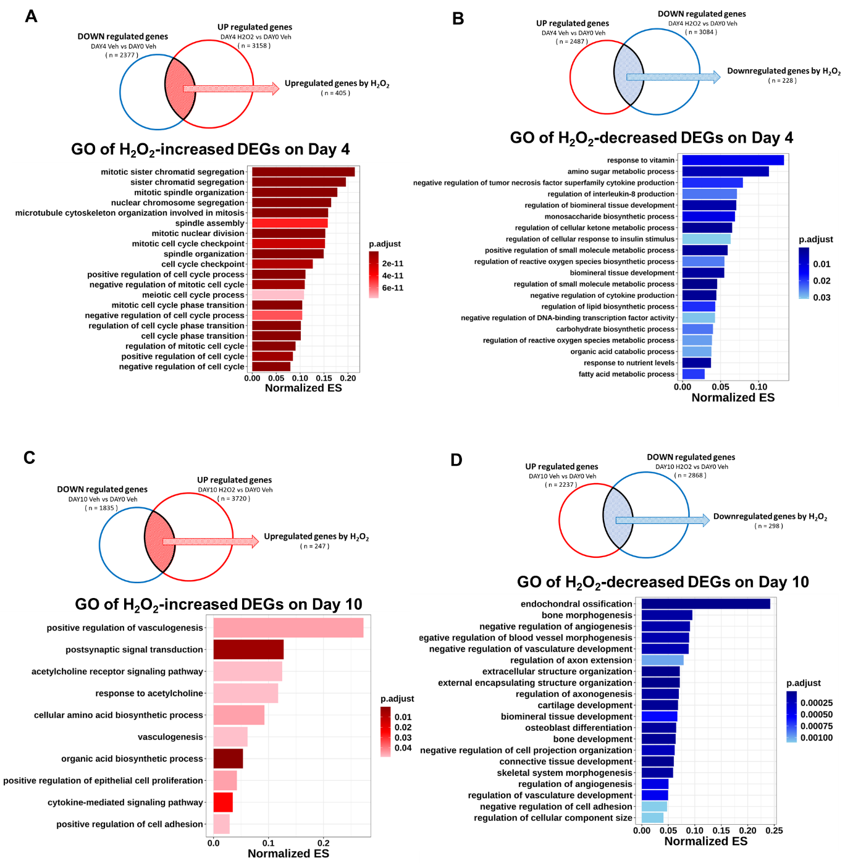
Supplementary Figure 5. RNA-seq analysis of H₂O₂-induced gene expression in osteoblasts. Related to Figure 5.
(A-B) GO analysis of upregulated or downregulated DEGs by 100 μM of H2O2 on day 4. The top 20 GO terms are selected based on adjusted p-value and sorted by enrichment score.
(C-D) GO analysis of upregulated or downregulated DEGs by 100 μM of H2O2 on day 10. The top 20 GO terms are selected based on adjusted p-value and sorted by enrichment score.

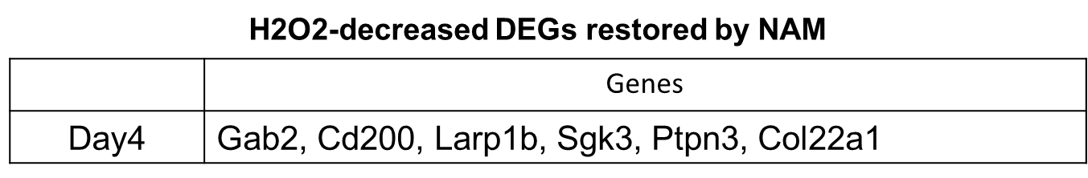
A

B C
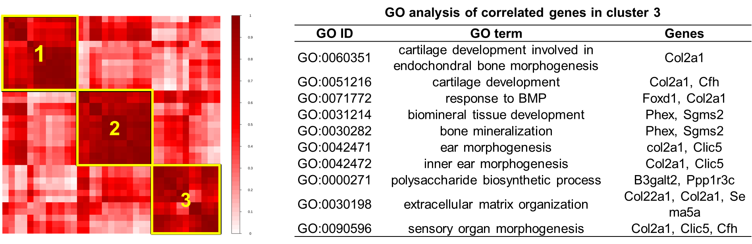
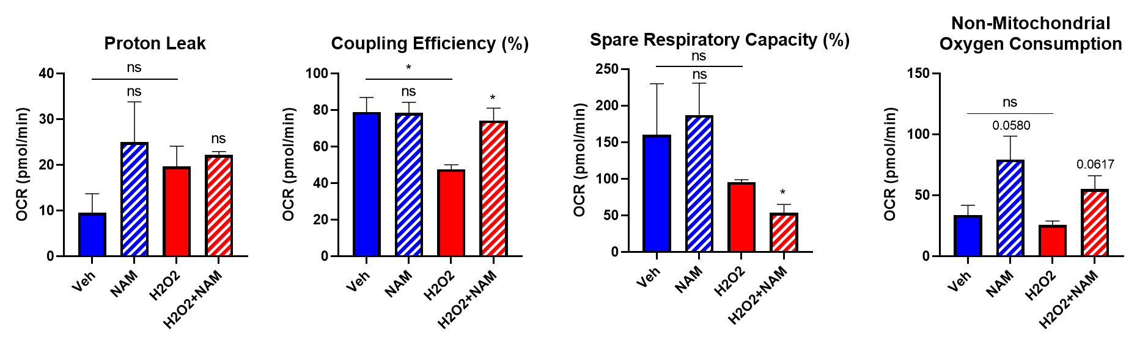
D E F G

Supplementary Figure 6. NAM prevents ROS-induced damage in osteoblasts. Related to Figure 5.
(A) H₂O₂-decreased DEGs restored by NAM on day 4 are listed in table.
(B) Correlation matrix plot on the DEGs whose expression was decreased by H2O2 -restored by NAM, included in top 20 GO category.
(C) The list of genes included in cluster 3 of correlation analysis (B).
(D-G) The mitochondrial OCR was evaluated after the treatment of 10 μM NAM together with or without 100 μM H₂O₂ for 7 d in osteogenic media using an XF96 Extracellular Flux Analyzer. The parameters calculated from the curved OCR plot (Figure 5E) were described into bar plots.

Supplementary Table 1. Primer sequences for RT-qPCR
gene | sequence
Runx2 | F: 5’-CCGCACGACAACCGCACCAT-3’
Runx2 | R: 5’-CGCTCCGGCCCACAAATCTC-3’
Osx | F: 5’-CCCACCCTTCCCTCACTCAT-3’
Osx | R: CCT TGT ACC ACG AGC CAT AGG-3’
Dlx5 | F: 5’-TCTCTAGGACTGACGCAAACA-3’
Dlx5 | R: GTTACACGCCATAGGGTCGC-3’
Bsp | F: 5’-CAG GGA GGC AGT GAC TCT TC-3’
Bsp | R: AGT GTG GAA AGT GTG GCG TT-3’
Ocn | F: 5’-CTG ACA AAG CCT TCA TGT CCA A -3’
Ocn | R: GCG CCG GAG TCT GTT CAC TA -3’
Opn | F: 5’-ATC TCA CCA TTC GGA TGA GTC T-3’
Opn | R: TCA GTC CAT AAG CCA AGC TAT CA-3’
Mepe | F: 5’-GTCTGTTGGACTGCTCCTCTT-3’
Mepe | R: CACCGTGGGATCAGGATACA-3’
Pgc1-α | F: 5’-ACTATGAATCAAGCCACTACAGAC-3’
Pgc1-α | R: TTCATCCCTCTTGAGCCTTTCG-3’
Ucp2 | F: 5’-TAAAGGTCCGCTTCCAGGCTCA-3’
Ucp2 | R: ACGGGCAACATTGGGAGAAGTC-3’
Trx2 | F: 5’-CCTTTAACGTCCAGGATGGACC-3’
Trx2 | R: TTGGCGACCATCTTCTCTAGCC-3’
Sod1 | F: 5’-GGTGAACCAGTTGTGTTGTCAGG-3’
Sod1 | R: ATGAGGTCCTGCACTGGTACAG-3’
Sod2 | F: 5’-TAACGCGCAGATCATGCAGCTG-3’
Sod2 | R: AGGCTGAAGAGCGACCTGAGTT-3’
Sirt3 | F: 5’-GCTACATGCACGGTCTGTCGAA-3’
Sirt3 | R: CAATGTCGGGTTTCACAACGCC-3’
Gapdh | F: 5’-CATGTTCCAGTATGACTCCACTC-3’
Gapdh | R: 5’-GGCCTCACCCCATTTGATGT-3’

Supplementary Table 2. GO analysis of correlated genes in cluster 1

GO ID | GO term | Genes
GO:0071772 | response to BMP | Hipk2, Smpd3, Runx2
GO:0031214 | biomineral tissue development | Co1a2, Smpd3, Wnt10b
GO:0030282 | bone mineralization | Col1a2, Smpd3, Wnt10b
GO:0042476 | odontogenesis | Smpd3, Pdgfra, Runx2
GO:0042475 | odontogenesis of dentin-containing tooth | Smpd3, Pdgfra, Runx2
GO:0048562 | embryonic organ morphogenesis | Chd7, Hipk2, Pdgfra, Runx2
GO:0030198 | extracellular matrix organization | Loxl4, Col1a2, Smpd3, Pdgfra
GO:0048705 | skeletal system morphogenesis | Smpd3, Pdgfra, Runx2
GO:0060541 | respiratory system development | Chd7, Smpd3, Pdgfra, Klf2
GO:0034614 | cellular response to reactive oxygen species | Hk3, Map3k5, Smpd3, Pdgfra

Supplementary Table 3. GO analysis of correlated genes in cluster 2
GO ID | GO term | Genes
GO:0060351 | cartilage development involved in endochodral bone morphogenesis | Mmp13
GO:0051216 | cartilage development | Mmp13, Bmp1
GO:0042471 | ear morphogenesis | Tmie, Dlx5
GO:0042472 | inner ear morphogenesis | Tmie, Dlx5
GO:0060350 | endochondral bone morphogenesis | Mmp13, Dlx5
GO:0090596 | sensory organ morphogenesis | Tmie, Fzd5, Dlx5
GO:0048705 | skeletal system morphogenesis | Mmp13, Dhrs3, Dlx5
GO:0060348 | bone development | Mmp13, Dhrs3, Dlx5
GO:0061138 | morphogenesis of a branching epithelium | Vdr, Tnc, Fzd5
GO:0060349 | bone morphogenesis | Mmp13, Dhrs3, Dlx5

