SUPPORTING INFORMATION

A Photochemical Study of Photo-induced Electron Transfer from DNAs to a Cationic Phthalocyanine Derivative

Shiori Hommaª, Atsuya Momotake ^{ac}, Takahisa Ikeue^{b}, Yasuhiko Yamamoto^{a*}

ª Department of Chemistry, University of Tsukuba, Tsukuba 305-8571, Japan
^{b}Department of Chemistry, Graduate School of Science and Engineering, Shimane University, Matsue 690-8504, Japan
^{c} Tsukuba Research Center for Energy Materials Science (TREMS), University of Tsukuba, Tsukuba 305-8571, Japan

* Corresponding author: Yasuhiko Yamamoto
Phone/Fax: +81-29-853-7365, E-mail: yamamoto@chem.tsukuba.ac.jp

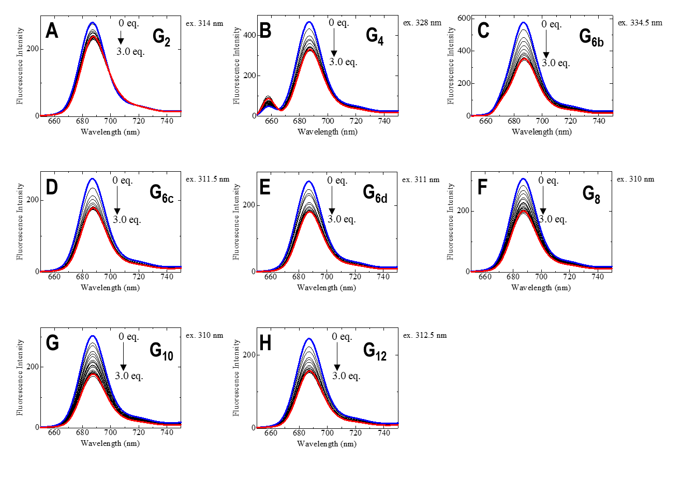

Figure S1. Fluorescence spectra of 2 μM GaPc (A) in the presence of 0-3 equivalent of duplex DNA G₂ (A), G₄ (B), G_{6b} (C), G_{6c} (D), G_{6d} (E), G₈ (F), G₁₀ (G), and G₁₂ (H) in 50 mM potassium phosphate buffer, pH 6.80, and 300 mM KCl at 25℃. The spectra of GaPc in the absence and presence of 3.0 equivalents DNAs are shown in blue and red, respectively. The excitation wavelengths were selected based on the isosbestic point of the change in the UV absorption spectra of GaPc upon the addition of the duplex DNAs.

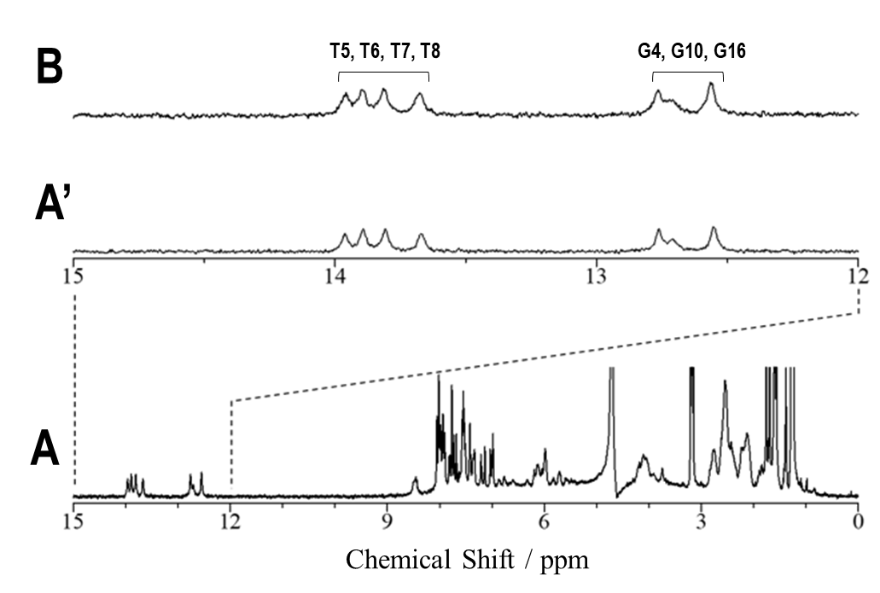
Figure S2. 600 MHz ¹H NMR spectrum of duplex DNA G_{6d} ([d(TTCGTTTTCGAAAACGAA)​]₂) in 90% ¹H₂O/10% ²H₂O, 50 mM potassium phosphate buffer, pH 6.80, and 300 mM KCl at 25℃. Downfield-shifted guanine and thymine imino proton signals of G_{6d} in (A) are expanded in (A’) and are compared with those of G_{6d} in the presence of a stoichiometric amount of GaPc in (B). Interaction between the DNA and GaPc was not reflected in the imino proton signals. Tentative imino proton signal assignments are shown with the spectrum. Since T1 and T2 are located at the termini, fast exchange of their imino protons with solvent protons possibly broadens their signals beyond the level of detection.

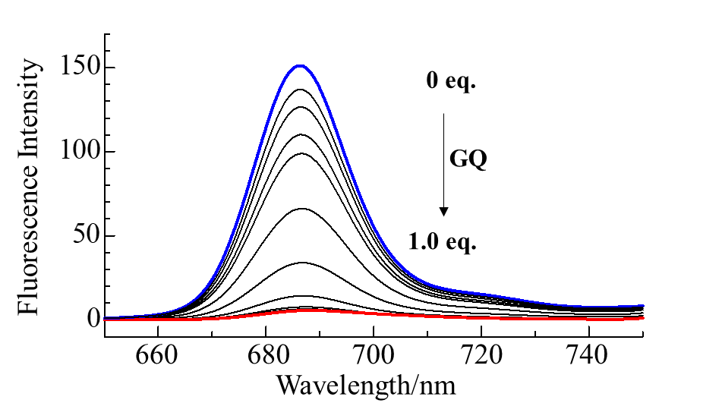
Figure S3. Fluorescence spectra of 2 μM GaPc (A) in the presence of 0-2 μM [d(TTAGGGT)]₄ (GQ) in 50 mM potassium phosphate buffer, pH 6.80, and 300 mM KCl at 25℃. The spectra were cited from previous paper.[25] The excitation wavelength was 380 nm. The spectra of GaPc in the absence and presence of 1.0 equivalent of GQ are shown in blue and red, respectively.

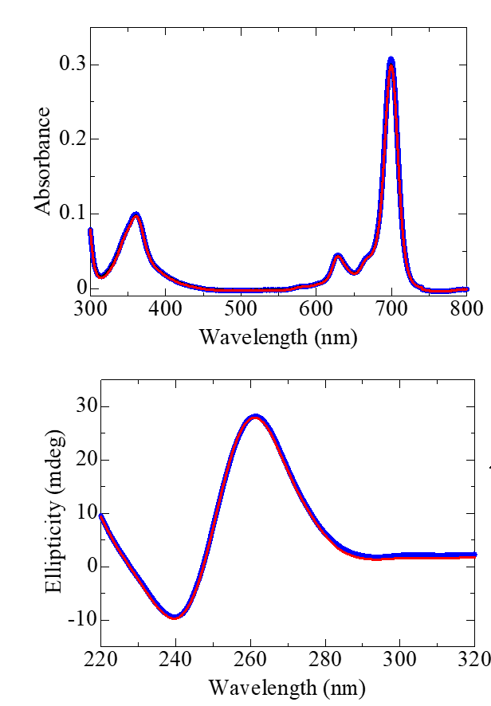

Figure S4. Absorption (A) and CD (B) spectra of 2 μM GaPc in the presence of 3 equivalent of GQ in 50 mM potassium phosphate buffer, pH 6.80, and 300 mM KCl at 25℃, before (blue) and after (red) photo irradiation (699 nm) for 60 min. No photo decomposition of GQ was detected in both spectra due to the electron transfer from guanine to the excited singlet state of GaPc.

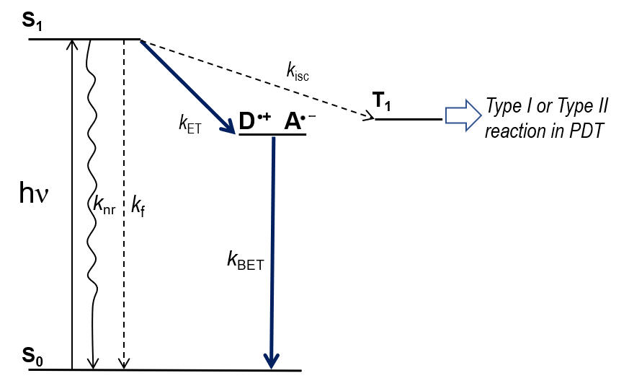

Figure S5. Reaction scheme for the photoinduced electron transfer from the guanine bases to GaPc in the excited state in GaPc-GQ complex. The parameters are as follows.
k_{nr}: the rate constant of nonradiative deactivation of GaPc.
k_{f}: the fluorescence emission rate constant of GaPc. The k_{f} contribution was calculated from τ_{f0} = 3.8 ns and Φ_{f} = 0.14.
k_{ET}: the rate constant of the electron transfer from the guanine bases of the DNA to the photo-excited GaPc bound to the DNA.
k_{BET}: the rate constant of the back electron transfer.
k_{isc}: the rate constant of intersystem crossing of GaPc.
The free energy change ΔG_{ET} of photoinduced electron transfer is expressed based on the Rehm-Weller equation, as follows:
​ΔG_{ET}＝E_{OX}−E_{RED}−E₀₀+ w ​ (1)
E_{OX} is the first oxidation potential of guanine bases (electron donor) and is 1.47 V in the buffer solution (vs NHE), E_{RED} is the first reduction potential of GaPc (electron acceptor) and is −0.14 V (vs NHE), E_{0,0} is the energy of the electron 0-0 transition of GaPc and is 1.82 V, and w is the work term of the charge-separated state, which is reported to be about −0.1 V for quenching reactions in aqueous solutions (Seidel, C. A. M.; Schulz, A.; Sauer, M. H. M. J. Phys. Chem. 1996, 100 (13), 5541-5553).
Substituting these values into equation (1), ΔG_{ET} is −0.31 V, which takes a negative value, indicating an exoergonic reaction.

