SUPPLEMENTARY INFORMATION

Engineering Broad-spectrum Inhibitors of Inflammatory Chemokines from a New Family of Tick Evasins

Shankar Raj Devkota¹, Pramod Aryal¹, Wanting Jiao², Andrew Perry³, Santosh Panjikar^{1,4}, Richard J. Payne^{5,6}, Matthew C.J. Wilce¹, Ram Prasad Bhusal^{1, *} and Martin J. Stone^{1, *}

¹Monash Biomedicine Discovery Institute, and Department of Biochemistry and Molecular Biology, Monash University, Clayton, VIC 3800, Australia
² Ferrier Research Institute, Victoria University of Wellington, Wellington 6140, New Zealand; Maurice Wilkins Centre for Molecular Biodiscovery, Auckland 1142, New Zealand
³Monash Bioinformatics Platform, Monash Biomedicine Discovery Institute, Monash University, Clayton, VIC 3800, Australia
⁴Australian Synchrotron, ANSTO, Clayton, VIC 3168, Australia
⁵ School of Chemistry, The University of Sydney, Sydney, NSW 2006, Australia
⁶Australian Research Council Centre of Excellence for Innovations in Peptide and Protein Science, The University of Sydney, NSW 2006, Australia
*Correspondence: ram.bhusal@monash.edu; Tel.: +61-3-9905-5937; martin.stone@monash.edu; Tel.: +61-3-9902-9246

Supplementary Figure 1. Sequences and features of class A3 evasins. Multiple sequence alignments (obtained using Clustal Omega) of the sequences of class A3 evasins. Sequence names are the primary accession code found in UniProt. Sequence A0A0C9S461 corresponds to EVA-AAM1001. Conserved cysteines (yellow), additional cysteines (red), conserved glycine (green), putative tyrosine sulfation sites (pink) and putative glycosylation sites (sky blue) are highlighted. Abbreviations used for tick species are ATL, A.tuberculatum; AAM, A. americanum; ACA, A. cajennense; APA, A. parvum; ATR, A. triste.

Supplementary Figure 2. Sequences of C₁₀ evasins from Rhipicephalus species. Multiple sequence alignments of a fourth subfamily of class A evasin-like proteins, all encoded by tick species from the genus Rhipicephalus and all containing the eight conserved cysteine residue from class A1 evasins (highlighted in yellow) as well as two additional cysteine residues (highlighted red) in positions distinct from class A3 evasins. Sequence names are the primary accession codes found in UniProt.

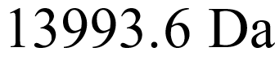
Supplementary Figure 3. Analysis of EVA -A by mass spectrometry. Purified EVA-A (with Linker Avi) was analysed by liquid chromatography-electrospray ionisation mass spectrometry (LC MS-ESI). The expected mass of EVA-A with five disulfide bonds is 13994.42 Da.

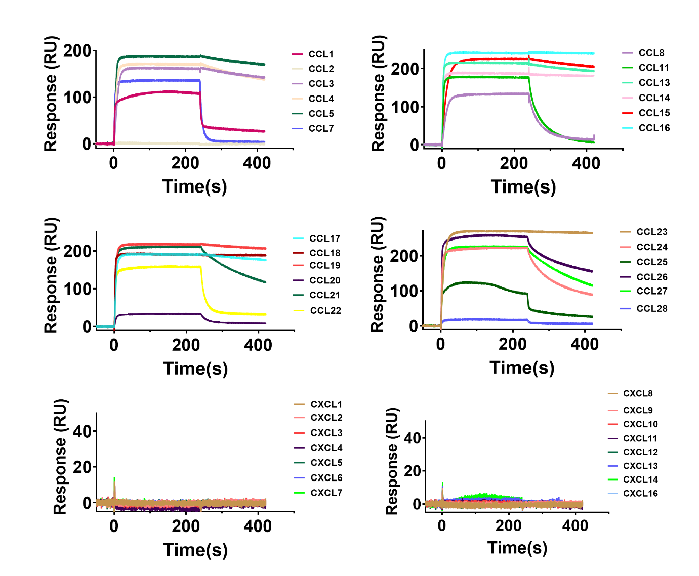
Supplementary Figure 4. EVA-A selectively binds to multiple human CC chemokines. Screening of EVA-A with multiple human chemokines (500 nM) by SPR using single-cycle kinetics at a single concentration. EVA-A selectively binds to CC chemokines but not to other classes of chemokines.

Supplementary Figure 5. SPR sensorgrams for CCL7 and C(A)CL7. Single-cycle kinetics SPR sensorgrams for CCL7(sky blue) and C(A)CL7 (red) binding to EVA-A.

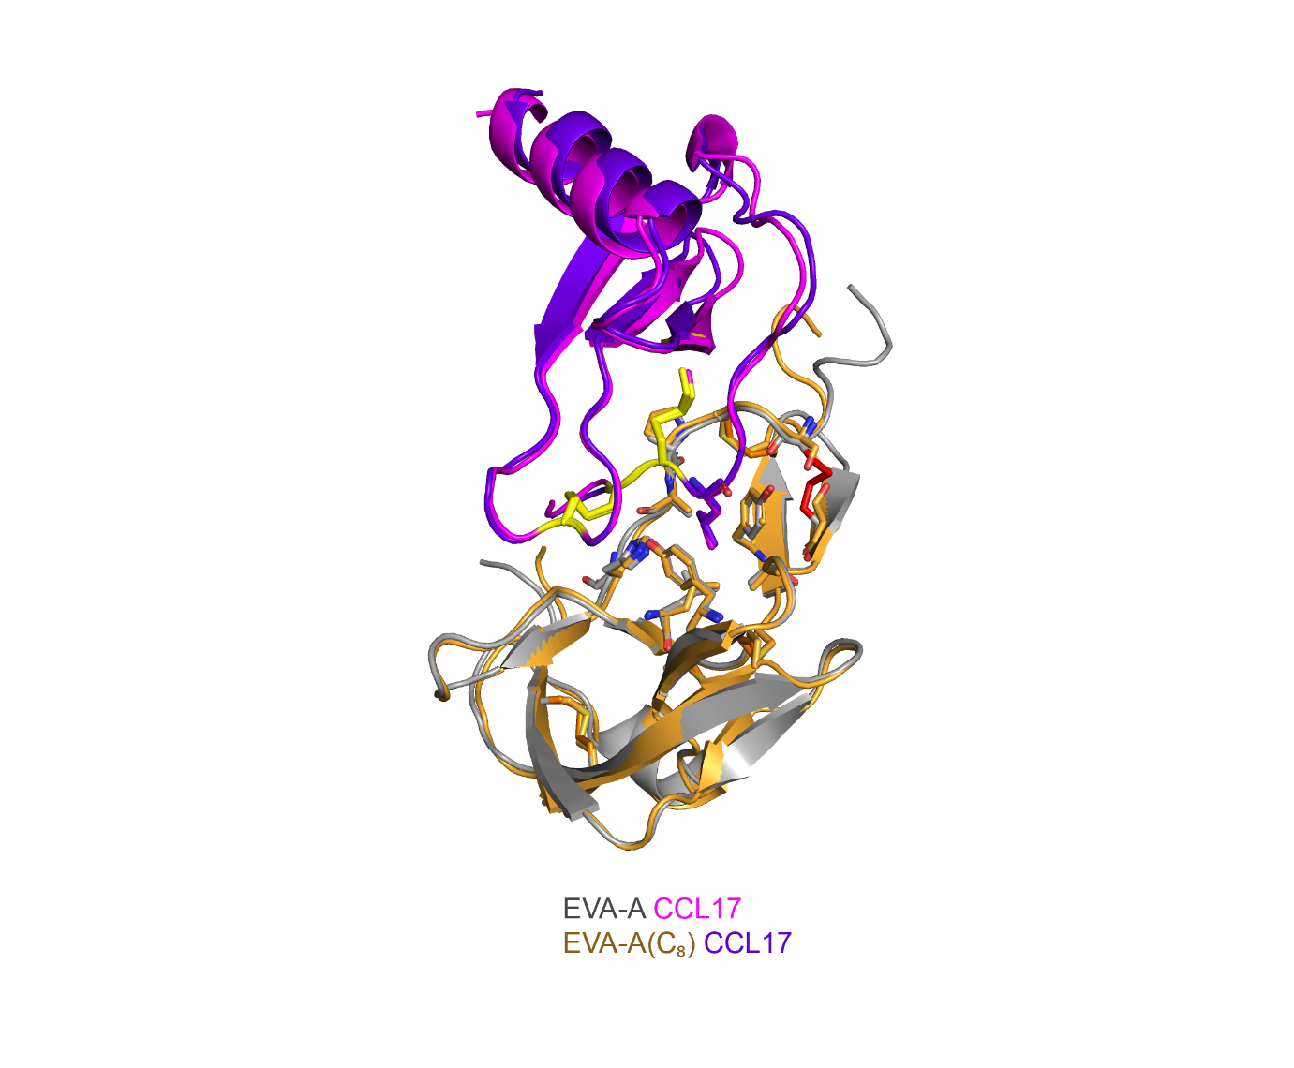
Supplementary Figure 6. Superimposition of EVA-A CCL17 and EVA-A (C₈) CCL17.
Overlay of EVA-A and EVA-A (C₈) CCL17 shows the same fold despite the removal of an additional disulfide bond.

Supplementary Figure 7. Surface plasmon resonance (SPR). Binding of chemokines (CCL7, CCL11, CCL16, CCL17) and EVA-A variants (EVA-A(WT): grey, EVA-A (Y44A): green, EVA-A(L39P): blue measured by SPR using single-cycle kinetics.



EVA-P overlaid with simulated structures
EVA-A overlaid with simulated structures

Supplementary Figure 8. Superimposition of the representative conformations of EVA-A and EVA-P from each of the three replicates MD simulations. (a) Figure showing the overlay of WT EVA-P (green teal) structure with three MD representative structures of EVA-P (pale cyan). (b) Figure showing the overlay of WT EVA-A (grey) structure with three MD representative structures of EVA-A (light blue). Both EVA-P and EVA-A retain the same fold over the MD simulations.

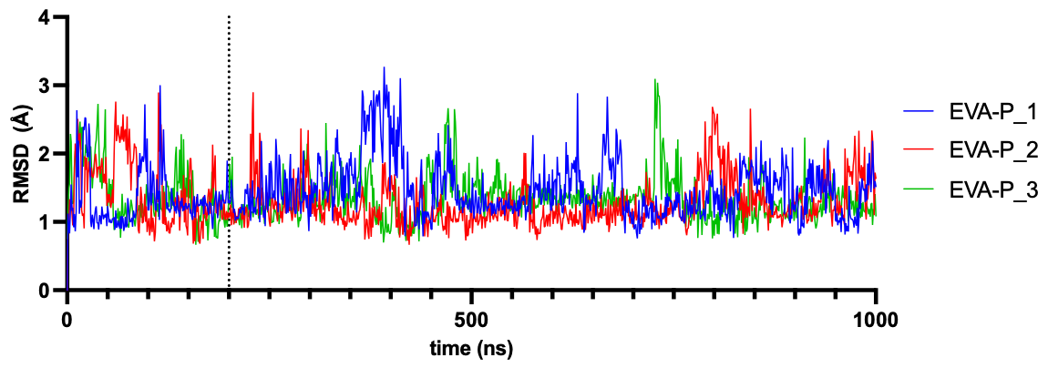
Supplementary Figure 9. (a). Protein backbone RMSD values of residues 13-90 during MD simulations for N-terminal truncated EVA-P. Each simulation was conducted for 1 μs. All three replicates appeared to be equilibrated after 200 ns, thus simulation periods 200 ns – 1 μs were analysed. Total time for analysis was 800 ns x 3 = 2.4 μs.

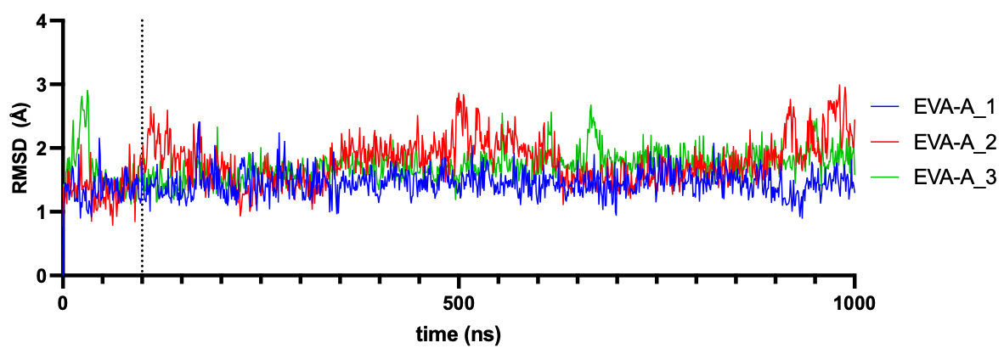
Supplementary Figure 9. (b) Protein backbone RMSD values of residues 21-101 during MD simulations for N-terminal truncated EVA-A. Each simulation was conducted for 1 μs. All three replicates appeared to be equilibrated after 100 ns, thus simulation periods 100 ns – 1 μs were analysed. Total time for analysis was 900 ns x 3 = 2.7 μs.

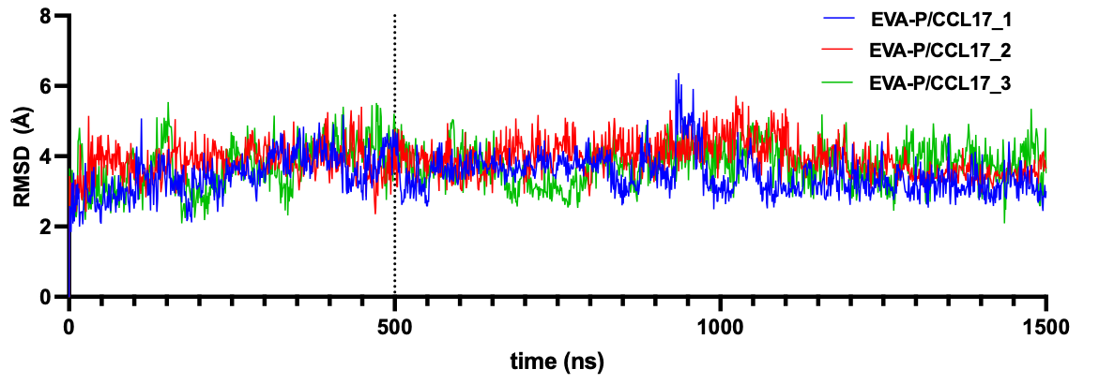
Supplementary Figure 9. (c) Protein backbone RMSD values of EVA-P/CCL17 complex during MD simulations. The trajectories were first aligned by backbone atoms of EVA-P and then the overall protein (including both EVA-P and CCL17) RMSD values were calculated. For EVA-P/CCL17 complex, the simulations appeared to have equilibrated after 500 ns of each simulation, therefore, time periods 500 ns – 1.5 μs were analysed. Total time for analysis was 3 μs.

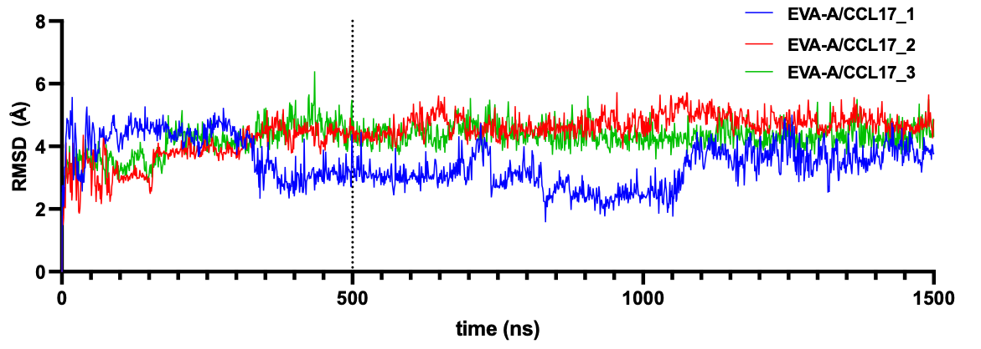
Supplementary Figure 9. (d) Protein backbone RMSD values of EVA-A/CCL17 complex during MD simulations. The trajectories were first aligned by backbone atoms of EVA-A and then the overall protein (including both EVA-P and CCL17) RMSD values were calculated. The overall protein backbone RMSD values appeared to have equilibrated after 350 ns in both simulations 2 and 3, but simulation 1 showed large fluctuations. Examination of the trajectories in simulation 1 showed the fluctuation may be due to movements of the flexible N-terminal region of CCL17 (residues 1-8). To confirm this, protein RMSD values including all backbone of EVA-A and backbone of residues 8 to 71 of CCL17 are plotted in Supplementary Figure 9 (e).

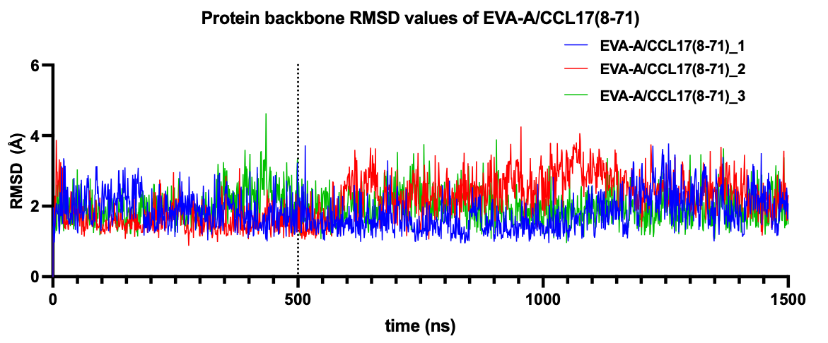
Supplementary Figure 9. (e) Protein backbone RMSD values of EVA-A/CCL17(residue 8-71) complex during MD simulations. When the flexible N-terminal region has been removed from the RMSD calculation, it is clear simulation 1 has also equilibrated. Therefore, trajectories between 500 ns – 1.5 μs from each simulation were used for analysis. The total time for analysis was 3 μs.

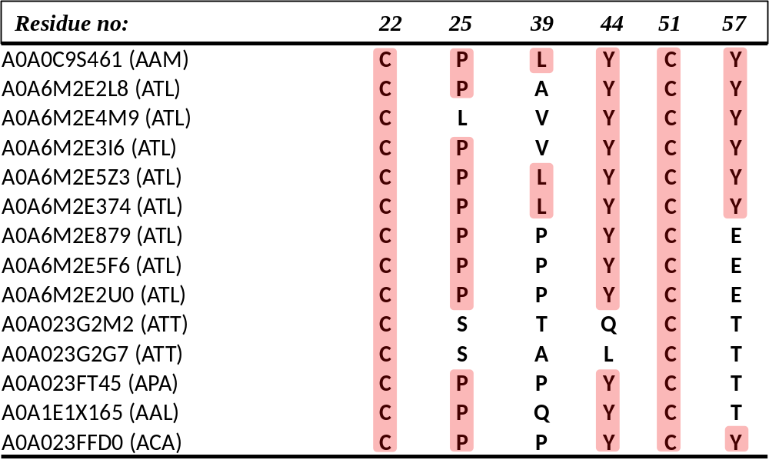
Supplementary Figure 10. Residues forming the CC+1 binding pocket in class A3 evasins. Residues numbers are for EVA-A. Residues conserved with EVA-A are highlighted in pink.

Supplementary Table 1. X-ray diffraction data collection and refinement statistics. Values in parentheses are for the outermost resolution shell.
 | EVA-A:CCL7 | EVA-A:CCL11 | EVA-A:CCL16 | EVA-A:CCL17
PDB ID | 7SCU | 7SCS | 7SCT | 7SCV
Data collection
Wavelength (Å) | 0.953 | 0.953 | 0.953 | 0.953
Resolution range | 48.59 - 1.86  (1.90 - 1.86) | 41.58 - 1.51  (1.54 - 1.51) | 48.13 - 1.84  (1.88 - 1.84) | 44.69 – 2.01  (2.07 – 2.01)
Space group | P 4₁ 2₁ 2 | P 4₁ 2₁ 2 | I 4 2 2 | P 3₁ 2 1
Cell dimensions
a, b, c (Å) | 71.2 71.2 66.4 | 75.0 75.0 66.9 | 96.2 96.2 84.7 | 88.0 88.0 55.1
a, b, g (⁰) | 90 90 90 | 90 90 90 | 90 90 90 | 90 90 120
R_{merge} | 0.102 (1.438) | 0.075 (1.130) | 0.076 (1.518) | 0.114 (1.460)
R_{meas} | 0.106 (1.497) | 0.077 (1.339) | 0.077 (1.549) | 0.117 (1.502)
R_{pim} | 0.021 (0.299) | 0.015 (0.270) | 0.015 (0.304) | 0.026 (0.346)
I/s(I) | 20.0 (2.7) | 23.9 (2.9) | 23.0 (2.7) | 17.4 (2.4)
CC_{1/2} | 0.996 (0.670) | 1.000 (0.774) | 0.999 (0.829) | 0.999 (0.699)
Completeness (%) | 99.8 (96.5) | 99.8 (96.9) | 99.9 (98.6) | 99.7 (96.5)
Total reflections | 377698 (21922) | 776078 (33204) | 459548 (26148) | 330673 (21345)
Unique reflections | 14877 (912) | 30361 (1433) | 17690 (1051) | 16612 (1165)
Multiplicity | 25.4 (24.0) | 25.6 (23.2) | 26.0 (24.9) | 19.9 (18.3)
Refinement
R_{work} / R_{free} | 0.193 / 0.210 | 0.184 / 0.206 | 0.203 / 0.210 | 0.236 / 0.251
No. of atoms | 1214 | 1331 | 1248 | 1177
Macromolecules | 1124 | 1174 | 1169 | 1089
Solvent | 90 | 157 | 79 | 88
Average B factors | 38.3 | 29.6 | 50.3 | 50.4
Macromolecules | 38.3 | 28.4 | 50.6 | 50.4
Solvent | 38.3 | 38.6 | 46.0 | 50.8
r. m. s. deviations
Bond lengths (Å) | 0.003 | 0.009 | 0.007 | 0.002
Bond angles (⁰) | 0.67 | 1.21 | 1.08 | 0.62
Ramachandran statistics (%)
Favoured | 99.31 | 97.97 | 97.28 | 96.53
Allowed | 0.69 | 2.03 | 2.72 | 3.47
Outliers | 0 | 0 | 0 | 0
Clashscore | 1.38 | 6.44 | 2.18 | 4.78
MolProbity score | 0.87 | 1.36 | 1.13 | 1.47

Supplementary Table 1. (continued)
 | EVA-A  (Y44A):  CCL2 | EVA-A  (Y44A):  CCL7 | EVA-A (L39P):  CCL7 | EVA-A(C₈):  CCL17 | EVA-A:  CCL7(Y13A)
PDB ID | 8FJ0 | 8FK6 | 8FK8 | 8FK9 | 8FJ3
Data collection
Wavelength (Å) | 0.953 | 0.953 | 0.953 | 0.953 | 0.953
Resolution range | 47.11 - 2.89  (3.07 - 2.89) | 49.25 - 1.74  (1.77 - 1.74) | 48.78 - 1.96  (2.01 - 1.96) | 46.34 - 2.07  (2.13 - 2.07) | 48.55 – 2.07  (2.13 -2.07)
Space group | P 1 2₁ 1 | P 4₁ 2₁ 2 | P 4₁ 2₁ 2 | I 2 2 2 | P 4₁ 2₁ 2
Cell dimensions
a, b, c (Å) | 82.4 49.6 88.3 | 72.3 72.3 67.2 | 72.5 72.5 65.9 | 60.6 62.5 92.6 | 72.2 72.2 65.5
a, b, g (⁰) | 90 112.9 90 | 90 90 90 | 90 90 90 | 90 90 90 | 90 90 90
R_{merge} | 0.427 (2.795) | 0.052 (0.351) | 0.130 (1.442) | 0.210 (1.954) | 0.197 (1.411)
R_{meas} | 0.465 (3.040) | 0.054 (0.358) | 0.133 (1.470) | 0.219 (2.048) | 0.201 (1.440)
R_{pim} | 0.180 (1.179) | 0.011 (0.069) | 0.026 (0.282) | 0.062 (0.598) | 0.040 (0.285)
I/s(I) | 5.4 (1.5) | 39.4 (10.4) | 18.2 (2.8) | 8.7 (2.0) | 14.1 (3.4)
CC_{1/2} | 0.971 (0.475) | 0.999 (0.985) | 0.999 (0.810) | 0.992 (0.551) | 0.998 (0.803)
Completeness (%) | 96.2 (90.5) | 100 (99.4) | 100 (99.4) | 99.3 (92.7) | 99.9 (98.9)
Total reflections | 97403 (14332) | 489279 (26691) | 335070 (23669) | 139936 (8894) | 272655 (20935)
Unique reflections | 14772 (2250) | 18937 (1025) | 13129 (903) | 10995 (785) | 11114 (846)
Multiplicity | 6.6 (6.4) | 25.8 (26.0) | 25.5 (26.2) | 12.7 (11.3) | 24.5 (24.7)
Refinement
R_{work} / R_{free} | 0.253 / 0.284 | 0.206 / 0.223 | 0.241 / 0.262 | 0.213 / 0.230 | 0.213 / 0.229
No. of atoms | 2886 | 1226 | 1078 | 1096 | 1160
Macromolecules | 1875 | 1123 | 1026 | 1053 | 1082
Solvent | 11 | 103 | 52 | 43 | 78
Average B factors | 62.5 | 38.9 | 42.5 | 57.2 | 37.1
Macromolecules | 62.5 | 38.8 | 42.6 | 57.4 | 37.2
Solvent | 50.3 | 39.5 | 40.0 | 52.5 | 36.1
r. m. s. deviations
Bond lengths (Å) | 0.002 | 0.003 | 0.018 | 0.008 | 0.019
Bond angles (⁰) | 0.70 | 0.63 | 1.80 | 1.02 | 1.67
Ramachandran statistics (%)
Favoured | 89.40 | 96.62 | 96.32 | 97.10 | 97.18
Allowed | 8.99 | 3.38 | 3.68 | 2.90 | 2.82
Outliers | 1.61 | 0 | 0 | 0 | 0
Clashscore | 4.53 | 1.37 | 6.20 | 5.37 | 7.22
MolProbity score | 2.38 | 1.08 | 1.59 | 1.45 | 1.55

Supplementary Table 2. H-bond established during MD simulations of EVA-P:CCL17 and EVA-A:CCL17. High occupancy hydrogen bonds are in red.
EVA-P:CCL17 |  |  | EVA-A:CCL17
Donor | Acceptor | Average | Donor | Acceptor | Average
Cys50^{CCL17}_{Main} | Thr16^{EVA-P}_{Main} | 39.96% | Cys50^{CCL17}_{Main} | Ala23^{EVA-A}_{Main} | 61.77%
Phe19^{EVA-P}_{Main} | Cys10^{CCL17}_{Main} | 62.94% | Ala26^{EVA-A}_{Main} | Cys10^{CCL17}_{Main} | 36.03%
Cys10^{CCL17}_{Main} | Phe19^{EVA-P}_{Main} | 35.03% | Cys10^{CCL17}_{Main} | Ala26^{EVA-A}_{Main} | 17.42%
Val21^{EVA-P}_{Main} | Arg8^{CCL17}_{Main} | 17.12% | His28^{EVA-A}_{Main} | Arg8^{CCL17}_{Main} | 12.45%
Arg8^{CCl17}_{Side} | Gly92^{EVA-P}_{Main} | 12.09% | Arg8^{CCL17}_{Side} | Asn30^{EVA-A}_{Side} | 14.99%
Ala29^{EVA-P}_{Main} | Asp33^{CCL17}_{Main} | 15.68% | Leu37^{EVA-A}_{Main} | Asp33^{CCL17}_{Main} | 51.41%
Asn27^{EVA-P}_{Side} | Asp33^{CCL17}_{Side} | 10.62% | Tyr44^{EVA-A}_{Side} | Glu13^{CCL17}_{Side} | 15.72%

