Table 1. Clinical and laboratory characteristics in patients with COVID-19 pneumonia.
 |  |  | All patients  (N:188) | Recovered  (n:147) | Deaths  (n:41) | P
Age | (years) | Mean (SD) | 59.79 (17.48) | 55.32 (15.64) | 75.80 (14.15) | < 0.001 *
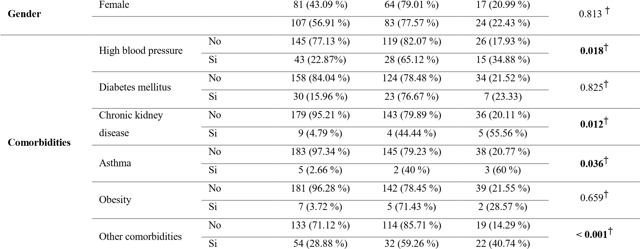
Leukocytes |  | (10³/mL) |  | Mean (SD) | 9.68 (4.44) | 9.49 (4.52) | 10.35 (4.13) | 0.281*
Lymphocytes |  | (10³/mL) |  | Mean (SD) | 1.44 (0.88) | 1.59 (0.90) | 0.90 (0.53) | < 0.001*
C-reactive  Protein |  | (mg/ L) |  | Mean (SD) | 94.04 (95.61) | 82.34 (88.95) | 136.48 (107.50) | 0.001*
pO2 |  | (mmHg) |  | Mean (SD) | 83.73 (24.39) | 83.94 (22.28) | 82.98 (31.18) | 0.827*
pCO₂ |  | (mmHg) |  | Mean (SD) | 33.40 (5.06) | 33.32 (4.96) | 33.67 (5.47) | 0.699*
O₂ saturation |  | (%) |  | Mean (SD) | 95.73 (8.74) | 95.23 (5.10) | 97.55 (16.09) | 0.138*
Days of hospitalization |  |  |  | Media (SD) | 11.75 (9.04) | 10.88 (7.08) | 14.82 (13.59) | 0.013*
(*): t-Student test, ( | † | ): Chi-2 test

Table 2. Symptoms at hospital admission of patients with COVID-19 pneumonia

SYMPTOMS | All patients  (N:188) | Recovered  (n₁:147) | Death  (n₂:41) | p-value (*)
Cough | 94 (59.87 %) | 75 (79.79 %) | 19 (20.21 %) | 0.154
General malaise | 81 (51.59 %) | 62 (76.54 %) | 19 (23.46 %) | 0.822
Fever | 88 (56.05 %) | 68 (77.27 %) | 20 (22.73 %) | 0.626
Dyspnea | 75 (47.77 %) | 55 (73.33 %) | 20 (26.67 %) | 0.491
Sore throat | 60 (38.22 %) | 52 (86.67 %) | 8 (13.33 %) | 0.012
Headache | 18 (11.46 %) | 16 (88.89 %) | 2 (11.11 %) | 0.168
Diarrhea | 18 (11.46 %) | 13 (72.22 %) | 5 (27.78 %) | 0.707
Nasal congestion | 13 (8.28 %) | 12 (92.31 %) | 1 (7.69 %) | 0.147
Muscle pain | 31 (19.75 %) | 22 (70.97 %) | 9 (29.03 %) | 0.484
Chest pain | 15 (9.55 %) | 12 (80.0 %) | 3 (20.0 %) | 0.689
Nausea | 9 (5.73 %) | 5 (55.56 %) | 4 (44.44 %) | 0.144
Abdominal pain | 5 (3.18 %) | 5 (100 %) | 0 | 0.199
Disorientation | 6 (3.82 %) | 3 (50 %) | 3 (50 % | 0.133
Ageusia | 2 (1.27 %) | 1 (50 %) | 1 (50 %) | 0.391
Anosmia | 2 (1.27 %) | 1 (50 %) | 1 (50 %) | 0.391

(*) Chi2 test was applied to all comparisons

Table 3. TSS score, CO-RADS and tomographic patterns in patients with COVID-19 pneumonia.
All patients  N:163 | Recovered n₁:128 | Death n₂:35 | p-value
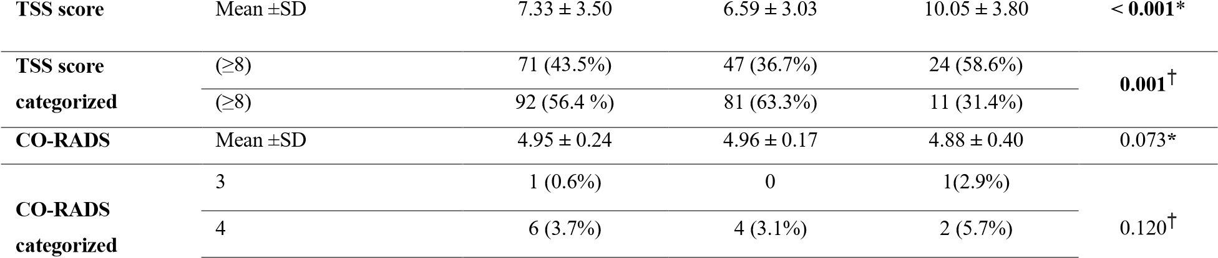
 | 5 | 156 (95.7%) | 124 (96.9 %) | 32 (91.4%)
Tomographic pattern | Ground glass opacities | 158 (96.34 %) | 125 (79.11 %) | 33 (20.89 %) | 0.091†
Tomographic pattern | Consolidations | 84 (51.22 %) | 61 (72.62 %) | 23 (27.38 %) | 0.085†
Tomographic pattern | Crazy paving | 17 (10.37 %) | 11 (64.71%) | 6 (35.29 %) | 0.160†
Tomographic pattern | Distortion of architecture | 38 (23.17 %) | 27 (71.05 %) | 11 (28.95 %) | 0.235†
Tomographic pattern | Subpleural lines | 25 (15.24 %) | 22 (88 %) | 3 (12 %) | 0.192†
Tomographic pattern | Bronchial dilation | 30 (18.29 %) | 17 (56.67 %) | 13 (43.33 %) | 0.002†
Tomographic pattern | Pleural effusion | 10 (6.71 %) | 4 (36.36 %) | 6 (63.64 %) | 0.001†
Tomographic pattern | Pneumomediastinum | 1 (0.61 %) | 1 (100%) | 0 | 0.595†
(*) Mann-Whitney U test; (†) Chi2 test

Table 4. Multivariate analysis using binary logistic regression to predict mortality.
 | adjusted  OR  (Model 1) | p | CI 95% | adjusted OR  (Model 2) | p | CI 95% | Adjusted OR  (Model 3) | p | CI 95%
TSS score | 1.49 | 0.002 | 1.15-1.92 | 1.27 | 0.005 | 1.07 – 1.51 | --- | --- | ---
TSS Score categorized
--- --- --- --- --- --- 2.55 0.063 0.94 – 6.89
(≥ 8 vs <8)
CO-RADS | 0.03 | 0.181 | 0.00-4.51 | --- | ---
Age (years) | 1.08 | 0.002 | 1.02-1.13 | 1.08 | < 0.001
1.04
---

---

---

---

–

1.13

1.08

< 0.001

1.04

–

1.13

Gender (M / F) |  | 0.99 | 0.997 | 0.29-3.33 | 1.10 | 0.847 | 0.39
High Blood Pressure  (Yes/No) |  | 1.26 | 0760 | 0.27-5.82 | --- | --- | --- | --- | --- |  | ---
Diabetes mellitus (Yes/No) |  | 0.44 | 0.436 | 0.05-3.37 | --- | --- | --- | --- | --- |  | ---
CKD (Yes/No) |  | 3.18 | 0.471 | 0.13-  74.34 | --- | --- | --- | --- | --- |  | ---
Asthma (Yes/No) |  | 77.44 | 0.048 | 1.03-5768 | 103 | 0.010 | 2.96 - 3582 | 96 | 0.008 |  | 3.34 - 2797
Obesity (Yes/No) |  | 0.11 | 0.294 | 0.00-6.70 | --- | --- | --- | --- | --- |  | ---
Other comorbidities  (Yes/No) |  | 2.18 | 0.248 | 0.57-8.26 | --- | --- | --- | --- | --- |  | ---
Leukocytes |  | 0.99 | 0.942 | 0.86-1.14 | --- | --- | --- | --- | --- |  | ---
Lymphocytes |  | 0.34 | 0.095 | 0.09-1.20 | 0.27 | 0.013 | 0.09 – 0.76 | 0.23 | 0.004 |  | 0.00-0.74
C-Reactive Protein |  | 0.99 | 0.340 | 0.98-1.00 | --- | --- | --- | --- | --- |  | ---
pO₂ |  | 0.98 | 0.420 | 0.94-1.02 | --- | --- | --- | --- | --- |  | ---
pCO₂ |  | 1.09 | 0.203 | 0.95-1.26 | --- | --- | --- | --- | --- |  | ---
O₂ saturation |  | 1.05 | 0.585 | 0.87-1.26 | --- | --- | --- | --- | --- |  | ---
Days of hospitalization |  | 1.07 | 0.056 | 0.99-1.16 | --- | --- | --- | --- | --- |  | ---

