Redox index of Cys-thiol residues of serum apolipoprotein E
and its diagnostic potential

Kazuyoshi Yamauchi ¹⁾*, Yasushi Kawakami ¹⁾

¹⁾ Department of Laboratory Medicine, Faculty of Medicine, University of Tsukuba, 1-1-1 Tennoudai, Tsukuba, 305-8575, Japan

*Address correspondence to: Kazuyoshi Yamauchi, PhD, Department of Laboratory Medicine, Faculty of Medicine, University of Tsukuba, 1-1-1 Tennoudai, Tsukuba, 305-8575, Japan, Tel & FAX: +81-29-853-3456, e-mail: yamauchi@md.tsukuba.ac.jp

Supplementary Figure: Typical pattern of band-shift assay for sera with different apoE phenotypes using PEG-PC-Mal (PM).

Supplementary Table 1: Relationship between each redox-IDX-apoE candidate and each laboratory test result

Supplementary Table 2: Laboratory test results of control subjects and subjects with atherosclerosis

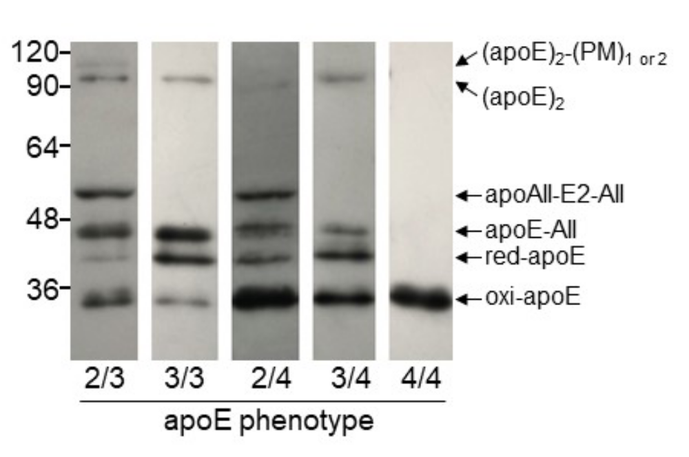

Supplemental Figure. Typical pattern of band-shift assay for sera with different apoE phenotypes using PEG-PC-Mal (PM).
Each serum, diluted to approximately 0.05 mg/dL, was incubated with 1.0 mmol/L PM for 30 min at 37 °C. The reaction was then quenched by the addition of non-reducing Laemmli buffer, and SDS-PAGE was performed using a 10% gel. After electrophoresis, the gel was UV irradiated for 15 min after which the separated proteins were detected by immunoblot analysis using a conjugated goat anti-apoE polyclonal antibody [21].

Supplemental Table 1 Relationship between each redox-IDX-apoE candidate and each laboratory test result
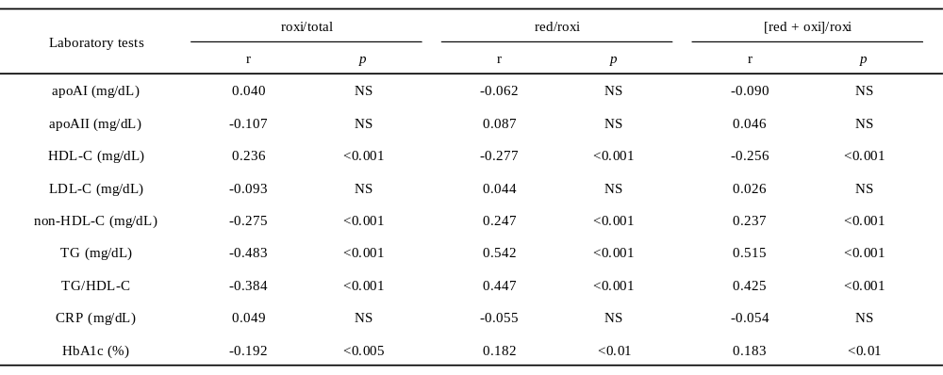

NS, not significant.

Supplemental Table 2 Laboratory test results of control subjects and subjects with atherosclerosis
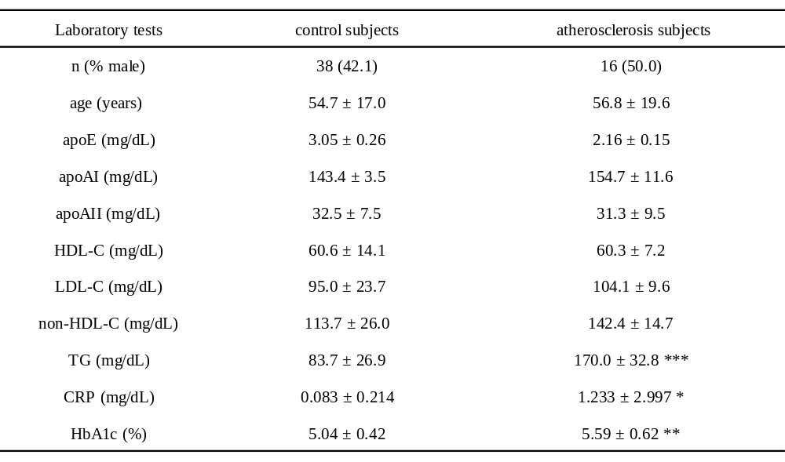
All parameters and ages of subjects are presented as the mean ± SE and mean ± SD, respectively. *, p<0.05; **, p<0.01; ***, p<0.005.

