Additional file 2: locations of participating districts by country

PERFORM2Scale districts in Ghana
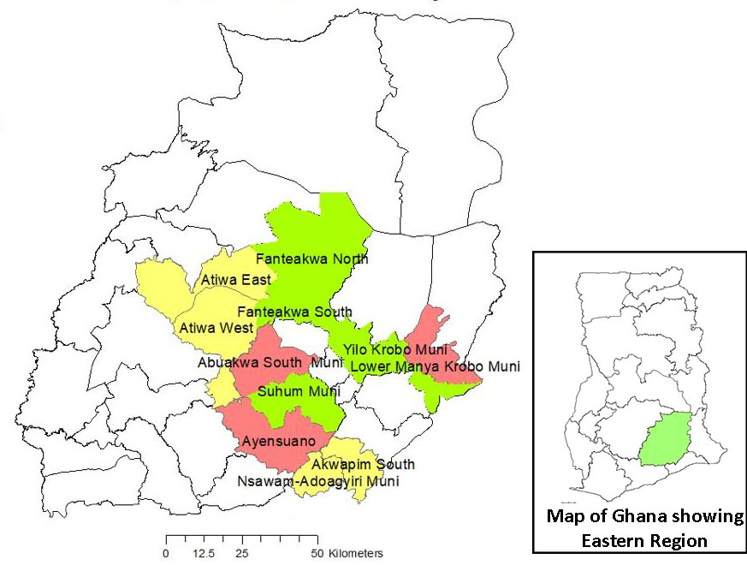
DG1 - Fanteakwa, Yilo Krobo and Suhum
DG2 - Ayensuano, Lower Manya Krobo and East Akim
DG3 – Nsawam-Adoagyiri, Akuapim South and Atiwa
PERFORM2Scale districts in Malawi

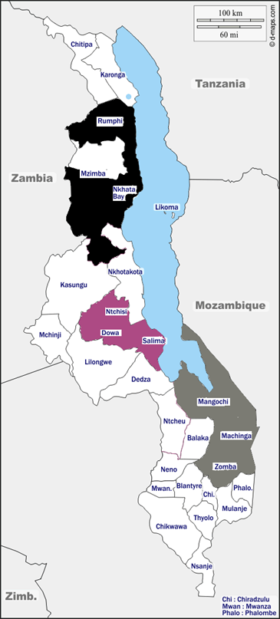
DG1 - Dowa, Ntchisi and Salima
DG2 - Machinga, Mangochi and Zomba
DG3 - Mzimba south, Nkhata Bay and Rumphi

PERFORM2Scale districts in Uganda

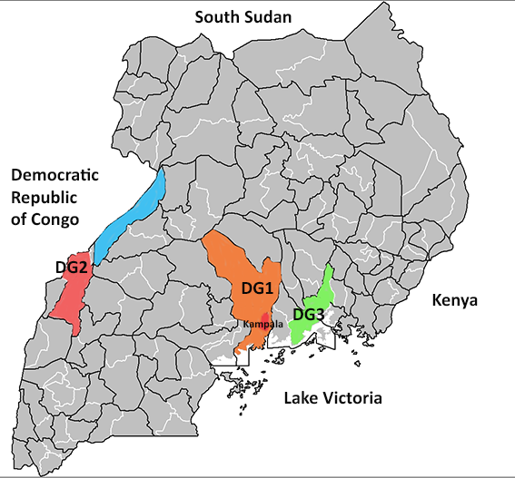
DG1 - Luwero, Nakaseke and Wakiso
DG2 - Kabarole, Ntoroko and Bunyangabu
DG3 - Jinja, Luuka and Buikwe

