A metagenomics and amplicon sequencing combined approach reveals the best primers to study aerobic anoxygenic phototrophs in the marine environment

Carlota R. Gazulla^{1,2}, Ana María Cabello³, Pablo Sánchez², Josep M. Gasol², Olga Sánchez¹, Isabel Ferrera³

Supplementary Material:

Table S1. Primer candidates designed for pufM amplification
Table S2. Variation of the PCR conditions for the primer candidates
Table S3. Oceanographic context of the samples used in this study
Figure S1. Alpha diversity
Figure S2. Non-metric multidimensional scaling (NMDS) analyses

Supplementary Information 1. PCR conditions for primers pufMF_Y/pufM_WAW and UniF/UniR
Supplementary Information 2. Metagenomic analyses of the Malaspina Expedition samples

Table S1. Primer candidates designed for pufM amplification. Abbreviations; Tm = mean melting temperature, mismt = mismatches.

Primer  candidate  name | Sequence | Length (bp) | Hybridization(%) |  | Tm  (ºC) | GC %
Primer  candidate  name | Sequence | Length (bp) | 0 mismt | 1-2 mismt | Tm  (ºC) | GC %
pufMF_V | 5’-GGS AAY CTS TWY TAY AAY CCV T-3’ | 22 | 54.3 | 93.3 | 53.6 | 44
pufMF_Y | 5’-GGS AAY CTS TWY TAY AAY C-3’ | 19 | 55.5 | 94.62 | 47.5 | 42.1
pufM_F1A | 5’- GAR GCN GTK CCN TWY GGN RT-3' | 20 | 61 | 94 | 58.9 | 57.5
pufM_F1B | 5’- GAR GCN GTK CCN TWY GGN AT-3' | 20 | 57 | 93 | 58.9 | 57.5
pufM_F2 | 5’- TGG GCN TTY GCN DSN GCV AT-3' | 20 | 60 | 75.5 | 62.9 | 60

Table S2. Variation of the PCR conditions for the primer candidates:

Forward primer | Reverse primer | Temperature (ºC) | Mg⁺²  (mM) | Primer concentration  (µM) | Amplicon length (bp)
pufMF_V | pufM_WAW | 55ºC – 63ºC | 2-2.5 | 0.2 – 0.8 | 203 bp
pufMF_Y | pufM_WAW | 55ºC – 63ºC | 2-2.5 | 0.2 – 0.8 | 203 bp
pufM_F1A | pufM_WAW | 50ºC – 59ºC | 2-2.5 | 0.2 – 0.8 | 265 bp
pufM_F1B | pufM_WAW | 50ºC – 59ºC | 2-2.5 | 0.2 – 0.8 | 265 bp
pufM_F2 | pufM_WAW | 50ºC – 59ºC | 2-2.5 | 0.2 – 0.8 | 340 bp
UniF | uniR | 48ºC – 58ºC | 2 | 0.5 | 145 bp
UniF | pufM_WAW | 48ºC – 58ºC | 2 | 0.5 | 198 bp

Table S3. Oceanographic context of the samples used in this study.
A. Open Ocean samples from the Malaspina Expedition (all collected at 3 m deep)
Sample | Date | Oceanic region | Latitude | Longitude
MP0311 | 4th January 2011 | South Atlantic | -7.28 | -29.32
MP0778 | 5th February 2011 | South Atlantic | -33.23 | 15.34
MP1176 | 7th March 2011 | Indian Ocean | -29.57 | 96.41
MP1421 | 25th March 2011 | South Australian Bight | -40.55 | 142.49
MP1517 | 20th April 2011 | South Pacific | -23.38 | -178.21
MP1672 | 29th April 2011 | South Pacific | -3.41 | -169.46
MP1857 | 14th May 2011 | North Pacific | 21.89 | -155.66
MP2243 | 2nd June 2011 | North Pacific | 10.76 | -102.44

B. Surface coastal samples from the Blanes Bay Microbial Observatory (41°40′N, 2°48′E), in the NW Mediterranean Sea.

Sample | Date
BL110208 | 8th February 2011
BL110412 | 12th April 2011
BL110615 | 15th June 2011
BL110802 | 2nd August 2011
BL111129 | 29th November 2011
BL120214 | 14th February 2012
BL120411 | 11th April 2012
BL120620 | 20th June 2012
BL120807 | 7th August 2012

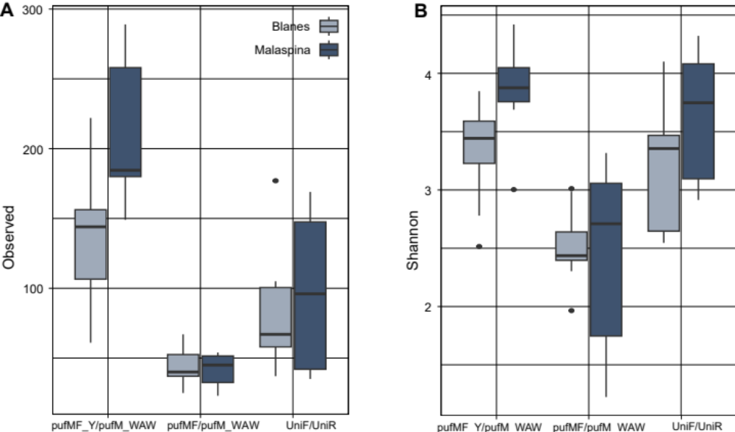

Figure S1. Alpha diversity as observed richness (A) and Shannon index (B) for each primer combination.

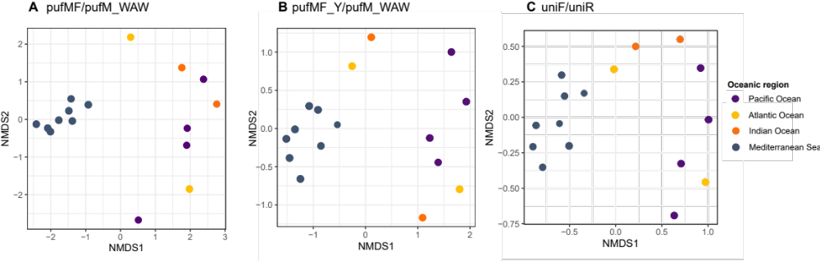
Figure S2. Non-metric multidimensional scaling (NMDS) analyses based on Bray-Curtis distances, for each primer combination: A) pufMF/pufM_WAW, B) pufMF_Y/pufM_WAW and C) UniF/UniR. Samples from the Malaspina Expedition (dark blue) are labeled to allow comparing the clustering similarities between the three different approaches.

Supplementary Information 1.

PCR conditions for primers pufMF_Y/pufM_WAW and UniF/UniR

Partial amplification of the pufM gene was performed with forward primer pufMF_Y and reverse primer pufM_WAW, each at 0.8 μM, and a final concentration of MgCl₂ of 2.5 mM. PCR conditions started with an initial denaturation step at 95 °C for 2 min, followed by 35 cycles at 95 °C (30s), 51°C (30s), 72 °C (40s) and a final elongation step at 72 °C for 10 min. PCR conditions for primers UniF and UniR were the following: an initial denaturation step at 95 °C for 2 min and 35 cycles at 95 °C (30s), 48°C (30s), 72 °C (40s) and a final elongation step at 72 °C for 10 min. The concentration of primers was 0.8 μM and the concentration of MgCl₂ was 2.5 mM.

Inferring amplicon sequence variants (ASVs) with the DADA2 pipeline:

The dataset from each combination of primers was processed separately in DADA2 v1.10 (Callahan et al., 2016). Sequences from primers pufMF and pufM_WAW were already analyzed in Auladell et al., (2019) and Gazulla et al., (2022), for the BBMO and the Malaspina Expedition samples respectively. In this study, we repeated the analyses with DADA2 for the 17 samples with the following parameters maxEE = c(2,2), trunclen = c(200,160). We kept 85% of total reads (mean 21311, min 8724, max 48334) after removing chimeras.
DADA2 parameters for the sequences obtained with primers pufMF_Y/pufM_WAW were maxEE = c(2,2), trunclen = c(190,120). After filtering we kept 83% of the total reads (mean 78047, min 26061, max 124270). Finally, for primers UniF/UniR DADA2 parameters were maxEE = c(2,2), trunclen = c(125,100) (the amplicon generated with this primer set is shorter). We kept 97% of total reads (mean 12319, min 1131, max 57444). Sample BL110412 had very low read counts (103) and was discarded from further analyses.

Supplementary Information 2.

Malaspina metagenomic analysis

A total of 76 DNA samples from 11 stations from the global tropical and sub-tropical oceans (water filtered through 3.0 and 0.22 µm polycarbonate filters) were sequenced on an Illumina HiSeq 2000 platform (2 x 101 bp) at the Centro Nacional de Análisis Genómicos (CNAG, Barcelona, Spain). Raw reads were trimmed in trimmomatic 0.38 (Bolger et al., 2014) with options ILLUMINACLIP:2:30:10 LEADING:3 SLIDINGWINDOW:4:20 MINLEN:45. Clean reads were assembled in megahit 1.1.3 (Li et al., 2016) with options --presets meta-large and --min-contig-len 500. Assembled contigs were annotated in prokka 1.14.6 for gene prediction (Seeman, 2014), clusters of orthologous groups (COGs), Enzyme Commission numbers (EC) and gene product name. Additionally, predicted genes were annotated for protein families’ domains (PFAM v34, El-Gebali et al., 2019) using HMMER 3.33 (Eddy, 2011), the Kyoto Encyclopedia of Genes and Genomes Orthologs (KEGG KO) release v98.0 using kofamscan 1.3.0 (Aramaki et al., 2019), and carbohydrate active enzymes (CAZyme) using HMMER 3.3 against dbCAN v10 (Yin et al., 2012).

Malaspina gene catalog
All predicted genes longer than 100 bp were pooled and clustered in cd-hit-est 4.6.1 (Li and Godzik 2006) with options -c 0.95 -G 0 -aS 0.9 -g 1 -r 1 -d 0 -s 0.8. Clean reads were back-mapped to the catalog with bowtie2 2.2.9 (Langmead and Salzberg 2012) and alignments were filtered with samtools 1.3.1 (Li et al., 2009) with options -q 10 -F 260. Reads mapping to catalog genes were counted in htseq-count 0.10.0 (Anders et al., 2015) with options --nonunique all to build gene profiles per sample. Counts were normalized by gene length in kbp and then normalized by the median abundance of 10 single copy COGs to obtain a proxy to per-cell number of gene copies as in Salazar et al., (2019).

References:

Anders, S., Pyl, P.T., Huber, W., (2015). HTSeq--a Python framework to work with high-throughput sequencing data. Bioinformatics 31, 166–169. https://doi.org/10.1093/bioinformatics/btu638

Aramaki, T., Blanc-Mathieu, R., Endo, H., Ohkubo, K., Kanehisa, M., Goto, S., Ogata, H., (2019). KofamKOALA: KEGG ortholog assignment based on profile HMM and adaptive score threshold. Bioinformatics 1–2. https://doi.org/10.1093/bioinformatics/btz859

Bolger, A.M., Lohse, M., Usadel, B., (2014). Trimmomatic: a flexible trimmer for Illumina sequence data. Bioinformatics 30, 2114–2120. https://doi.org/10.1093/bioinformatics/btu170

Eddy, S.R., (2011). Accelerated profile HMM searches. PLoS Computational Biology 7, e1002195, 1–16. https://doi.org/10.1371/journal.pcbi.1002195

El-Gebali, S., Mistry, J., Bateman, A., Eddy, S.R., Luciani, A., Potter, S.C., Qureshi, M., Richardson, L.J., Salazar, G.A., Smart, A., Sonnhammer, E.L.L., Hirsh, L., Paladin, L., Piovesan, D., Tosatto, S.C.E., Finn, R.D., (2019). The Pfam protein families database in 2019. Nucleic Acids Research 47, D427–D432. https://doi.org/10.1093/nar/gky995

Langmead, B., Salzberg, S.L., (2012). Fast gapped-read alignment with Bowtie 2. Nature Methods 9, 357–359. https://doi.org/10.1038/nmeth.1923

Li, D., Luo, R., Liu, C.M., Leung, C.M., Ting, H.F., Sadakane, K., Yamashita, H., Lam, T.W., (2016). MEGAHIT v1.0: A fast and scalable metagenome assembler driven by advanced methodologies and community practices. Methods 102, 3–11. https://doi.org/10.1016/j.ymeth.2016.02.020

Li, H., Handsaker, B., Wysoker, A., Fennell, T., Ruan, J., Homer, N., Marth, G., Abecasis, G., Durbin, R., (2009). The Sequence Alignment/Map format and SAMtools. Bioinformatics 25, 2078–2079. https://doi.org/10.1093/bioinformatics/btp352

Li, W., Godzik, A., (2006). Cd-hit: A fast program for clustering and comparing large sets of protein or nucleotide sequences. Bioinformatics 22, 1658–1659. https://doi.org/10.1093/bioinformatics/btl158

Salazar, G., Paoli, L., Alberti, A., Huerta-Cepas, J., Ruscheweyh, H.-J., Cuenca, M., Field, C.M., Coelho, L.P., Cruaud, C., Engelen, et al., (2019). Gene Expression Changes and Community Turnover Differentially Shape the Global Ocean Metatranscriptome. Cell 179, 1068-1083.e21. https://doi.org/10.1016/j.cell.2019.10.014

Seemann, T., (2014). Prokka: Rapid prokaryotic genome annotation. Bioinformatics. https://doi.org/10.1093/bioinformatics/btu153

Yin, Y., Mao, X., Yang, J., Chen, X., Mao, F., Xu, Y., (2012). dbCAN: a web resource for automated carbohydrate-active enzyme annotation. Nucleic Acids Res 40, W445-51. https://doi.org/10.1093/nar/gks479

