Supplementary document

Natalia Musiał^{1*}, Aleksandra Bogucka^{1,2}, Dimitry Tretiakow³, Andrzej Skorek³, Jacek Ryl⁴,
Paulina Czaplewska^{1*}
¹ Intercollegiate Faculty of Biotechnology UG&MUG, University of Gdańsk, Abrahama 58, 80-307 Gdańsk, Poland
². Institute of Biochemistry, Medical Faculty, Justus Liebig University of Giessen, Friedrichstrasse 24, 35392 Giessen, Germany
^{3.} Department of Otolaryngology, Faculty of Medicine, Medical University of Gdansk, Smoluchowskiego str. 17, 80-214 Gdansk, Poland
⁴ Department of Electrochemistry, Corrosion and Materials Engineering, Gdansk University of Technology, Poland

*Corresponding authors:
Paulina Czaplewska, PhD. Intercollegiate Faculty of Biotechnology UG&MUG, University of Gdańsk, Abrahama 58, 80-307 Gdańsk, Poland. paulina.czaplewska@ug.edu.pl, ORCID 0000-0002-6469-6014
Natalia Musiał, MSc, Intercollegiate Faculty of Biotechnology UG&MUG, University of Gdańsk, Abrahama 58, 80-307 Gdańsk, Poland. natalia.musial@phdstud.ug.edu.pl, ORCID 0000-0001-9883-7965

Samples
All 20 salivary stone samples were collected from patients treated in the Department of Otolaryngology at the Medical University of Gdańsk. All patients were included in the study only after signing the necessary written consent and approval by the Independent Bioethics Commission at the Medical University of Gdańsk. First, they were analysed using spectroscopic methods and then divided into 3 three groups according to the proposed classification (Tretiakow et al., 2021) There are 6 calcified stones, 4 lipid stones and 10 mixed stones. Because they were tested earlier, all of them were in pieces; there was no sialolith in one piece. Collecting the samples was optimised and standardised according to the applicable routine protocol from the Clinic of Otolaryngology with the Department of Oral and Maxillofacial Surgery at The University Clinical Centre in Gdańsk. Sialoliths were removed during endoscopic, transoral or transcervical surgery. After that, the salivary stone samples were washed with the use buffer (25 mM NH₄HCO₃) and then transported in sterile falcon tubes to the Intercollegiate Faculty of Biotechnology of the University of Gdańsk and Medical University of Gdańsk and stored at 80°C for further experiments.
Table S1. Division of clinical samples into 3 separate groups based on spectroscopic studies: calcified (CAL) group, lipid (LIP) group and mixed (MIX) group.

 | CAL group | LIP group | MIX group
Sample no. | 1,4,5,9 (outer layers),10,12 | 3,11,19,20 | 2,6,13,14,15,16,17,18,21,  22

Figure S1. Chart presenting the numbers of human and bacterial proteins groups at 1% FDR with minimum 2 different peptides (bar graph) and the numbers of bacteria species from which the bacterial proteins were detected in each sample (blue curve).
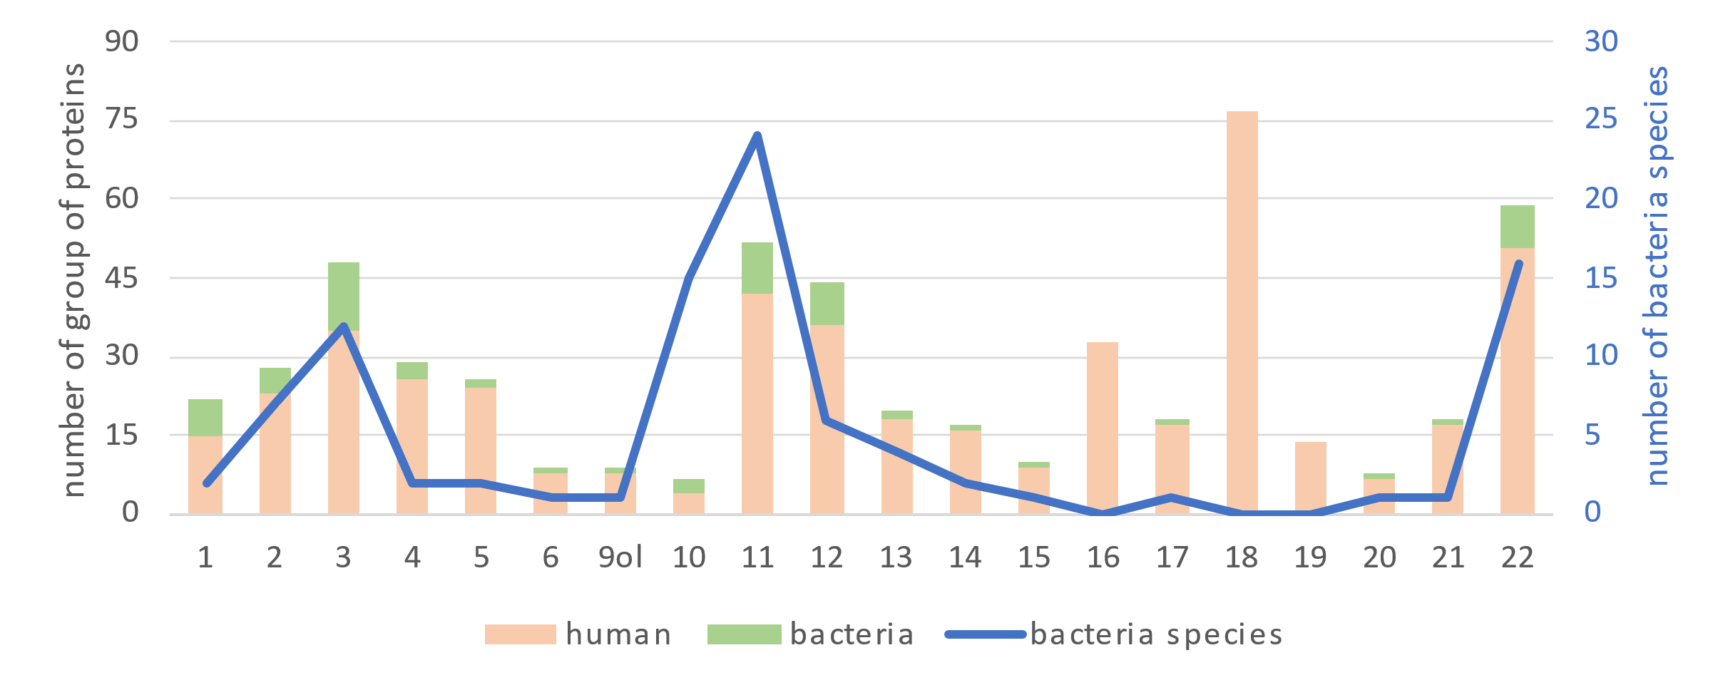

Table S2. All of the bacteria species, from which the proteins at 1% FDR with minimum 2 different peptides were detected.
Actinomyces bowdenii | Actinomyces sp. Oral | Fretibacterium sp. | Haemophilus parainfluenzae | Porphyromonas sp. Oral
Actinomyces glycerinitolerans | Actinomyces succiniciruminis | Fusobacterium canifelinum | Kingella potus | Pseudopropionibacterium propionicum
Actinomyces johnsonii | Actinomyces urogenitalis | Fusobacterium hwasookii | Neisseria bacilliformis | Rothia dentocariosa
Actinomyces massiliensis | Actinomyces viscosus | Fusobacterium nucleatum | Neisseria macacae | Selenomonas noxia
Actinomyces naeslundii | Aggregatibacter aphrophilus | Fusobacterium nucleatum subsp. Animalis | Neisseria sicca | Selenomonas sp. Oral
Actinomyces oris | Capnocytophaga sp. Oral | Fusobacterium nucleatum subsp. Polymorphum | Neisseria sp. Oral | Streptococcus mitis
Actinomyces radicidentis | Comamonadaceae bacterium | Fusobacterium periodonticum | Nitrospina sp. | Tannerella forsythia
Actinomyces ruminicola | Desulfobulbus oralis | Fusobacterium pseudoperiodonticum | Ottowia sp. Oral | Treponema denticola
Actinomyces slackii | Eikenella corrodens | Haemophilus haemolyticus | Peptostreptococcus stomatis

Table S3. A table with the number of up-regulated and down-regulated proteins for each clinical sample from the CAL group, which are statistically significant (q<0.05) and the log2FC≥0.45 for up-regulated proteins and log2FC≤-0.45 for down-regulated proteins.
 | sample 1 | sample 4 | sample 5 | sample 9 (outer layers) | sample 10 | sample 12
Number of up-regulated proteins | 18 | 89 | 41 | 30 | 93 | 48
Number of down-regulated proteins | 6 | 15 | 8 | 7 | 11 | 17

Table S4. A table with the number of up-regulated and down-regulated proteins for each clinical sample from the LIP group, which are statistically significant (q<0.05) and the log2FC≥0.45 for up-regulated proteins and log2FC≤-0.45 for down-regulated proteins.
 | sample 3 | sample 11 | sample 19 | sample 20
Number of up-regulated proteins | 15 | 15 | 6 | 5
Number of down-regulated proteins | 26 | 49 | 9 | 24

Table S5. A table with the number of up-regulated and down-regulated proteins for each clinical sample from the MIX group, which are statistically significant (q<0.05) and the log2FC≥0.45 for up-regulated proteins and log2FC≤-0.45 for down-regulated proteins.
 | sample 2 | sample 6 | sample 13 | sample 14 | sample 15 | sample 16 | sample 17 | sample 18 | sample 21 | sample 22
Number of up-regulated proteins | 76 | 4 | 15 | 25 | 2 | 20 | 5 | 37 | 5 | 18
Number of down-regulated proteins | 14 | 20 | 14 | 11 | 19 | 13 | 19 | 29 | 70 | 46

Figure S2. PCA analysis of all the clinical sialolith and pooled samples were used in relative quantitative analysis. Data were normalised using the total area sums (TAS) approach, and technical replicates of samples were averaged.

