Ivermectin and Doxycycline Combination as a Promising Anti-Viral Drug Candidate: An in-silico and DFT Study

Meenakshi Rana¹*, Pooja², Shradha Lakhera¹, Papia Chowdhury²

¹Department of Physics, School of Sciences, Uttarakhand Open University, Haldwani, 263139, Uttarakhand, India

²Department of Physics and Materials Science and Engineering,
Jaypee Institute of Information Technology, Noida 201309, Uttar Pradesh, India.

SD1: Various parameters like binding affinity, hydrogen bonded interaction, hydrophobic interaction, dipole moment, inhibition constant for three best docked pose structures for ivermectin+doxycycline: 6LU7 complex.

Pose | Binding affinity (Kcal/mol) | No of Hydrogen bond | No of Hydrophobic interaction | Dipole moment
1 | -7.4 | 11 | 0 | 2.237
2 | -7.1 | 2 | 3 | 2.424
3 | -6.7 | 6 | 3 | 1.633

SD 2: Pressure progression data for bare 6LU7, Ivermectin: 6LU7, Doxycycline: 6LU7 and Ivermectin+Doxycycline: 6LU7 complex.

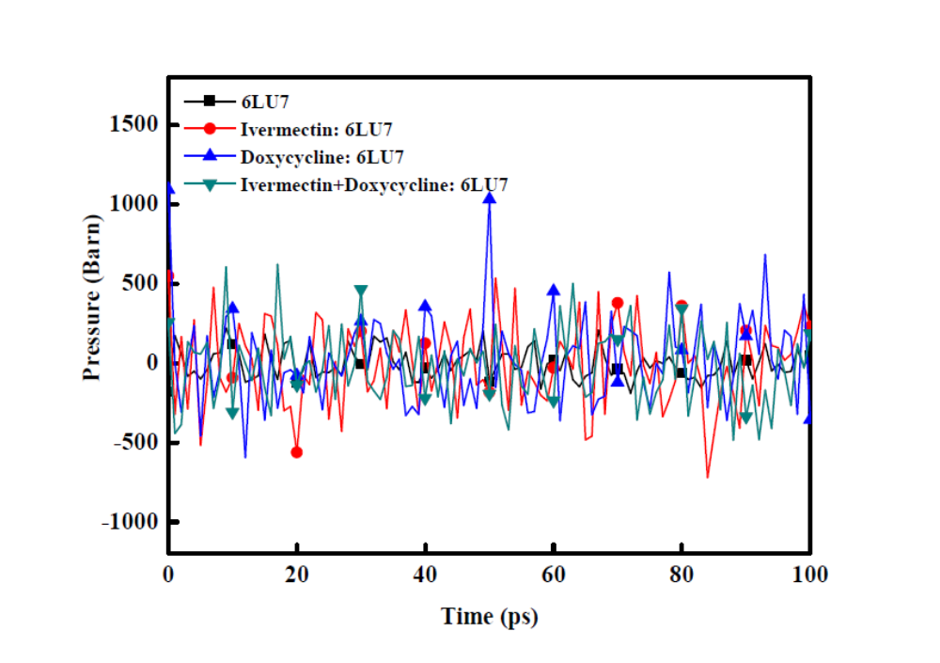

SD 3: Density progression data for bare 6LU7, Ivermectin: 6LU7, Doxycycline: 6LU7 and Ivermectin+Doxycycline: 6LU7 complex.

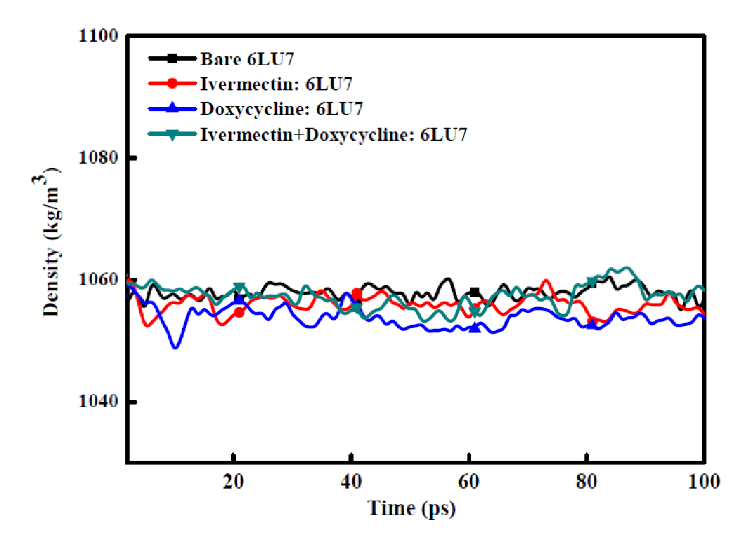

SD 4: Radius of gyration progression data for bare 6LU7, Ivermectin: 6LU7, Doxycyline: 6LU7 and Ivermectin+Doxycycline: 6LU7 complex.

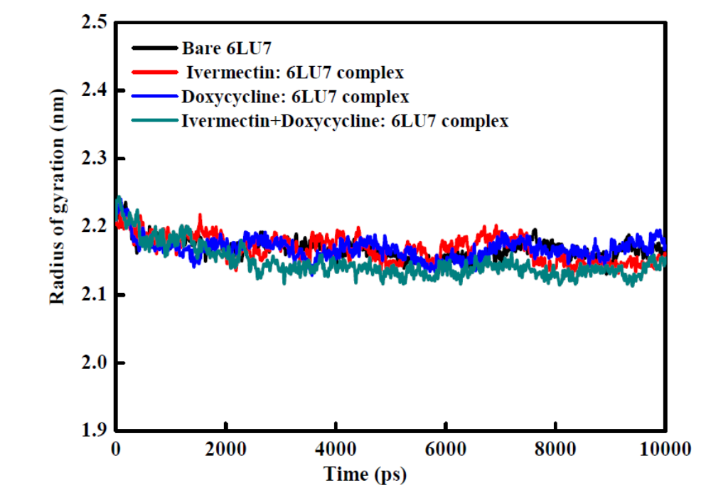

SD 5: SASA area progression data for bare 6LU7, Ivermectin: 6LU7, Doxycyline: 6LU7 and Ivermectin+Doxycyline: 6LU7 complex.

