SUPPLEMENTARY INFORMATION
The belowground of resurrection plant Myrothamnus flabellifolia: Exploring the drought-tolerant root-associated microbiome
Shandry M. Tebele¹, Rose A. Marks^{1,2,3} and Jill M. Farrant^{1*}
¹ Department of Molecular and Cell Biology, University of Cape Town, Rondebosch 7701, South Africa
² Department of Horticulture, Michigan State University, East Lansing, MI 48824, USA
³ Plant Resiliency Institute, Michigan State University, East Lansing, MI 48824, USA
*Corresponding Author (jill.farrant@uct.ac.za)

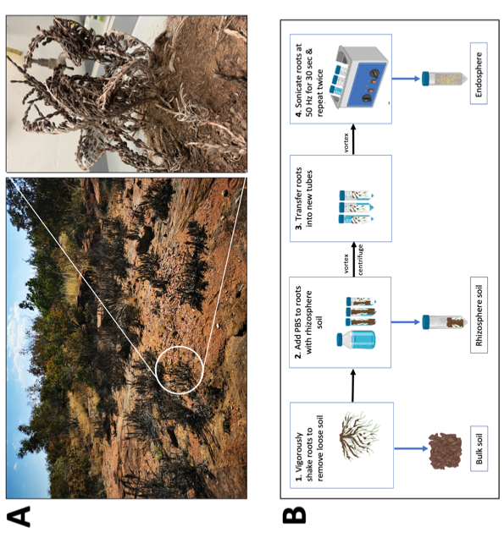
Fig. S1 Overview of experimental design and sample processing. A) Myrothamnus flabellifolia at Swebeswebe Nature Reserve. The bulk soil, rhizosphere and roots were collected at the desiccated state of M. flabellifolia. Briefly, plants were harvested from the field with their native soil and transported to the University of Cape Town. B) The bulk soil, rhizosphere, and endosphere compartments were separated.
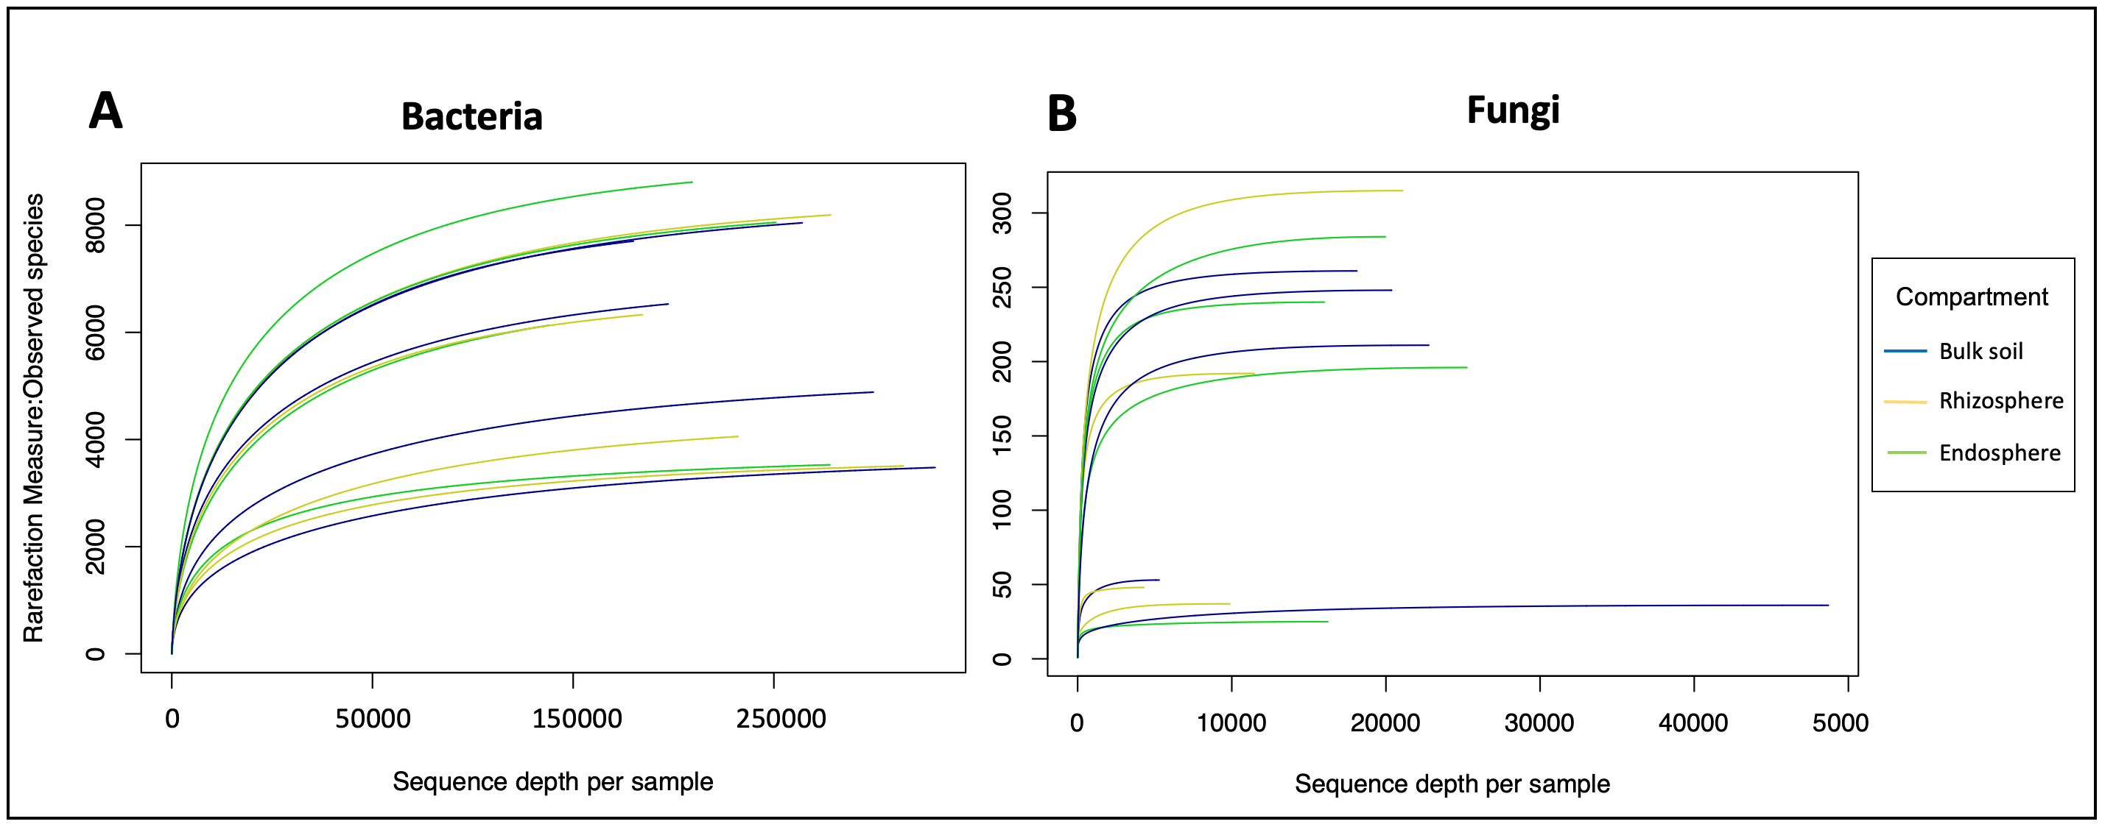
Fig. S2 Rarefaction curves show the number of amplicon sequence variants (ASVs) from A) bacteria and B) fungi sequencing data. Observed species from bulk soil, rhizosphere and endosphere of M. flabellifolia resurrection plant.
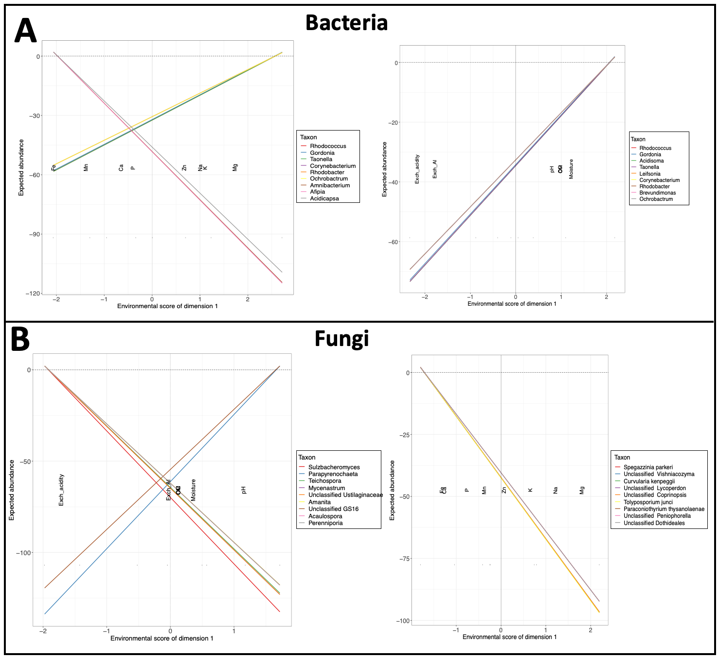
Fig. S3 Non-parametric analysis of soil factors. A) The influence of soil factors and elements on bacterial abundance and B) fungi abundance at the genus level.
Table 1. Alpha-diversity adjusted p-values of three compartments using pairwise Wilcox test
 | Bacteria |  | Fungi
 | Shannon p-value | Simpson p-value | Shannon p-value | Simpson p-value
Bulk soil vs rhizosphere | 0.39 | 0.78 | 0.25 | 0.14
Bulk soil vs endosphere | 0.05 | 0.05 | 0.05 | 0.05
Rhizosphere vs endosphere | 0.02 | 0.05 | 0.02 | 0.02

