online supplement 3
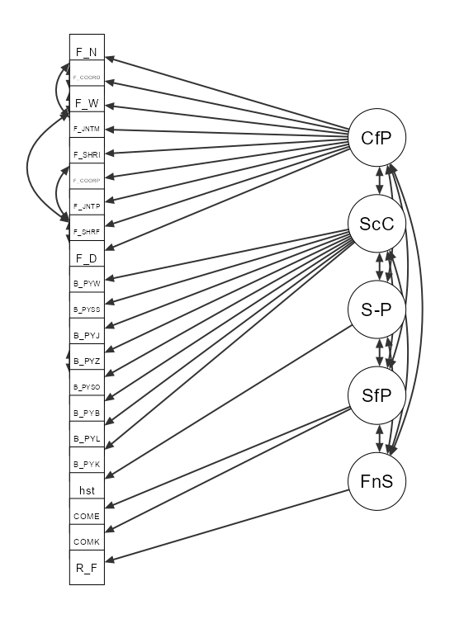
CfP: Collaboration for prevention, ScC: Sectoral-Collaboration, S-P: Science-based prevention, SfP: Support for prevention, FnS: Financial support.
An overview of the abbreviations of the indicators can be found in online supplement 1.

