Supplementary materials
Long-term effective remediation of black-odorous water via regulating calcium nitrate sustained-release
Rui Wan ¹*, Yunyi Zha ¹, Mengqi Wu ¹, Xiaoxiao Li ^{1, 2}, Haifeng Yang ³, Hongming Liu ⁴
(¹ School of Ecology and Environment, Anhui Normal University, Wuhu, 241002, China; ² College of Environment, Hohai University, Nanjing 210098, China, ³ Anhui Phoneya Environmental Technology Co. Ltd., Donghu Innovation Center, Hefei, 230601, China; ⁴ College of Life Sciences, Anhui Normal University, Wuhu, 241001, China)

*Corresponding author
Tel: +86-553-5910724
E-mail: wanrui910@163.com
Number of pages: 5
Number of tables: 5
Number of figures: 4

Supplementary methods

Morphology of the concretes
The morphological difference was observed using scanning electron microscope (SEM). After long-term experiment, the concrete blocks in the NC and EC group were collected. Immediately, the collected concrete blocks were rinsed with saline solution (0.9%) gently for twice. Subsequently, the concrete blocks were submerged into the Phosphate Buffered Saline (PBS, 10mM, 7.00) containing 2.5% glutaraldehyde at 4ºC overnight. After washing away the glutaraldehyde using PBS (10mM, 7.00), the blocks were sequentially dehydrated in the ethanol serials (50%, 70%, 80%, 90%, and 100%) 15 min per step, and dried in air at room temperature. Then, the blocks’ observation was performed using a scanning electron microscope (SEM, JSM-6701F, JEOL, Ltd.)

Supplementary Figures

Figure S1 The schematic graph of experimental protocol.

Figure S2 Effect of Eco-concrete on black-odorous water treatment performance. Evolution of DO (A) and ORP (B).

Figure S3 The final removal efficiency of COD (A), NH₄⁺-N (B), and turbidity (C) of the black-odorous water treated by concrete and ecoN-concrete at each cycle.
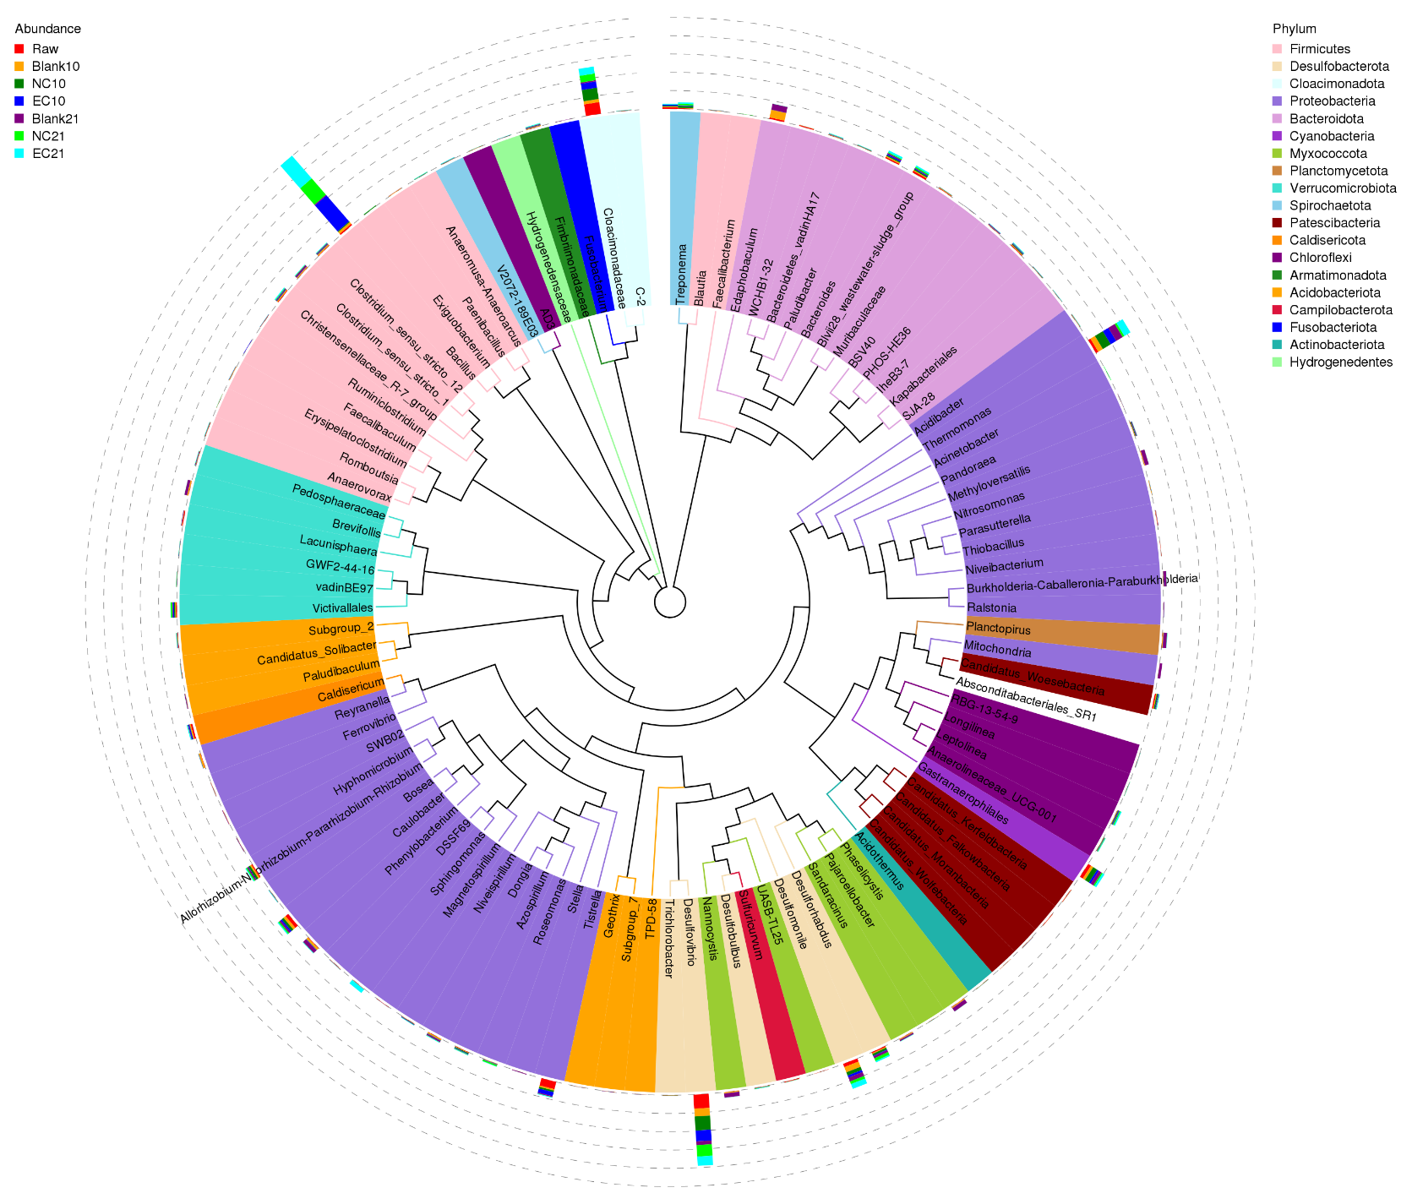
Figure S4 Phylogenetic relationships of the detected samples at genus level.

