Supporting Information
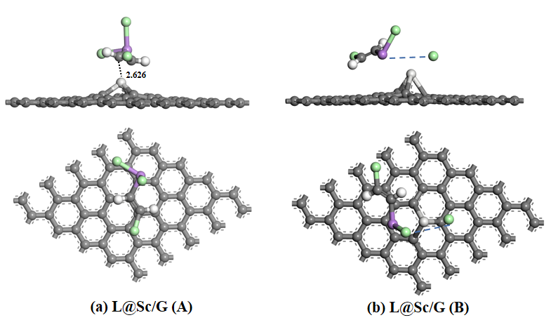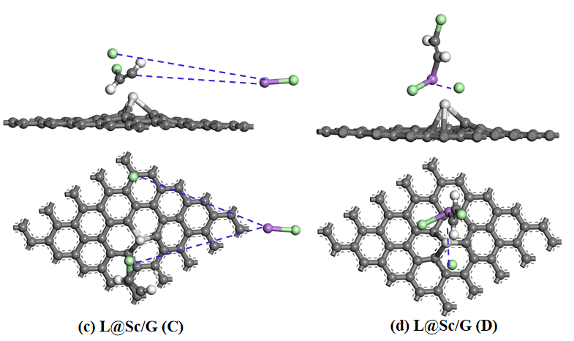
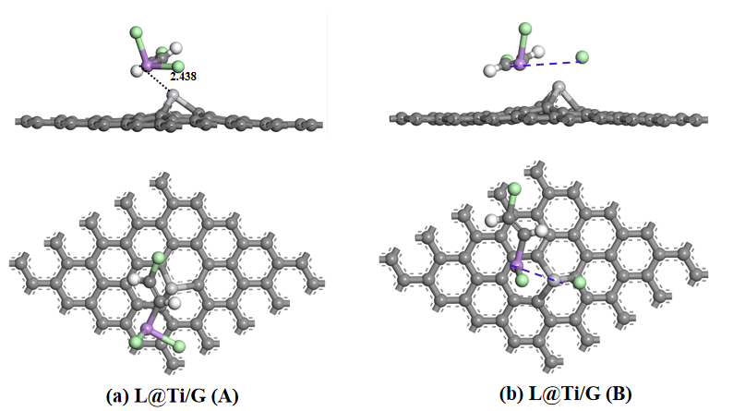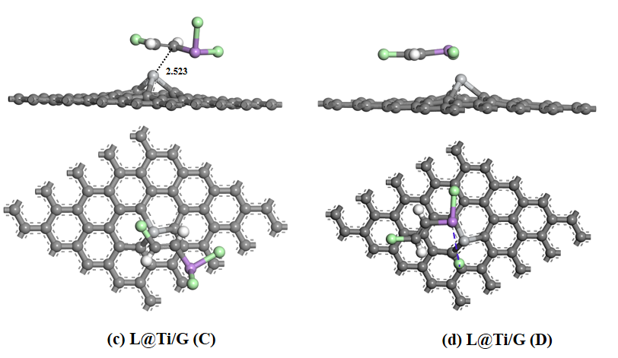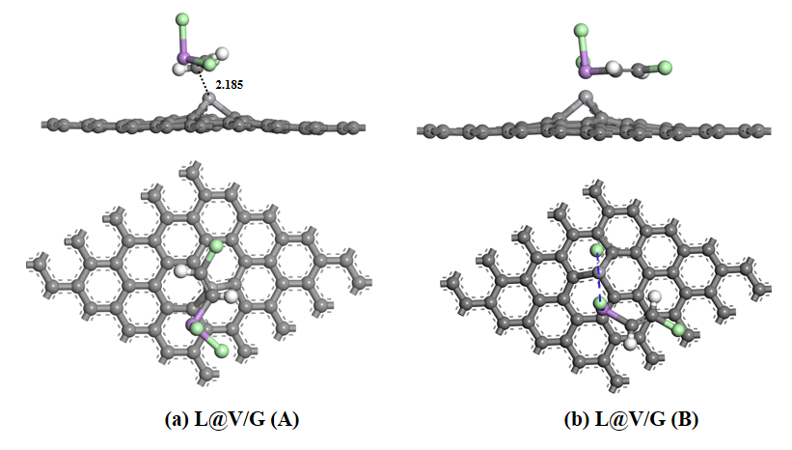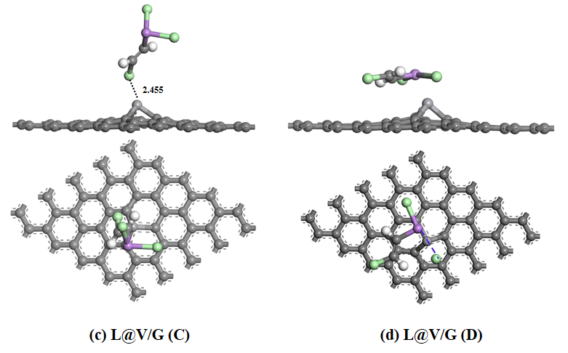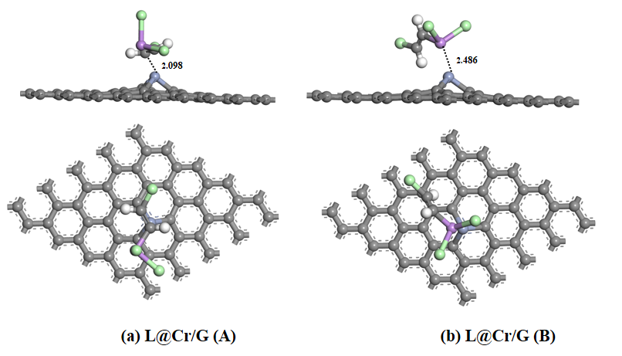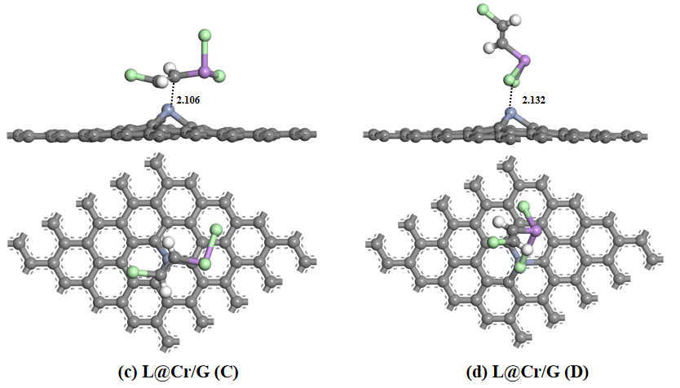

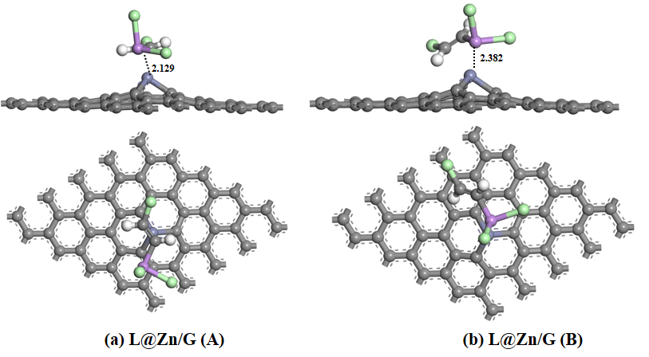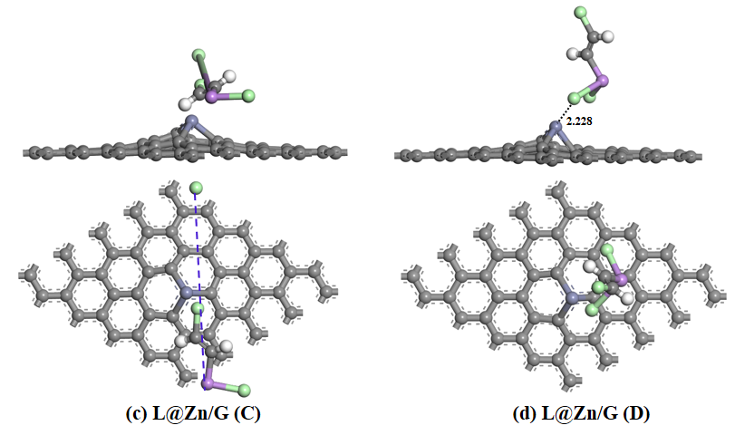
Figure S1 The optimized structures of the lewisite molecule adsorption on TM/G sheet with different orientation.

Table S1The adsorption configuration and distance between lewisite and TM/G sheet, along with the adsorption energies (E_{ads}) of lewisite on the TM/G. ( “/”represents the lewisite decomposition after adsorption）
Species | Initial configurations | The distance_{TM-L}  (Å) | Final configurations | E_{ads} (eV)
L@Sc/G | A | 2.626 | A | -1.216
 | B | / | / | /
 | C | / | / | /
 | D | / | / | /
L@Ti/G | A | 2.438 | A | -1.315
 | B | / | / | /
 | C | 2.523 | A | -1.328
 | D | / | / | /
L@V/G | A | 2.185 | A | -1.826
 | B | / | / | /
 | C | 2.455 | C | -0.789
 | D | / | / | /
L@Cr/G | A | 2.098 | A | -2.179
 | B | 2.486 | B | -1.438
 | C | 2.106 | A | -2.213
 | D | 2.232 | D | -1.689
L@Mn/G | A | 2.082 | A | -2.362
 | B | 2.387 | B | -1.592
 | C | 2.066 | A | -2.298
 | D | 2.205 | D | -2.039
L@Fe/G | A | 2.055 | A | -2.024
 | B | 2.439 | B | -1.587
 | C | 2.346 | C | -1.356
 | D | 2.181 | D | -1.913
L@Co/G | A | 2.032 | A | -1.479
 | B | 2.398 | B | -1.273
 | C | 2.432 | C | -1.078
 | D | 2.137 | D | -1.639
L@Ni/G | A | 2.042 | A | -1.451
 | B | 2.381 | B | -1.344
 | C | 2.427 | C | -0.996
 | D | 2.170 | D | -1.326
L@Cu/G | A | 2.050 | A | -1.652
 | B | 2.319 | B | -1.293
 | C | 2.352 | C | -1.103
 | D | 2.213 | D | -1.345
L@Zn/G | A | 2.129 | A | -1.224
 | B | 2.382 | B | -1.297
 | C | / | / | /
 | D | 2.228 | D | -1.051
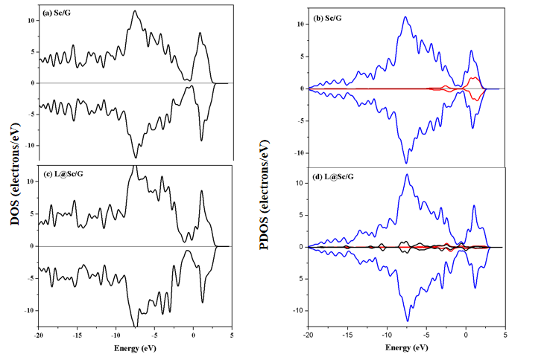

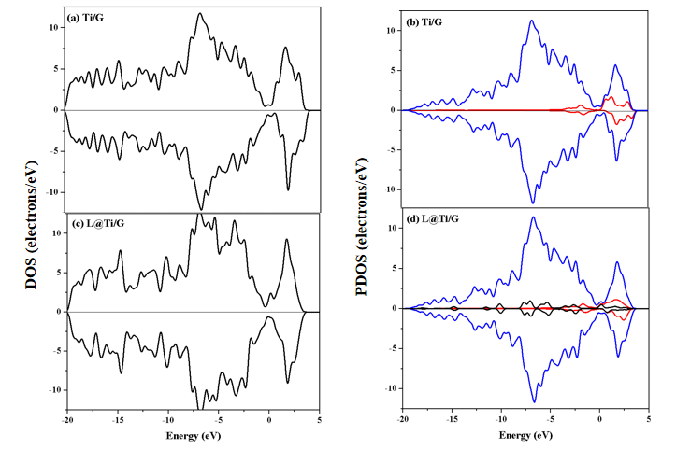

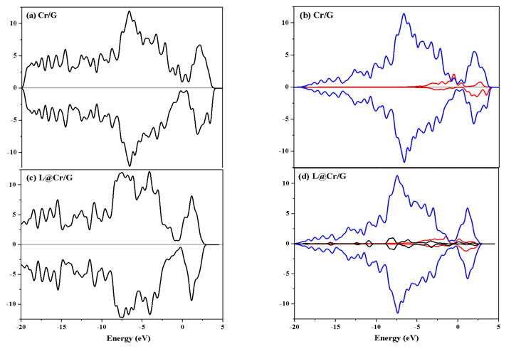
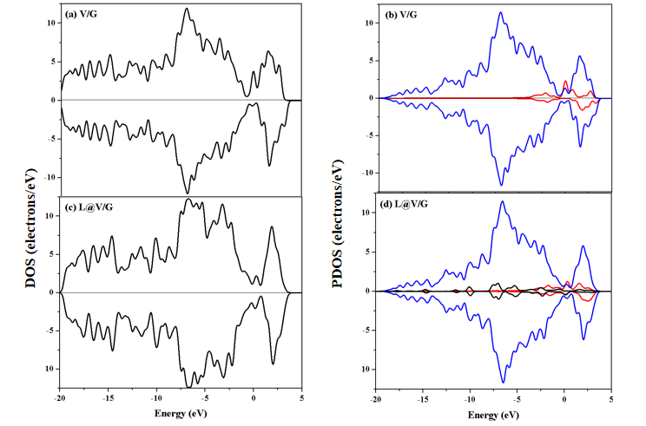

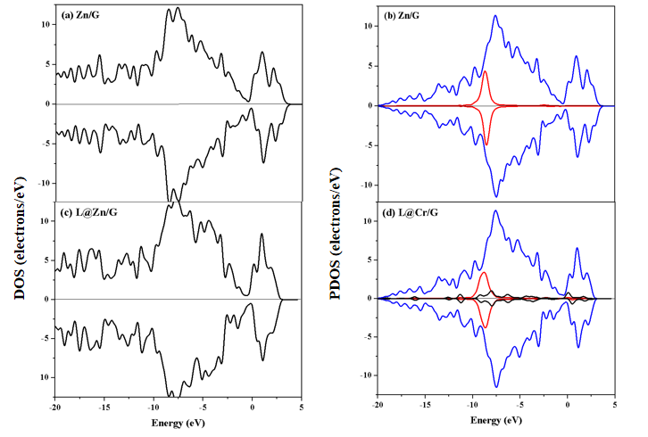

Figure S2 Total and partial DOS for TM/G sheets and L@TM/G. (a) total DOS of the TM/G (b) partial DOS of TM/G (c) the total DOS of L@TM/G (d) partial DOS of L@TM/G. Note: C(G) and C(L) represent the carbon atom in graphene sheet and lewisite, respectively.

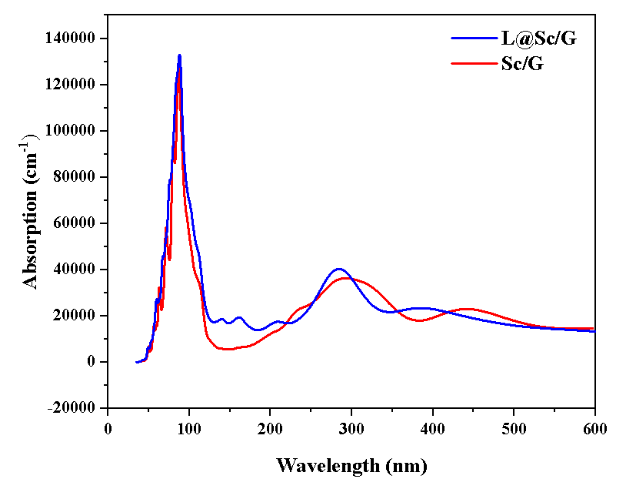

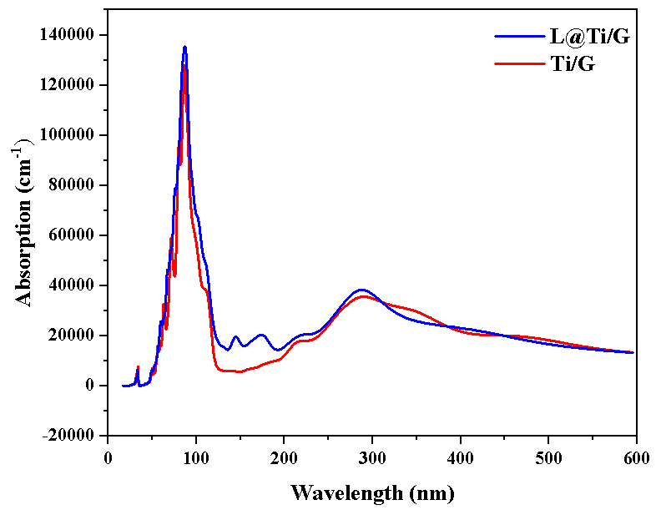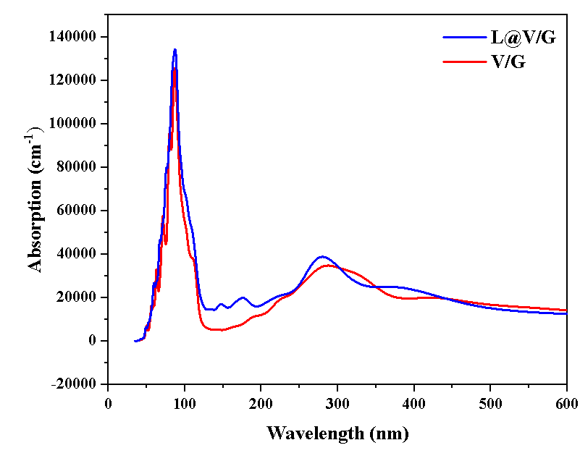

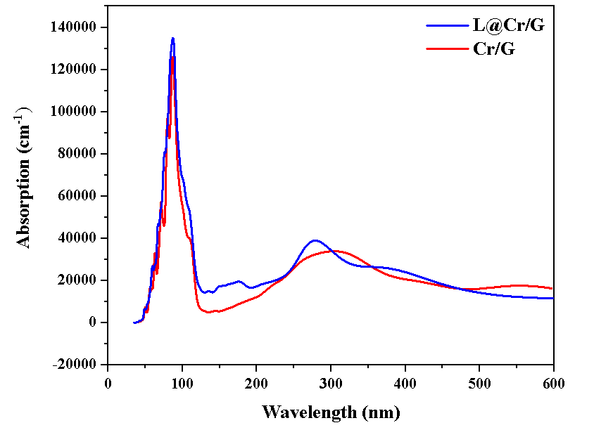

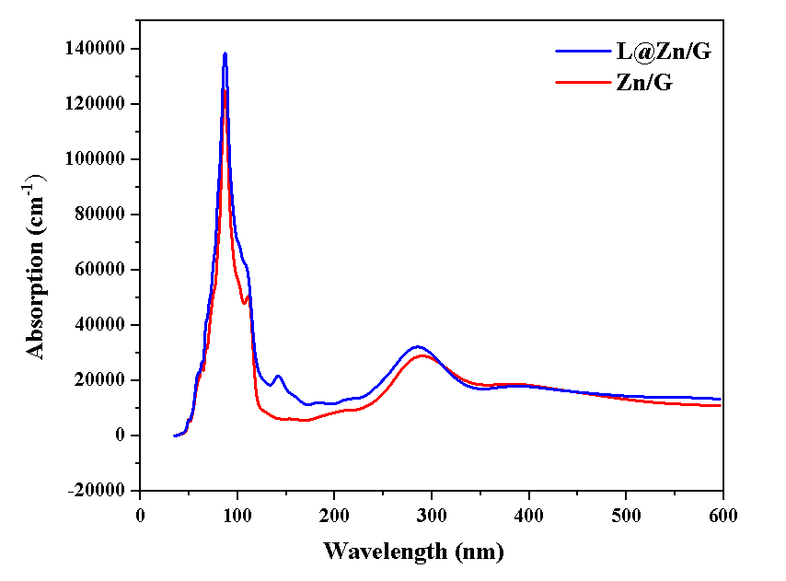
Figure S3 UV absorption spectra of TM/G substrates and L@TM/G

