Functions | Full names | Gene ID | Gene  symbol
K⁺ and Na⁺ vacuolar transportation  Na⁺ exclusion from plant tissues  K⁺ transportation  Antioxidation defense  Osmolyte synthesis  Sucrose degradation  Reference gene | Sodium/hydrogen exchanger 1  Sodium/hydrogen exchanger 2  salt overly sensitive 1  salt overly sensitive 2  High-affinity K⁺ transporter 1  High-affinity K⁺ transporter 5  Cu-Zn superoxide dismutase 1  Cu-Zn superoxide dismutase 2  Peroxidase 27  Peroxidase 41  Catalase A  Catalase C  Glutathione reductase 1  Glutathione reductase 2  Monodehydroascorbate reductase 1  Monodehydroascorbate reductase 2  Δ-1-pyrroline-5-carboxylate synthase 1  Δ-1-pyrroline-5-carboxylate synthase 2  Vacuolar invertase 2  Cell wall invertase 5  Neutral/alkaline invertase 1  Protein kinase  Nucleic acid binding protein  Translationally controlled tumor protein | Os07g0666900  Os11g0648000  Os12g0641100  Os06g0606000  Os04g0401700  Os01g0930400  Os03g0351500  Os07g0665200  Os02g0236600  Os03g0339300  Os02g0115700  Os03g0131200  Os03g0163300  Os02g0813500  Os02g0707000  Os02g0707100  Os05g0455500  Os01g0848200  Os04g0535600  Os04g0664900  Os03g0314800  Os06g0702800  Os06g0215200  Os11g0660500 | NHX1  NHX2  SOS1  SOS2  HAK1  HAK5  CSD1  CSD2  PRX27  PRX41  CATA  CATC  GR1  GR2  MDAR1  MDAR2  P5CS1  P5CS2  VIN2  CIN5  NIN1  PK  NABP  TCTP
Table S1. The names and brief description of functions of the analyzed genes and reference genes

Table S2. Primer sequences used for quantitative real-time PCR
Gene  symbol | Forward primer (5'–3') | Reverse primer (5'–3') | Amplified  length (bp)
NABP  PK  TCTP  CATA  CATC  CIN5  CSD1  CSD2  GR1  GR2  HAK1  HAK5  MDAR1  MDAR2  NHX1  NHX2  NIN1  P5CS1  P5CS2  PRX27  PRX41  SOS1  SOS2  VIN2 | CTCAGGAAGAGGCATACGCA  TTAGGAGGAAAGGTGCTGCG  ATGGCAAGTGGGTCGTTCAA  GCCGGATAGACAGGAGAGGT  TCGGACCAAACTACCTGCTG  CCAGGACTTCTACATGGTGGG  TTGGAAATGTCACCGCTGGA  GACCTCTGTGACGGGAAGTG  AGTCTCATGGCTTTGGGTGG  TGGGACGTGTGTGATACGTG  CCTCAAGGCCTTCAATCCGT  CATTGTGGACTATTTTGAAAGAA  GCGTTCGAGTACGTGATCCT  GGTCTTCCCTGAAAGCCACT  ACATAGATGCGGCTGTCGTT  CCATTCAGACTCGCTCCGTT  GCTCCACACTTTGCAACTCC  GGTCAGAGTGGACTGATGGC  GCAGAACCCACAGATGGACA  CTGCAGTCCATCGTGAGGTC  GCTTTGTCCAAGGATGCGAC  GGTTATATCAGGCACAAGATGCAC  CTCCAGGTGCTACATCGCTT  CGGTACGACTACGGCAAGTT | GCCCCCTTTAATTGTGGGGA  TATCTGGGTGGAGAAGGCGA  ACCACCTTCACAGCTTGGTC  TCTTCACATGCTTGGCTTCA  TCGTAGCGGGATGGGAAGTA  TACTCGTTGACCCACAGCCA  TTTCCGGTGGTCTTGCTCAG  AGTAAGGGGGATCTGGCTGT  GTAAATGCCAACAAGGCGCT  CCCCATTGATTTCCCACCCA  ATTTCCTCAGGTACGCTGCC  GGAGAACTACAGAAAAGCCAATC  TGCAGTCACCGTGTTCGTT  GCACGGATGCCAATACCAAC  TCATAAGGGCAACCTCACGG  GTCACAGTGCCCAGTTGAGA  CACGTCCAATGGCTGACTCT  CCCGGAACTTTGGGTTCTCA  CTCCTGGTACTGATGGCGTC  CATTGACGAAGCAGTCGTGG  AATCCCCTCAGCGAGTTGAC  GGGATACACAGAATAGGTCGCC  CACAAGAGGGCCACCATCAT  TTGAGTATGTCAGCCCGCTC | 116  104  109  166  127  182  166  238  104  110  224  149  207  216  159  148  170  109  240  103  100  104  227  116

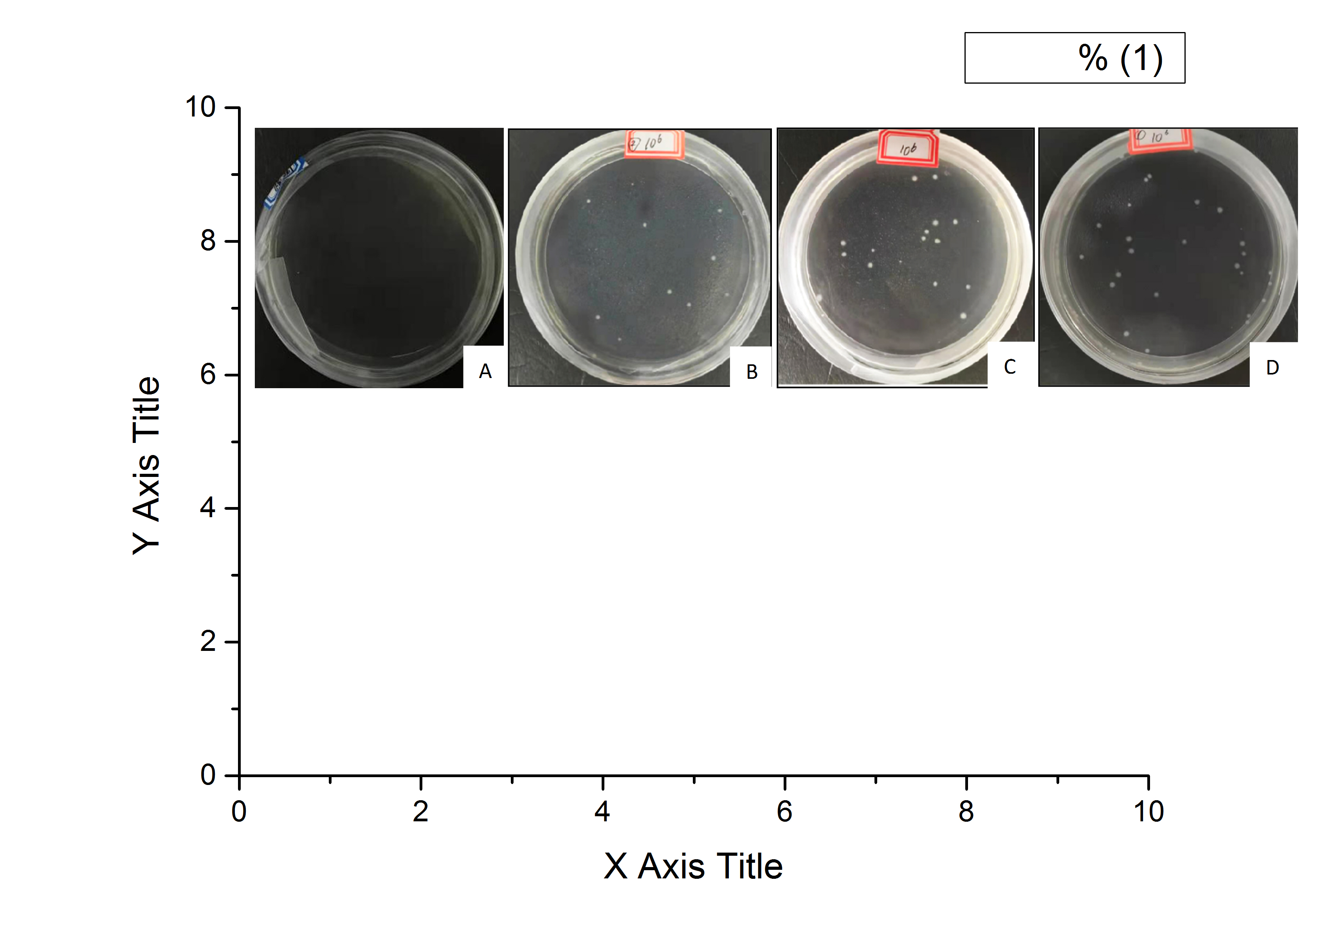
Fig. S1 Effect of inoculation time of P. sp. GD17 on the colonization efficiency inside roots. Colony-forming units (CFU) were observed on control plants grown in 1/2 strength of sterilized Hoagland's nutrient solution only added LB culture medium (A), and inoculation plants grown in nutrient solution applied with 10 ml 10⁸ CFU ml⁻¹ of GD17 fermentation liquor at 2 d (B), 3 d (C), and 4 d (D) after seed germination, respectively. After 4 d of GD17 inoculation, root samples were collected to evaluate the colonization efficiency according to the description in “materials and methods” section.

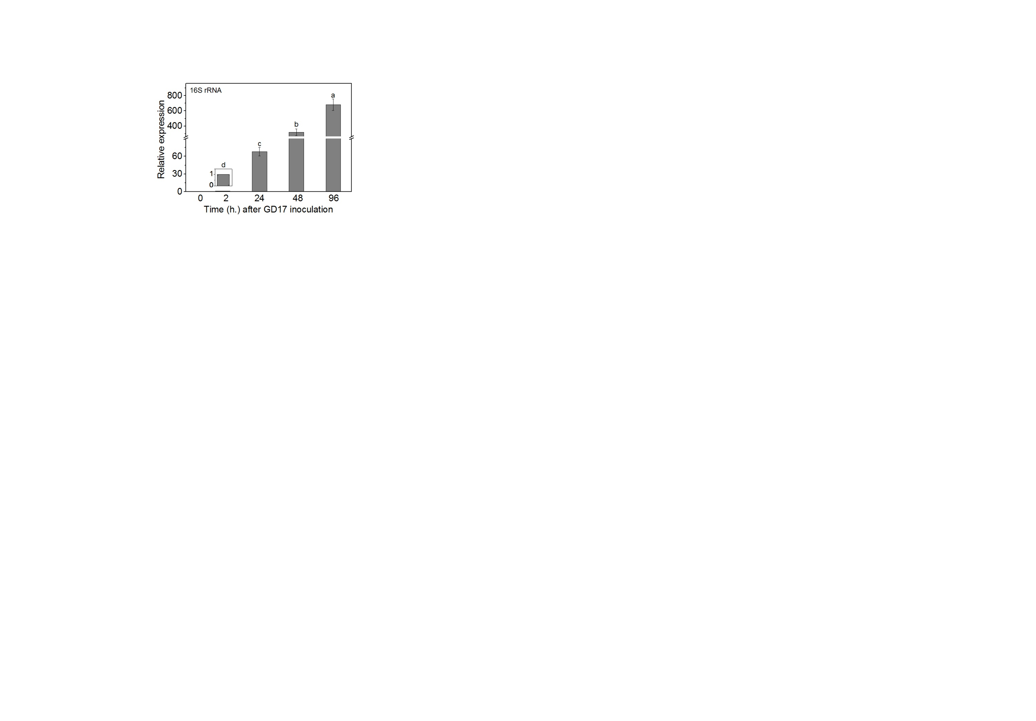

Fig. S2 Colonization efficiency of GD17 inside roots as indicated by the relative expression of 16S rRNA. GD17 inoculation was performed at 4 d after seed germination. The data were collected from three replicated experiments (n = 3) with 10 plants used in each batch of experiment, and represented as means ± SD. Bars with different lower-case letters indicate significant differences at p < 0.05

Fig. S3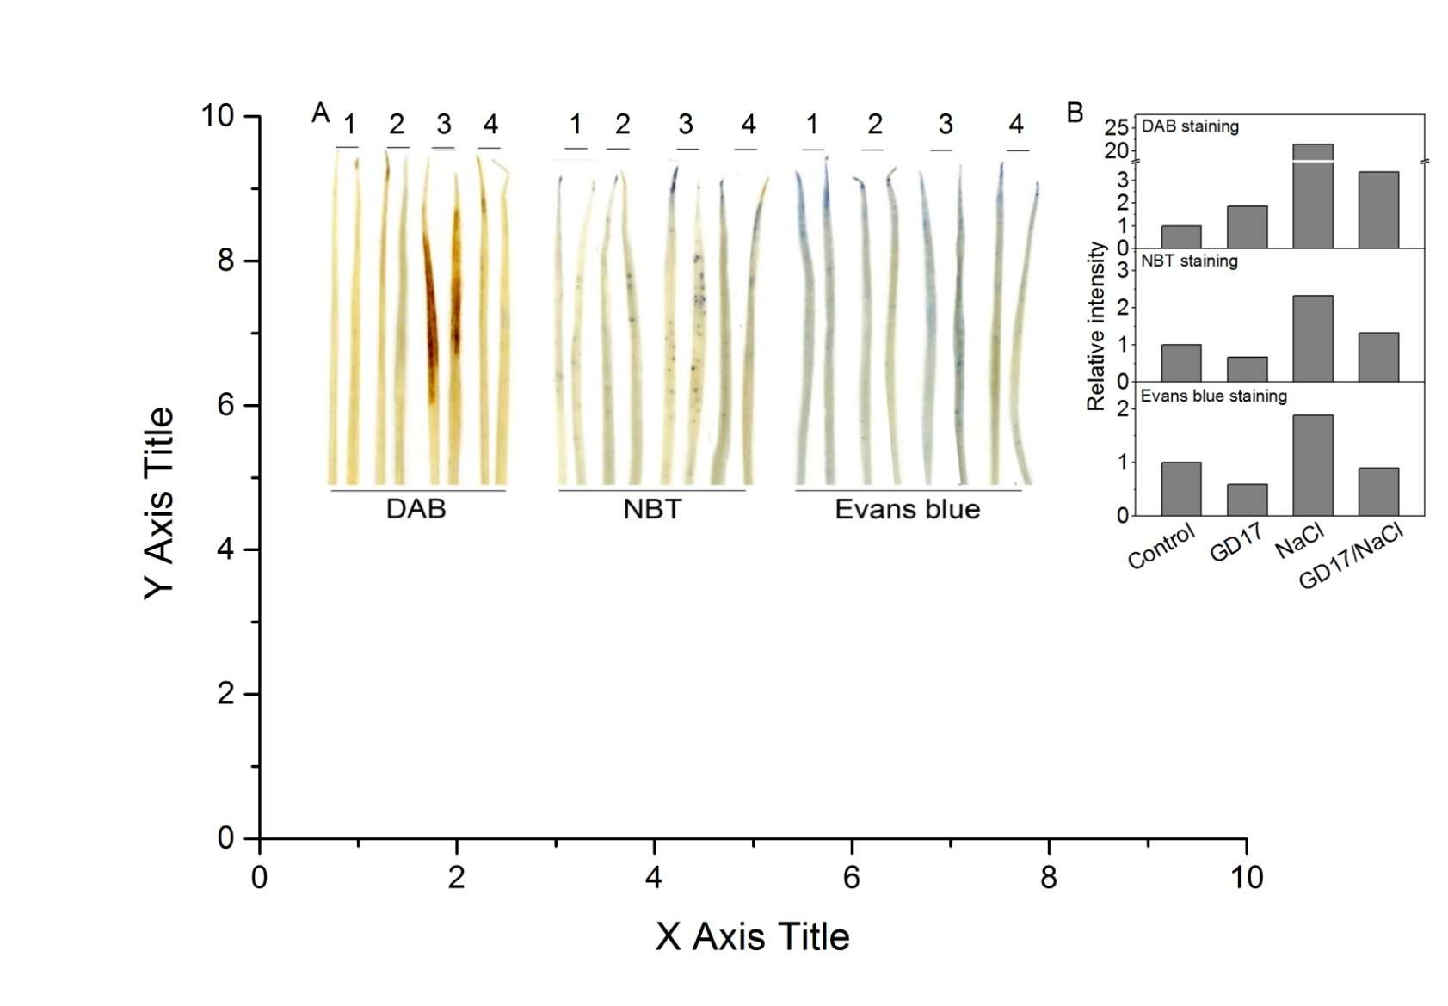 Representative pictures of rice leaves stained by 3,3′-diaminobenzidine tetrahydrochloride (DAB), nitroblue tetrazolium (NBT), and Evens blue, respectively, showing the formations of H₂O₂, superoxide anion (O₂˙ˉ), and dead cells (A), and their relative intensity (B). Eight-day-old plants (sequential 4 d germination, 4 d GD17 infection) were exposed to 68 mM NaCl for 48 h.
1, Control; 2, +GD17; 3, +NaCl; 4, +GD17 and NaCl

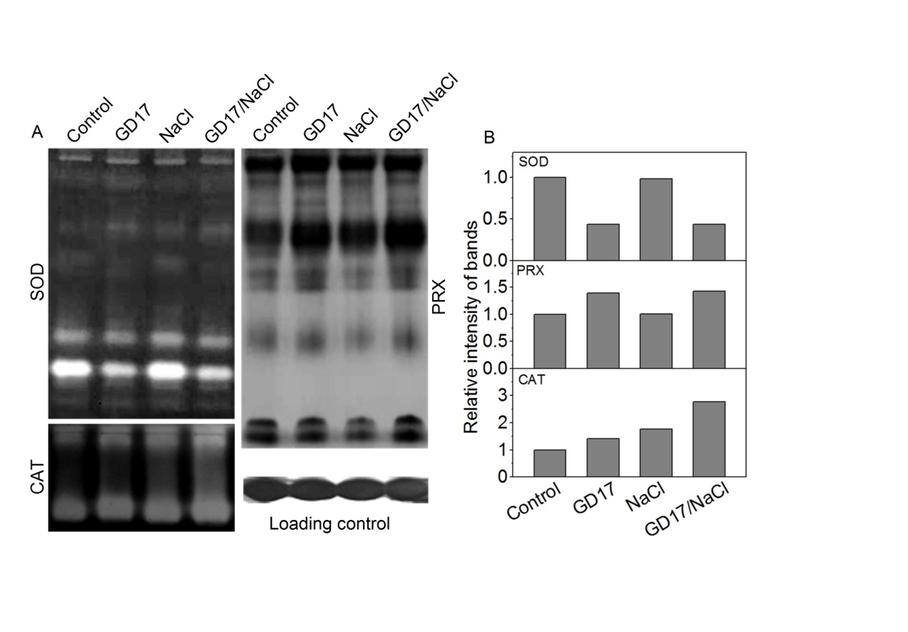

Fig. S4 Effect of salt stress and/or GD17 inoculation on the isozymes of SOD, PRX and CAT in the representative plant leaves stained in polyacrylamide gels (A), and their relative intensity (B). Loading amount of protein per lane is 10 μg. Eight-day-old plants (sequential 4 d germination, 4 d GD17 infection) were exposed to 68 mM NaCl for 48 h.

