Supplementary Materials
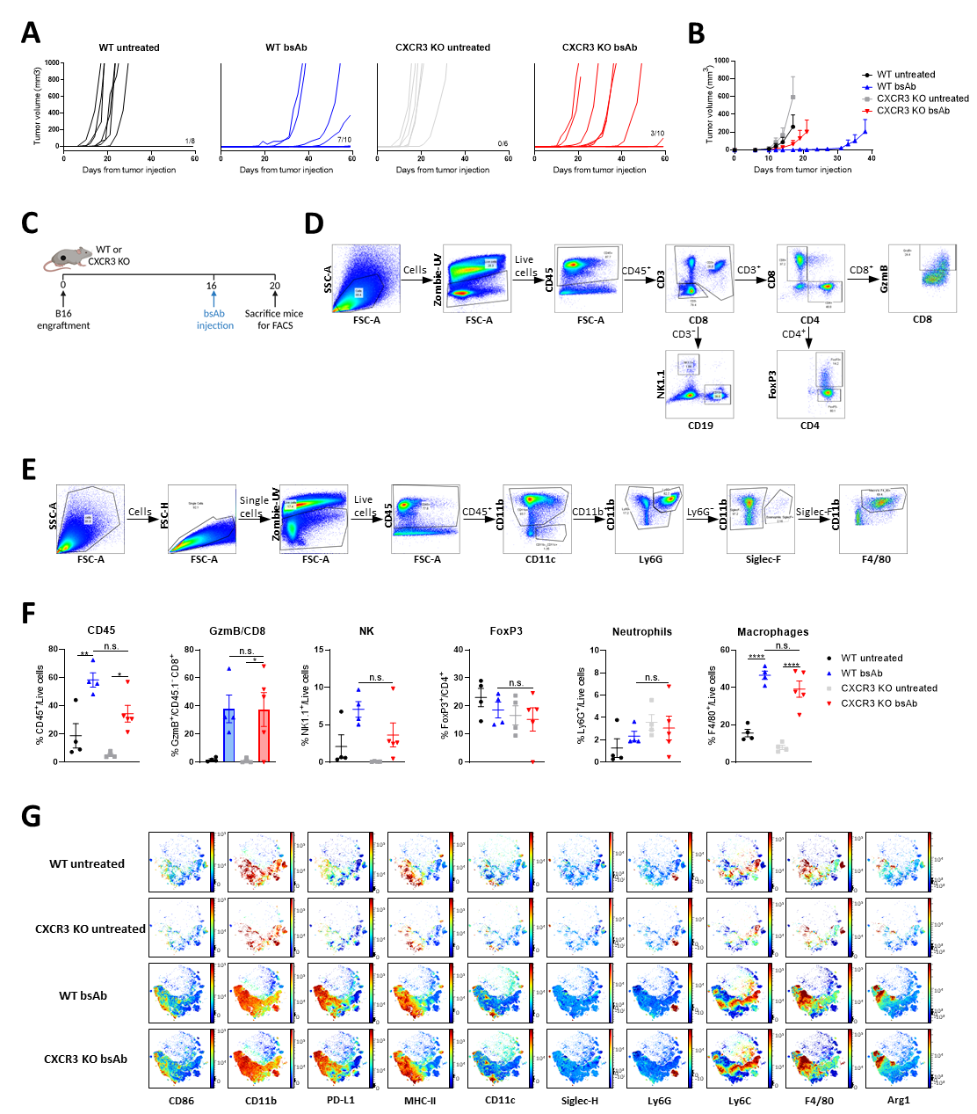
Fig. S1. Tumor growth curves, flow cytometry gating and results of infiltration data in WT and CXCR3 KO mice. (A-B) Tumor growth curves for indicated groups belonging to figure 1B depicted as individual growth curves (A), or mean tumor volumes (B) (C) Treatment schedule for TME analysis of WT and CXCR3 KO mice bearing B16F10 tumors receiving CD3xTRP1 treatment by using flow cytometry. (D) Gating strategy for lymphoid cells belonging to figure 1C and S1F. (E) Gating strategy for myeloid cells belonging to figure S1F. (F) Frequencies of intratumoral immune cells for the indicated groups bearing B16F10 tumors treated with CD3xTRP1 on day 16 and sacrificed on day 20. (G) Expression of indicated markers (mean fluorescence intensity) from live CD45⁺ cells for indicated groups in opt-SNE plots, generated using OMIQ software. Color scale indicates expression: red, high; blue, low. Data represented as mean ± SEM of n=6-10 (B) or n=4-5 (F). Significance was calculated with one-way ANOVA and Tukey post-hoc tests comparing all groups (F), * P<0.05, ** P<0.01, *** P<0.001, **** P<0.0001.

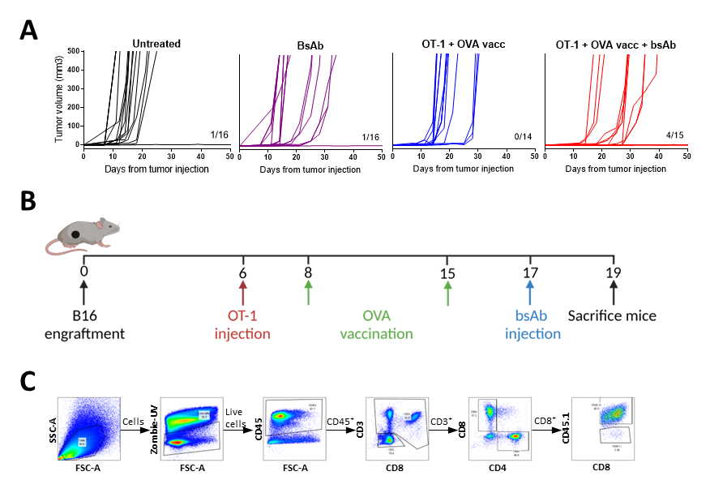
Fig. S2. Tumor growth curves, treatment schedule and flow cytometry gating for OT-1, OVA peptide vaccination and CD3xTRP1 treatment. (A) Individual tumor growth curves for indicated groups belonging to figure 1E. (B) Treatment schedule for mice bearing B16F10 tumors receiving OT-1, OVA peptide vaccination and/or CD3xTRP1 treatment for subsequent TME analysis. (C) Gating strategy for lymphoid cells belonging to figure 1F.

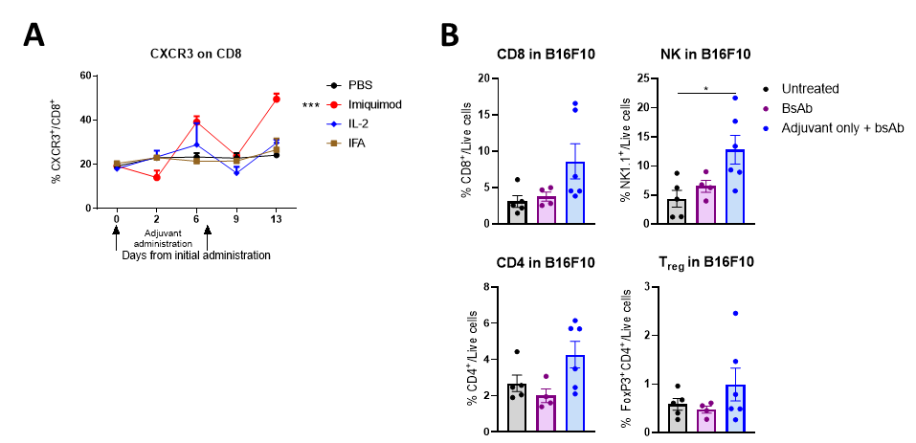
Fig. S3. Effect of adjuvant on CXCR3 expression and T-cell infiltration. (A) Frequency of CD8 T cells in the blood expressing CXCR3 after administration of indicated adjuvants. Black arrows indicate adjuvant administration. Significance is shown for day 13. (B) Frequencies of intratumoral lymphoid cells for the indicated groups on day 19 in mice bearing B16F10 tumors and receiving adjuvant on day 8 and 15 and CD3xTRP1 on day 17. Data represented as mean ± SEM of n=3 (A), or n=4-5 (B). Significance was calculated using one-way ANOVA and Tukey post-hoc tests comparing all groups (A and B), * P<0.05, ** P<0.01, *** P<0.001, **** P<0.0001.

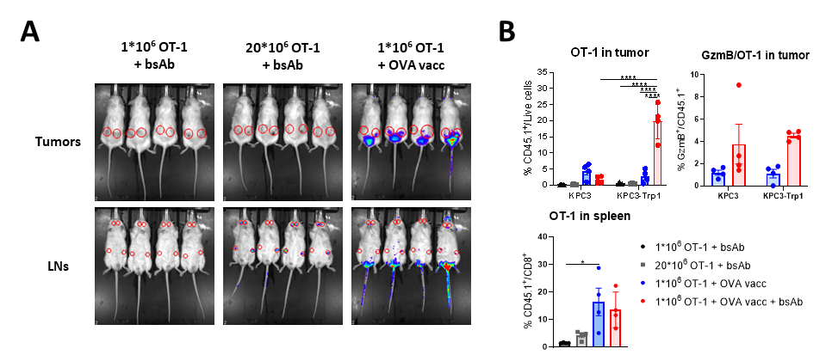
Fig. S4. Vaccine-activated non-specific T cells infiltrate the tumor, whereas naïve T cells home towards lymph organs (A) Representative IVIS images at day 19 according to the schedule in figure 2A. Red circles indicate tumors (left flank KPC3; right flank KPC3-TRP1) or LNs. Color gradient indicates expression level: blue, low; red, high. Signal at the tail base indicates vaccination site. (B) Frequencies of OT-1 T cells in tumor and spleen and fraction of Grz-B positive OT-1 cells treated according to scheme in figure 2A. Data represented as mean ± SEM of n=4 (B). Significance was calculated using one-way ANOVA with Tukey post-hoc tests comparing all groups (B), * P<0.05, ** P<0.01, *** P<0.001, **** P<0.0001.

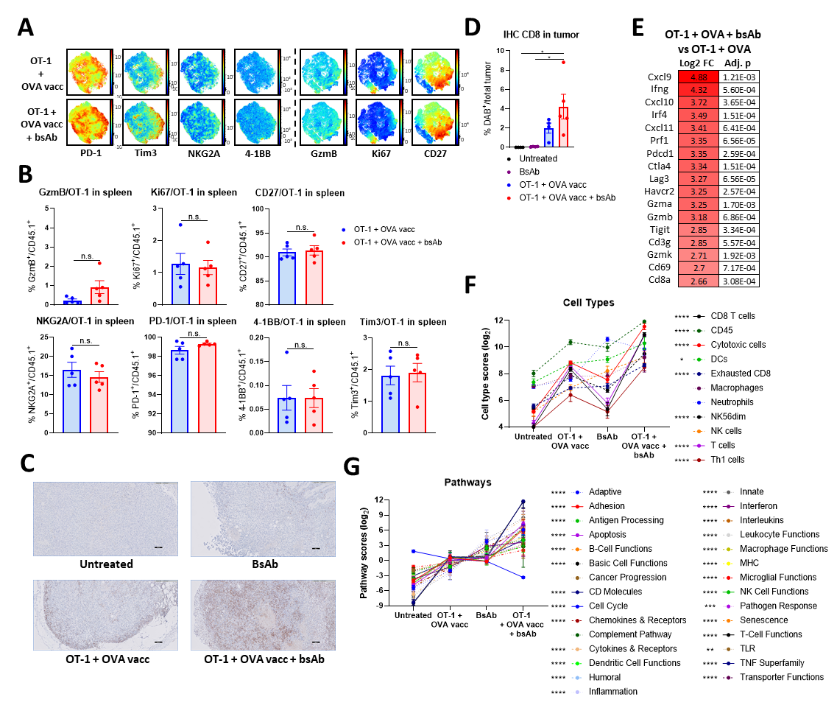
Fig. S5. Vaccine-activated OT-1 T cells are locally activated in the tumor after CD3xTRP1 administration (A) Expression of T-cell activation markers (mean fluorescence intensity) in opt-SNE plots, generated using OMIQ software, from pre-gated OT-1 T cells in B16F10 tumors from mice that received OT-1 transfer on day 6, OVA vaccination on day 8 and 15, CD3xTRP1 on day 17 and were sacrificed on day 19. OT-1 cells were pre-gated based on CD45.1 expression and then further selected on selective abundance in the tumor to avoid mixing up systemic and local effects. Color scale indicates expression: red, high; blue, low. (B) Expression of T-cell activation markers on OT-1 T cells in the spleen from mice bearing KPC3-TRP1 tumors. (C and D) Representative images of tissue slide staining for CD8 of B16F10 tumors (according to treatment schedule described in S4A) (C) and quantification (D). (E) Nanostring transcriptomics analysis with the PanCancer Immune Profiling Panel showing a selected list of differentially expressed genes. (F and G) Representation of differential gene expression in KPC3-TRP1 tumors from Nanostring analysis in scores for cell types (F) and immune pathways (G). Statistical significance in (F and G) is shown for the comparison between bsAb and OT-1 + vacc + bsAb. Data represented as mean ± SEM of n=4-5 (B and D), or n=3-5 (F and G). Significance was calculated using two-sided t-tests (B) and one-way ANOVA with Tukey post-hoc tests comparing all groups (D, F and G), * P<0.05, ** P<0.01, *** P<0.001, **** P<0.0001.

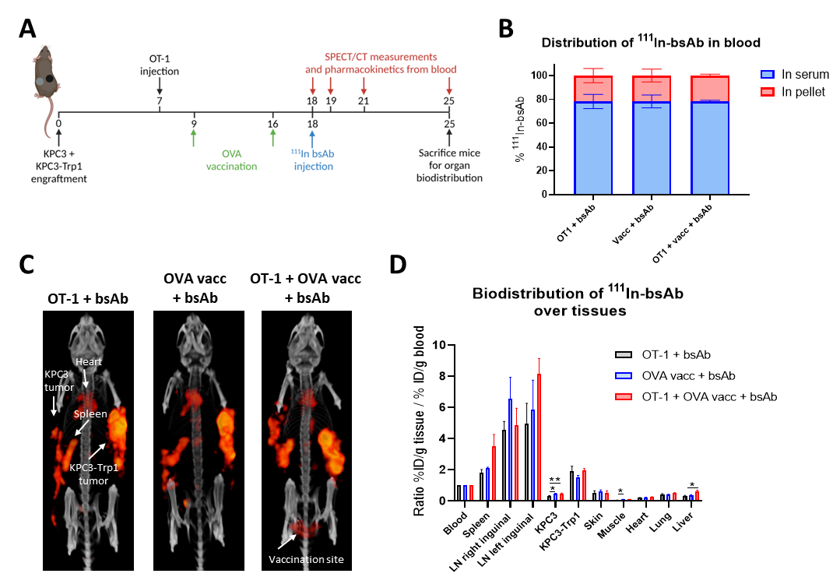
Fig. S6 Biodistribution of radiolabeled CD3xTRP1 in combination with OT-1 T cells and OVA peptide vaccination. (A) Treatment scheme for mice bearing KPC3 and KPC3-TRP1 tumors on distinct flanks receiving treatment with OT-1 T cells, OVA peptide vaccination and radiolabeled CD3xTRP1. SPECT/CT imaging was performed at indicated time points. (B) Distribution of radiolabeled CD3xTRP1 in blood, divided over serum fraction and cell pellet, 24 hours after injection of CD3 bsAb. (C) Representative SPECT/CT images 24 hours after injection with radiolabeled CD3xTRP1 from dorsal perspective. Orange indicates radiolabeled CD3 bsAb, white arrows indicate most important tissues/locations. (D) Biodistribution of radiolabeled CD3xTRP1 over indicated tissues after normalization to blood. Data represented as mean ± SEM of n=3 (B and D). Significance was calculated using one-way ANOVA and Tukey post-hoc tests comparing all groups (B and D), * P<0.05, ** P<0.01, *** P<0.001, **** P<0.0001.

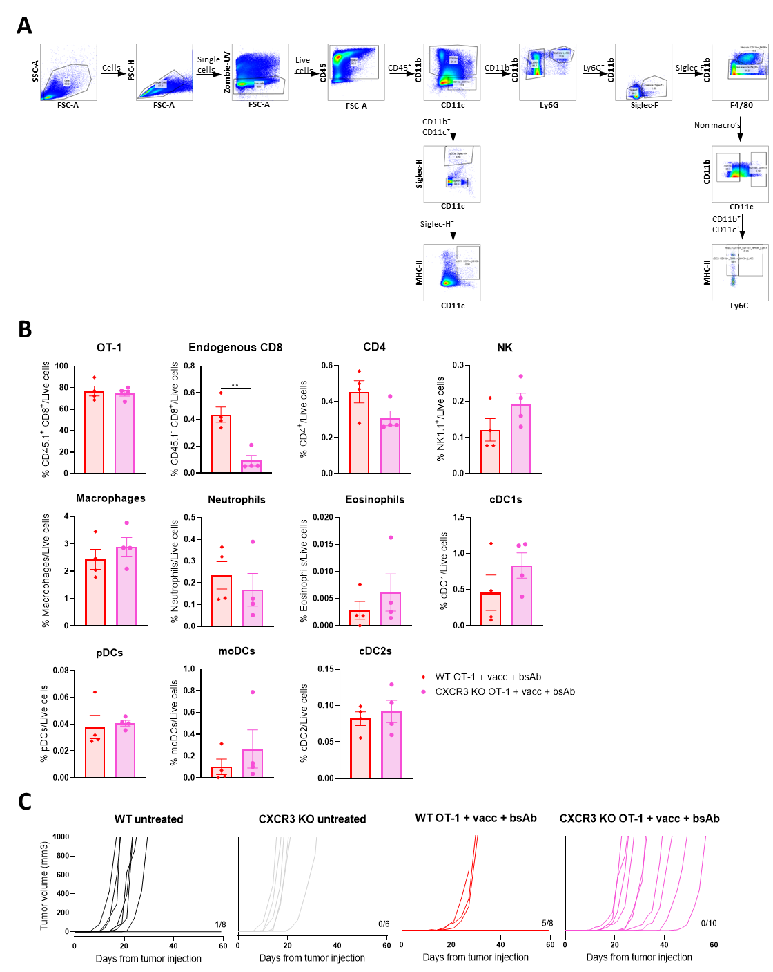
Fig. S7. Tumor growth curves, myeloid gating strategy and influx of immune cells for CXCR3 KO related experiments. (A) Gating strategy for myeloid cells belonging to figure S6C. (B) Frequencies of intratumoral immune cell populations within B16F10 tumors of WT or CXCR3 KO mice on day 20 from mice that were treated with WT OT-1 on day 6, OVA peptide vaccination on day 7 and 14 and CD3xTRP1 on day 16. (C) Individual tumor growth curves for indicated groups belonging to figure 4E. Data represented as mean ± SEM of n=4 (B). Significance was calculated using two-sided t-tests (B), * P<0.05, ** P<0.01, *** P<0.001, **** P<0.0001.

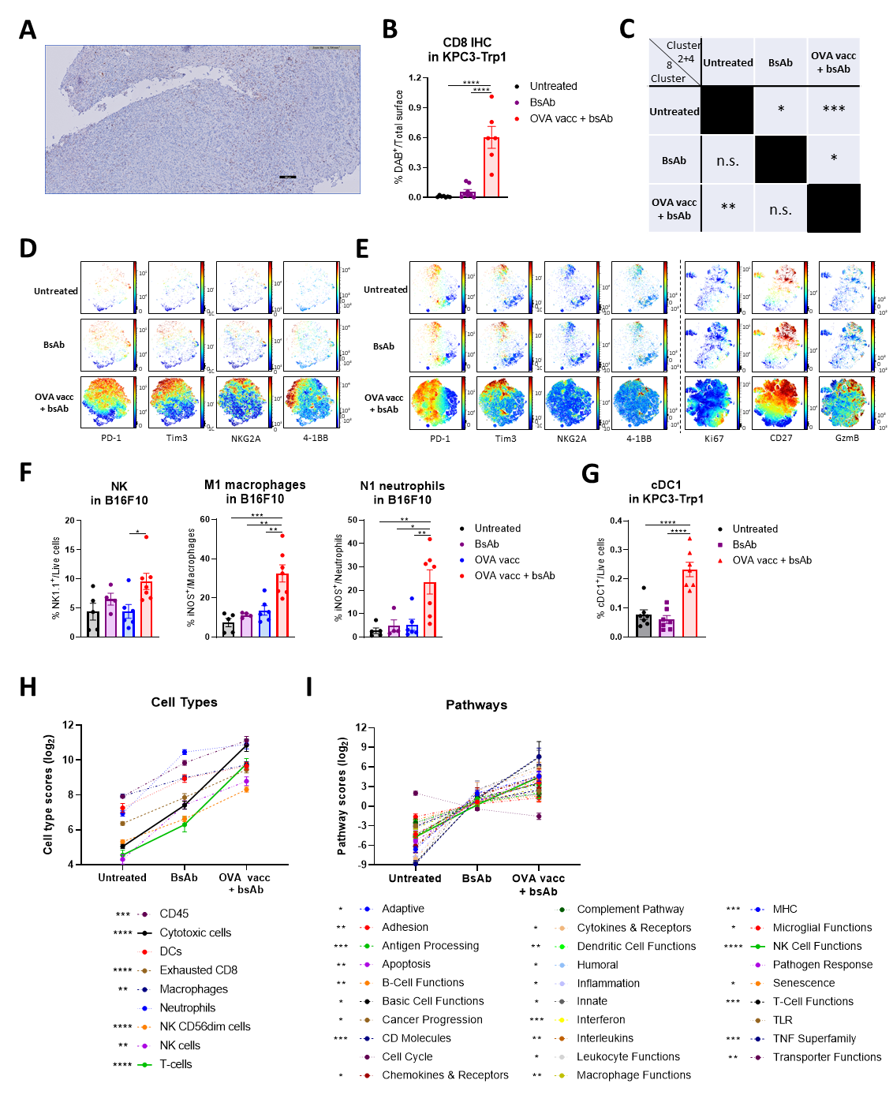
Fig. S8. TME analysis for the combination of OVA vaccination with CD3xTRP1. (A-H) Treatment schedule according to figure 5A with KPC3-TRP1 tumors, unless indicated otherwise. (A and B) IHC staining for CD8 for indicated groups, showing representative images (A) and quantification (B). Images were altered by decreasing brightness with 20% and increasing contrast with 40%. (C) Table showing statistical significances of cluster frequencies between different treatments belonging to figure 5C. (D and E) Expression of indicated T-cell activation markers (mean fluorescence intensity) from pre-gated CD8 T cells in tumors from KPC3-TRP1-bearing mice (D) or B16F10-bearing mice (E) for indicated groups in opt-SNE plots, generated using OMIQ software. Color scale indicates expression: red, high; blue, low. (F) Frequencies of intratumoral NK cells, M1-type macrophages, defined as iNOS-positive, and N1-type neutrophils, defined as iNOS-positive in B16F10 bearing mice. (G) Frequencies of intratumoral cDC1 cells for the indicated groups. (H and I) Representation of differential gene expression from Nanostring analysis in scores for cell types (G) and immune pathways (H), using nSolver4.0 analysis software. Statistical significance in (G and H) is shown for the comparison between bsAb and OVA vacc + bsAb. Data represented as mean ± SEM of n=6-7 (B, F-G), or n=5 (H-I). Significance was calculated using one-way ANOVA and Tukey post-hoc tests comparing all groups (B, C and F-I), * P<0.05, ** P<0.01, *** P<0.001, **** P<0.0001.

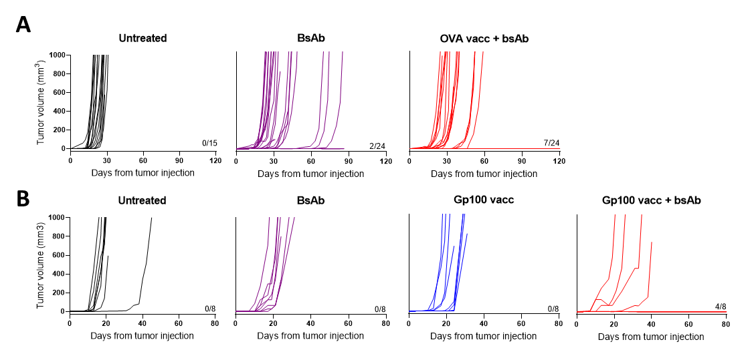
Fig. S9. Individual tumor growth curves for combination of OVA or Gp100 SLP vaccination and CD3xTRP1. (A-B) Individual tumor growth curves for indicated groups belonging to figure 6B (A) or figure 6C (B).

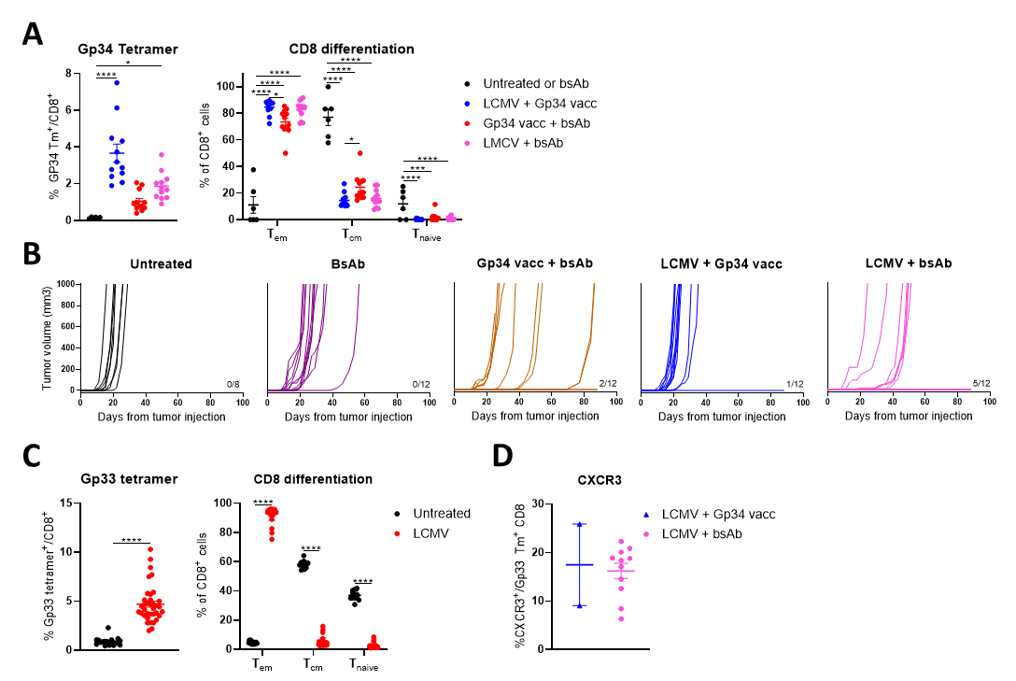
Fig. S10. CD8 T-cell responses to LCMV viral infection and peptide vaccination and individual growth curves for the LCMV experiment. (A-D) Treatment schedule according to figure 6D. (A) CD8 T cells in blood, showing Gp34 tetramer responses and differentiation of CD8 T cells on day 19. (B) Individual tumor growth curves for indicated groups belonging to figure 6E. (C) CD8 T cells in blood, showing Gp33 tetramer responses and differentiation of CD8 T cells on day -22. (D) CXCR3 expression on Gp33 tetramer-positive CD8 T cells in blood on day 63. Data represented as mean ± SEM of n=6-12 (A), n=18-36 (C), or n=2-11 (D). Significance was calculated with a two-sided t-test (C and D), or one-way ANOVA and Tukey post-hoc tests comparing all treatment groups (A), * P<0.05, ** P<0.01, *** P<0.001, **** P<0.0001.

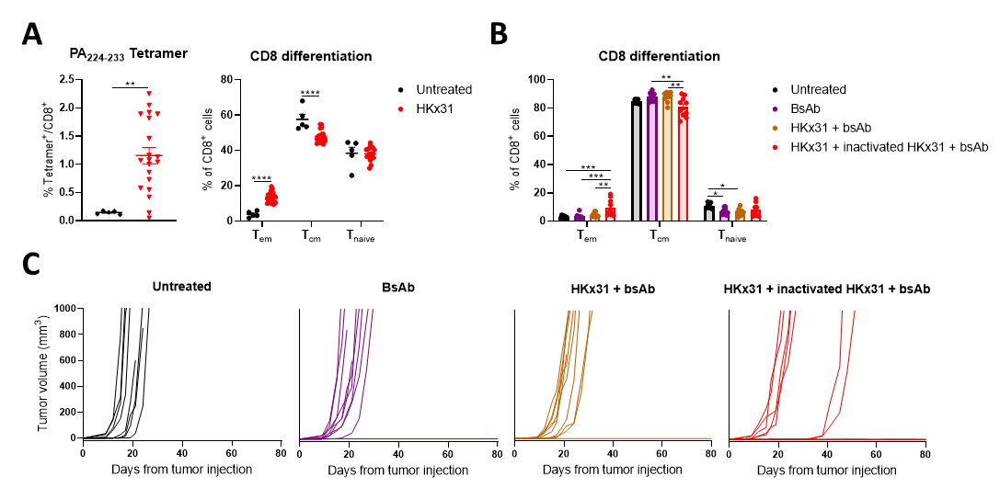
Fig. S11. CD8 T-cell responses to HKx31 infection and boost and individual growth curves. (A-C) Treatment schedule according to figure 6D. (A) CD8 T cells in blood, showing HKx31-specific tetramer responses and differentiation of CD8 T cells on day -14. (B) Differentiation of CD8 T cells in blood on day 16 after mice received the HKx31 booster vaccine. (C) Individual tumor growth curves for indicated groups belonging to figure 6F. Data represented as mean ± SEM of n=5-20 (A), or n= 8-10 (B). Significance was calculated with a two-sided t-test (A), or one-way ANOVA and Tukey post-hoc tests comparing all treatment groups (B), * P<0.05, ** P<0.01, *** P<0.001, **** P<0.0001.

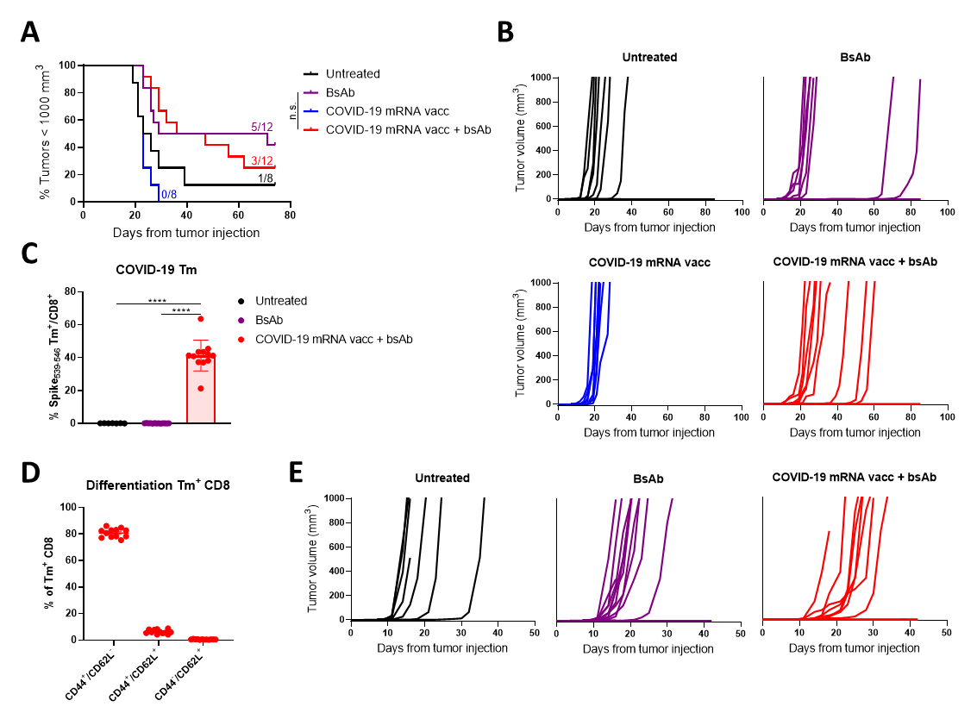
Fig. S12. CD8 T-cell responses and tumor outgrowth for combination of COVID-19 mRNA vaccination with CD3xTRP1. (A and B) Treatment schedule according to Fig. 6D; mice were vaccinated with COVID-19 mRNA on day -30, inoculated with tumor cells on day 0, vaccinated with COVID-19 mRNA on day 8 and received CD3xTRP1 on day 12 and 15. (D) Kaplan-Meier curves for indicated groups. (E) Individual tumor growth curves for indicated groups belonging to fig. S12A. (C-E) Treatment schedule according to Fig. 6A. (C and D) CD8 T cells in blood, showing SARS-CoV-2-specific tetramer responses (C) and differentiation of these tetramer-positive T cells on day 15 (D). (E) Individual tumor growth curves for indicated groups belonging to Fig. 6G. Data represented as mean ± SEM of n=8-12 (C and D). Significance was calculated using Mantel-Cox Log-Rank tests (A), or a one-way ANOVA and Tukey post-hoc tests comparing all treatment groups (C), * P<0.05, ** P<0.01, *** P<0.001, **** P<0.0001.

Table S1. Overview of all used antibodies for flow cytometry experiments.
Marker | Fluorochrome | Clone | Catalog number | Supplier | Fold dilution
4-1BB | APC | 17B5 | 106110 | Biolegend | 200
Arginase 1 | PE-Cy7 | A1exF5 | 25-3697-82 | Invitrogen | 200
CD3 | FITC | 145-2C11 | 11-0031-85 | Invitrogen | 800
CD3 | PE-Cy5 | 145-2C11 | 100310 | Biolegend | 500
CD4 | BUV496 | RM4-4 | 741051 | BD | 600
CD8 | BUV395 | 53-6.7 | 563786 | BD | 400
CD8 | BV711 | 53-6.7 | 100759 | Biolegend | 800
CD11b | BUV563 | M1/70 | 741242 | BD | 1200
CD11c | BV605 | HL3 | 563057 | BD | 200
CD19 | Spark Blue | 6D5 | 115566 | Biolegend | 800
CD25 | BV421 | PC61 | 102033 | Biolegend | 200
CD27 | BV785 | LG.3A10 | 124241 | Biolegend | 200
CD28 | PE-Cy7 | 37.51 | 102126 | Biolegend | 200
CD44 | BV510 | IM-7 | 103043 | Biolegend | 600
CD44 | BV785 | IM-7 | 103059 | Biolegend | 100
CD45 | AF700 | 30-F11 | 103128 | Biolegend | 400
CD45.1 | APC | A20 | 110714 | Biolegend | 400
CD62L | BUV805 | MEL-14 | 741924 | BD | 800
CD62L | BV421 | MEL-14 | 104436 | Biolegend | 100
CD69 | BUV737 | H1.2F3 | 612793 | BD | 200
CD86 | BUV496 | PO3 | 750437 | BD | 200
CD115 | PE/dazzle | AFS98 | 135528 | Biolegend | 100
CXCR3 | APC | CXCR3-173 | 126511 | Biolegend
Egr2 | APC | Erongr2 | 17-6691-82 | Invitrogen | 100
Eomes | PE/dazzle | Dan11mag | 61-4875-82 | Invitrogen | 200
F4/80 | PE-Cy5 | BM8 | 123112 | Biolegend | 300
FoxP3 | Pacific Blue | MF-14 | 126410 | Biolegend | 200
GATA-3 | AF488 | 16E10A23 | 653808 | Biolegend | 100
Grz-B | PerCP-Cy5.5 | QA16A02 | 372212 | Biolegend | 100
I-A/I-E (MHC-II) | Pacific Blue | M5/114.15.2 | 107620 | Biolegend | 800
iNOS | AF488 | CXNFT | 53-5920-82 | Invitrogen | 100
Ki-67 | BV605 | 16A8 | 652413 | Biolegend | 200
Ly6C | PerCP-Cy5.5 | HK1.4 | 128012 | Biolegend | 500
Ly6G | Spark Blue | 1A8 | 127663 | Biolegend | 300
NK1.1 | BV650 | PK136 | 564143 | BD | 200
NKG2A | PE-Cy7 | 16A11 | 142810 | Biolegend | 200
PD-1 | BV605 | 29F.1A12 | 135220 | Biolegend | 200
PD-L1 | BUV737 | MIH5 | 741877 | BD | 300
RORγT | PE | AFKJS-9 | 12-6988-82 | Invitrogen | 100
Siglec-F | BV711 | E50-2440 | 740764 | BD | 400
Siglec-H | BV650 | 440c | 747672 | BD | 200
T-bet | BV711 | 4B10 | 644819 | Biolegend | 100
TCF-1 | APC | C63D9 | 37636S | Cell signalling technology | 100
Tim-3 | BV785 | RMT3-23 | 119725 | Biolegend | 300
XCR1 | PE | ZET | 148204 | Biolegend | 100

