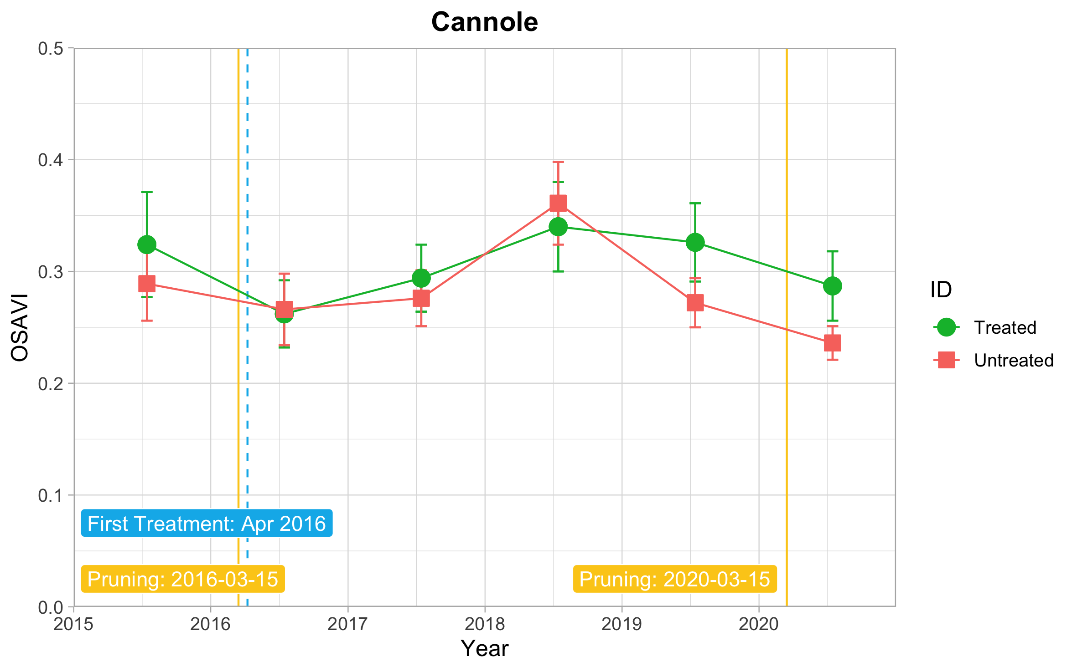
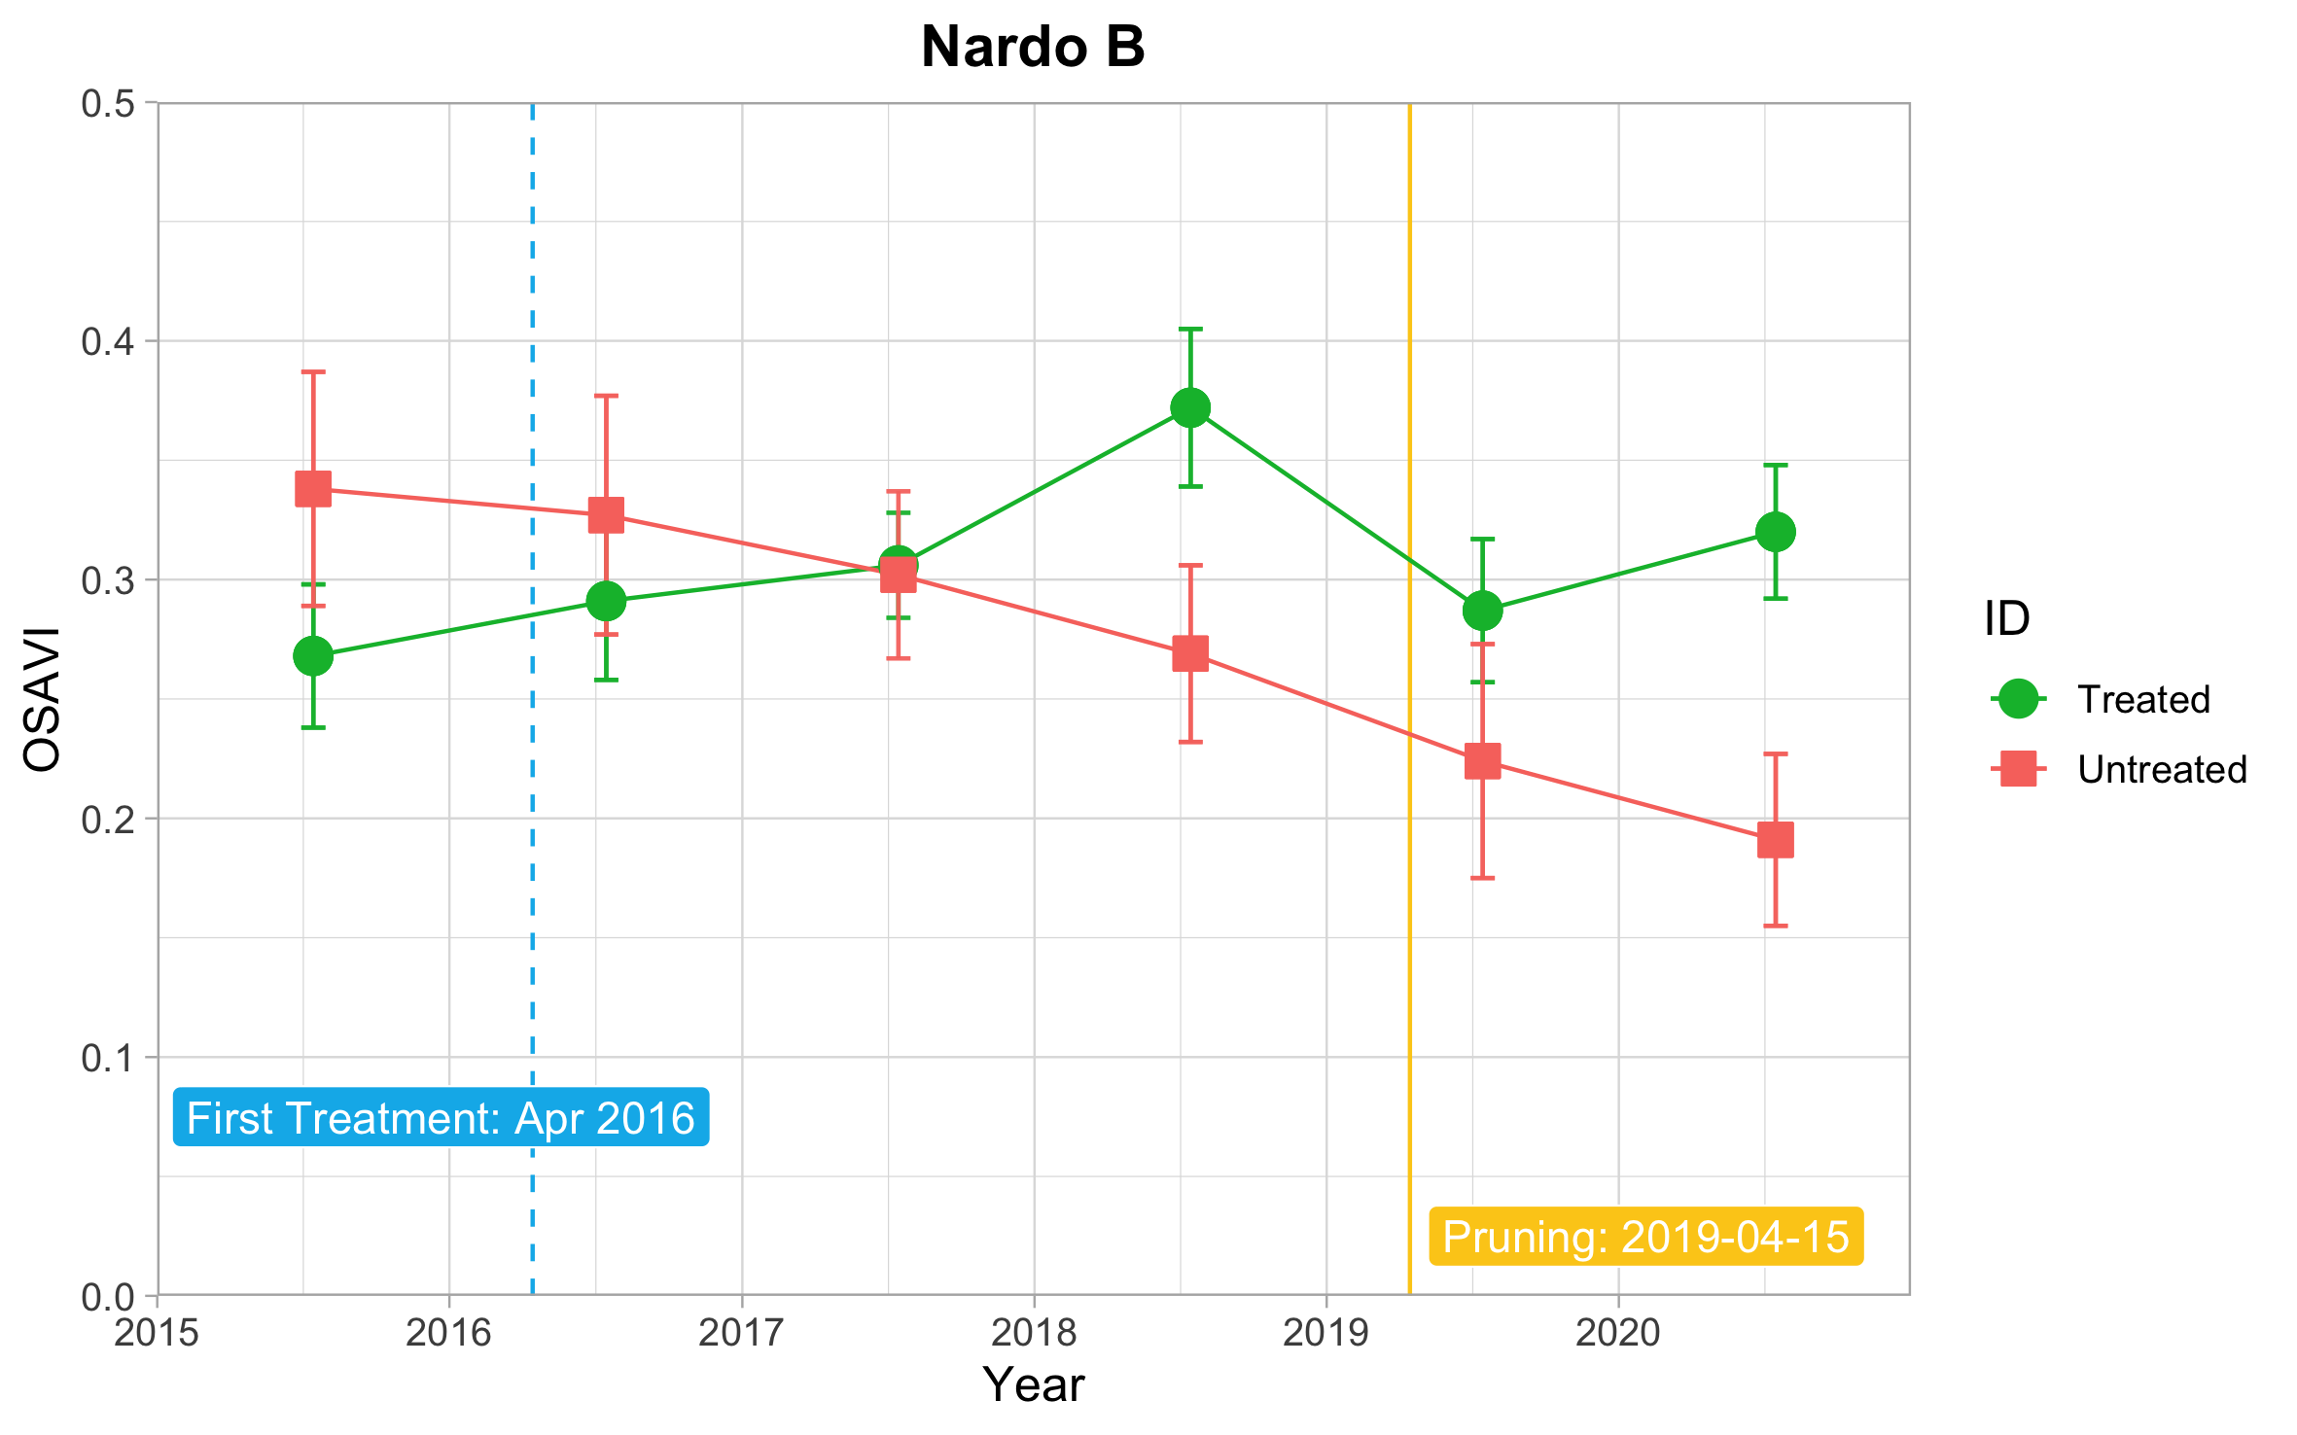
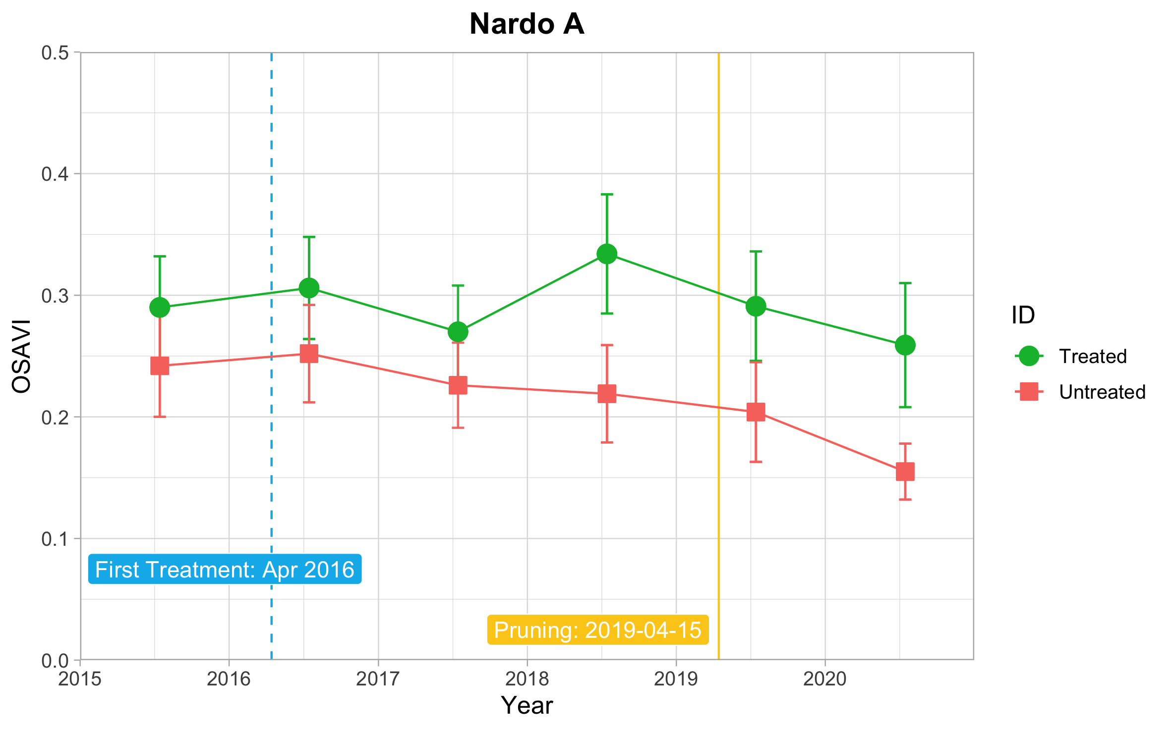
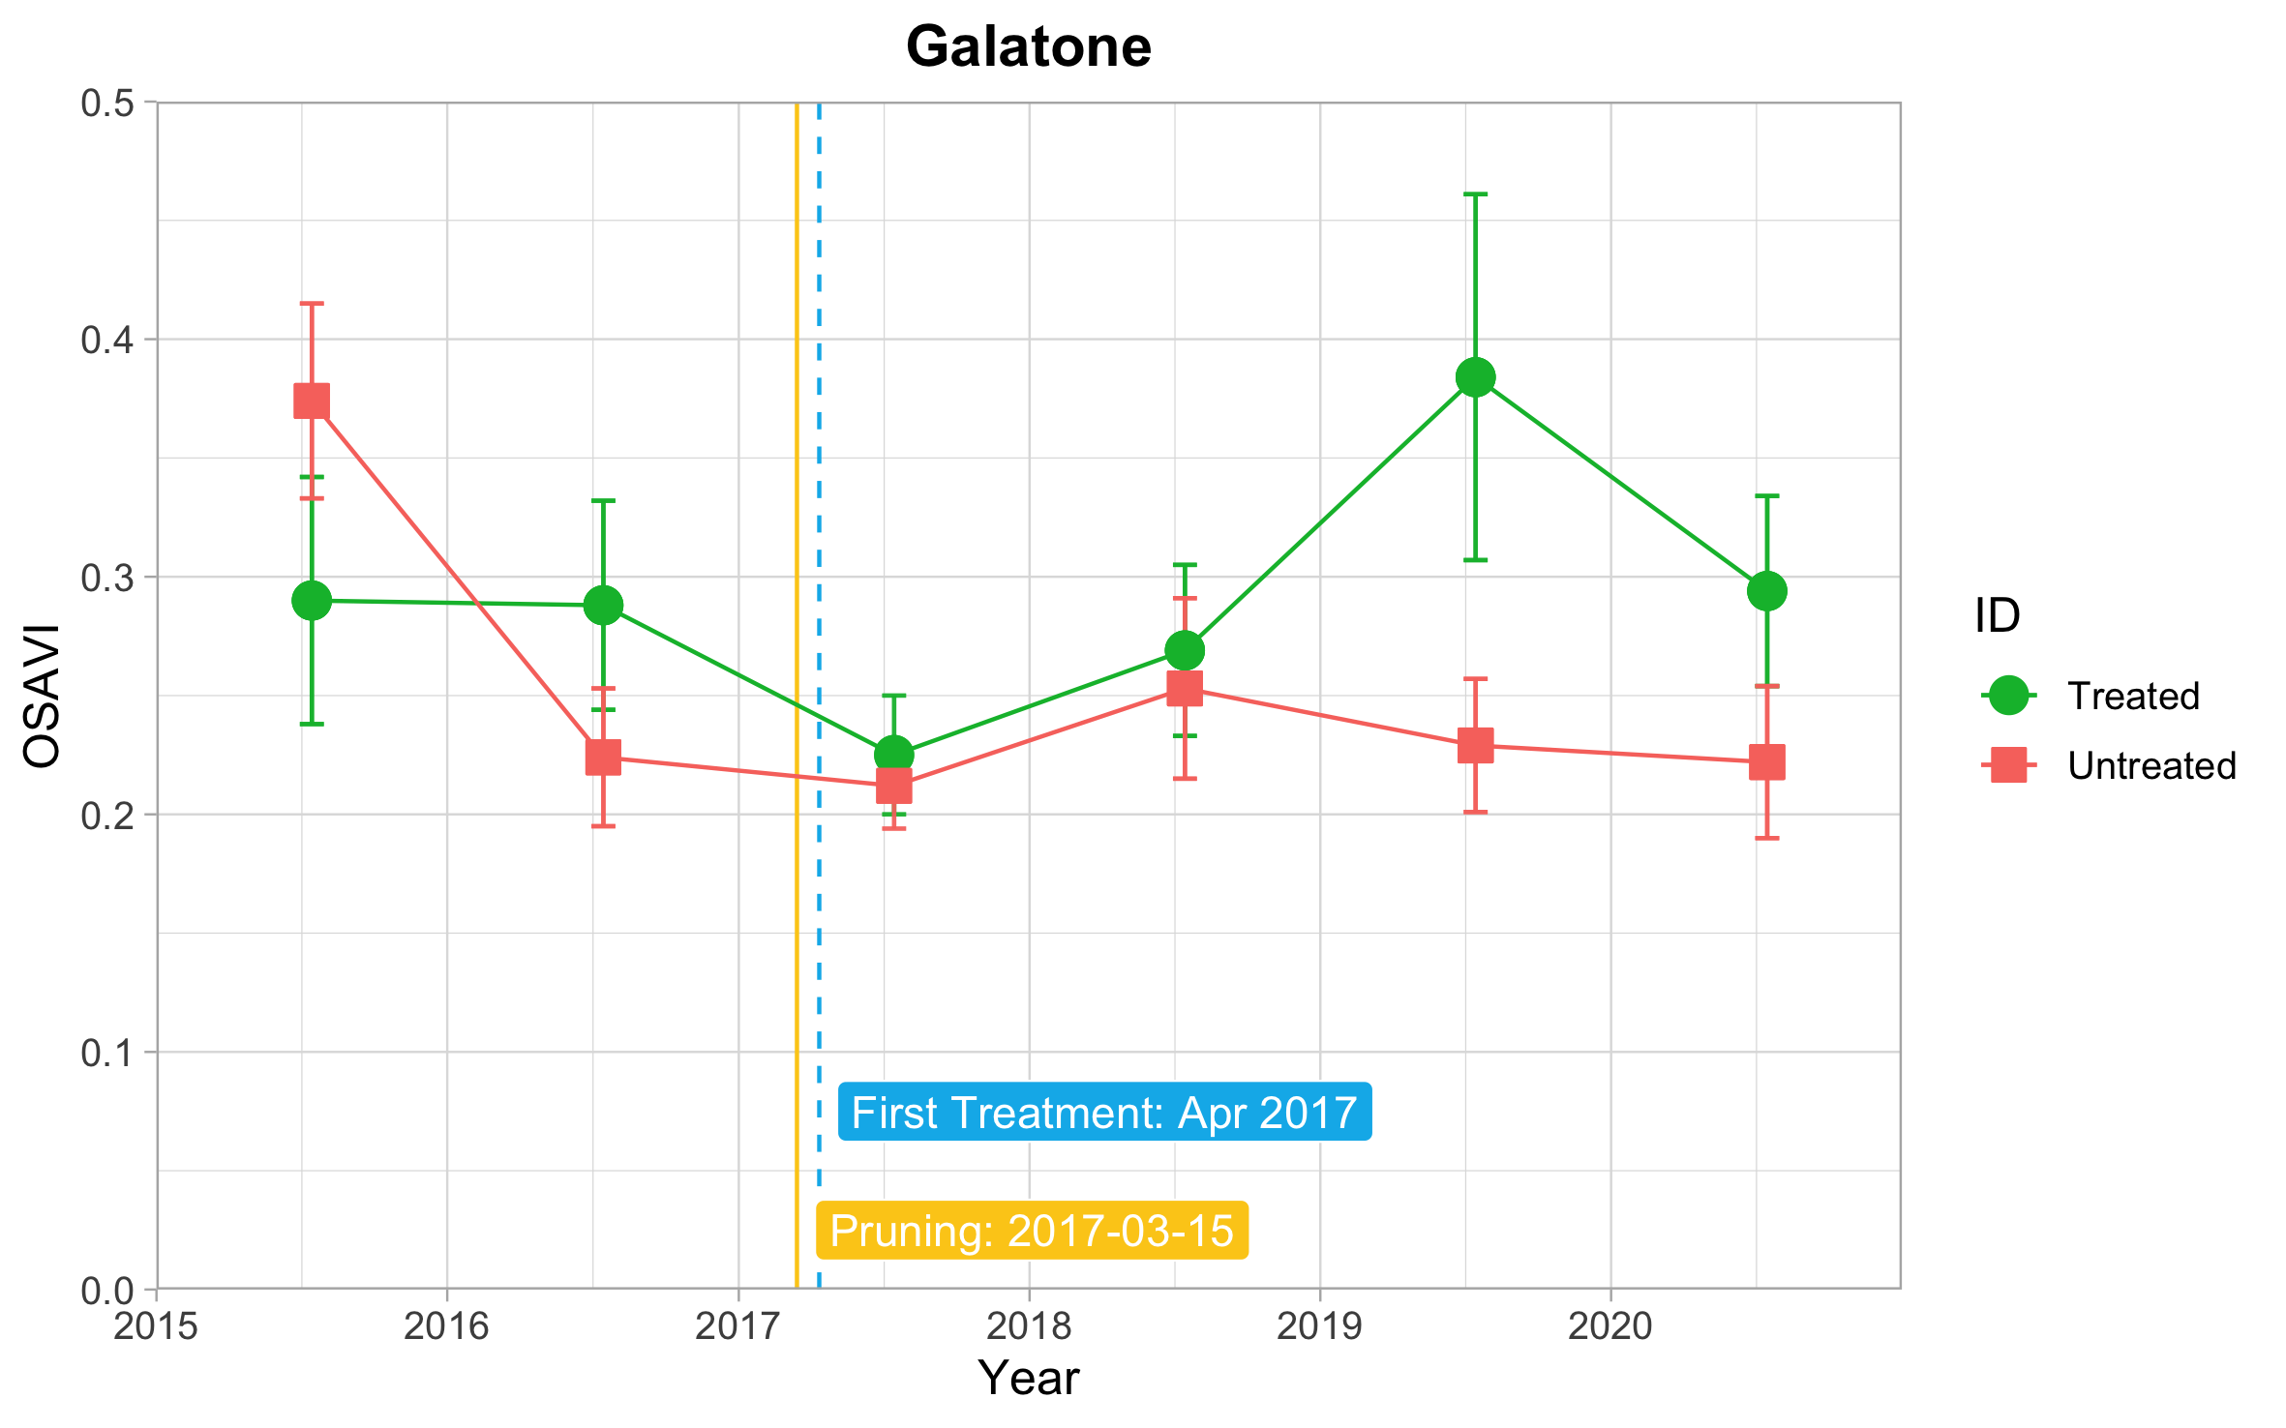
(d)
(c)
(b)
(a)

Figure S1. S-2 OSAVI trend from each site in different fields with or without restoration treatment. (a) Galatone; (b) Nardò_A; (c) Nardò_B; (d) Cannole. Starting period for the restoration treatment and pruning date are indicated. Sites (a), (b), (c) on the Ionian coast and site (d) on the Adriatic coast.

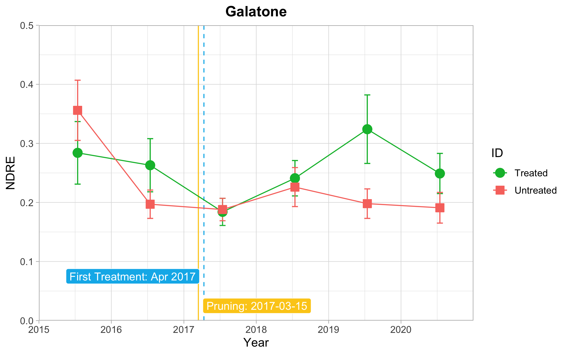
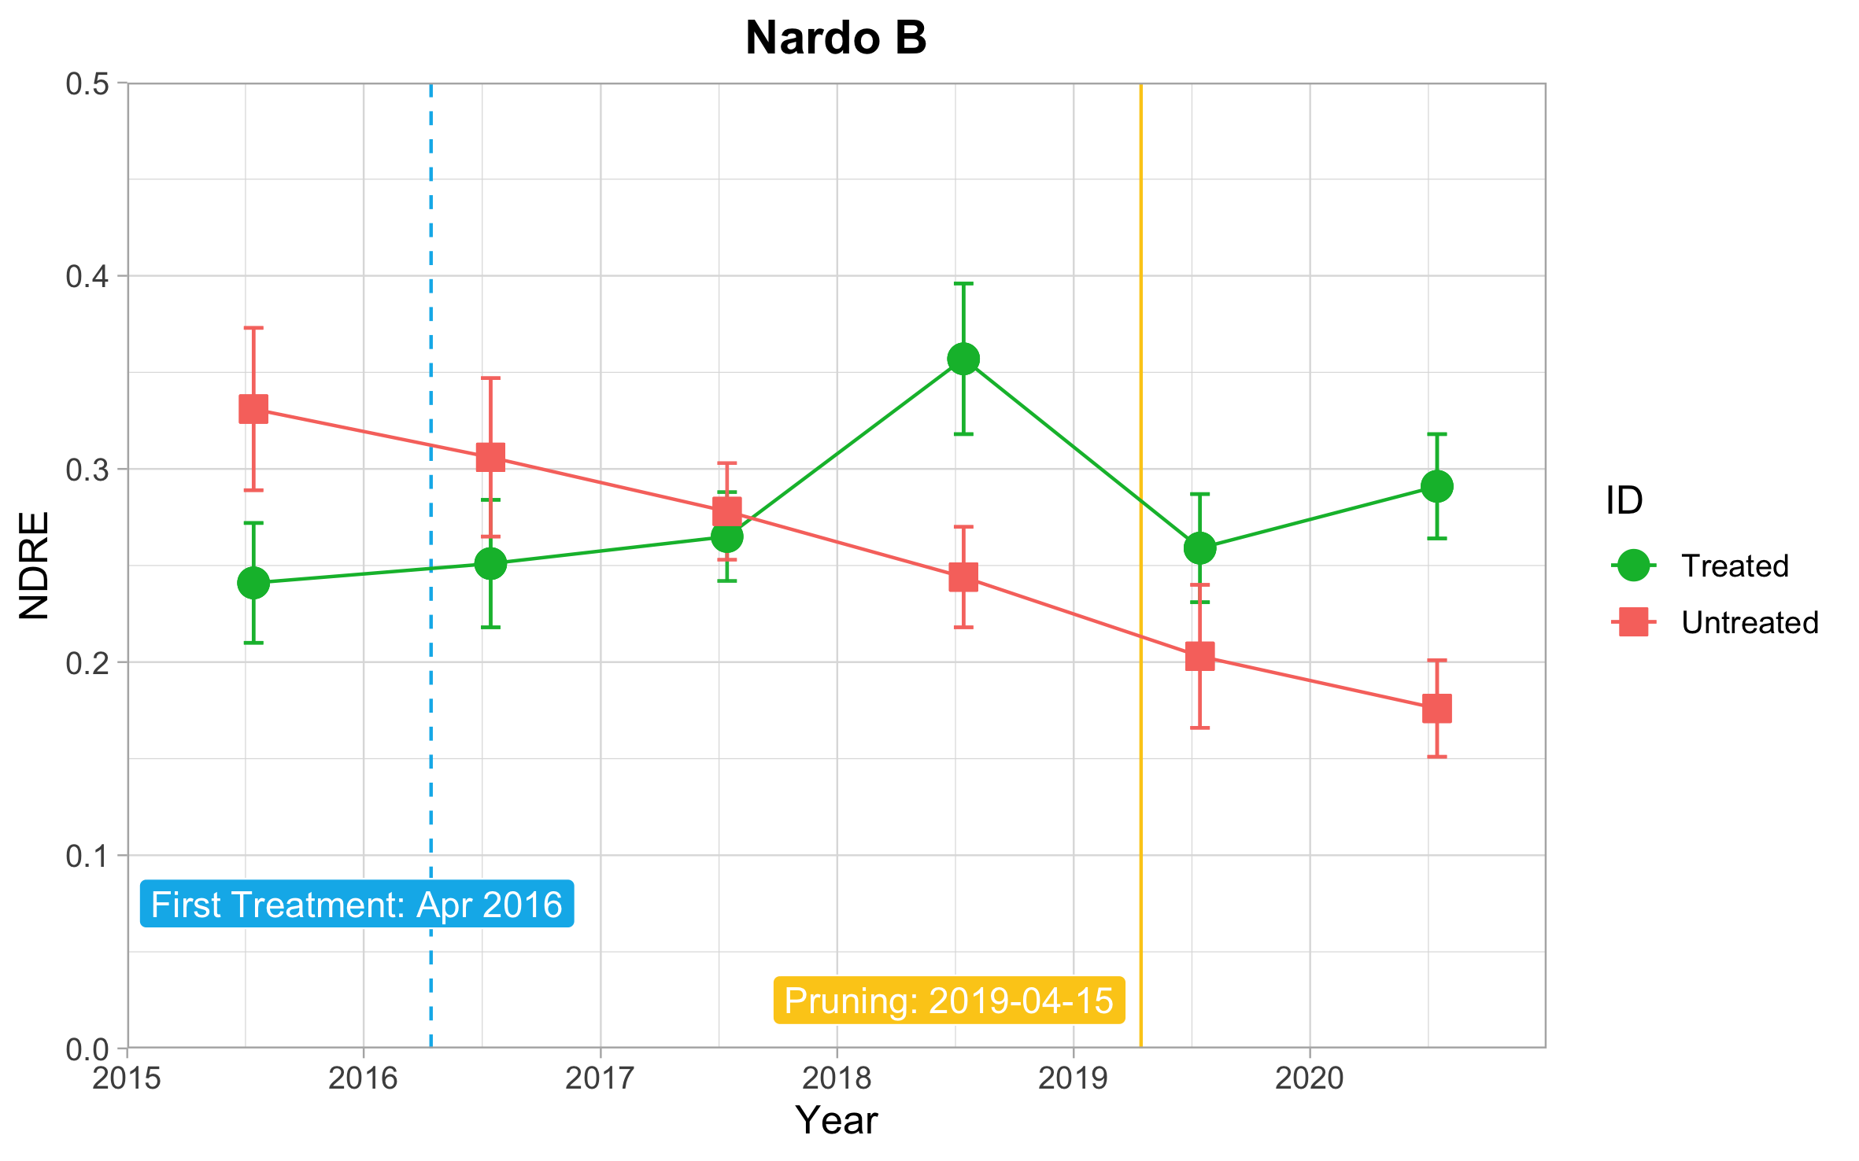
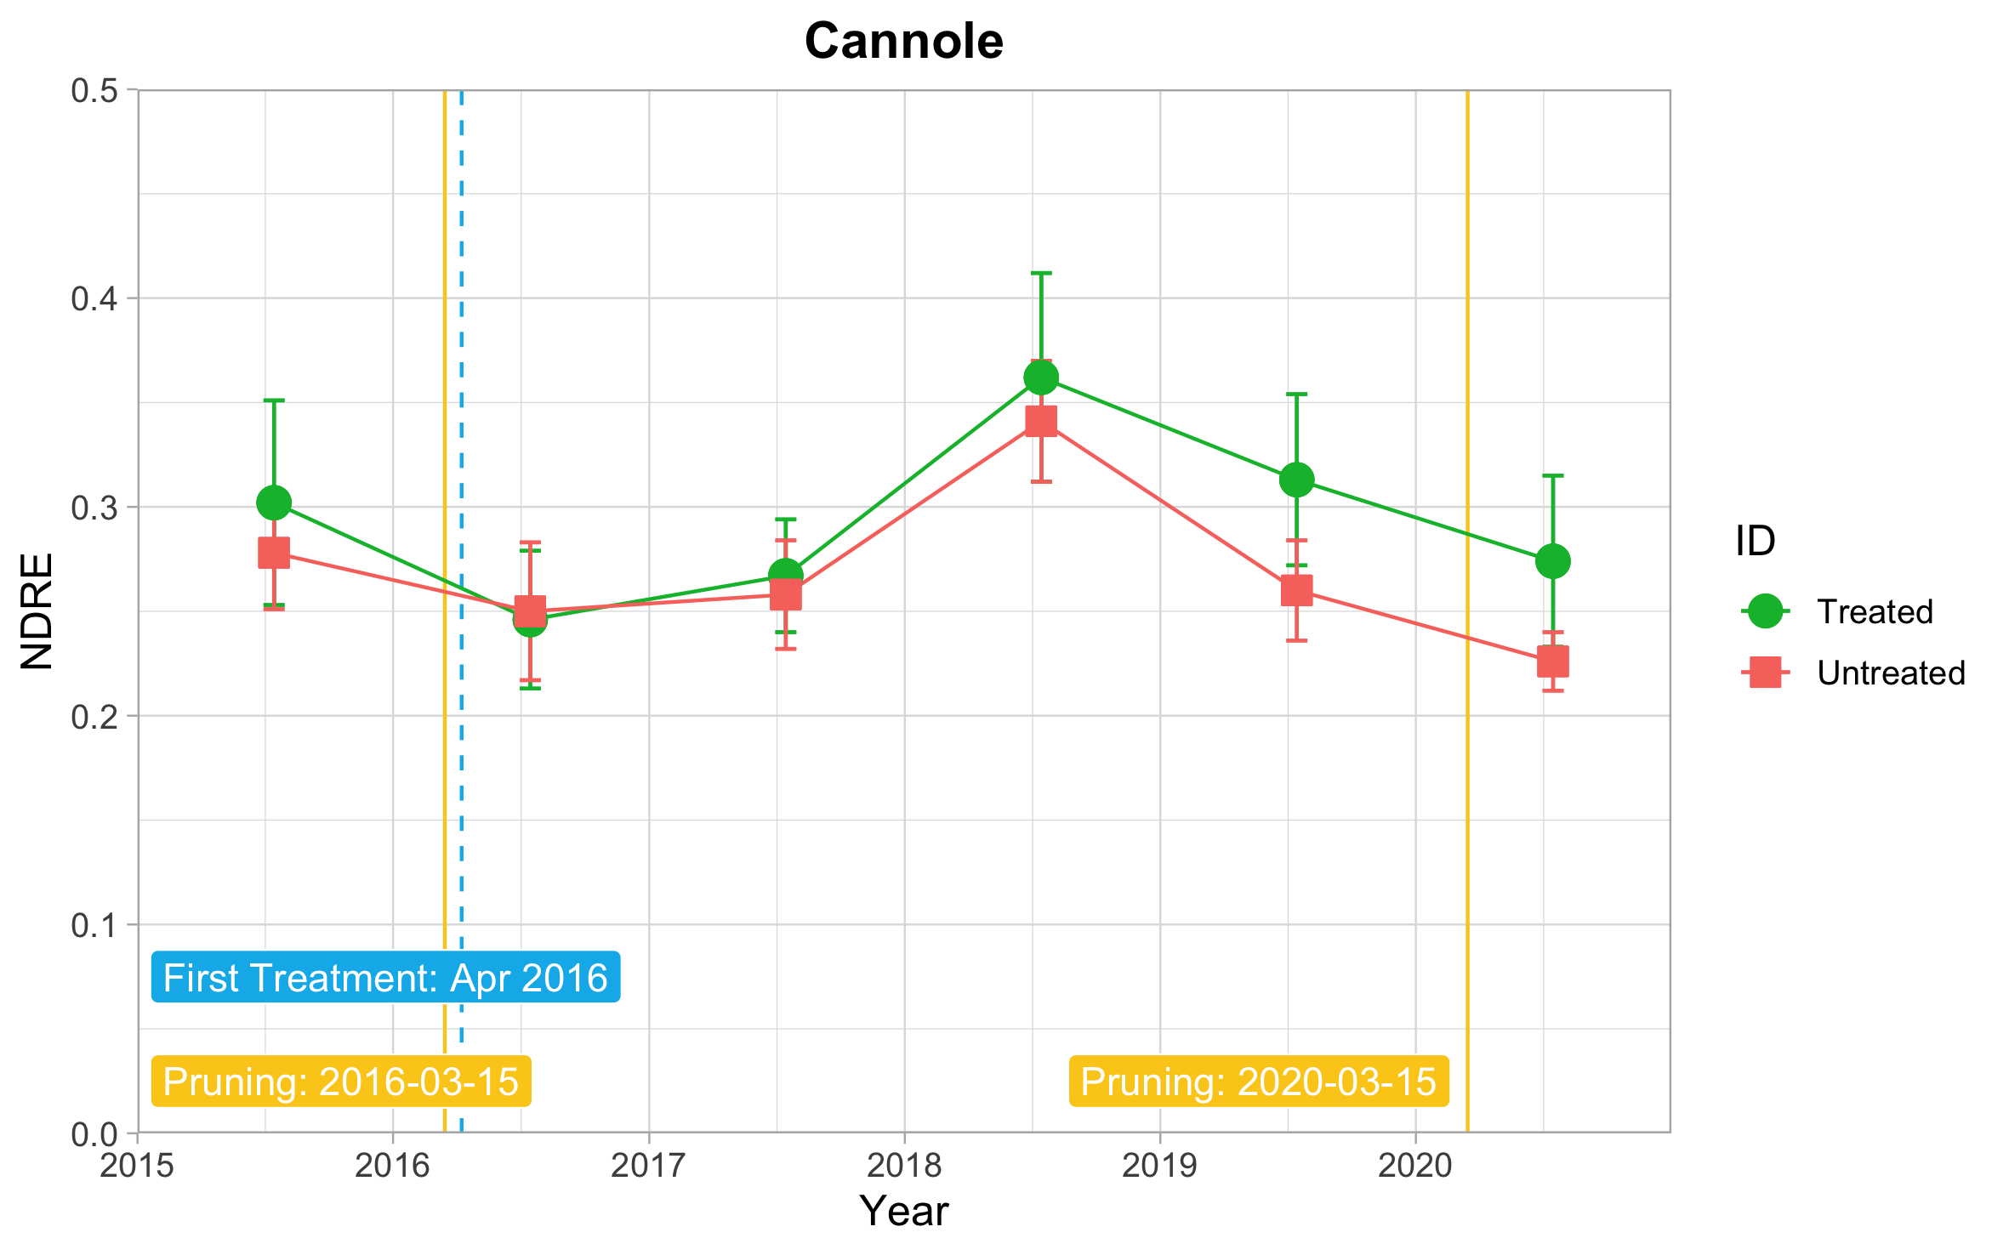
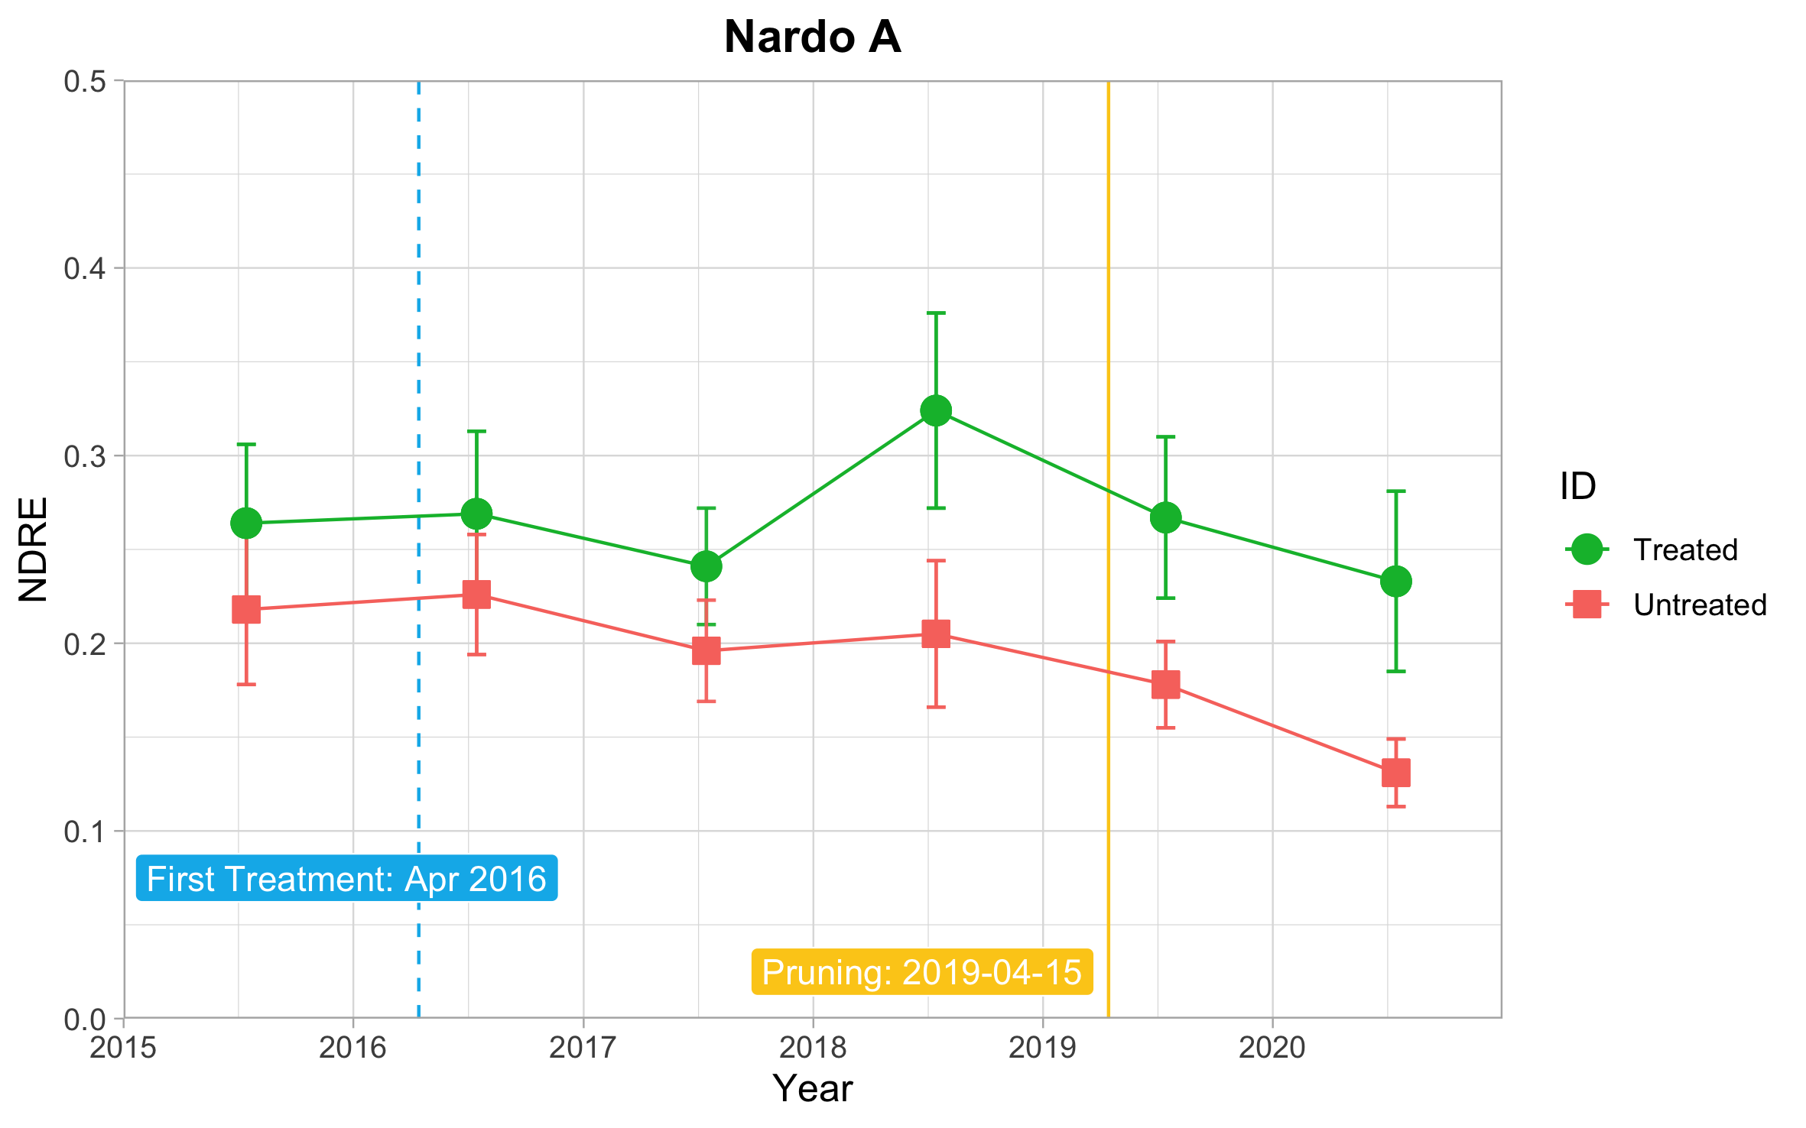
(a)
(c)
(d)
(b)

Figure S2. S-2 NDRE trend from each site in different fields with or without restoration treatment. (a) Galatone; (b) Nardò_A; (c) Nardò_B; (d) Cannole. Starting period for the restoration treatment and pruning date are indicated. Sites (a), (b), (c) on the Ionian coast and site (d) on the Adriatic coast.

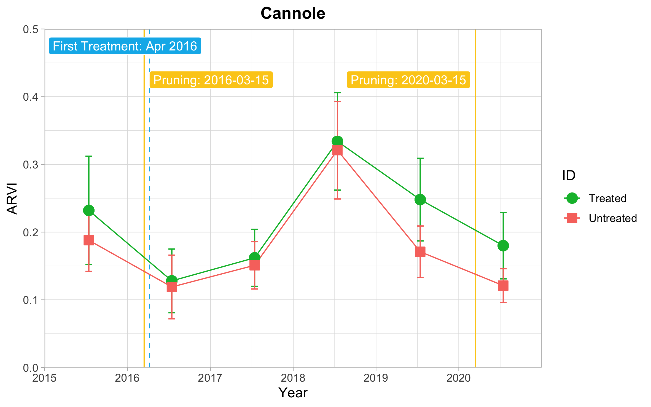
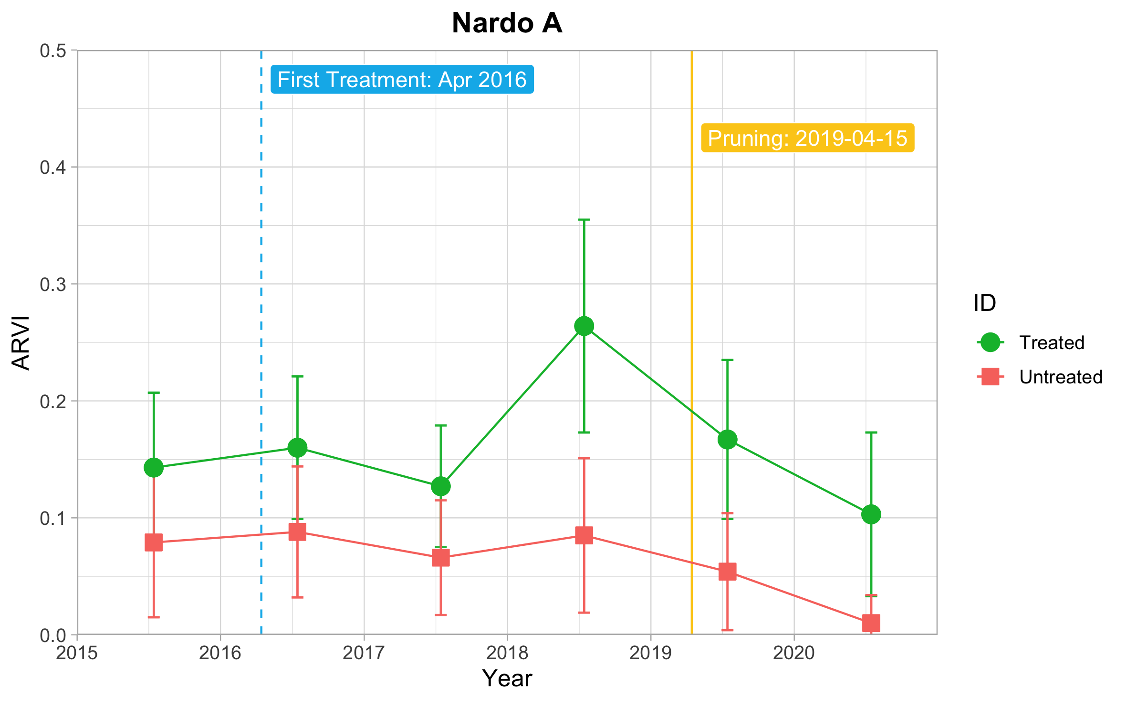
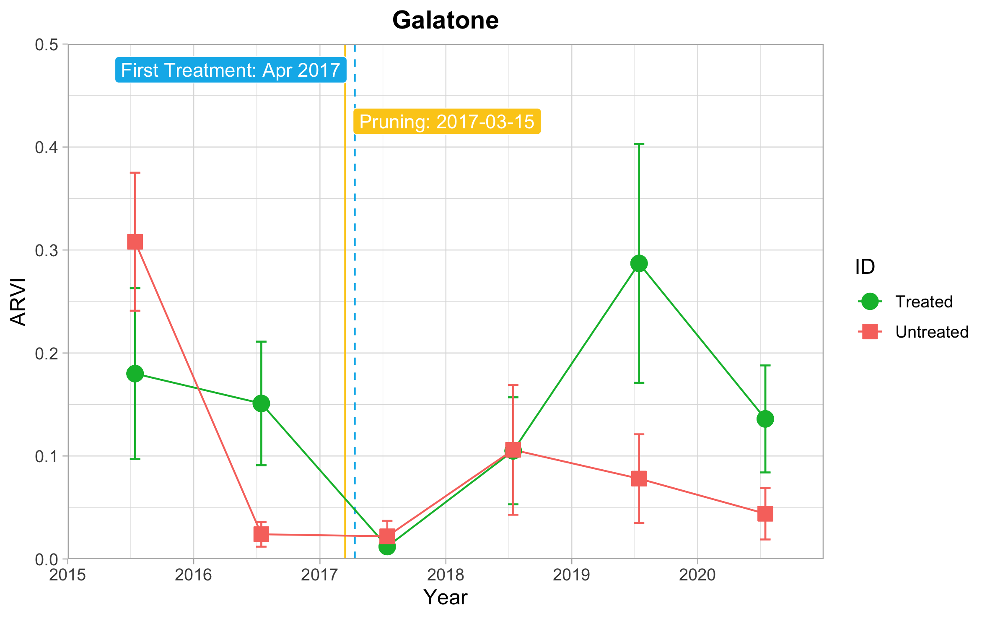
(d)
(b)
(a)

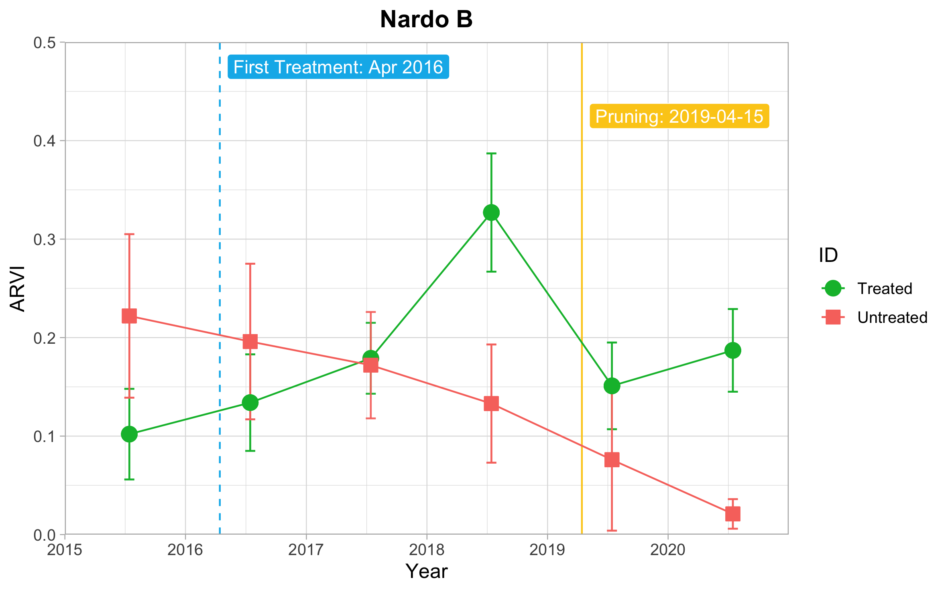
(c)

Figure S3. S-2 ARVI trend from each site in different fields with or without restoration treatment. (a) Galatone; (b) Nardò_A; (c) Nardò_B; (d) Cannole. Starting period for the restoration treatment and pruning date are indicated. Sites (a), (b), (c) on the Ionian coast and site (d) on the Adriatic coast.

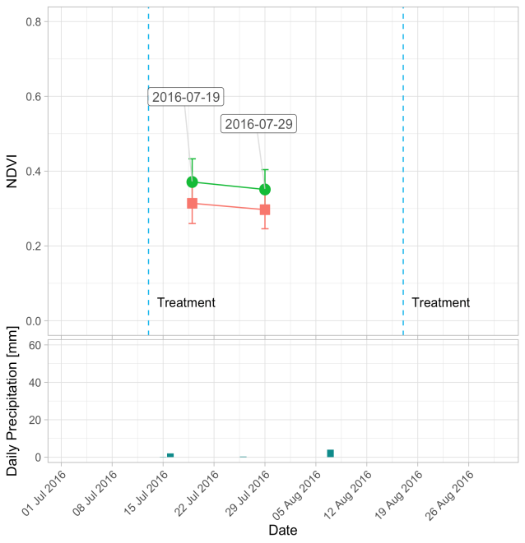
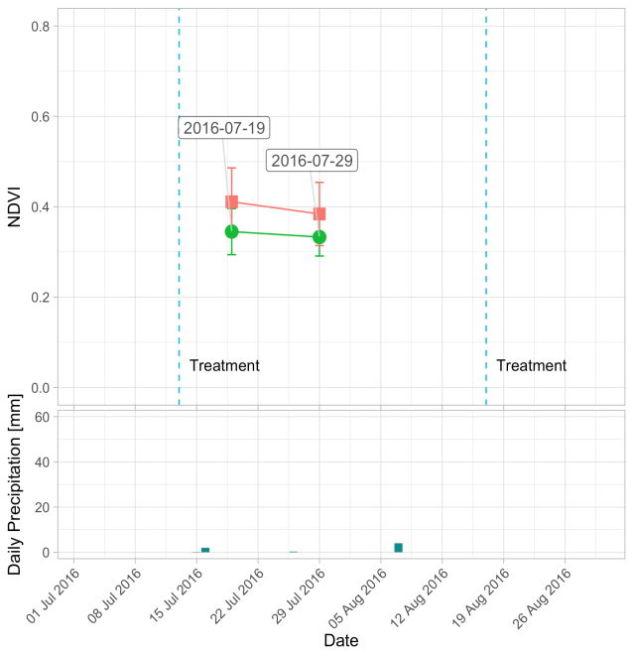
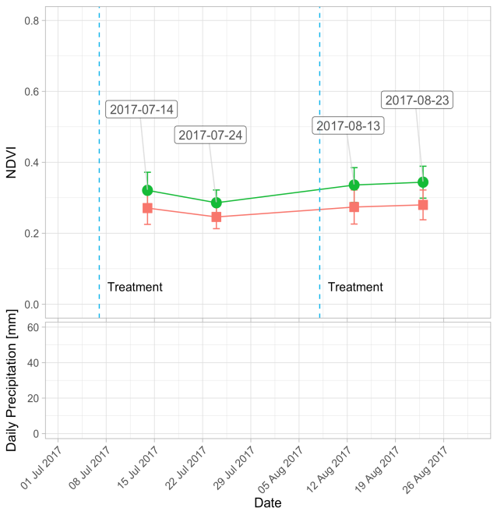
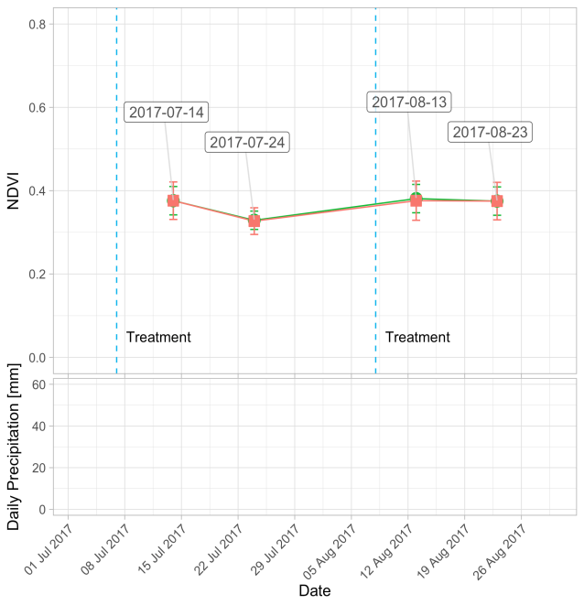
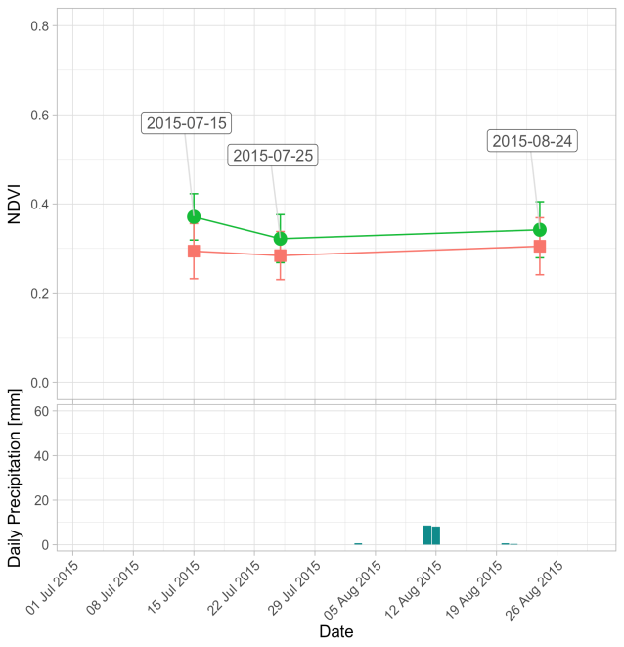
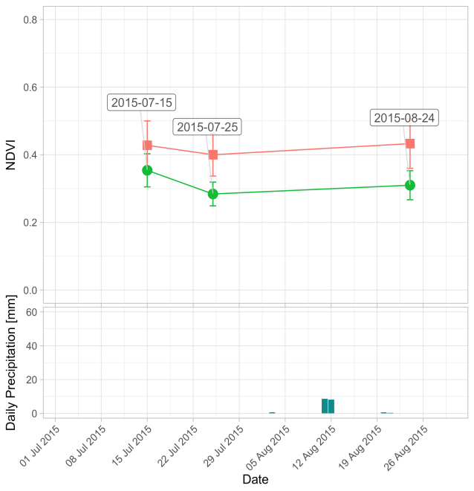
Nardò_A
Nardò_B
(a)
(b)

Figure S4. NDVI trend for each year (2015-2017) from S-2 date: (a) Nardò_A; (b) Nardò_B

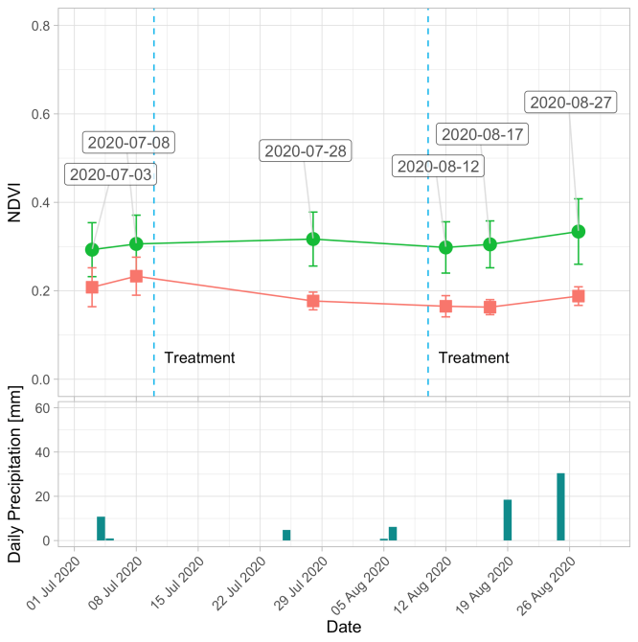
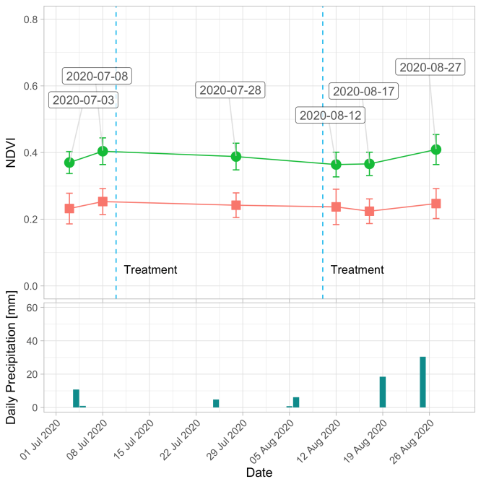
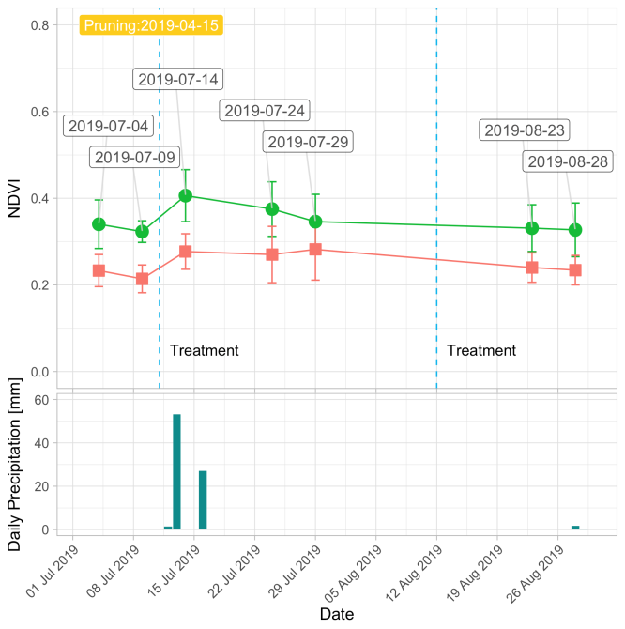
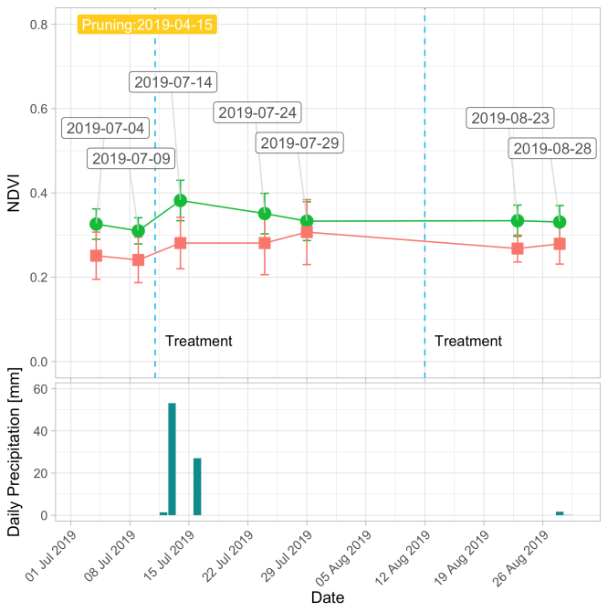
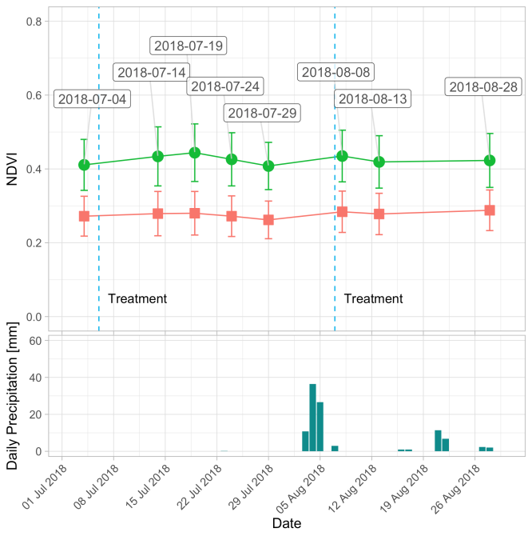
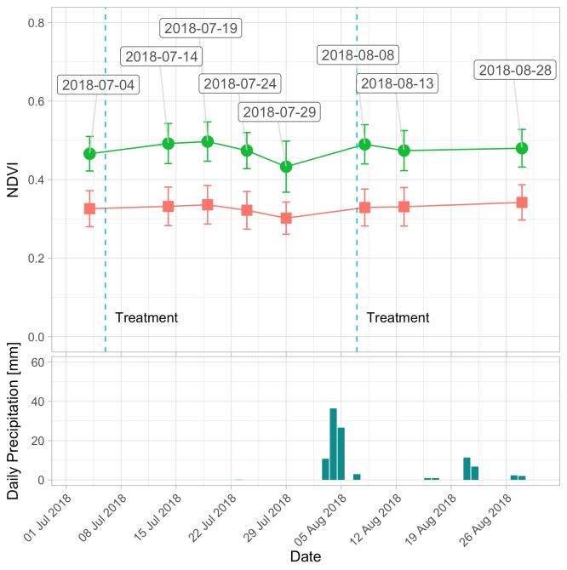
Nardò_A
Nardò_B
(a)
(b)

Figure S5. NDVI trend for each year (2018-2020) from S-2 date: (a) Nardò_A; (b) Nardò_B

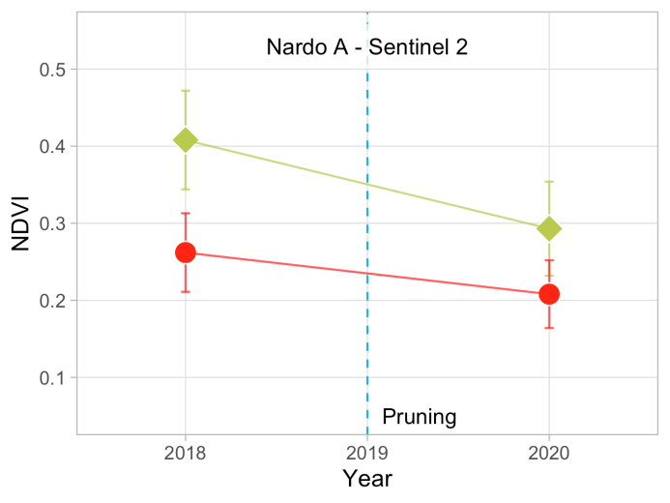
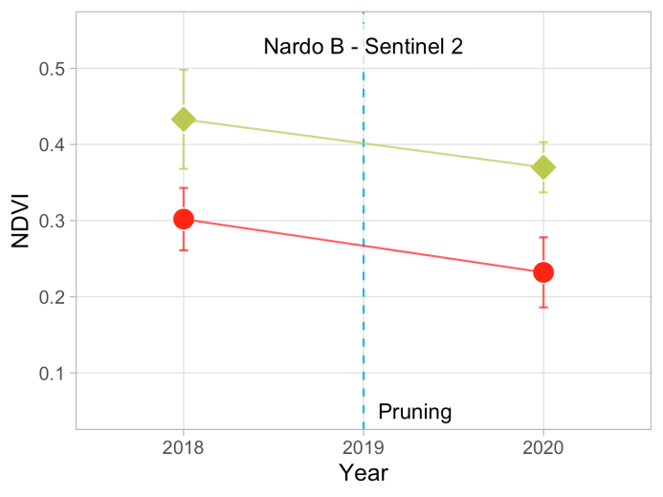
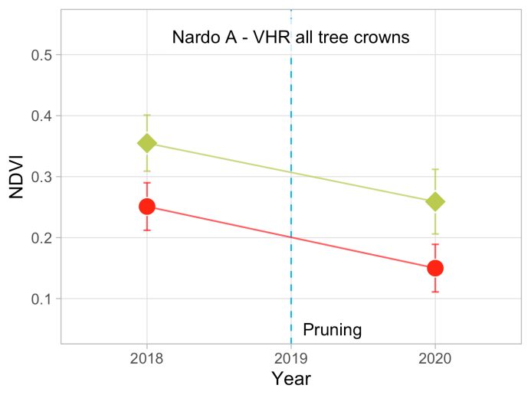
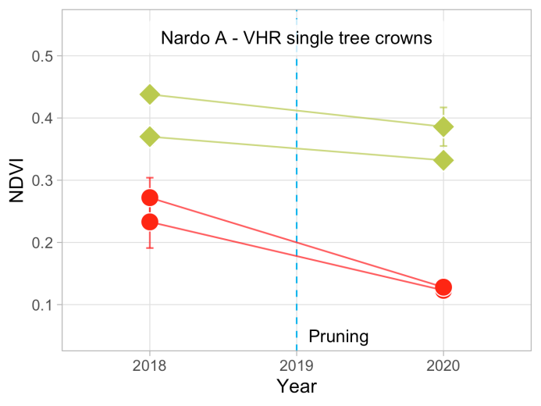
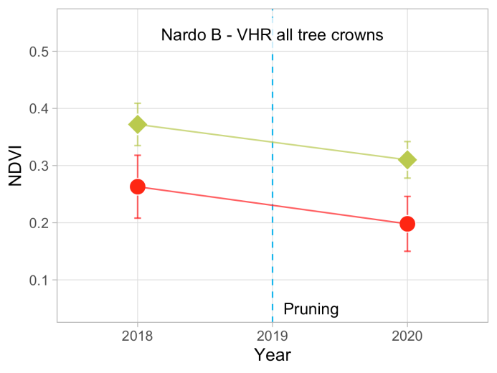
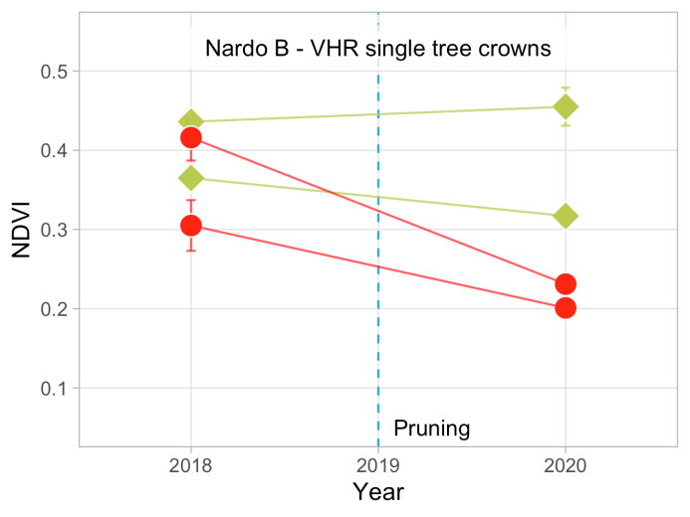
(a)
(b)
Treated
Untreated

Figure S6. NDVI mean value for Nardo_A (column a) and Nardo_B (column b) test fields on the same Ionian coast from: all S-2 pixels in the field, first line; all tree crown pixels, only, in Pléiades images, second line; tree crown pixels of different sample trees, third line.

