Supporting Information
Cooperative phototherapy based on bimodal imaging guidance for the treatment of uveal melanoma
Tong Huang¹, Xinzhi Xu², Chen Cheng¹, Jianxin Wang^{3*} and Liping Yang^{4*}
1. Chongqing Key Laboratory of Ultrasound Molecular Imaging, Ultrasound Department of the Second Affiliated Hospital of Chongqing Medical University, Chongqing, 400010, P. R. China.
2. Department of Ultrasound, Chongqing University Cancer Hospital, Chongqing, 400030, P. R. China.
3. Department of Ultrasound, The First Affiliated Hospital of Harbin Medical University, Harbin 150001, P. R. China.
4. Department of Laboratory Medicine, The Second Affiliated Hospital of Chongqing Medical University, Chongqing, 400010, P. R. China.

Part A: In Vitro Calculation of Photothermal Conversion Efficiency
Photothermal Conversion Efficiency of FTCPNPs
The photothermal conversion efficiency of FCPNPs was measured according to the previous method(1). Briefly, 200 μL FTCPNPs (1.0 mg/mL) solution in 96-well was irradiated under 808 nm laser at a power density of 2 W/cm² for 10 min. Then the laser was turned off and the temperature change of the solutions was real-time recorded. The time constant (τs) for heat transfer was determined by applying the linear time-dependent data collected during the cooling period. The photothermal conversion efficiency (η) was calculated by the following equations:
(1). η=$\frac{hAΔT_{Max}-Qs}{I (1-{10}^{-Aλ})}$
In this equation, η is the conversion efficiency value, ∆Tmax is the maximum temperature change when the temperature reaches a steady state. Qs is relevant to the light absorbance of pure water here. I is the laser power density. Lastly, Aλ is the absorbance of the solution at 808 nm in the UV-Vis spectrum. Only the value of hA was unknown and could be calculated from the following equation.
(2). τ_{s}=$\frac{mD cD}{hA}$
$m$_{D} is the mass of water used to suspend the nanoparticles, $c$_{D} here is the heat capacity of water and τs is the time constant for heat transfer. As a typical example, we calculated the η value of FTCPNPs in detaily. Here, the mass of water ($m$_{D}) is 0.2 g, the heat capacity of water ($c$_{D}) is 4.22 J/(g·K), and τ_{s} of FTCPNPs is determined to be 249.3 s from the linear time-dependent data collected during the cooling period as shown in Fig 2F. According to equation (2), the hA was calculated to be 3.369434×10⁻³ W/K.
For the sample of FTCPNPs, ∆Tmax value is 41.4 ℃ as shown in Fig 2F. Qs here is measured to be 1.52766 mW. I is the laser power density that is 2 W/cm². Aλ is the absorbance of FTCPNPs at 808 nm in the UV-Vis spectrum which is determined to be 0.116. According to equation (1), the photothermal conversion efficiency (η) of FTCPNPs was calculated to be 29.43%.
References
1. Liu Y, Ai K, Liu J, Deng M, He Y, Lu L. Dopamine-melanin colloidal nanospheres: an efficient near-infrared photothermal therapeutic agent for in vivo cancer therapy. Adv Mater. 2013;25(9):1353-9.

Part B: Supplementary figure
Fig S1. (A). CLSM image of FTCPNPs (red fluorescence comes from Ce6) Scale bar: 50 μm. (B). UV-vis-NIR absorbance spectra of free Ce6 at elevated concentrations and (C). The standard curve of free Ce6. (D). UV-vis absorption of FTCPNPs aqueous solution at different concentrations. (E) The standard curve of Fe.

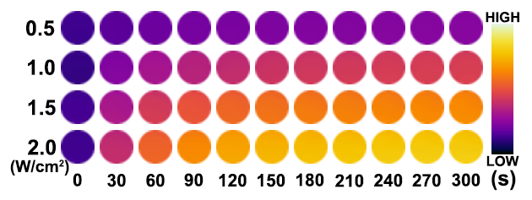
Fig S2. Photothermal images of FTCPNPs aqueous solution irradiated under increased power intensities (0.5, 1.0, 1.5, and 2.0 W/cm²).

Fig S3. (A-C) Time-dependent ¹O₂ generation of FTCPNPs at different concentrations irradiated by 660 nm laser (5 mW/cm²).

Fig S4. The cell viability after varied treatments (FTCPNPs concentration: 1.0 mg/mL) (n=5)

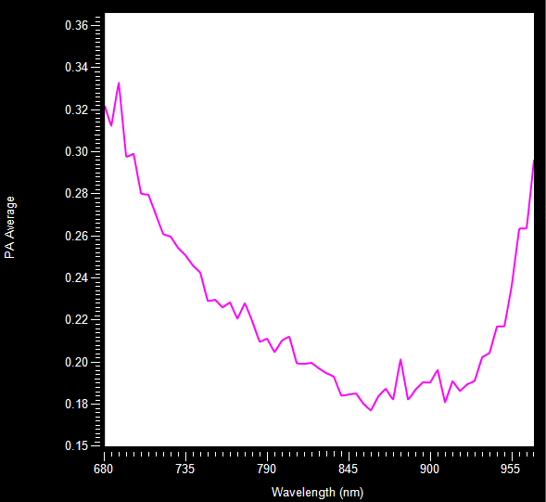
Fig S5. PAI intensity under full-spectrum scanning of FTCPNPs.

Fig S6. Tumor inhibition rate of C918 tumor-bearing nude mice after different treatment.

Fig S7. Weight of tumors 14 d post various treatments. (n = 5, ***p < 0.001).

Fig S8. (A). Hematological and blood biochemical test of mice after intravenous injection of FTCPNPs (n=5). (B). Images of H&E staining slices of major organs. Scale bar: 100 μm.

