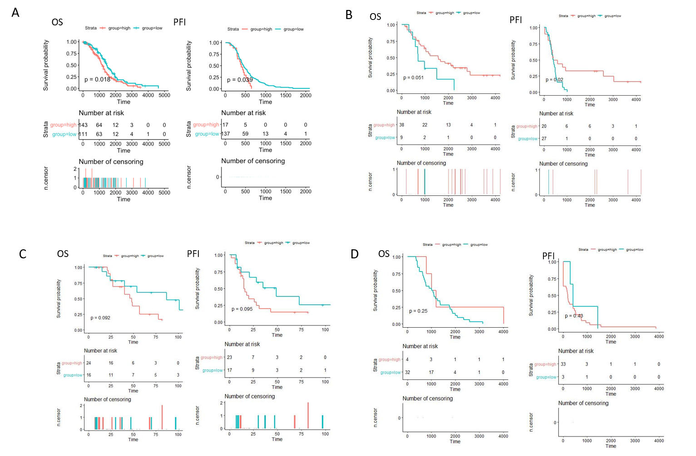
Supplementary Figure 1. Relationship of ISG15 expression with survival outcome. (A) Overall survival (OS) and progress free interval (PFI) in ISG15 high and low expression group in TCGA-OV dataset. (B) Overall survival (OS) and progress free interval (PFI) in ISG15 high and low expression group in GSE30161 dataset. (C) Overall survival (OS) and progress free interval (PFI) in ISG15 high and low expression group in GSE32063 dataset. (D) Overall survival (OS) and progress free interval (PFI) in ISG15 high and low expression group in GSE63885 dataset. The numbers below the figures denote the number of patients at risk in each group.

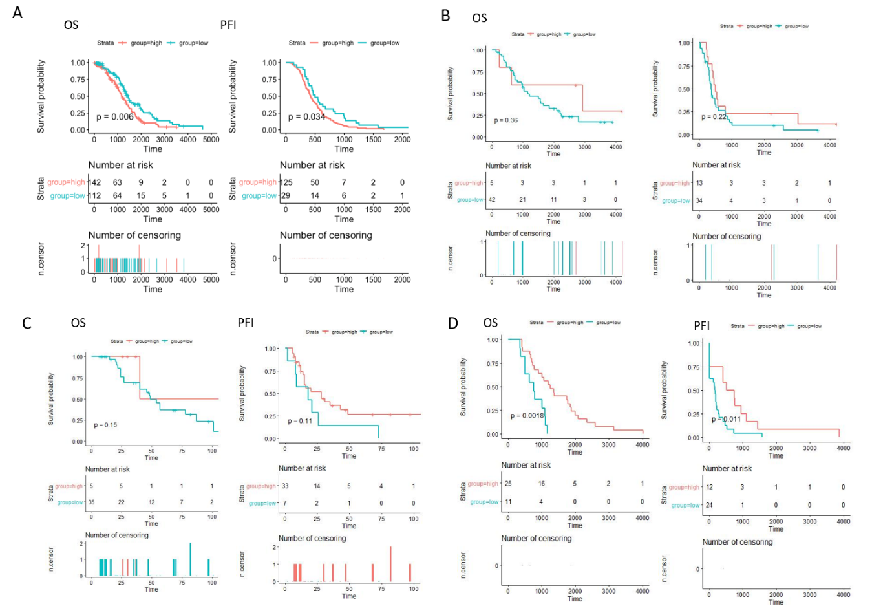
Supplementary Figure 2. Relationship of SNCA expression with survival outcome. (A) Overall survival (OS) and progress free interval (PFI) in SNCA high and low expression group in TCGA-OV dataset. (B) Overall survival (OS) and progress free interval (PFI) in SNCA high and low expression group in GSE30161 dataset. (C) Overall survival (OS) and progress free interval (PFI) in SNCA high and low expression group in GSE32063 dataset. (D) Overall survival (OS) and progress free interval (PFI) in SNCA high and low expression group in GSE63885 dataset. The numbers below the figures denote the number of patients at risk in each group.

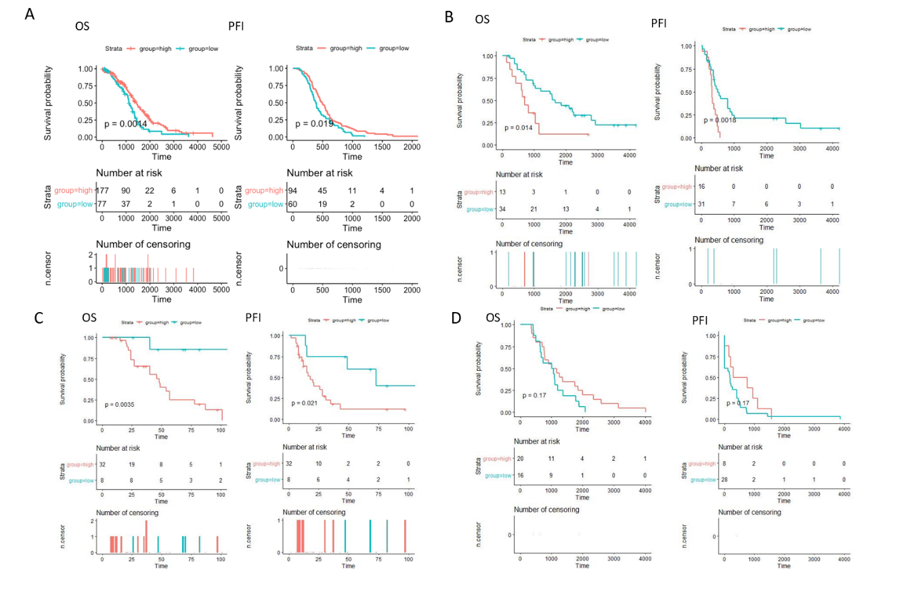
Supplementary Figure 3. Relationship of PLCG2 expression with survival outcome. (A) Overall survival (OS) and progress free interval (PFI) in PLCG2 high and low expression group in TCGA-OV dataset. (B) Overall survival (OS) and progress free interval (PFI) in PLCG2 high and low expression group in GSE30161 dataset. (C) Overall survival (OS) and progress free interval (PFI) in PLCG2 high and low expression group in GSE32063 dataset. (D) Overall survival (OS) and progress free interval (PFI) in PLCG2 high and low expression group in GSE63885 dataset. The numbers below the figures denote the number of patients at risk in each group.

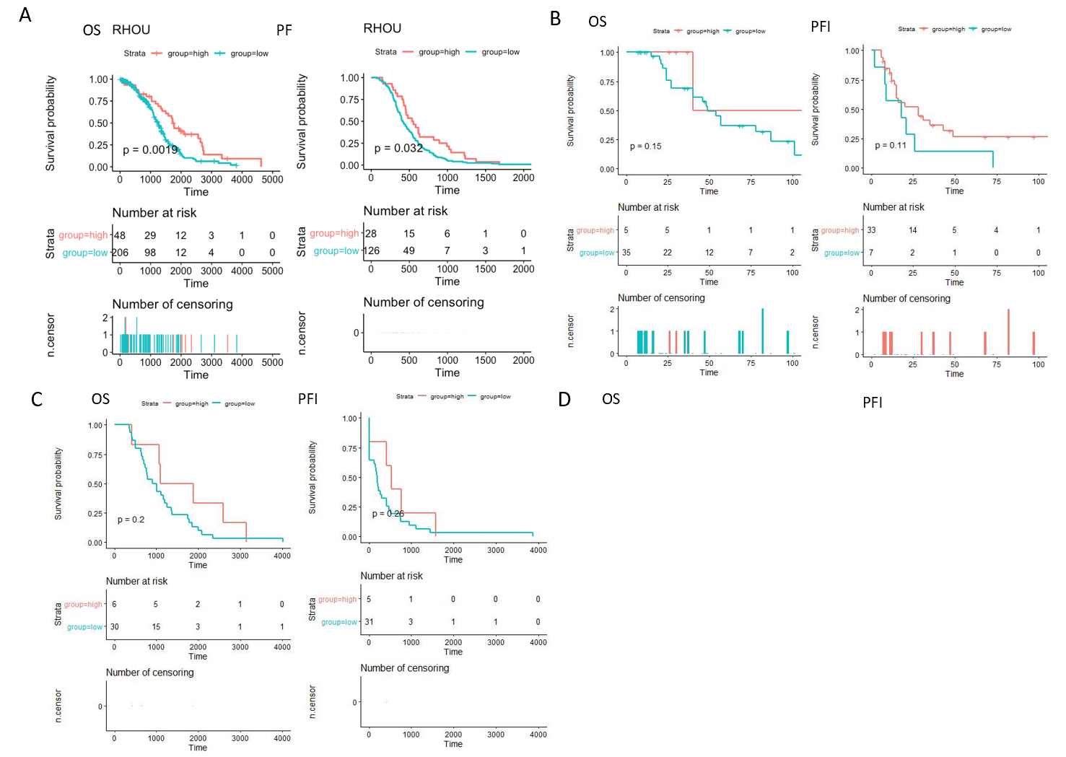
Supplementary Figure 4. Relationship of RHOU expression with survival outcome. (A) Overall survival (OS) and progress free interval (PFI) in RHOU high and low expression group in TCGA-OV dataset. (B) Overall survival (OS) and progress free interval (PFI) in RHOU high and low expression group in GSE32063 dataset. (C) Overall survival (OS) and progress free interval (PFI) in RHOU high and low expression group in GSE63885 dataset. The numbers below the figures denote the number of patients at risk in each group.

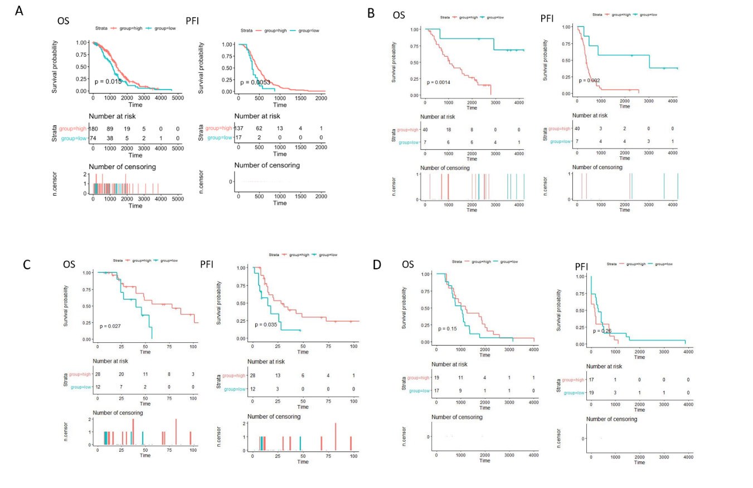
Supplementary Figure 5. Relationship of TRIB2 expression with survival outcome. (A) Overall survival (OS) and progress free interval (PFI) in TRIB2 high and low expression group in TCGA-OV dataset. (B) Overall survival (OS) and progress free interval (PFI) in TRIB2 high and low expression group in GSE30161 dataset. (C) Overall survival (OS) and progress free interval (PFI) in TRIB2 high and low expression group in GSE32063 dataset. (D) Overall survival (OS) and progress free interval (PFI) in TRIB2 high and low expression group in GSE63885 dataset. The numbers below the figures denote the number of patients at risk in each group.

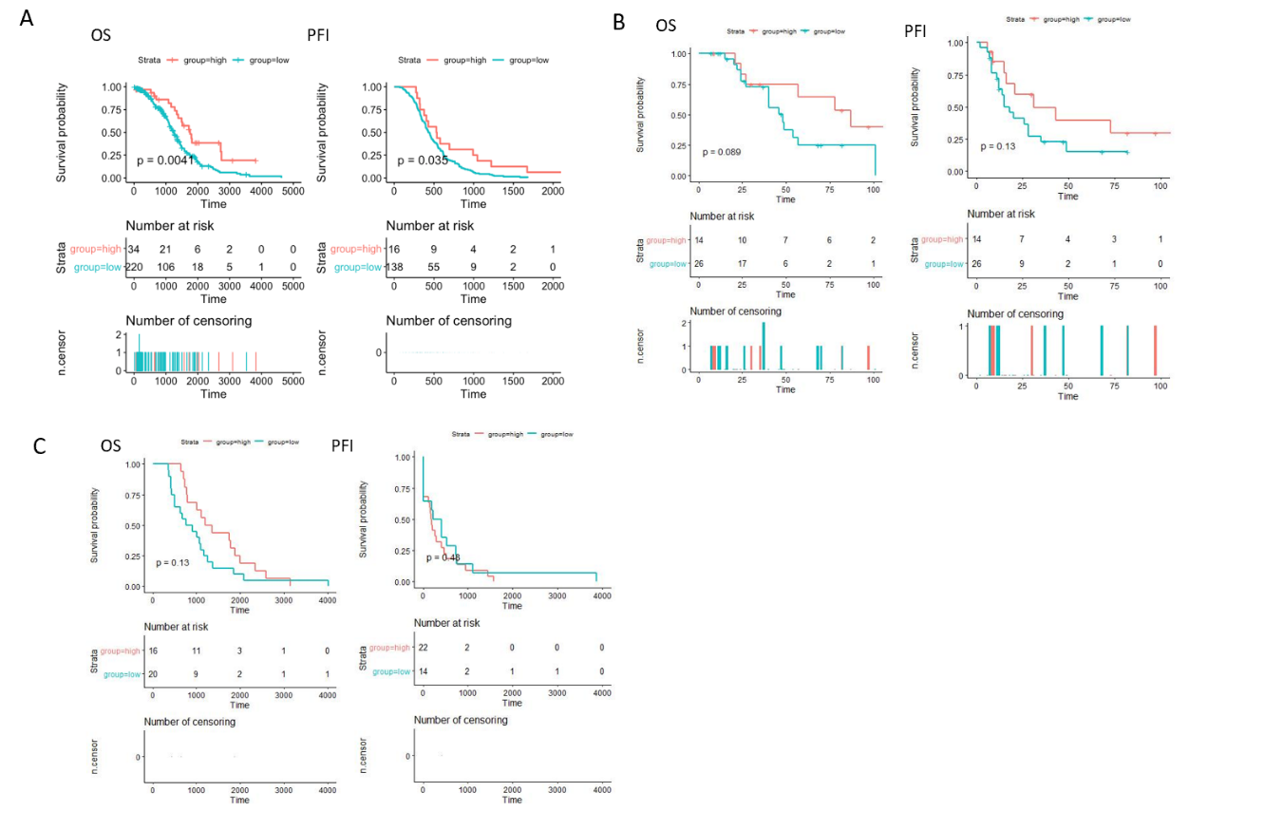
Supplementary Figure 6. Relationship of ELP3 expression with survival outcome. (A) Overall survival (OS) and progress free interval (PFI) in ELP3 high and low expression group in TCGA-OV dataset. (B) Overall survival (OS) and progress free interval (PFI) in ELP3 high and low expression group in GSE32063 dataset. (C) Overall survival (OS) and progress free interval (PFI) in ELP3 high and low expression group in GSE63885 dataset. The numbers below the figures denote the number of patients at risk in each group.

