Table 3. Bacteriostatic diagram of deleting the PyrR gene in L. casei
Bacillus subtilis | Lactobacillus culture suspension
Bacillus subtilis | 200 µL | 100 µL
Oxford cup diffusion method | 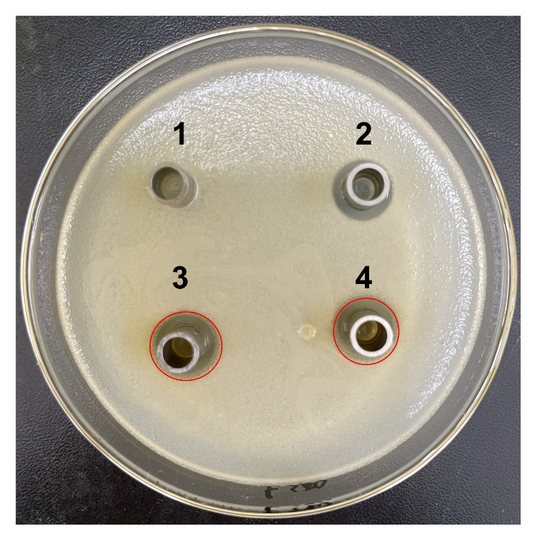 | 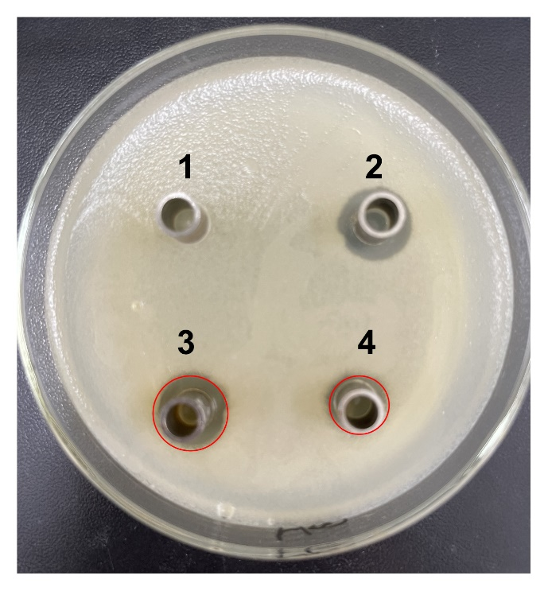
Growth inhibition diameter | 3: 13.56 mm 4: 12.04 mm | 3: 13.40 mm 4: 10.24 mm

Staphyloccocus aureus | Lactobacillus culture suspension
Staphyloccocus aureus | 200 µL | 100 µL
Oxford cup diffusion method | 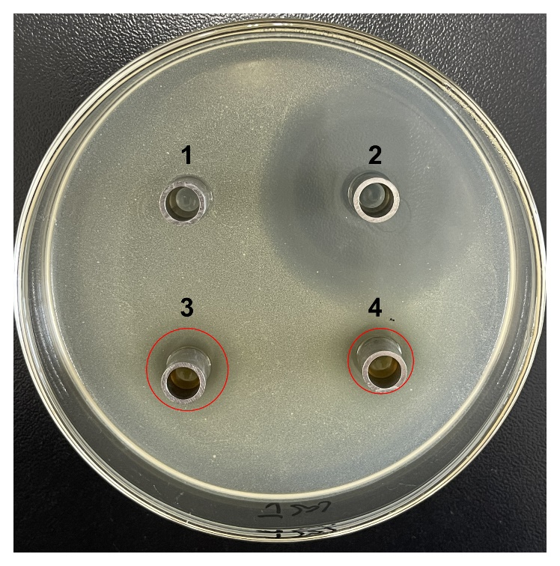 | 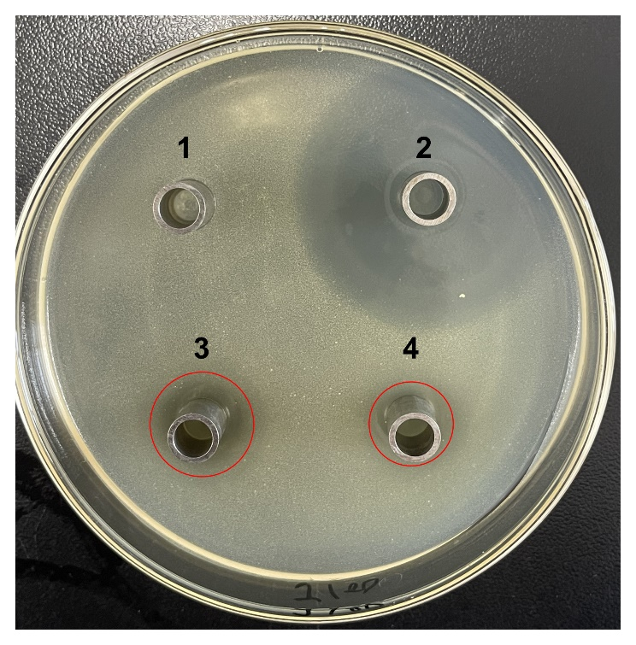
Growth inhibition diameter | 3: 12.36 mm 4: 11.16 mm | 3: 12.32 mm 4: 9.64 mm

Salmonella | Lactobacillus culture suspension
Salmonella | 200 µL | 100 µL
Oxford cup diffusion method | 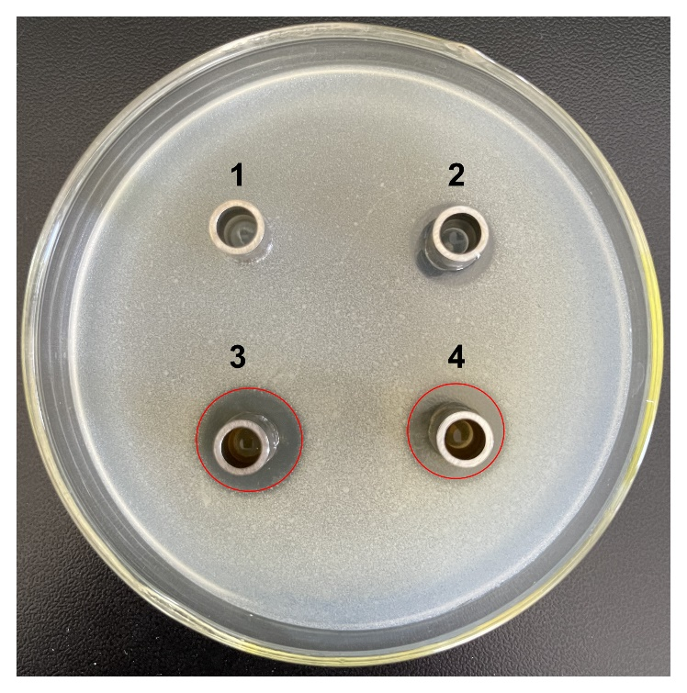 | 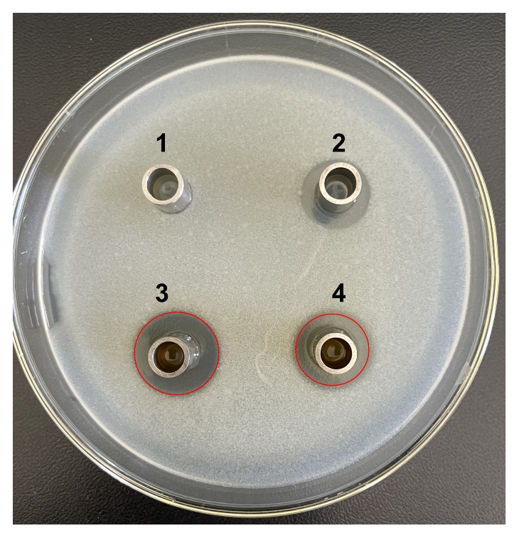
Growth inhibition diameter | 3: 17.92 mm 4: 16.16 mm | 3: 17.00 mm 4: 14.02 mm
The outer diameter of the Oxford cup is 8 mm. The liquid in the plate were: PBS buffer of negative control group (No. 1), antibiotic of positive control group (No. 2), suspension from L. casei (No. 3) and suspension from L. caseiΔPyrR (No. 4).

