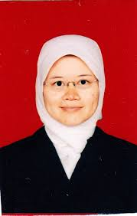
Nina Siti Aminah was born in Bogor, Indonesia. She received the B.Eng. degree in electronics from the National Institute of Technology, Indonesia, and the B.S., M.S., and Ph.D. degrees in physics from Bandung Institute of Technology, Indonesia. She is currently a postdoctoral fellow at University of Indonesia and lecturer at the Instrumentation and Computational Physics Research Group, Bandung Institute of Technology.
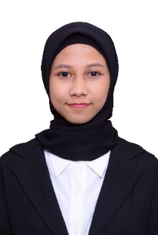
Arsharizka Syahadati Ichwanda was born in Depok, Indonesia, May 29th, 1998. She is undergraduate student in Physics from Bandung Institute of Technology, Indonesia (2016 – 2020). She is a Laboratory Assistant in Elementary Physics Laboratory, Thermodynamics and Magnetism Physics Laboratory, Electronic and Instrumentation Laboratory from Bandung Institute of Technology, Indonesia. Her current research interests include indoor localization, tracking and navigating system, and Internet of Things.

Daryanda Dwiammardi Djamal was born in Bandung, Indonesia, February 17th, 1998. He is undergraduate student from Institut Teknolgi Bandung, Physics Major (2016-2020). He used to be the assistant of Electronic and Instrumentation Laboratory Department of Physics. His research about the indoor localization, tracking, and navigation using the ecosystem of Internet of Things.


Yohanes Baptista Wijaya Budiharto was born in Jakarta, Indonesia, July 9th, 1998. He is a physics undergraduate student from Institut Teknologi Bandung, Indonesia (2016 – 2020). He is a laboratory assistant in electronic and instrumentation laboratory from ITB and actively contribute in physics organization of Institut Teknologi Bandung as a head division. His current research interest is indoor localization, tracking and navigating system using the technology of Internet of Things.
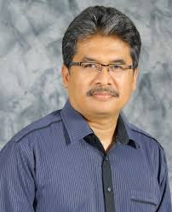
Maman Budiman was born in Garut, Indonesia. He received the B.S. degree in physics from the Bandung Institute of Technology, Indonesia, and the M.Eng., and Ph.D. degrees in electrical engineering from Tokyo Institute of Technology, Japan. He is currently a Lecturer at the Instrumentation and Computational Physics Research Group and Head of IoT Laboratory, Bandung Institute of Technology.

