Fig S1. A. The 13 CpG loci achieved an accuracy of 0.7 or higher for population classification (NMF and KM). B. Gene ontology results for 151 genes that were significantly different in Methylation Gene Base analyses (MGBA) suggested response to oxidative stress (P_{Bonferroni} ≤ 0.05). C. AltitudeOmics cohort hypoxia exposure process. D. Linear correlation of LIPN and PLCH1 with CA. E. Reactome Pathway Knowledgebase and Gene Ontology (GO) analysis of 11 genes in which 13 CpGs are located.F. Methylation Gene Base analyses suggested 151 significantly different Gene (P _{Bonferroni} < 0.05), and the 11 genes marked in the figure showed significant correlation with the number of REH perturbations in the OLS study.
Fig S2. A. The expression differences of LIPN in tissue and tissue cells (IMMPORT). B. The expression differences of PLCH1 in tissue and tissue cells (IMMPORT). C. The expression differences of PI3 in tissue and tissue cells (IMMPORT).
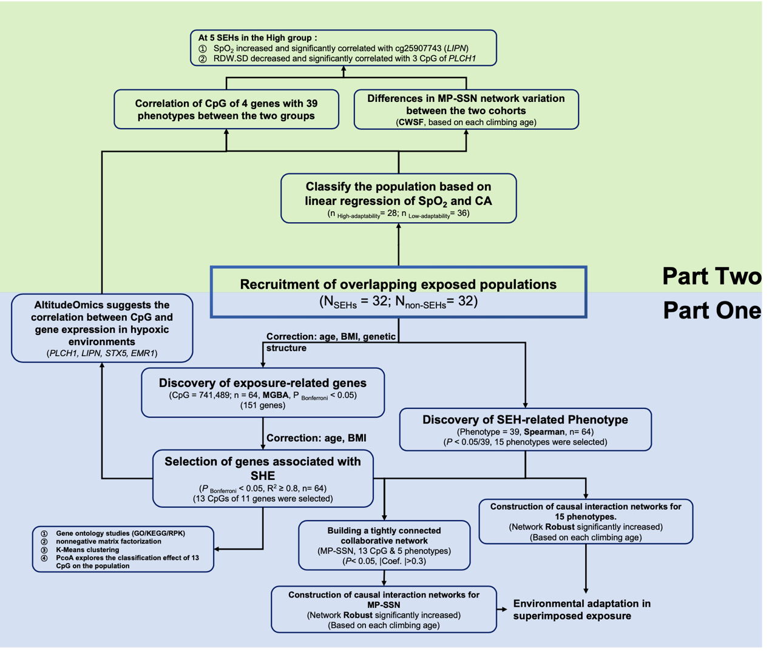
Fig S3. Ideas for exploring methylation environmental memory in superimposed states

Table S1 Gene base analysis results and OLS model prediction
CHR | MAPINFO | CpG | Gene Name | Feature | CGI | P _{bfn. Gene} | P _{bfn. CpG} | R²_{(OLS)}
22 | 25027515 | cg08891605 | LOC644165 | TSS1500 | opensea | 3.47E-04 | 8.29E-05 | 0.81
1 | 8000314 | cg08840010 | TNFRSF9 | 5'UTR | shelf | 7.46E-03 | 3.41E-04 | 0.83
19 | 6887530 | cg05025071 | EMR1 | TSS200 | opensea | 1.41E-03 | 4.06E-04 | 0.82
20 | 32583476 | cg02605461 | RALY | 5'UTR | shore | 2.82E-04 | 9.17E-04 | 0.81
10 | 90519680 | cg25907743 | LIPN | TSS1500 | opensea | 6.85E-03 | 1.56E-03 | 0.82
3 | 155423168 | cg25234117 | PLCH1 | TSS1500 | opensea | 7.31E-03 | 3.21E-03 | 0.82
3 | 155421970 | cg18623216 | PLCH1 | 5'UTR | opensea | 7.31E-03 | 1.25E-03 | 0.81
3 | 155422145 | cg07480762 | PLCH1 | TSS200 | opensea | 7.31E-03 | 2.60E-02 | 0.81
4 | 74713356 | cg16007497 | PPBPL1 | TSS1500 | opensea | 7.39E-03 | 5.06E-03 | 0.81
20 | 43803224 | cg19931348 | PI3 | TSS1500 | opensea | 8.69E-03 | 8.58E-03 | 0.81
2 | 223724754 | cg23325384 | ACSL3 | TSS1500 | shore | 2.89E-04 | 8.84E-03 | 0.81
17 | 72709096 | cg17056607 | CD300LF | 5'UTR | opensea | 6.96E-03 | 1.12E-02 | 0.82
11 | 62574403 | cg21702188 | STX5 | 3'UTR | shore | 9.83E-03 | 4.24E-02 | 0.81
Note: R²_{(OLS)} represents the R Square that OLS returns, the decision coefficient; P _{bfn. Gene} represents the Bonferroni-corrected p value of the entire gene of Gene base; P _{bfn. CpG} represents the Bonferroni-corrected p value of the CpG site

Table S2. Phenotypic Organ Classes Significantly Associated with Climbing Age
Group | Number | Phenotype
Oxygen saturation | 1 | SpO2
Heart Function | 3 | HR, SP, BP [1]
Kidney Function (Blood chemistry) | 1 | Cre [2]
Liver Function (Blood chemistry) | 1 | TBIL [3]
Immune Cells (Blood) | 2 | NEUT, NEUT% [4]
Hematopoietic function (Blood) | 7 | PLT, MCH, MCHC, RDW.CV, RDW.SD, MCV, PDW
Fat metabolism (Blood chemistry) | 2 | LDL.C, TG [5]
[1]. Tanaka, S., et al. Assessment of visit-to-visit variability in systolic blood pressure over 5 years and phasic left atrial function by two-dimensional speckle-tracking echocardiography. Heart Vessels 36, 827-835 (2021).
[2]. Levey, A.S., Perrone, R.D. & Madias, N.E. Serum creatinine and renal function. Annu Rev Med 39, 465-490 (1988).
[3]. Hamoud, A.R., Weaver, L., Stec, D.E. & Hinds, T.D., Jr. Bilirubin in the Liver-Gut Signaling Axis. Trends Endocrinol Metab 29, 140-150 (2018).
[4]. Rincón, E., Rocha-Gregg, B.L. & Collins, S.R. A map of gene expression in neutrophil-like cell lines. BMC Genomics 19, 573 (2018).
[5]. Aryal, B., Singh, A.K., Rotllan, N., Price, N. & Fernández-Hernando, C. MicroRNAs and lipid metabolism. Curr Opin Lipidol 28, 273-280 (2017).

Table S3 The pathway of 151 genes between she and Non-SHE exploration.
Category | GO | Description | Log P | Enrichment | Z-score | Hits
GO BP | GO:0016540 | protein autoprocessing | -3.5 | 23 | 7.9 | CAPN2|F12|HJV
GO BP | GO:0009064 | glutamine family amino acid metabolic process | -3.1 | 9.6 | 5.6 | CTPS1|MTHFS|ASNSD1|AGMAT
GO BP | GO:0043114 | regulation of vascular permeability | -2.7 | 12 | 5.6 | PTPRJ|AKAP12|C2CD4B
GO BP | GO:0002673 | regulation of acute inflammatory response | -2.7 | 12 | 5.5 | F12|GSTP1|C2CD4B
GO BP | GO:0030514 | negative regulation of BMP signaling pathway | -2.6 | 11 | 5.3 | SOST|CRIM1|TRIM33
GO BP | GO:0071320 | cellular response to cAMP | -2.5 | 11 | 5.1 | FDX1|PKD2|AKAP9
GO BP | GO:0006979 | response to oxidative stress | -3.9 | 4.2 | 5 | CAPN2|RCAN1|GPX3|GSTP1|IL10|MMP9|PKD2|RBPMS|MSRB3|MIR19A
GO BP | GO:0009913 | epidermal cell differentiation | -3.1 | 5.7 | 4.8 | NCOA3|KLF7|PALLD|PPHLN1|TMC1|LIPN
GO BP | GO:0030509 | BMP signaling pathway | -2.9 | 6.3 | 4.7 | SMAD1|SOST|CRIM1|TRIM33|HJV
GO BP | GO:0019731 | antibacterial humoral response | -2.4 | 9.4 | 4.7 | CAMP|PI3|RNASE2
GO BP | GO:1903670 | regulation of sprouting angiogenesis | -2.3 | 9.1 | 4.7 | IL10|SMAD1|MIR19A
GO BP | GO:0071772 | response to BMP | -2.7 | 5.8 | 4.5 | SMAD1|SOST|CRIM1|TRIM33|HJV
GO BP | GO:0071773 | cellular response to BMP stimulus | -2.7 | 5.8 | 4.5 | SMAD1|SOST|CRIM1|TRIM33|HJV
KEGG | hsa04919 | thyroid hormone signaling pathway | -2.4 | 6.2 | 4.2 | RCAN1|RHEB|NCOA3|NCOA2
GO BP | GO:0019730 | antimicrobial humoral response | -2.4 | 6.2 | 4.2 | CAMP|LYZ|PI3|RNASE2
GO BP | GO:0071229 | cellular response to acid chemical | -2.1 | 7.1 | 4 | CAPN2|PKD2|CPEB1
GO BP | GO:0001101 | response to acid chemical | -2.2 | 5.6 | 3.9 | CAPN2|GSTP1|PKD2|CPEB1
Canonical Pathways | M2 | PID SMAD2 3NUCLEAR PATHWAY | -2 | 7 | 3.9 | IL10|TGIF1|NCOA2
GO BP | GO:0046889 | positive regulation of lipid biosynthetic process | -2 | 7 | 3.9 | CAPN2|ACSL3|RDH10
GO BP | GO:0001892 | embryonic placenta development | -2 | 6.9 | 3.9 | IL10|KRT19|PKD2
GO BP | GO:0030216 | keratinocyte differentiation | -2.2 | 5.5 | 3.8 | NCOA3|PALLD|PPHLN1|LIPN
GO BP | GO:0071417 | cellular response to organonitrogen compound | -2.7 | 3 | 3.7 | CAMP|CAPN2|FDX1|GABRA1|GSTP1|PKD2|RANGAP1|AKAP9|CPEB1|RAB12
KEGG | ko04514 | Cell adhesion molecules (CAMs) | -2.1 | 5.3 | 3.7 | CD8A|NCAM2|MPZL1|NTNG2
KEGG | hsa04514 | Cell adhesion molecules (CAMs) | -2.1 | 5.3 | 3.7 | CD8A|NCAM2|MPZL1|NTNG2
KEGG | hsa04915 | Estrogen signaling pathway | -2.1 | 5.2 | 3.7 | KRT19|MMP9|NCOA3|NCOA2
GO BP | GO:0071219 | cellular response to molecule of bacterial origin | -2.2 | 4.3 | 3.6 | CAMP|CAPN2|GSTP1|IL10|MIR19A
GO BP | GO:0000302 | response to reactive oxygen species | -2.2 | 4.3 | 3.6 | CAPN2|GSTP1|IL10|MMP9|PKD2
WikiPathways | WP1984 | Integrated breast cancer pathway | -2 | 4.9 | 3.5 | SMAD1|RHEB|NCOA3|RASGEF1A
GO BP | GO:1901699 | cellular response to nitrogen compound | -2.4 | 2.7 | 3.4 | CAMP|CAPN2|FDX1|GABRA1|GSTP1|PKD2|RANGAP1|AKAP9|CPEB1|RAB12
GO BP | GO:0006397 | mRNA processing | -2.3 | 3 | 3.4 | SRSF4|SCAF11|SLU7|XRN2|RALY|ACIN1|RBFOX1|CPEB1
GO BP | GO:0060537 | muscle tissue development | -2.3 | 3.3 | 3.4 | RCAN1|FOXN2|SMAD1|PKD2|RBFOX1|DIPK2A|MIR19A
GO BP | GO:0016071 | mRNA metabolic process | -2.4 | 2.7 | 3.3 | SRSF4|SCAF11|SLU7|XRN2|RALY|ACIN1|SMG1|RBFOX1|TENT5A|CPEB1
GO BP | GO:0008544 | epidermis development | -2.1 | 3.5 | 3.3 | NCOA3|KLF7|PALLD|PPHLN1|TMC1|LIPN
GO BP | GO:0071216 | cellular response to biotic stimulus | -2 | 3.9 | 3.3 | CAMP|CAPN2|GSTP1|IL10|MIR19A
GO BP | GO:0009617 | response to bacterium | -2.2 | 2.5 | 3.1 | CAMP|CAPN2|GSTP1|IL10|LYZ|PI3|RNASE2|AKAP12|TENT5A|MIR19A
GO BP | GO:0030855 | epithelial cell differentiation | -2.1 | 2.7 | 3.1 | MMP9|RHEB|NCOA3|KLF7|PALLD|PPHLN1|BARX1|TMC1|LIPN

Table S4 Analysis of the correlation between climbing age and phenotype
Phenotyope | P | Coefficient
SP | 4.29E-09 | (0.66)
PLT | 1.84E-06 | (0.56)
SPO | 7.78E-06 | 0.61
MCH | 3.73E-04 | (0.43)
TG | 4.70E-04 | 0.42
MCHC | 8.59E-04 | (0.41)
RDW.CV | 1.38E-03 | (0.39)
PDW | 1.53E-03 | 0.39
RDW.SD | 3.75E-03 | (0.36)
MCV | 7.07E-03 | (0.33)
TBIL | 8.96E-03 | (0.32)
NEUT.R | 1.05E-02 | (0.32)
LDL.C | 1.73E-02 | 0.30
Cre | 2.09E-02 | (0.29)
NEUT | 3.62E-02 | (0.26)
HDL.C | 5.64E-02 | (0.24)
LYM | 6.20E-02 | 0.23
ALT | 7.25E-02 | 0.23
RBC | 9.09E-02 | 0.21
STB | 9.35E-02 | (0.21)
P.LCR | 1.37E-01 | 0.19
LYM. | 1.41E-01 | 0.19
MXD. | 1.97E-01 | 0.16
K.HBS | 2.10E-01 | 0.16
HCT | 2.12E-01 | 0.16
MXD | 2.24E-01 | 0.15
TC | 2.64E-01 | (0.14)
MPV | 3.22E-01 | 0.13
DP | 3.28E-01 | (0.12)
WBC | 3.86E-01 | (0.11)
HR | 4.01E-01 | 0.11
DBil | 4.92E-01 | 0.09
BUN | 5.35E-01 | (0.08)
UA | 6.19E-01 | (0.06)
HGB | 7.65E-01 | 0.04
Note: Brackets represent negative values

Table S5 Gene ontology study of 11 genes in MP-SSN
Method | Pathway identifier | Description | Count | Submitted entities found | P adj. | Found reaction identifiers
RPK | R-HSA-6809371 | Formation of the cornified envelope | 2 | LIPN; PI3 | 3.30E-03 | R-HSA-6811539; R-HSA-6814387;R-HSA-6789310;R-HSA-6814734;R-HSA-6814764;R-HSA-6814298;R-HSA-6810937
RPK | R-HSA-6805567 | Keratinization | 2 | LIPN; PI3 | 9.07E-03 | R-HSA-6811539; R-HSA-6814387;R-HSA-6789310;R-HSA-6814734;R-HSA-6814764;R-HSA-6814298;R-HSA-6810937
RPK | R-HSA-1855204 | Synthesis of IP3 and IP4 in the cytosol | 1 | PLCH1 | 1.78E-02 | R-HSA-1855221
RPK | R-HSA-1483249 | Inositol phosphate metabolism | 1 | PLCH1 | 3.26E-02 | R-HSA-1855221
RPK | R-HSA-9609523 | Insertion of tail-anchored proteins into the endoplasmic reticulum membrane | 1 | STX5 | 1.51E-02 | R-HSA-9609921;R-HSA-9609860;R-HSA-9610442;R-HSA-9609899;R-HSA-9609917
RPK | R-HSA-5694530 | Cargo concentration in the ER | 1 | STX5 | 2.25E-02 | R-HSA-5694413;R-HSA-5694522
RPK | R-HSA-6811438 | Intra-Golgi traffic | 1 | STX5 | 2.99E-02 | R-HSA-8847638;R-HSA-8847637;R-HSA-8847635;R-HSA-6811433;R-HSA-8847544
RPK | R-HSA-204005 | COPII-mediated vesicle transport | 1 | STX5 | 4.59E-02 | R-HSA-5694423;R-HSA-5694418;R-HSA-203973;R-HSA-5694417;R-HSA-5694527;R-HSA-204008;R-HSA-5694522;R-HSA-5694425;R-HSA-5694439;R-HSA-5694446;R-HSA-5694441;R-HSA-5694409
RPK | R-HSA-9013408 | RHOG GTPase cycle | 1 | STX5 | 4.99E-02 | R-HSA-9014467
RPK | R-HSA-5669034 | TNFs bind their physiological receptors | 1 | TNFRSF9 | 2.05E-02 | R-HSA-8858475
GO/BP | GO:0070268 | cornification | 2 | PI3/LIPN | 7.34E-04
GO/MF | GO:0016298 | lipase activity | 2 | PLCH1/LIPN | 1.05E-03
GO/BP | GO:0031424 | keratinization | 2 | PI3/LIPN | 2.89E-03
GO/BP | GO:0030216 | keratinocyte differentiation | 2 | PI3/LIPN | 5.29E-03
GO/BP | GO:0016042 | lipid catabolic process | 2 | PLCH1/LIPN | 6.28E-03
GO/BP | GO:0009913 | epidermal cell differentiation | 2 | PI3/LIPN | 7.22E-03
GO/CC | GO:0009897 | external side of plasma membrane | 2 | EMR1/TNFRSF9 | 7.79E-03
Note：Reactome pathway knowledgebase(RPK)

