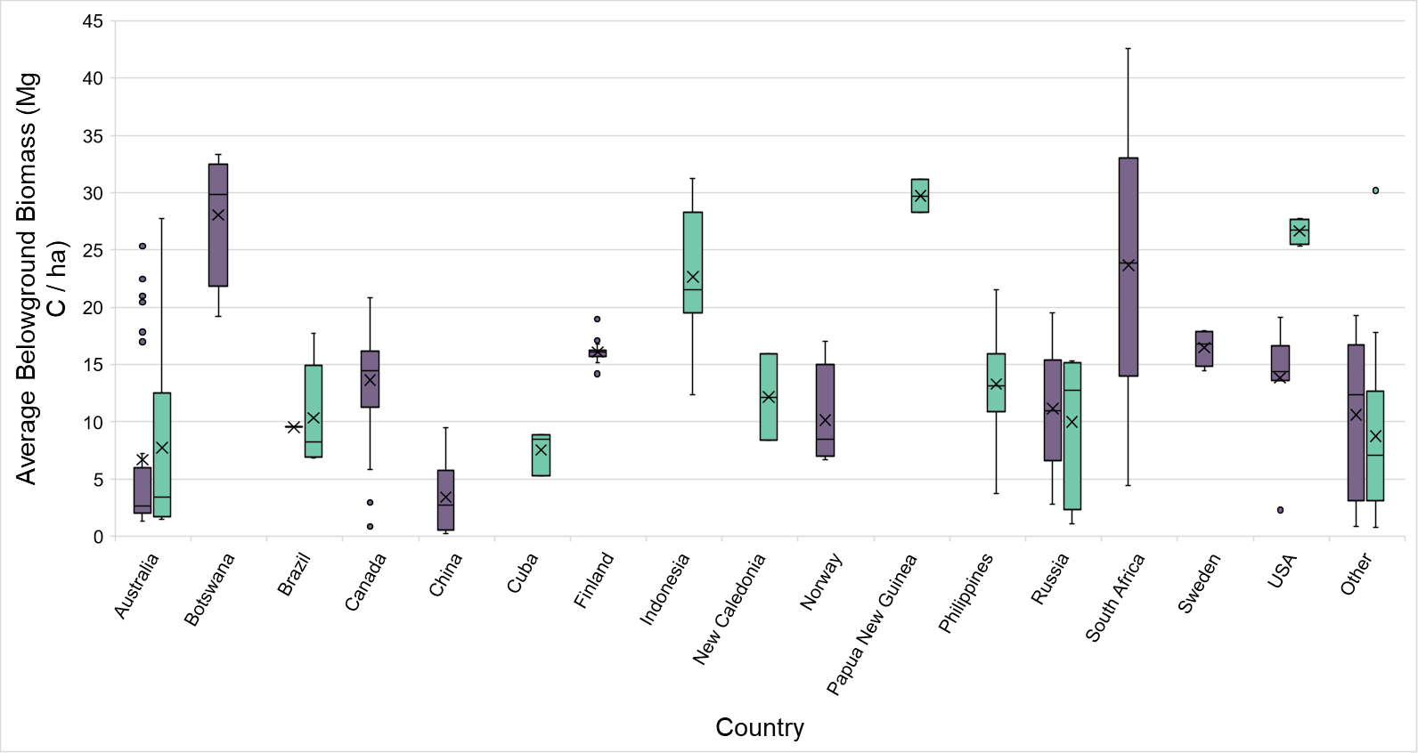

Fig. S1.
Belowground biomass carbon densities (Mg C / ha) for undeveloped nickel deposits. The carbon biomass densities are the average values from the Spawn et al. (14) dataset within 5 km radius circles around the coordinates of the deposits. Sulfide deposits are shown in purple while laterite deposits are shown in turquoise. The box-and-whisker plots show the mean (x), median (line), and upper and lower quartiles (whiskers). If there are any statistical outliers, these are shown as dots above or below the whiskers.

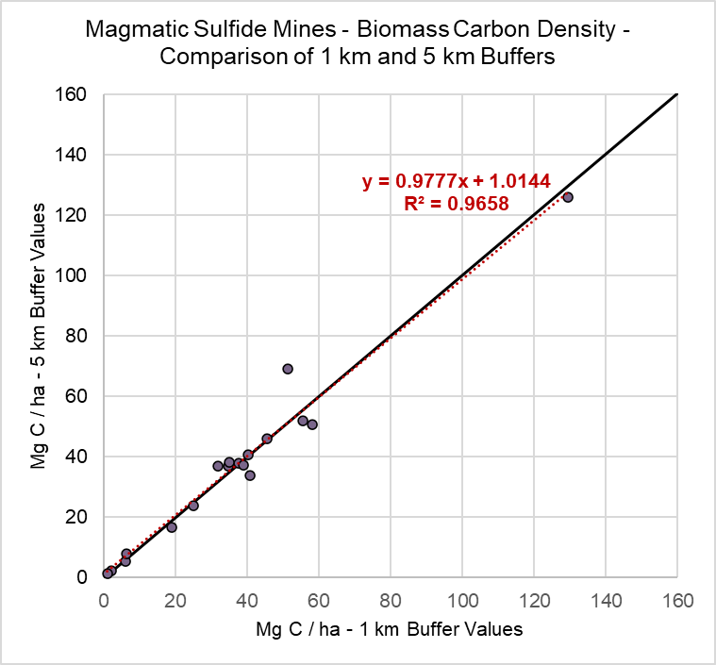
A

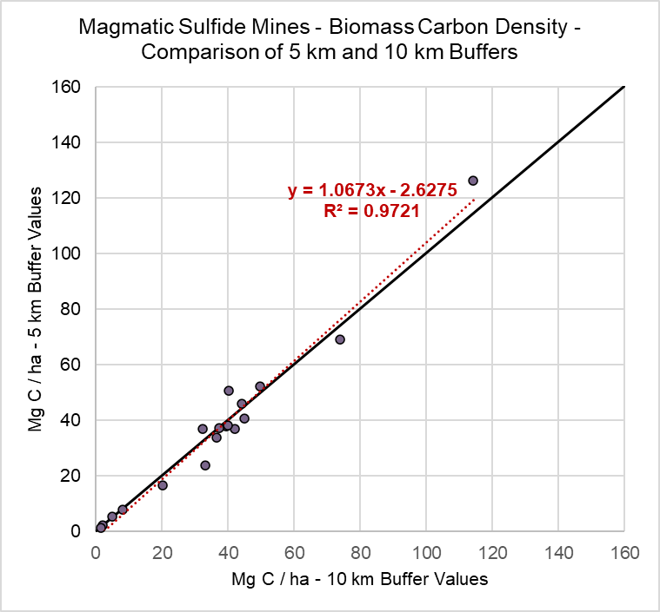
B

Fig. S2.
Sensitivity analysis comparing biomass carbon density calculations (including aboveground and belowground biomass) for 1 km and 5 km (A) and 5 km and 10 km (B) buffers for magmatic sulfide nickel mines.

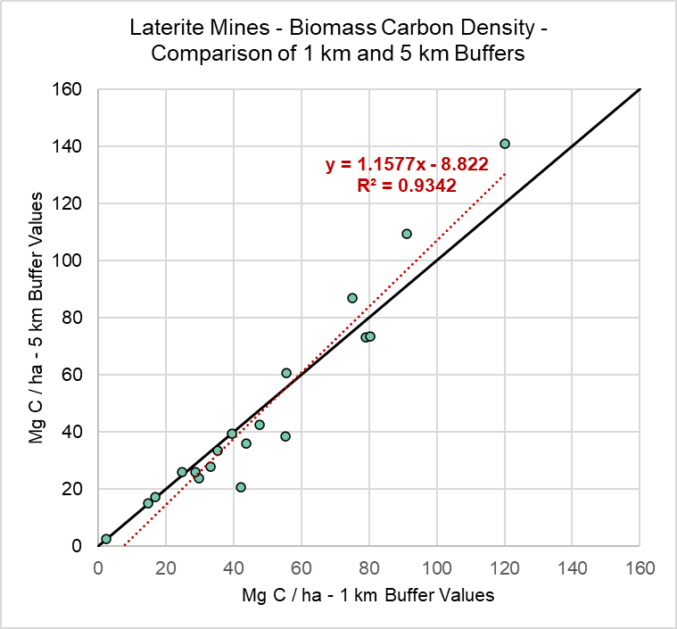
A

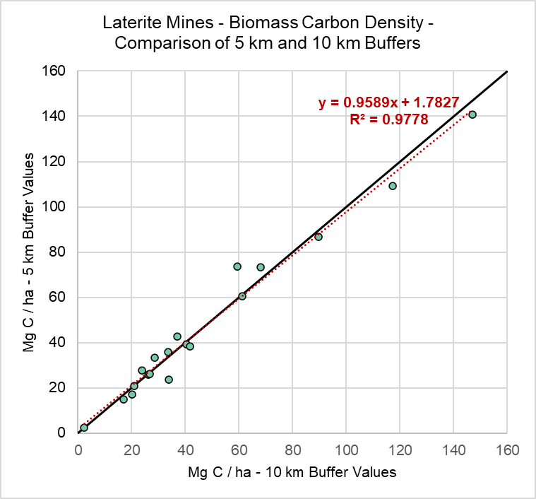
B

Fig. S3.
Sensitivity analysis comparing biomass carbon density calculations (including aboveground and belowground biomass) for 1 km and 5 km (A) and 5 km and 10 km (B) buffers for laterite nickel mines.

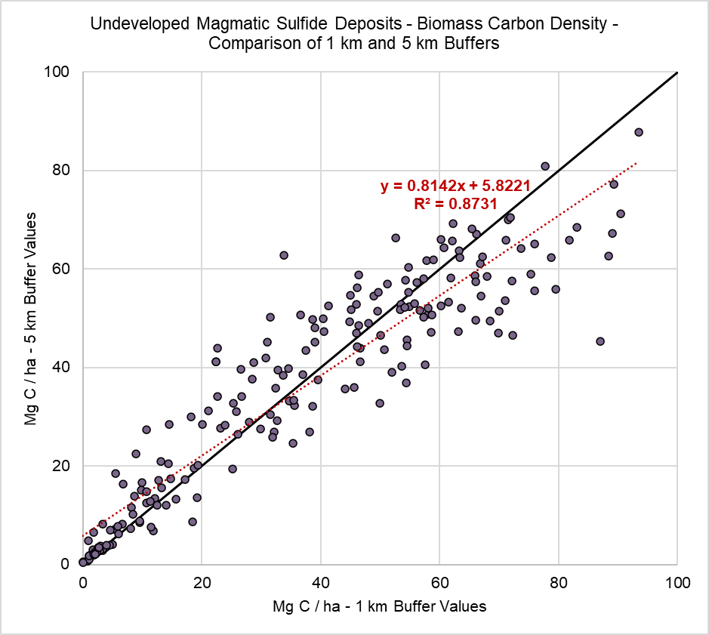
A

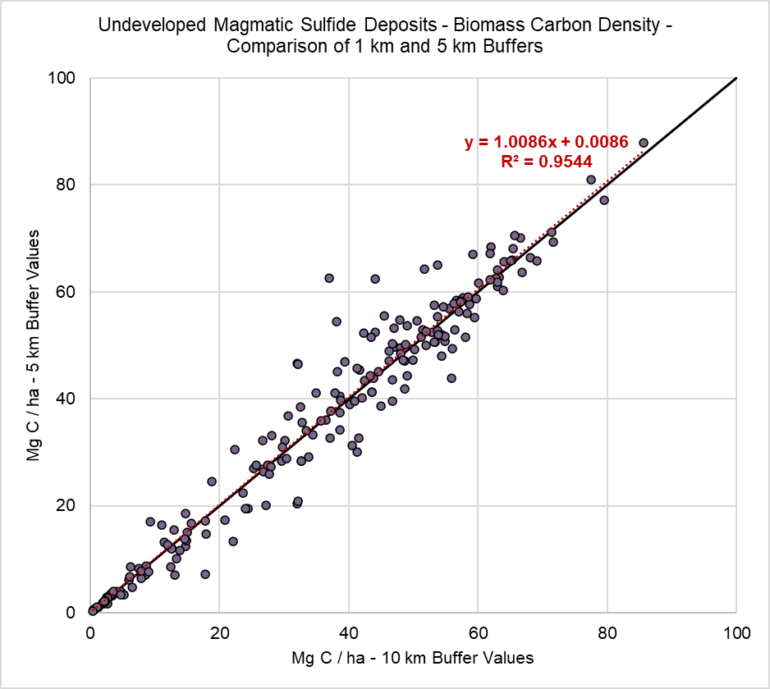
B

Fig. S4.
Sensitivity analysis comparing aboveground biomass carbon density calculations (including aboveground and belowground biomass) for 1 km and 5 km (A) and 5 km and 10 km (B) radius buffer circles for undeveloped magmatic sulfide deposits.

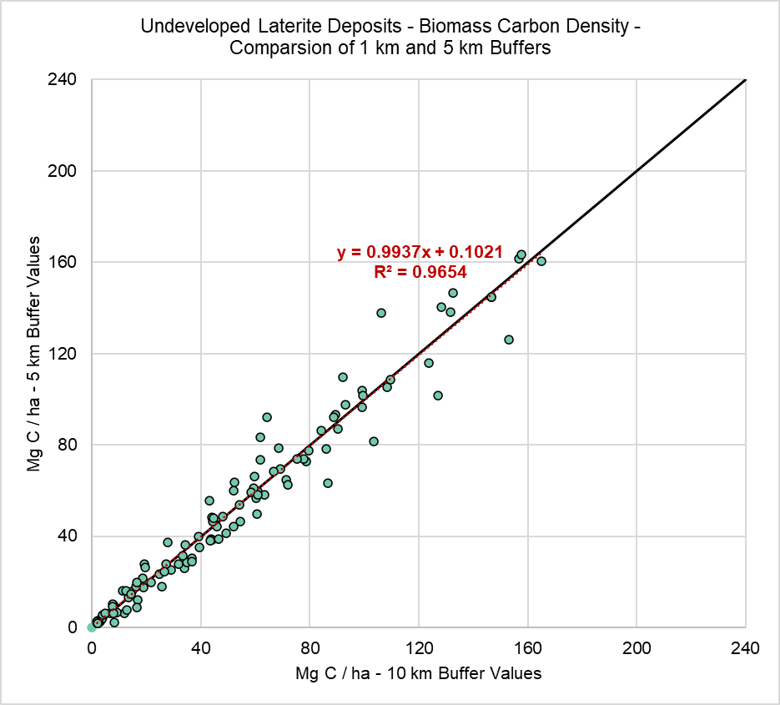
A

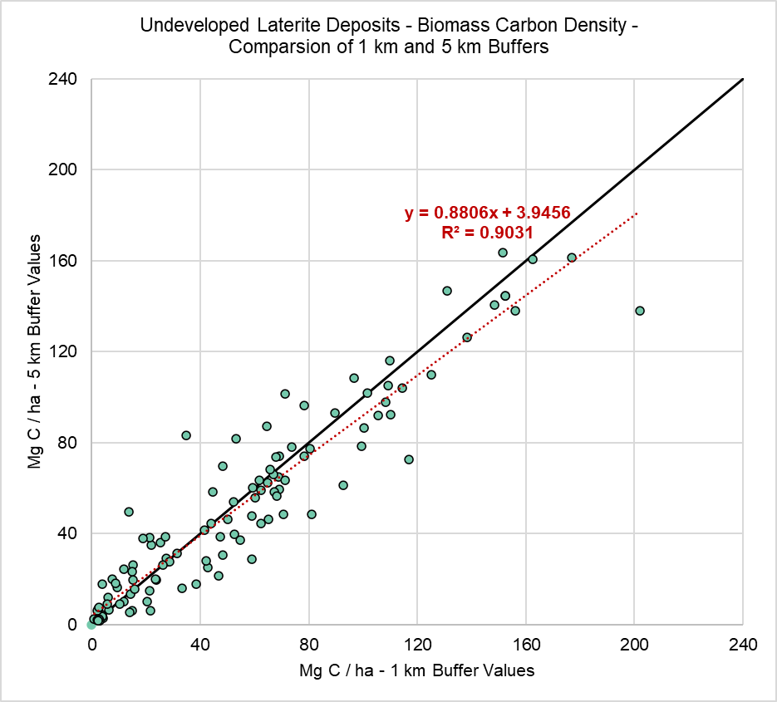
B

Fig. S5.
Sensitivity analysis comparing belowground biomass carbon density calculations (including aboveground and belowground biomass) for 1 km and 5 km (A) and 5 km and 10 km (B) radius buffer circles for undeveloped laterite deposits.

