SUPPORTING INFORMATION

Manuscript: Patient self-reported functioning by pain severity and usual analgesic treatment among older adults with osteoarthritis: Analysis of the 2017 Spanish National Health Survey.

Authors: Sofía García-López, Natalia Llopart-Carles, Francisco Castro-Domínguez, Javier Rejas-Gutierrez

ASSESSMENT OF PAIN AND TAKING OF ANALGESIC MEDICATION
Q45. In the past 4 weeks, what degree of pain have you suffered from?
- None
- Very mild
- Mild
- Moderate
- Severe
- Extreme
- I don't know
- No answer
MODULE P — USE OF MEDICATIONS
Introduction to Q.85: Interviewer, please read to the survey participant: "Next, I am going to ask you about your use of medications in the past 2 weeks."
Q.85. In the past 2 weeks, have you used any medication prescribed to you by a doctor?
- Yes
- No
Q.87. Next I am going to read to you a list of types of medication. Please tell me which of them you have used in the past 2 weeks and which of them were prescribed to you by a doctor.
Note on Q.87: Interviewer, please read the list of medications to the survey participant. Ask the survey participant whether he or she has used them in the past 2 weeks and, if yes, whether they were prescribed to him or her by a doctor. The Prescribed column should be filled in for each medication that the survey participant has used.

Q.87.2. Pain medicines (example: paracetamol, ibuprofen or similar, tramadol, etc.)
Used
- YES
- No
- I don't know
- No answer
Prescribed
- Yes
- No
- I don't know
- No answer

ASSESSMENT OF DEPENDENCY AND FUNCTIONAL CAPACITY
MODULE K — PHYSICAL, SENSORY AND COGNITIVE LIMITATIONS
PHYSICAL FUNCTIONING
37. Do you have difficulty walking 500 meters on a flat plane without any sort of assistance?
- No, no difficulty
- Yes, some difficulty
- Yes, a great deal of difficulty
- I can't do it at all
- I don't know
- No answer
38. Do you have difficulty walking up or down 12 steps?
- No, no difficulty
- Yes, some difficulty
- Yes, a great deal of difficulty
- I can't do it at all
- I don't know
- No answer

MODULE L — LIMITATIONS IN GOING ABOUT ACTIVITIES OF DAILY LIVING
39. Of the activities that I am going to read to you, do you usually have difficulty doing them without help?
39.A Eating
39.B Sitting down, getting up from a chair or bed, or lying down
39.C Getting dressed or undressed
39.D Going to the toilet
39.E Showering or bathing
- No, no difficulty
- Yes, some difficulty
- Yes, a great deal of difficulty
- I can't do it by myself
- I don't know
- No answer
42. Do you usually have difficulty doing any of these activities alone, without help?
42.A Preparing meals
42.B Using the telephone (looking up a number, dialing, etc.)
42.C Shopping (buying food, clothing, etc.)
42.D Taking your medications, including remembering how much of each to take and when to take them
42.E Doing light housework such as doing the laundry, making the bed or cleaning the house
42.F Occasionally doing more physically demanding housework such as moving furniture, cleaning windows or carrying the shopping...
42.G Managing your own money (paying bills, dealing with the bank, signing checks, etc.)
- No, no difficulty
- Yes, some difficulty
- Yes, a great deal of difficulty
- I can't do it by myself
- I don't know
- No answer

MODULE M — MENTAL HEALTH AND OCCUPATIONAL STRESS
MENTAL FUNCTIONING
Introduction to Q.47:
Now we would like to know how you have felt, generally speaking, over the past few weeks. Please answer each question by specifying the response that in your opinion best applies to you. Remember that your response should only deal with current and recent problems, not problems that you have had in the past.
It is important for you to answer all questions.
Interviewer, please read to the survey participant: "I am going to give you a card with questions on how often you have experienced or encountered what the question says. When I ask you, please give me the number corresponding to your response. Please bear in mind that the responses are not the same for all the questions." Note on Q47: Interviewer, the concept of "the past few weeks" should be interpreted as the survey participant wishes.
Q47.1 Have you been able to concentrate well on what you have been doing?
Q47.2 Have your concerns caused you to lose a lot of sleep?
Q47.3 Have you felt that you are playing a useful role in life?
Q47.4 Have you felt capable of making decisions?
Q47.5 Have you found that you are constantly overwhelmed and stressed?
Q47.6 Have you had the feeling that you are unable to overcome your difficulties?
Q47.7 Have you been able to enjoy your normal day-to-day activities?
Q47.8 Have you been able to adequately address your problems?
Q47.9 Have you felt unhappy or depressed?
Q47.10 Have you lost confidence in yourself?
Q47.11 Have you thought that you are a worthless person?
Q47.12 Have you felt reasonably happy, all things considered?
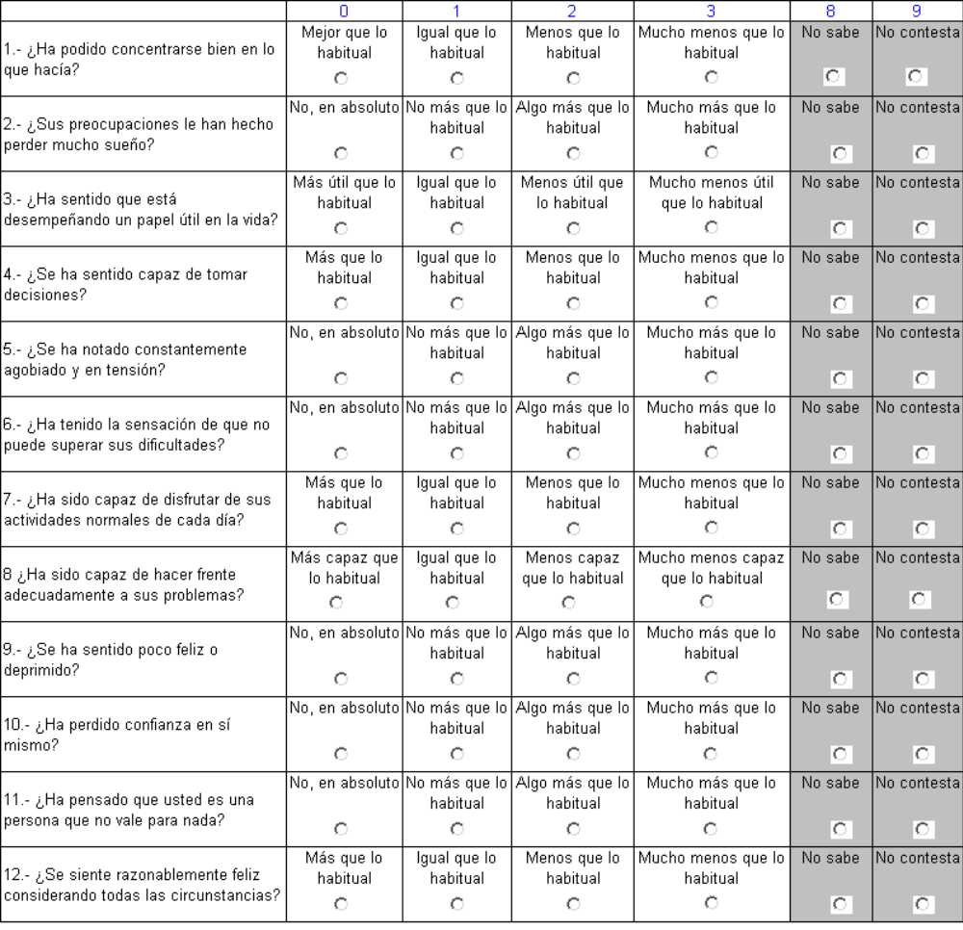
1. Have you been able to concentrate well on what you have been doing?
More than usual
No different than usual
Less than usual
Much less
than usual
2. Have your concerns caused you to lose a lot of sleep?
No, not at all
No more than usual
Somewhat more than usual
Much more than usual
3. Have you felt that you are playing a useful role in life?
More useful than usual
No different than usual
Less useful than usual
Much less useful than usual
4. Have you felt capable of making decisions?
More than usual
No different than usual
Less than usual
Much less than usual
5. Have you found that you are constantly overwhelmed and stressed?
No, not at all
No more than usual
Somewhat more than usual
Much more than usual
6. Have you had the feeling that you are unable to overcome your difficulties?
No, not at all
No more than usual
Somewhat more than usual
Much more than usual
7. Have you been able to enjoy your normal day-to-day activities?
More than usual
No different than usual
Less than usual
Much less than usual
8. Have you been able to adequately address your problems?
More capable than usual
No different than usual
Less capable than usual
Much less capable than usual
9. Have you felt unhappy or depressed?
No, not at all
No more than usual
Somewhat more than usual
Much less capable than usual
Much more than usual
10. Have you lost confidence in yourself?
No, not at all
No more than usual
Somewhat more than usual
Much more than usual
11. Have you thought that you are a worthless person?
No, not at all
No more than usual
Somewhat more than usual
Much more than usual
12. Have you felt reasonably happy, all things considered?
More than usual
No different than usual
Less than usual
Much less than usual
I don't know
No answer
I don't know
No answer
I don't know
No answer
I don't know
No answer
I don't know
No answer
I don't know
No answer
I don't know
No answer
I don't know
No answer
I don't know
No answer
I don't know
No answer
I don't know
No answer
I don't know
No answer
0
1
2
3
8
9

MODULE I. RESTRICTION OF ACTIVITY (past 2 weeks)
SOCIAL FUNCTIONING: Questions 28b and 29b
Introduction to Q.28: Interviewer, please read to the survey participant: "Next I am going to ask you about restrictions on your usual activities in the past 2 weeks, that is to say, from _______ [day corresponding to two weeks ago] to yesterday."
28. In the past 2 weeks, have you had to reduce or limit your usual activities for at least half a day due to one or more symptoms, including pain?
- Yes 28b. How many days? └─┴─┘ Unk.  98 No ans.  99
- No
29. In the past 2 weeks, have you had to stay in bed for more than half a day for health reasons? (If you were hospitalized, also consider days spent in hospital)
- Yes 29b. How many days? └─┴─┘ Unk.  98 No ans. 99
- No
MODULE K — PHYSICAL, SENSORY AND COGNITIVE LIMITATIONS
COGNITIVE FUNCTIONING
38.a Do you have difficulty remembering or concentrating?
- No, no difficulty
- Yes, some difficulty
- Yes, a great deal of difficulty
- I can't do it at all
- I don't know
- No answer

STROBE Statement—Checklist of items that should be included in reports of cross-sectional studies
 | Item No | Recommendation
Title and abstract | 1 | (a) Page 1 and 2, title and abstract
Title and abstract | 1 | (b) Page 2, structured abstract
Introduction
Background/rationale | 2 | Page 3 and 4
Objectives | 3 | Page 4
Methods
Study design | 4 | Page 4
Setting | 5 | Page 4
Participants | 6 | Page 4 and 5
Variables | 7 | Page 5, 6 and 7
Data sources/ measurement | 8* | Page 4
Bias | 9 | Page 4, national health survey with nationwide representability
Study size | 10 | Not applicable, cross-sectional study using existing database
Quantitative variables | 11 | Page 5, 6 and 7 and supporting information
Statistical methods | 12 | (a) Page 7 and 8
Results
Participants | 13* | (a) Page 9 and table 1
Descriptive data | 14* | (a) Page 9 and table 1
Outcome data | 15* | Page 9, 10 and 11 and tables 2 and 3 and figures 1, 2 and 3
Main results | 16 | Page 9, 10 and 11 and tables 2 and 3 and figures 1, 2 and 3
Other analyses | 17 | Not applicable
Discussion
Key results | 18 | Page 12, 13, 14 and 15
Limitations | 19 | Page 12 and 13
Interpretation | 20 | Page 14 and 15
Generalizability | 21 | Not applicable
Other information
Funding | 22 | Page 20

*Give information separately for exposed and unexposed groups.

Note: An Explanation and Elaboration article discusses each checklist item and gives methodological background and published examples of transparent reporting. The STROBE checklist is best used in conjunction with this article (freely available on the Web sites of PLoS Medicine at http://www.plosmedicine.org/, Annals of Internal Medicine at http://www.annals.org/, and Epidemiology at http://www.epidem.com/). Information on the STROBE Initiative is available at http://www.strobe-statement.org.

