Electronic Supplementary Material

Two putative glutamate decarboxylases of Streptococcus pneumoniae as possible antigens for the production of anti-GAD65 antibodies leading to type 1 diabetes mellitus

Ernesto García
Departamento de Biotecnología Microbiana y de Plantas, Centro de Investigaciones Biológicas Margarita Salas (CSIC), Ramiro de Maeztu 9, 28040 Madrid, Spain
Email address: e.garcia@cib.csic.es

Table S2 General features of four pneumococcal strains having an insert different to that of the gadA_{Spn} gene.
Strain | Year | Country | Source | Serotype | ST | GPSC | Acc. No.
SA_GPS_SP505-sc-1895675 | 2006 | South Africa | Blood | 19F | 10619 | 21 | LR216035
1245STDY5775874 | 2005 | South Africa | Blood | 19F | 8328 | 90 | LR216032
2245STDY5699394 | 2000 | Malawi | Blood | 10B | 7055 | 30 | LR216024
B1900ª | 2012 | USA | Brain | 3 | – | – | CP051650
ª Isolated from a non-human primate after a sudden death caused by meningitis.

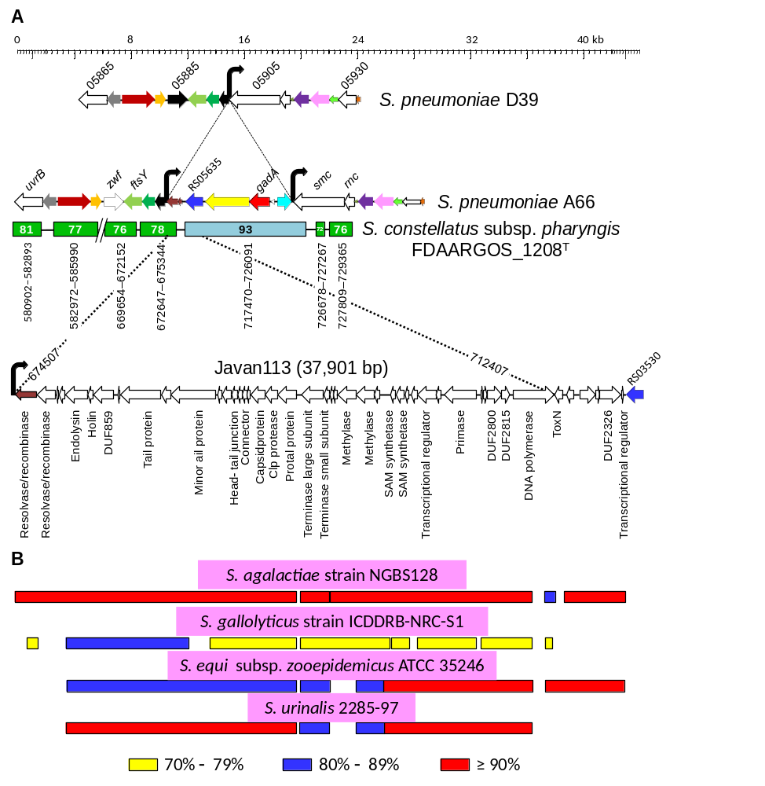

Fig. S1 (A) A comparative diagram of the chromosomal region containing a gadA gene in S. pneumoniae A66 and the type strain of S. constellatus subsp. pharyngis harboring the prophage Javan113. The percentage of nucleotide identity between those genomes is indicated in rectangles. The corresponding region of the pneumococcal D39 genome is shown for comparison. (B) Prophages of four different streptococcal species in comparison with Javan113. The percentage of identical nucleotides is indicated at the bottom.

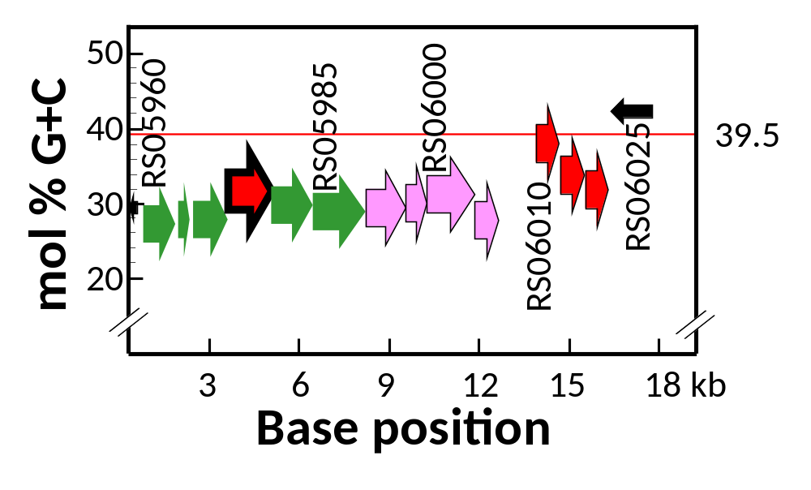

Fig. S2. Mol % G+C content of genes included in the DNA region encompassing the gadB_{Spn} gene of S. pneumoniae 2245STDY6178826 (NZ_LR216061). Some genes have been identified by letters and numbers (locus tag: E0F38_RS).The G+C content of the chromosome is indicated by a red line and at the right of the figure. The color code of genes is the same of Fig. 3. The mol % G+C content was calculated for each gene.

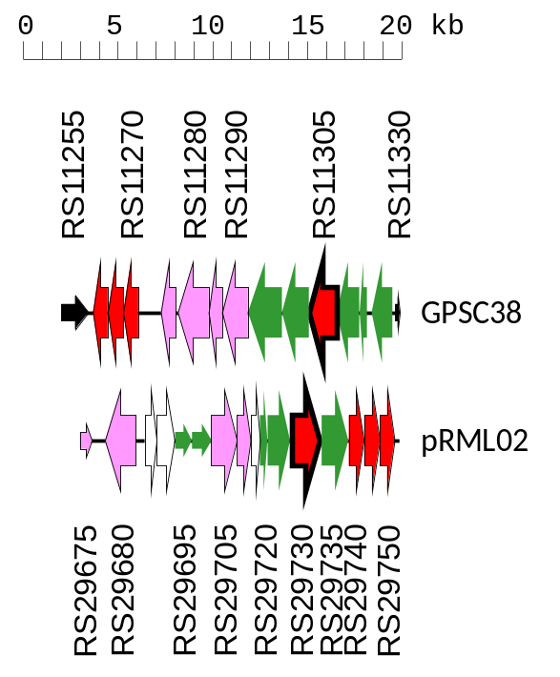

E0F14_RS | Predicted gene product | % id./simil.ª | Log₁₀E | WR52_RS
11255 | IS110 family transposase (pseudo)
11260 | ABC transporter permease |  | ABC transporter permease | 29750
11265 | ABC-2 family transporter protein |  | ABC transporter permease | 29745
11270 | ATP-binding cassette domain-containing protein | 40/57 | −41 | 29740
11275 | tyrosine-protein phosphatase |  |  | 20675 (pseudo)
11280 | methionine–tRNA ligase | 63/78 | ≤−180 | 29680
11285 | CatA-like O-acetyltransferase | 37/60 | −52 | 29710
11290 | HP | 32/50 | −48 | 29705
11295 | aminotransferase class I/II-fold pyridoxal phosphate-dependent enzyme | 34/54 | −31/−53 | 29695/29700
11300 | acyl–CoA ligase | 32/50 | −48 | 29735
11305 | pyridoxal-dependent decarboxylase | 56/75 | ≤−180 | 29730
11310 | HP | 42/56 | −93 | 29725
11315 | acyl carrier protein | 34/58 | −10 | 29720
11320 | HP
11330 | IS5-like element IS1515 family transposase (pseudo)
ª Percentage of amino acid identity/similarity.
Fig. S3 Comparison of the genes embracing the pneumococcal gadB_{Spn} and gadB_{Bce} of pRML02 (NZ_CP011157; locus tag WR52_RS), a megaplasmid (141,238 bp) of B. cereus HN001. The color code is the same than in Fig. 2B. At the lower part of the figure, pairwise comparisons of the diverse gene products. The pneumococcal strain used for comparison was 2245STDY5605669 (GPSC38 ST310; NZ_LR216017; locus tag E0F14_RS)
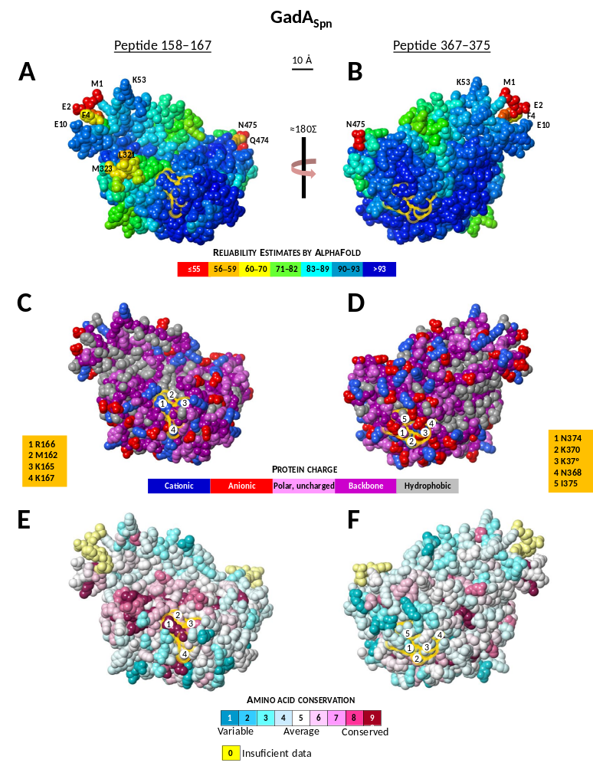
Fig. S5 Localization of two possible epitopes in the three-dimensional structure of GadB_{Spn}. The folding of the protein was predicted with AlphaFold and the positions of the epitopes are shown at the top and highlighted with yellow halos in each panel. (A, B) Reliability estimates. To assist orientation, the positions of several residues are included. (C, D) Charges of different amino acid residues. (E, F) Amino acid conservation calculated with ConSurf (https://consurf.tau.ac.il/) running with default parameters. Color scales are shown. In panels C to F, several surface-located amino acid residues of the predicted epitopes are indicated with numbered circles.
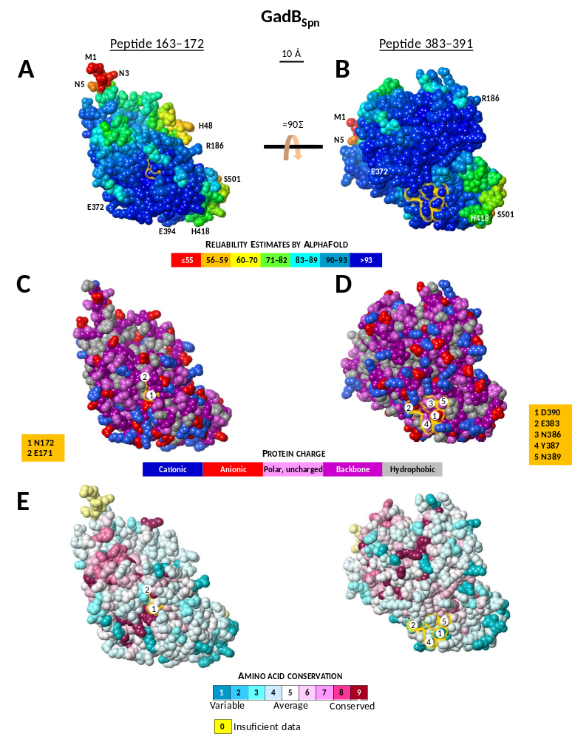
Fig. S5 Localization of two possible epitopes in the three-dimensional structure of GadB_{Spn}. The folding of the protein was predicted with AlphaFold and the positions of the epitopes are shown at the top and highlighted with yellow halos in each panel. (A, B) Reliability estimates. To assist orientation, the positions of several residues are included. (C, D) Charges of different amino acid residues. (E, F) Amino acid conservation calculated with ConSurf (https://consurf.tau.ac.il/) running with default parameters. Color scales are shown. In panels C to F, several surface-located amino acid residues of the predicted epitopes are indicated with numbered circles.

