TITLE: Necroptosis Drives Major Adverse Cardiovascular Events During Severe COVID-19

AUTHORS: Rosana Wiscovitch-Russo^{1#}, Ph.D.; Elsa D. Ibáñez-Prada^{2,3#}, M.D.; Cristian C. Serrano-Mayorga^{2,3}, M.D.; Benjamin L. Sievers¹, Ph.D.; Maeve A. Engelbride¹, Ph.D.; Surya Padmanabhan¹, Ph.D.; Gene S. Tan^{1,4}, Ph.D.; Sanjay Vashee¹, Ph.D.; Ingrid G. Bustos², Esp; Carlos Pachecho^{2,3}, Esp; Lina Mendez³, MSc; Peter H. Dube^{5$}, Ph.D.; Harinder Singh¹, Ph.D.; Luis Felipe Reyes*^{##2,3,6}, M.D., MSc, Ph.D.; and Norberto Gonzalez-Juarbe*^{##1}, Ph.D.

AFFILIATIONS: ¹Infectious Diseases and Genomic Medicine Group, J Craig Venter Institute, 9605 Medical Center Drive Suite 150, Rockville, MD, USA; ²Universidad de la Sabana, Chía, Colombia; ³Clinica Universidad de La Sabana, Chía, Colombia; ⁴Division of Infectious Diseases, Department of Medicine, University of California San Diego, La Jolla, CA 92037; ⁵Department of Microbiology, Immunology and Molecular Genetics, The University of Texas Health Science Center at San Antonio, San Antonio, TX 78229, USA; ⁶Pandemic Science Institute, University of Oxford, Oxford, United Kingdom.

* Corresponding authors: Luis Felipe Reyes, MD., PhD., Universidad de La Sabana, Chía, Colombia. Phone number: 57 861 55 55 Ext: 23342. Email: luis.reyes5@unisabana.edu.co, Norberto Gonzalez-Juarbe, Ph.D., Infectious Diseases and Genomic Medicine Group, J Craig Venter Institute, 9605 Medical Center Drive Suite 150, Rockville, MD 20850. Tel. 795-301-7393, Fax. 301-795-7051, Email: ngonzale@jcvi.org
# Co-first Authors, ## Co-Senior Authors
$ Current Address: Boehringer Ingelheim, Ames, Iowa, United States.

ADDITIONAL FIGURES
Additional Figure S1: complete uncropped gel and blot images of Hamsters Hearts. A. Immunoblot for pMLKL in homogenates of hamsters' hearts (Panel B in Figure 5 of the original manuscript). B. Immunoblot for pMLKL in serum of hospitalized patients experiencing MACE or no-MACE (Panel C in Figure 5 of the original manuscript).
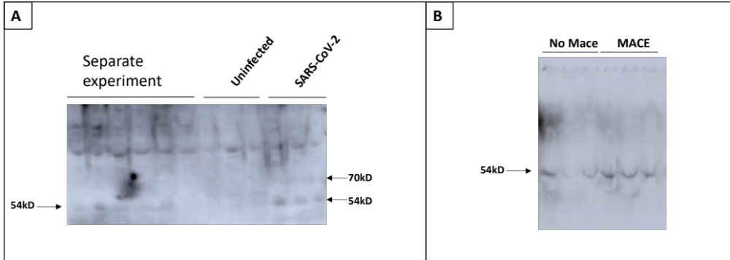

Additional Figure S2: Troponin-I, pro-BNP, pMLKL, IL-10, and circulating SARS-CoV-2 are robust prognostic biomarkers of MACE. The mean Accuracy plot shows the accuracy of specific biomarkers to define the development of MACE in human patients with COVID-19.
