Additional file 1. Literature search strategy in Ovid MEDLINE table

# | Searches | Results
1 | exp Exercise | 227179
2 | exp Exercise Therapy | 58660
3 | exp Exercise Test | 69036
4 | exp Sports | 203170
5 | exp Exercise Movement Techniques | 9538
6 | exp Physical Exertion | 57218
7 | exp Physical Endurance | 36132
8 | exercise*.mp. | 426846
9 | physical activit*.mp. | 134933
10 | resistance training*.mp. | 16064
11 | (high intensity interval training* or HIIT).mp. | 3164
12 | endurance training*.mp. | 5355
13 | running.mp. | 75013
14 | cycling.mp. | 70883
15 | swimming.mp. | 39727
16 | jogging.mp. | 2191
17 | or/1-16 | 764871
18 | exp Angiogenic Proteins | 66177
19 | angiogen*.mp. | 145804
20 | exp Vascular Endothelial Growth Factors | 59964
21 | (vascular endothelial growth factor* or VEGF).mp. | 106400
22 | (vascular permeability factor or VPF).mp. | 731
23 | exp Placenta Growth Factor | 2060
24 | (placenta* growth factor* or PLGF or PGF).mp. | 8689
25 | exp Platelet-Derived Growth Factor | 13952
26 | (platelet derived growth factor* or PDGF).mp. | 30667
27 | exp Hepatocyte Growth Factor | 8168
28 | (hepatocyte growth factor* or HGF or hepatopoietin-A or Scatter factor*).mp. | 16036
29 | exp Angiopoietins | 4072
30 | (antiopoietin* or ANGP* or ANGPT or ANG or AGPT).mp. | 23110
31 | exp Endostatins | 1770
32 | (endostatin* or collagen type XVIII or COL18A1).mp. | 2664
33 | exp Fibroblast Growth Factors | 33859
34 | (fibroblast growth factor* or heparin binding growth factor* or FGF* or HBGF or BFGF or FGFB).mp. | 64320
35 | exp Matrix Metalloproteinases | 50161
36 | (matrix metalloproteinase or matrix metallopeptidase or MMP*).mp. | 97266
37 | exp Collagen Type IV | 4057
38 | (tumstatin* or collagen type IV* or COL4A3).mp. | 6151
39 | exp Angiostatins | 652
40 | angiostatin*.mp. | 995
41 | exp Thrombospondins | 4288
42 | (thrombospondin* or TSP or THBS).mp. | 13613
43 | (E-selectin* or CD62* or endothelial-leukocyte adhesion molecule* or LEAM-1 or LEAM-2).mp. | 14909
44 | or/18-43 | 427111
45 | exp Blood | 1160559
46 | blood.mp. | 3995032
47 | exp Plasma | 29851
48 | plasma.mp. | 984230
49 | exp Serum | 69445
50 | serum.mp. | 1162772
51 | peripheral.mp. | 644337
52 | or/45-51 | 5711835
53 | 17 and 44 and 52 | 2611
54 | limit 53 to english language | 2542

Identification of studies via databases and registers

Records removed before screening:
Duplicate records removed (n = 2911)
Records identified from*:
Registers (n = 9288; MEDLINE: 2542, EMBASE: 5861, COCHRANE CENTRAL: 885)
References of included articles (n = 2)

Identification

Records excluded
(n = 5238)
Unique records screened
(n = 6379)

Reports excluded (n =1097):
No proteins of interest (n = 285)
Abstracts, reviews, comments, editorials, case reports, letters (n = 225)
Mean age below 50 (n = 209)
Diseased or psychiatric populations (n = 170)
Proteins of interest not in blood (n = 76)
No exercise interventions (n = 41)
Co-interventions, i.e. drugs (n = 35)
Exercise intervention below moderate intensity or implied (n = 16)
No pre- and post-intervention protein concentrations described (n = 16)
Not in English (n = 15)
Animal study (n = 4)
Same population as another included paper (n = 3)
No age reported (n = 2)

Screening

Full text articles assessed for eligibility
(n = 1141)

Articlesª included in review
(n = 44)
Articles^{b} included in meta-analysis
(n = 38)
Included

ª some articles included multiple comparisons (different exercise interventions or populations)
^{b} at least 1 comparison from the article was included

Additional file 2. Study selection for the systematic review and meta-analysis.

Additional file 3. Characteristics of included studies table
Studyª | Population | Proteins Measured | Age years | Male % | BMI  kg/m² | V̇O_{2peak} (mL⋅kg⁻¹⋅ min⁻¹) | Exercise Type | Exercise Modality | Exercise Duration Type | Exercise  wk# | Exercise  wkfrequency# | Exercise  Session (m) | Exercise Intensity Described
Adams 2004 | Healthy | VEGF, FGF2 | 59 | ? | 24.8 | ? | aerobic | cycle ergometer | 1 session | 1 | 1 | 22 | maximal exercise testing
Adams 2008 | Healthy | VEGF | 57 | 100 | 23.8 | ? | aerobic | marathon race | 1 session | 1 | 1 | 251 | ?
Brenner 2019a | Healthy | VEGF, FGF2 | 59.5 | 0 | 29.4 | ? | aerobic | unspecific, any aerobic | ≥4 weeks | 12 | 5 | 30 | moderate volume
Brenner 2019b | Healthy | VEGF, FGF2 | 59.4 | 0 | 29.1 | ? | aerobic | unspecific, any aerobic | ≥4 weeks | 12 | 5 | 60 | high volume
Brevetti 2001 | Healthy | CD62E | 63 | 83.3 | ? | ? | aerobic | graded treadmill exercise | 1 session | 1 | 1 | 26.6 | reach HR_{max}
Brixius 2008a | Overweight | VEGF, endostatin | 58.7 | 100 | 29.8 | ? | aerobic | running | ≥4 weeks | 26 | 3 | 60 | at pulse 2-4 mmol/L lactate
Brixius 2008b | Overweight | VEGF, endostatin | 58.9 | 100 | 31.1 | ? | aerobic | cycling | ≥4 weeks | 26 | 3 | 90 | at pulse 2-4 mmol/L lactate
Bruserud 2005 | Healthy | Endostatin, FGF2, angiogenin | 76 | 45 | ? | ? | aerobic | mountain walk 12km | 1 session | 1 | 1 | 180 | moderate activity
Cho 2019 | Healthy | VEGF | 68.9 | 0 | 24.1 | ? | aerobic | taekwondo | ≥4 weeks | 16 | 5 | 60 | 50-80% HR_{max}
Chupel 2021 | Healthy | MMP9 | 83.5 | 0 | 27.2 | ? | both | combined resistance exercise with elastic bands and aerobic activities | ≥4 weeks | 14 | 2 | 60 | low-moderate intensity
Despeghel 2021 | Healthy | VEGF | 70.3 | 46.7 | 27.7 | ? | both | combined strength training and endurance training (cycle ergometers/cross-trainers) | ≥4 weeks | 6 | 2 | 60 | strength training: started at 60% of the participants 1RM, increasing load over time. Endurance: aimed for HR 190 minus age
Duggan 2014 | Overweight | VEGF | 60.7 | 0 | 30.5 | 20 | aerobic | aerobic exercise: treadmill walking and stationary cycling; home exercises, including walking, aerobics, and bicycling. | ≥4 weeks | 52 | 1 | 176 | 60–75% of HR_{max}
Duggan 2016 | Overweight | VEGF | 58.1 | 0 | 30.7 | 22.5 | aerobic | aerobic exercise | ≥4 weeks | 52 | 5 | 45 | moderate-to-vigorous (≥4 metabolic equivalents);70-85% observed HR_{max}
El-Kader 2019a | Healthy | CD62E | 64.3 | ? | ? | ? | aerobic | treadmill | ≥4 weeks | 24 | 3 | 30 | 60–80% of HR_{max}
El-Kader 2019b | Healthy | CD62E | 64 | ? | ? | ? | resistance training | resistance training | ≥4 weeks | 24 | 3 | 30 | 60-80% of 1RM
Formica 2020 | Healthy | VEGF | 70.7 | 38 | 27.9 | ? | both | cycling, treadmill, walking, postural exercises, progressive resistance training | ≥4 weeks | 24 | 3 | 75 | 10-point Borg RPE: 5-8 (3-4 in the first two weeks)
Goldberg 2016 | Overweight | CD62E | ? | ? | ? | ? | aerobic | exercise education, individual and group sessions | ≥4 weeks | 52 | 1 | 150 | moderate
Grace 2015a | Healthy | VEGF | 62.7 | 100 | 29.3 | 26.9 | aerobic | aerobic exercise training and HITT | ≥4 weeks | 12 | 1.5 | 60.5 | 55-65% of HRR and 50% of Peak Power Output (PPO) (for HIIT) or peak heart rates >90% HRR (for HIIT)
Grace 2015b | Healthy | VEGF | 61.1 | 100 | 26.4 | 40.6 | aerobic | HIIT | ≥4 weeks | 6 | 1.5 | 21 | 50% of PPO or peak heart rates >90% HRR
Izzicupo 2017 (1)a | Healthy | VEGF | 56.2 | 0 | 27.1 | ? | aerobic | walking training | ≥4 weeks | 13 | 4 | 50 | 15-point RPE: 11-13
Izzicupo 2017 (2)a | Healthy | VEGF | 56.6 | 0 | 27.4 | 23.6 | aerobic | walking | ≥4 weeks | 13 | 3 | 50 | 15-point RPE: 11-13
Izzicupo 2017 (2)b | Healthy | VEGF | 59.2 | 0 | 24.7 | 22.3 | aerobic | Nordic walking | ≥4 weeks | 13 | 3 | 50 | 15-point RPE: 11-13
Jamka 2021a | Obese | VEGF, MMP2, MMP9 | 55 | 0 | 35.9 | ? | aerobic | endurance training | ≥4 weeks | 12 | 3 | 60 | 50–70% of HRmax
Jamka 2021b | Obese | VEGF, MMP2, MMP9 | 55 | 0 | 36.0 | ? | both | endurance-strength training | ≥4 weeks | 12 | 3 | 60 | resistance: 50–60% of 1RM, cycling: 50–70% of HR_{max}
Juliana 2017 | Healthy | MMP9 | 50.2 | 0 | 30.3 | ? | unspecified | unspecified, includes exercise education | ≥4 weeks | 16 | 1 | 3355 | moderate to intense
Kang 2020 | Healthy | VEGF | 73.8 | 0 | ? | ? | aerobic | aquatic exercise program | ≥4 weeks | 16 | 3 | 60 | 40–70% of HRR
Kennedy 2021 | Healthy | FGF2, PIGF, VEGF, VEGF-C, VEGF-D | 67 | 85 | 25.4 | 18.76 | both | aerobic exercise and resistance training | ≥4 weeks | 12 | 3 | 40.55 | target 45% to 60% HRR (moderate intensity activity); 6 sets of 17 repetition maximum.
Kolasa-Trela 2017 | Healthy | HGF, VEGF | 59.8 | 53.1 | 29.3 | ? | aerobic | cycle ergometer | 1 session | 1 | 1 | 10.8 | maximal exercise testing
Larouche 2015a | Healthy | ANGPLT2 | 61 | 50 | 23.8 | 44.6 | aerobic | cycle ergometer | 1 session | 1 | 1 | 30 | high intensity interval exercise
Larouche 2015b | Healthy | ANGPLT2 | 61 | 50 | 23.8 | 44.6 | aerobic | cycle ergometer | 1 session | 1 | 1 | 28 | moderate intensity continuous exercise
Li 2020 | Healthy | ANGPTL4 | 61 | 51.4 | 31.3 | 21.7 | aerobic | treadmill | ≥4 weeks | 24 | 3 | 60 | 50–80% V̇O_{2max}
Lim 2015 | Healthy | CD62E | 56.8 | 100 | 23.4 | ? | aerobic | walking exercise | ≥4 weeks | 10 | 9 | 10 | 60-79% of HR_{max}
Luttrell 2020 | Healthy | VEGF, endostatin, TSP-1 | 68 | 55.6 | 24.4 | ? | aerobic | recumbent cycle ergometer | 1 session | 1 | 1 | 45 | 60% of the estimated HR_{max}
Maass 2016 | Healthy | VEGF | 68.8 | 48 | 25 | ? | aerobic | walking/running | ≥4 weeks | 12 | 3 | 30 | 65% of target HR
MacNeil 2020a | Healthy | FGF2, VEGF, PDGF-AA, PDGF-BB | 71.7 | 71.4 | 22.9 | 36.6 | aerobic | cycling | 1 session | 1 | 1 | 30 | 50% of the maximum attained at V̇O_{2peak}
MacNeil 2020b | Healthy | FGF2, VEGF, PDGF-AA, PDGF-BB | 71.8 | 60.9 | 27.6 | 26.7 | aerobic | cycling | 1 session | 1 | 1 | 30 | 50% of the maximum attained at V̇O₂ _{peak}
Marston 2019a | Healthy | VEGF | 55.2 | 14.3 | 25.9 | ? | resistance training | resistance training | ≥4 weeks | 12 | 2 | 70 | high-load, 5 sets of 5 repetitions at 85% of 1RM, resistance increased by 2.5–5% per week or per individual tolerance (no greater than 10%)
Marston 2019b | Healthy | VEGF | 58 | 20 | 24.9 | ? | resistance training | resistance training | ≥4 weeks | 12 | 2 | 30 | moderate-load, 3 sets of 10 repetitions at 70% of 1RM, resistance increased by 2.5–5% per week or per individual tolerance (no greater than 10%)
Niebauer 2005 | Healthy | CD62E | 51.3 | 88.9 | ? | 36.9 | both | bicycle ergometer and calisthenics | ≥4 weeks | 8 | 5 | 35 | 70% and 80% HR_{max}
Niederseer 2016 | Healthy | CD62E | 66.6 | 54.5 | 27.1 | ? | aerobic | skiing | ≥4 weeks | 12 | 2.4 | 67.6 | average 72.7 ± 8.5% of HR_{max} (measured)
Pakiz 2011 | Overweight | VEGF | 56 | 0 | 30.8 | ? | unspecified | unspecified; exercise counselling | ≥4 weeks | 16 | 1 | 324 | moderate
Park 2010 | Obese | VEGF | 66.1 | 0 | 24.2 | 30.7 | both | combined aerboic +elastic band + yoga program | ≥4 weeks | 12 | 3 | 70 | aerobic exercise: indoor walking 12-13 RPE target, 10 band exercises with 12-15 repetitions target
Park 2020 | Obese | VEGF | 69.1 | 100 | 26.2 | 25.7 | both | combined resistance training sessions and treadmill/biking aerobic exercises | ≥4 weeks | 12 | 3 | 100 | resistance: 3 sets of 10–15 repetitions at an exercise intensity ranging from 6–7 on the OMNI-RES. aerobic: 60%–70% of HR_{max}
Ratajczak 2019a | Obese | VEGF | 51 | 0 | 35.9 | 17.3 | aerobic | cycle ergometer | ≥4 weeks | 13 | 3 | 60 | 50–80% HR_{max}
Ratajczak 2019b | Obese | VEGF | 51 | 0 | 35 | 18.3 | both | cycle ergometer and strength training | ≥4 weeks | 13 | 3 | 60 | 50–80% HR_{max}; resistance: unspecified intensity for 20 minutes
Roh 2020 | Obese | VEGF | 70.9 | 0 | 24.7 | ? | resistance training | resistance training | ≥4 weeks | 12 | 3 | 60 | RPE: 10–14
Ross 2018 | Healthy | VEGF | 65 | 100 | 26.1 | 35.1 | aerobic | cycling ergometer | 1 session | 1 | 1 | 30 | 70% of V̇O_{2max}
Sabaratnam 2018 | Obese | ANGPTL4 | 54.7 | 100 | 29 | 3.5 | aerobic | bicycle ergometer | 1 session | 1 | 1 | 60 | 70% of V̇O_{2max}
Sandri 2016 | Healthy | VEGF | 72 | 0.8 | 28 | 21.1 | aerobic | bicycle ergometer | ≥4 weeks | 4 | 5 | 92 | 70% of the symptom-limited V̇O_{2max}
Sponder 2014a | Healthy | Endostatin | 58.6 | 0 | 23.9 | ? | aerobic | cycling | 1 session | 1 | 1 | ? | Until exhaustion (individual maximum workload)
Sponder 2014b | Healthy | Endostatin | 52.8 | 100 | 27.1 | ? | aerobic | cycling | 1 session | 1 | 1 | ? | Until exhaustion (individual maximum workload)
Thijssen 2006a | Healthy | VEGF | ? | 100 | 25.4 | 30.8 | aerobic | electrically braked leg-cycle ergometer | ≥4 weeks | 8 | 3 | 30 | Until exhaustion, started at 20W per minute and increased at 10 W per minute
Thijssen 2006b | Healthy | VEGF | ? | 100 | 25.4 | 30.8 | aerobic | electrically braked leg-cycle ergometer | 1 session | 1 | 1 | 15.1 | Until exhaustion, started at 20W per minute and increased at 10 W per minute
Voss 2013a | Healthy | VEGF | 66.8 | 29 | 28.9 | 21.5 | aerobic | walking | ≥4 weeks | 52 | 3 | 40 | 50–75% of HR_{max}
Voss 2013b | Healthy | VEGF | 65.7 | 36 | 28.5 | 22.0 | resistance training | non-aerobic flexibility, toning, and balance exercises | ≥4 weeks | 52 | 3 | 40 | RPE: 13-15 was encouraged
Windsor 2018a | Healthy | MMP9 | 71 | 100 | 26 | 24.3 | aerobic | cycling | 1 session | 1 | 1 | 24 | 40% PPO
Windsor 2018b | Healthy | MMP9 | 71 | 100 | 26 | 24.3 | aerobic | cycling | 1 session | 1 | 1 | 24 | 12 × 1-min intervals at 70% PPO separated by 1 min of active recovery at 10% PPO
Yasar 2021 | Healthy | VEGF | 68 | 100 | 23 | 39 | aerobic | sprint interval training | ≥4 weeks | 8 | 2 | 13 | Until exhaustion, 10-point RPE: >= 9 (final)
?: not reported/unclear; 1RM: one-repetition maximum; HIIT: high-intensity interval training; HR_{max}: maximal heart rate; HRR: heart rate reserve; OMNI-RES: OMNI Resistance Exercise Scale of Perceived Exertion (from 0 = extremely easy to 10 = extremely hard); PPO: peak power output; RPE: rating of perceived exertion; V̇O_{2max}: maximal oxygen consumption; V̇O_{2peak}: peak oxygen update; W: watt; wk#: number of weeks (for the exercise); wkfrequency#: number of exercise sessions per week.
ªStudy names that include an “a” or “b” at the end showed comparisons from the same article with different populations/exercise interventions. For some characteristics where specific information was not reported for each comparison, the combined/overall study characteristics were used.

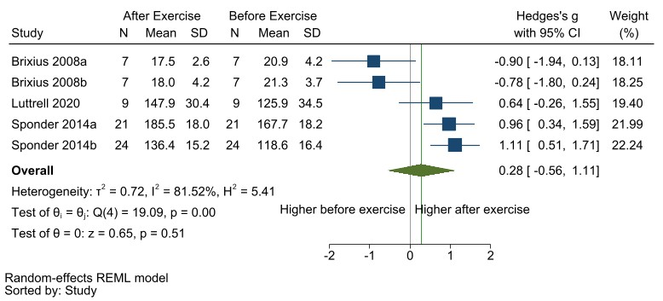
Additional file 4. Meta-analysis of resting endostatin concentrations pre-and-post exercise. No change was found in endostatin with exercise.

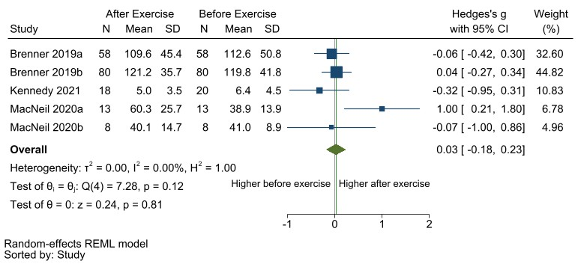

Additional file 5. Meta-analysis of resting FGF2 concentrations pre-and-post exercise. No change was found in FGF2 with exercise.

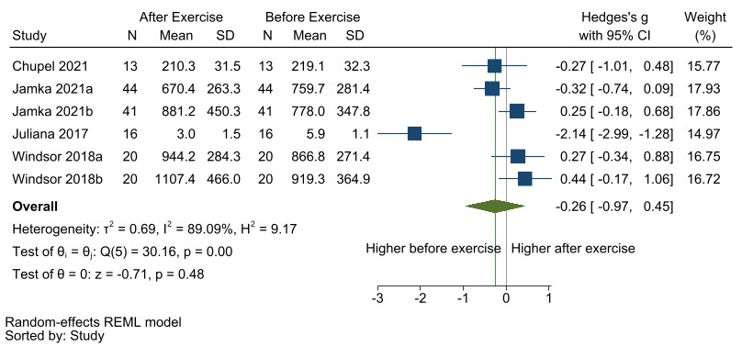
Additional file 6. Meta-analysis of resting MMP9 concentrations pre-and-post exercise. No change was found in MMP9 with exercise.

Additional file 7. Systematic review summary
Protein | Study | Exercise Type | Exercise Length | Exercise Modality | Compartment | Direction | Included in meta-analysis
Angiogenin | Bruserud 2005 | aerobic | 1 session | mountain walk 12km | serum | Unclear, but no significant change | N
ANGPTL2 | Larouche 2015a | aerobic | 1 session | bicycle ergometer | plasma | Increased | N
ANGPTL2 | Larouche 2015b | aerobic | 1 session | bicycle ergometer | plasma | Increased | N
ANGPTL4 | Li 2020 | aerobic | ≥4 weeks | treadmill | serum | Increased | N
ANGPTL4 | Sabaratnam 2018 | aerobic | 1 session | bicycle ergometer | plasma | Increased* | N
CD62E | Brevetti 2001 | aerobic | 1 session | treadmill (graded) | plasma | Increasedª | Y
CD62E | El-Kader 2019a | aerobic | ≥4 weeks | treadmill | serum | Decreased* | Y
CD62E | El-Kader 2019b | resistance training | ≥4 weeks | resistance training | serum | Decreased* | Y
CD62E | Goldberg 2016 | aerobic | ≥4 weeks | Education program on diet, exercise, and behaviour modification | plasma | Decreased* | N
CD62E | Lim 2015 | aerobic | ≥4 weeks | walking | serum | Decreased* | Y
CD62E | Niebauer 2005 | both | ≥4 weeks | bicycle ergometer and calisthenics | plasma | Decreased | Y
CD62E | Niederseer 2016 | aerobic | ≥4 weeks | skiing | plasma | Decreased* | Y
Endostatin | Brixius 2008a | aerobic | ≥4 weeks | running | plasma | Decreased* | Y
Endostatin | Brixius 2008b | aerobic | ≥4 weeks | cycling | plasma | Decreased* | Y
Endostatin | Bruserud 2005 | aerobic | 1 session | mountain walk 12km | serum | Not reported | N
Endostatin | Luttrell 2020 | aerobic | 1 session | bicycle ergometer | serum | Increased | Y
Endostatin | Sponder 2014a | aerobic | 1 session | bicycle ergometer | serum | Increased* | Y
Endostatin | Sponder 2014b | aerobic | 1 session | bicycle ergometer | serum | Increased* | Y
FGF2 | Adams 2004 | aerobic | 1 session | bicycle ergometer | plasma | Not reported | N
FGF2 | Brenner 2019a | aerobic | ≥4 weeks | unspecific, any aerobic | plasma | Increasedª | Y
FGF2 | Brenner 2019b | aerobic | ≥4 weeks | unspecific, any aerobic | plasma | Decreasedª | Y
FGF2 | Bruserud 2005 | aerobic | 1 session | mountain walk 12km | serum | Decreased* | N
FGF2 | Kennedy 2021 | both | ≥4 weeks | Aerobic exercise and resistance training | serum | Decreased | Y
FGF2 | MacNeil 2020a | aerobic | 1 session | bicycle ergometer | plasma | Increased ª | Y
FGF2 | MacNeil 2020b | aerobic | 1 session | bicycle ergometer | plasma | Increased ª | Y
HGF | Kolasa-Trela 2017 | aerobic | 1 session | bicycle ergometer | plasma | Increased ª | N
MMP2 | Jamka 2021a | aerobic | ≥4 weeks | Endurance training | serum | Decreased | N
MMP2 | Jamka 2021b | both | ≥4 weeks | Endurance-strength training | serum | Decreased | N
MMP9 | Chupel 2021 | both | ≥4 weeks | combined resistance exercise with elastic bands and aerobic activities | plasma | Decreased | Y
MMP9 | Jamka 2021a | aerobic | ≥4 weeks | Endurance training | serum | Decreased | Y
MMP9 | Jamka 2021b | both | ≥4 weeks | Endurance-strength training | serum | Increased | Y
MMP9 | Juliana 2017 | unspecified | ≥4 weeks | Exercise education | serum | Decreased | Y
MMP9 | Windsor 2018a | aerobic | 1 session | bicycle ergometer | blood (unspecified) | Increased* | Y
MMP9 | Windsor 2018b | aerobic | 1 session | bicycle ergometer | blood (unspecified) | Increased* | Y
PDGF-AA | MacNeil 2020a | aerobic | 1 session | bicycle ergometer | plasma | Increased ª | N
PDGF-AA | MacNeil 2020b | aerobic | 1 session | bicycle ergometer | plasma | Increased ª | N
PDGF-BB | MacNeil 2020a | aerobic | 1 session | bicycle ergometer | plasma | Increased | N
PDGF-BB | MacNeil 2020b | aerobic | 1 session | bicycle ergometer | plasma | Increased ª | N
PIGF | Kennedy 2021 | both | ≥4 weeks | Aerobic exercise and resistance training | serum | Decreased | N
TSP-1 | Luttrell 2020 | aerobic | 1 session | bicycle ergometer | serum | Increased* | N
VEGF | Adams 2004 | aerobic | 1 session | bicycle ergometer | plasma | Increased | Y
VEGF | Adams 2008 | aerobic | 1 session | marathon race | plasma | Decreased* | Y
VEGF | Brenner 2019a | aerobic | ≥4 weeks | unspecific, any aerobic | plasma | Increased ª | Y
VEGF | Brenner 2019b | aerobic | ≥4 weeks | unspecific, any aerobic | plasma | Decreased ª | Y
VEGF | Brixius 2008a | aerobic | ≥4 weeks | running | plasma | Increased | Y
VEGF | Brixius 2008b | aerobic | ≥4 weeks | cycling | plasma | Decreased | Y
VEGF | Cho 2019 | aerobic | ≥4 weeks | taekwondo | serum | Increased* | Y
VEGF | Despeghel 2021 | both | ≥4 weeks | combined strength training and endurance training (cycle ergometers/cross-trainers) | plasma | Decreased* | Y
VEGF | Duggan 2014 | aerobic | ≥4 weeks | aerboic exericse; treadmill walking and stationary bicycling, variety of home exercises were suggested and encouraged, including walking, aerobics, and bicycling. | serum | Decreased | Y
VEGF | Duggan 2016 | aerobic | ≥4 weeks | aerobic exercise | serum | Decreased | Y
VEGF | Formica 2020 | both | ≥4 weeks | cycling, treadmill, walking, postural exercises, progressive resistance training | serum | Decreased | Y
VEGF | Grace 2015a | aerobic | ≥4 weeks | Aerobic exercise training and HITT | serum | Increased* | Y
VEGF | Grace 2015b | aerobic | ≥4 weeks | HIIT | serum | Decreased | Y
VEGF | Izzicupo 2017 (1)a | aerobic | ≥4 weeks | walking | plasma | Increased | Y
VEGF | Izzicupo 2017 (2)a | aerobic | ≥4 weeks | walking | plasma | Increased | Y
VEGF | Izzicupo 2017 (2)b | aerobic | ≥4 weeks | nordic walking | plasma | Increased* | Y
VEGF | Jamka 2021a | aerobic | ≥4 weeks | Endurance training | serum | Decreased | Y
VEGF | Jamka 2021b | both | ≥4 weeks | Endurance-strength training | serum | Increased | Y
VEGF | Kang 2020 | aerobic | ≥4 weeks | Aquatic exercise program | serum | Increased | Y
VEGF | Kennedy 2021 | both | ≥4 weeks | Aerobic exercise and resistance training | serum | Decreased | Y
VEGF | Kolasa-Trela 2017 | aerobic | 1 session | bicycle ergometer | plasma | Increased ª | Y
VEGF | Luttrell 2020 | aerobic | 1 session | bicycle ergometer | serum | Increased* | Y
VEGF | Maass 2016 | aerobic | ≥4 weeks | walking/running | serum | Increased ª | Y
VEGF | MacNeil 2020a | aerobic | 1 session | bicycle ergometer | plasma | Increased ª | Y
VEGF | MacNeil 2020b | aerobic | 1 session | bicycle ergometer | plasma | Decreased ª | Y
VEGF | Marston 2019a | resistance training | ≥4 weeks | resistance training | serum | Decreased | Y
VEGF | Marston 2019b | resistance training | ≥4 weeks | resistance training | serum | Increased | Y
VEGF | Pakiz 2011 | unspecified | ≥4 weeks | Exercise counselling | blood (unspecified) | Increased | Y
VEGF | Park 2010 | both | ≥4 weeks | combined aerboic +elastic band + yoga program | plasma | Increased* | Y
VEGF | Park 2020 | both | ≥4 weeks | combined resistance training sessions and treadmill/biking aerobic exercises | serum | Decreased | Y
VEGF | Ratajczak 2019a | aerobic | ≥4 weeks | bicycle ergometer | serum | Increased | Y
VEGF | Ratajczak 2019b | both | ≥4 weeks | bicycle ergometer and strength training | serum | Increased | Y
VEGF | Roh 2020 | resistance training | ≥4 weeks | resistance training | serum | Increased | Y
VEGF | Ross 2018 | aerobic | 1 session | bicycle ergometer | plasma | Increased | Y
VEGF | Sandri 2016 | aerobic | ≥4 weeks | bicycle ergometer | plasma | Increased | Y
VEGF | Thijssen 2006a | aerobic | ≥4 weeks | bicycle ergometer | plasma | Decreased | Y
VEGF | Thijssen 2006b | aerobic | 1 session | bicycle ergometer | plasma | Decreased | Y
VEGF | Voss 2013a | aerobic | ≥4 weeks | Walking | serum | Increased | Y
VEGF | Voss 2013b | resistance training | ≥4 weeks | non-aerobic flexibility, toning, and balance exercises. Four muscle toning exercises utilizing dumbbells or resistance bands, two exercises designed to improve balance, one yoga sequence, and one exercise of their choice | serum | Increased | Y
VEGF | Yasar 2021 | aerobic | ≥4 weeks | Sprint interval training | serum | Decreased | Y
VEGF-C | Kennedy 2021 | both | ≥4 weeks | Aerobic exercise and resistance training | serum | Increased | N
VEGF-D | Kennedy 2021 | both | ≥4 weeks | Aerobic exercise and resistance training | serum | Increased | N
*significant results, p-value < 0.05
ªsignificance (p-value) not reported

Additional file 8. Quality of Assessmentª
Study | Population Representative | Intervention Adequately Described | Outcomes Reported Objectively | Follow-up rate reported and adequate (dropout < 50%) | Adherence to intervention Reported | Adherence to intervention adequate (> 50%) | Protein Assay Details Reported Adequately | Co-interventions Documented If Present | Overall likelihood of high quality evidence
Adams 2004 | + | ? | + | ? | - | ? | + | + | ?
Adams 2008 | + | + | + | + | + | + | + | + | +
Brenner 2019 | + | ? | + | + | + | + | + | + | +
Brevetti 2001 | + | + | + | + | - | ? | + | + | +
Brixius 2008 | ? | + | + | - | ? | + | + | + | ?
Bruserud 2005 | + | + | + | - | - | ? | + | + | +
Cho 2019 | + | + | + | + | + | - | + | + | +
Chupel 2021 | + | + | + | - | - | ? | + | + | ?
Despeghel 2021 | - | + | + | + | + | + | + | + | ?
Duggan 2014 | + | + | + | + | + | + | + | + | +
Duggan 2016 | + | + | + | + | ? | ? | + | + | +
El-Kader 2019 | + | + | + | - | - | ? | + | + | +
Formica 2020 | + | + | + | + | + | + | + | + | +
Goldberg 2016 | + | ? | + | + | + | + | ? | + | ?
Grace 2015 | + | + | + | + | + | + | + | + | +
Izzicupo 2017 | + | + | + | - | + | + | + | + | +
Izzicupo 2017 | + | + | + | + | + | + | + | + | +
Jamka 2021 | + | + | + | + | + | + | + | + | +
Juliana 2017 | + | ? | + | + | + | + | + | + | ?
Kang 2020 | + | + | + | - | ? | ? | + | + | +
Kennedy 2021 | + | + | + | + | + | + | + | + | +
Kolasa-Trela 2017 | + | + | + | + | - | ? | + | + | +
Larouche 2015 | + | + | + | + | + | + | + | + | +
Li 2020 | + | + | + | - | + | + | + | + | +
Lim 2015 | + | + | + | - | - | ? | + | + | +
Luttrell 2020 | + | + | + | + | + | + | + | + | +
Maass 2016 | + | + | + | + | - | ? | + | + | +
MacNeil 2020 | + | + | + | + | + | + | + | + | +
Marston 2019 | + | + | + | + | + | + | + | + | +
Niebauer 2005 | + | + | + | - | + | + | + | + | +
Niederseer 2016 | ? | + | + | + | + | + | + | + | ?
Pakiz 2011 | + | - | + | + | ? | ? | ? | + | ?
Park 2010 | + | + | + | - | - | ? | + | + | +
Park 2020 | + | + | + | + | - | ? | + | + | +
Ratajczak 2019 | + | + | + | + | + | + | + | + | +
Roh 2020 | + | + | + | + | - | ? | + | + | +
Ross 2018 | + | + | + | + | + | + | + | + | +
Sabaratnam 2018 | + | + | + | + | ? | ? | + | + | +
Sandri 2016 | + | + | + | + | + | + | + | + | +
Sponder 2014 | + | + | + | + | + | + | + | + | +
Thijssen 2006 | + | + | + | + | - | ? | + | + | +
Voss 2013 | + | + | + | ? | + | + | + | + | +
Windsor 2018 | + | + | + | - | - | ? | ? | + | ?
Yasar 2021 | + | + | + | + | - | ? | + | + | +
“+” = yes; “-“ = no; “?” = unclear.
ª Assessed based on the published articles and data received during correspondence.

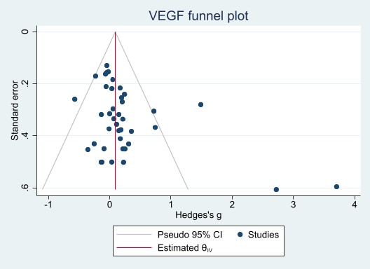

Additional file 9. Funnel plot for meta-analysis of VEGF pre-and post-exercise comparisons. Egger’s test was significant (B[SE] = 1.91 [0.62], p = 0.002). Trim-and-fill did not impute any studies.

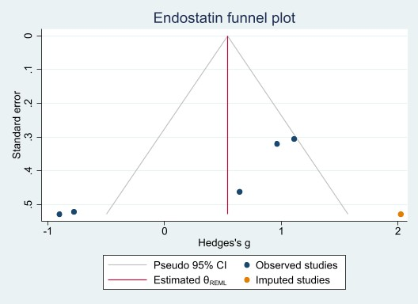

Additional file 10. Funnel plot for meta-analysis of endostatin pre-and post-exercise comparisons. Egger’s test was significant (B[SE] = -7.62 [1.90], p < 0.0001). After trim-and-fill (1 study imputed), the estimated effect size remained non-significant (estimated SMD [95%CI] = 0.54 [-0.33, 1.41]).

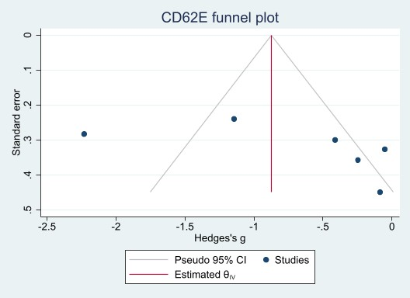
Additional file 11. Funnel plot for meta-analysis of CD62E pre-and post-exercise comparisons. Egger’s test was not significant (B[SE] = 7.31 [4.95], p = 0.1).

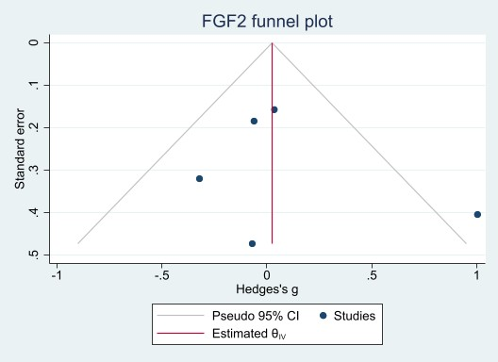

Additional file 12. Funnel plot for meta-analysis of FGF2 pre-and post-exercise comparisons. Egger’s test: B[SE] = 1.11 [1.61], p = 0.5.

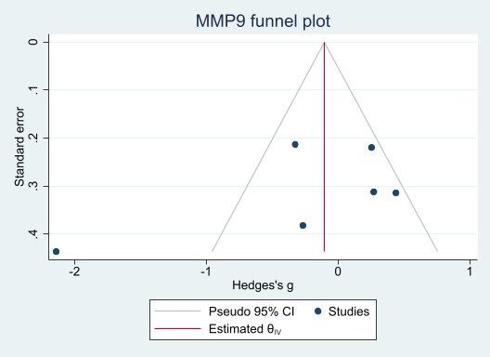
Additional file 13. Funnel plot for meta-analysis of MMP9 pre-and post-exercise comparisons. Egger’s test was not significant (B[SE] = -6.52 [4.02], p = 0.1).

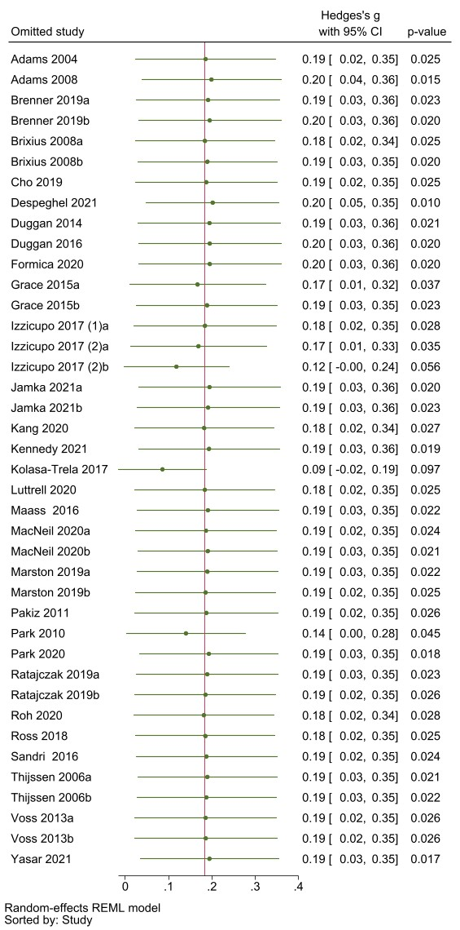
Additional file 14. VEGF leave-one-out meta-analysis findings.

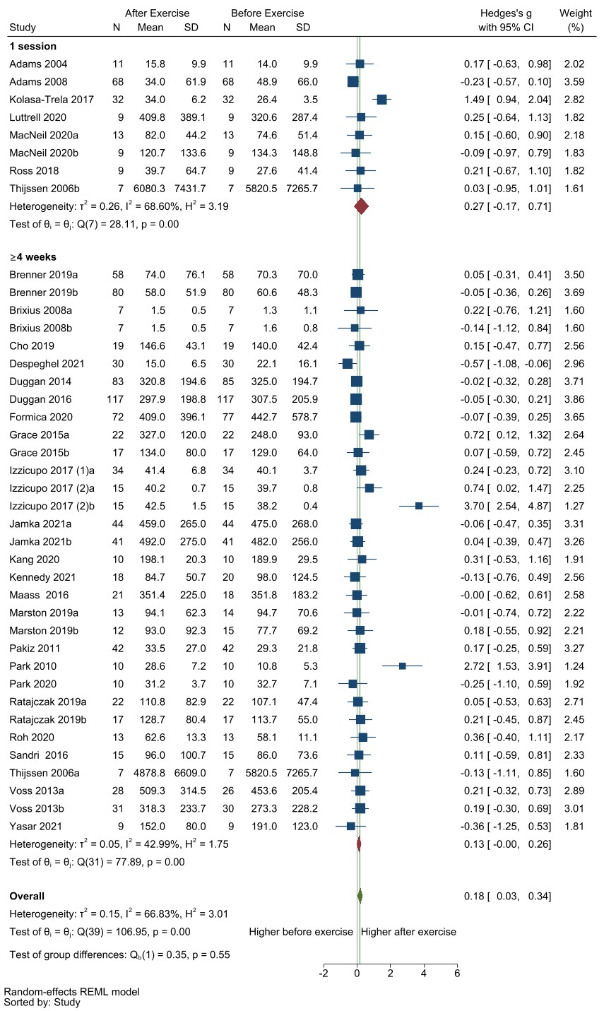
Additional file 15. Subgroup analysis of exercise duration on resting VEGF concentrations pre-and-post exercise. Studies all had either at least 4 weeks of exercise (≥4 weeks; SMD [95%CI] = 0.13 [-0.003, 0.26], p = 0.06) or had a single session of exercise (1 session; SMD [95%CI] = 0.27 [-0.17, 0.71], p = 0.2).

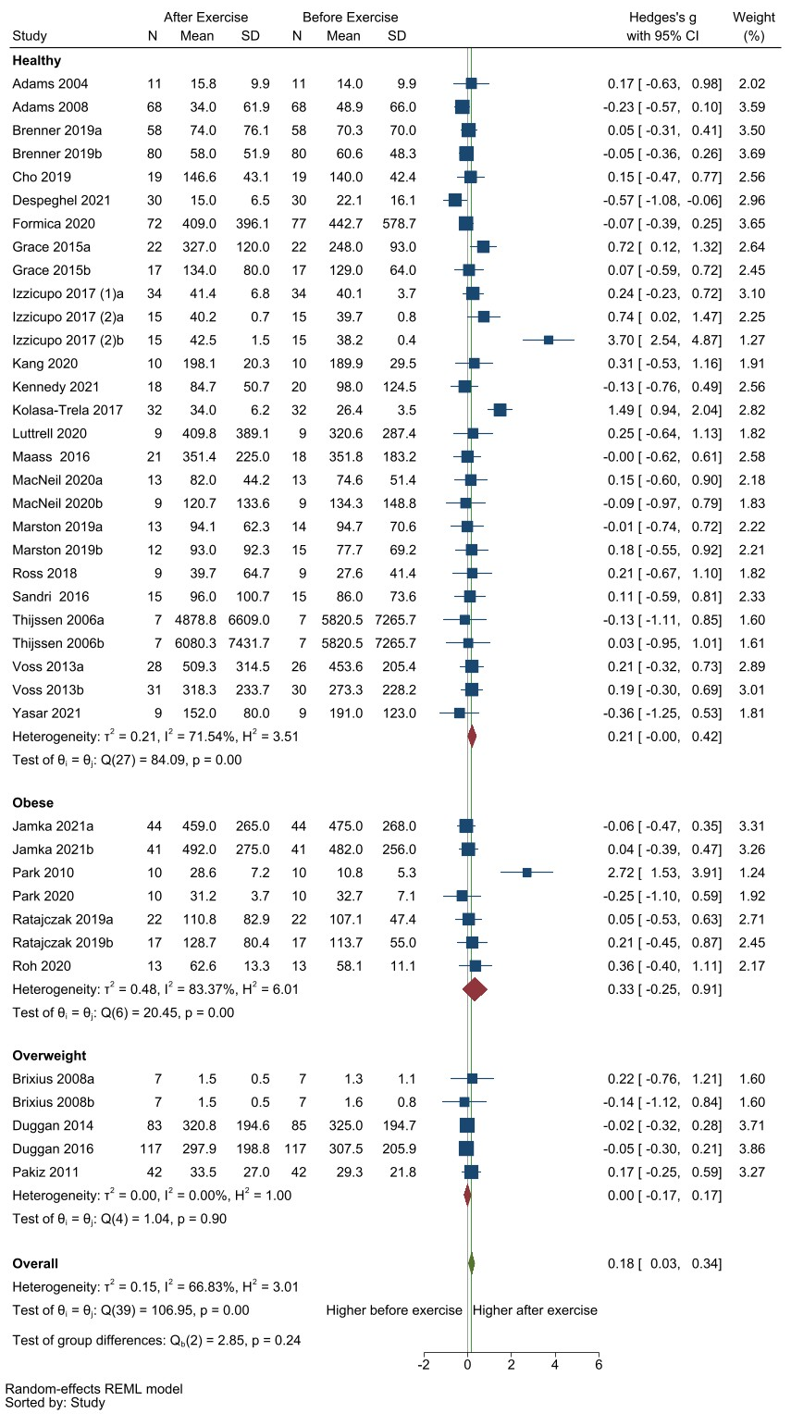
Additional file 16. Subgroup analysis of population on resting VEGF concentrations pre-and-post exercise. Based on the description from the studies, they were categorized into healthy (SMD [95%CI] = 0.21 [-0.004, 0.42], p= 0.05), obese (SMD [95%CI] = 0.33 [-0.25, 0.91], p= 0.3) or overweight subgroups (SMD [95%CI] = 0.00 [-0.17, 0.17], p= 0.98).
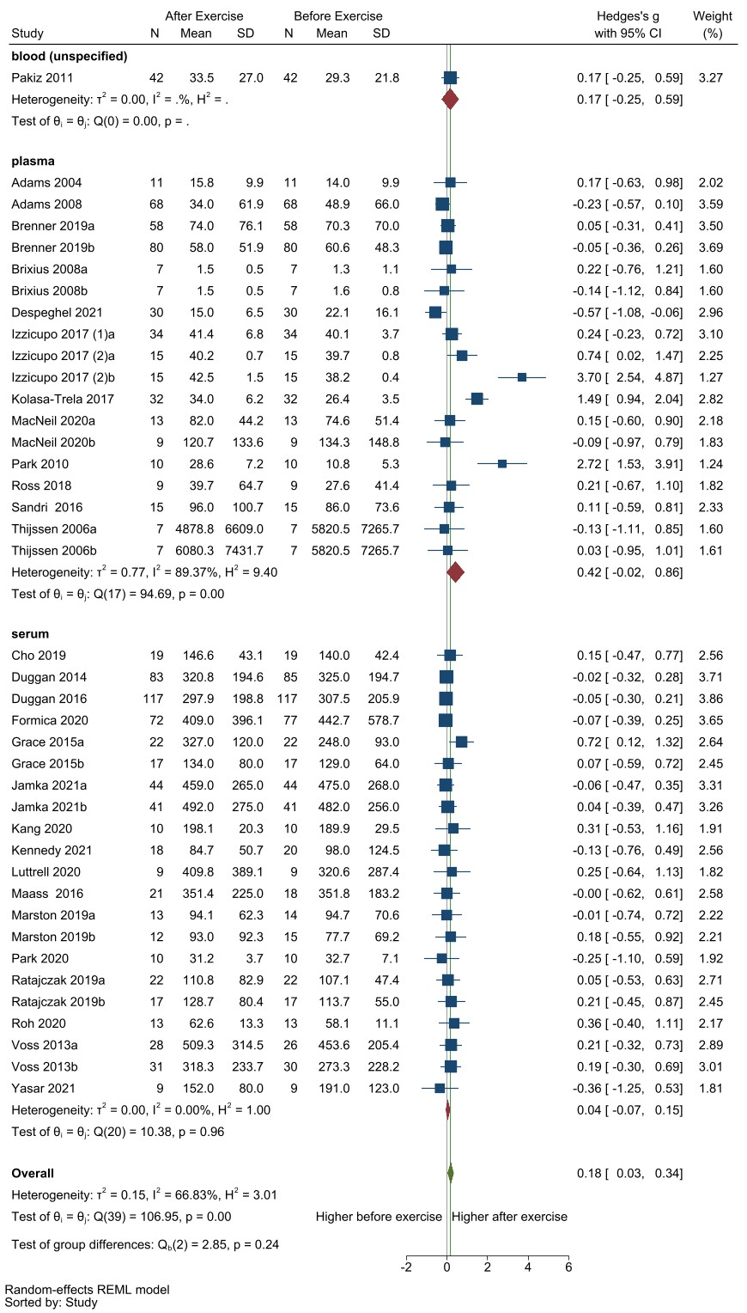
Additional file 17. Sub-group analysis of the compartment measured on resting VEGF concentrations pre-and-post exercise. Studies measured the marker concentrations either from serum (SMD [95%CI] = 0.04 [-0.07, 0.15], p = 0.5), plasma (SMD [95%CI] = 0.42 [-0.02, 0.86], p = 0.06), or blood (unspecified: only one comparison).

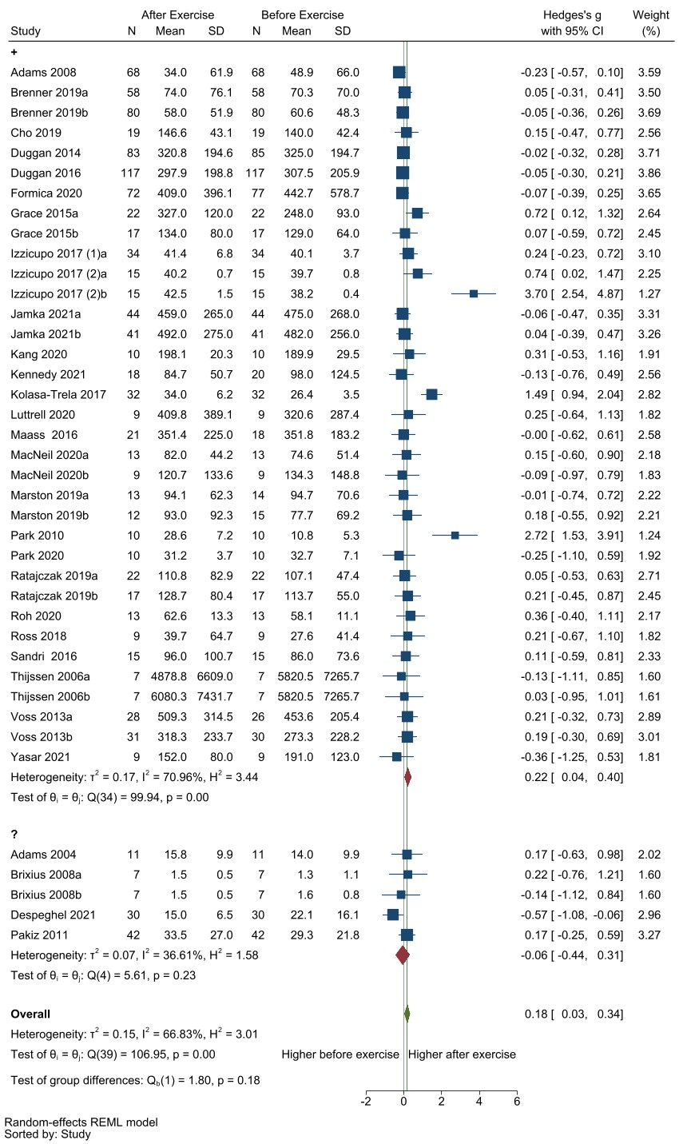
Additional file 18. Subgroup analysis of risk of bias on resting VEGF concentrations pre-and-post exercise. Studies either had unclear overall risk of bias (“?”: SMD [95%CI] = -0.07 [-0.44, 0.31], p = 0.7) or low overall risk of bias (“+”: SMD [95%CI] = 0.22 [0.04, 0.40], p = 0.01).

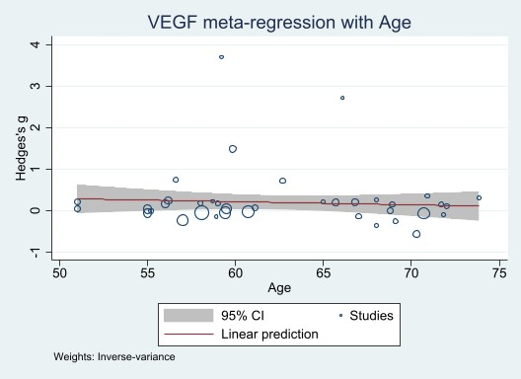
Additional file 19. Meta-regression of mean baseline age on resting VEGF concentrations pre-and-post exercise. Age showed no significant association with the VEGF change (B[95% CI] = -0.0076 [-0.034, 0.019], p = 0.6).

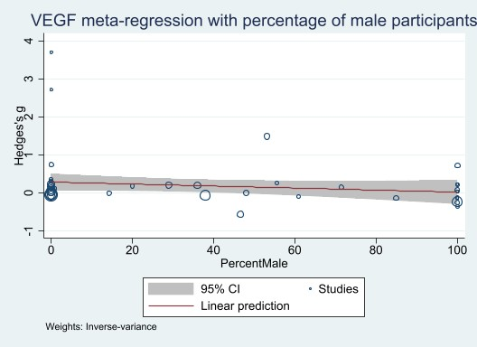
Additional file 20. Meta-regression of percentage of male participants on resting VEGF concentrations pre-and-post exercise. The percentage of male participants showed no significant association with the VEGF change (B[95% CI] = -0.0026 [-0.0068, 0.0015], p = 0.2).

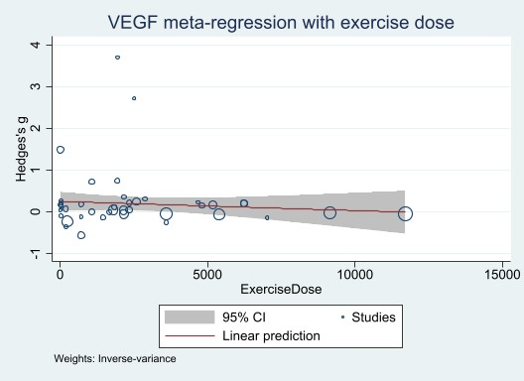

Additional file 21. Meta-regression of exercise dose on resting VEGF concentrations pre-and-post exercise. Exercise dose showed no significant association with the VEGF change (B[95% CI] = -0.000022 [-0.000077, 0.000033], p = 0.4).

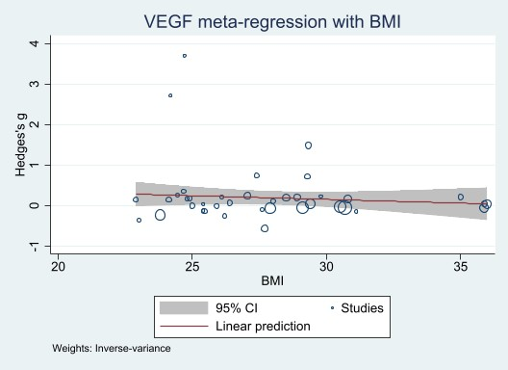
Additional file 22. Meta-regression of baseline BMI on resting VEGF concentrations pre-and-post exercise. Baseline BMI showed no significant association with the VEGF change (B[95% CI] = -0.18 [-0.65, 0.029], p = 0.4).

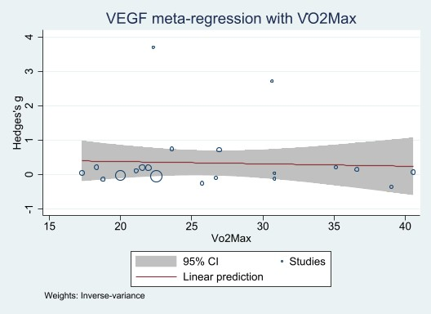

Additional file 23. Meta-regression of baseline V̇O_{2max} on resting VEGF concentrations pre-and-post exercise. Baseline V̇O_{2max} showed no significant association with the VEGF change (B[95% CI] = -0.0067 [-0.59, 0.045], p = 0.8).

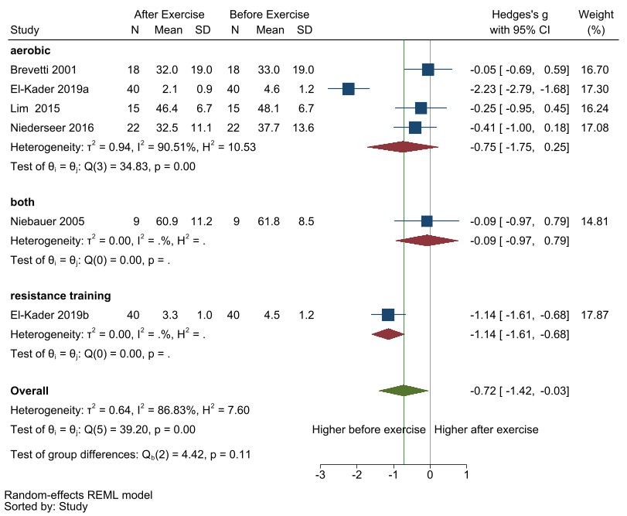
Additional file 24. Subgroup analysis of exercise type on resting CD62E concentrations pre-and-post exercise. Studies either had aerobic exercise (aerobic; SMD [95%CI] = -0.75 [-1.75, 0.25], p= 0.1), resistance training (only one comparison), or a combination of both aerobic and resistance training (both: only one comparison).

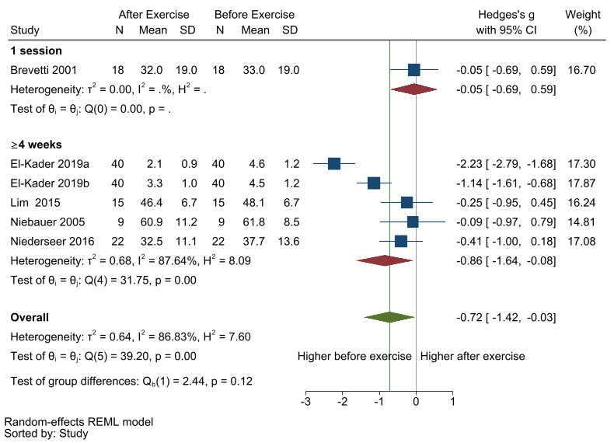
Additional file 25. Subgroup analysis of exercise duration on resting CD62E concentrations pre-and-post exercise. Studies all had either at least 4 weeks of exercise (≥4 weeks: SMD [95%CI] = -0.86 [-1.64, -0.08], p= 0.03) or had a single session of exercise (1 session: only one comparison).

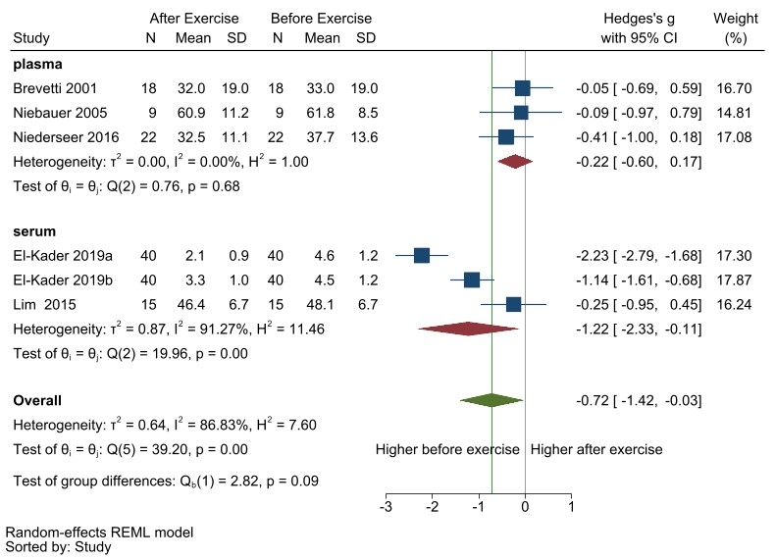
Additional file 26. Subgroup analysis of compartment measured on resting CD62E concentrations pre-and-post exercise. Studies measured the marker concentrations either from plasma (SMD [95%CI] = -0.22 [-0.60, 0.17], p= 0.3) or serum (SMD [95%CI] = -1.22 [-2.33, -0.11], p= 0.03).

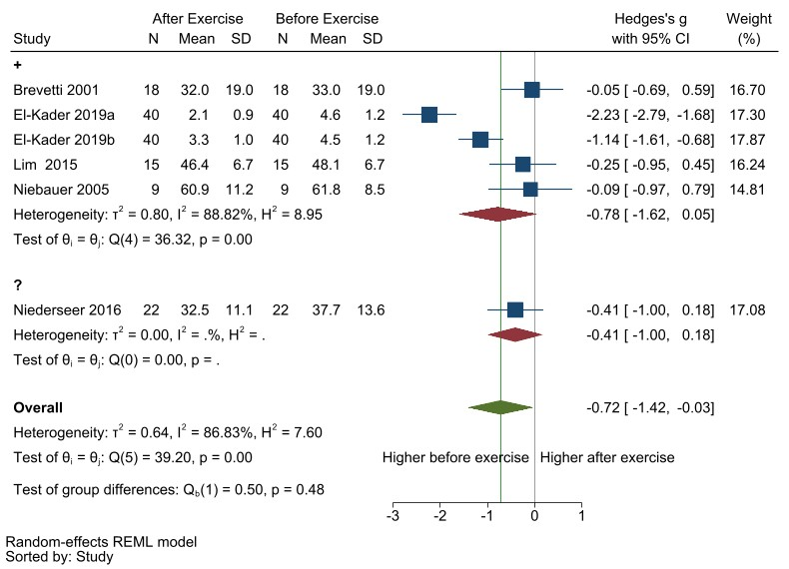
Additional file 27. Subgroup analysis of potential risk of bias on resting CD62E concentrations pre-and-post exercise. Studies either had low overall risk of bias (“+”: SMD [95%CI] = -0.78 [-1.62, 0.05], p= 0.07) or unclear overall risk of bias (“?”: only one comparison).

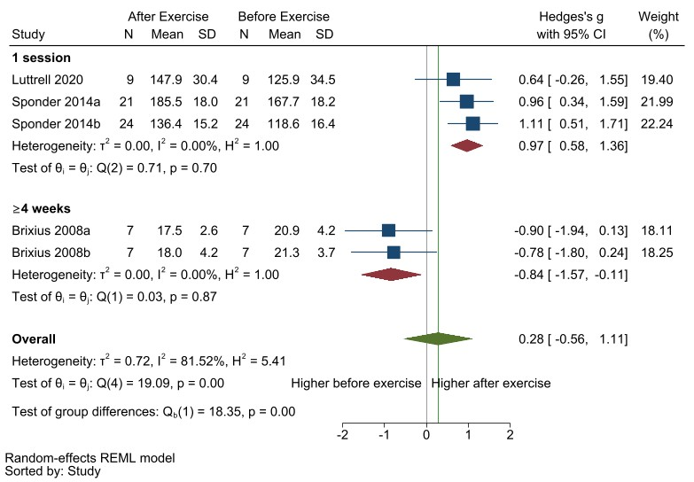
Additional file 28. Subgroup analysis of exercise duration on resting endostatin concentrations pre-and-post exercise. Studies all had either a single session of exercise (1 session: SMD [95%CI] = 0.97 [0.58, 1.36], p< 0.001) or at least 4 weeks of exercise (≥4 weeks: only two comparisons).

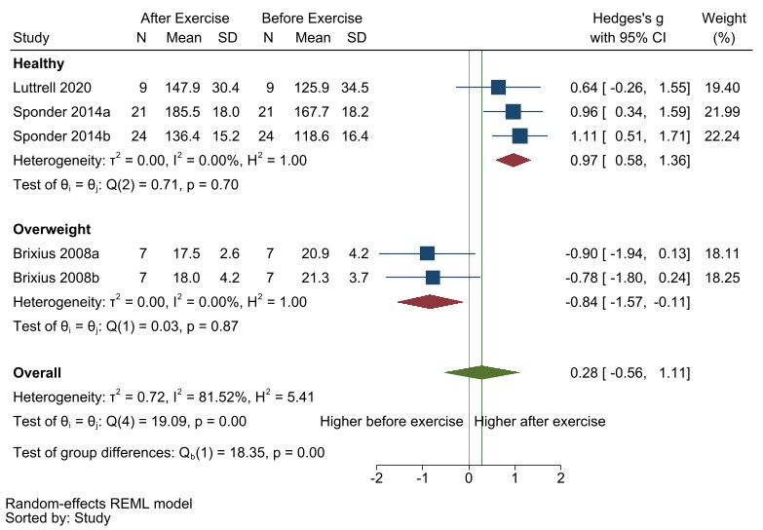
Additional file 29. Subgroup analysis of population on resting endostatin concentrations pre-and-post exercise. Based on the description from the studies, they were all able to be categorized into healthy (SMD [95%CI] = 0.97 [0.58, 1.36], p< 0.001) or overweight (only two comparisons).

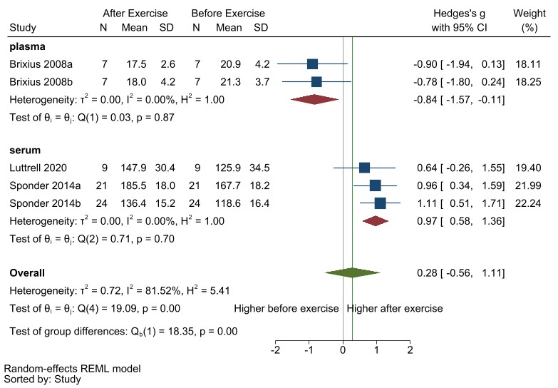
Additional file 30. Subgroup analysis of compartment measured on resting endostatin concentrations pre-and-post exercise. Studies measured the marker concentrations either from serum (SMD [95%CI] = 0.97 [0.58, 1.36], p< 0.001) or plasma (only two comparisons).

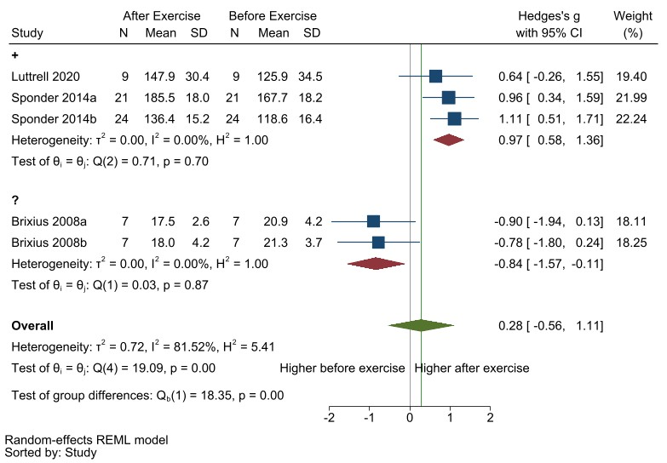
Additional file 31. Subgroup analysis of potential risk of bias on resting endostatin concentrations pre-and-post exercise. Studies either had unclear overall risk of bias (“?”: only two comparisons) or low overall risk of bias (“+”: SMD [95%CI] = 0.97 [0.58, 1.36], p< 0.001).

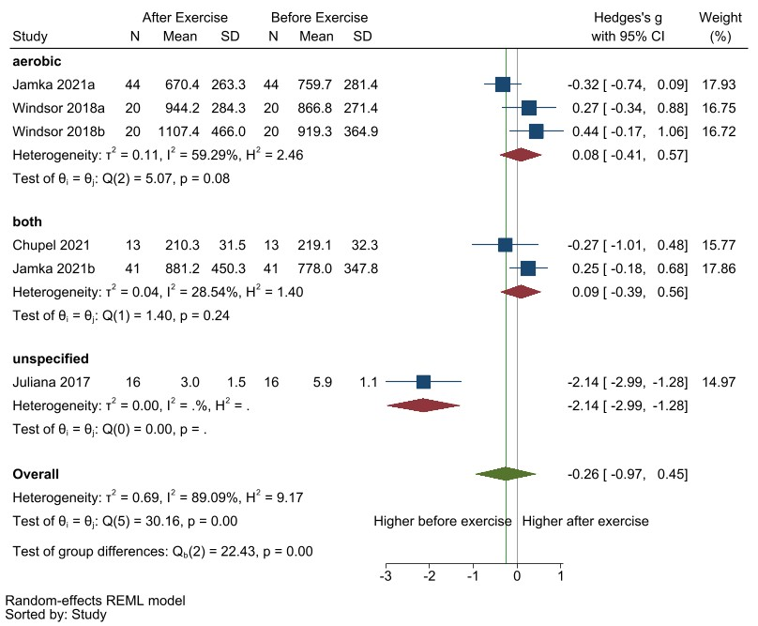
Additional file 32. Subgroup analysis of exercise type on resting MMP9 concentrations pre-and-post exercise. Studies either had aerobic exercise (SMD [95%CI] = 0.08 [-0.41, 0.57], p= 0.7), a combination of both aerobic and resistance training (both: only two comparisons), or did not specify the exercise intervention (unspecified: only one comparison).

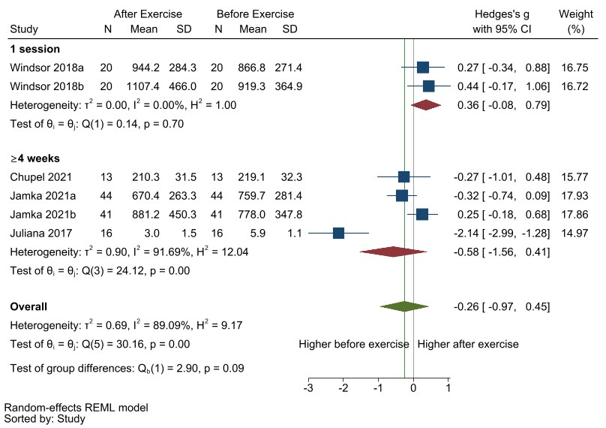
Additional file 33. Subgroup analysis of exercise duration on resting MMP9 concentrations pre-and-post exercise. Studies all had either more than 4 weeks of exercise (≥4 weeks: SMD [95%CI] = -0.58 [-1.56, 0.41], p= 0.3) or had a single session of exercise (1 session: only two comparisons)

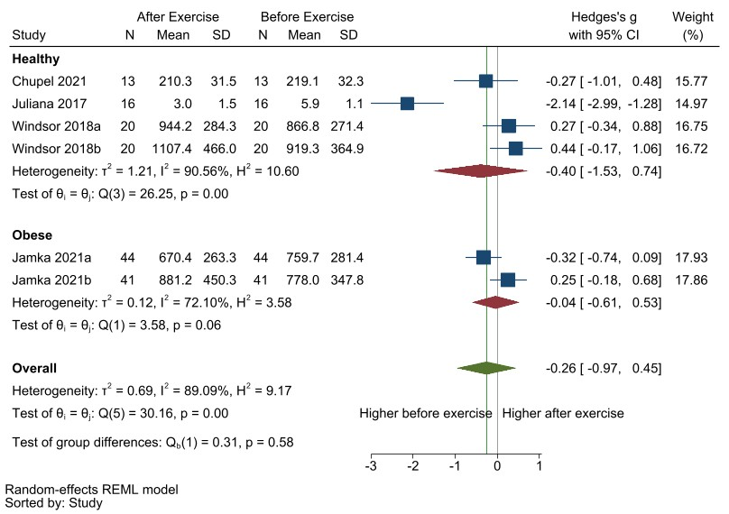
Additional file 34. Subgroup analysis of population on resting MMP9 concentrations pre-and-post exercise. Based on the description given in the published articles, they were able to be categorized into (SMD [95%CI] = -0.40 [-1.53, 0.74], p= 0.5) or obese (only two comparisons).

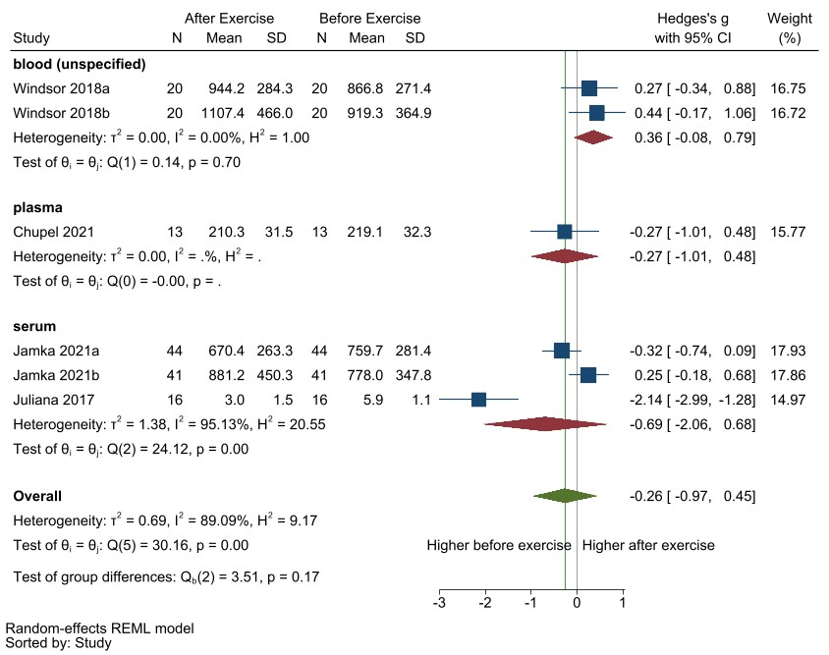
Additional file 35. Subgroup analysis of compartment measured on resting MMP9 concentrations pre-and-post exercise. Studies measured the marker concentrations either from serum (SMD [95%CI] = -0.69 [-2.06, 0.68], p= 0.3), plasma (only one comparison), or blood (unspecified: only two comparisons).

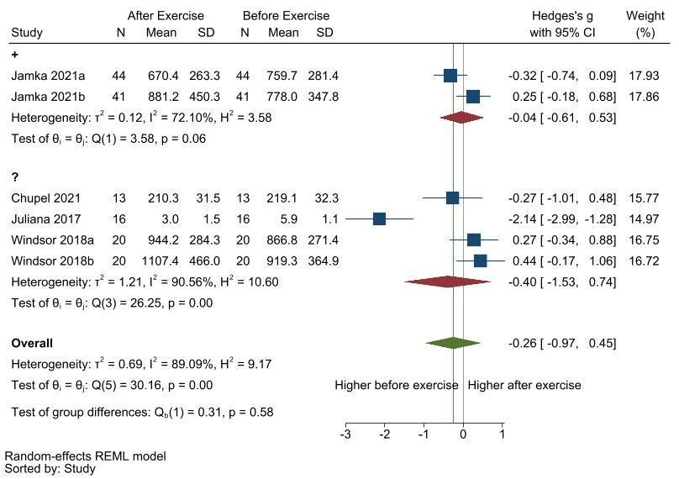
Additional file 36. Subgroup analysis of potential risk of bias on resting MMP9 concentrations pre-and-post exercise. Studies either had unclear overall risk of bias (“?”: SMD [95%CI] = -0.40 [-1.53, 0.74], p= 0.5) or low overall risk of bias (“+”: only two comparisons).

