In situ growth and characterization of lubricious carbon-based film using microscale colloidal probe microscopy

J. B. McClimon, J. Hilbert, K.M. Koshigan, J. Fontaine, J. Lukes, R.W. Carpick
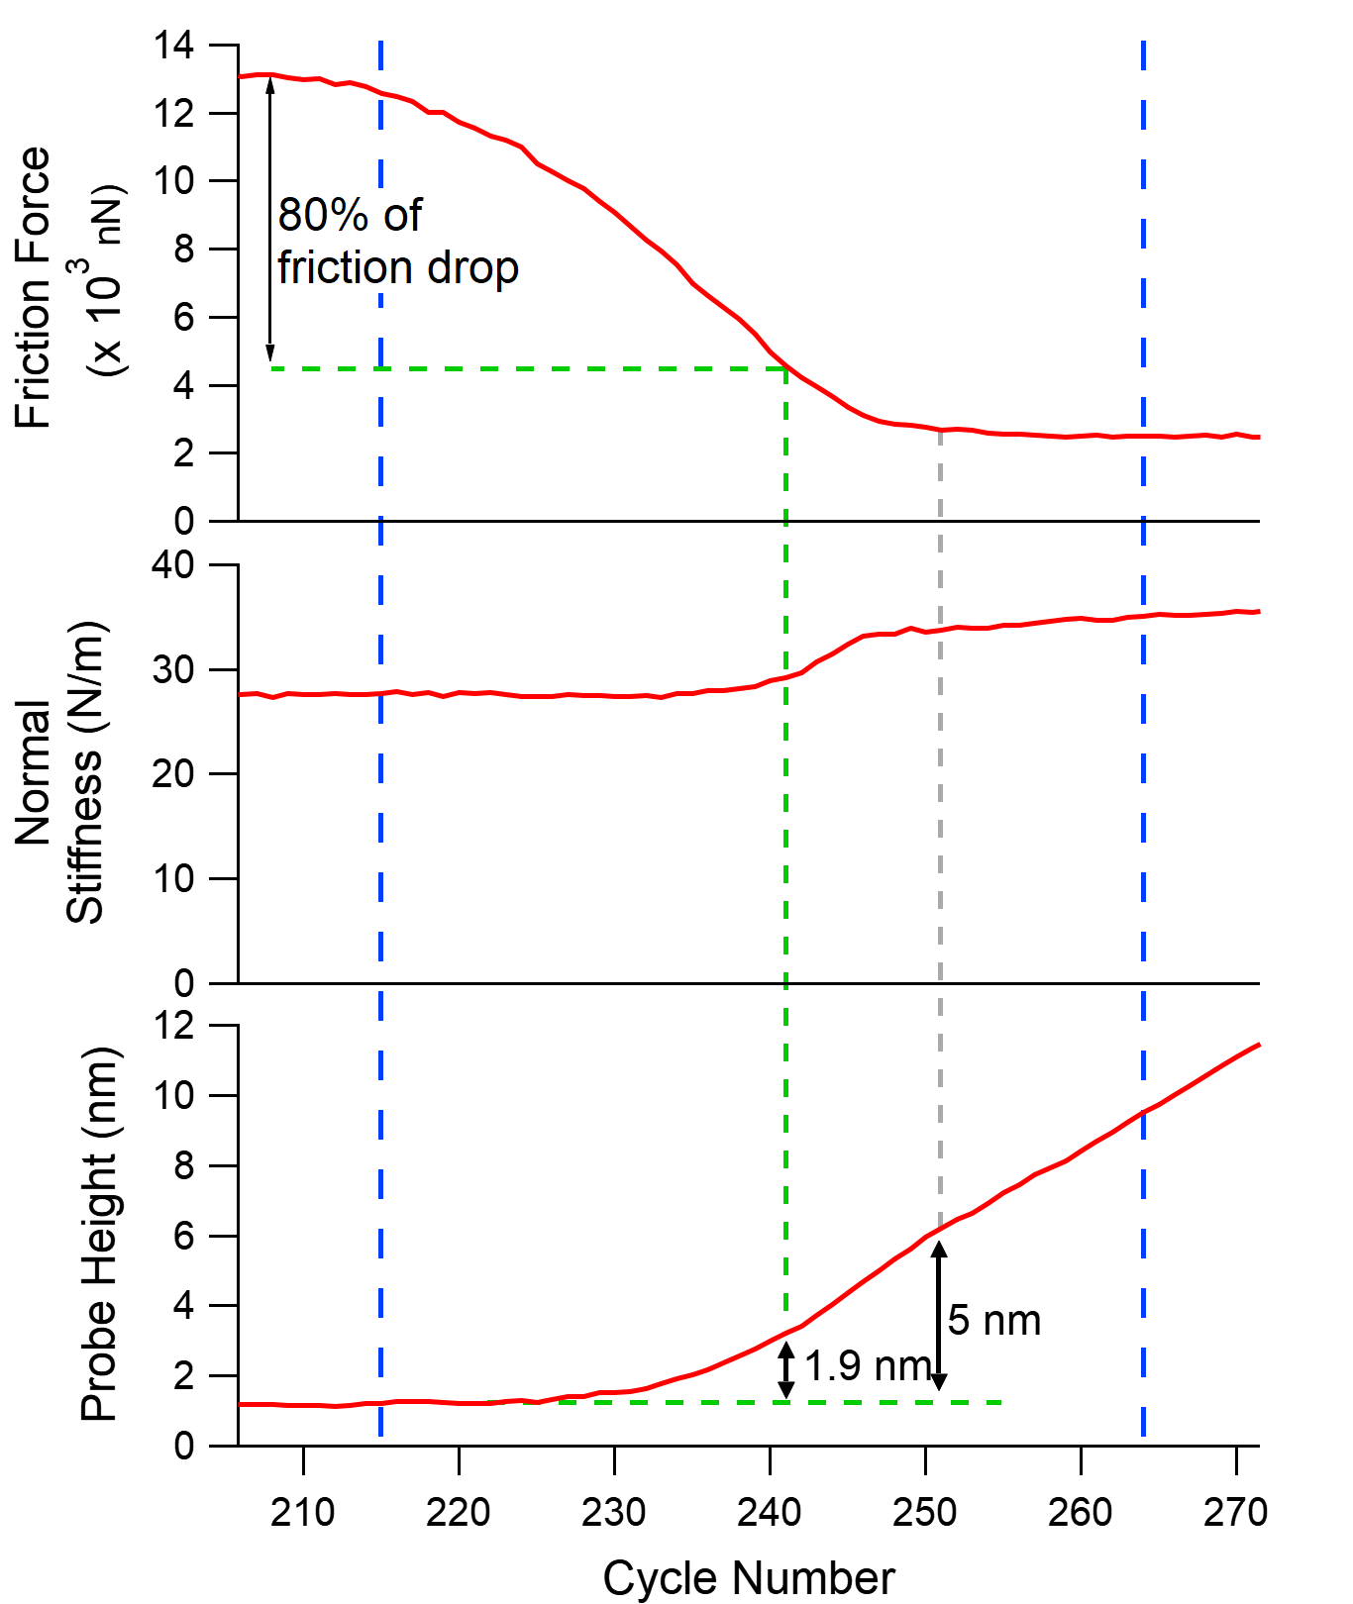
Figure S 1: Zoomed view of data in Figure 1. Demonstrates that friction reduction is complete prior to tribofilm thickness exceeding 5 nm, and 80% of friction drop is complete prior to tribofilm exceeding 2 nm thickness. Dashed blue vertical bars appear at the same cycle numbers as they do in the main text.

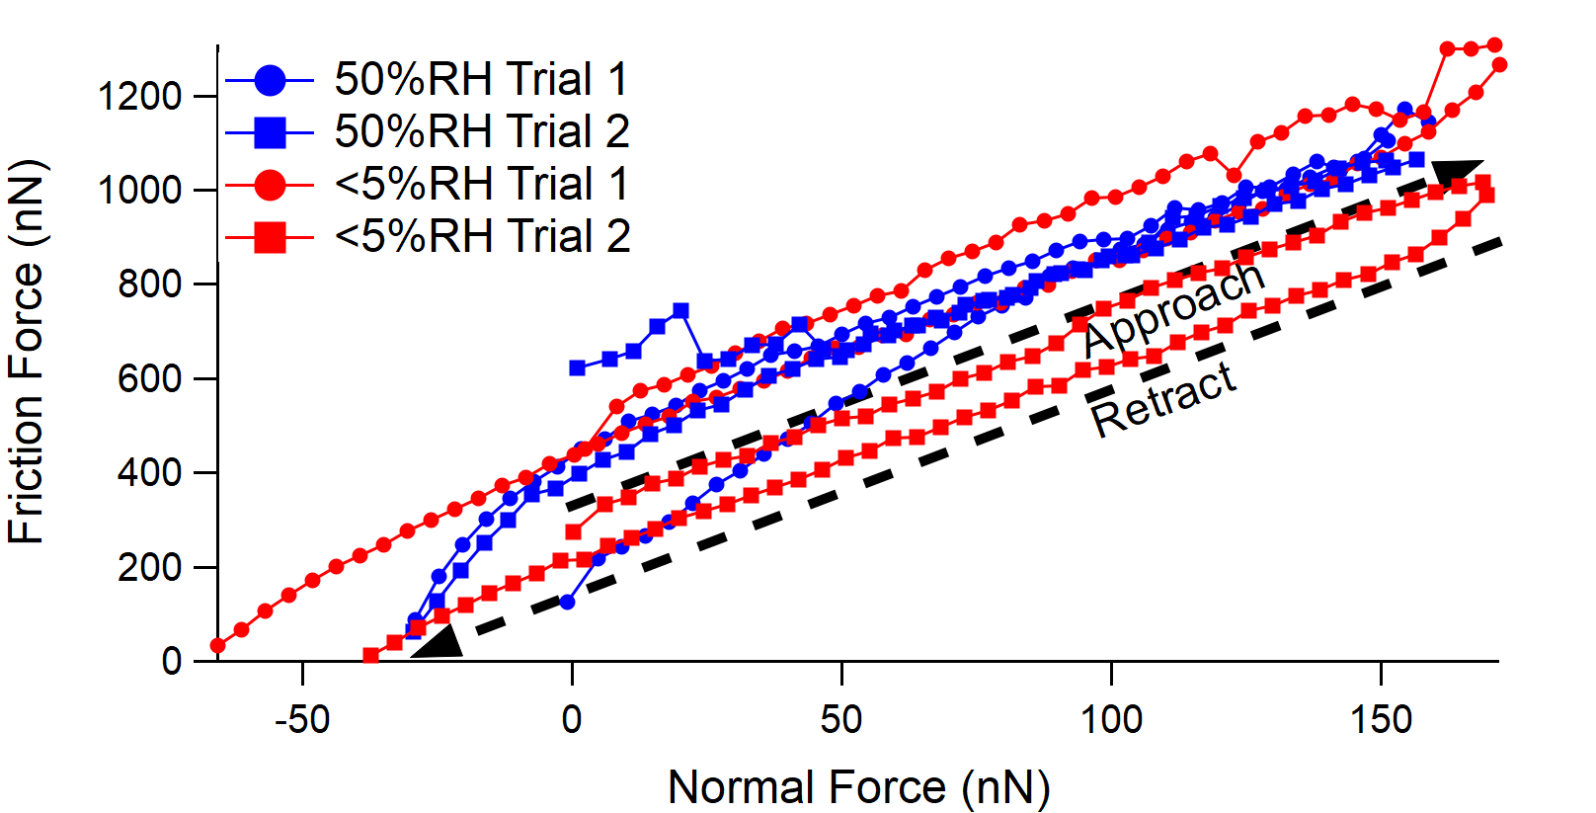
Figure S 2: Friction vs. load curves for the tribofilm on colloid geometry while sliding on unworn a-C:H:Si:O as a function of the relative humidity in N₂. Tests were performed by approaching via increasing the load setpoint, then retracting to pulloff, as indicated by arrows. The lack of repeatability in the low humidity trials suggests that the tribofilm geometry/structure evolve during the set of tests. There is no indication of the humidity dependence of the friction that was observed in macroscale testing. Also, there is no increase in adhesion for the humid environment, showing that capillary condensation does not occur here.

Tribofilm Growth with smaller colloid apex
The experiment discussed in the manuscript used a steel colloid where the colloid apex radius was close to the nominal value of 40 μm. Sometimes colloids had protrusions at the apex leading to much smaller radii, in some cases precluding the formation of a tribofilm under the experimental conditions. In other cases, the smaller radius did not preclude tribofilm formation and the comparison to the larger radius case is instructive.
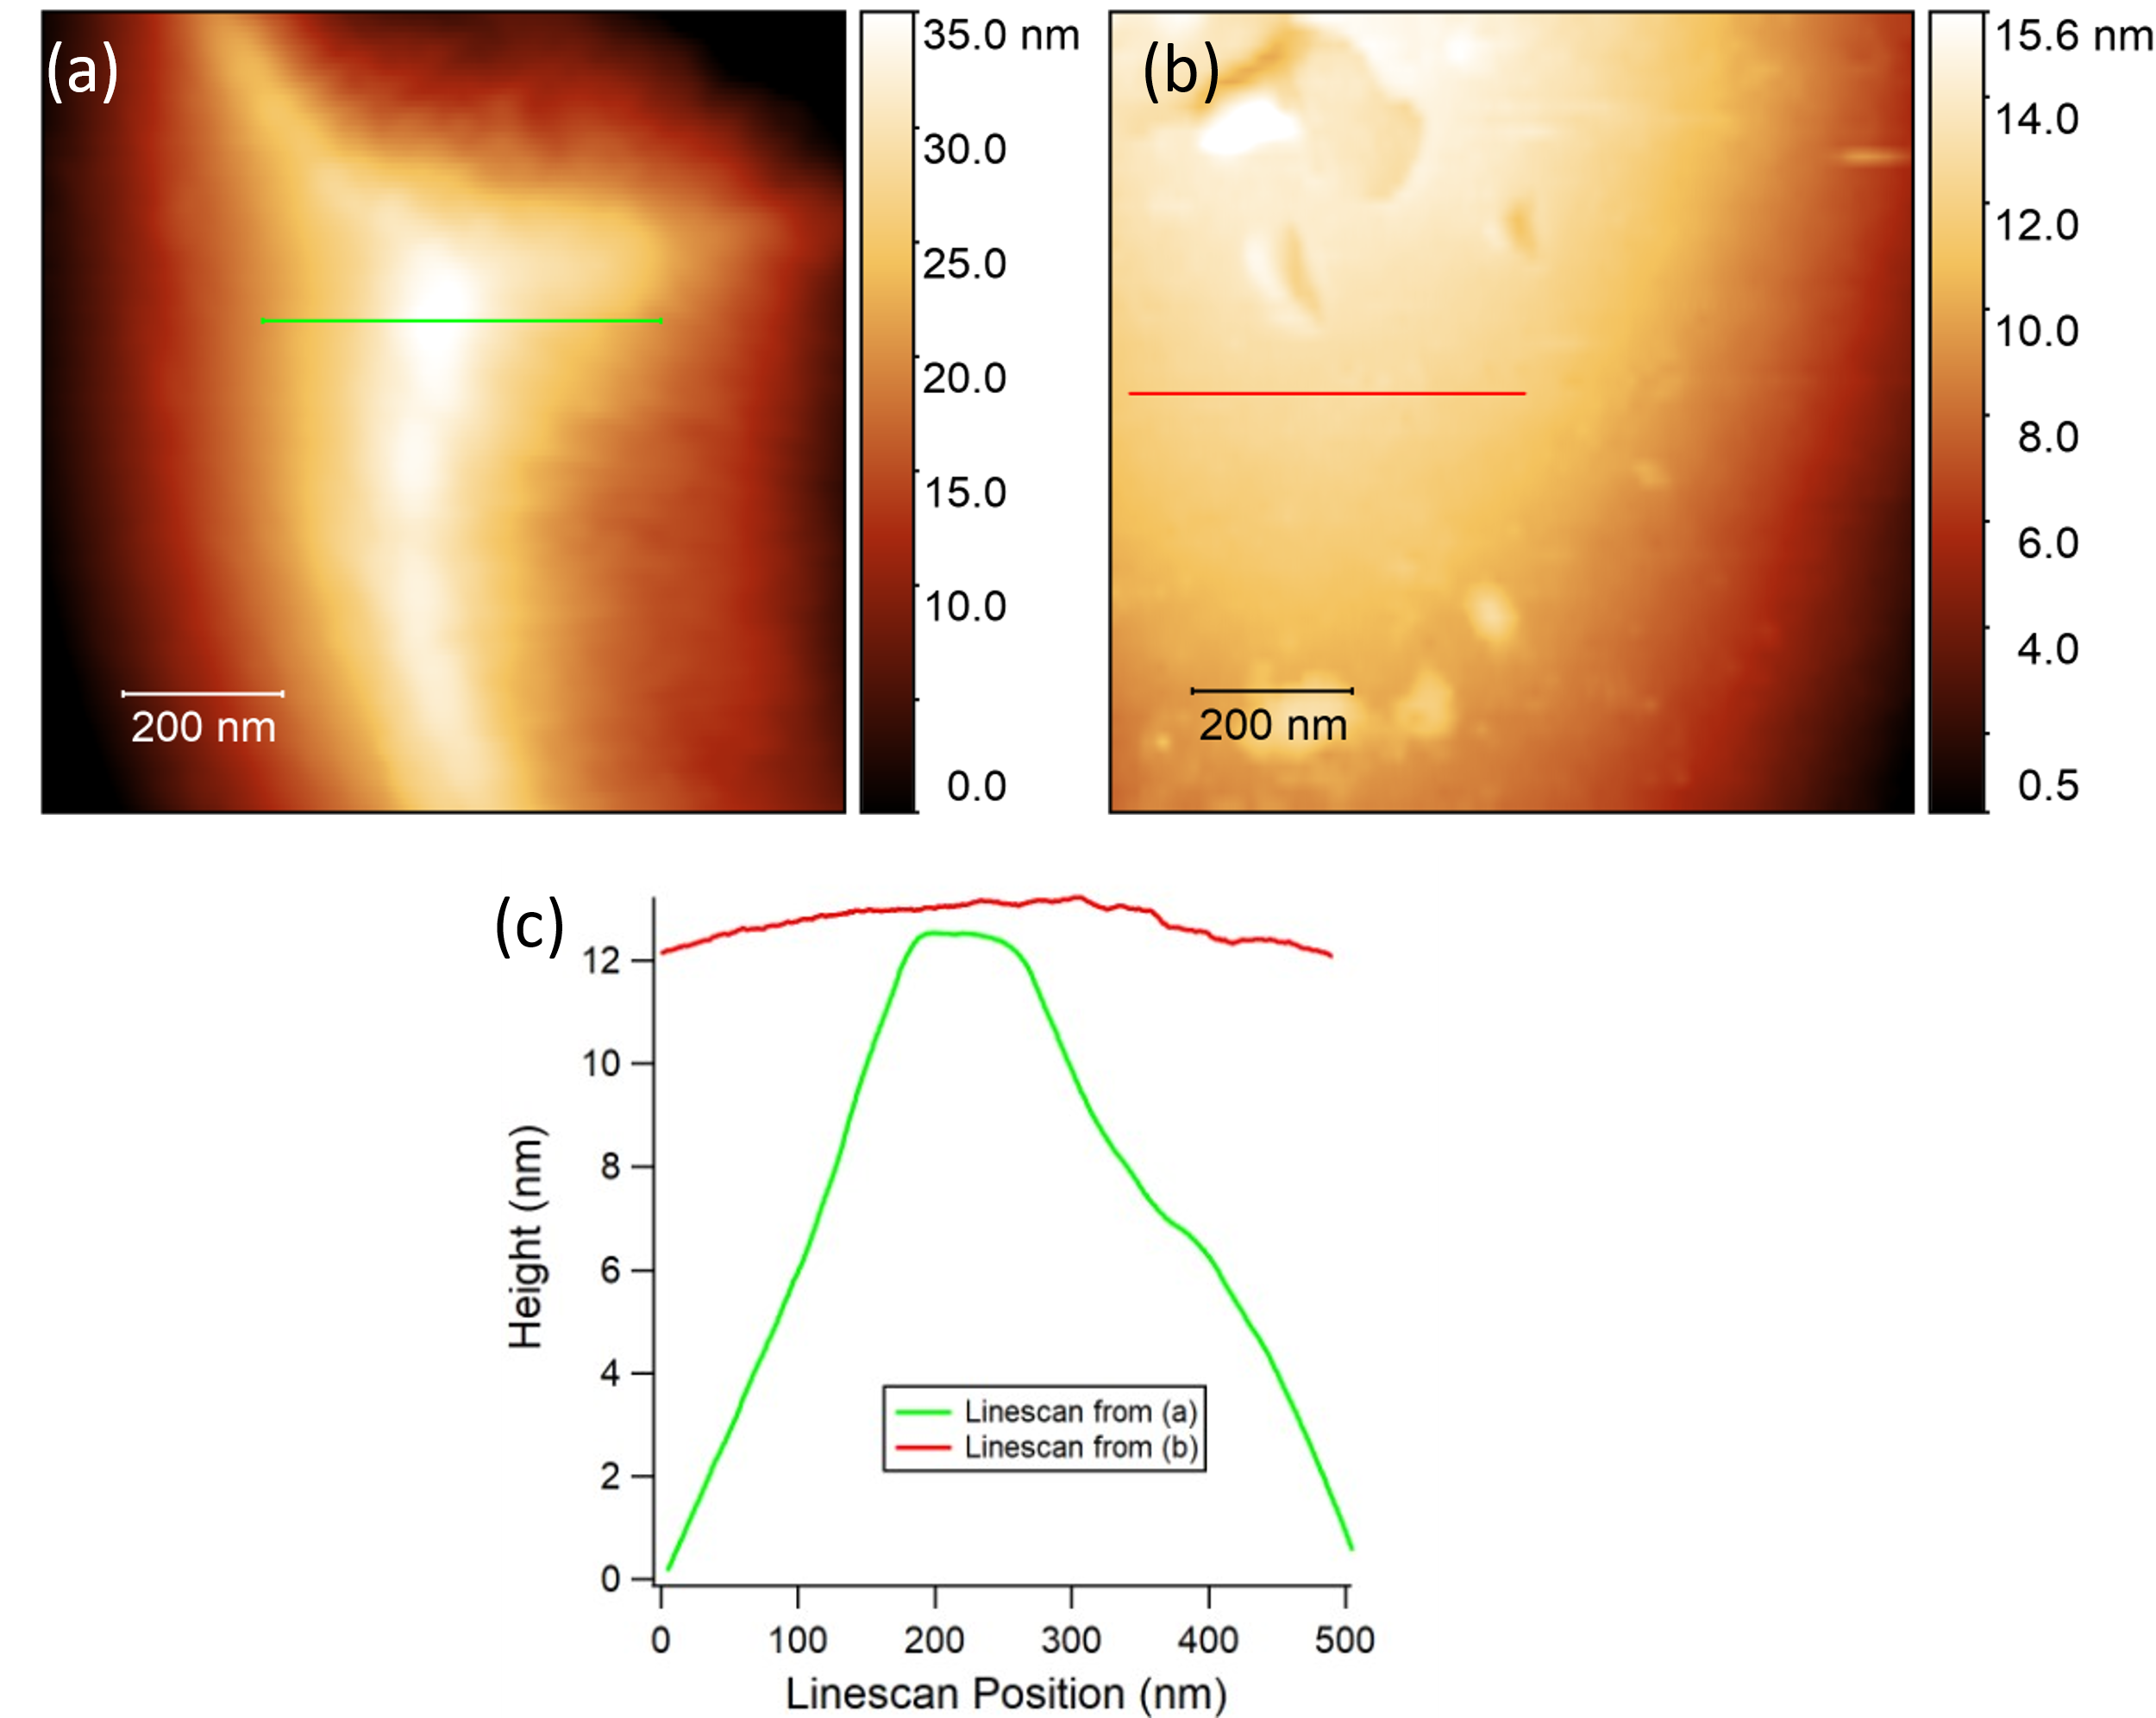
Figure S 3: a) Tapping mode AFM image of colloid apex prior to tribofilm growth test. b) Typical colloid topography c) Linescans from (a) and (b). Linescans are offset vertically to make visual comparison easier.
Figure S 3 shows the topography of the colloid apex for one such case. The comparison of the apex linescan to one from the manuscript makes clear how much smaller the contact area is for the same applied load. To achieve similar contact pressures to those applied when the colloid apex radius was close to the nominal value, the applied load was reduced to 100 nN leading to an average normal pressure for this punch geometry of 215 MPa, although it will be clear later that wear of the steel counterface reduces this value by the time stable tribofilm growth starts.
Figure S 4 shows the evolution of friction, total normal stiffness, and topography during the test with this colloid. In the first 1000 cycles of the test, friction and stiffness increase due to wear of the steel counterface. The change in topographic height at the start of the test is not meaningful since there is piezo creep after the load is initially applied which likely obscure real height trends. The piezo creep extends the piezo causing an increase in load which is counteracted by feedback to reduce the excitation voltage and retract the piezo. This excitation voltage is the source of the topography signal. A similar apparent increase in height is seen at the start of the test in the manuscript.
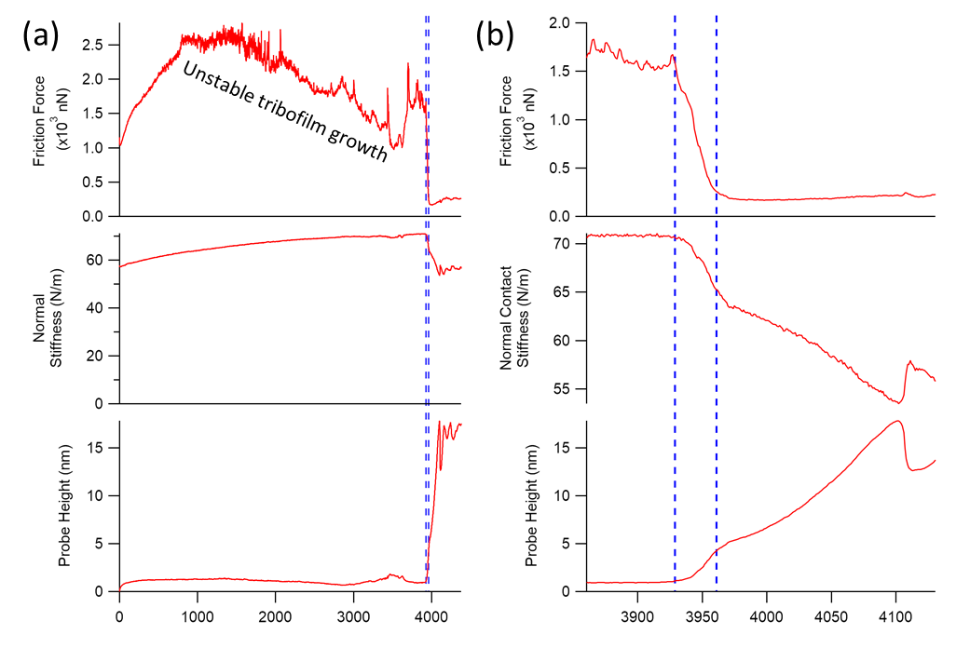
Another regime of behavior persists from cycles 1000-3900. This regime is characterized by unstable but predominantly decreasing friction and a continuing increase in stiffness. This behavior is interpreted as unstable nucleation and removal of tribofilm from the steel counterface as the steel continues to wear, increasing the real contact area, which increases the normal stiffness. To bolster this hypothesis, it can be seen that there is an increase in topographic height starting at cycle 3000 corresponding to the most rapid decrease in friction, suggesting the growth of tribofilm. The friction then increases around cycle 3500 while the height drops back to its prior value, suggesting the tribofilm becomes unstable and is removed.
Figure S 4: a) Friction, total normal stiffness, and probe height as a function of reciprocating sliding cycles on 2 μm track at 4 μm /s and 100nN load. b) Zoomed view of cycles corresponding to growth of bulk tribofilm.

The final regime is closely analogous to the stable tribofilm growth regime in the manuscript. The friction drops precipitously as the tribofilm forms, with the friction drop complete by the time the tribofilm reaches a thickness of 5 nm. In this case, the behavior of the total stiffness is different. In the manuscript, the stiffness increases as the tribofilm grows, which was attributed to tribofilm filling the space between asperities and growing the real contact area to such a degree that the overall contact stiffness increases. In this case, the stiffness clearly decreases. This is attributed to the different contact geometry. The flat punch geometry with a much smaller nominal contact area does not allow for much growth in the real contact area as the tribofilm grows, especially lateral growth outside the nominal contact area, so that the effect of the tribofilm on the contact stiffness is dominated by its modulus, rather than its area. Since the tribofilm is very compliant relative to the steel and a-C:H:Si:O, the overall effect on the stiffness is a decrease.
As was seen in the manuscript, the tribofilm growth terminates abruptly at a particular thickness, which in this case is about 15 nm. In the manuscript this thickness was larger.
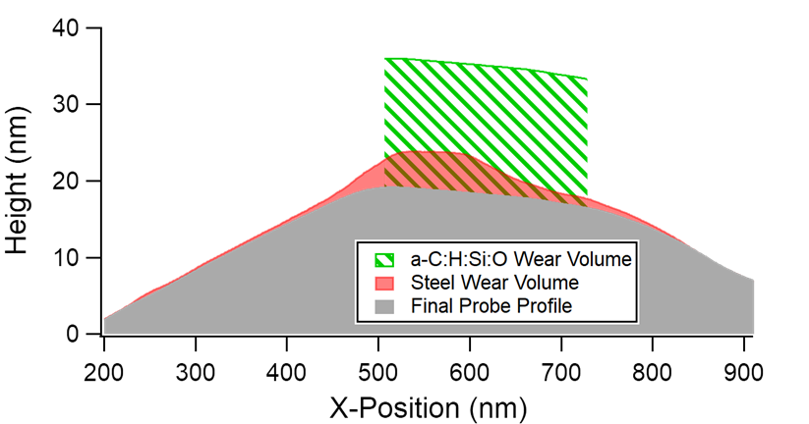
Figure S 5 shows the evolution of the steel counterface geometry schematically. The tribofilm could not be successfully imaged after the test before it was removed from the colloid apex, which allowed for a clear measurement of the steel wear profile. It can be seen that the steel experienced 5 nm of wear, presumably prior to cycle 3900 when tribofilm growth separated the counterfaces. This may help explain the delay in the growth of stable tribofilm. By the time a stable tribofilm grew, the real area of contact had increased, with a starting punch radius of 38 nm and a final punch radius of 115 nm. This change is likely what allowed the stable tribofilm to form and grow, although the mechanism remains unclear. One possibility is that a reduction in the normal contact pressure favored tribofilm growth over tribofilm wear. This hypothesis is consistent with our previous work with sharp AFM probes where tribofilm growth was typically not observed. Adhesion with sharp AFM probes prevented contact pressures below 1 GPa from being attained.[1]
Figure S 5: Schematic demonstration of the disparate wear volumes of the two counterfaces during the test via colloid tapping-mode imaging before and after the test along with the measured tribofilm thickness during the test.
Figure S 5 also demonstrates how different the wear rate of the steel was early in the test when compared to the a-C:H:Si:O wear rate during the tribofilm growth. The volume of a-C:H:Si:O worn away (as estimated via the contact area and height of tribofilm grown) over the course of 170 cycles before the vertical growth terminated was three times that of the steel wear over the first 3900 cycles of the test. This result is in accord with an important result from a previous study of friction on a-C:H:Si:O,[2] where the presence of H₂ or O₂ above some threshold pressure (much lower than what is present in the atmospheric pressure tests here) led to the breaking of adhesive junctions between steel and a-C:H:Si:O with a transfer of a-C:H:Si:O to the steel counterface, with the transfer in the opposite direction favored at low gas pressures.

References
1. McClimon, J.B., Hilbert, J., Lukes, J.R., Carpick, R.W.: Nanoscale Run-In of Silicon Oxide-Doped Hydrogenated Amorphous Carbon: Dependence of Interfacial Shear Strength on Sliding Length and Humidity. Tribol Lett. 68, 80 (2020). https://doi.org/10.1007/s11249-020-01319-4
2. Koshigan, K.D., Mangolini, F., McClimon, J.B., Vacher, B., Bec, S., Carpick, R.W., Fontaine, J.: Understanding the hydrogen and oxygen gas pressure dependence of the tribological properties of silicon oxide–doped hydrogenated amorphous carbon coatings. Carbon. 93, 851–860 (2015). https://doi.org/10.1016/j.carbon.2015.06.004

