Supplementary materials

Table S1. Factors associated with distant metastasis in patients with lepidic adenocarcinoma (n = 4087).
Characteristics | Distant metastasis |  | Pearson χ ² P-value | Multivariate analysis
Characteristics | Yes; n = 1128 | No; n = 2959 | Pearson χ ² P-value | OR | 95% CI | P-value
Characteristics | Number (%) | Number (%) | Pearson χ ² P-value
Age, years old |  |  | 0.460
0-69 | 539 (47.8) | 1413 (47.8) |  | NI
70-79 | 374 (33.2) | 1026 (34.7)
>=80 | 215 (19.1) | 520 (17.6)
Sex
Male | 468 (41.5) | 1078 (36.4) | 0.003 | 1.000
Female | 660 (58.5) | 1881 (63.6) |  | 1.168 | (0.979,1.394) | 0.086
Race |  |  | <0.001
White | 854 (75.7) | 2427 (82.0) |  | 1.000
Black | 119 (10.5) | 231 (7.8) |  | 1.331 | (0.989,1.791) | 0.059
Other | 155 (13.7) | 301 (10.2) |  | 1.636 | (1.261,2.122) | <0.001
Laterality |  |  | <0.001
Left | 402 (35.6) | 1172 (39.6) |  | 1.000
Right | 604 (53.5) | 1785 (60.3) |  | 0.891 | (0.746,1.066) | 0.207
Unknown | 122 (10.8) | 2 (0.1) |  | 31.189 | (7.260,133.988) | <0.001
Lobe |  |  | <0.001
Upper | 463 (41.0) | 1682 (56.8) |  | 1.000
Middle | 51 (4.5) | 145 (4.9) |  | 1.426 | (0.959,2.118) | 0.079
Lower | 347 (30.8) | 1053 (35.6) |  | 1.046 | (0.868,1.261) | 0.635
Unknown | 267 (23.7) | 79 (2.7) |  | 3.696 | (2.618,5.217) | <0.001
Tumor Size |  |  | <0.001
<3 cm | 303 (26.9) | 1870 (63.2) |  | 1.000
>=3 & <5 cm | 252 (22.3) | 642 (21.7) |  | 2.191 | (1.771,2.709) | <0.001
>=5 cm | 199 (17.6) | 315 (10.6) |  | 3.293 | (2.575,4.211) | <0.001
Unknown | 374 (33.2) | 132 (4.5) |  | 8.932 | (6.821,11.697) | <0.001
Separate tumor nodules |  |  | <0.001
Yes | 241 (21.4) | 91 (3.1) |  | 1.000
No | 124 (11.0) | 997 (33.7) |  | 0.047 | (0.032,0.069) | <0.001
Unknown | 763 (67.6) | 1871 (63.2) |  | 0.069 | (0.048,0.100) | <0.001
Pleural invasion |  |  | <0.001
Yes | 23 (2.0) | 87 (2.9) |  | 1.000
No | 56 (5.0) | 621 (21.0) |  | 0.663 | (0.327,1.342) | 0.253
Unknown | 1049 (93.0) | 2251 (76.1) |  | 3.352 | (1.718,6.540) | <0.001
Grade |  |  | <0.001
I | 329 (29.2) | 1263 (42.7) |  | 1.000
II | 205 (18.2) | 864 (29.2) |  | 0.890 | (0.706,1.123) | 0.326
III | 70 (6.2) | 174 (5.9) |  | 1.480 | (1.038,2.111) | 0.030
IV | 1 (0.1) | 6 (0.2) |  | 0.168 | (0.009,3.090) | 0.230
Unknown | 523 (46.4) | 652 (22.0) |  | 1.895 | (1.538,2.336) | <0.001
Abbreviations: CI, confidence interval; NI, not included; OR, odds ratio.

Table S2. Factors associated with lymph node metastasis in patients with lepidic adenocarcinoma (n = 4087).
Characteristics | Lymph node metastasis |  | Pearson χ ² P-value | Multivariate analysis
Characteristics | Yes; n = 991 | No; n = 3096 | Pearson χ ² P-value | OR | 95% CI | P-value
Characteristics | Number (%) | Number (%) | Pearson χ ² P-value
Age, years old |  |  | 0.017
0-69 | 512 (51.7) | 1440 (46.5) |  | 1.000
70-79 | 311 (31.4) | 1089 (35.2) |  | 0.772 | (0.650,0.916) | 0.003
>=80 | 168 (17.0) | 567 (18.3) |  | 0.689 | (0.555,0.854) | 0.001
Sex |  |  | <0.001
Male | 437 (44.1) | 1109 (35.8) |  | 1.000
Female | 554 (55.9) | 1987 (64.2) |  | 0.845 | (0.724,0.987) | 0.033
Race |  |  | 0.007
White | 763 (77.0) | 2518 (81.3) |  | 1.000
Black | 93 (9.4) | 257 (8.3) |  | 1.020 | (0.779,1.335) | 0.885
Other | 135 (13.6) | 321 (10.4) |  | 1.354 | (1.074,1.708) | 0.010
Laterality |  |  | 0.008
Left | 364 (36.7) | 1210 (39.1) |  | 1.000
Right | 583 (58.8) | 1806 (58.3) |  | 1.074 | (0.913,1.263) | 0.391
Unknown | 44 (4.4) | 80 (2.6) |  | 1.196 | (0.742,1.928) | 0.463
Lobe |  |  | 0.008
Upper | 500 (50.5) | 1645 (53.1) |  | 1.000
Middle | 52 (5.2) | 144 (4.7) |  | 1.189 | (0.831,1.703) | 0.343
Lower | 330 (33.3) | 1070 (34.6) |  | 0.955 | (0.806,1.132) | 0.595
Unknown | 109 (11.0) | 237 (7.7) |  | 0.819 | (0.597,1.122) | 0.214
Tumor Size |  |  | <0.001
<3 cm | 321 (32.4) | 1852 (59.8) |  | 1.000
>=3 & <5 cm | 264 (26.6) | 630 (20.3) |  | 2.169 | (1.787,2.633) | <0.001
>=5 cm | 212 (21.4) | 302 (9.8) |  | 3.544 | (2.839,4.424) | <0.001
Unknown | 194 (19.6) | 312 (10.1) |  | 2.788 | (2.181,3.563) | <0.001
Separate tumor nodules |  |  | <0.001
Yes | 111 (11.2) | 221 (7.1) |  | 1.000
No | 196 (19.8) | 925 (29.9) |  | 0.680 | (0.501,0.922) | 0.013
Unknown | 684 (69.0) | 1950 (63.0) |  | 0.588 | (0.445,0.776) | <0.001
Pleural invasion |  |  | <0.001
Yes | 29 (2.9) | 81 (2.6) |  | 1.000
No | 60 (6.1) | 617 (19.9) |  | 0.420 | (0.249,0.709) | 0.001
Unknown | 902 (91.0) | 2398 (77.5) |  | 1.332 | (0.824,2.155) | 0.242
Grade |  |  | <0.001
I | 246 (24.8) | 1346 (43.5) |  | 1.000
II | 263 (26.5) | 806 (26.0) |  | 1.660 | (1.353,2.036) | <0.001
III | 89 (9.0) | 155 (5.0) |  | 2.703 | (1.982,3.686) | <0.001
IV | 3 (0.3) | 4 (0.1) |  | 2.608 | (0.551,12.338) | 0.227
Unknown | 390 (39.4) | 785 (25.4) |  | 1.917 | (1.577,2.329) | <0.001
Abbreviations: CI, confidence interval; NI, not included; OR, odds ratio.

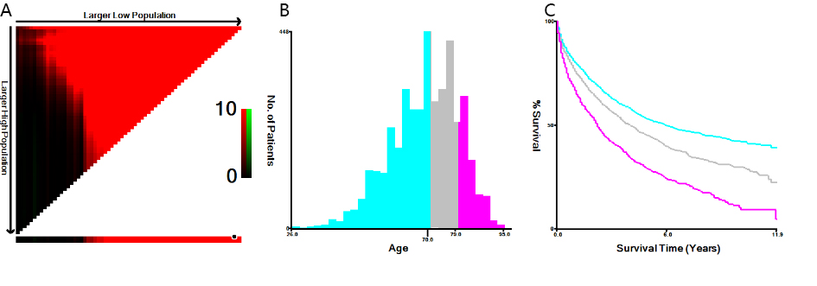
Figure S1. (A, B) The optimal cutoff value of age was identified by X-tail; (C) the Kaplan–Meier curves of overall survival in three age subgroups (0–69, 70–79, and 80+ years old).

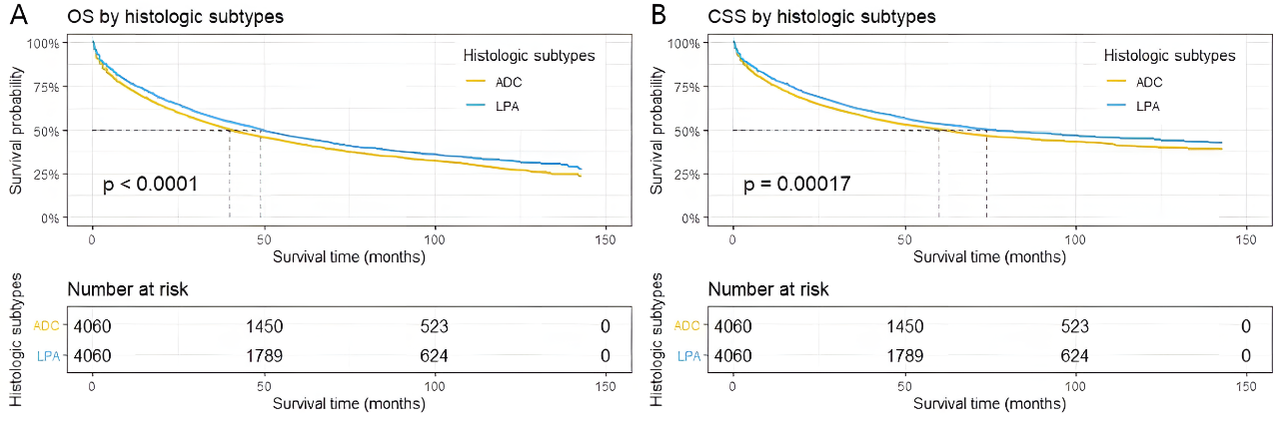 Figure S2. Kaplan–Meier curves of overall survival (A) and cancer-specific survival (B) in patients with lung ADC-NOS and LPA after propensity score matching.
Abbreviations: ADC, adenocarcinoma; LPA, lepidic adenocarcinoma; NOS, not otherwise specified.

