Table S1. Factors associated with distant metastasis in patients with lepidic adenocarcinoma (n = 4087).
Characteristics | Distant metastasis |  | Pearson χ ² P-value | Multivariate analysis
Characteristics | Yes; n = 1128 | No; n = 2959 | Pearson χ ² P-value | OR | 95% CI | P-value
Characteristics | Number (%) | Number (%) | Pearson χ ² P-value
Age, years old |  |  | 0.460
0-69 | 539 (47.8) | 1413 (47.8) |  | NI
70-79 | 374 (33.2) | 1026 (34.7)
>=80 | 215 (19.1) | 520 (17.6)
Sex
Male | 468 (41.5) | 1078 (36.4) | 0.003 | 1.000
Female | 660 (58.5) | 1881 (63.6) |  | 1.168 | (0.979,1.394) | 0.086
Race |  |  | <0.001
White | 854 (75.7) | 2427 (82.0) |  | 1.000
Black | 119 (10.5) | 231 (7.8) |  | 1.331 | (0.989,1.791) | 0.059
Other | 155 (13.7) | 301 (10.2) |  | 1.636 | (1.261,2.122) | <0.001
Laterality |  |  | <0.001
Left | 402 (35.6) | 1172 (39.6) |  | 1.000
Right | 604 (53.5) | 1785 (60.3) |  | 0.891 | (0.746,1.066) | 0.207
Unknown | 122 (10.8) | 2 (0.1) |  | 31.189 | (7.260,133.988) | <0.001
Lobe |  |  | <0.001
Upper | 463 (41.0) | 1682 (56.8) |  | 1.000
Middle | 51 (4.5) | 145 (4.9) |  | 1.426 | (0.959,2.118) | 0.079
Lower | 347 (30.8) | 1053 (35.6) |  | 1.046 | (0.868,1.261) | 0.635
Unknown | 267 (23.7) | 79 (2.7) |  | 3.696 | (2.618,5.217) | <0.001
Tumor Size |  |  | <0.001
<3cm | 303 (26.9) | 1870 (63.2) |  | 1.000
>=3 & <5cm | 252 (22.3) | 642 (21.7) |  | 2.191 | (1.771,2.709) | <0.001
>=5cm | 199 (17.6) | 315 (10.6) |  | 3.293 | (2.575,4.211) | <0.001
Unknown | 374 (33.2) | 132 (4.5) |  | 8.932 | (6.821,11.697) | <0.001
Separate tumor nodules |  |  | <0.001
Yes | 241 (21.4) | 91 (3.1) |  | 1.000
No | 124 (11.0) | 997 (33.7) |  | 0.047 | (0.032,0.069) | <0.001
Unknown | 763 (67.6) | 1871 (63.2) |  | 0.069 | (0.048,0.100) | <0.001
Pleural invasion |  |  | <0.001
Yes | 23 (2.0) | 87 (2.9) |  | 1.000
No | 56 (5.0) | 621 (21.0) |  | 0.663 | (0.327,1.342) | 0.253
Unknown | 1049 (93.0) | 2251 (76.1) |  | 3.352 | (1.718,6.540) | <0.001
Grade |  |  | <0.001
I | 329 (29.2) | 1263 (42.7) |  | 1.000
II | 205 (18.2) | 864 (29.2) |  | 0.890 | (0.706,1.123) | 0.326
III | 70 (6.2) | 174 (5.9) |  | 1.480 | (1.038,2.111) | 0.030
IV | 1 (0.1) | 6 (0.2) |  | 0.168 | (0.009,3.090) | 0.230
Unknown | 523 (46.4) | 652 (22.0) |  | 1.895 | (1.538,2.336) | <0.001
Abbreviations: CI, confidence interval; NI, not included; OR, odds ratio.

Table S2. Factors associated with lymph node metastasis in patients with lepidic adenocarcinoma (n = 4087).
Characteristics | Lymph node metastasis |  | Pearson χ ² P-value | Multivariate analysis
Characteristics | Yes; n = 991 | No; n = 3096 | Pearson χ ² P-value | OR | 95% CI | P-value
Characteristics | Number (%) | Number (%) | Pearson χ ² P-value
Age, years old |  |  | 0.017
0-69 | 512 (51.7) | 1440 (46.5) |  | 1.000
70-79 | 311 (31.4) | 1089 (35.2) |  | 0.772 | (0.650,0.916) | 0.003
>=80 | 168 (17.0) | 567 (18.3) |  | 0.689 | (0.555,0.854) | 0.001
Sex |  |  | <0.001
Male | 437 (44.1) | 1109 (35.8) |  | 1.000
Female | 554 (55.9) | 1987 (64.2) |  | 0.845 | (0.724,0.987) | 0.033
Race |  |  | 0.007
White | 763 (77.0) | 2518 (81.3) |  | 1.000
Black | 93 (9.4) | 257 (8.3) |  | 1.020 | (0.779,1.335) | 0.885
Other | 135 (13.6) | 321 (10.4) |  | 1.354 | (1.074,1.708) | 0.010
Laterality |  |  | 0.008
Left | 364 (36.7) | 1210 (39.1) |  | 1.000
Right | 583 (58.8) | 1806 (58.3) |  | 1.074 | (0.913,1.263) | 0.391
Unknown | 44 (4.4) | 80 (2.6) |  | 1.196 | (0.742,1.928) | 0.463
Lobe |  |  | 0.008
Upper | 500 (50.5) | 1645 (53.1) |  | 1.000
Middle | 52 (5.2) | 144 (4.7) |  | 1.189 | (0.831,1.703) | 0.343
Lower | 330 (33.3) | 1070 (34.6) |  | 0.955 | (0.806,1.132) | 0.595
Unknown | 109 (11.0) | 237 (7.7) |  | 0.819 | (0.597,1.122) | 0.214
Tumor Size |  |  | <0.001
<3cm | 321 (32.4) | 1852 (59.8) |  | 1.000
>=3 & <5cm | 264 (26.6) | 630 (20.3) |  | 2.169 | (1.787,2.633) | <0.001
>=5cm | 212 (21.4) | 302 (9.8) |  | 3.544 | (2.839,4.424) | <0.001
Unknown | 194 (19.6) | 312 (10.1) |  | 2.788 | (2.181,3.563) | <0.001
Separate tumor nodules |  |  | <0.001
Yes | 111 (11.2) | 221 (7.1) |  | 1.000
No | 196 (19.8) | 925 (29.9) |  | 0.680 | (0.501,0.922) | 0.013
Unknown | 684 (69.0) | 1950 (63.0) |  | 0.588 | (0.445,0.776) | <0.001
Pleural invasion |  |  | <0.001
Yes | 29 (2.9) | 81 (2.6) |  | 1.000
No | 60 (6.1) | 617 (19.9) |  | 0.420 | (0.249,0.709) | 0.001
Unknown | 902 (91.0) | 2398 (77.5) |  | 1.332 | (0.824,2.155) | 0.242
Grade |  |  | <0.001
I | 246 (24.8) | 1346 (43.5) |  | 1.000
II | 263 (26.5) | 806 (26.0) |  | 1.660 | (1.353,2.036) | <0.001
III | 89 (9.0) | 155 (5.0) |  | 2.703 | (1.982,3.686) | <0.001
IV | 3 (0.3) | 4 (0.1) |  | 2.608 | (0.551,12.338) | 0.227
Unknown | 390 (39.4) | 785 (25.4) |  | 1.917 | (1.577,2.329) | <0.001
Abbreviations: CI, confidence interval; NI, not included; OR, odds ratio.

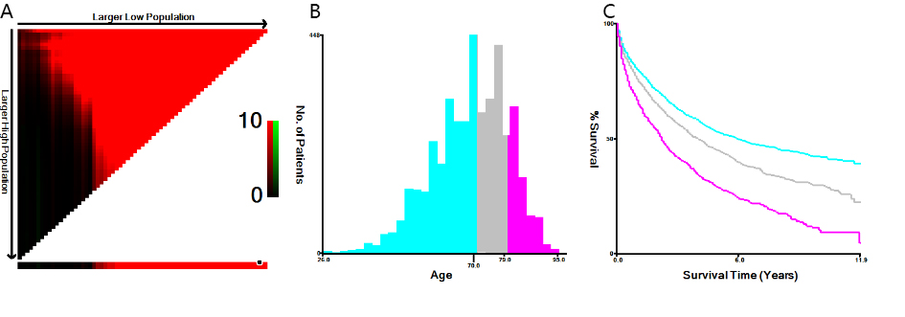
Figure S1. (A, B) The optimal cutoff value of age was identified by X-tail; (C) the Kaplan-Meier curves for age subgroups (0–69, 70–79, and 80+ years old) for overall survival.

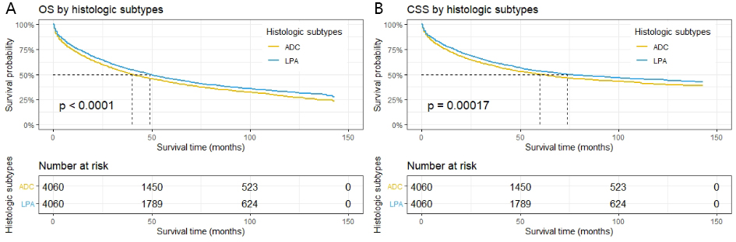
Figure S2. Kaplan-Meier curves of overall survival (A) and cancer-specific survival (B) for patients with lung ADC and LPA after propensity-score matching.
Abbreviations: ADC, adenocarcinoma; LPA, lepidic adenocarcinoma.

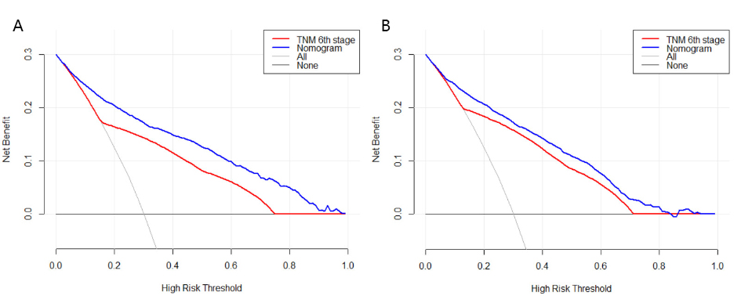
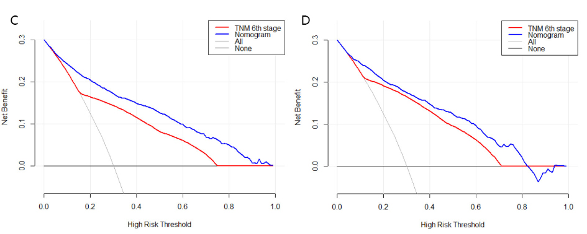
Figure S3. Decision curve analysis for the nomograms predicting OS and CSS. (A, B) The decision curve analysis of nomogram in internal validation for OS (A) and CSS (B); (C, D) the decision curve analysis of nomogram in external validation for OS (C) and CSS (D).

