SUPLEMENTARY INFORMATION
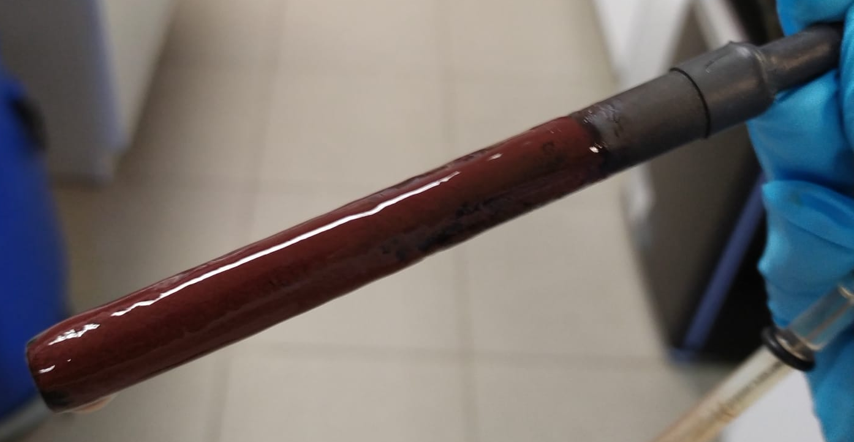
Figure S1. Full-growth PPB mixed biofilm developed for photo-bioelectrochemical and Open Circuit Control experiments.
Figure S2. Absorbance screening of PPB mixed biofilm presented at the beginning of the experiment carried out at -0.8V.
Figure S3.Cyclic Voltammperometry of photo-bioelectrochemical test on day 2 and formal potential (E_{f}) of each experiment (a) -0.4V and (b) -0.8V.
a
b
Figure S4. Chemical Oxygen Demand (COD) and short-chain carboxylic acids (SCCA) time-course of dark control: Malic (orange). fumaric (green), acetic (pink) and propionic (purple).
Figure S5. Example of apparent midpoint potential (E_{f}) from a Cyclic voltamperometry obtained from the day 2 of the photo-bioelectrochemical experiment at -0.8V

Table S1 Molecules involved in different metabolic pathways and their acronym used in Figure 8.

ROUTE | ACRONYM | MOLECULES
Tricarboxilic Acid Cycle (TCA) | Mal | Malate
Tricarboxilic Acid Cycle (TCA) | Ox | Oxalacetate
Tricarboxilic Acid Cycle (TCA) | Cit | Citrate
Tricarboxilic Acid Cycle (TCA) | Cis-Ac | Cis-aconitate
Tricarboxilic Acid Cycle (TCA) | DTI | D-theo-isocitrate
Tricarboxilic Acid Cycle (TCA) | 2Ox | 2-oxoglutarate
Tricarboxilic Acid Cycle (TCA) | SCoA | Succinyl-CoA
Tricarboxilic Acid Cycle (TCA) | Succ | Succinate
Tricarboxilic Acid Cycle (TCA) | Fum | Fumarate
Calvin–Benson–Bassham (CBB) Cycle | DR1,5B | D-ribulosa-1,5-biphosphate
Calvin–Benson–Bassham (CBB) Cycle | 3PDG | 3-phospho-D-glycerate
Calvin–Benson–Bassham (CBB) Cycle | 3PDGP | 3-phospho-D-glyceroyl phosphate
Calvin–Benson–Bassham (CBB) Cycle | DG3P | D-glyceraldehyde 3-phosphate
Calvin–Benson–Bassham (CBB) Cycle | GP | Glycerone phosphate
Calvin–Benson–Bassham (CBB) Cycle | βDF1,6B | β-D-fructofuranose 1,6-biphosphate
Calvin–Benson–Bassham (CBB) Cycle | βDF6P | β-D-fructofuranose 6-phosphate
Calvin–Benson–Bassham (CBB) Cycle | DX5P | D-xylulose 5-phosphate
Calvin–Benson–Bassham (CBB) Cycle | DR5P | D-ribulose 5-phosphate
Polyhydroxyalkanoate synthesis | ACoA | Acetyl-CoA
Polyhydroxyalkanoate synthesis | AaCoA | Acetoacetyl-CoA
Polyhydroxyalkanoate synthesis | PCoA | Propionyl-CoA
Polyhydroxyalkanoate synthesis | KCoA | Ketovaleryl-CoA
Polyhydroxyalkanoate synthesis | HCoA | Hexanol-CoA
Polyhydroxyalkanoate synthesis | H2ECoA | Hex-2-enoyl-CoA
Polyhydroxyalkanoate synthesis | 3HBCoA | 3-Hydroxybutyryl-CoA
Polyhydroxyalkanoate synthesis | 3HVCoA | 3-Hydroxyvaleryl-CoA
Polyhydroxyalkanoate synthesis | 3HHCoA | 3-Hydroxyhexanoyl-CoA
Anaplerotic CO₂ fixation | PEP | Phosphoenolpyruvate
Anaplerotic CO₂ fixation | Pyr | Pyruvate
Anaplerotic CO₂ fixation | ACoA | Acetyl-CoA

Table S2 Enzymes involved in involved in different metabolic pathways and their acronym used in Figure 8
 | ACRONYM | ENZYMES
Tricarboxilic Acid Cycle (TCA) | MD | Malate dehydrogenase
Tricarboxilic Acid Cycle (TCA) | CS | Citrate synthase
Tricarboxilic Acid Cycle (TCA) | DRS | Dihydrolipoyllysine-residue succinyltransferase component of 2-oxoglutarate dehydrogenase complex
Tricarboxilic Acid Cycle (TCA) | SCoAL (subα) | Succinate-CoA ligase subunit α
Tricarboxilic Acid Cycle (TCA) | SCoAL (subβ) | Succinate-CoA ligase subunit β
Tricarboxilic Acid Cycle (TCA) | SD | Succinate dehydrogenase
Tricarboxilic Acid Cycle (TCA) | MS | Malate synthase
Tricarboxilic Acid Cycle (TCA) | Is | Isocitrase
Tricarboxilic Acid Cycle (TCA) | ID | Isocitrate dehydrogenase
Calvin–Benson–Bassham (CBB) Cycle | RuBisCo | Ribulose biphosphate carboxylase
Calvin–Benson–Bassham (CBB) Cycle | PGK | Phosphoglycerate kinase
Calvin–Benson–Bassham (CBB) Cycle | F1,6BA | Fructose-1,6-bisphosphate aldolase
Calvin–Benson–Bassham (CBB) Cycle | F1,6B | Frustose 1,6-biphosphatase
Polyhydroxyalkanoate synthesis | ACoAat | Acetyl-CoA acetyltransferase
Polyhydroxyalkanoate synthesis | 3O[acp]R | 3-oxoacyl-[acyl-carrier-protein] reductase
Polyhydroxyalkanoate synthesis | ACoAD | Acyl-CoA dehydrogenase
Polyhydroxyalkanoate synthesis | ECoAH | Enoyl-CoA hydratase
Anaplerotic CO₂ fixation | PC | Pyruvate carboxylase
Anaplerotic CO₂ fixation | PEPC | Phosphoenolpyruvate carboxykinase
Anaplerotic CO₂ fixation | En | Enolase
Anaplerotic CO₂ fixation | PK | Pyruvate Kinase
Anaplerotic CO₂ fixation | PD | Pyruvate dehydrogenase
Anaplerotic CO₂ fixation | P-f | Pyruvate-ferredoxin/flavodoxin oxidoreductase
Anaplerotic CO₂ fixation | PEPS | Phosphoenolpyruvate synthetase
Anaplerotic CO₂ fixation | Podk | Pyruvate, orthophosphate dikinase
Anaplerotic CO₂ fixation | CS | Citrate synthase

CALCULATIONS
CALCULATION OF BIOMASS CONCENTRATION
The total biomass, in terms of mg COD/L, was calculated as the difference between the total COD and soluble COD using equations [1]. The fraction of biomass from biofilm in of mg COD/L was calculated using the equation [2], assuming COD/VSS ratio for PPB of 1.61 ¹ and COD/VSS ratio for non-PPB of 1.42 ², and percentages of PPB and Non-PPB microorganisms in the biofilm estimated according to genus data from microbial community analyses.
$${COD}_{total}- {COD}_{soluble}= {COD}_{particulate}$$ | [1]
$$\left({VSS}_{PPB} . \% PPB\right) . 1.61+\left({VSS}_{Non-PPB} . \%Non-PPB\right) . 1.42= {COD}_{biofilm}$$ | [2]
CALCULATION OF AMOUNT OF CO₂ IN CATHODE’S CHAMBER’S HEAD-SPACE
The total amount of CO₂ present in the cathode chamber was calculated by adding up the total inorganic carbon (TIC) in the aqueous medium and the amount of CO₂ analyzed in the head space, expressed as mg of inorganic carbon (mg IC). The calculation to obtain the total IC in the reactor is described in equation [3]. Besides, the theorical amount of CO₂ produced from malic acid was calculated following the stoichiometry reported by Gest et al.,³ so we obtained the percentage of carbon dioxide fixed under bioelectrochemical conditions (see below).
$${CO}_{2} \left(mg IC\right)= \frac{P.V_{HS*}}{R.T} . \frac{CO_{2} \%}{100} . Mm . 0.27 . 1000$$ | [3]
where P is the total pressure inside the cathode chamber, V_{HS} is the headspace volume in the cathode chamber, R is the ideal gases constant (0.082 atm. L. mol⁻¹. K⁻¹), T is the temperature of the laboratory (20ºC was used as an average temperature), CO₂% is the percentage of carbon dioxide detected by GC in the head space every day, Mm is the molecular mass of CO₂, 0.27 is the relation mg IC/mg CO₂, and 1000 is used to unit conversion.
CALCULATION OF PERCENTAGE OF CO₂ CONSUMED
The reaction of malic consumption by the Rhodospirillum rubrum is: ³
The theorical amount of CO₂ produced by malic degradation was calculated using the stoichiometry of this reaction. The mass of malate used was the experimental data determined at the beginning of each experiment. The CO₂ calculated from this reaction is considered the theorical CO₂ obtained by PPB from malic acid, via TCA.
The percentage of CO₂ consumed was calculated using the experimental data of CO₂ (as mg IC) from the day where the COD was almost completely consumed, that is the day when the amount of CO₂ (produced due to malic degradation by microorganism) is the maximum.
METAPROTEOMIC CALCULATIONS
The selection of relevant enzymes from metaproteomic data was made by searching manually the enzymes involved in metabolic routes of interest: TCA, CBB, PHA synthesis, anaplerotic CO₂ fixation, and extracellular electron uptake mechanism. ⁴⁻⁷ The fold change parameter was calculated as the relative ratio of each protein between two conditions (photo-bioelectrochemical experiment vs. open circuit control).⁸ Every sample was made by triplicate, and the average value of the area was used to estimate FC as it represented in Eq. [4]
$$FC= {{Area}_{PBE}}/{{Area}_{OC}}$$ | [4]
where Area_{PBE} is the area of the protein from the Photo-BioElectrochemical experiment and Area_{OC} is area of the protein from the Open Circuit control. The data used to study the taxon level changes between experiments was normalized to calculate the FC. The areas of proteins were individually normalized based on a summed area of all peptides for each sample. Only fold change higher than 1.5 or lower than 0.66 and having a p-value lower than 0.05 for reactor’s level estimations, and lower than 0.1 for taxons’ level estimations, were further considered. ⁹
To make the volcano plots’ figures of the proteins quantified, the log₁₀(p-value) was calculated and plotted against the log₂(FC). ⁹

SUPPLEMENTARY REFERENCES
1. Carlozzi, P. & Sacchi, A. Biomass production and studies on Rhodopseudomonas palustris grown in an outdoor, temperature controlled, underwater tubular photobioreactor. J Biotechnol 88, 239–249 (2001).
2. Batstone, D. J. et al. The IWA Anaerobic Digestion Model No 1 (ADM1). Water Science and Technology 45, 65–73 (2002).
3. Gest, Howard., Kamen, M. D. & Bregoff, Herta. Maas. Studies on the Metabolism of Photosynthetic Bacteria. Journal of Biological Chemistry 182, 153–170 (1950).
4. Caspi, R. et al. The MetaCyc database of metabolic pathways and enzymes and the BioCyc collection of Pathway/Genome Databases. Nucleic Acids Res 42, D459–D471 (2014).
5. The UniProt Consortium. UniProt: the universal protein knowledgebase in 2021. Nucleic Acids Res 49, D480–D489 (2021).
6. Cabecas Segura, P. et al. Study of the production of poly(hydroxybutyrate-co-hydroxyhexanoate) and poly(hydroxybutyrate-co-hydroxyvalerate-co-hydroxyhexanoate) in Rhodospirillum rubrum. Appl Environ Microbiol AEM.01586-21 (2022) doi:10.1128/AEM.01586-21.
7. Fradinho, J. C., Oehmen, A. & Reis, M. A. M. Photosynthetic mixed culture polyhydroxyalkanoate (PHA) production from individual and mixed volatile fatty acids (VFAs): Substrate preferences and co-substrate uptake. J Biotechnol 185, 19–27 (2014).
8. J.T. Aguilan, K. Kulej, S. Sidoli, Guide for protein fold change and: P-value calculation for non-experts in proteomics, Mol. Omi. 16 (2020) 573–582. https://doi.org/10.1039/d0mo00087f.
9. G. Bayon-Vicente, R. Wattiez, B. Leroy, Global Proteomic Analysis Reveals High Light Intensity Adaptation Strategies and Polyhydroxyalkanoate Production in Rhodospirillum rubrum Cultivated With Acetate as Carbon Source, Front. Microbiol. 11 (2020) 1–17. https://doi.org/10.3389/fmicb.2020.00464.

