Supplementary appendix for

Economic pathways to healthy, sustainable and culturally acceptable diets in Mexico
(Version revised 10th January, 2022)

Marcos E. Dominguez-Viera1*, Zuzana Smeets-Kristkova, Anali Castellanos-Gutierrez, Carolina Batis, Marrit van den Berg, Joana C. Chapa Cantu.

*Corresponding author.
Development Economics Group, Wageningen University, Droevendaalsesteeg 4, 6708 PB Wageningen, Netherlands. Email address: marcos.dominguezviera@wur.nl.

Economic pathways to healthy, sustainable and culturally acceptable diets in Mexico

Supplementary materials

Contents

Appendix 1: Additional tables for Mexican energy intakes...............................................................................2
Appendix 2: GENUS database adjustments...............................................................................................................7
Appendix 3: Variable construction for microsimulations..................................................................................7
Appendix 4: Calorie availability calculations based on microdata.................................................................8
Appendix 5: Additional tables MAGNET simulations........................................................................................10
Appendix 6: Tables for demand system estimations.........................................................................................12
Appendix 7 Sensitivity analysis...................................................................................................................................19
References............................................................................................................................................................................22

Table A.1
Mean Mexican energy intake and contribution from traditional foods by food group and area.
 | Urban area |  |  |  | Rural area
Food groups | Mean intake (MI) | Mean intake of traditional foods | Contribution from traditional foods to MI |  | Mean intake (MI) | Mean intake of traditional foods | Contribution from traditional foods to MI
Food groups | kcal/day |  | % |  | kcal/day |  | %
 | (1) | (2) | (3) |  | (4) | (5) | (6)
Grains
High-fiber grains
Corn | 406 | 406 | 100.0 |  | 580 | 580 | 100.0
Other high-fiber grains (e.g., wheat,  rice, amaranth) | 11 | 0 | 0.0 |  | 9 | 0 | 0.0
Low-fiber grains
Refined grains | 123 | 0 | 0.0 |  | 109 | 0 | 0.0
Grains with excess added sugar or saturated fat | 232 | 0 | 0.0 |  | 209 | 0 | 0.0
Tubers or starchy vegetables
Potatoes and cassava | 23 | 0 | 2.0 |  | 23 | 1 | 3.9
Vegetables
All vegetables | 47 | 23 | 48.4 |  | 45 | 25 | 55.5
Fruits
All fruits | 82 | 12 | 14.5 |  | 48 | 5 | 9.5
Dairy foods
Whole milk or derivative equivalents (e.g., cheese) | 97 | 31 | 32.3 |  | 76 | 27 | 35.5
Dairy with excess added sugar | 83 | 0 | 0.0 |  | 49 | 0 | 0.0

Appendix 1: Additional tables for Mexican energy intakes

Table A.1 (Continued)
 | Urban area |  |  |  | Rural area
Food groups | Mean intake (MI) | Mean intake of traditional foods | Contribution from traditional foods to MI |  | Mean intake (MI) | Mean intake of traditional foods | Contribution from traditional foods to MI
Food groups | kcal/day |  | % |  | kcal/day |  | %
 | (1) | (2) | (3) |  | (4) | (5) | (6)
Protein sources
Red meat | 139 | 0 | 0.0 |  | 87 | 0 | 0.0
Processed meat | 32 | 0 | 0.0 |  | 24 | 0 | 0.0
Insects | 0 | 0 | -- |  | 0 | 0 | --
Other meats (e.g. iguana, rabbit) | 0 | 0 | 100.0 |  | 0 | 0 | 100.0
Chicken and other poultry | 82 | 82 | 99.9 |  | 68 | 68 | 100.0
Eggs | 46 | 46 | 99.7 |  | 50 | 50 | 99.7
Fish | 15 | 5 | 35.3 |  | 13 | 9 | 70.3
Legumes | 66 | 58 | 87.3 |  | 106 | 100 | 94.4
Nuts and seeds | 8 | 2 | 26.7 |  | 5 | 3 | 67.2
Added fats
Plant oils | 167 | 10 | 6.1 |  | 144 | 34 | 23.9
Lard or tallow | 23 | 0 | 0.0 |  | 27 | 0 | 0.0
Added sugars
All sweeteners | 13 | 4 | 31.1 |  | 7 | 2 | 34.5
Confectionary and desserts | 16 | 0 | 0.0 |  | 8 | 0 | 0.0
Sugar-sweetened beverages | 229 | 0 | 0.0 |  | 188 | 0 | 0.0
Others | 20 | 5 | 25.5 |  | 26 | 10 | 37.3
Total energy | 1,964 | 686 | 34.9 |  | 1,899 | 914 | 48.1
Source: Castellanos-Gutiérrez et al. (2021) and Mexican National Health and Nutrition Surveys (ENSANUTs) in 2012 and 2016.

Table A.2
Mean Mexican energy intake and contribution from traditional foods by food group and socioeconomic status.
 | SES tertile 1 |  |  |  | SES tertile 2 |  |  |  | SES tertile 3
Food groups | Mean intake (MI)** | Mean intake of traditional foods | Contribution from traditional foods to MI |  | Mean intake (MI)** | Mean intake of traditional foods | Contribution from traditional foods to MI |  | Mean intake (MI)** | Mean intake of traditional foods | Contribution from traditional foods to MI
Food groups | kcal/day |  | % |  | kcal/day |  | % |  | kcal/day |  | %
 | (1) | (2) | (3) |  | (4) | (5) | (6) |  | (7) | (8) | (9)
Grains
High-fiber grains
Corn | 620 | 620 | 100.0 |  | 490 | 490 | 100.0 |  | 335 | 335 | 100.0
Other high-fiber grains (e.g., wheat,  rice, amaranth) | 9 | 0 | 0.0 |  | 9 | 0 | 0.0 |  | 13 | 0 | 0.0
Low-fiber grains
Refined grains | 99 | 0 | 0.0 |  | 122 | 0 | 0.0 |  | 130 | 0 | 0.0
Grains with excess added sugar or  saturated fat | 148 | 0 | 0.0 |  | 269 | 0 | 0.0 |  | 242 | 0 | 0.0
Tubers or starchy vegetables
Potatoes and cassava | 32 | 1 | 2.7 |  | 19 | 1 | 4.8 |  | 20 | 0 | 1.0
Vegetables
All vegetables | 41 | 21 | 51.6 |  | 46 | 23 | 50.9 |  | 51 | 25 | 49.2
Fruits
All fruits | 46 | 6 | 12.0 |  | 49 | 6 | 11.6 |  | 103 | 15 | 14.6
Dairy foods
Whole milk or derivative equivalents  (e.g., cheese) | 53 | 18 | 33.5 |  | 92 | 30 | 32.4 |  | 113 | 37 | 33.2
Dairy with excess added sugar | 51 | 0 | 0.0 |  | 75 | 0 | 0.0 |  | 86 | 0 | 0.0

Table A.2 (Continued)
 | SES tertile 1 |  |  |  | SES tertile 2 |  |  |  | SES tertile 3
Food groups | Mean intake (MI) | Mean intake of traditional foods | Contribution from traditional foods to MI |  | Mean intake (MI) | Mean intake of traditional foods | Contribution from traditional foods to MI |  | Mean intake (MI) | Mean intake of traditional foods | Contribution from traditional foods to MI
Food groups | kcal/day |  | % |  | kcal/day |  | % |  | kcal/day |  | %
 | (1) | (2) | (3) |  | (4) | (5) | (6) |  | (7) | (8) | (9)
Protein sources
Red meat | 94 | 0 | 0.0 |  | 116 | 0 | 0.0 |  | 147 | 0 | 0.0
Processed meat | 20 | 0 | 0.0 |  | 34 | 0 | 0.0 |  | 33 | 0 | 0.0
Insects | 0 | 0 | -- |  | 0 | 0 | -- |  | 0 | 0 | --
Other meats (e.g. iguana, rabbit) | 0 | 0 | 100.0 |  | 0 | 0 | 100.0 |  | 0 | 0 | 100.0
Chicken and other poultry | 70 | 70 | 100.0 |  | 86 | 86 | 99.7 |  | 78 | 78 | 100.0
Eggs | 64 | 64 | 99.9 |  | 44 | 44 | 99.1 |  | 40 | 40 | 99.9
Fish | 15 | 6 | 42.7 |  | 11 | 7 | 62.1 |  | 17 | 6 | 37.2
Legumes | 104 | 99 | 94.8 |  | 82 | 69 | 83.9 |  | 58 | 52 | 90.4
Nuts and seeds | 4 | 2 | 57.7 |  | 6 | 1 | 25.6 |  | 10 | 3 | 31.2
Added fats
Plant oils | 111 | 6 | 5.4 |  | 143 | 32 | 22.4 |  | 201 | 13 | 6.6
Lard or tallow | 22 | 0 | 0.0 |  | 36 | 0 | 0.0 |  | 18 | 0 | 0.0
Added sugars
All sweeteners | 7 | 2 | 30.8 |  | 11 | 6 | 53.0 |  | 14 | 3 | 20.6
Confectionary and desserts | 7 | 0 | 0.0 |  | 13 | 0 | 0.0 |  | 18 | 0 | 0.0
Sugar-sweetened beverages | 233 | 0 | 0.0 |  | 229 | 0 | 0.0 |  | 203 | 0 | 0.0
Others | 34 | 21 | 63.0 |  | 19 | 2 | 12.4 |  | 16 | 0 | 2.2
Total energy | 1,885 | 937 | 49.7 |  | 2,002 | 797 | 39.8 |  | 1,947 | 608 | 31.2
Notes: SES Socioeconomic status.
Source: Castellanos-Gutiérrez et al. (2021) and Mexican National Health and Nutrition Surveys (ENSANUTs) in 2012 and 2016.

Table A.3
Mean Mexican energy intake and contribution from traditional foods among actual consumers by food group.
Food groups | Percentage of consumers | Mean intake in consumers | Average intake of traditional foods in consumers
Food groups | % | kcal/day
 | (1) | (2) | (3)
Grains
High-fiber grains
Corn | 88.8 | 510 | 510
Other high-fiber grains (e.g., wheat,  rice, amaranth) | 5.8 | 183 | 0
Low-fiber grains
Refined grains | 61.2 | 195 | 0
Grains with excess added sugar or saturated fat | 57.4 | 393 | 0
Tubers or starchy vegetables
Potatoes and cassava | 28.2 | 81 | 2
Vegetables
All vegetables | 95.1 | 49 | 25
Fruits
All fruits | 52.3 | 139 | 19
Dairy foods
Whole milk or derivative equivalents (e.g., cheese) | 50.8 | 180 | 59
Dairy with excess added sugar | 34.3 | 216 | 0
Protein sources
Red meat | 49.5 | 252 | 0
Processed meat | 23.8 | 125 | 0
Insects | 0.0 | 11 | 11
Other meats (e.g. iguana, rabbit) | 0.1 | 141 | 141
Chicken and other poultry | 33.4 | 234 | 234
Eggs | 42.6 | 111 | 111
Fish | 14.4 | 102 | 45
Legumes | 57.5 | 134 | 120
Nuts and seeds | 7.2 | 100 | 34
Added fats
Plant oils | 84.4 | 190 | 20
Lard or tallow | 13.3 | 183 | 0
Added sugars
All sweeteners | 11.6 | 97 | 31
Confectionary and desserts | 16.4 | 86 | 0
Sugar-sweetened beverages | 78.9 | 276 | 0
Others | 55.6 | 38 | 11
Source: Castellanos-Gutiérrez et al. (2021) and Mexican National Health and Nutrition Surveys (ENSANUTs) in 2012 and 2016.

Appendix 2: GENUS database adjustments
In this research, the GENUS database was updated from 2011 to 2014 based on FBS to be in line with MAGNET’s reference year (FAO, 2021). Then, we mapped the food items in GENUS with the EAT Lancet food groups to compare GENUS’s supply of calories in 2014 with the mean intakes from the ENSANUTs 24-hour dietary recalls shown in Table 1 in the manuscript. Total estimated caloric supply in GENUS is 3,167 kcal/capita/day for Mexico, equivalent to 1.6-fold the mean intake in ENSANUT (1,947). The shares of calories by food group from both sources are shown in Table A.4. Most of the values are quite similar, except for high- and low-fiber grains, dairy foods, animal-based proteins and added sugars. The shares in GENUS were adjusted to resemble the structure of caloric consumption in the 24-hour dietary recall surveys, which makes it easier to interpret the EAT dietary shift.
Table A.4
Share of calories in GENUS and ENSANUT by food group.
EAT food groups | GENUS 2014 | ENSANUTs 2012/2016
EAT food groups | %
High-fiber grains | 37.4 | 23.8
Low-fiber grains | 10.1 | 17.7
Tubers or starchy vegetables | 1.0 | 1.2
Vegetables | 1.1 | 2.4
Fruits | 3.2 | 3.8
Dairy foods | 4.6 | 8.5
Animal-based proteins | 8.9 | 15.2
Plant-based proteins | 3.8 | 4.3
Added fats | 11.5 | 9.5
Added sugars | 18.1 | 12.5
Others | 0.3 | 1.1
Total | 100.0 | 100.0
Estimated calories (kcal/capita/day) | 3,167 | 1,947
Sources: GENUS database, FAO (2021) and Mexican National Health and Nutrition Surveys (ENSANUTs) in 2012 and 2016.

Appendix 3: Variable construction for microsimulations
To obtain expenditure shares, quarterly monetary expenses by food group were calculated and then divided by the total expenditure in the 11 groups. Quantities are expressed in kilograms, where food items originally measured in litres were converted to kilograms based on densities (kg/lts) obtained from ENSANUT’s food composition table. Items in concentrate and powdered form were rehydrated following (Crovetto M. and Uauy, 2014) and then converted to kilograms using the same densities. As proxies for prices, we calculated unitary values, which are equal to the ratio of total expenses over total quantities by food group. Standard procedures were applied to make the unitary values of the others (i.e., numeraire) group equal to 1. To avoid outliers affecting our estimations, when household level expenses, quantities and unitary values differed from the mean value at the municipal level +/- 2.5 standard deviations, we replaced it with the mean value at the municipal level +/- 2.5 standard deviations. If a household reported no expenses for a particular food group, their unitary value was imputed with the mean value at the municipality level (total 1,090 municipalities) or from neighbour municipalities when there were no data in a given municipality. In our demand system estimations, we used prices averaged at the municipality level.
Further adjustments to the prices and an additional covariate were computed to handle two issues typically identified on demand systems estimations. First, the indirect estimation of prices through unitary values may pose measurement errors and hide household preferences for food product quality (i.e., price endogeneity). To correct this issue, we followed the procedure described in (Capacci and Mazzocchi, 2011; Caro et al., 2017a), where we ran two-stage least squares regressions to obtain adjusted price estimates at the municipality level. Second, endogeneity in expenditures arises as we used total food expenditures as an explanatory variable for budget shares by food group, which are mutually determined in practice. This aspect was managed by adding a residual term in the demand system obtained by regressing total expenditures on basic sociodemographics (Caro et al., 2017a; Segovia et al., 2020).

Appendix 4: Calorie availability calculations based on microdata
Data on calories per 100 g. for 224 out of the 247 food items in the ENIGH were obtained from the database of nutritional values compiled by Mexican National Institute of Public Health (INSP, 2012). To estimate the household calorie intakes, the available conversions were multiplied by the quantities reported as expenditures. From the food items with no calorie conversions available, we excluded 7 items that are not meant for human intake (e.g., tobacco, animal foods) from the calorie calculations; for foods consumed at home, we estimated the calorie conversions per 100 g. based on the average from the rest of food items in their corresponding EAT food group; for foods away from home, we used an estimate of the calorie intake per MXN peso from the rest of the data and multiplied the resulting number by 2/3 to reflect processing margins (Subramanian and Deaton, 1996; Valero-Gil and Valero, 2018). The resulting calorie availability by food group is shown below in Table A.5.

Table A.5
Calorie content by food group.
EAT Food groups | Kcal per 100 g.
High-fiber grains | 261.6
Low-fiber grains | 359.7
Tubers or starchy vegetables | 215.0
Vegetables | 45.4
Fruits | 70.4
Dairy foods | 280.9
Animal-based proteins | 223.4
Plant-based proteins | 337.4
Added fats | 674.9
Added sugars | 232.3
Others | 135.7
Notes: Values computed as the average calories in the ENIGH's food items classified in each food group.
Source: Own calculations based on INSP (2012).

Appendix 5: Additional tables MAGNET simulations
Table A.6
Percentage change in private consumption by food group, 2019-2040.
MAGNET food groups | Scenario
MAGNET food groups | Baseline | EAT-Mx | Milpa-EAT-Mx
MAGNET food groups | %
MAGNET food groups | (1) | (2) | (3)
Paddy and processed rice | 22.2 | -23.9 | -58.2
Wheat | 19.0 | 284.1 | -58.6
Other grains (maize, amaranth) | 19.7 | 29.1 | 56.0
Oil seeds | 21.9 | 335.9 | 456.4
Fruits, vegetables, nuts and legumes | 25.5 | 125.2 | 248.2
Raw sugar | 20.8 | -27.4 | -58.3
Other crops | 19.3 | 23.6 | -58.7
Raw milk | 26.1 | 1.6 | 5.7
Beef cattle | 22.1 | 30.9 | 39.6
Other grazing animals such as sheep, goats, horses | 21.8 | 30.1 | 38.8
Pigs | 23.4 | 30.2 | 36.6
Poultry | 24.0 | 30.8 | 37.3
Wild fish | 23.6 | 60.6 | 64.2
Aquaculture | 28.3 | 66.5 | 66.2
Vegetable oils and fats | 24.7 | 109.0 | -58.1
Sugar processing | 24.8 | -26.4 | -29.8
Other food and beverages | 22.9 | -23.8 | -53.5
Dairy | 27.7 | 1.9 | -58.7
Beef meat | 27.7 | -34.8 | -58.7
Meat from other grazing animals | 27.7 | -4.3 | -21.1
Other meat products | 29.7 | -34.7 | -52.6
Poultry meat | 30.1 | 1.4 | 3.7
Fish processing | 24.0 | 29.3 | 37.0
Source: Own calculations based on MAGNET model.

Table A.7
Percentage change in C02 emissions from agriculture relative to baseline scenario by food group.
MAGNET food groups | EAT-Mx |  | Milpa-EAT-Mx
MAGNET food groups | 2030 | 2040 | 2030 | 2040
MAGNET food groups | %
MAGNET food groups | (1) | (2) | (3) | (4)
Dairy | -10.1 | -19.9 | -32.9 | -65.3
Vegetable oils and fats | 26.5 | 53.8 | -30.9 | -62.9
Raw milk | -10.0 | -19.7 | -31.3 | -62.0
Paddy and processed rice | -15.0 | -31.8 | -27.4 | -57.7
Other food and beverages | -16.0 | -32.2 | -26.3 | -52.9
Other meat products | -18.8 | -36.8 | -25.4 | -50.2
Raw sugar | -16.1 | -33.4 | -22.6 | -46.4
Beef meat | -16.0 | -30.8 | -22.0 | -42.7
Crude vegetable oil | -0.6 | 1.7 | -19.1 | -37.8
Sugar processing | -13.1 | -27.8 | -15.6 | -33.4
Meat from other grazing animals | -9.3 | -17.9 | -14.3 | -27.8
Poultry meat | -11.0 | -21.4 | -10.6 | -20.7
Pigs | -6.6 | -13.5 | -8.6 | -17.6
Beef cattle | -6.2 | -12.2 | -7.8 | -15.3
Other grains (maize, amaranth) | -5.4 | -11.9 | -6.7 | -15.3
Oil seeds | 15.0 | 32.5 | -2.6 | -13.5
Other grazing animals such as sheep, goats, horses | -3.8 | -7.5 | -5.3 | -10.3
Poultry | -4.1 | -8.1 | -3.5 | -6.6
Fish processing | 0.2 | 0.7 | 1.9 | 5.1
Other crops | 2.9 | 6.2 | 5.2 | 11.4
Plant fibres | 2.6 | 5.4 | 5.0 | 11.6
Wheat | 6.9 | 14.0 | 7.2 | 15.4
Wild fish | 11.0 | 22.3 | 11.8 | 24.2
Fruits, vegetables, nuts and legumes | 6.0 | 13.0 | 13.1 | 29.6
All food groups | -4.9 | -9.6 | -7.1 | -13.8
Source: Own calculations based on MAGNET model.

Table A.8
Percentage change in irrigated water volume relative to baseline scenario by food group, 2040.
MAGNET food groups | EAT-Mx | Milpa-EAT-Mx
MAGNET food groups | %
MAGNET food groups | (1) | (2)
Paddy and processed rice | -22.9 | -43.3
Wheat | 16.1 | 24.2
Other grains (maize, amaranth) | -5.8 | -2.8
Oil seeds | 31.8 | -2.2
Fruits, vegetables, nuts and legumes | 11.0 | 26.4
Raw sugar | -24.3 | -32.1
Other crops | 6.4 | 14.2
Plant fibres | 5.7 | 13.9
All food groups | 7.1 | 15.7
Source: Own calculations based on MAGNET model.

Appendix 6: Tables for demand system estimations
Table A.9
Selected food expenditure indicators in the sample by sample subgroup and food group.
Indicator/Food groups | Highest income¹ | Lowest income² | Urban | Rural | Total sample
Indicator/Food groups | (1) | (2) | (3) | (4) | (5)
Mean expenditure share (%)
High-fiber grains | 7.22 | 11.68 | 8.88 | 11.07 | 9.72
Low-fiber grains | 7.78 | 10.06 | 8.17 | 10.18 | 8.94
Tubers or starchy vegetables | 1.23 | 1.77 | 1.27 | 1.94 | 1.52
Vegetables | 5.81 | 8.32 | 6.45 | 8.32 | 7.17
Fruits | 3.35 | 2.77 | 3.18 | 2.78 | 3.03
Dairy foods | 7.97 | 8.54 | 8.35 | 8.36 | 8.35
Animal-based proteins | 25.11 | 23.81 | 25.51 | 23.53 | 24.75
Plant-based proteins | 1.49 | 3.58 | 1.98 | 3.47 | 2.55
Added fats | 1.67 | 2.55 | 1.69 | 2.80 | 2.12
Added sugars | 8.68 | 10.03 | 8.66 | 10.58 | 9.39
Others | 29.67 | 16.89 | 25.85 | 16.97 | 22.45
Share of households with expenditure>0 (%)
High-fiber grains | 87.97 | 81.23 | 89.29 | 79.28 | 85.46
Low-fiber grains | 85.47 | 86.06 | 85.49 | 87.06 | 86.09
Tubers or starchy vegetables | 44.56 | 40.42 | 41.57 | 44.85 | 42.83
Vegetables | 78.28 | 77.88 | 77.44 | 80.39 | 78.57
Fruits | 56.78 | 40.83 | 51.98 | 42.78 | 48.46
Dairy foods | 81.88 | 71.21 | 79.68 | 72.80 | 77.05
Animal-based proteins | 91.59 | 87.78 | 90.98 | 88.58 | 90.06
Plant-based proteins | 43.40 | 51.34 | 46.10 | 51.60 | 48.20
Added fats | 44.23 | 42.25 | 40.83 | 47.42 | 43.35
Added sugars | 83.01 | 76.45 | 79.94 | 80.21 | 80.04
Others | 89.61 | 77.99 | 86.08 | 79.54 | 83.58
Observations | 26,435 | 32,535 | 45,822 | 28,376 | 74,198
Notes: ¹Households in the top 40% income percentile. ²Households in the bottom 40% income percentile.
Source: 2018 Mexican National Household Income and Expenditure Survey (INEGI, 2019).

Table A.10
Uncensored model. Expenditure elasticities by sample subgroup and food group.
EAT food groups | Highest income¹ | Lowest income² | Urban areas | Rural areas | Total sample
EAT food groups | (1) | (2) | (3) | (4) | (5)
High-fiber grains | 0.318*** | 0.547*** | 0.402*** | 0.538*** | 0.461***
 | (0.010) | (0.005) | (0.008) | (0.006) | (0.007)
Low-fiber grains | 0.774*** | 0.798*** | 0.775*** | 0.805*** | 0.788***
 | (0.007) | (0.005) | (0.007) | (0.005) | (0.006)
Tubers or starchy vegetables | 0.786*** | 0.826*** | 0.771*** | 0.853*** | 0.811***
 | (0.013) | (0.010) | (0.014) | (0.009) | (0.011)
Vegetables | 0.887*** | 0.919*** | 0.892*** | 0.924*** | 0.906***
 | (0.008) | (0.006) | (0.007) | (0.005) | (0.007)
Fruits | 1.091*** | 1.129*** | 1.099*** | 1.134*** | 1.111***
 | (0.012) | (0.012) | (0.012) | (0.012) | (0.012)
Dairy foods | 0.870*** | 0.903*** | 0.881*** | 0.900*** | 0.888***
 | (0.008) | (0.006) | (0.007) | (0.006) | (0.007)
Animal-based proteins | 1.106*** | 1.131*** | 1.111*** | 1.130*** | 1.118***
 | (0.005) | (0.005) | (0.005) | (0.005) | (0.005)
Plant-based proteins | 0.586*** | 0.736*** | 0.610*** | 0.757*** | 0.685***
 | (0.016) | (0.008) | (0.014) | (0.008) | (0.011)
Added fats | 1.038*** | 1.020*** | 1.039*** | 1.017*** | 1.028***
 | (0.014) | (0.010) | (0.015) | (0.008) | (0.011)
Added sugars | 0.734*** | 0.782*** | 0.743*** | 0.787*** | 0.762***
 | (0.009) | (0.006) | (0.008) | (0.006) | (0.007)
Others | 1.406*** | 1.539*** | 1.418*** | 1.606*** | 1.472***
 | (0.007) | (0.010) | (0.007) | (0.011) | (0.008)
N | 26,435 | 32,535 | 45,822 | 28,376 | 74,198
Notes: Estimations based on QUAIDS modelling with corrections for potential price and expenditure endogeneity. ¹Households in the top 40% income percentile. ²Households in the bottom 40% income percentile.* p<0.1, ** p<0.05, *** p<0.01.
Sources: 2018 Mexican National Household Income and Expenditure Survey (INEGI, 2019).

Table A.11
Censored model. Expenditure elasticities by sample subgroup and food group.
EAT food groups | Highest income¹ | Lowest income² | Urban areas | Rural areas | Total sample
EAT food groups | (1) | (2) | (3) | (4) | (5)
High-fiber grains | 0.545*** | 0.945*** | 0.701*** | 0.952*** | 0.665***
 | (0.008) | (005) | (0.004) | (0.007) | (0.007)
Low-fiber grains | 0.854*** | 0.896*** | 0.760*** | 0.916*** | 0.684***
 | (0.014) | (0.012) | (0.011) | (0.013) | (0.007)
Tubers or starchy vegetables | 1.565*** | 0.835*** | 0.889*** | 0.881*** | 0.880***
 | (0.098) | (0.029) | (0.013) | (0.021) | (0.015)
Vegetables | 0.623*** | 0.900*** | 0.898*** | 0.807*** | 0.443***
 | (0.045) | (0.012) | (0.017) | (0.018) | (0.037)
Fruits | 1.033*** | 0.737*** | 1.040*** | 0.778*** | 1.191***
 | (0.016) | (0.060) | (0.008) | (0.035) | (0.023)
Dairy foods | 1.172*** | 1.035*** | 0.987*** | 0.997*** | 1.790***
 | (0.128) | (0.019) | (0.027) | (0.021) | (0.093)
Animal-based proteins | 1.321*** | 1.236*** | 1.352*** | 1.257*** | 1.220***
 | (0.022) | (0.006) | (0.009) | (0.006) | (0.009)
Plant-based proteins | 2.149*** | 1.234*** | 1.088*** | 1.135*** | 1.150***
 | (0.067) | (0.016) | (0.004) | (0.011) | (0.007)
Added fats | 0.998*** | 0.133** | 1.035*** | -0.054 | 1.132***
 | (0.026) | (0.059) | (0.010) | (0.071) | (0.025)
Added sugars | 0.802*** | 0.705*** | 0.841*** | 0.735*** | 0.861***
 | (0.020) | (0.012) | (0.010) | (0.010) | (0.013)
Others | 1.133*** | 1.206*** | 1.152*** | 1.196*** | 1.112***
 | (0.004) | (0.013) | (0.003) | (0.015) | (0.004)
N | 26,435 | 32,535 | 45,822 | 28,376 | 74,198
Notes: Estimations based on censored QUAIDS model with corrections for potential price and expenditure endogeneity. ¹Households in the top 40% income percentile. ²Households in the bottom 40% income percentile.* p<0.1, ** p<0.05, *** p<0.01.
Sources: 2018 Mexican National Household Income and Expenditure Survey (INEGI, 2019).

Table A.12
Uncensored model. Uncompensated own-price elasticities by sample subgroup and food group.
EAT food groups | Highest income¹ | Lowest income² | Urban areas | Rural areas | Total sample
EAT food groups | (1) | (2) | (3) | (4) | (5)
High-fiber grains | -0.872*** | -0.919*** | -0.888*** | -0.918*** | -0.901***
 | (0.025) | (0.018) | (0.023) | (0.019) | (0.021)
Low-fiber grains | -0.965*** | -0.969*** | -0.966*** | -0.970*** | -0.968***
 | (0.001) | (0.001) | (0.001) | (0.001) | (0.001)
Tubers or starchy vegetables | -0.189*** | -0.305*** | -0.122*** | -0.413*** | -0.262***
 | (0.018) | (0.016) | (0.020) | (0.014) | (0.016)
Vegetables | -1.272*** | -1.224*** | -1.270*** | -1.210*** | -1.243***
 | (0.039) | (0.032) | (0.038) | (0.030) | (0.034)
Fruits | -1.371*** | -1.406*** | -1.374*** | -1.424*** | -1.391***
 | (0.040) | (0.043) | (0.040) | (0.045) | (0.042)
Dairy foods | -1.235*** | -1.225*** | -1.228*** | -1.230*** | -1.229***
 | (0.020) | (0.019) | (0.019) | (0.019) | (0.019)
Animal-based proteins | -1.309*** | -1.342*** | -1.314*** | -1.340*** | -1.323***
 | (0.010) | (0.011) | (0.010) | (0.011) | (0.010)
Plant-based proteins | 0.512*** | -0.098*** | 0.401*** | -0.168*** | 0.112***
 | (0.055) | (0.031) | (0.050) | (0.029) | (0.039)
Added fats | -0.099* | -0.266*** | 0.004 | -0.395*** | -0.198***
 | (0.057) | (0.047) | (0.064) | (0.039) | (0.051)
Added sugars | -0.777*** | -0.816*** | -0.785*** | -0.820*** | -0.799***
 | (0.014) | (0.011) | (0.013) | (0.011) | (0.012)
Others | -1.777*** | -2.146*** | -1.823*** | -2.272*** | -1.951***
 | (0.034) | (0.053) | (0.037) | (0.059) | (0.043)
N | 26,435 | 32,535 | 45,822 | 28,376 | 74,198
Notes: Estimations based on QUAIDS modelling with corrections for potential price and expenditure endogeneity. ¹Households in the top 40% income percentile. ²Households in the bottom 40% income percentile.* p<0.1, ** p<0.05, *** p<0.01.
Sources: 2018 Mexican National Household Income and Expenditure Survey (INEGI, 2019).

Table A.13
Censored model. Uncompensated own-price elasticities by sample subgroup and food group.
EAT food groups | Highest income¹ | Lowest income² | Urban areas | Rural areas | Total sample
EAT food groups | (1) | (2) | (3) | (4) | (5)
High-fiber grains | -1.056*** | -0.936*** | -0.973*** | -0.943*** | -0.947***
 | (0.025) | (0.004) | (0.017) | (0.005) | (0.007)
Low-fiber grains | -0.972*** | -0.973*** | -0.961*** | -0.970*** | -0.986***
 | (0.002) | (0.002) | (0.001) | (0.001) | (0.001)
Tubers or starchy vegetables | -1.429*** | -0.660*** | -0.868*** | -0.825*** | -0.849***
 | (0.042) | (0.011) | (0.006) | (0.008) | (0.005)
Vegetables | -1.028*** | -1.195*** | -1.276*** | -1.218*** | -1.775***
 | (0.057) | (0.009) | (0.020) | (0.014) | (0.030)
Fruits | -0.878*** | -1.449*** | -0.914*** | -1.207*** | -0.912***
 | (0.015) | (0.034) | (0.007 | (0.018) | (0.013)
Dairy foods | 0.791*** | -1.095*** | -0.111*** | -1.043*** | -2.228***
 | (0.098) | (0.011) | (0.020) | (0.013) | (0.049)
Animal-based proteins | -1.179*** | -1.123*** | -1.090*** | -1.104*** | -1.104***
 | (0.023) | (0.004) | (0.008) | (0.004) | (0.005)
Plant-based proteins | -0.880*** | -1.015*** | -0.940*** | -0.908*** | -0.999***
 | (0.068) | (0.014) | (0.004) | (0.009) | (0.005)
Added fats | -1.096*** | -0.275*** | -1.044*** | -0.033 | -1.249***
 | (0.041) | (0.076) | (0.016) | (0.094) | (0.030)
Added sugars | -0.819*** | -1.059*** | -0.952*** | -1.067*** | -0.976***
 | (0.013) | (0.006) | (0.005) | (0.005) | (0.006)
Others | -0.960*** | -1.121*** | -0.976*** | -1.102*** | -0.923***
 | (0.002) | (0.012) | (0.002) | (0.013) | (0.003)
N | 26,435 | 32,535 | 45,822 | 28,376 | 74,198
Notes: Estimations based on censored QUAIDS model with corrections for potential price and expenditure endogeneity. ¹Households in the top 40% income percentile. ²Households in the bottom 40% income percentile.* p<0.1, ** p<0.05, *** p<0.01.
Sources: 2018 Mexican National Household Income and Expenditure Survey (INEGI, 2019).

Table A.14 shows the full set of own- and cross-price elasticities in the uncensored model. Regarding the food groups with projected increases in the EAT diets, we highlighted the following complementarities: 1) a reduction on the price of high-fiber grains would increase the purchases of vegetables, fruits, plant-based proteins and added fats; 2) fruit consumption is particularly complementary to vegetables’ prices; 3) if prices of plant-based proteins fall, the consumption of added fats increases. On the contrary, the purchases of plant-based proteins and added-fats would be reduced if vegetables and fruits are cheaper, respectively (i.e., substitution effects). Nevertheless, substitution effects between foods with targeted reductions and increases in consumption may result in positive outcomes for the adoption of the EAT diets: 1) if the prices of dairy products rise, the purchases of vegetables would benefit; 2) a reduction in animal-based proteins’ prices may result in increased consumption of fruits and added fats; 3) fruit consumption would increase if added sugars are more expensive. On the negative side, a rise in the price of dairy foods would decrease the purchases of plant-based proteins and added fats, while the same goes for the purchases of plant-based proteins when the price of added sugars rises (i.e., complementary effects).

Table A.14
Uncensored model. Uncompensated own- and cross-price elasticities by food group.
EAT food groups | High-fiber grains | Low-fiber grains | Tubers or starchy vegetables | Vegetables | Fruits | Dairy foods | Animal-based proteins | Plant-based proteins | Added fats | Added sugars | Others
EAT food groups | (1) | (2) | (3) | (4) | (5) | (6) | (7) | (8) | (9) | (10) | (11)
High-fiber grains | -0.901*** | -0.023*** | -0.017** | -0.345*** | -0.056*** | 0.156*** | -0.137*** | -0.191*** | -0.089*** | 0.128*** | 1.014***
 | (0.021) | (0.001) | (0.008) | (0.031) | (0.021) | (0.017) | (0.013) | (0.021) | (0.027) | (0.010) | (0.037)
Low-fiber grains | -0.063*** | -0.968*** | 0.001 | 0.006 | 0.010 | 0.010 | 0.077*** | 0.001 | 0.009 | 0.001 | 0.128***
 | (0.021) | (0.001) | (0.009) | (0.033) | (0.022) | (0.018) | (0.014) | (0.022) | (0.028) | (0.011) | (0.039)
Tubers or starchy vegetables | -0.154*** | 0.001 | -0.262*** | -0.103* | 0.268*** | 0.127*** | 0.033 | -0.219*** | 0.045 | 0.134*** | -0.679***
 | (0.040) | (0.001) | (0.016) | (0.060) | (0.041) | (0.032) | (0.026) | (0.040) | (0.052) | (0.019) | (0.071)
Vegetables | -0.562*** | -0.003*** | -0.024*** | -1.243*** | -0.294*** | 0.270*** | 0.099*** | 0.175*** | -0.006 | 0.039*** | 0.642***
 | (0.023) | (0.001) | (0.009) | (0.034) | (0.024) | (0.019) | (0.015) | (0.023) | (0.030) | (0.011) | (0.041)
Fruits | -0.272*** | 0.002 | 0.134*** | -0.725*** | -1.391*** | 0.171*** | 0.253*** | 0.152*** | 0.208*** | 0.203*** | 0.155**
 | (0.041) | (0.001) | (0.016) | (0.061) | (0.042) | (0.033) | (0.026) | (0.040) | (0.052) | (0.020) | (0.072)
Dairy foods | 0.150*** | 0.001 | 0.022** | 0.230*** | 0.067*** | -1.229*** | 0.171*** | -0.076*** | -0.066** | 0.040*** | -0.198***
 | (0.024) | (0.001) | (0.009) | (0.036) | (0.024) | (0.019) | (0.015) | (0.024) | (0.031) | (0.011) | (0.042)
Animal-based proteins | -0.133*** | -0.002*** | -0.003 | 0.014 | 0.031* | 0.040*** | -1.323*** | 0.007 | 0.015 | -0.037*** | 0.272***
 | (0.016) | (0.001) | (0.006) | (0.023) | (0.016) | (0.012) | (0.010) | (0.015) | (0.020) | (0.007) | (0.027)
Plant-based proteins | -0.815*** | 0.012*** | -0.129*** | 0.502*** | 0.188*** | -0.231*** | 0.169*** | 0.112*** | -0.255*** | -0.240*** | 0.003
 | (0.039) | (0.001) | (0.015) | (0.057) | (0.039) | (0.031) | (0.024) | (0.039) | (0.049) | (0.019) | (0.068)
Added fats | -0.525*** | 0.019*** | 0.030* | -0.031 | 0.303*** | -0.284*** | 0.201*** | -0.331*** | -0.198*** | -0.105*** | -0.109
 | (0.040) | (0.001) | (0.016) | (0.059) | (0.040) | (0.032) | (0.025) | (0.039) | (0.051) | (0.019) | (0.070)
Added sugars | 0.111*** | 0.003*** | 0.022** | 0.040 | 0.074*** | 0.046** | -0.006 | -0.067*** | -0.017 | -0.799*** | -0.169***
 | (0.026) | (0.001) | (0.010) | (0.038) | (0.026) | (0.021) | (0.016) | (0.025) | (0.033) | (0.012) | (0.045)
Others | 0.431*** | -0.005*** | -0.063*** | 0.189*** | 0.012 | -0.134*** | 0.240*** | -0.020 | -0.020 | -0.150*** | -1.951***
 | (0.025) | (0.001) | (0.010) | (0.037) | (0.025) | (0.020) | (0.016) | (0.024) | (0.031) | (0.012) | (0.043)
Notes: Estimations based on QUAIDS modelling with corrections for potential price and expenditure endogeneity. * p<0.1, ** p<0.05, *** p<0.01.
Sources: 2018 Mexican National Household Income and Expenditure Survey (INEGI, 2019).

Appendix 7: Sensitivity analysis

Panel I: EAT-Mx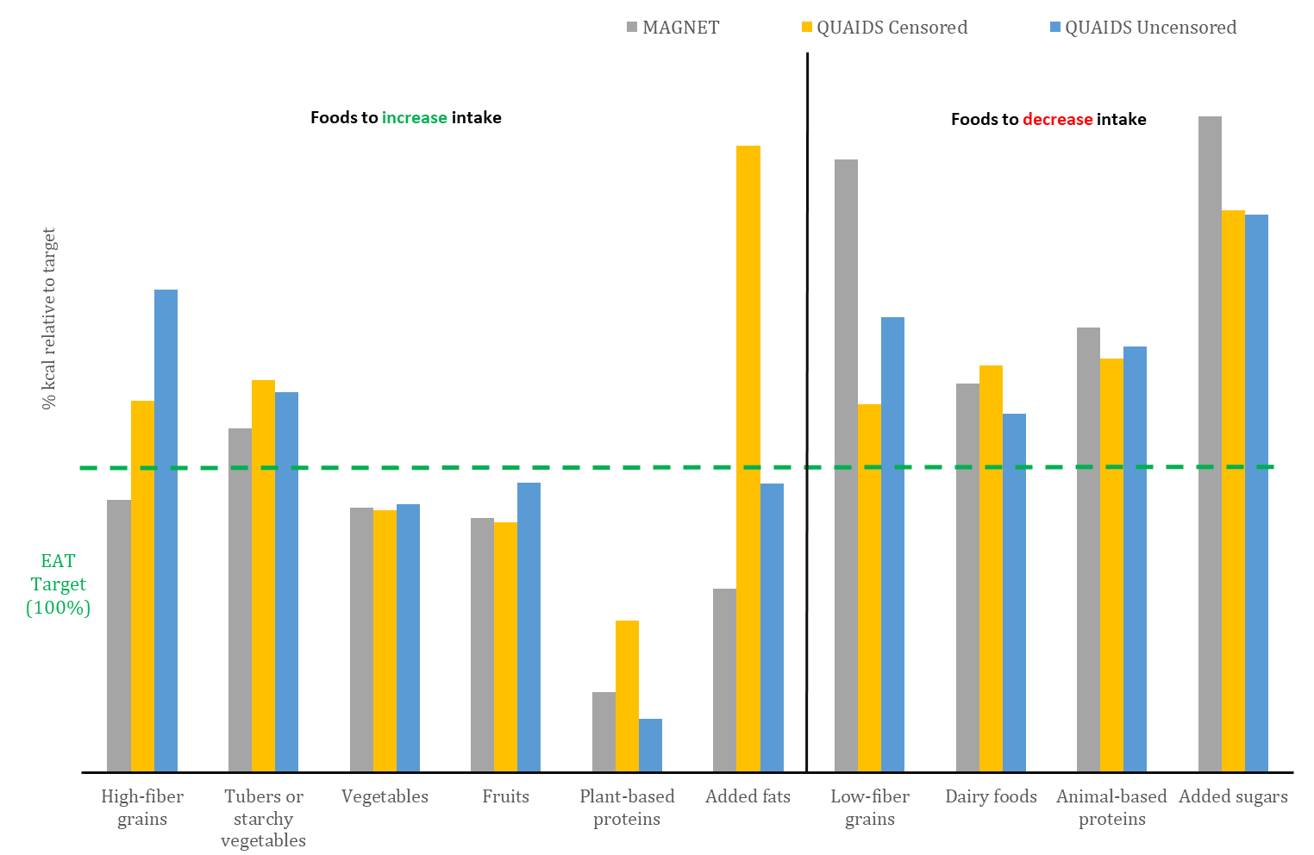

Panel II: Milpa-EAT-Mx
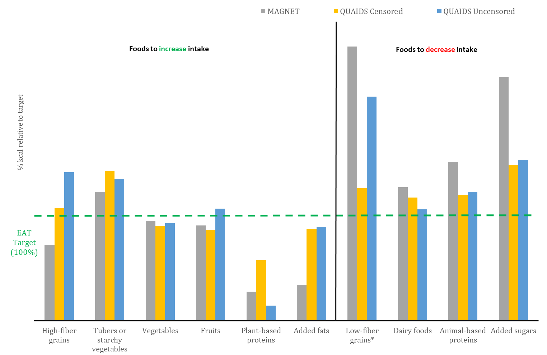
Fig. A.1. Comparison of models. Macro-microsimulation of taxes and subsidies to reach the EAT targets. Percentage of progress by 2040 with respect to the dietary targets by model and food group.
Notes: The distribution of calorie values before the simulation was adjusted to be consistent with the ENSANUT structure of shares by food group. The dietary target corresponds to the goal by 2050. QUAIDS modelling based on calculations with corrections for potential price and expenditure endogeneity (with and without censoring corrections). *Percentage values downscaled for visualization purposes.
Source: Own calculations with data from 2018 Mexican National Household Income and Expenditure Survey (INEGI, 2019).
Panel I: EAT-Mx
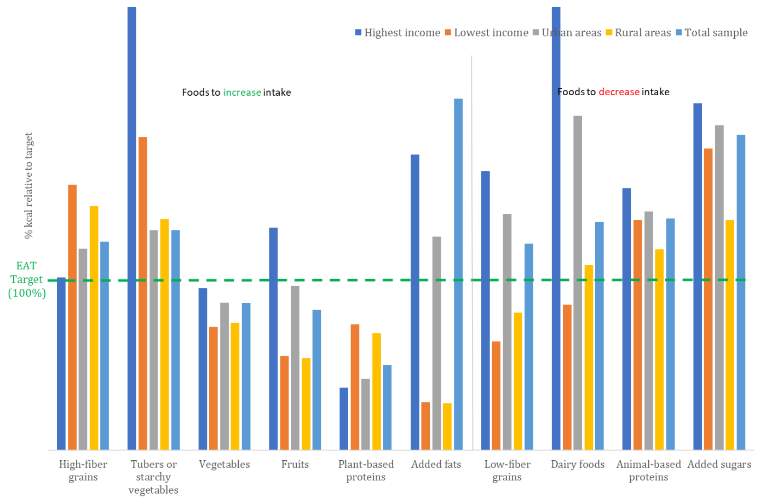

Panel II: Milpa-EAT-Mx

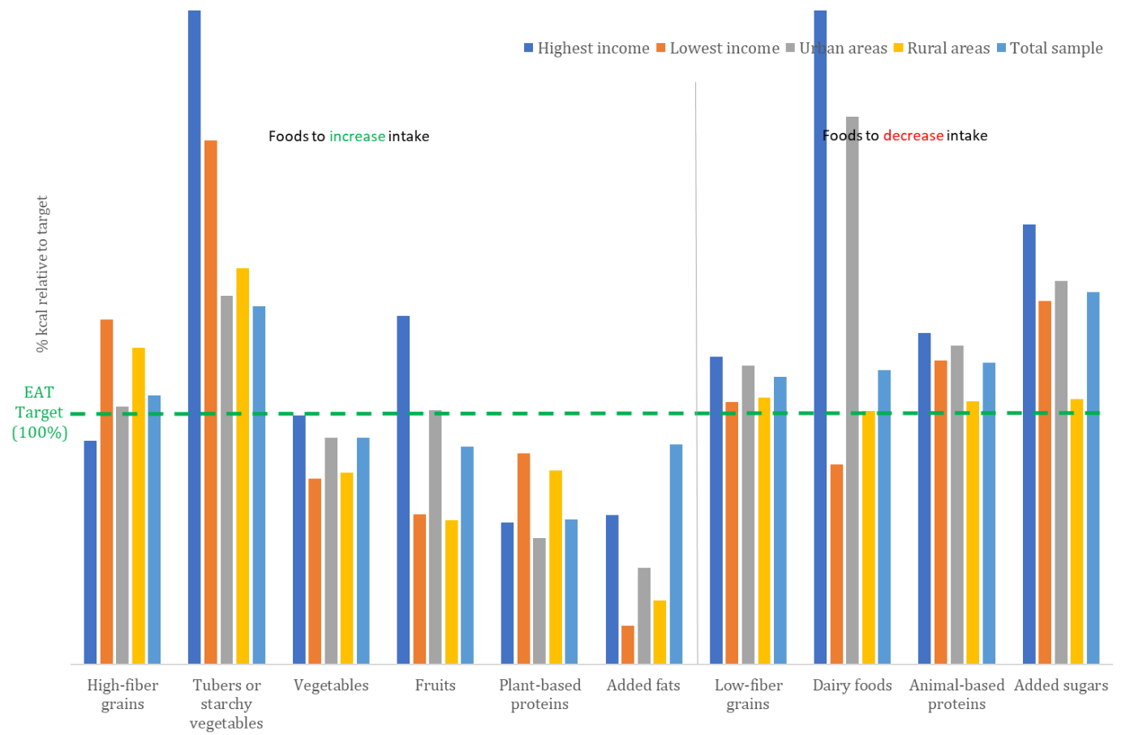
Fig. A.2. Censored model. Macro-microsimulation of taxes and subsidies to reach the EAT targets. Percentage of progress by 2040 with respect to the dietary targets by sample subgroup and food group.
Notes: The distribution of calorie values before the simulation was adjusted to be consistent with the ENSANUT structure of shares by food group. The dietary target corresponds to the goal by 2050. Calculations based on QUAIDS modelling with corrections for censoring in the data, potential price and expenditure endogeneity.
Source: Own calculations with data from 2018 Mexican National Household Income and Expenditure Survey (INEGI, 2019).

References
Capacci, S., Mazzocchi, M., 2011. Five-a-day, a price to pay: An evaluation of the UK program impact accounting for market forces. J Health Econ 30, 87–98. https://doi.org/10.1016/j.jhealeco.2010.10.006
Caro, J.C., Ng, S.W., Bonilla, R., Tovar, J., Popkin, B.M., 2017. Sugary drinks taxation, projected consumption and fiscal revenues in Colombia: Evidence from a QUAIDS model. PLoS One 12, 1–16. https://doi.org/10.1371/journal.pone.0189026
Castellanos-Gutiérrez, A., Sánchez-Pimienta, T.G., Batis, C., Willett, W., Rivera, J.A., 2021. Toward a healthy and sustainable diet in Mexico: where are we and how can we move forward? Am J Clin Nutr 1–8.
Crovetto M., M., Uauy, R., 2014. Cambios en el consumo aparente de lácteos, bebidas azucaradas y jugos procesados en el gran Santiago. Chile. 1987-2007. Rev Med Chil 142, 1530–1539. https://doi.org/10.4067/S0034-98872014001200006
FAO, 2021. Food Balances (2010-) [WWW Document]. FAOSTAT. URL https://www.fao.org/faostat/en/#data/FBS (accessed 7.19.21).
INEGI, 2019. Encuesta Nacional de Ingresos y Gastos de los Hogares (ENIGH). 2018 Nueva serie [WWW Document]. URL https://www.inegi.org.mx/programas/enigh/nc/2018/ (accessed 10.27.21).
INSP, 2012. Database of food’s nutritional value. Compilation of the National Institute of Public Health. Mexico City.
Segovia, J., Orellana, M., Sarmiento, J.P., Carchi, D., 2020. The effects of taxing sugar-sweetened beverages in Ecuador: An analysis across different income and consumption groups. PLoS One 15, 1–18. https://doi.org/10.1371/journal.pone.0240546
Subramanian, S., Deaton, A., 1996. The Demand for Food and Calories. Source: Journal of Political Economy 104, 133–162.
Valero-Gil, J., Valero, M., 2018. Calories and poverty during a prolonged crisis. Food Policy 76, 56–69. https://doi.org/10.1016/j.foodpol.2018.03.006

