Supplemental Figures
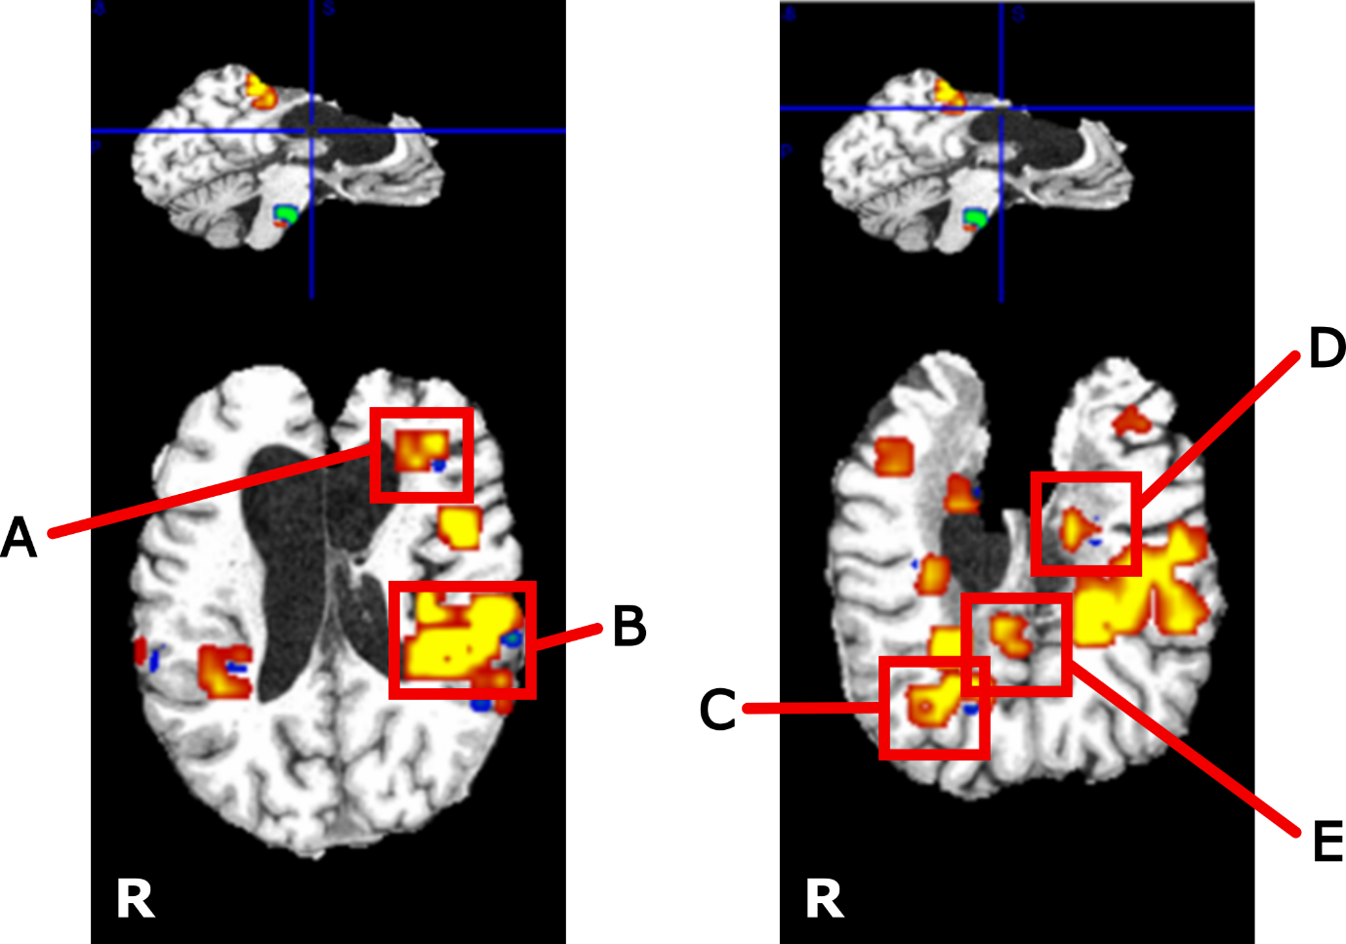

Supplemental Figure 1 Part A: Five regions – randomly labelled A-E - of greatest fMRI activation change over the three-year study duration from Phase 1, showing increased activation in areas immediately posterior to damaged structures. Co-registered functional data were concatenated into a 4D volume and passed to FSL MELODIC for independent components analysis along the 4th dimension, using automatic dimensionality estimation. Resulting temporal components were averaged into years 1-3 and compared using a paired t-test. Spatial distribution maps localized the regions of greatest changing brain activity. FSL Cluster was used to extract “neuroplasticity clusters” from the lower limb IC3 map. (Refer to Part B for activation changes over time for each of these regions). All activation is thresholded for p<0.05 (corrected).
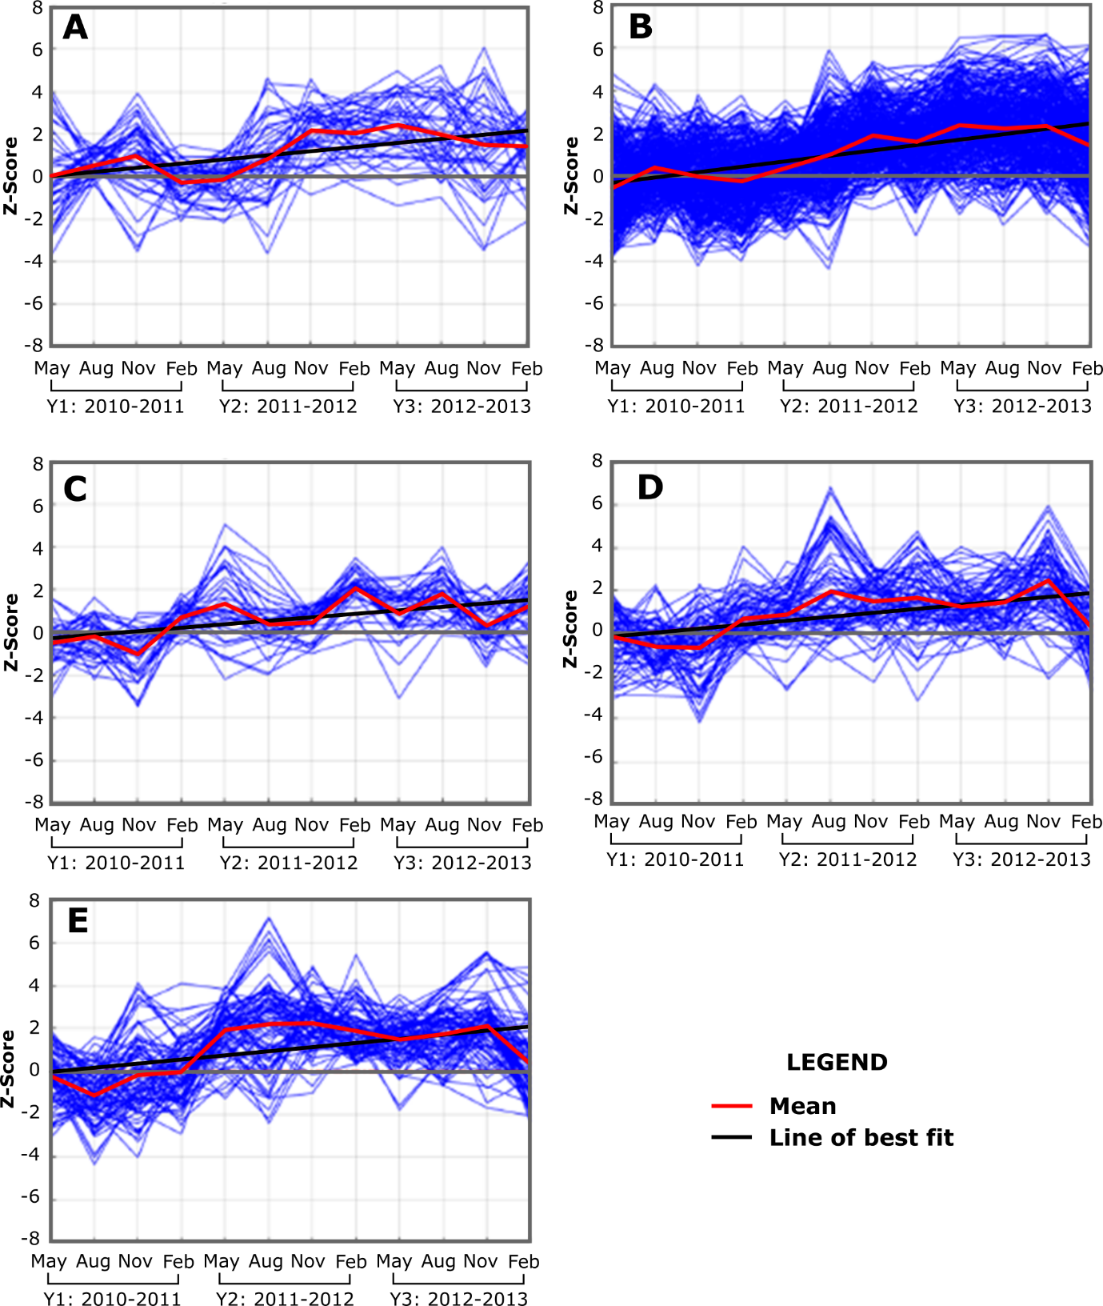

Supplemental Figure 1 Part B: Activation changes over the three-year study duration for the five clustered regions (labelled A-E) of largest overall fMRI change (shown in Supplemental Figure Part A). Blue lines represent the activation for each voxel within the cluster, red lines show the average activation of all voxels, and the line of best fit indicated in black to show the general trend over time.

