Supplemental Figures
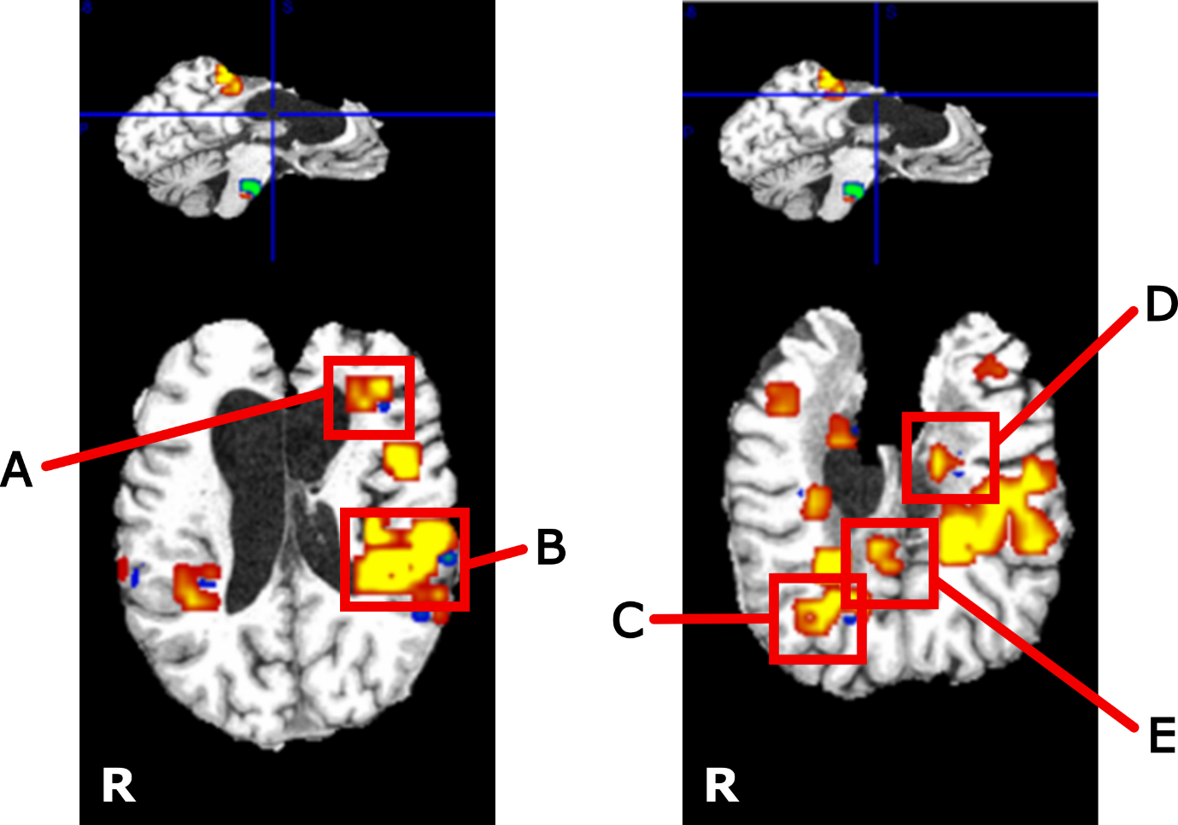

Supplemental Figure 1 Part A: Regions of greatest fMRI activation change over the three-year study duration. Co-registered functional data were concatenated into a 4D volume and passed to FSL MELODIC for independent components analysis along the 4th dimension, using automatic dimensionality estimation. Resulting temporal components were averaged into years 1-3 and compared using a paired t-test. Spatial distribution maps localized the regions of greatest changing brain activity. FSL Cluster was used to extract “neuroplasticity clusters” from the lower limb IC3 map. (Refer to Part B for activation changes over time for each of these regions). All activation is thresholded for p<0.05 (corrected).
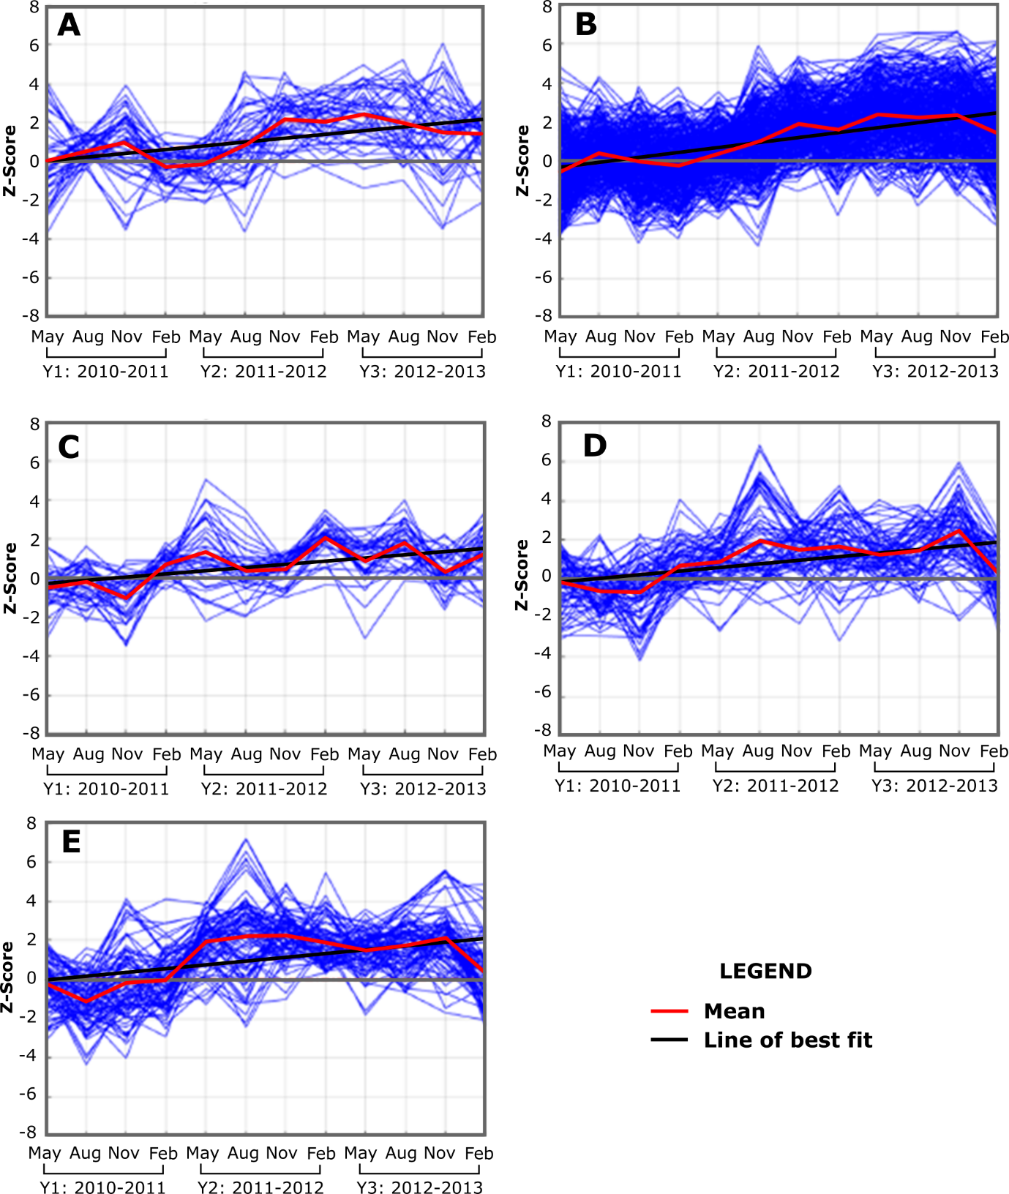

Supplemental Figure 1 Part B: Activation changes over the three-year study duration for the five regions of largest overall fMRI change (shown in Supplemental Figure Part A)

