UPTAKE, TRANSLOCATION AND METABOLIZATION OF TRAMADOL, AMITRIPTYLINE, ORPHENADRINE AND LIDOCAINE BY GARDEN CRESS, PEA AND WATER HYACINTH

Anna Detzlhofer¹, Christian Grechhamer¹, Lawrence Madikizela², Markus Himmelsbach¹, Franz Mlynek¹, Wolfgang Buchberger¹ and Christian W. Klampfl¹*

¹ Institute of Analytical and General Chemistry, Johannes Kepler University, Altenberger Strasse 69, 4040 Linz, Austria
² Institute for Nanotechnology and Water Sustainability, College of Science, Engineering and Technology, University of South Africa, Florida Science Campus, 1710, South Africa

SUPPLEMENTARY MATERIAL

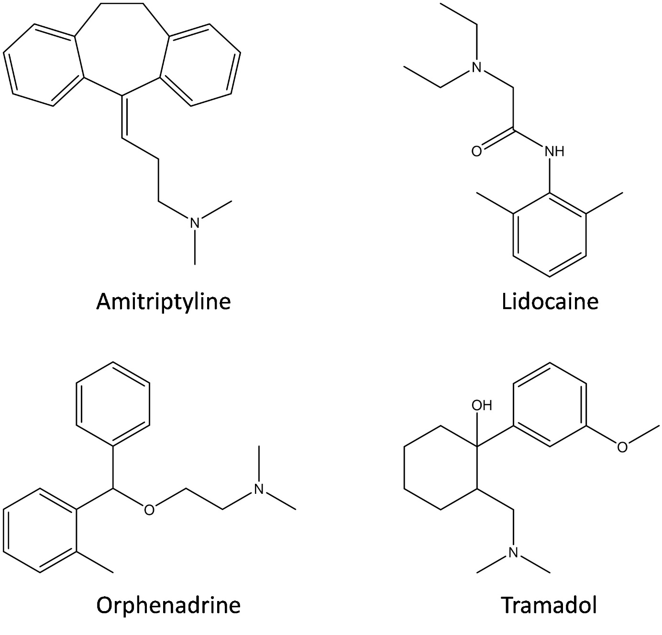

Figure S1: Structures of the investigated API´s

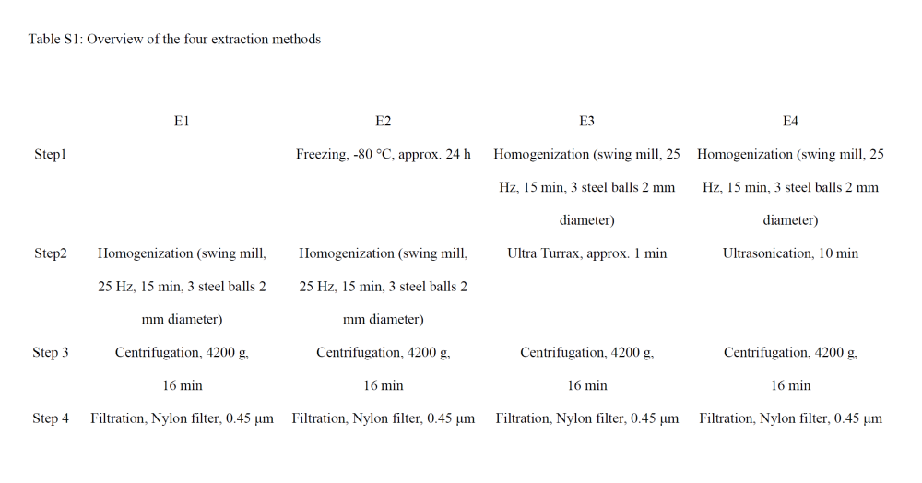
Table S1: Overview of the four extraction methods
Table S2: Overview of the tested extraction agents.

Solvent mixture |  | Solvent 1 | Solvent 2 | Ratio
SM 1* | - |  | MeOH | -
SM2 | 0.1 M HCl |  | MeOH | 80/20
SM3 | 0.1 M HCl |  | MeOH | 50/50
SM4 | H₂O |  | MeOH | 50/50
SM 5 | 0.1 M HCl |  | ACN | 80/20
SM 6* | - |  | ACN

*sample diluted with equal amounts of MilliQ® water before HPLC-MS analysis.
MeOH methanol
ACN acetonitrile

Table S3: MRM transitions of the APIs

Compound | Precursor Ion [m/z] | Product Ion [m/z] | Fragmentor Voltage [V] | CE [V]
Amitriptyline | 278.2 | 233.1 | 80 | 14
Amitriptyline | 278.2 | 191.1 | 80 | 25
Atenolol | 267.2 | 145.1 | 110 | 26
Atenolol | 267.2 | 190.1 | 110 | 15
Citalopram | 325.2 | 109.1 | 105 | 26
Citalopram | 325.2 | 262.1 | 105 | 17
Lidocaine | 235.2 | 86.1 | 80 | 12
Lidocaine | 235.2 | 58.1 | 80 | 35
Orphenadrine | 270.2 | 181.1 | 60 | 10
Orphenadrine | 270.2 | 166.1 | 60 | 8
Telmisartan | 515.3 | 497.2 | 80 | 36
Telmisartan | 515.3 | 276.1 | 80 | 50

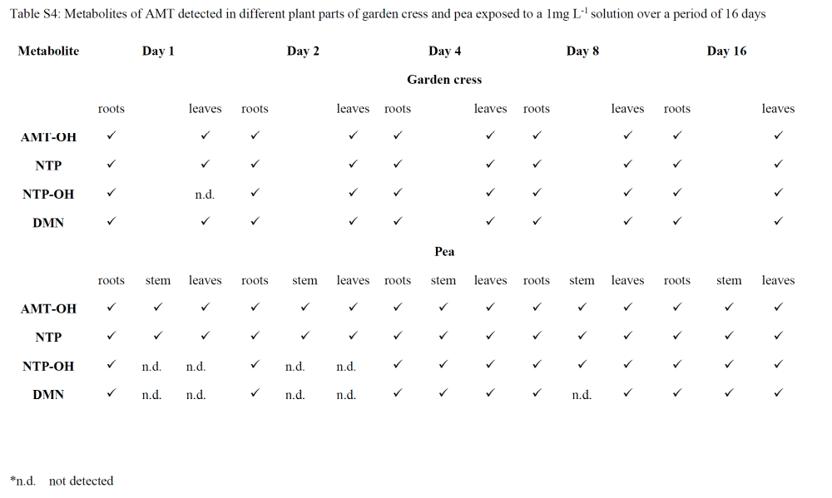
Table S4: Metabolites of AMT detected in different plant parts of garden cress and pea exposed to a 1mg L⁻¹ solution over a period of 16 days

