Online Resource Animal Cognition
Tolerant macaque species are less impulsive and reactive
Louise Loyant¹, Bridget M. Waller², Jérôme Micheletta¹, Hélène Meunier³, Sébastien Ballesta³, and Marine Joly¹
¹ Centre for Comparative and Evolutionary Psychology, Department of Psychology, University of Portsmouth, Portsmouth, United Kingdom
² Department of Psychology, Nottingham Trent University, Nottingham, United Kingdom
³ Laboratoire de Neurosciences Cognitives et Adaptatives, CNRS and Université de Strasbourg, UMR (7364), Strasbourg, France
Corresponding Author:
Louise Loyant¹
Department of Psychology, King Henry I Street, King Henry Building, Portsmouth PO1 2DY, United Kingdom
Email address: louise.loyant@port.ac.uk

S1 Supplementary information on the subjects
Rhesus macaques from the MRC
All the adult rhesus macaques (Macaca mulatta) taking part in this study were from the breeding colony of the Medical Research Council’s Center for Macaques (MRC-CFM) in Porton Down, United Kingdom. Each group had access to an indoor free-roaming room (3.35 m × 8.04 m × 2.8m) and an adjacent caged area (1.5m×6.12m×2.8m), with a minimum total space of 3.5 m3 /breeding animal in the largest groups. All rooms were temperature controlled (20 °C ± 5) with humidity at 55% +/-10. Each free-roaming area had a large bay window at one end facing outdoors and allowing a natural day-night cycle. At the other end of each room was an internal window fitted with movable mirrors which the monkey could control using a handle, allowing them to view the activities outside their area. Rooms were enriched with climbing structures (platforms, poles, fire hose and ladders) and enrichment devices (food puzzles, boxes, plastic barrels and balls, and small plastic blocks attached to structures or walls). Subjects received a supply of fruit and vegetables, dried forage mix (cereal, peas, beans, lentils etc.), bread and boiled eggs, in the morning and afternoon, with enough food to last for a 24 h period. All subjects had access to water and food prior to and during the experiment. Eighteen of the subjects already participated in a behavioural study involving looking at pictures (Howarth et al. 2021) and all of them were familiar with basic training and clicker procedures. However, none of them had experience with touchscreen experiments. Thirty subjects (14 males, 16 females; aged from 3 to 17 years old, mean age in years M ± S.D. = 8.10 ± 4.05, N = 30) started the touch screen training phases but only 21 (12 males and 9 females, aged from 3 to 17 years old, mean age in years M ± S.D. = 8.9 ± 4.41) successfully completed the training and were able to take part in the experiment.
The subjects were housed in 14 different social groups with an average of 12 individuals per group.
Macaques from the CPUS
The rhesus macaques from the Centre of Primatology of the University of Strasbourg, FR (CPUS) (N = 7 subjects, 5 females and 3 males, aged from 2 to 25 years old) were raised in social groups from 3 to 5 individuals consisting of one dominant male and several females and younglings. They lived in cages, measuring 16.5 to 33 m² for the indoor area and 14 to 29 m² for the outdoor area. Cages were enriched with climbing devices. Tested subjects were naive to previous behavioural studies and cognitive experiments except two subjects which did touch screen experiments in their youth (Ballesta et al. 2021).
The long-tailed macaques from the CPUS (N = 20, 12 females, 8 males, aged from 7 to 21 years old) were all born in the centre and raised in social groups. The subjects were taken from 8 mixed groups of 2 to 13 individuals with one dominant male and several females and younglings. One group was constituted of only males and one group of only females. They lived in cages, measuring 16.5 to 33 m² for the indoor area and 16.5 to 23 m² for the outdoor area. Cages were enriched with climbing devices. Tested subjects were naive to any previous clicker training procedures and behavioural studies and experiments.
The Tonkean macaques from the CPUS (N = 18, 6 females, 12 males, aged from 4 to 23 years old) were all born in the centre and raised in social groups. The subjects were taken from two groups. Four subjects tested were from a group of five males. In this group, subjects had free access to an approximately 1364 m² wooded outdoor area, connected to a 20m² heated indoor area. Tested subjects were familiar with basic training and clicker procedures and they already took part in behavioural studies and experiments. They all had access to touch screen modules when they were young but were never tested with pictures (Fizet et al. 2017). Fourteen subjects were from a group of 21 to 23 individuals. In this group, subjects had free access to an approximately 3700 m² wooded outdoor area, connected to a 20m² heated indoor area. All subjects have free access to touch screen modules (Ballesta et al. 2021; Nioche et al. 2021). They were exposed to pictures of familiar conspecifics, but they have never been tested with pictures of unknown or threatening conspecifics. At the CPUS, all animals were provisioned with commercial monkey pellets seven days a week, in addition to a supply of fresh fruit and vegetables once a week. Water was available ad libitum.

 |  |  | rhesus macaques | long-tailed macaques | Tonkean macaques
Total number |  |  | 28 | 20 | 18
Sex |  | Male | 16 | 8 | 12
Sex |  | Female | 12 | 12 | 6
Age |  | average | 10 | 13.8 | 11
Age |  | S.D | 5.7 | 2.9 | 5.6
Age |  | Min | 2 | 7 | 4
Age |  | Max | 25 | 21 | 23
Ranking | High | Male | 13 | 6 | 5
Ranking | High | Female | 8 | 5 | 0
Ranking | Low | Male | 2 | 2 | 7
Ranking | Low | Female | 5 | 7 | 6
Description of the sex, the age and the ranking of the subject rhesus, long-tailed and Tonkean macaques. Average, S.D. (standard deviation), minimum and maximum of the values are given.

S2 Training procedures
Training phase 1
Monkeys were trained by positive reinforcement (based on food rewards) to touch a red square target (10 x 12 cm). The target was moved in all directions and the monkey should follow it for at least 20 trials in a row.
Training phase 2
The second training phase used a rectangular transparent Plexiglas sheet (42 x 30 cm) with a plastic red square target (10 x 12 cm) moved by hand. Monkeys were progressively rewarded for approaching the Plexiglas sheet, touching the target as it moved. This phase was judged as complete if the macaques followed the target 20 times in a row.
Training phase 3
After completion of the first training phase, the touchscreen was introduced. The aim of training phase 2 was to be trained to touch a target on the screen.
Stimuli
The target was a red (RGB 255, 0, 0) rectangle of a maximum of 1200 x 1000 pixels (ca. 32 x 26 cm) and was gradually reduced to 360 x 500 pixels (ca. 10 x 13 cm).
Procedure
When the program was launched, the experimenter entered the name of the individual, the number of trials per session, the size of the target and the time limit to complete the task. Every session was initiated by the subject touching a red cross located in the centre of the screen, starting the time recording. Then, the target was displayed in the middle of a white background. Once the subject touched the target, a high-pitched chime (composed of 3 sound frequencies: 800, 1300 and 2000 Hz) was played, the timer was stopped, and the reward was given. After an inter-trial of 2000 ms, with only the white background displayed, the next trial was presented. Based on a pilot study (N = 4 subjects), we set up a maximum response time of 35s.
If the subject left the testing area or was not focusing attention on the screen the session was aborted. If the target was not touched within the time limit (35 s), the timer was paused, a red cross appeared in the centre of the screen until the session was resumed by touching it. The size of the target was gradually reduced to 360 x 500 pixels (ca. 10 x 13 cm).
Once the macaques performed successfully 20 times in a row with the target in the centre of the screen, the target was displayed randomly at the far left or right of the screen. This phase was judged as complete if the macaque followed the target 20 trials in a row. If the subject stayed inactive for more than 5 min the session was stopped and continued the next testing day, if the subject did not participate for three testing days in a row the subject was excluded from the task.

S3 Rank calculation
We considered high ranking individuals the two subjects at the top of the hierarchy at the time of the testing (e.g., in mixed groups, the top-ranking male and the top-ranking female).

Rank calculation at the MRC
Calculated ranks by David’s Scores:
Ranks obtained from David’s Scores (DS) (De Vries et al. 2006) were calculated in 2016. They were also based on agonistic interactions recorded ad libidum. Agonistic behaviours included threats (e.g., open mouth threat), displacements (i.e., a macaque approaches another who departs immediately), chases, and physical conflict (e.g. bite, slaps). These calculated ranks were regularly monitored and updated during observations and training sessions by caretakers. After a regression analysis all calculated ranks were found significant.
Total Number of conflicts: 734
Number of conflicts: [48-136]
Number of observations: [4-14]
Observed ranks:
To confirm the calculated ranks at the time our experiments were conducted we coded agonistic behaviour with a focus on the studied subject. A blind observer recorded agonistic interactions (winner/loser) between a focal individual and other members of the group during the training and test sessions. Agonistic behaviours included threats (e.g. open mouth threat), displacements (i.e. a macaque approaches another who departs immediately), chases, and physical conflict (e.g. bite, slaps). If the male never lost, he was considered as high ranked. If the female never lost against other females, she was considered as high ranked (H), otherwise she was considered low ranked (L).

Females | loser (suppl/threat) | winner (suppl/threat) | No observations | Sex | Observed rank | Rank from DS
Ylang | 18 | 30 | 26 | F | L | L
Adele | 32 | 13 | 23 | F | L | L
Rach | 0 | 21 | 32 | F | H | H
Ybbi | 0 | 8 | 18 | F | H | H
Blossom | 0 | 33 | 27 | F | H | H
Tes | 1 | 7 | 12 | F | L | L
Aqua | 4 | 5 | 10 | F | L | L
Saphy | 0 | 8 | 7 | F | H | H
Talula | 0 | 34 | 27 | F | H | H
Males | loser (suppl/threat) | winner (suppl/threat) | No observations | Sex | Observed rank | Rank from DS
Yew | 0 | 6 | 22 | M | H | H
Yorkie | 0 | 34 | 39 | M | H | H
Yosser | 0 | 3 | 40 | M | H | H
Zazy | 0 | 2 | 36 | M | H | H
Sol | 0 | 81 | 19 | M | H | H
Vincent | 0 | 16 | 26 | M | H | H
Abbott | 0 | 14 | 28 | M | H | H
Sequel | 0 | 14 | 22 | M | H | H
Nodon | 0 | 41 | 31 | M | H | H
Star | 0 | 23 | 29 | M | H | H
Plum | 0 | 31 | 18 | M | H | H
Yeti | 5 | 0 | 15 | M | L | L

Rank calculation at the CPUS

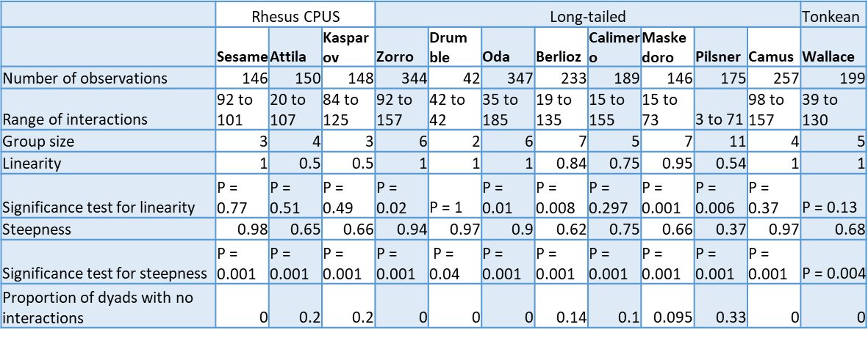
Rank of the subjects were also based on agonistic interactions recorded ad libidum using David’s score and ELO ratings (Ballesta et al. 2021; Neumann et al. 2011). Agonistic behaviours included threats (e.g., open mouth threat), displacements (i.e. a macaque approaches another who departs immediately), chases, and physical conflict (e.g. bite, slaps). Here is presented the number of observations per group, the range of interactions, the group size, the coefficient of linearity and associated P value, the coefficient of steepness and associated P value and the proportion of dyads with no interactions. We considered high ranking individuals the two subjects at the top of the hierarchy at the time of the testing (e.g. the top-ranking male and the top-ranking female in mixed groups).
The rank of the individuals from the large group of Tonkean macaques was automatically calculated in real-time using the modules installed in their enclosure. Ballesta and colleagues (2020), demonstrated that the calculation of the ranking they developed, using displacements occurring in the modules, was highly correlated with traditional behavioural observations (using agonist interactions as we did).

S4 Design of the Distraction task
Every session was initiated by the subject touching a red cross in the centre of the screen. Then the timer started, and the subject had to touch a target (a red rectangle of 10 x 13 cm) randomly displayed at the far left or right of the screen. When the subject successfully touched the target, a high-pitched chime was played, the timer was stopped, and the reward was given. After an inter-trial of 2000 ms with only a white background displayed, the next trial was presented. Such a trial without a distractor was considered as a “Control” trial. Two “Control” trials were followed by a block of four trials with pictures from the same categories (either four pictures of objects, neutral or threatening conspecific faces). Each block of pictures of the same category was seen 2 times per session. The distractors were displayed at the centre of the screen at the same time as the regular target. We used 3 categories of stimuli. The category “Object” included a leather ball, leather bag, brown stone and wooden log (see below).
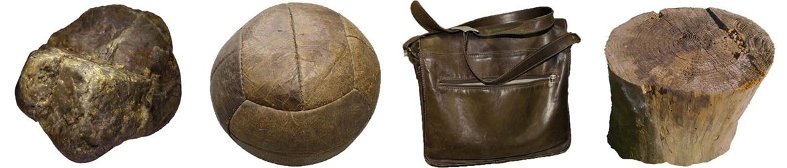
“Object trials”. Objects presented in the Distraction task (“Object” trials). We used a rock, a leather ball, a leather bag and a log of wood as stimuli.
For each species, the conspecific pictures were also chosen to be as realistic as possible, depicting a frontal view of the face and the torso of four unknown adult macaques. The “Neutral” conspecific included, for each species, four pictures of individuals with a neutral facial expression. The “Threatening” conspecific also included for each species, four pictures showing a “open mouth threat” facial expression (see below).
Low tolerance species:

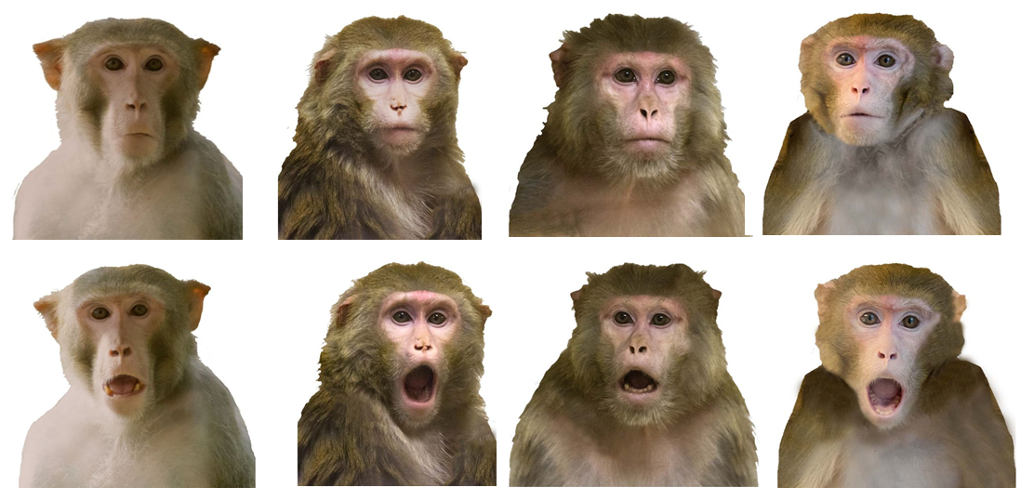

Medium tolerance species:
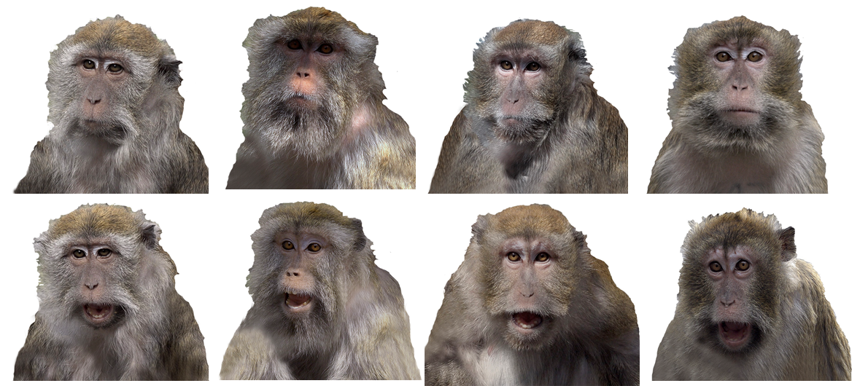

High tolerance species
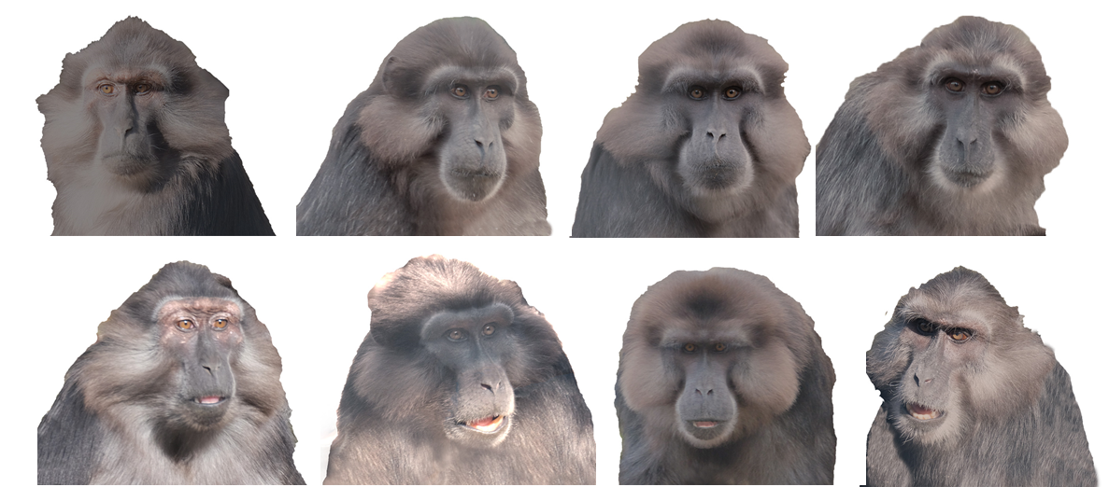“Neutral” and “Threatening” trials. Stimuli used in the Distraction task in rhesus macaques. The first row displays neutral unknown conspecific faces (“Neutral” trials). The second row displays the same conspecifics but with a threatening facial expression (“Threat” trials).
Each subject was tested in 3 sessions of 36 trials. The subjects were not rewarded to touch the distractors and the screen remained the same until the target on the side was touched. During a pilot study (N = 4 subjects, these data were not included in our analysis), we observed that the subjects were, for a long duration, intensely reacting to the pictures of their conspecifics’ faces (lip-smacking, stares and threats) so we set up a maximum response time of 35 s (at the condition that the subject kept looking at the screen). This time period allowed the subject to display a behavioural response, overcome it, and continue the task. If the subject did not touch the target within 35 sec, the response latency was not taken into account in the analysis and the red cross appeared. Each block and trial were counterbalanced across subjects.

S5 Design of the Go/No-go task
In the Go/No-go task, the subjects need to respond to frequently presented stimuli while withholding prepotent response to infrequently presented no-go stimuli. Each subject was tested in 5 sessions of 40 trials. A “Go” (red rectangle of 16x18 cm) or a “No-go” stimulus (green circle of 16x16 cm) appeared randomly in the centre of the screen. The “Go” stimulus was preceded by a high-pitched sound (0.6 sec before the stimulus appeared) and the “No-go” stimulus a low pitch sound to help the subjects to anticipate the next trial. The “Go” stimuli appeared 75% of the 40 trials to elicit a prepotent response toward the screen. If the screen was touched outside the stimulus no sound was produced and the trial continued. The “Go” stimulus stayed on the screen until it was touched. We set up a maximum response time (i.e., touching the “Go” stimuli) of 15 s after this the red cross appeared on the screen and the response latency was not recorded. From a pilot study conducted with a shorter response limit, we observed that the subjects frequently left the testing session as they were not rewarded on each “Go” trial. The “No-go” stimulus disappeared if not touched during 2000 ms and the subject received a reward. If the “No-go” stimulus was touched during this lapse of time, a blank white background appeared for 3000 ms (as a time out), an “incorrect” sound (with frequency 800, 1300, 2000 Hz) was produced and the reward was not given.

S6 Design of the Reversal learning task
At the beginning of the task, two stimuli, a “Go” rewarded stimulus (a red square of 15.34 x 15.34 cm) and a “No-go” unrewarded stimulus (a green circle of 15.34 cm of diameter), were displayed at the same time on the screen at counterbalanced locations (left or right of the screen). When the subject touched the “Go” stimulus, the usual “correct” sound was played, the subject received a reward, and a new trial began. If the subject touched the incorrect stimulus the “incorrect” sound was played, the subject did not receive a reward and the two stimuli stayed on the screen until the correct stimulus was touched. If the background was touched nothing happened. We set up a maximum response time (i.e. touching the “Go” stimuli) of 15 s after this the red cross appeared on the screen and the response variables were not recorded. We set up this response limit to keep the subjects engaged with the task. From a pilot study we observed that this period of time allowed the subject to frequently receive a reward and to keep engaged with the task. A session consisted of 40 trials. Once a criterion of success was achieved (75% of correct trials out of 20 trials, i.e., the subjects touched the correct stimulus from the first attempt), the rule was reversed: the correct stimulus became the incorrect and the incorrect the correct. One male macaque was excluded from the study as he did not reach the first criterion. The reversed session was continued until the success criterion was reached again (75% of success for the whole session).

S7 Effect of the factor institution on the inhibitory control scores from the model comparison
For the distraction task, individuals from the low tolerance species came from two institutions but there was no difference in their Distraction control score (χ² ₁ = 0.292, N = 28, P = 0.589). For the Go/No-go task, individuals from the low tolerance species came from two institutions but there was no difference in their proportion of success in this task (χ² ₁ = 0.292, N = 28, P = 0.589). For the Reversal learning task, The model with the factor institution did not have a main significant effect when compared with the null model ( χ²₁ = 01.878, N = 28, P = 0.171). Therefore we pooled all of the individuals from the low tolerance species together for each score.

S8 Comparison of response latency between the three species
Response latency | Estimate | Std. Error | t value | Pr(>|t|)
(Intercept) | 4732.576 | 569.781 | 8.305 | 1.47E-12
age | 89.058 | 34.663 | 2.569 | 0.0123
Sex (male) | 502.453 | 362.173 | 1.387 | 0.1709
RANK (high) | 352.350 | 395.550 | 0.891 | 0.3763
Tolerance (low) | -593.691 | 456.8312 | -1.299 | 0.198
Tolerance (medium) | 818.972 | 466.010 | 1.757 | 0.0836
trial | -10.153 | 10.450 | -0.971 | 0.331
session | -561.78 | 98.2642 | -5.7170 | 1.21E-08**
Results of the LMM for the response latency in the training trials (touching a target on the screen, phase 2 of the training, 20 times in a row). Explanatory variables were individual characteristics (sex, age and tolerance), experimental determinants (trial and session). All full models the individual ID as a random factor. The Estimates (representing the change in the dependent variable relative to the baseline category of each predictor variable), Standard Error, t-value and p-value are represented. 6822 observations were analysed. * p < 0.05, ** p < 0.01, *** p < 0.001.
The factor tolerance did not influence the response latency of the subjects in the last step of the training sessions (χ² ₁ = 12.69, N = 66, P > 0.05).

S9 Distraction control score for all sessions together

Predictors |  | Estimate | Std. Error | t value | Pr(>|t|)
(Intercept) |  | 95.019 | 2.157 | 44.042 | 0.000
age |  | -0.012 | 0.132 | -0.103 | 0.9127
sex | female vs male | 0.502 | 1.360 | 0.369 | 0.669
tolerance | Low vs high | 2.608 | 1.709 | 1.497 | 0.091
tolerance | high vs medium | 3.349 | 1.736 | -1.929 | 0.049*
tolerance | Low vs medium | 5.922 | 1.560 | -3.797 | 0.000***
type of picture | control vs picture | 0.553 | 0.164 | 3.382 | 0.001**
type of picture | object vs face | 0.877 | 0.2777 | 3.162 | 0.002**
type of picture | threat vs neutral | -1.194 | 0.482 | -2.475 | 0.013*
trial |  | -0.075 | 0.030 | -2.506 | 0.012*
session |  | -2.780 | 0.331 | -8.405 | 0.000***
Results of the LMM for the normalised Distraction control score (Distraction task) when all the sessions were taken together. Explanatory variables were individual characteristics (sex, age and tolerance), experimental determinants (type of picture, trial and session). All full models included the type of picture nested in the individual ID as a random factor. The Estimates (representing the change in the dependent variable relative to the baseline category of each predictor variable), Standard Error, t-value and p-value are represented. 6822 observations were analysed. * p < 0.05, ** p < 0.01, *** p < 0.001.

S10 Results for the Distraction control score for session 1
Predictors |  | Estimate | Std. Error | t value | Pr(>|t|)
(Intercept) |  | 96.243 | 3.352 | 28.708 | 0.000
age |  | 0.044 | 0.237 | 0.187 | 0.853
sex | male vs female | -0.909 | 2.352 | -0.386 | 0.701
tolerance | Low vs high | 7.535 | 2.847 | -2.647 | 0.010*
 | high vs medium | 0.282 | 3.133 | -0.09 | 0.929
 | Low vs medium | 7.817 | 2.923 | -2.675 | 0.009**
type  of picture | control vs picture | 1.245 | 0.301 | 4.136 | <0.000***
type  of picture | object vs face | 1.332 | 0.494 | 2.694 | 0.0071**
type  of picture | threat vs neutral | -2.314 | 0.865 | -2.675 | 0.008**
trial |  | -0.021 | 0.056 | -0.375 | 0.708
Results of the LMM for the normalised Distraction control score (Distraction task) for session 1. Explanatory variables were individual characteristics (sex, age and tolerance), experimental determinants (type of picture and trial). All full models included the type of picture nested in the individual ID as a random factor. The Estimates (representing the change in the dependent variable relative to the baseline category of each predictor variable), Standard Error, t-value and p-value are represented. 2102 observations were analysed. * p < 0.05, ** p< 0.01, *** p < 0.001.

S11 Results of the Tukey Post Hoc Tests of the Distraction control score for session 1
Tolerance degree | Estimates | Std. Error | Z value | Pr (>|z|)
Low - high | 7.535 | 2.487 | -2.47 | 0.022*
high - medium | 0.282 | 3.133 | 0.090 | 0.996
Low - medium | 7.817 | 2.923 | -23.675 | 0.021*
Results of the Tukey HSD test comparing the normalised Distraction control score for each tolerance degree (low, medium and high tolerance species), for session 1. * p < 0.05

S12 Results for the Tukey HSD test comparing the normalised Distraction control score for session 1
Type of picture | Estimates | Std. Error | z value | Pr (>|z)
Control - Neutral | -3.995 | 1.552 | -2.573 | 0.049*
Object - Neutral | -1.678 | 1.706 | -0.984 | 0.758
Threat - Neutral | 4.615 | 1.731 | 2.667 | 0.038*
Object - Control | 2.317 | 1.553 | 1.492 | 0.441
Threat - Control | 8.61 | 1.579 | 5.452 | <0.001***
Threat - Object | 6.293 | 0.729 | 3.64 | 0.002**
Each type of picture are presented: Control (no picture presented), Neutral (a picture of a neutral conspecific face presented), Threat (a picture of the face of a threatening conspecific is presented), Object (a picture of an object). * p < 0.05, ** p< 0.01, *** p < 0.001.

S13 Result for the number of emotional reactions

 |  | Tolerance
 |  | Low | Medium | High
Type of pictures | Control | 0 | 0 | 0
Type of pictures | Object | 0 | 0 | 0
Type of pictures | Neutral | 6 | 4 | 0
Type of pictures | Threat | 18 | 4 | 0
Summary of the number of emotional reactions (threats, lips smacking and teeth chattering toward the screen) for each tolerance degree (low, medium and high tolerance species) and the type of picture (control: no picture, picture of an object, picture of a neutral conspecific and picture of a threatening conspecific).
Tolerance degree | Estimates | Std. Error | Z value | Pr (>|z|)
high - low | -0.214 | 0.068 | 3.176 | 0.0043**
high - medium | -0.100 | 0.056 | 1.791 | 0.1725
Low - medium | 0.114 | 0.088 | 1.305 | 0.3923
Result of the Tukey HSD test comparing the number of emotional responses for each tolerance degree (low, medium and high tolerance species) all sessions together. ** p < 0.01
Type of picture | Estimates |  | Std. Error |  | z value |  | Pr (>|z)
Control - Neutral |  | -0.152 |  | 0.061 | 2.492 | 0.0611
Object - Neutral |  | -0.152 |  | 0.061 | 2.492 | 0.0611
Threat - Neutral |  | 0.182 |  | 0.134 | -1.356 | 0.527
Object - Control |  | 0.000 |  | 7.03e-6 | 0.000 | 1.000
Threat - Control |  | 0.333 |  | 0.120 | -2.788 | 0.027*
Threat - Object |  | 0.333 |  | 0.120 | -2.788 | 0.027*
Results of the Tukey HSD test comparing the number of emotional reactions, for each type of picture: Control (no picture presented), Neutral (a picture of a neutral conspecific face presented), Threat (a picture of the face of a threatening conspecific is presented), Object (a picture of an object). * p < 0.05

S14 Results for the Go/No-go task, all sessions together
Predictors |  | Estimate | Std. Error | z value | Pr(>|z|)
(Intercept) |  | 0.168 | 0.297 | 0.567 | 0.571
sex | male vs female | -0.025 | 0.177 | -0.142 | 0.887
age |  | -0.017 | 0.017 | -0.958 | 0.338
tolerance | Low vs high | -0.426 | 0.214 | -1.992 | 0.046*
tolerance | medium vs high | 0.300 | 0.231 | 1.303 | 0.192
tolerance | medium vs Low | 0.726 | 0.219 | 3.322 | 0.001**
trial |  | -0.001 | 0.003 | -0.453 | 0.650
session |  | 0.116 | 0.027 | 4.311 | 0.000***
Results of the GLMM for the probability of success in the Go/No-go task for a No-go stimulus when all the sessions were taken together. Explanatory variables were individual characteristics (sex, age and tolerance), experimental determinants (trial and session). All full models included the type of picture nested in the individual ID as a random factor. The Estimates (representing the change in the dependent variable relative to the baseline category of each predictor variable), Standard Error, t-value and p-value are represented. 3150 observations were analysed. * p < 0.05, ** p< 0.01, *** p < 0.001.

S15 Results for the Go/No-go task, last session

Predictors |  | Estimate | Std. Error | z value | Pr(>|z|)
(Intercept) |  | 0.355 | 0.369 | 0.962 | 0.336
sex | male vs female | -0.442 | 0.251 | -1.761 | 0.078.
age |  | -0.005 | 0.024 | -0.224 | 0.823
tolerance | Low - high | -0.701 | 0.301 | 2.334 | 0.020*
tolerance | medium - high | 0.189 | 0.326 | 0.579 | 0.563
tolerance | medium - low | 0.890 | 0.312 | 2.854 | 0.004**
trial |  | 0.003 | 0.008 | 0.403 | 0.687
Results of the GLMM for the probability of success in the Go/No-go task for a No-go stimulus for session 5. Explanatory variables were individual characteristics (sex, age and tolerance) and trial. All full models included the type of picture nested in the individual ID as a random factor. The Estimates (representing the change in the dependent variable relative to the baseline category of each predictor variable), Standard Error, t-value and p-value are represented. 624 observations were analysed. * p < 0.05, ** p< 0.01
When looking at the Tukey Post Hoc test we found only the difference between the Low tolerance species and the medium tolerance species. Therefore, we considered it as the true significant difference.
Tolerance degree | Estimates | Std. Error | Z value | Pr (>|z|)
Low - high | -0.702 | 0.301 | 2.334 | 0.051.
medium - high | 0.189 | 0.326 | -0.579 | 0.813
medium - low | 0.890 | 0.312 | 2.854 | 0.012*
Results of the Tukey HSD test comparing the success on a No-go trial for each tolerance degree (low, medium and high tolerance species) for session 5. * p < 0.05

S16 Results for the reversal learning task

Tolerance degree | Estimates | Std. Error | t value | Pr (>|z|)
high - low | -36.11 | 025.21 | -1.433 | 0.331
high - medium | -24.09 | 26.59 | -0.906 | 0.638
Low - medium | 12.02 | 24.83 | 0.484 | 0.879
Result of the Tukey HSD test comparing the number of trials to learn the reversed rule for each tolerance degree (low, medium and high tolerance species).

Predictors | Estimate | Std. Error | t value | Pr(>|t|)
(Intercept) | 75.979 | 25.187 | 3.017 | 0.004
age | 5.092 | 2.105 | 2.419 | 0.019*
sex (male) | -6.499 | 23.159 | -0.281 | 0.780
rule (reversed) | -23.879 | 22.291 | -1.071 | 0.289
Rank (high ranking) | 27.857 | 49.785 | 0.560 | 0.581
Results of the LMM for the number of trials to learn the rules (Reversal learning task) in the low tolerance species. Explanatory variables included age, sex, rule (reversed versus acquisition rule), location (Centre of Primatology of the University of Strasbourg vs MRC) and rank (analysis only conducted in females). All full models included the individual ID as a random factor. The estimates (representing the change in the dependent variable relative to the baseline category of each predictor variable), standard error, t-value and p-value are represented.
Predictors | Estimate | Std. Error | t value | Pr(>|t|)
(Intercept) | 52.382 | 46.200 | 1.134 | 0.270
age | 1.042 | 3.407 | 0.306 | 0.763
sex (male) | -21.920 | 20.465 | -1.071 | 0.296
rule (reversed) | 34.972 | 16.466 | 2.124 | 0.046*
Rank (high ranking) | -29.00 | 25.464 | -1.139 | 0.277
Results of the LMM for the number of trials to learn the rules (Reversal learning task) in the species with medium degree of tolerance. Explanatory variables included age, sex, rule (reversed versus acquisition rule) and rank (analysis only conducted in females). All full models included the individual ID as a random factor. The estimates (representing the change in the dependent variable relative to the baseline category of each predictor variable), standard error, t-value and p-value are represented.
Predictors | Estimate | Std. Error | t value | Pr(>|t|)
(Intercept) | 50.594 | 43.572 | 35.579 | 1.161
age | -0.735 | 2.457 | 35.441 | -0.299
Sex (male) | -3.761 | 28.445 | 35.441 | -0.132
rule (reversed) | 77.778 | 22.573 | 3.446 | 0.001*
Rank (high ranking) | -6.745 | 40.404 | -0.167 | 0.869
Results of the GLMM for the accuracy on a No-go trial (Go/No-go task) in high tolerance species. Explanatory included age, sex, rule (reversed versus acquisition rule) and rank (analysis only conducted in males). All full models included the individual ID as a random factor. The estimates (representing the change in the dependent variable relative to the baseline category of each predictor variable), standard error, t-value and p-value are represented.
References:
- Ballesta S, Sadoughi B, Miss F, Whitehouse J, Aguenounon G, Meunier H. (2021) Assessing the reliability of an automated method for measuring dominance hierarchy in non-human primates. Primates. 1-13. https://doi.org/10.1101/2020.11.23.389908
- De Vries H, Stevens JM, Vervaecke H (2006) Measuring and testing the steepness of dominance hierarchies. Anim Behav 71(3):585-592. https://doi.org/10.1016/j.anbehav.2005.05.015
- Fizet J, Rimele A, Pebayle T, Cassel JC, Kelche C, Meunier, H (2017) An autonomous, automated and mobile device to concurrently assess several cognitive functions in group-living non-human primates. Neurobiol Learn Mem 145:45-58. https://doi.org/10.1016/j.nlm.2017.07.013
- Howarth ER, Kemp C, Thatcher HR, Szott ID, Farningham D, Witham CL., ... Bethell EJ (2021) Developing and validating attention bias tools for assessing trait and state affect in animals: A worked example with Macaca mulatta. Appl Anim Behav Sci 234:105198. https://doi.org/10.1016/j.applanim.2020.105198
- Neumann C, Duboscq J, Dubuc C, Ginting A, Irwan AM, Agil M, ... Engelhardt A (2011) Assessing dominance hierarchies: validation and advantages of progressive evaluation with Elo-rating. Anim Behav 82(4):911-921. https://doi.org/10.1016/j.anbehav.2011.07.016
- Nioche A, Rougier NP, Deffains M, Bourgeois-Gironde S, Ballesta S, Boraud T (2021) The adaptive value of probability distortion and risk-seeking in macaques’ decision-making. Trans R Soc B: Biol Sci 376(1819):20190668. https://doi.org/10.1098/rstb.2019.0668

