Journal of Pest Science
Integrated Prediction of Potato Cyst Nematodes’ (Globodera rostochiensis and Globodera pallida) Potential Distribution and Risk Regions: Taking China as An Example
Yitong He ^{1, 2}, Guanjin Wang^{2, 3}, Yonglin Ren², Dan Zheng⁴, Shan Gao⁵, Simon J. McKirdy^{2 *}, and Dong Chu ^{1, *}
¹ Shandong Engineering Research Centre for Environment-friendly Agricultural Pest Management, College of Plant Health and Medicine, Qingdao Agricultural University, Qingdao 266109, P. R. China.
² Harry Butler Institute, Murdoch University, 90 South St., Murdoch, WA 6150, Australia; hoyt.he@murdoch.edu.au; y.ren@murdoch.edu.au (Y. R.)
³ School of Information Technology, Murdoch University, Perth, WA 6150, Australia; guanjin.wang@murdoch.edu.au
⁴ College of Economics, Qingdao Agricultural University, Qingdao 266109, P. R. China; zhengdan1818@163.com
⁵ Hebei Dahaituo National Nature Reserve Management Centre, Chicheng 075500, P. R. China; jialugao@foxmail.com
* Corresponding authors: chinachudong@qau.edu.cn (D. C.), s.mckirdy@murdoch.edu.au (S. M.).
ORCID: 0000-0002-7468-6071 (Y. H.)

Supplementary

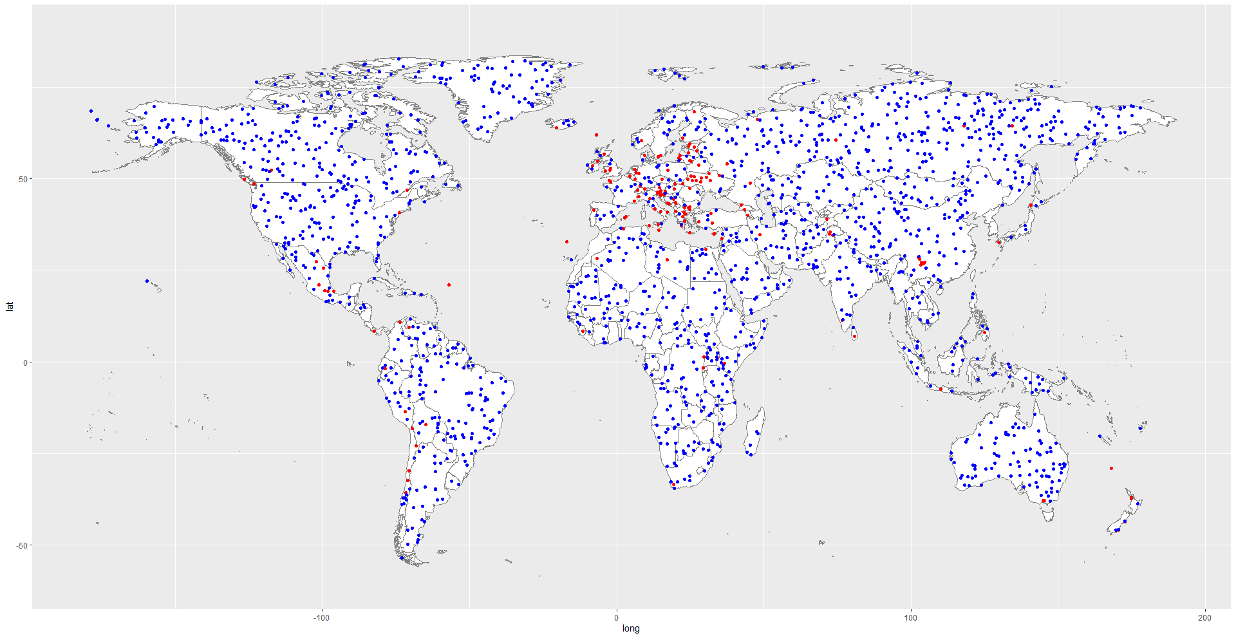
(a)
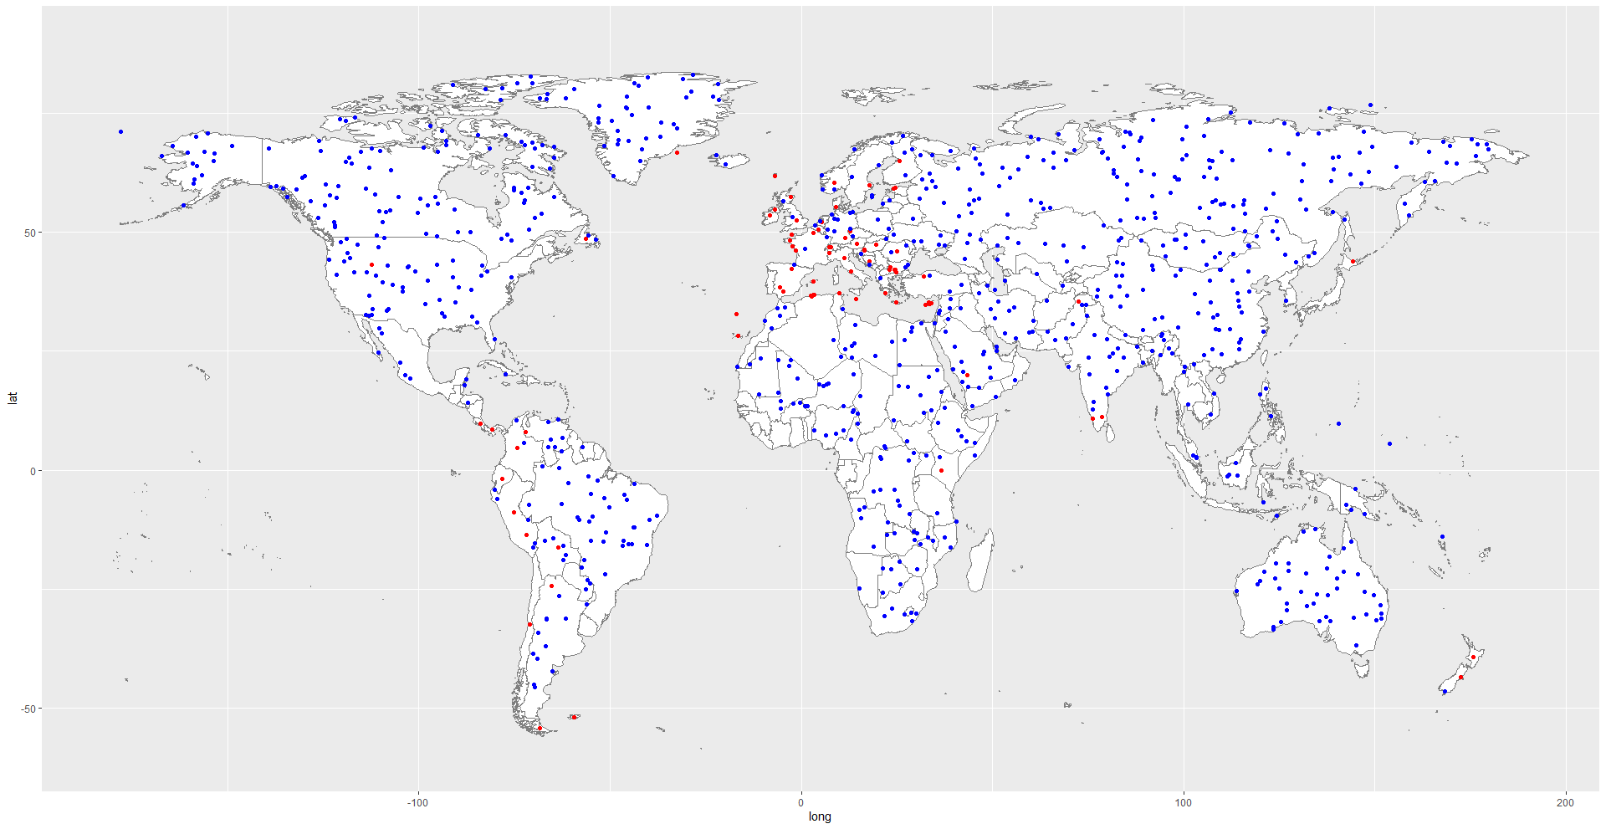
(b)
Fig 1 Presence/Pseudo-absence points for potato cyst nematodes. (a) Globodera rostochiensis, (b) Globodera pallida. Red points represent presence, and blue points are for pseudo-absence. The world map was accessed from Nature Earth in public domain (https://www.naturalearthdata.com/downloads/). The locations of occurrence were collected from open databases: GBIF (http:// www. gbif. org), CABI (http:// www. cabi. org/ isc) and EPPO (http:// www. eppo. int). Pseudo-absence points were generated by biomod2 R package (https://cran.r-project.org/web/packages/biomod2/index.html). Maps were modified with ArcMap (version 10.4.1, https:// www. arcgis. com/).
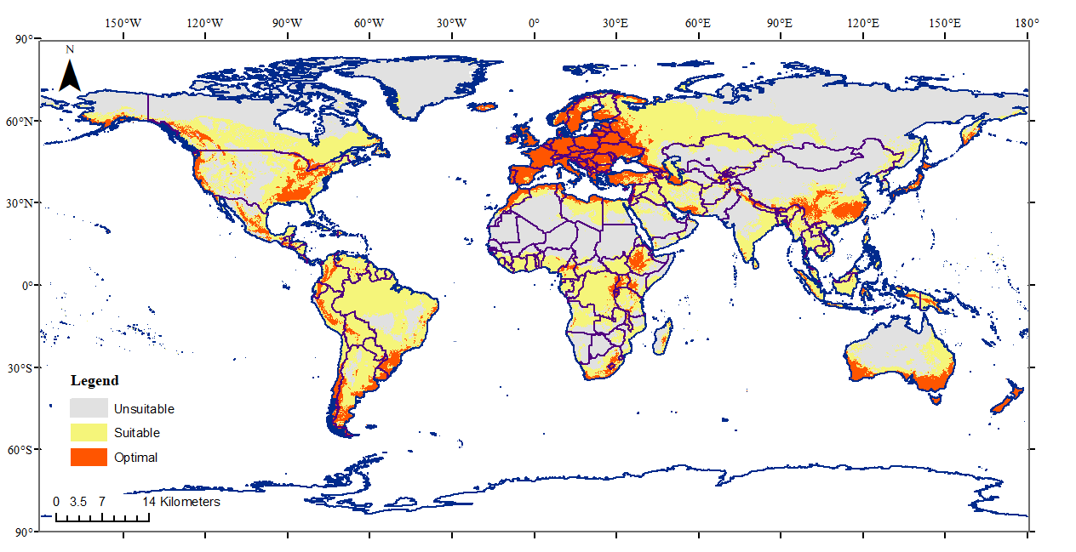
Fig 2 Environmentally Suitable habitat for potato cyst nematodes (both G. rostochiensis and G. pallida) worldwide. Red areas are optimal habitats for potato cyst nematodes, while yellow regions are suitable habitats for potato cyst nematodes. Grey areas are unsuitable for either G. rostochiensis or G. pallida. The world map was accessed from Nature Earth in public domain (https://www.naturalearthdata.com/downloads/). Climate variables were downloaded from the WorldClim open database (https:// world clim. org). The locations of occurrence were accessed from open databases: GBIF (http:// www. gbif. org), CABI (http:// www. cabi. org/ isc) and EPPO (http:// www. eppo. int). The species distribution model was conducted with kuenm R package (https://github.com/marlonecobos/kuenm), and map was modified with ArcMap (version 10.4.1, https:// www. arcgis. com/).
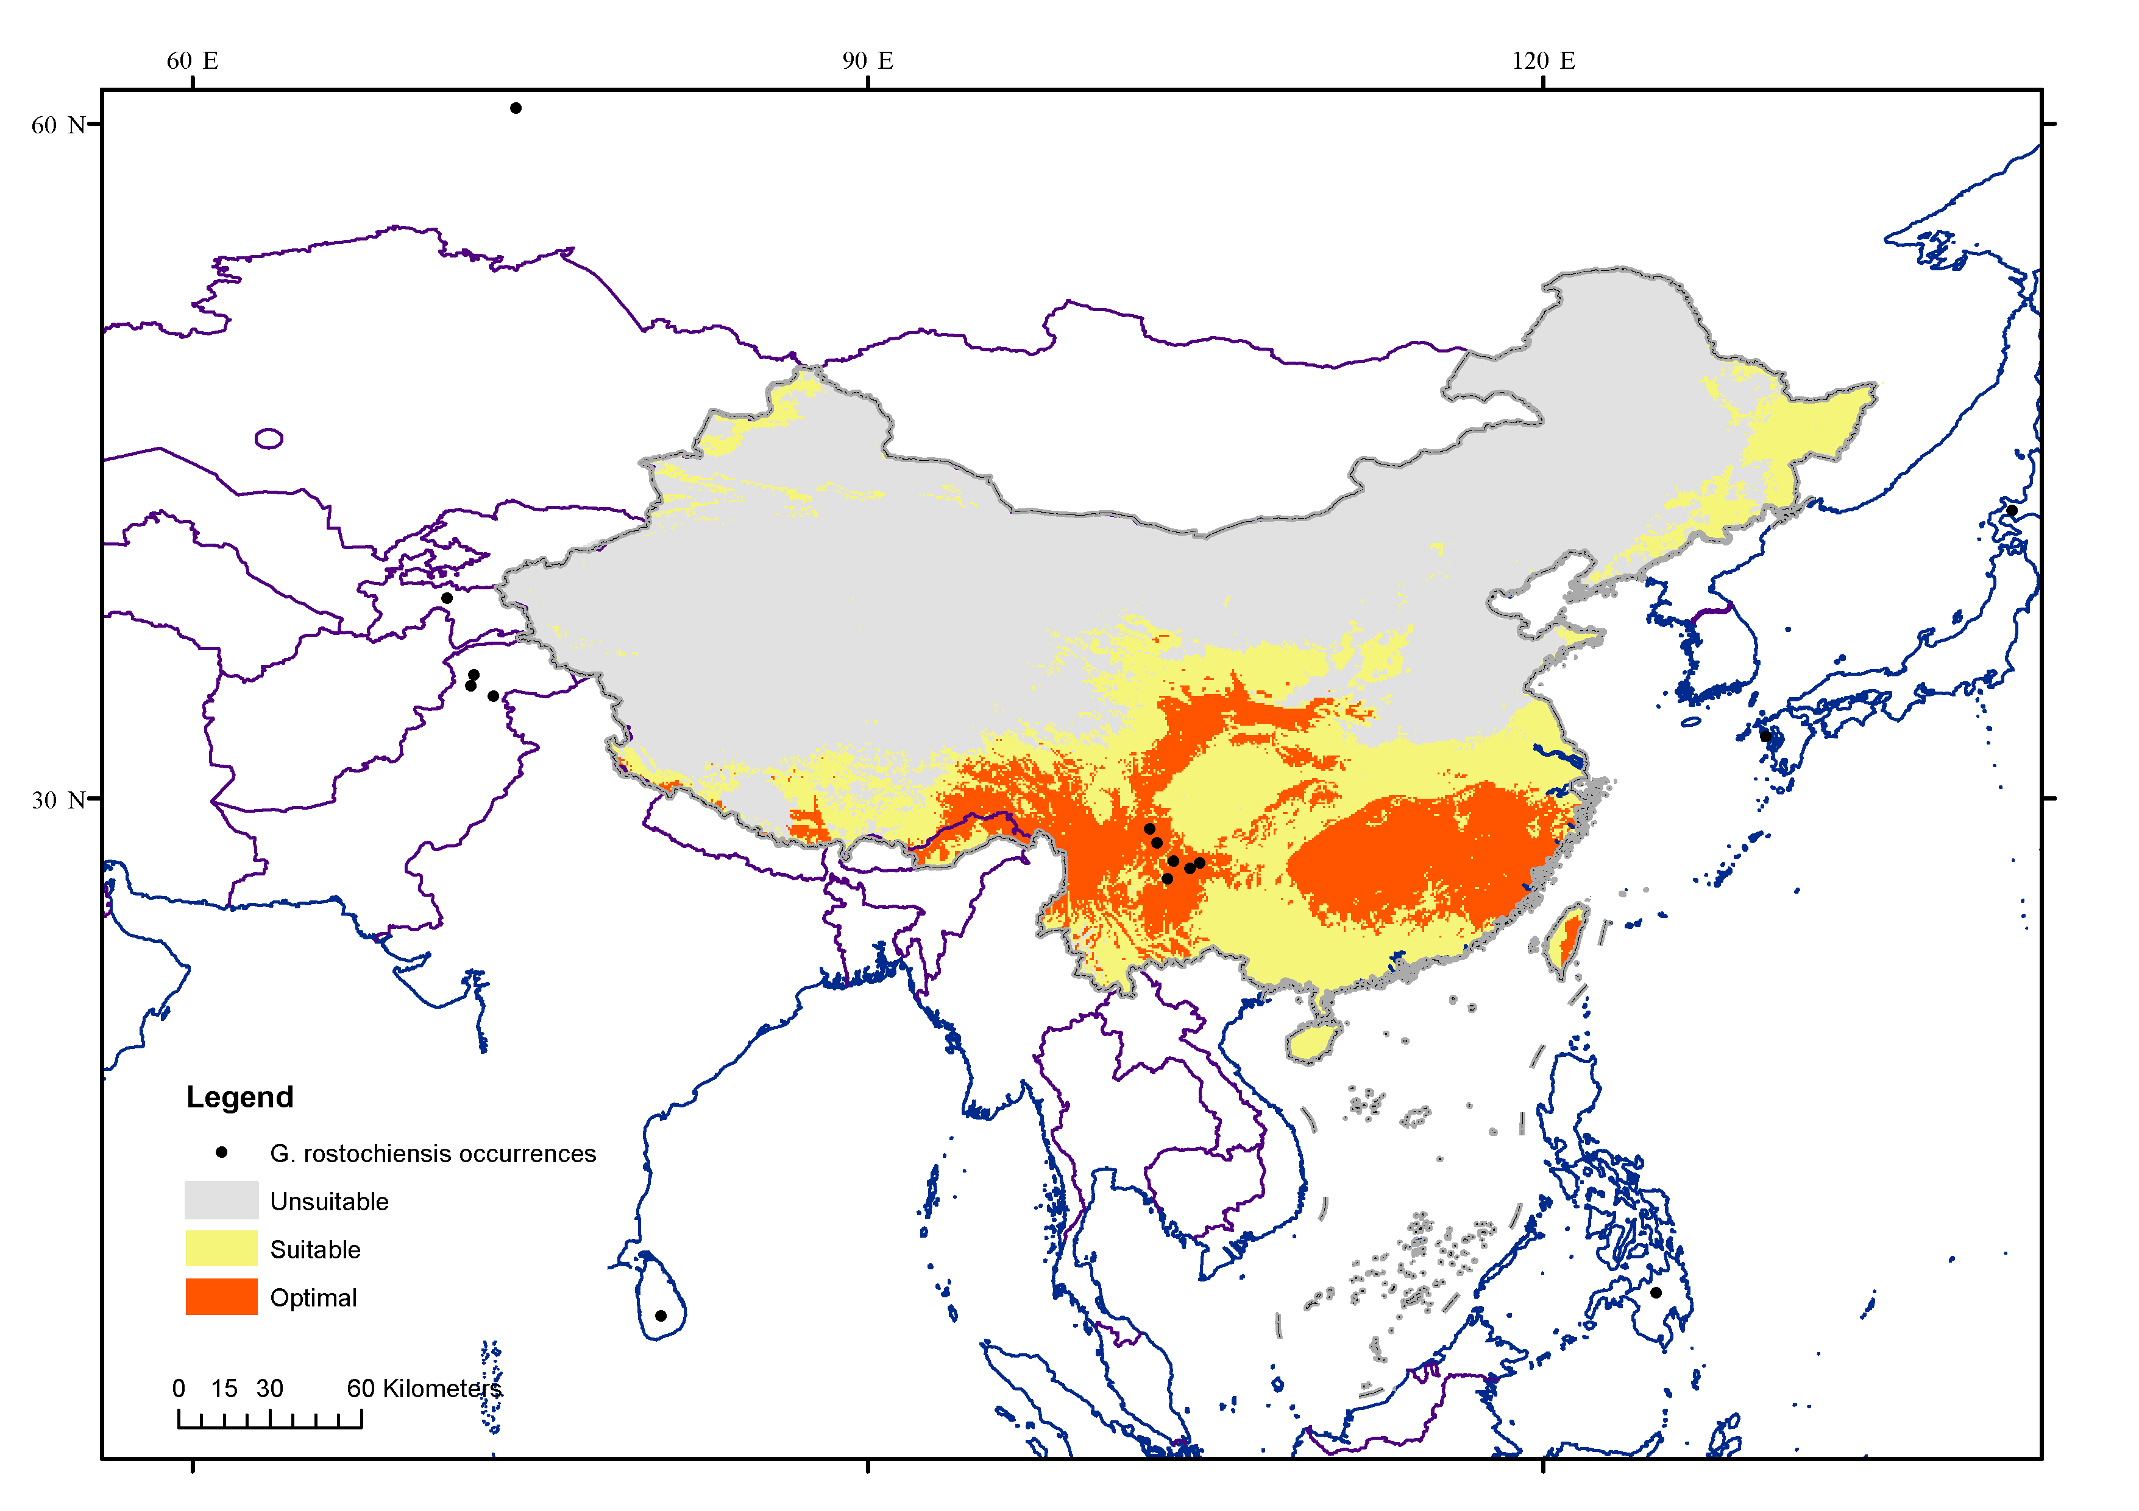
Fig 3 The recent incursions of Globodera rostochiensis in China distributed in the predicted optimal habitats. Red areas are optimal habitats for potato cyst nematodes, while yellow regions are suitable habitats for potato cyst nematodes. Grey areas are unsuitable for either G. rostochiensis or G. pallida. The world map was accessed from Nature Earth in public domain (https://www.naturalearthdata.com/downloads/). Global bioclimate data were acquired from the WorldClim open database (https:// world clim. org). The locations of occurrence were collected from open databases: GBIF (http:// www. gbif. org), CABI (http:// www. cabi. org/ isc) and EPPO (http:// www. eppo. int). The species distribution model was conducted with kuenm R package (https://github.com/marlonecobos/kuenm), and map was modified with ArcMap (version 10.4.1, https:// www. arcgis. com/).

Table 1 The proportion of suitable areas in each province (or region) to the total area of China
Row Labels | Unsuitable | Suitable | Optimal
Anhui | 0.65% | 3.02% | 1.76%
Chognqing | 0.00% | 2.71% | 0.94%
Fujing | 0.00% | 0.35% | 7.68%
Gansu | 4.67% | 4.69% | 3.72%
Guangdong (including Hongkong and Macao) | 0.01% | 5.62% | 1.46%
Guangxi | 0.00% | 7.50% | 2.12%
Guizhou | 0.00% | 4.36% | 4.16%
Hainan | 0.01% | 1.13% | 0.00%
Hebei (including Beijing and Tianjin) | 3.77% | 0.20% | 0.01%
Heilongjiang | 6.26% | 7.26% | 0.00%
Henan | 2.02% | 1.59% | 0.33%
Huhei | 0.03% | 5.64% | 2.91%
Hunan | 0.00% | 1.19% | 12.72%
Jiangsu (including Shanghai) | 0.39% | 3.30% | 0.00%
Jiangxi | 0.00% | 0.58% | 10.68%
Jilin | 2.30% | 3.14% | 0.00%
Liaoning | 2.24% | 0.86% | 0.00%
Neimenggu | 21.97% | 0.02% | 0.00%
Ningxia | 0.65% | 0.58% | 0.05%
Qinghai | 10.16% | 4.00% | 0.07%
Shaanxi | 1.26% | 3.27% | 3.90%
Shandong | 2.34% | 0.62% | 0.00%
Shanxi | 1.98% | 1.79% | 0.01%
Sichuan | 0.36% | 11.00% | 13.14%
Taiwan | 0.00% | 0.83% | 0.81%
Tibet | 10.81% | 13.12% | 14.73%
Xinjiang | 27.97% | 4.19% | 0.00%
Yunnan | 0.14% | 6.01% | 14.26%
Zhejing | 0.00% | 1.41% | 4.56%
Grand Total | 100% | 100% | 100%

Table 2 Proportion of each suitable level’s acreage to the total acreage of each province (or region) in China
Province | Unsuitable | Suitable | Optimal | Total
Anhui | 28.60% | 54.35% | 17.05% | 100%
Chognqing | 0.18% | 84.11% | 15.71% | 100%
Fujian | 0.00% | 7.77% | 92.23% | 100%
Gansu | 62.88% | 26.01% | 11.11% | 100%
Guangdong (including Hongkong and Macao) | 0.22% | 87.52% | 12.26% | 100%
Guangxi | 0.03% | 86.79% | 13.18% | 100%
Guizhou | 0.00% | 66.09% | 33.91% | 100%
Hainan | 1.75% | 98.25% | 0.00% | 100%
Hebei (including Beijing and Tianjin) | 97.82% | 2.15% | 0.03% | 100%
Heilongjiang | 67.67% | 32.33% | 0.00% | 100%
Henan | 73.57% | 23.80% | 2.63% | 100%
Huhei | 0.87% | 77.59% | 21.54% | 100%
Hunan | 0.00% | 14.85% | 85.15% | 100%
Jiangsu (including Shanghai) | 22.41% | 77.59% | 0.00% | 100%
Jiangxi | 0.00% | 9.10% | 90.90% | 100%
Jilin | 64.06% | 35.94% | 0.00% | 100%
Liaoning | 86.33% | 13.67% | 0.00% | 100%
Neimenggu | 99.96% | 0.04% | 0.00% | 100%
Ningxia | 72.31% | 26.51% | 1.18% | 100%
Qinghai | 85.94% | 13.93% | 0.13% | 100%
Shaanxi | 36.38% | 38.76% | 24.86% | 100%
Shandong | 90.10% | 9.90% | 0.00% | 100%
Shanxi | 72.86% | 27.10% | 0.04% | 100%
Sichuan | 4.66% | 58.04% | 37.31% | 100%
Taiwan | 0.90% | 64.94% | 34.16% | 100%
Tibet | 55.50% | 27.75% | 16.75% | 100%
Xinjiang | 94.20% | 5.80% | 0.00% | 100%
Yunnan | 2.36% | 42.88% | 54.76% | 100%
Zhejing | 0.00% | 36.58% | 63.42% | 100%

Table 3 Distribution of potato production cities in each risk level. The proportion is the ratio of the city's producing area to the country's total producing area
Risk levels | Provinces | Cities | Proportion
lower risk |  |  | 3.56%
 | Gansu |  | 0.00%
 |  | Jiayuguan | 0.00%
 | Neimenggu |  | 3.24%
 |  | Alxa | 0.00%
 |  | Erdos | 0.43%
 |  | HulunBuir | 1.93%
 |  | Wuhai | 0.00%
 |  | Xilinguole | 0.88%
 | Liaoning |  | 0.07%
 |  | Dandong | 0.07%
 | Qinghai |  | 0.04%
 | Hainan |  | 0.03%
 |  | Haixi | 0.01%
 | Shanxi |  | 0.12%
 |  | Taiyuan | 0.12%
 | Tibet |  | 0.00%
 |  | Nagqu | 0.00%
 |  | Ngari | 0.00%
 | Xinjiang |  | 0.08%
 |  | Bayingolin | 0.01%
 |  | Urumchi | 0.07%
lower-medium risk |  |  | 1.68%
 | Gansu |  | 0.17%
 |  | Gannan | 0.17%
 | Hunan |  | 0.08%
 |  | Changsha | 0.08%
 | Qinghai |  | 0.59%
 |  | Huangnan | 0.02%
 |  | Xinign | 0.55%
 |  | Yushu | 0.02%
 | Sichuan |  | 0.20%
 |  | Aba | 0.17%
 |  | Panzhihua | 0.04%
 | Tibet |  | 0.02%
 |  | Nyingchi | 0.01%
 |  | Qamdo | 0.01%
 | Yunnan |  | 0.61%
 |  | Diqing | 0.10%
 |  | Lijiang | 0.41%
 |  | Pu'er | 0.10%
upper-medium risk |  |  | 28.61%
 | Gansu |  | 2.30%
 |  | Baiyin | 1.32%
 |  | Jinchang | 0.13%
 |  | Jiuquan | 0.01%
 |  | Wuwei | 0.41%
 |  | Zhangye | 0.44%
 | Hebei |  | 3.33%
 |  | Baoding | 0.16%
 |  | Cangzhou | 0.01%
 |  | Chengde | 1.01%
 |  | Handan | 0.02%
 |  | Hengshui | 0.01%
 |  | Langfang | 0.01%
 |  | Qinhuangdao | 0.18%
 |  | Shijiazhuang | 0.05%
 |  | Tangshan | 0.16%
 |  | Xingtai | 0.02%
 |  | Zhangjiakou | 1.70%
 | Heilongjiang |  | 2.13%
 |  | Ha'erbin | 0.58%
 |  | Mudanjiang | 0.12%
 |  | Suihua | 0.66%
 |  | Tsitsihar | 0.77%
 | Henan |  | 0.56%
 |  | Kaifeng | 0.11%
 |  | Luoyang | 0.10%
 |  | Nanyang | 0.10%
 |  | Shangqiu | 0.22%
 |  | Zhengzhou | 0.03%
 | Neimenggu |  | 8.34%
 |  | Baotou | 0.33%
 |  | BayanNur | 0.08%
 |  | Chifeng | 1.07%
 |  | Hohhot | 0.69%
 |  | Tongliao | 0.09%
 |  | Ulanqab | 5.67%
 |  | Xinggan | 0.41%
 |  | Jilin | 0.85%
 |  | Baicheng | 0.09%
 |  | Baishan | 0.01%
 |  | Changchun | 0.33%
 | Jilin |  | 0.06%
 |  | Liaoyuan | 0.03%
 |  | Siping | 0.12%
 |  | Songyuan | 0.17%
 |  | Yanbian | 0.04%
 | Liaoning |  | 1.33%
 |  | Anshan | 0.01%
 |  | Benxi | 0.03%
 |  | Chaoyang | 0.21%
 |  | Dalian | 0.16%
 |  | Fushun | 0.05%
 |  | Huludao | 0.25%
 |  | Jinzhou | 0.05%
 |  | Liaoyang | 0.05%
 |  | Shenyang | 0.26%
 |  | Tieling | 0.27%
 |  | Yingkou | 0.00%
 | Ningxia |  | 0.39%
 |  | Shizuishan | 0.00%
 |  | Yinchuan | 0.00%
 |  | Zhongwei | 0.39%
 | Shaanxi |  | 3.82%
 |  | Tongchuan | 0.02%
 |  | Yulin | 3.80%
 | Shandong |  | 2.27%
 |  | Binzhou | 0.05%
 |  | Dezhou | 0.02%
 |  | Heze | 0.03%
 |  | Jinan | 0.09%
 |  | Jining | 0.19%
 |  | Laiwu | 0.04%
 |  | Liaocheng | 0.02%
 |  | Linyi | 0.24%
 |  | Rizhao | 0.03%
 |  | Tai'an | 0.36%
 |  | Weifang | 0.40%
 |  | Zaozhuang | 0.79%
 |  | Zibo | 0.02%
 | Shanxi |  | 2.86%
 |  | Changzhi | 0.17%
 |  | Datong | 0.43%
 |  | Jinzhong | 0.10%
 |  | Linfen | 0.12%
 |  | Lvliang | 0.77%
 |  | Shuozhou | 0.41%
 |  | Xinzhou | 0.82%
 |  | Yangquan | 0.03%
 |  | Yuncheng | 0.01%
 | Xinjiang |  | 0.44%
 |  | Akesu | 0.07%
 |  | Altay | 0.04%
 |  | Bortala | 0.01%
 |  | Changji | 0.12%
 |  | Hani | 0.02%
 |  | Hotan | 0.02%
 |  | Ili | 0.09%
 |  | Kashi | 0.09%
high risk |  |  | 66.15%
 | Anhui |  | 0.17%
 |  | Anqing | 0.03%
 |  | Chaohu | 0.07%
 |  | Hefei | 0.01%
 |  | Huangshan | 0.01%
 |  | Liu'an | 0.02%
 |  | Ma'anshan | 0.00%
 |  | Xuancheng | 0.03%
 | Chongqing |  | 6.82%
 |  | Kaixian | 1.14%
 |  | Shizhu | 1.14%
 |  | Wanzhou | 1.14%
 |  | Wulong | 1.14%
 |  | Wuxi | 1.14%
 |  | Yunyang | 1.14%
 | Fujian |  | 0.79%
 |  | Fuzhou | 0.17%
 |  | Ningde | 0.24%
 |  | Putian | 0.01%
 |  | Quanzhou | 0.30%
 |  | Xiamen | 0.02%
 |  | Zhangzhou | 0.04%
 | Gansu |  | 9.06%
 |  | Dingxi | 3.38%
 |  | Lanzhou | 0.44%
 |  | Linxia | 0.50%
 |  | Longnan | 1.19%
 |  | Pingliang | 1.49%
 |  | Qingyang | 0.47%
 |  | Tianshui | 1.59%
 | Guangdong |  | 0.12%
 |  | Huizhou | 0.12%
 | Guangxi |  | 0.84%
 |  | Guigang | 0.22%
 |  | Guilin | 0.10%
 |  | Hechi | 0.53%
 | Guizhou |  | 14.90%
 |  | Anshun | 0.30%
 |  | Bijie | 6.00%
 |  | Guyang | 0.31%
 |  | Liupanshui | 1.65%
 |  | Qiandongnan | 1.65%
 |  | Qiannan | 0.85%
 |  | Qianxinan | 1.65%
 |  | Tongren | 1.65%
 |  | Zhunyi | 0.84%
 | Heilongjiang |  | 0.06%
 |  | Qitaihe | 0.06%
 | Hubei |  | 3.28%
 |  | Enshi | 1.93%
 |  | Huanggang | 0.23%
 |  | Jingzhou | 0.09%
 |  | Xianning | 0.00%
 |  | Yichang | 1.04%
 | Hunan |  | 1.19%
 |  | Changde | 0.15%
 |  | Chenzhou | 0.18%
 |  | Hangyang | 0.13%
 |  | Shaoyan | 0.17%
 |  | Xiangtan | 0.02%
 |  | Xiangxi | 0.26%
 |  | Yongzhou | 0.06%
 |  | Zhangjiajie | 0.19%
 |  | Zhuzhou | 0.04%
 | Jiangsu |  | 0.03%
 |  | Taizhou | 0.03%
 | Jiangxi |  | 0.56%
 |  | Fuzhou | 0.01%
 |  | Ganzhou | 0.02%
 |  | Ji'an | 0.10%
 |  | Jiujiang | 0.10%
 |  | Nanchang | 0.10%
 |  | Pingxiang | 0.07%
 |  | Xinyu | 0.09%
 |  | Yichun | 0.07%
 |  | Yingtan | 0.00%
 | Jilin |  | 0.05%
 |  | Tonghua | 0.05%
 | Ningxia |  | 1.33%
 |  | Guyuan | 1.33%
 | Qinghai |  | 1.17%
 |  | Haidong | 1.17%
 | Shaanxi |  | 1.99%
 |  | Ankang | 1.02%
 |  | Shangluo | 0.54%
 |  | Yannan | 0.42%
 | Shandong |  | 0.60%
 |  | Qingdao | 0.51%
 |  | Weihai | 0.04%
 |  | Yantai | 0.05%
 | Shanxi |  | 0.03%
 |  | Jincheng | 0.03%
 | Sichuan |  | 13.48%
 |  | Bazhong | 0.91%
 |  | Chengdu | 0.48%
 |  | Dazhou | 1.78%
 |  | Deyang | 0.29%
 |  | Ganzi | 0.18%
 |  | Guang'an | 0.63%
 |  | Guangyuan | 0.39%
 |  | Leshan | 0.44%
 |  | Liangshan | 1.79%
 |  | Luzhou | 1.06%
 |  | Meishan | 0.22%
 |  | Mianyang | 0.33%
 |  | Nanchong | 1.13%
 |  | Neijiang | 0.87%
 |  | Suining | 0.47%
 |  | Yanan | 0.15%
 |  | Yibin | 1.04%
 |  | Zigong | 0.49%
 |  | Ziyang | 0.84%
 | Taiwan |  | 0.05%
 | Yunnan |  | 9.35%
 |  | Baoshan | 0.37%
 |  | Chuxiong | 0.16%
 |  | Dali | 0.39%
 |  | Dehong | 0.20%
 |  | Honghe | 0.41%
 |  | Kunming | 0.61%
 |  | Lincang | 0.20%
 |  | Nujiang | 0.20%
 |  | Qujing | 3.67%
 |  | Wenshan | 0.37%
 |  | Yuxi | 0.10%
 |  | Zhaotong | 2.65%
 | Zhejiang |  | 0.29%
 |  | Huzhou | 0.03%
 |  | Shaoxing | 0.25%
Grand Total |  |  | 100.00%

