AMB Express

Klebsiella michiganensis: A nitrogen-fixing endohyphal bacterium from Ustilago maydis
Pengyu Liang¹, Jianwei Jiang¹, Zhengxiang Sun¹, Yanyan Li², Chunlei Yang^{2*}, Yi Zhou^{1*}

¹Department of Plant Protection, College of Agriculture, Yangtze University, Jingzhou 434025, China
²Tobacco Research Institute of Hubei Province, Wuhan 430000, China

*Corresponding author. Tel: +86-13617263127; Fax: +86-13617263127
E-mail address: zhouyi@yangtzeu.edu.cn (Y. Zhou); ycl193737@163.com(C. Yang)

Figure S1. (a): Colony of strain Ustilago maydis YZZF202006 grown on YEPSL medium. (b): Haploid primary hypha. (c): Phylogenetic tree (Maximu likelihood) of strain Ustilago maydis YZZF202006 based on the ITS region. Bootstrap values (≥60%) of a bootstrap test of 1,000 replicates are shown on branching points. The GenBank accession number are noted after the strains names.

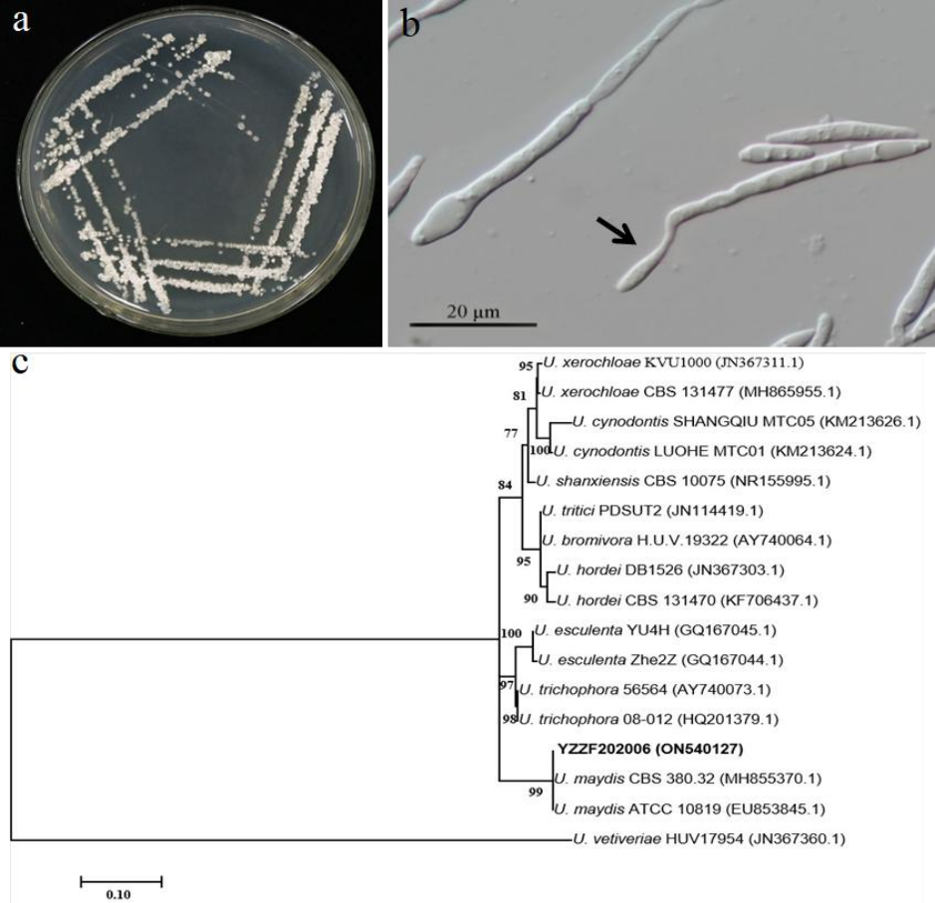

Figure S2. Map of plasmid pLac-EGFP-Chl-signal-Hyg (Miaolingbio, China).

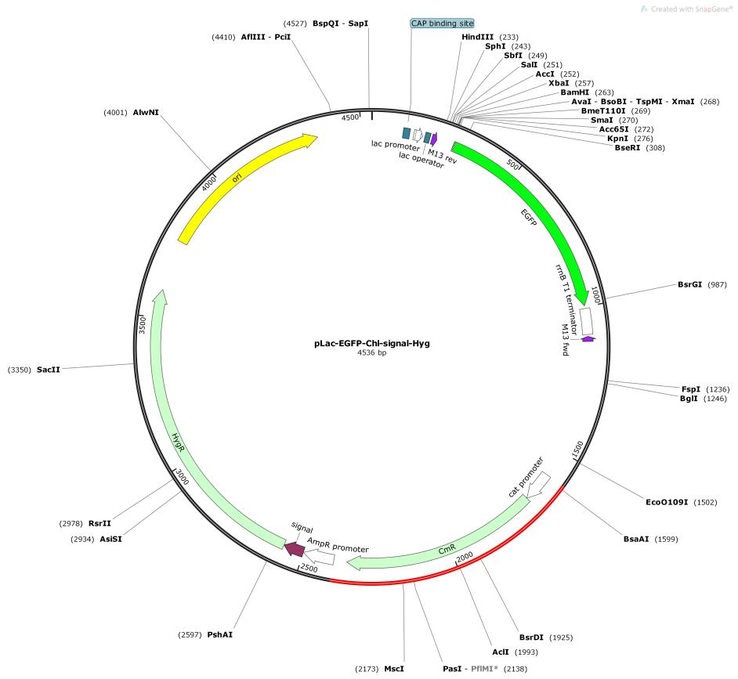

Figure S3. The circular genome map of Klebsiella michiganensis YZUMF202001.
chr1
−0. 1
0kb
0
100
50
150
200
100
0
200
300
400
500
0
0. 1
0.2
65
60
55
50
45
40
35

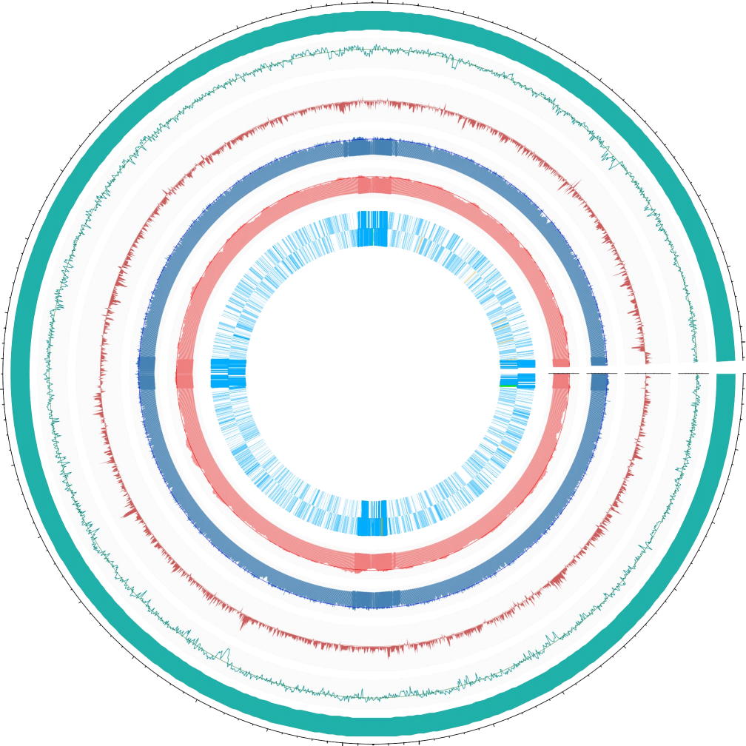
Refer size: 6048476 bp
Refer GC: 56.01

GC % ( Average: 56.01 % )

GC shew

Coverage of illumina: 99.9999669338194 %
Depth of illumina ( average: 453. 15 X )

Coverage of nanopore: 99.9996693381936 %
Depth of nanopore ( average: 165.89 X )

CDS | rRNA | tRNA

CDS
rRNA
tRNA

Table S1: Ani values of 17 Klebsiella strains including YZUMF202001 based on genome information.
 | K.aerogenes NCTC 10006 | K.africana 200023 | K.huaxiensis WCHKl090001 | K.indica TOUT106 | K.pasteurii SB6412 | K.spallanzanii SB6411 | K.grimontii 06D021 | K.michiganensis DSM 25444 | K.oxytoca NCTC 13727 | K.variicola DSM 15968 | K.pneumoniae ATCC 13883 | K.quasipneumoniae 01A030 | K.quasivariicola KPN1705 | YZUMF202001 | K.pasteurii Kox205 | K.pasteurii SB6415 | K.michiganensis E718
K.aerogenes NCTC 10006 | 100 | 85.49 | 82.91 | 82.1 | 83.44 | 83 | 83.54 | 83.71 | 83.51 | 85.83 | 85.59 | 85.22 | 85.43 | 83.82 | 83.42 | 83.48 | 83.67
K.africana 200023 | 85.49 | 100 | 82.89 | 81.92 | 83.46 | 83.21 | 83.66 | 83.87 | 83.53 | 94.29 | 95.1 | 93.06 | 95.15 | 83.95 | 83.65 | 83.45 | 83.88
K.huaxiensis WCHKl090001 | 82.91 | 82.89 | 100 | 85.43 | 87.71 | 91.93 | 87.94 | 87.97 | 87.46 | 82.97 | 82.84 | 83.1 | 83.09 | 87.95 | 87.74 | 87.74 | 87.91
K.indica TOUT106 | 82.1 | 81.92 | 85.43 | 100 | 85.85 | 85.99 | 85.94 | 86.07 | 85.57 | 82.08 | 82.14 | 82.24 | 82.06 | 86.09 | 85.81 | 85.87 | 85.97
K.pasteurii SB6412 | 83.44 | 83.46 | 87.71 | 85.85 | 100 | 88.59 | 96.03 | 94 | 91.33 | 83.94 | 83.78 | 84.09 | 83.56 | 94.04 | 99.43 | 99.48 | 93.88
K.spallanzanii SB6411 | 83 | 83.21 | 91.93 | 85.99 | 88.59 | 100 | 88.86 | 88.93 | 88.52 | 83.12 | 83.03 | 83.18 | 83.16 | 88.93 | 88.5 | 88.69 | 88.83
K.grimontii 06D021 | 83.54 | 83.66 | 87.94 | 85.94 | 96.03 | 88.86 | 100 | 93.86 | 91.51 | 84.13 | 83.87 | 84.42 | 83.98 | 93.85 | 95.82 | 95.94 | 93.6
K.michiganensis DSM 25444 | 83.71 | 83.87 | 87.97 | 86.07 | 94 | 88.93 | 93.86 | 100 | 92.38 | 84.25 | 84.1 | 84.47 | 84.33 | 99.04 | 93.91 | 93.97 | 98.44
K.oxytoca NCTC 13727 | 83.51 | 83.53 | 87.46 | 85.57 | 91.33 | 88.52 | 91.51 | 92.38 | 100 | 83.67 | 83.59 | 83.91 | 83.32 | 92.44 | 91.26 | 91.38 | 92.35
K.variicola DSM 15968 | 85.83 | 94.29 | 82.97 | 82.08 | 83.94 | 83.12 | 84.13 | 84.25 | 83.67 | 100 | 94.66 | 93.64 | 94.22 | 84.24 | 83.97 | 83.97 | 84.22
K.pneumoniae ATCC 13883 | 85.59 | 95.1 | 82.84 | 82.14 | 83.78 | 83.03 | 83.87 | 84.1 | 83.59 | 94.66 | 100 | 93.71 | 93.97 | 84.01 | 83.82 | 83.7 | 83.95
K.quasipneumoniae 01A030 | 85.22 | 93.06 | 83.1 | 82.24 | 84.09 | 83.18 | 84.42 | 84.47 | 83.91 | 93.64 | 93.71 | 100 | 93.03 | 84.34 | 83.97 | 83.99 | 84.56
K.quasivariicola KPN1705 | 85.43 | 95.15 | 83.09 | 82.06 | 83.56 | 83.16 | 83.98 | 84.33 | 83.32 | 94.22 | 93.97 | 93.03 | 100 | 83.94 | 83.75 | 83.41 | 83.99
YUZMF202001 | 83.82 | 83.95 | 87.95 | 86.09 | 94.04 | 88.93 | 93.85 | 99.04 | 92.44 | 84.24 | 84.01 | 84.34 | 83.94 | 100 | 93.98 | 94.03 | 98.68
K.pasteurii Kox205 | 83.42 | 83.65 | 87.74 | 85.81 | 99.43 | 88.5 | 95.82 | 93.91 | 91.26 | 83.97 | 83.82 | 83.97 | 83.75 | 93.98 | 100 | 99.43 | 93.86
K.pasteurii SB6415 | 83.48 | 83.45 | 87.74 | 85.87 | 99.48 | 88.69 | 95.94 | 93.97 | 91.38 | 83.97 | 83.7 | 83.99 | 83.41 | 94.03 | 99.43 | 100 | 93.94
K.michiganensis E718 | 83.67 | 83.88 | 87.91 | 85.97 | 93.88 | 88.83 | 93.6 | 98.44 | 92.35 | 84.22 | 83.95 | 84.56 | 83.99 | 98.68 | 93.86 | 93.94 | 100

Table S2: Chitinase related genes of Klebsiella michiganensis YZUMF202001.
Gene | Description | E.C. number | Chromosome location | Gene_id
chiA1 | Chitinase A1 | 3.2.1.14 | 3563132-3564385 | assembly_03407
chiA_1 | Chitinase A | 3.2.1.14 | 4358697-4360814 | assembly_04169
chiA_2 | Chitinase A | 3.2.1.14 | 4917333-4919123 | assembly_04693
chiA_3 | Chitinase A | 3.2.1.14 | 5157108-5159207 | assembly_04898

