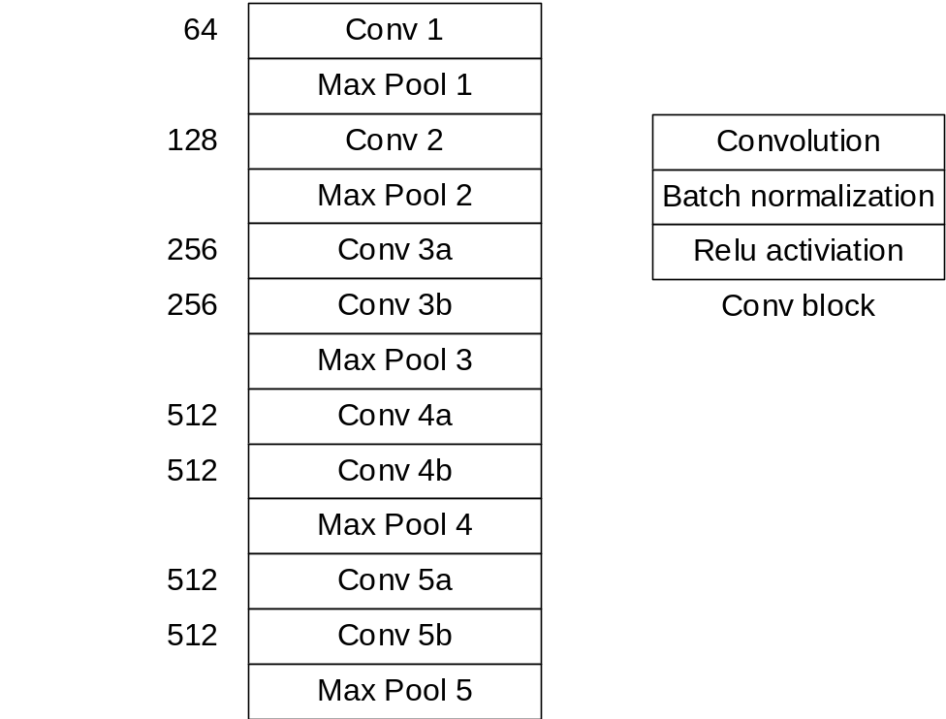

Figure S1. The structure of the convolutional layers of the convolutional neural network.

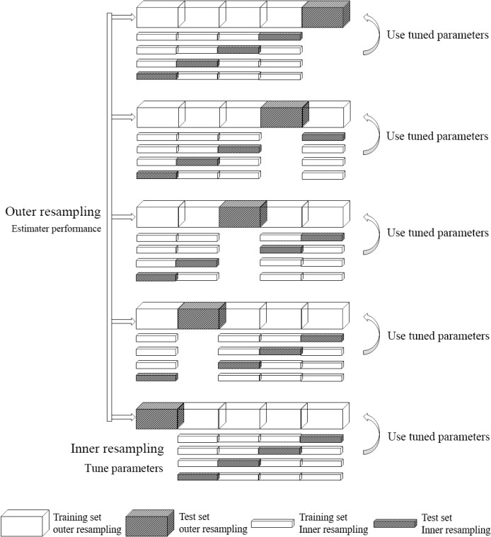
Figure S2. Nested sampling method with an “inner” 4-fold cross-validation (CV) nested on an “outer” 5-fold cross-validation.

Table S1. Dosimetric parameters of the esophagus.
 | Mean | SD
Dmean(Gy) | 27.61 | 9.29
Dmax(Gy) | 57.54 | 9.18
EUD(Gy) | 48.64 | 8.95
V20 (%) | 52.35 | 15.58
V30 (%) | 47.69 | 16.72
V40 (%) | 42.14 | 18.23
V50 (%) | 33.39 | 19.62
V60 (%) | 11.30 | 19.26
V70 (%) | 0.07 | 0.79

Table S2. Dosimetric features in the LR model
 | Coef | OR | p-value
Intercept | -2.310 | 0.109 | 2×10⁻¹⁶
Max | -1.423 | 0.196 | 0.0621
EUD (a = 10) | 1.242 | 6.067 | 0.1448
V60 | 0.395 | 1.448 | 0.0459

Table S3. Handcrafted features in the LR model
 | Coef | OR | p-value
Intercept | -2.469 | 0.085 | 1.58×10⁻¹⁵
Shape_flatness | -0.647 | 0.524 | 0.0305
glcm_SumSquares | 0.963 | 2.620 | 0.0009
glcm_Correlation | -0.576 | 0.562 | 0.0100

Table S4. CNN-extracted features in the LR model
 | Coef | OR | p-value
Intercept | -2.894 | 0.055 | 3.49×10⁻¹¹
Predictor 1 | 0.582 | 1.790 | 0.002
Predictor 2 | -0.880 | 0.415 | 0.059
Predictor 3 | 0.302 | 1.352 | 0.117
Predictor 4 | 0.4558 | 1.577 | 0.067

1. mMRM

The features were evaluated by an importance score, which was calculated as:
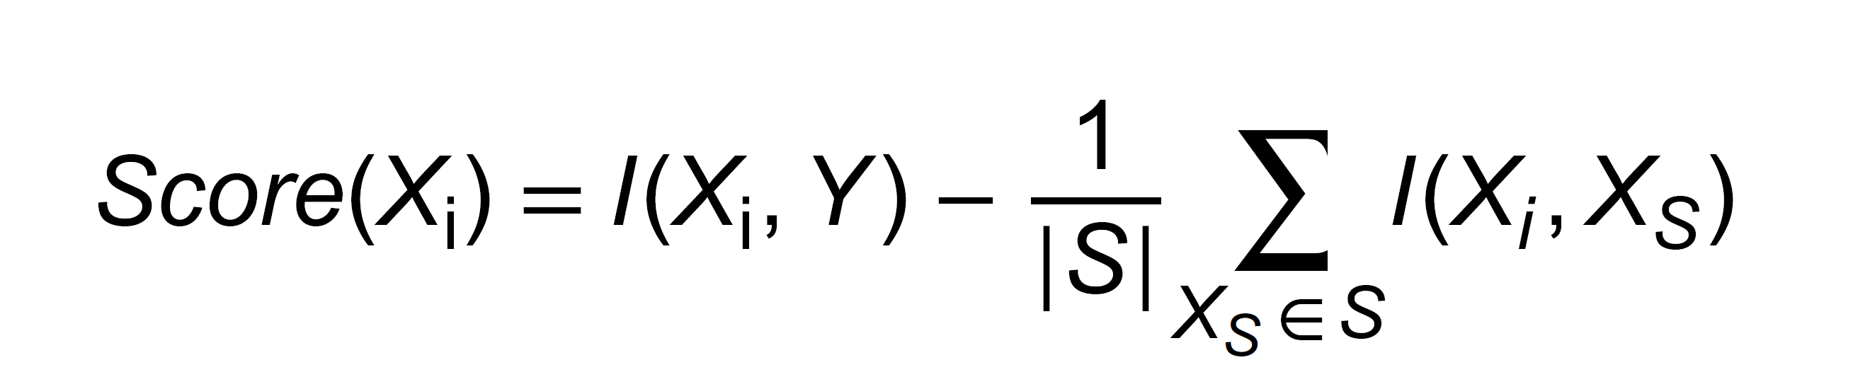
where Y was the binary variable standing for whether ≥2 RE occurred, S and |S| were the set of selected features and its size, respectively. I represented the function of mutual information calculation. In general, the incremental search method was used. The search began with an empty S. The first selected feature was the feature with maximum I. Then, the Score values of all candidate features were calculated, and the feature with the maximum Score value was selected (moved to S). The incremental search continued until |S| reached the pre-determined threshold of the number of selected features (Fn).

2. Entropy-based method for feature filtering
The entropy-based method was designed to remove the singular features: zero value for most patients and non-zero value for only a limited number of patients. The singular features only contained the information of a minimal population, which was not suitable for prediction of the whole population. Hence, it was necessary to filter these singular features before further processing. As the measure of information, the entropy can also be used to evaluate the singularity of extracted features. For this study, the extracted feature was a vector in n dimension, where n was the number of patients. As listed in Table, suppose the vector was composed of k unique non-zero elements (not equal) and n-k zero elements, the possibility (P(xi)) of each non-zero and zero elements (xi) would be 1/n and (n-k)/n, respectively. The entropy(H) was calculated as:
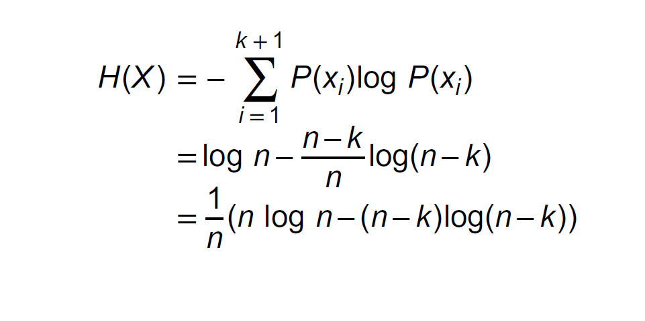
H increased with k. Lower H indicated higher singularity and vice versa. Based on the quantitative evaluation of H, a threshold of k was determined. With a none-zero value for less than the threshold of k patients, the features would be filtered out.

Table. Element possibility of the n-dimension feature
Index | None-zero elements |  |  |  | Zero elements
i | 1 | 2 | … | k | k+1, … , n
P(x_{i}) | 1/n | 1/n | 1/n | 1/n | (n-k)/n

3. Calculation of indexes to evaluate the models.
Accuracy = (TP+TN)/(TP+FP+FN+TN)
Sensitivity = TP/(TP+FN)
Specificity = TN/(TN+FP)
F1 score = 2TP/(2TP+FN+FP)
where TP, TN, FP, and FN are the true positive, true negative, false positive, and false negative, respectively.

4. The definition and explanation of 3 dosiomics features.
glcm Sum of Squares
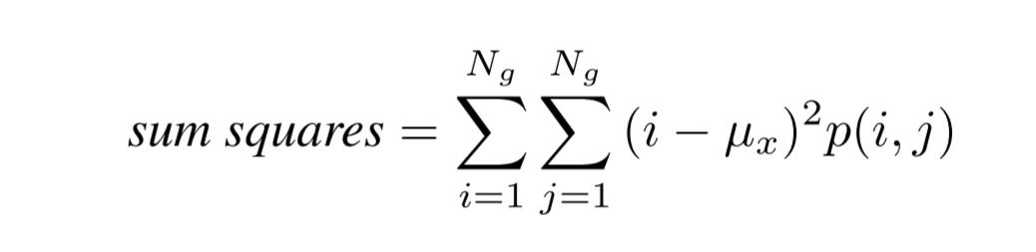
Sum of Squares or Variance is a measure in the distribution of neigboring intensity level pairs about the mean intensity level in the GLCM.

glcm Correlation
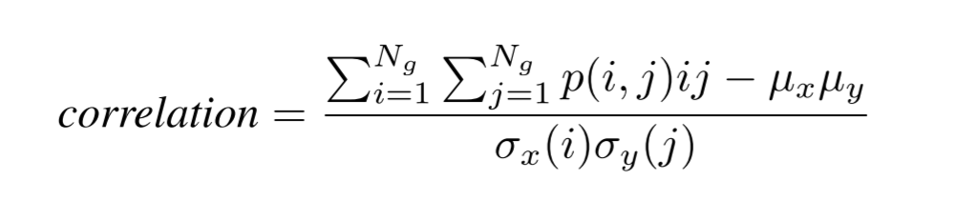
Correlation is a value between 0 (uncorrelated) and 1 (perfectly correlated) showing the linear dependency of gray level values to their respective voxels in the GLCM.The principal component analysis is performed using the physical coordinates of the voxel centers defining the ROI. It therefore takes spacing into account, but does not make use of the shape mesh.

Shape Flatness
Flatness shows the relationship between the largest and smallest principal components in the ROI shape. For computational reasons, this feature is defined as the inverse of true flatness.

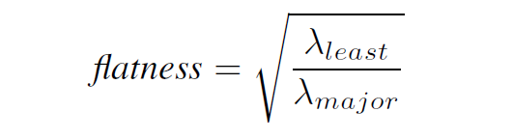
Here, 𝜆major and 𝜆least are the lengths of the largest and smallest principal component axes. The values
range between 1 (non-flat, sphere-like) and 0 (a flat object, or single-slice segmentation).
The principal component analysis is performed using the physical coordinates of the voxel centers defining the ROI. It therefore takes spacing into account, but does not make use of the shape mesh.

