EXTENDED DATA

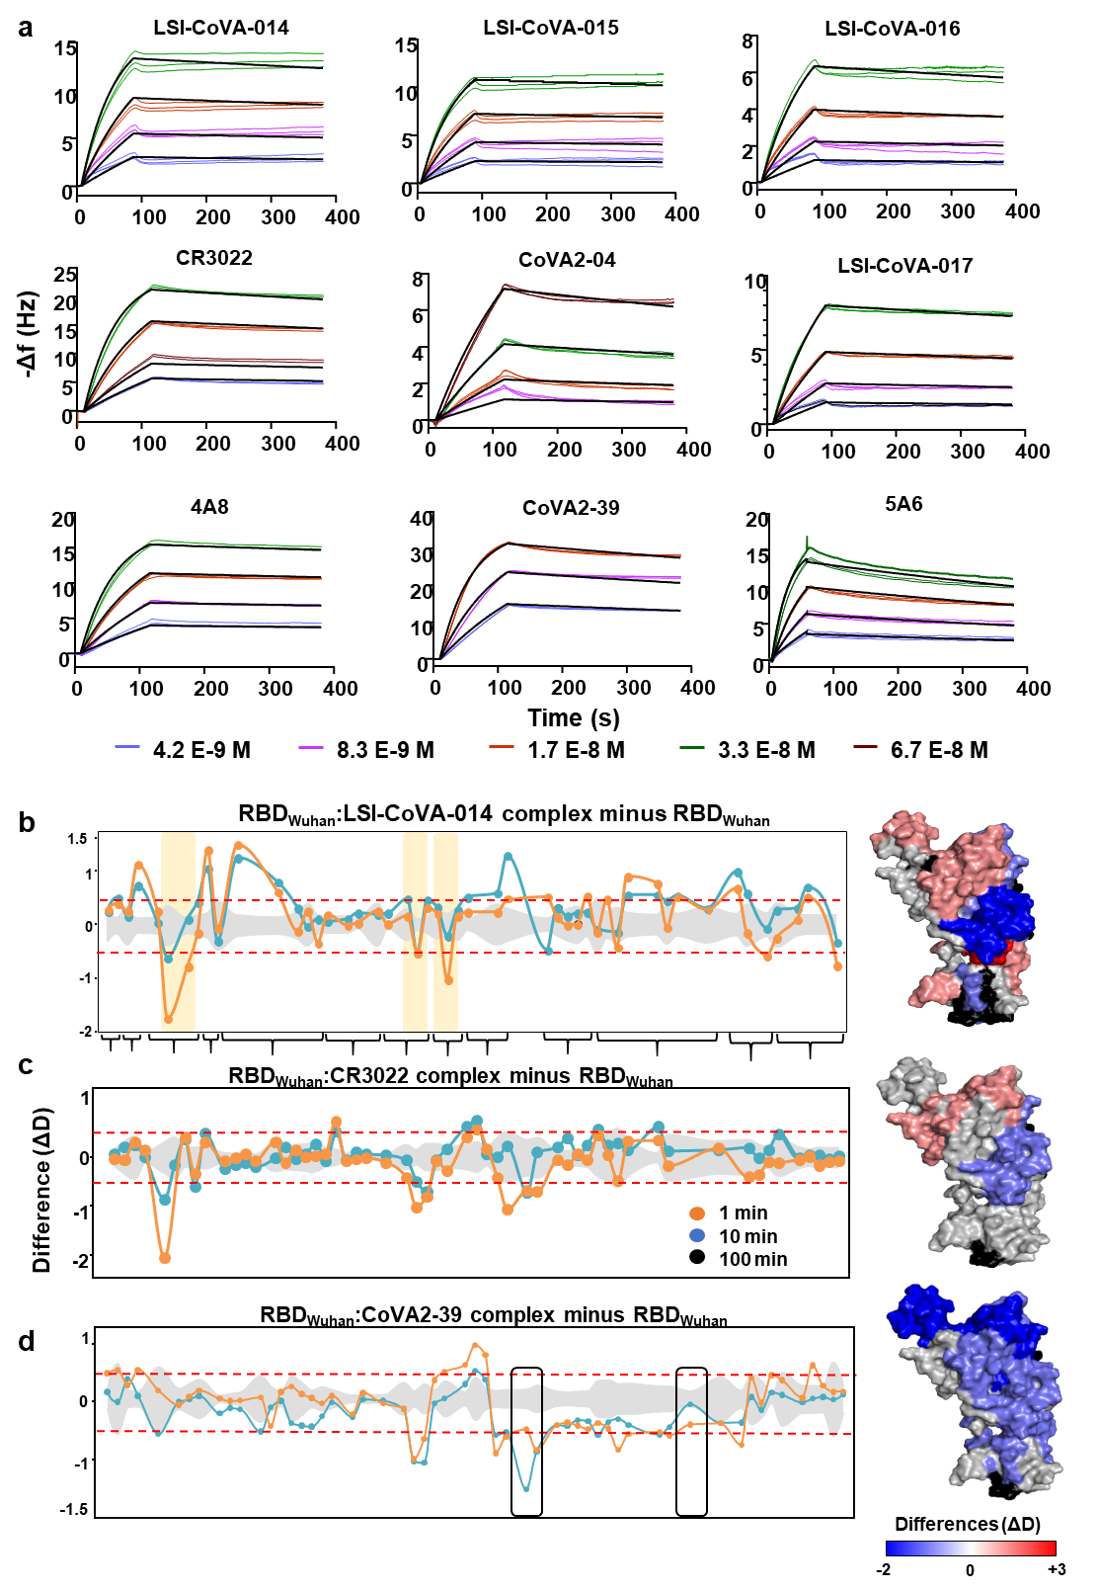
Extended data Fig. 1: QCM kinetic evaluation of the interactions between Spike and SARS CoV-2 antibodies and identifying the epitope sites by HDXMS
(a) Kinetic plots showing association-dissociation of in-house (LSI-CoVA-014, LSI-CoVA-015, LSI-CoVA-016, and LSI-CoVA-017) and previously studied (CR3022, CoVA2-04, 4A8, CoVA2-39, and 5A6) huMAbs. Antibodies at varying concentrations (4.2 nM – 66.7 nM) were flowed over Spike trimer immobilized onto the surface of a vibrating quartz crystal. Each experiment was performed in triplicate. Thick black lines show the theoretical 1:1 fit obtained using TraceDrawer evaluation software (Ridgeview Instruments). (b) Plots showing differences in HDX (ΔD) across RBD complexed with (b) LSI-CoVA-014, (c) CR3022, and (d) CoVA2-39 antibodies compared to RBD alone. Overlapping peptides grouped as clusters are indicated as per supplementary information. Positive values indicate increased exchange, and negative values denote decreased deuterium exchange in the antibody-bound complex. Cryptic epitope sites are highlighted in yellow, while RBM epitope sites are highlighted in black box. Red-dashed lines indicate a significance threshold of ± 0.5 D, and standard deviations in grey. (Right panels) Deuterium exchange differences at 10 min labelling are mapped on to structure (surface representation) of RBD, as per key.

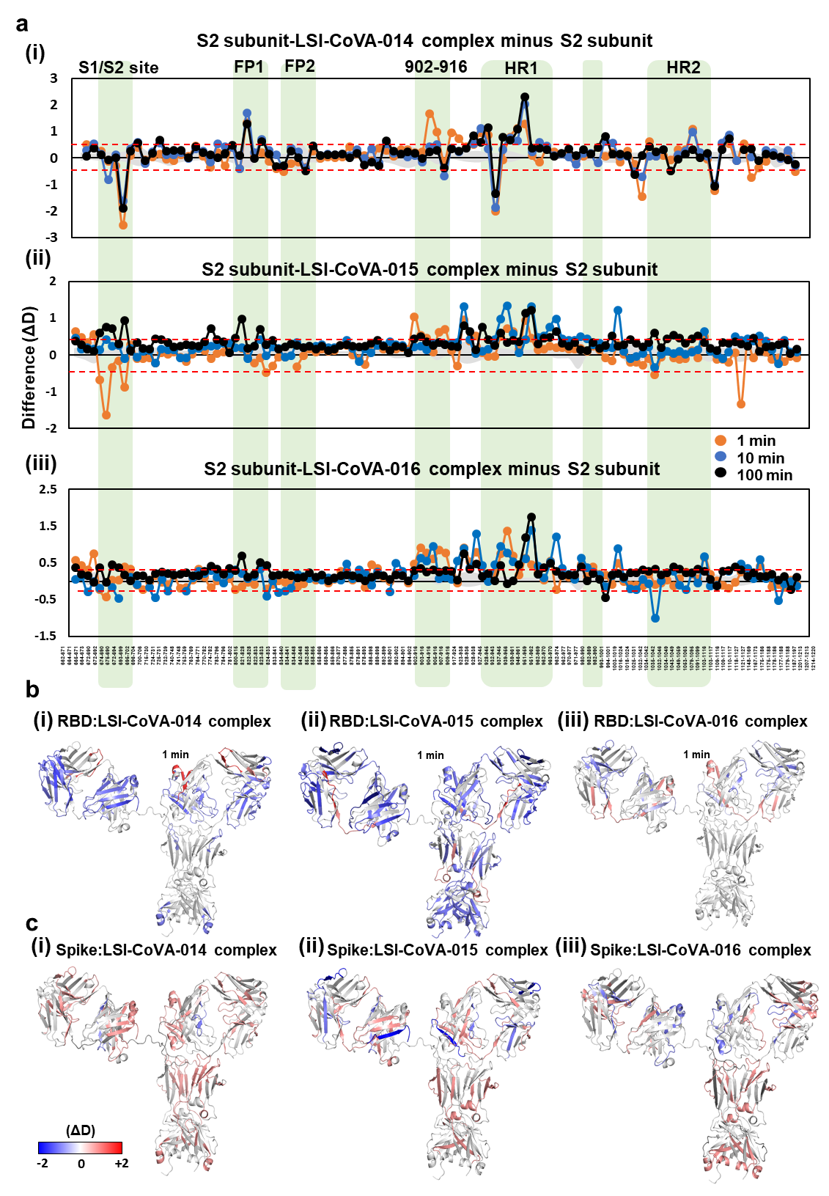
Extended data Fig.2: Probing conformational changes across the S2 subunit and the RBD-binding antibodies upon their complex formation.
(a) Plots of differences in deuterium exchange between antibody-bound and free states of the S2 subunit of Spike trimer complexes with (i) LSI-CoVA-014, (ii) LSI-CoVA-015, and (iii) LSI-CoVA-016 are shown for indicated labeling times. Residue numbers are indicated for the peptides, as per supplementary information. S1/S2 cleavage site, Fusion peptide (FP) 1 and 2, Heptad Repeats (HR) 1 and 2, Central helix are highlighted in green. (b, c) Conformational dynamics induced by isolated RBD (B) and Spike (C) trimer on the three antibodies (i) LSI-CoVA-014, (ii) LSI-CoVA-015, and (iii) LSI-CoVA-016 are mapped onto a model of IgG structure, shown in cartoon. Changes in deuterium exchange at the paratope-sites of light (CDRL1-L3) and heavy (CDRH1-H3) chains of each antibody are tabulated in Table S2.

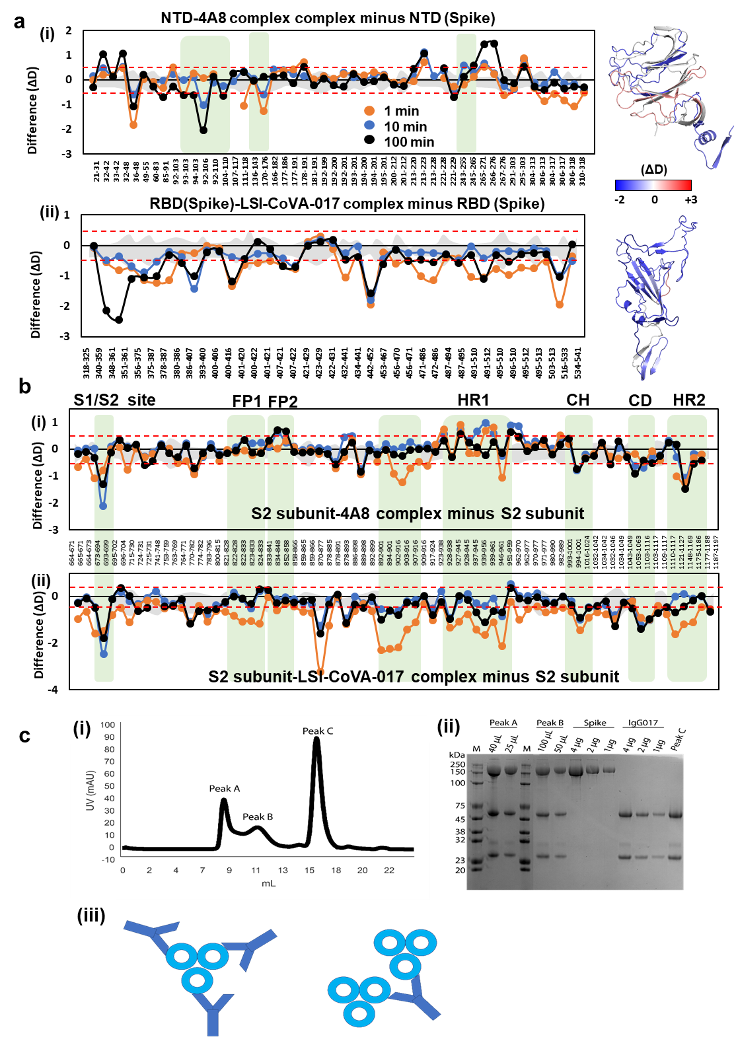
Extended data Fig. 3: Determining the effect of NTD-binding antibodies on Spike.
Plots showing differences in deuterium exchange across (a i) N-terminal domain, (a ii) RBD, and (b) S2 subunit of Spike trimer bound to 4A8 and LSI-CoVA-017 antibodies. Each time point is indicated and the residue numbers of individual peptides are shown, as per supplementary information. Green boxes highlight important regions. (Right panels) Differences in deuterium exchange values at 1 min labeling timepoint were mapped onto structures of Spike, with close-up views of (a i) NTD and (a ii) RBD shown for clarity. (c) Chromatogram of Spike-LSI-CoVA-017 mixture following injection on a Superose 6 Increase 10/300 GL gel filtration column. Peak A corresponds to high molecular weight oligomers, peak B contains lower molecular weight oligomers of Spike-LSI-CoVA-017 complexes, and peak C corresponds to unbound LSI-CoVA-017 added in excess. (ii) Image of denaturing polyacrylamide electrophoretic analysis of peak fractions of A and B. LSI-CoVA-017 and Spike were loaded for reference and for densitometry analysis calibration. (iii) Schematics of the two most plausible binding modes of interaction between LSI-CoVA-017 (Y-shaped) and Spike trimer (circles), based on the stoichiometric ratios determined and listed in Table S4.

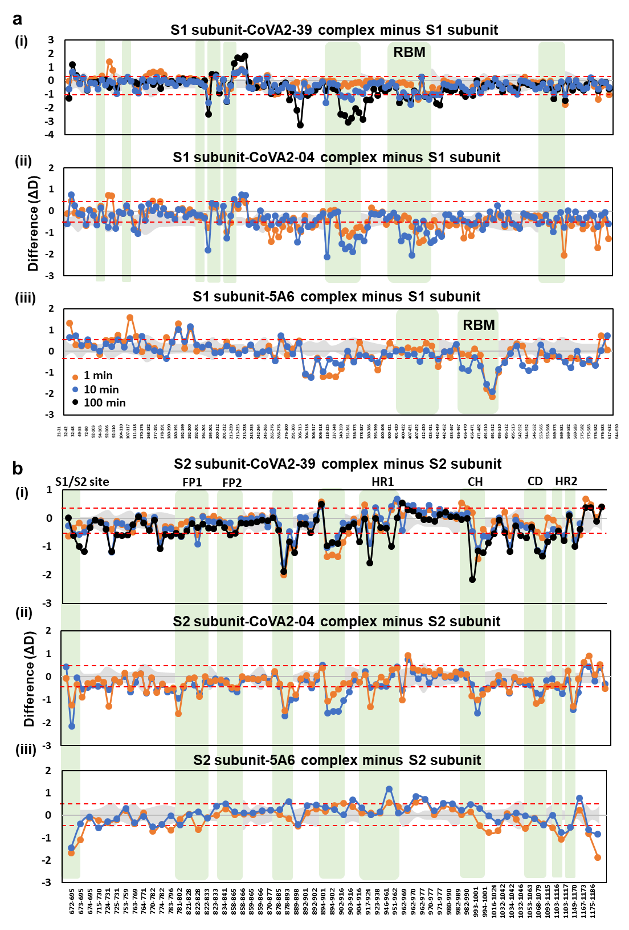
Extended data Fig. 4: RBM binding antibodies stabilize the dynamics of Spike trimer.
Plots showing differences in deuterium exchange kinetics of the (a) S1 and the (b) S2 subunits of Spike in the presence and absence of (i) CoVA2-39, (ii) CoVA2-04, and (iii) 5A6 HuMAbs for various peptides indicated by their residue numbers indicated (X-axis). A value of ± 0.5 D was considered significant and indicated by red-dashed line and the standard deviations as grey areas. Green boxes highlight the epitope sites spanning RBM, and various domains of the S2 subunit as indicated.

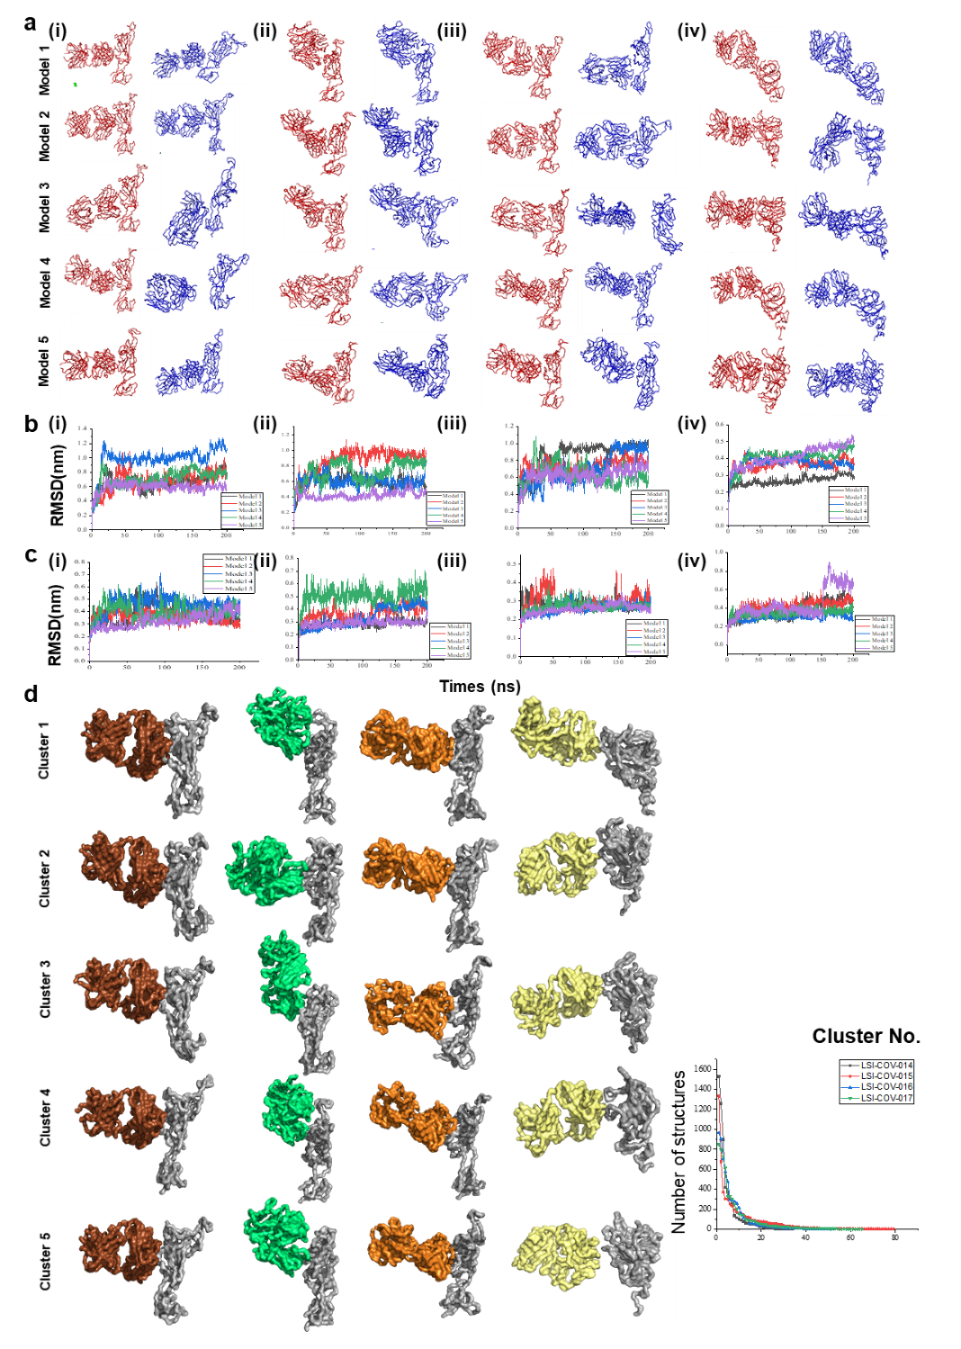
Extended data Fig. 5: Visualization and cluster analysis of models of Fab:RBD/NTD complexes.
(a) Initial (red) and final (blue) trace representations of (i) LSI-CoVA-014-RBD, (ii) LSI-CoVA-015-RBD, (iii) LSI-CoVA-016-RBD, and (iv) LSI-CoVA-017-NTD Fab-antigen complexes from 200 ns simulations. (b, c) Variations in RMSD of (b) RBD and (c) Fab after least-squares fit to the backbone of the complexes for five models from the four systems for 200 ns simulations. (d) Surface representation of central structures of the five most populated clusters from LSI-CoVA-014:RBD, LSI-CoVA-015:RBD, LSI-CoVA-016:RBD, LSI-CoVA-017:NTD complexes. RBD and NTD are in gray, with LSI-CoVA-014 (brown), LSI-CoVA-015 (green), LSI-CoVA-016 (orange), and LSI-CoVA-017 (yellow). (inset) Plot showing the size of each cluster of RBD with LSI-CoVA-014 (black), LSI-CoVA-015 (red), LSI-CoVA-016 (cyan), and LSI-CoVA-017 (green). Cluster analysis was performed for concatenated trajectories derived from triplicate 200 ns simulations for each complex using GROMOS method with an RMSD cut-off of 0.35 nm.

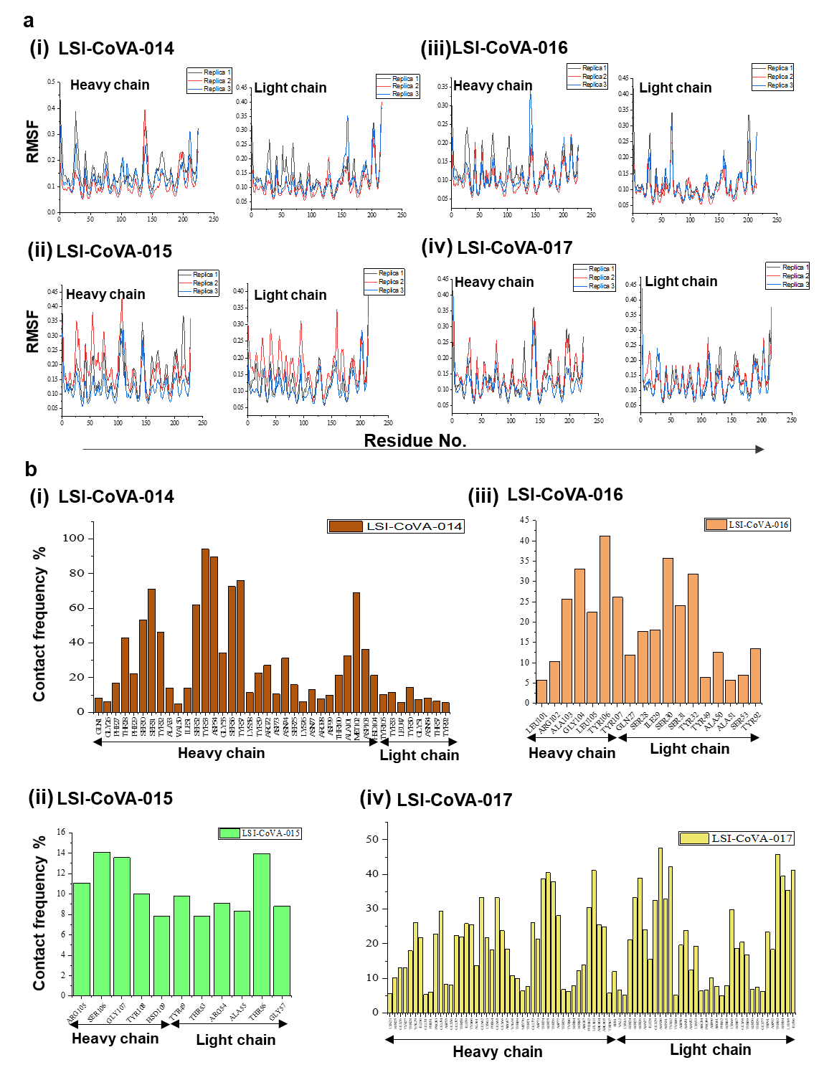
Extended data Fig, 6: Determining the variations of simulations between different Fab:RBD/NTD models and the role of glycans.
(a) Root mean square fluctuation (RMSF) of triplicate simulations of (i) LSI-CoVA-014, (ii) LSI-CoVA-015, (iii) LSI-CoVA-016, and (iv) LSI-CoVA-017 antibodies for heavy (left) and light (right) chains from each model bound to RBD and NTD. (b) Contact frequencies greater than 0.1 (residues interacting with glycan for at least 10% of simulation time) of the Fab residues from the four antibodies with the glycan moiety of RBD or NTD during 200 ns simulations. Models wherein Fab separates from RBD or NTD were not considered and the maximum contact frequency value of each residue from remaining models is plotted.

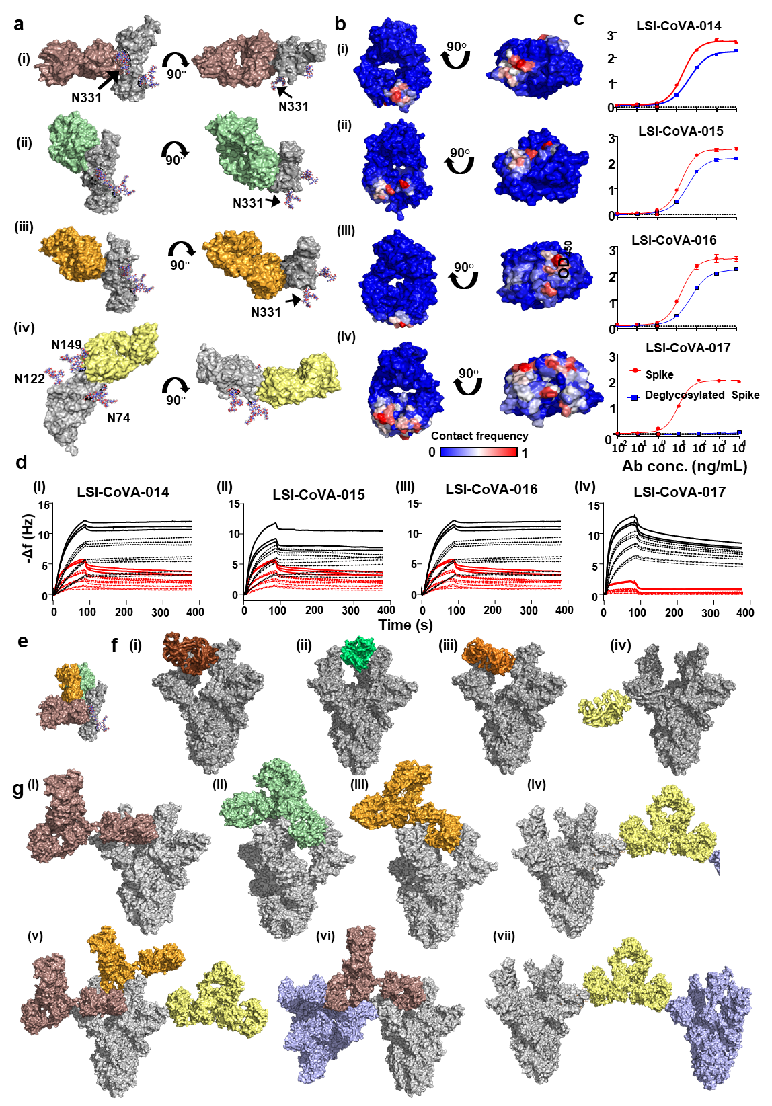
Extended Data Fig. 7: Essential role of glycan groups in facilitating antigen-antibody interactions and determining competitive binding of antibodies to Spike.
(a) Representative structures from the most populated cluster from MD simulation trajectories are depicted in two orientations for: RBD (grey) complexes with Fab of (i) LSI-CoVA-014 (brown), (ii) LSI-CoVA-015 (green), (iii) LSI-CoVA-016 (orange); and NTD-complex with (iv) LSI-CoVA-017 (yellow). Glycans are shown in ball-and-stick representation. (b) Contact frequencies during simulations between glycan moieties and Fab are mapped onto the structure of each Fab. (c) Plots showing the binding activity of varying concentrations of (i) LSI-CoVA-014, (ii) LSI-CoVA-015, (iii) LSI-CoVA-016, and (iv) LSI-CoVA-017 antibodies with Spike (red circles) and deglycosylated Spike (blue squares) as determined by ELISA. (d) Antibodies at varying concentrations (4.2 nM – 133 nM) were flowed over Spike (black) and deglycosylated (red) Spike trimer immobilized onto the surface of a vibrating quartz crystal. (e, f) Lateral view of surface representations showing Fab arms of (i) LSI-CoVA-014 (brown), (ii) LSI-CoVA-015 (green), (iii) LSI-CoVA-016 (orange), and (iv) LSI-CoVA-017 (yellow) aligned onto (e) RBD and (f) Spike trimer (grey, 7a98.pdb). Representative structures from most populated cluster of Fab:RBD and Fab:NTD cluster analysis were used respectively. (g i-iv) The corresponding full-length IgGs modeled onto Spike trimer, based on the position of their Fab determined by cluster analysis. (g v) Representative structure of the competition of LSI-CoVA-015/LSI-CoVA-016 with each other whilst allowing binding of LSI-CoVA-014 or LSI-CoVA-017. (g vi-vii) Predicted models showing two Spike trimers (grey and blue) bound to both Fab arms of (vi) LSI-CoVA-014 (brown) and (vii) LSI-CoVA-017 (yellow).
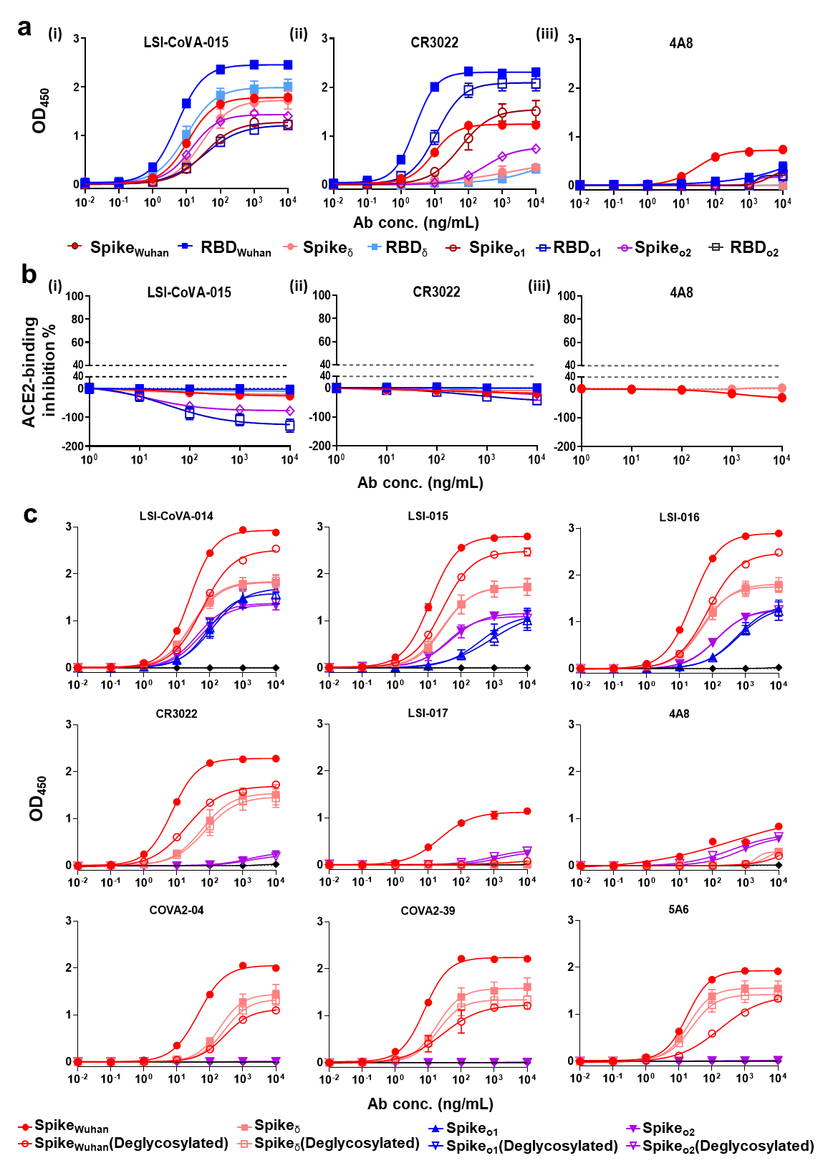
Extended data Fig. 8. Binding activity of antibodies to Delta and Omicron variants of Spike
(a) Antibody binding activity to Delta and Omicron (o1 and o2) variants of Spike compared with Wuhan-Hu-1 strain. Antibodies (i) LSI-CoVA-015, (ii) CR3022, and (iii) 4A8 at concentrations from 10 pg/mL-10 µg/mL were tested for binding to SARS-CoV-2 Spike and MBP-RBD by ELISA. 4A8 binds to spike variants tested with reduced activities compared to Wuhan-Hu-1. (b) ACE2-binding inhibition assays for the three antibodies (at varying concentrations) are shown. No inhibition to the binding of ACE2 to Wuhan-Hu-1/Delta/Omicron BA1 or BA2 spike/RBD was observed. (c) Plots showing varying concentrations of the nine antibodies to glycosylated (closed plots) and deglycosylated (open plots) trimers of Wuhan (red), Delta (peach), Omicron BA.1 (blue), and Omicron BA.2 (lilac). LSI-CoVA-017 and 4A8 demonstrate no binding activity, with minimal or negligible reduction in binding activity to deglycosylated Spike VoCs.

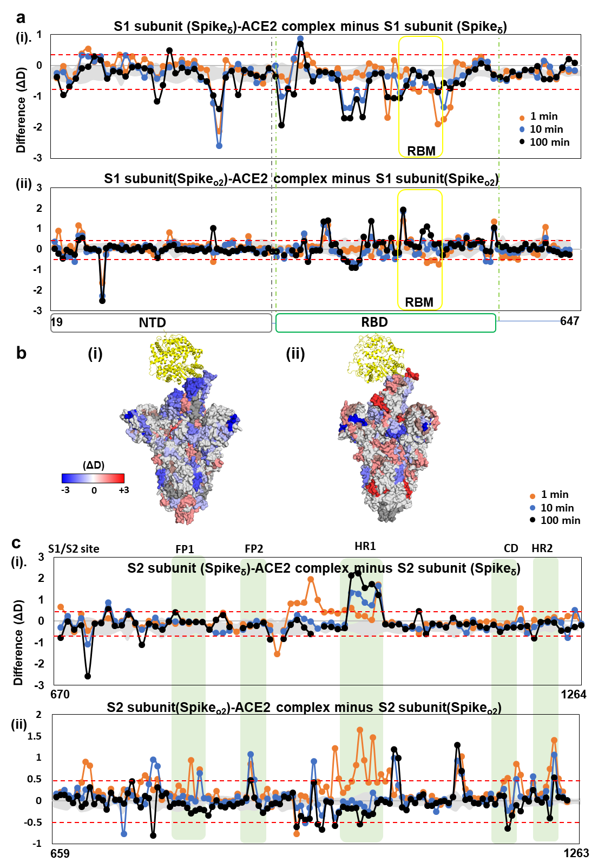
Extended data Fig. 9. ACE2-binding induced dynamics varies between Delta and Omicron Spike variants.
Plots comparing differences in deuterium exchange (ΔD) in the presence and absence of ACE2 for various peptides across (a) the S1 and (c) the S2 subunits of Spike variants (i) Delta and (ii) Omicron BA.2. Various labelling timepoints are indicated with peptide numbers tabulated in supplementary tables. Peptides covering NTD and RBD are grouped as per domain organization shown. ACE2-binding sites RBM are highlighted in yellow. (b) Surface representation of the deuterium exchange differences upon binding to ACE2 are mapped onto the trimeric structure of (i) Spike_{δ} (7w98.pdb) and (ii) Spike_{o2} (7wpa.pdb), as indicated. ACE2 is shown in yellow. ACE2 binding shows distinct effects on the dynamics of Spike_{δ} and Spike_{o2}, as seen by varying intensities of protection (blue) and exposure (red) to deuterium exchange. In (c) various regions across the S2 subunit showed significant changes in deuterium exchange and are highlighted in green.

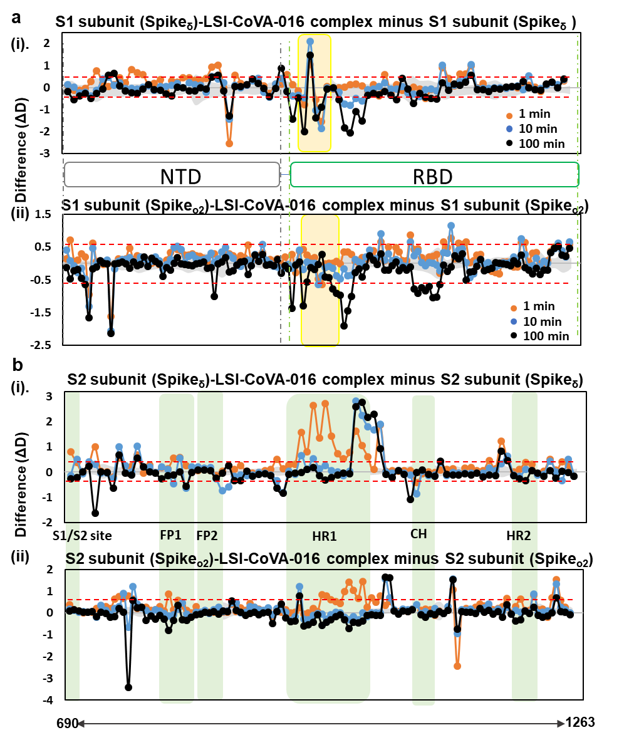
Extended data Fig. 10. Weak neutralizers bind to Spike VoCs at cryptic epitope site
Plots comparing differences in deuterium exchange across the (a) S1 and (b) S2 subunits of (i) Spike_{δ} and (ii) Spike_{o2} complexed to LSI-CoVA-016 versus the apo states. Peptides covering NTD and RBD are indicated. Yellow zones highlights the peptides spanning the cryptic epitope site, as observed for Spike_{Wuhan} strain. LSI-CoVA-016 showed larger decreases in deuterium exchange to the two VoCs. Key regions showing distinct deuterium exchange differences are highlighted in green.

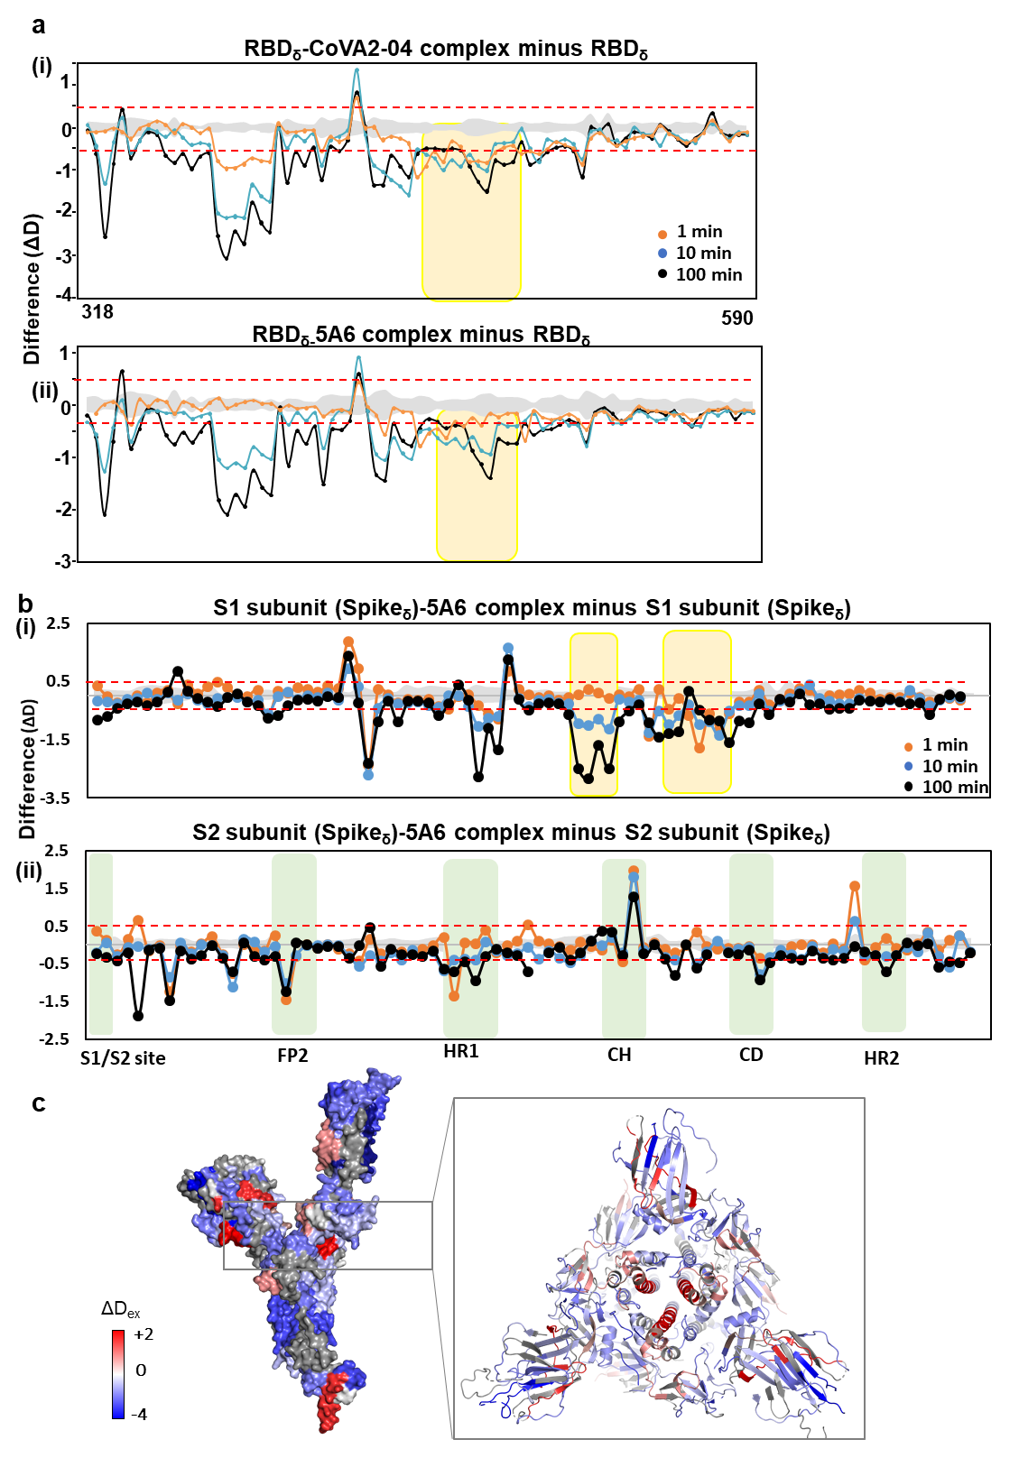
Extended data Fig. 11. Strong neutralizers show minimal binding to Spikeδ.
(a) Effects of binding of RBM-binding antibodies (i) CoVA2-04 and (ii) 5A6 on RBD_{δ} are shown as plots showing differences in deuterium exchange. Antibody binding epitope sites are in yellow, and exhibit minor changes in deuterium exchange, as opposed to large-scale decreased deuterium exchange observed at other peptides. (b) Difference in deuterium exchange in Spike_{δ} trimer upon binding to 5A6 antibody are shown for peptides spanning the (i) S1 and (ii) S2 subunits. Key regions are highlighted. (c) Differences at 1 min labeling timepoint are mapped onto Spike_{δ} (7w98.pdb) monomer, shown as surface representation. A cross section across the trimer is shown as inset, which highlights the quaternary effects of 5A6 binding. Residue numbers for the peptides (represented by circles in difference plots) are indicated in supplementary tables.

Table S1: Quartz crystal microbalance analysis of antibody binding kinetics to Hexapro Spike trimer (0.03 μM). k_{a} = association constant; k_{d}: dissociation constant

Antibody | B_{max} | k_{a} (1/[(M⁻s)] | k_{d} [1/s] | K_{D} (M) | Chi²
LSI-CoVA-016 | 9.61 | 3.90 E+05 | 3.00 E-04 | 7.68 E-10 | 0.06
LSI-CoVA-017 | 19.66 | 4.46 E+05 | 7.48 E-05 | 1.67 E-10 | 0.12
4A8 | 18.03 | 5.74 E+05 | 1.95 E-04 | 3.40 E-10 | 0.10
LSI-CoVA-015 | 13.86 | 5.61 E+05 | 1.88 E-04 | 3.35 E-10 | 0.21
COVA2-39 | 36.07 | 1.25 E+06 | 4.87 E-04 | 3.88 E-10 | 0.57
LSI-CoVA-014 | 17.12 | 5.57 E+05 | 2.88 E-04 | 5.16 E-10 | 0.35
CR3022 | 24.53 | 6.05 E+05 | 3.16 E-04 | 5.21 E-10 | 0.38
COVA2-04 | 15.25 | 9.32 E+04 | 5.55 E-04 | 5.96 E-09 | 0.05
5A6 | 15.52 | 1.18 E+06 | 8.87 E-04 | 7.55 E-10 | 0.15

Table S2: Differences in deuterium exchange values for complementarity-determining regions (CDR) of light (CDR L1-L3) and heavy (CDR H1-H3) chains of various antibodies in the presence and absence of RBD_{iso} (top) and Spike_{Wuhan} (bottom) as indicated. Positive differences (>0.5 D) are highlighted in red, and negative differences (<-0.5 D) are in green.

 | CDRL1 | CDRL2 | CDRL3 | CDRH1 | CDRH2 | CDRH3
 | RBD | RBD | RBD | RBD | RBD | RBD
LSI-CoVA-014 | -1.00 | -0.32 | -1.86 | 0.65 | -1.74 | -1.70
LSI-CoVA-015 | -0.51 | -1.73 | -0.70 | -1.08 | -1.18 | 0.41
LSI-CoVA-016 | -0.23 | -0.41 | -0.76 | -0.25 | -0.55 | 0.24
LSI-CoVA-017 | 0.35 | -0.36 | -0.05 | -0.21 | -0.45 | -0.17

 | CDRL1 | CDRL2 | CDRL3 | CDRH1 | CDRH2 | CDRH3
 | Spike | Spike | Spike | Spike | Spike | Spike
LSI-CoVA-014 | -0.55 | -0.52 | -0.81 | 0.45 | 0.40 | -1.01
LSI-CoVA-015 | 0.17 | -1.88 | -0.41 | -0.89 | -0.27 | 0.60
LSI-CoVA-016 | -0.16 | -0.27 | -0.71 | -0.25 | -0.20 | 0.80
LSI-CoVA-017 | 0.32 | 0.80 | 0.31 | 0.43 | -0.51 | -0.26

Table S3: Determination of Spike:LSI-CoVA-017 binding stoichiometry.
The absolute quantities of Spike, heavy and light chains of LSI-CoVA-017 were estimated based on the SDS-PAGE band intensities relative to quantification standards. The quantities of LSI-CoVA-017 were calculated based on the quantities of either heavy chain or light chain. Both approaches resulted in similar quantities determined of LSI-CoVA-017, and thus consistently suggest a binding stoichiometry of three LSI-CoVA-017 bound per Spike trimer. To confirm the reliability of the densitometry, samples were loaded at two different amounts and analyzed from each peak of size-exclusion chromatogram.

Peak A (40 µl) | mg | MW(kDa) | pmol | Spike trimer/IgG (pmol) | LSI-CoVA-017:Spike trimer stoichiometry
Spike | 3.02 | 160.00 | 18.88 | 6.29
Heavy Chain | 1.87 | 50.00 | 37.33 | 18.67 | 2.96
Light Chain | 0.95 | 25.00 | 37.87 | 18.93 | 3.01
Peak A (25 µl) | mg | MW(kDa) | pmol | Spike trimer or IgG (pmol) | LSI-CoVA-017:Spike trimer stoichiometry
Spike | 2.02 | 160.00 | 12.63 | 4.21
Heavy Chain | 1.23 | 50.00 | 24.53 | 12.27 | 2.91
Light Chain | 0.61 | 25.00 | 24.53 | 12.27 | 2.91
Peak B (100 µl) | mg | MW(kDa) | pmol | Spike trimer or IgG (pmol) | LSI-CoVA-017:Spike trimer stoichiometry
Spike | 2.53 | 160.00 | 15.81 | 5.27
Heavy Chain | 1.57 | 50.00 | 31.33 | 15.67 | 2.97
Light Chain | 0.82 | 25.00 | 32.67 | 16.33 | 3.09
Peak B (50 µl) | mg | MW(kDa) | pmol | Spike trimer or IgG (pmol) | LSI-CoVA-017:Spike trimer stoichiometry
Spike | 1.30 | 160.00 | 8.13 | 2.71
Heavy Chain | 0.81 | 50.00 | 16.13 | 8.07 | 2.98
Light Chain | 0.41 | 25.00 | 16.53 | 8.27 | 3.05

Table S4: Monitoring dynamics of antigen-antibody complexes.
Details of simulation setup for molecular dynamics of top 5 models of complexes between RBD/NTD and Fab domains of LSI-CoVA-014, LSI-CoVA-015, LSI-CoVA-016 and LSI-CoVA-017, as described in Methods. Models highlighted in bold show simulations performed in triplicates.

System | Model# | No. of water ions | No. of Na⁺ ions | No. of Cl⁻ ions | Box size  nm × nm × nm | Production run (ns)
LSI-CoVA-014-RBD | Model 1 | 71807 | 203 | 212 | 13.4×13.4×13.4 | 200
LSI-CoVA-014-RBD | Model 2 | 64934 | 185 | 194 | 13×13×13 | 200 × 3
LSI-CoVA-014-RBD | Model 3 | 87998 | 250 | 259 | 14.3×14.3×14.3 | 200
LSI-CoVA-014-RBD | Model 4 | 73478 | 208 | 217 | 13.5×13.5×13.5 | 200
LSI-CoVA-014-RBD | Model 5 | 77021 | 218 | 227 | 13.7×13.7×13.7 | 200
LSI-CoVA-015-RBD | Model 1 | 95807 | 273 | 283 | 14.7×14.7×14.7 | 200 × 3
LSI-CoVA-015-RBD | Model 2 | 78446 | 223 | 233 | 13.8×13.8×13.8 | 200
LSI-CoVA-015-RBD | Model 3 | 85899 | 245 | 255 | 14.2×14.2×14.2 | 200
LSI-CoVA-015-RBD | Model 4 | 57277 | 162 | 172 | 12.5×12.5×12.5 | 200
LSI-CoVA-015-RBD | Model 5 | 57277 | 163 | 173 | 12.5×12.5×12.5 | 200
LSI-CoVA-016-RBD | Model 1 | 76917 | 218 | 227 | 13.7×13.7×13.7 | 200
LSI-CoVA-016-RBD | Model 2 | 80876 | 229 | 238 | 13.9×13.9×13.9 | 200
LSI-CoVA-016-RBD | Model 3 | 82268 | 234 | 243 | 14×14×14 | 200
LSI-CoVA-016-RBD | Model 4 | 85898 | 245 | 254 | 14.2×14.2×14.2 | 200 × 3
LSI-CoVA-016-RBD | Model 5 | 85946 | 245 | 254 | 14.2×14.2×14.2 | 200
LSI-CoVA-017-NTD | Model 1 | 129534 | 368 | 372 | 16.2×16.2×16.2 | 200
 | Model 2 | 110527 | 314 | 318 | 15.4×15.4×15.4 | 200
 | Model 3 | 85427 | 243 | 247 | 14.2×14.2×14.2 | 200 × 3
 | Model 4 | 115354 | 327 | 331 | 15.6×15.6×15.6 | 200
 | Model 5 | 78027 | 222 | 226 | 13.8×13.8×13.8 | 200

Supplementary data Table S5-S6 are provided as separate files.
Table S5 contains the metadata which summarizes the HDXMS experimental conditions, sequence coverage, and replicate analysis.
Table S6 contains the raw deuterium exchange values for the various antibody-bound conditions of Spike and its variants.

