Supporting information for
Suppressing infiltration and coffee-ring effects of colorimetric reagents on paper for trace-level detection of Ni (II)

Table S 1 Comparison of different color channels at RGB mode on change, slope, and R²
Channel | Concentration (ppm) | Color change | Sensitivity (0.5-50 ppm) | R² (0.5-50 ppm)
R | 0.5-500 | 9.228 | 0.0549 | 0.2585
G | 0.5-500 | 166.589 | 1.5985 | 0.9837
B | 0.5-500 | 95.904 | 0.4754 | 0.9828
R+G+B | 0.5-500 | 91.16 | 0.7127 | 0.958

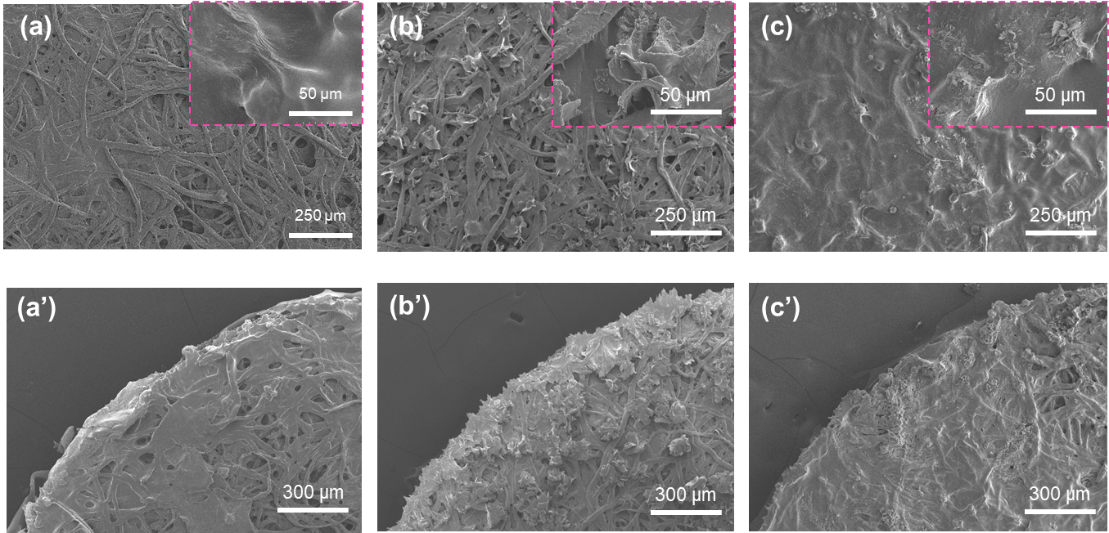
Figure S1 SEM result of sensor under different BA adding conditions: (a) and (a’) BA was added before the PVA/DMG solution (BA-pre), (b) and (b’) no BA was added to cross-link the PVA/DMG (no BA), (c) and (c’) BA was added right after the PVA/DMG addition (BA-post). Ni²⁺ was absent from all above cases.

Table S 2 Parameters of the commercial filters used in this paper.
Filter paper  (type) | Particle retention (µm) | Thickness  (µm) | Basis weight  (g/m²) | Flow Rate  (mm/30 min)
1 F | 11 | 180 | 87 | 150
3 F | 6 | 390 | 185 | 325
4 F | 25 | 210 | 92 | 37
1 CHR | 11 | 175 | 87 | 130
Data source: the data was provided by the producer(cytiva).

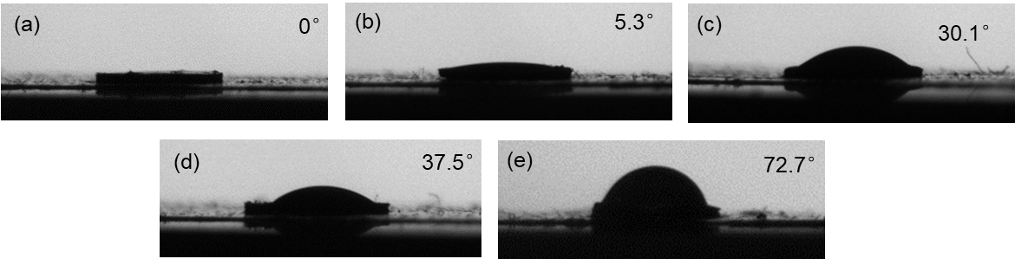
Figure S 2 Water contact angle (WCA) of sensor under different BA adding conditions: (a) blank filter paper (1 CHR), (b) the regular sensor, (c) no BA was added to cross-link the PVA mixture with DMG (no BA), (d) BA was added before the PVA/DMG solution (BA-pre), (e) BA was added right after the PVA/DMG addition (BA-post)

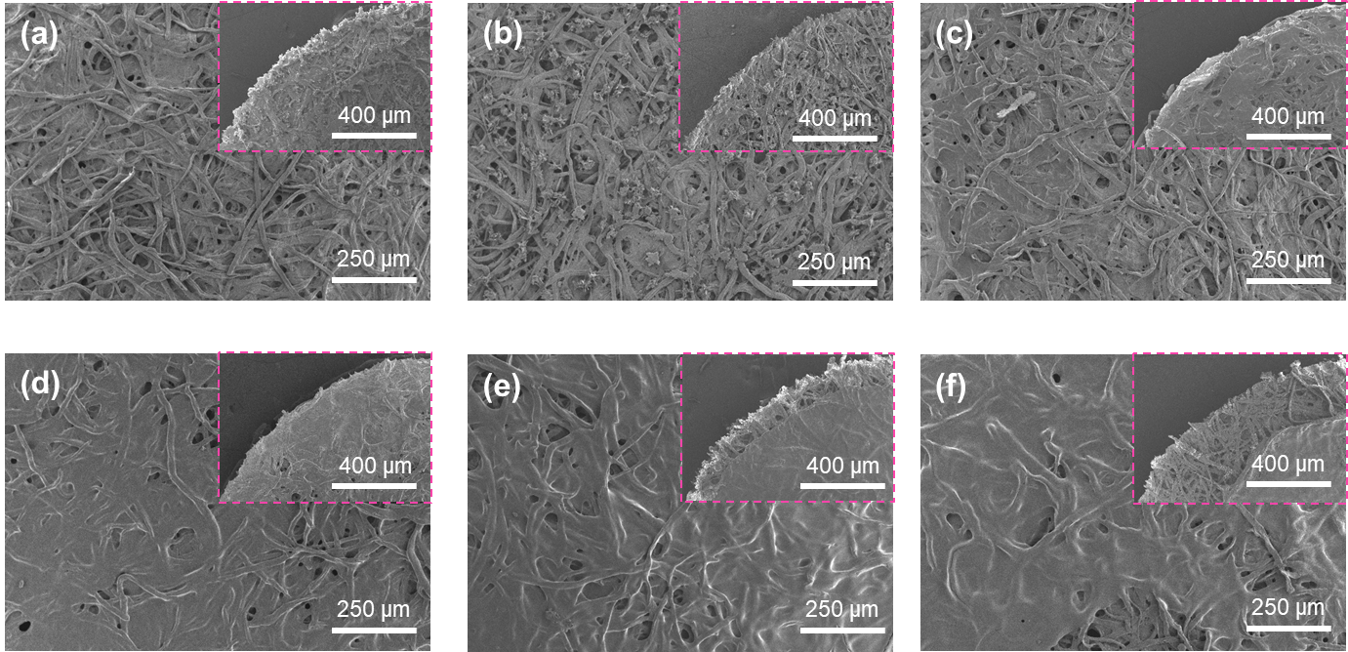
Figure S 3 SEM results of sensor at different BA weight ratios (PVA, 5% wt): (a) 0% wt, (b) 1% wt, (c) 2 wt%, (d) 3% wt, (e) 4% wt, (f) 5% wt.

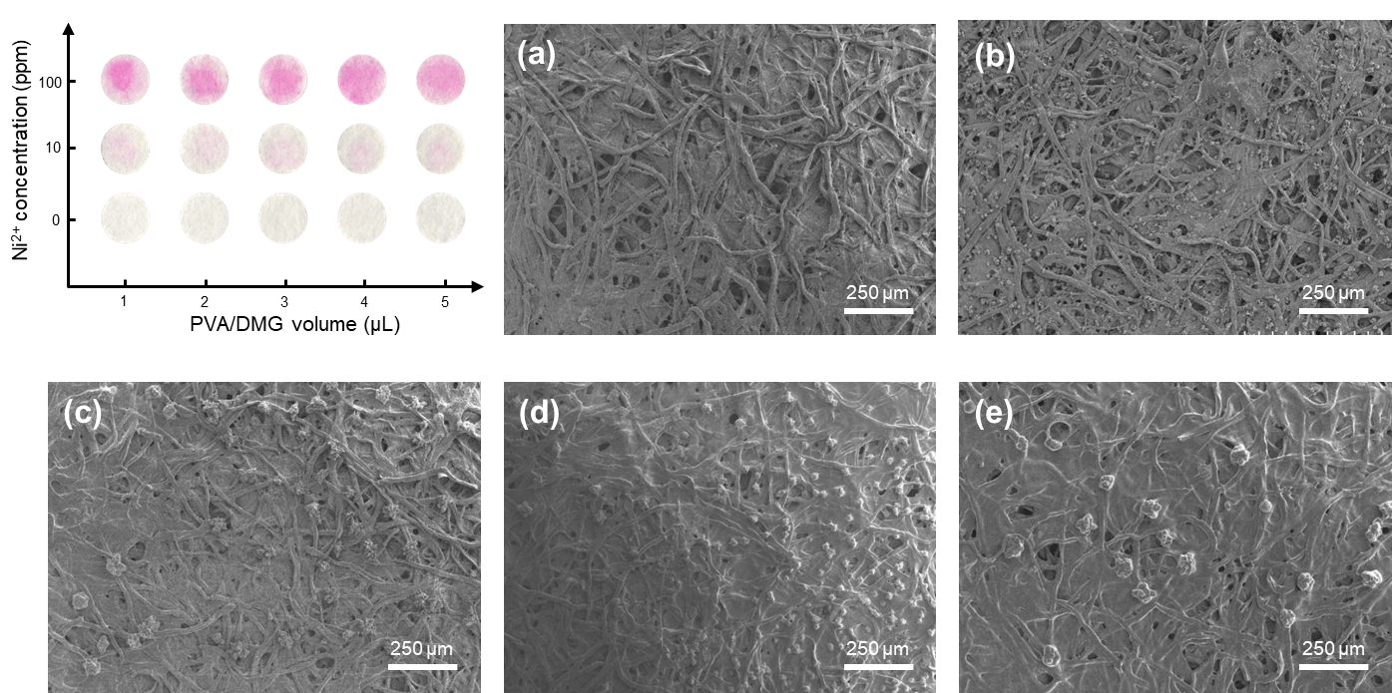
Figure S 4 Original images of the sensors detecting N²⁺ after adding different volumes of PVA/DMG solution (a) and the correspondent SEM image：(b) 1 μL, (c) 2 μL, (d) 3 μL, (e) 4 μL, (f) 5 μL.

Table S 3 Ni²⁺ detection in real environmental samples by two methods
 |  | PVA-assisted |  | regular
samples | sipked (ppm) | found (ppm) | recovery (%) | found (ppm) | recovery (%)
Tap water | 0 | N.D. |  | N.D.
 | 5 | 5.03±0.50 | 100.86% | 5.68±1.33 | 113.72%
 | 50 | 50.53±0.53 | 101.07% | 48.64±2.82 | 97.30%
pond water 1 | 0 | N.D. |  | N.D.
 | 5 | 4.95±0.34 | 99.13% | 5.84±1.68 | 116.83%
 | 50 | 51.05±0.90 | 102.11% | 52.78±3.56 | 105.57%
pond water 2 | 0 | N.D. |  | N.D.
 | 5 | 5.02±0.73 | 100.53% | 5.91±1.03 | 118.26%
 | 50 | 51.26±0.82 | 102.54% | 51.71±3.81 | 103.43%
wastewater | 0 | N.D. |  | N.D.
 | 5 | 4.92±0.45 | 98.42% | 5.69±1.72 | 113.89%
 | 50 | 50.24±0.82 | 100.48% | 49.36±2.83 | 98.73%

Reference
cytiva. A Guide to Whatman Filter Paper Grades.

