Supplementary table 1 Details about seminal root angle, root biomass and the QTL status for the selected Borlaug100 intro-selection lines, the recurrent parent (Borlaug100) and the donors (SW107 and SW309). Seminal root angle was measured using the clear pot method (Richard et al. 2015) and the root biomass measured using a semi-hydroponic sand-based system (Rambla et al. 2022). QTL status: --/- = line carries the haplotypes associated with low root biomass (i.e. h1, h2 or h8 for haploblock b and h1 for haploblock a; Voss-Fels et al. 2017; Makhoul et al. 2020), whereas ++/+ = line carries both desirable haplotypes for high root biomass (i.e. h3 for haploblock b and h2 for haploblock a; Voss-Fels et al. 2017; Makhoul et al. 2020).

 | Seminal root angle |  | Root dry biomass
Genotype | (°) | SD | (mg) | SD | QTL status
SW107 | 79.2 | 5.95 | 435 | 0.060 | ++/+
SW309 | 93.7 | 5.68 | 280 | 0.014 | - -/-
Borlaug100 | 89.6 | 5.96 | 313 | 0.017 | - -/-
UQR001 | 89.6 | 5.46 | 343 | 0.028 | - -/-
UQR002 | 84.8 | 5.69 | 325 | 0.091 | ++/+
UQR003 | 85.6 | 5.47 | 371 | 0.053 | ++/+
UQR004 | 90.3 | 5.95 | 418 | 0.033 | - -/-
UQR005 | 76.2 | 5.69 | 340 | 0.053 | - -/-
UQR006 | 95.2 | 5.96 | 360 | 0.029 | - -/-
UQR007 | 87.4 | 5.69 | 320 | 0.088 | - -/-
UQR008 | 89.7 | 5.70 | 360 | 0.081 | - -/-
UQR010 | 77.5 | 5.69 | 315 | 0.048 | ++/+
UQR011 | 77.6 | 6.26 | 308 | 0.028 | - -/-
UQR014 | 86.2 | 5.69 | 375 | 0.110 | ++/+
UQR016 | 79.8 | 5.96 | 403 | 0.100 | - -/-
UQR017 | 86.5 | 5.47 | 430 | 0.084 | - -/-
UQR018 | 88.9 | 5.69 | 365 | 0.064 | - -/-
UQR019 | 92.0 | 5.47 | 325 | 0.031 | - -/-
UQR020 | 94.8 | 5.46 | 420 | 0.082 | ++/+
*Standard deviation (SD)

Supplementary Fig. 1 Distribution curves of the morphological root traits extracted through RhizoVision Explorer (Seethepalli and York 2020) for all the panel of wheat. The red curve displays the recurrent parent Borlaug100, and the purple line shows the distribution of all the intro-selection lines. Root morphological traits extracted from the rhizobox images taken with a camera/mobile for the (a) whole root system (b) upper (0-30 cm), (c) middle (30-60 cm) and (d) lower (60-90 cm) section.
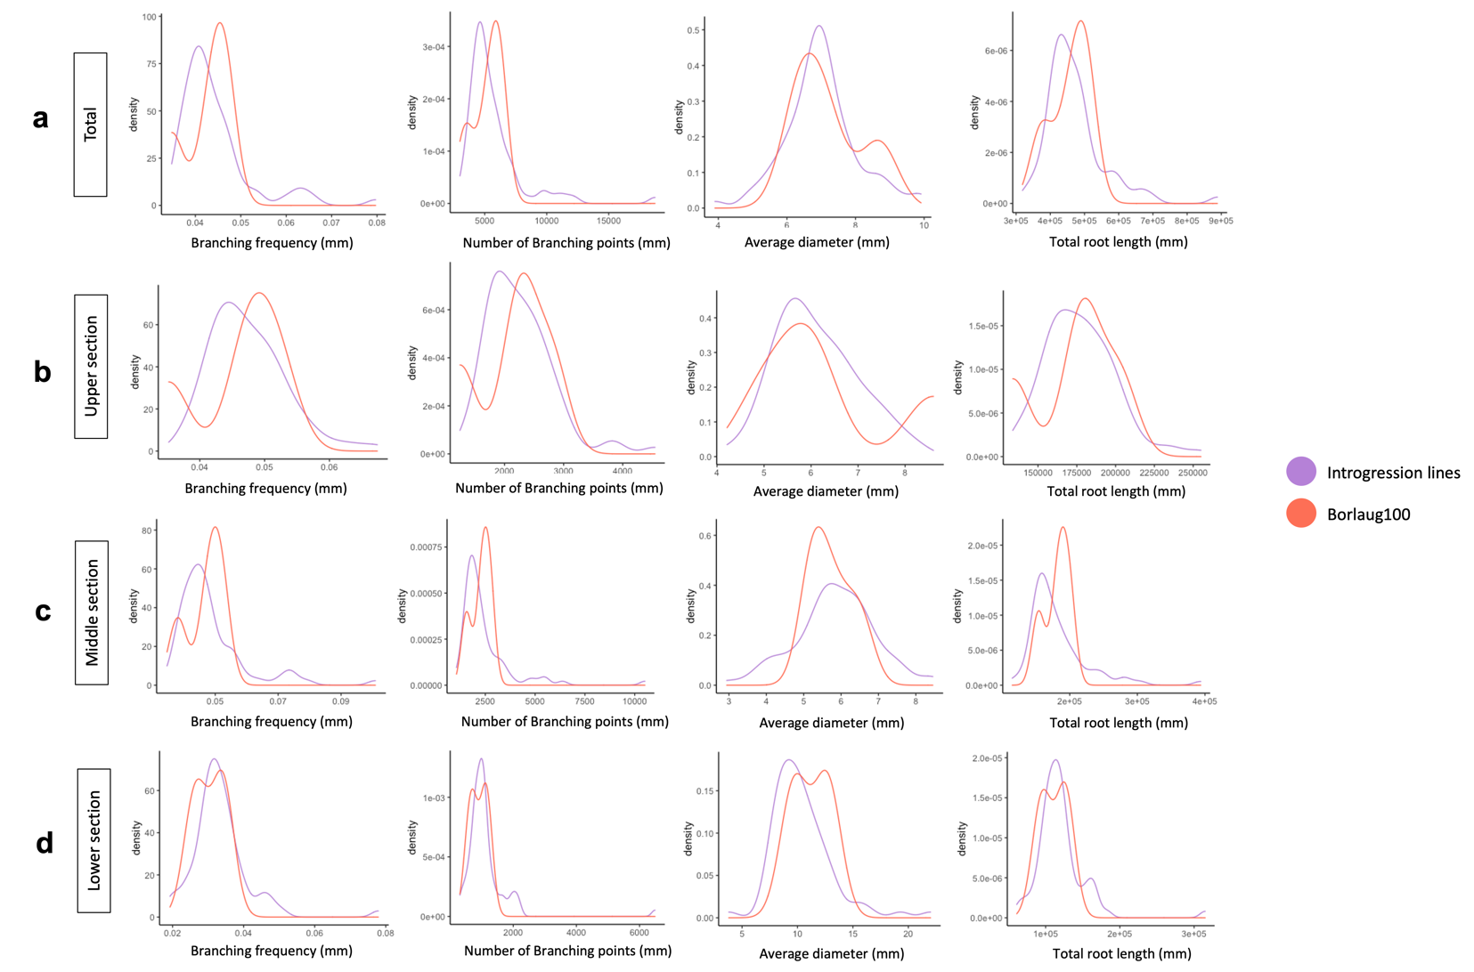

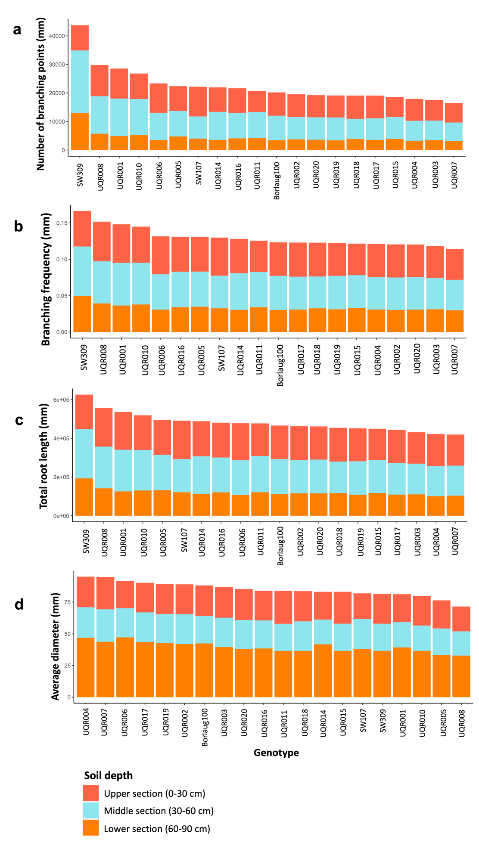
Supplementary Fig. 2 Investigation of morphological root traits using RhizoVision Explorer (Seethepalli and York 2020) for all the panel of wheat (n=320). The root morphological traits were extracted from the rhizobox images taken with a camera/mobile for the whole root system and at three different depths: upper (red, 0-30 cm), middle (light blue, 30-60 cm) or lower (orange, 60-90 cm) section. (a) Number of branching points (b) Branching frequency (c) Total root length (d) Average diameter.

