Integrating seascape resistances and gene flow to produce area-based metrics of functional connectivity for marine conservation planning

Landscape Ecology
Mark A. Wilcox^{1,2}, Nicholas W. Jeffery¹, Claudio DiBacco¹, Ian R. Bradbury³, Ben Lowen¹, Zeliang Wang¹, Robert G. Beiko², and Ryan R. E. Stanley¹
Affiliations
¹ Fisheries and Oceans Canada, Bedford Institute of Oceanography, 1 Challenger Dr., Dartmouth, NS, B2Y 4A2, Canada
² Faculty of Computer Science, Dalhousie University, 6399 South St., Halifax, NS, B3H 4R2, Canada
³ Fisheries and Oceans Canada, Northwest Atlantic Fisheries Centre, 80 White Hills Rd., St. John’s, NL, A1A 5J7 Canada
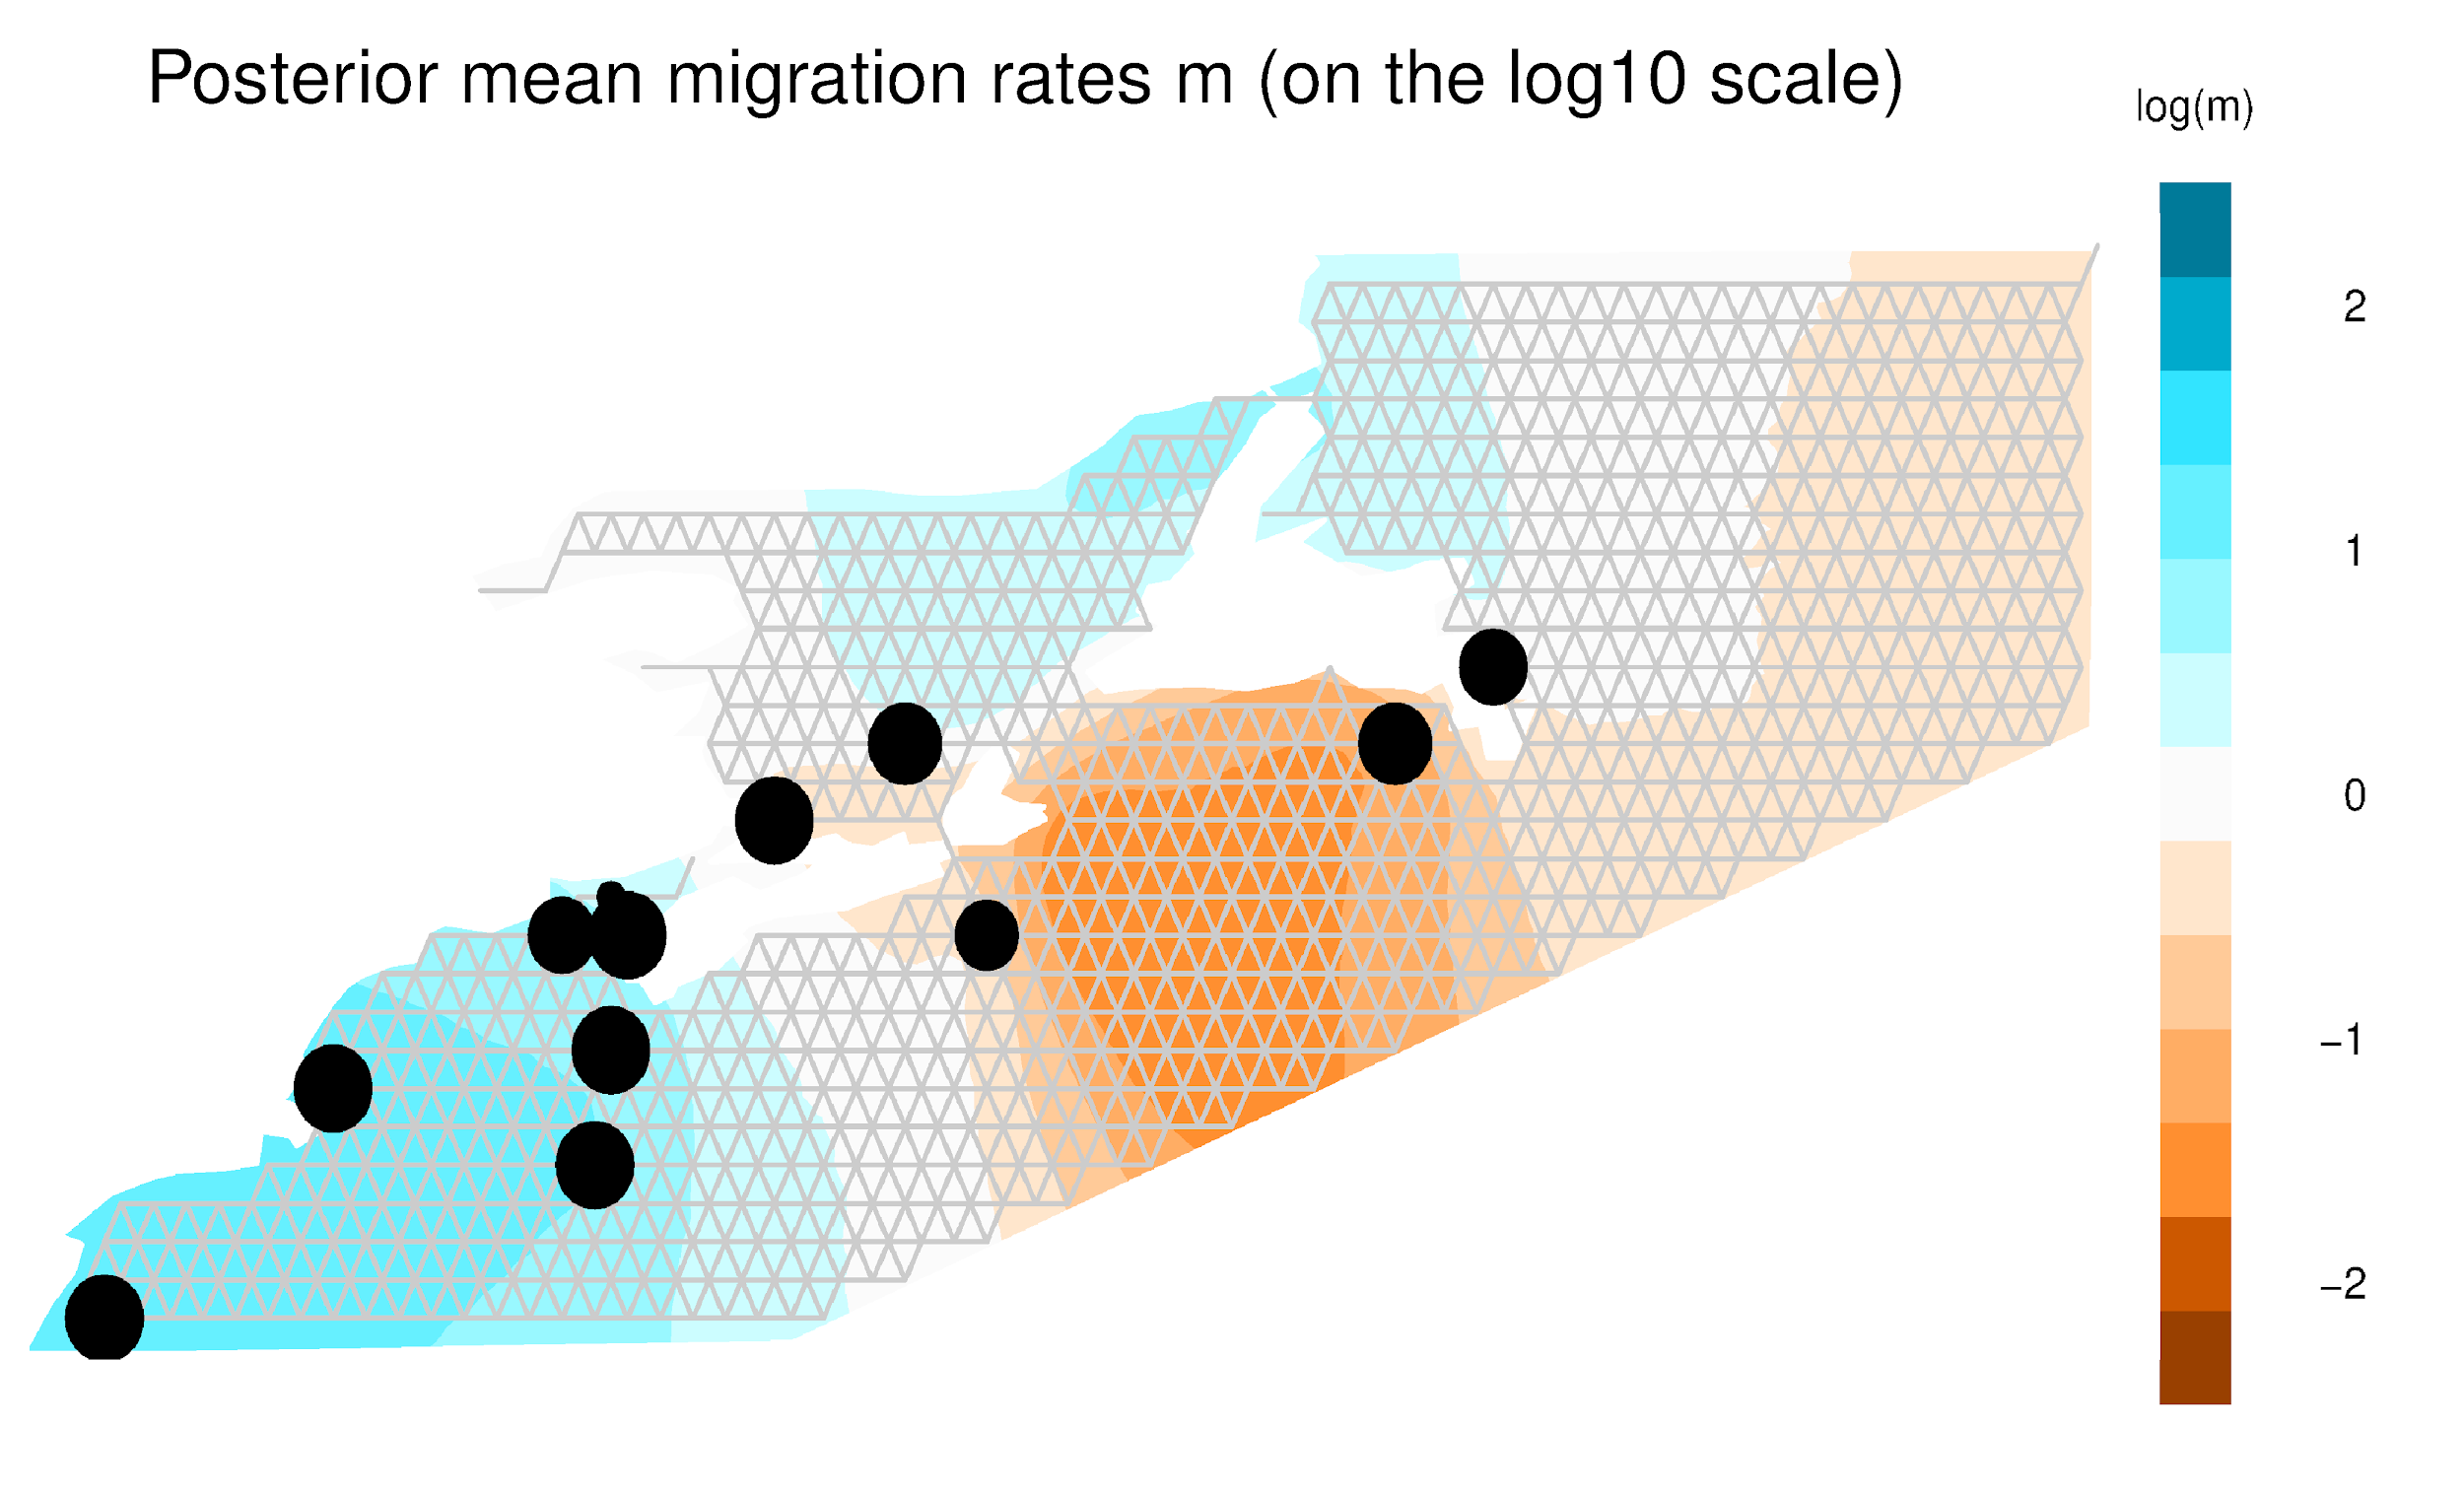
Online Resource 1 Example output from EEMS (Estimates of Effective Migration Surfaces) for Atlantic Sea Scallop, showing sampling locations and the grid (1000 demes) used to calculate migration rates. 1000 demes were used as this allowed for fine-scale gene flow into areas such as the inner Bay of Fundy and the Strait of Belle Isle. Sampling locations are represented by black dots, and the size of each dot corresponds to the number of individuals sampled at that location.

