Integrating seascape resistances and gene flow to produce area-based metrics of functional connectivity for marine conservation planning

Landscape Ecology
Mark A. Wilcox^{1,2}, Nicholas W. Jeffery¹, Claudio DiBacco¹, Ian R. Bradbury³, Ben Lowen¹, Zeliang Wang¹, Robert G. Beiko², and Ryan R. E. Stanley¹
Affiliations
¹ Fisheries and Oceans Canada, Bedford Institute of Oceanography, 1 Challenger Dr., Dartmouth, NS, B2Y 4A2, Canada
² Faculty of Computer Science, Dalhousie University, 6399 South St., Halifax, NS, B3H 4R2, Canada
³ Fisheries and Oceans Canada, Northwest Atlantic Fisheries Centre, 80 White Hills Rd., St. John’s, NL, A1A 5J7 Canada
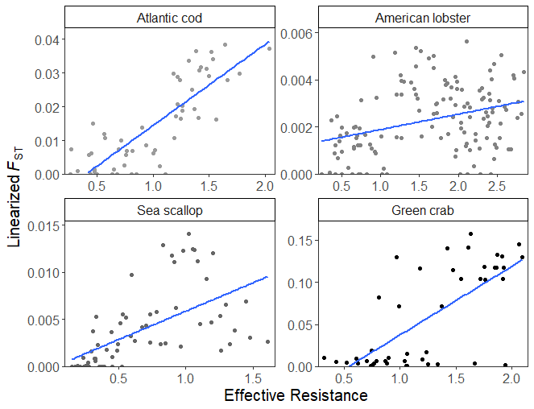
Online Resource 3 The correlations between linearized F_{ST} and effective resistance distances derived from Circuitscape among sampling locations for the four species examined in this study.

