Supplementary Material
Table S1. The effect of clinical variables on CSS analyzed by Cox regression analysis
Variables | Univariate analysis |  | Multivariate analysis
Variables | HR (95%CI) | P | HR (95%CI) | P
Gender
Female | - |  | -
Male | 1.176(1.137-1.217) | <0.001 | 1.102(1.065-1.141) | <0.001
Age
<65 | - |  | -
≥65 | 1.310(1.266-1.357) | <0.001 | 1.408(1.359-1.458) | <0.001
Race
White | - |  | -
Black | 0.881(0.831-0.934) | <0.001 | 0.908(0.856-0.963) | 0.001
Others | 0.974(0.894-1.060) | 0.538 | 0.948(0.870-1.033) | 0.222
Stage
I | - |  | -
II | 1.350(1.166-1.563) | <0.001 | 1.319(1.319-1.528) | <0.001
III | 1.909(1.709-2.132) | <0.001 | 1.925(1.721-2.152) | <0.001
IV | 4.449(3.997-4.952) | <0.001 | 3.359(3.003-3.758) | <0.001
Tumor Size
<50mm | - |  | -
≥50mm | 1.296(1.252-1.341) | <0.001 | 1.158(1.118-1.199) | <0.001
Lung metastasis
No | - |  | -
Yes | 1.633(1.557-1.713) | <0.001 | 1.116(1.063-1.172) | <0.001
Liver metastasis
No | - |  | -
Yes | 2.271(2.188-2.357) | <0.001 | 1.582(1.517-1.649) | <0.001
Brain metastasis
No | - |  | -
Yes | 1.646(1.575-1.719) | <0.001 | 1.248(1.192-1.307) | <0.001
Bone metastasis
No | - |  | -
Yes | 1.733(1.665-1.803) | <0.001 | 1.068(1.023-1.115) | 0.003
HR, hazard ratio; CI, Confidence interval; CSS, cancer specific survival.

Table S2. The effect of clinical variables on OS analyzed by Cox regression analysis
Variables | Univariate analysis |  | Multivariate analysis
Variables | HR (95%CI) | P | HR (95%CI) | P
Gender
Female | - |  | -
Male | 1.189(1.150-1.229) | <0.001 | 1.117(1.080-1.155) | <0.001
Age
<65 | - |  | -
≥65 | 1.335(1.290-1.381) | <0.001 | 1.424(1.376-1.473) | <0.001
Race
White | - |  | -
Black | 0.8895(0.845-0.947) | <0.001 | 0.923(0.872-0.977) | 0.006
Others | 0.987(0.909-1.071) | 0.752 | 0.960(0.884-1.043) | 0.334
Stage
I | - |  | -
II | 1.221(1.069-1.395) | 0.003 | 1.199(1.049-1.371) | 0.008
III | 1.562(1.415-1.725) | <0.001 | 1.587(1.436-1.755) | <0.001
IV | 3.673(3.339-4.041) | <0.001 | 2.844(2.572-3.146) | <0.001
Tumor Size
<50mm | - |  | -
≥50mm | 1.258(1.217-1.300) | <0.001 | 1.141(1.103-1.180) | <0.001
Lung metastasis
No | - |  | -
Yes | 1.618(1.545-1.695) | <0.001 | 1.112(1.060-1.160) | <0.001
Liver metastasis
No | - |  | -
Yes | 2.226(2.147-2.308) | <0.001 | 1.561(1.498-1.625) | <0.001
Brain metastasis
No | - |  | -
Yes | 1.604(1.536-1.674) | <0.001 | 1.218(1.164-1.275) | <0.001
Bone metastasis
No | - |  | -
Yes | 1.695(1.630-1.761) | <0.001 | 1.052(1.008-1.097) | 0.019
HR, hazard ratio; CI, Confidence interval; OS, overall survival.

Fig. S1 Factors associated with prognosis in male patients. (A) Factors associated with CSS in male patients; (B) Factors associated with OS in male patients. HR, hazard ratio; CI, Confidence interval; CSS, cancer specific survival; OS, overall survival.
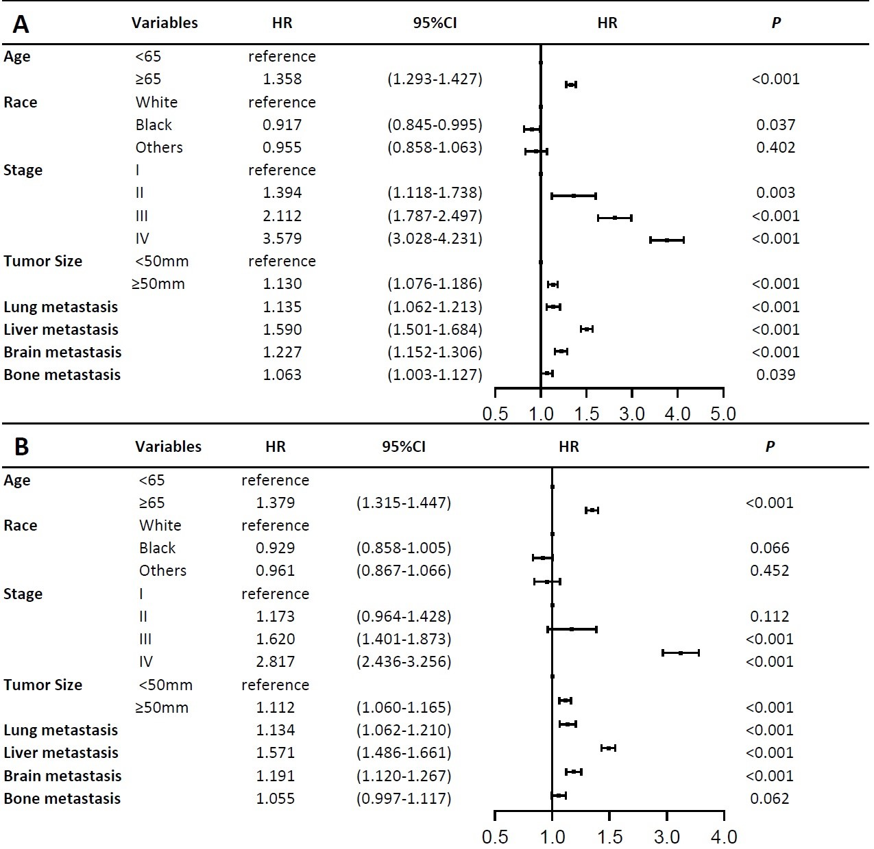

Fig. S2 The survival difference between female and male patients in First Affiliated Hospital of Xi'an Jiaotong University. (A) The percent of female and male patients; (B) the percent of smokers and non-smokers for females and males; (C) the OS difference between females and males; (D) the OS difference between females and males for non-smokers. OS, overall survival.
