Structural and Reactivity Effects of Secondary Metal Doping into Iron-Nitrogen-Carbon Catalysts for Oxygen Electroreduction

Fang Luo¹, Aaron Roy², Moulay Tahar Sougrati², Anastassiya Khan³, David A. Cullen⁴, Xingli Wang¹, Mathias Primbs¹, Andrea Zitolo^{3*}, Frédéric Jaouen^{2*} and Peter Strasser^{1*}

¹Department of Chemistry, The Electrochemical Catalysis, Catalysis and Materials Science Laboratory, Chemical Engineering Division, Technical University Berlin, Straße des 17. Juni 124, 10623 Berlin, Germany
² ICGM, Univ. Montpellier, CNRS, ENSCM, Montpellier, France
³Synchrotron SOLEIL, L’orme des Merisiers, BP 48 Saint Aubin, 91192 Gif-sur-Yvette, France.
⁴Center for Nanophase Materials Sciences, Oak Ridge National Laboratory, Oak Ridge, TN 37831, USA.

*To whom correspondence should be addressed:
*e-mail: pstrasser@tu-berlin.de; frederic.jaouen@umontpellier.fr; andrea.zitolo@synchrotron-soleil.fr

Methods

Catalyst synthesis

FeCoNC and FeSnNC bimetallic catalysts
2 mL Aniline (Sigma-Aldrich) was first dissolved in 500 mL of 0.5 M HCl solution. Thereafter, metal precursors (6 g FeCl₃•6H₂O and 2.5 g SnCl₂ •2H₂O for preparing FeSnNC, or 6 g FeCl₃•6H₂O and 0.317 g CoCl₂•6H₂O for preparing FeCoNC) were added into the solution and the solution was stirred for 15 min. This corresponds to molar ratios Fe/Sn and Fe/Co of 2 and 20, respectively. The lower cobalt amount was chosen based on our previous experience that it is difficult to acid wash excess cobalt in CoNC materials prepared similarly. After homogenization, 5 g ammonium peroxydisulfate (APS, (NH₄)₂S₂O₈, Sigma-Aldrich) was dissolved in the solution, to act as an oxidant to form polyaniline, followed by adding 0.4 g of the pretreated carbon. The carbon (Ketjen EC 600JC) was previously pretreated with a mixed acid solution consisting of 500 mL of 0.5 M HCl and 100 mL of 67% HNO₃ for 7-8 h at 80-90°C, in order to remove metal residues possibly present. The pre-treatment also functionalizes the carbon with N- and O-groups, favoring interaction with polyaniline.¹⁻² The polymer/carbon/metal suspension was stirred for 1 hour at room temperature, refluxed afterwards for 5 h at 80-90°C and then dried at 80 °C overnight with an oil bath. The subsequent dried powder was ball milled for 20 min, pouring the powder inside a ZrO₂ vial along with 10 ZrO₂ beads of 5 mm diameter, at a rotation of 875 rpm. The milled powder was then pyrolyzed at 900 °C for 1 h in N₂. The quartz tube was purged with N₂ for 2 h before ramping the temperature at 5 °C/min up to 900 °C. The oven temperature was held at 900°C for 1 h under N₂ flow, then let to cool down overnight under N₂ flow. The powder was then twice acid leached (for 7-8 h each, at 80-90°C in 4.0 M HCl solution for FeSnNC and 1.0 M H₂SO₄ solution for FeCoNC) and the powder was pyrolyzed again after each acid washing, with the same pyrolysis protocol as described above, except that the pyrolysis duration was increased to 3 h.
FeNC and SnNC parent materials
FeNC: The synthesis was identical as for FeCoNC except that no cobalt salt was aded, 6.05 g FeCl₃⋅6H₂O was added into the aniline solution at the initial stage.
SnNC: 2 mL aniline (Sigma-Aldrich) was first dissolved in 500 mL 0.5 M HCl solution. Thereafter, 5 g ammonium peroxydisulfate (APS, (NH₄)₂S₂O₈, Sigma-Aldrich) was added to the solution for in situ polymerization of aniline while the mixture was kept at room temperature. The polymer suspension was kept at low temperature as long as no color change was observed. 0.4 g of the pretreated carbon (Ketjen EC 600JC) was mixed with de-ionized water for 30 min, and then it was added with PANI and stirred for 48 h to achieve a uniform suspension. Carbon supported PANI was refluxed for 5 hours at 80-90°C and then dried at 80 °C overnight by using an oil bath. Then Tin(II) chloride dehydrate (2.5 g SnCl₂·2H₂O, Sigma-Aldrich) was added to the dried carbon-supported PANI powder, and ball milling was performed for half an hour. The remainder of the synthesis was identical to the one for FeSnNC.
CoNC model material with atomically dispersed Co-N_{x} sites
A mass of 0.8 g of a Zn(II) zeolitic imidazolate framework (ZIF-8, Sigma Aldrich) and 0.2 g of 1,10-phenanthroline were weighed, poured into a ZrO₂ crucible, followed by adding cobalt(II) acetate, with the mass of cobalt acetate corresponding to 0.5 wt.% of cobalt to the total mass of ZIF-8, phenanthroline and cobalt acetate. Then, one-hundred zirconium-oxide balls of 5 mm diameter were added and the ZrO₂ crucible was sealed under air. The precursors were homogenized in a planetary ball-miller (Fritsch Pulverisette 7 Premium, Fritsch, Idar-Oberstein, Germany) with 4 cycles of 30 min at 400 rpm. The resulting catalyst precursor was flash-pyrolyzed at 1050 °C in Ar flow for 1 h. The pyrolysis was stopped by opening the split hinge oven, removing the quartz tube and letting cool down the catalyst under Ar flow.
NH₃ activation
For some of the PEMFC tests, FeSnNC and FeCoNC were further activated in ammonia by loading 100–200 mg of pristine catalyst into a tubular furnace. The flow rate of anhydrous NH₃ was maintained at ~200 sccm for 2 hours while the furnace was allowed to equilibrate at the temperature of 750 °C, with the catalyst powder outside of the heating zone. The temperature of of 750 °C for the NH₃ treatment was optimized previously for the FeNC catalyst.³ Once the oven had equilibrated at the set temperature (i.e. 2 h of equilibration once the temperature indicator reached the set temperature), the catalyst powder was inserted in ca 30 s in the heating zone with an outer magnet, by pushing a quartz rod/magnet assembly, previously installed inside the quartz tube. The NH₃ activation was carried out for 5 min, and the split hinge furnace was then opened and quartz tube removed to quench the temperature and stop the NH₃ activation. The catalysts after ammonia activation are labelled by adding ‘-NH₃’ to the previous label, e.g. FeSnNC-NH₃.

Ex situ physico-chemical characterization

Elemental Analysis was performed with a Thermo Electron, Flash EA 1112 analyzer. N₂-physisorption measurements were performed on an Autosorb-1-C from Quantachrome Company. The tubes were filled with catalyst powder and degassed by heating for 24 h at 60 °C under vacuum. Subsequently, the sample was cooled down with liquid nitrogen and the N₂ adsorption and desorption isotherms recorded. The BET-specific surface area and pore size distribution were then calculated with the Quantachrome software (DFT model). Bulk metal contents were measured with ICP-OES on a Varian 715-ES. A known amount of sample was digested in a mixture of 2 mL sulfuric (98 wt%), 2 mL nitric (69 wt%), and 6 mL chlorhydric (37 wt.%) acid in a Microwave (CEM SP-D Discover) until the solution became transparent. Cu Kα XRD was recorded by a D8 Advanced X-ray diffractometer from Bruker AXS (tube settings fixed at 40 kV and 40 mA), equipped with a position sensitive LynxEye detector (PSD). The samples were analyzed using a micro focused, monochromated Al K_{α} X-ray source (1486.68 eV; 400 μm spot size). The K-Alpha+ charge compensation system was employed during analysis to prevent any localized charge buildup. The spectra were analyzed using the Avantage software from Thermo Scientific. For each sample, a survey and high-resolution C_{1s}, O_{1s}, N_{1s}, and Fe_{2p} regions were measured. The C_{1s} signal of graphitic-like carbon was used for binding energy calibration and assigned to 285.0 eV. The Casa XPS software with pseudo-Voight Gaussian-Lorentzian product functions and Shirley background was used for peak deconvolution. Elemental concentrations were calculated from XPS intensities corrected by the corresponding sensitivity factors provided by the manufacturing company (SPECS). TEM on FeSnNC and FeCoNC was performed using a FEI Tecnai G2 20 S-TWIN with LaB₆-cathode, 200 kV accelerating voltage and a resolution limit of 0.24 nm. The samples were dispersed on a 200 mesh copper grid. Atomic-resolution images of atomically-dispersed Sn sites, Fe sites, and Co sites in FeSnNC and FeCoNC were captured by aberration-corrected scanning transmission electron microscopy (STEM) using a Nion UltraSTEM 100 operated at 60 kV and equipped with a Gatan Enfina electron energy loss spectrometer. Aberration-corrected STEM images were acquired using both bright field (BF) and annular dark-field (ADF) detectors at Oak Ridge National Laboratory. ⁵⁷Fe Mössbauer spectroscopy measurements were acquired on FeSnNC and FeCoNC in transmission mode, both at room temperature and at 5 K. A CMCA-550 (Wissel) equipped with a constant electronic drive system, triangular reference wave form (Halder Electronics) and 0.8 GBq ⁵⁷Co/Rh source was used. The velocity scale and isomer shift δ_{iso} were calibrated with an α-Fe foil (25 μm thick, 99.99 % purity). ¹¹⁹Sn Mössbauer spectrum of FeSnNC was recorded in transmission at room temperature. The 0.2 GBq Ca^{119m}SnO₃ source and the absorber were both kept at 300 K. The spectra were fitted to appropriate combinations of Lorentzian profiles by least-squares method using the program Fulham (by R. P. Hermann). XAS measurements were carried out at room temperature in transmission geometry at the SAMBA beamline (Synchrotron SOLEIL). The energy was monochromatized by means of a sagittally bent Si 220 double crystal monochromator, and two Pd-coated collimating/focusing mirrors were used to remove X-ray harmonics. The catalysts were pelletized as disks of 10 mm diameter using boron nitride as a binder. The EXAFS data analysis was performed with the GNXAS code⁴⁻⁵. The EXAFS χ(k) signal is decomposed into a summation over n-body distribution functions γ^{(n)} calculated by means of the multiple-scattering (MS) theory, and depending on four parameters, namely, the coordination number N, the average distance R, the mean-square variation σ², and the skewness β. Each signal was calculated in the Muffin-tin (MT) approximation using the Hedin-Lundqvist (HL) energy dependent exchange and correlation potential model, which includes inelastic loss effects. The FeNC and SnNC theoretical spectra were modelled including the first shell Fe/Sn-N(C) and Sn-O γ⁽²⁾ two body signals, and Fe/Sn-C and Sn-Sn γ⁽²⁾ two body signals. The γ⁽³⁾ signal associated with the N(C)-Fe/Sn-N(C) three-body distributions were also included. Least-square fits of the EXAFS raw experimental data was performed by minimizing a residual function of the type:
$R_{i }\left(\left\{λ\right\}\right)= \sum_{i=1}^{N}{\frac{[α_{\exp\left(E_{i}\right) }{- α}_{mod}\left(E_{i} ; λ_{1}, λ_{2},…, λ_{p}\right)]^{2} }{σ_{i}^{2}}}$ (1)
where N is the number of experimental points, $Ei\left\{λ\right\}=\left(λ1, λ2,…, λp\right)$ are the p parameters to be refined and σ_{i}² is the variance associated with each experimental point α_{exp}(E_{i}). Additional non-structural parameters were minimized, namely E₀ (core ionization threshold energy) and the many body amplitude reduction factor S₀².

CO Pulse Chemisorption

CO pulse chemisorption experiments were performed using a Thermo Scientific TPD/R/O 1110 instrument (setup illustrated in Figure S1 of Ref⁶) under a 20 ml min⁻¹ flow of helium as carrier gas. 100-150 mg of catalyst was filled in a U-shaped quartz reactor and underwent the following three-step analysis. (i) a cleaning treatment involving heating the sample to 600 °C with a ramp rate of 10 °C min⁻¹ under 20 sccm flow of 5 N helium, followed by a hold of 15 min at 600 °C and then by subsequent convective cooling back to room temperature. (ii) cooling of the cleaned catalyst to -80 °C, using a mixture of dry ice and acetone, followed by six consecutives 0.338 mL CO pulses, dosed at 25 min intervals, which were passed through the catalyst samples. The amount of CO retained in the catalyst was quantified using a TCD detector. (iii) a temperature-programmed CO desorption (TPD) was performed by ramping the temperature from -80 °C up to 600 °C with a ramp rate of 10 °C min⁻¹ under 20 sccm flow of 5 N helium. The CO uptake was then normalized to the analyzed mass of the catalyst (n_{CO}, in mol_{CO} g⁻¹), and the site density per mass of catalyst (SD) was then obtained from n_{CO} from the following equation:
$SD\left[sites g^{-1}\right]=n_{CO}\left[mol g^{-1}\right]×N_{A}$ (2)
Where N_{A} is Avogadro’s number.
Operando XAS measurements

Operando XAS measurements were performed in a three-electrode liquid cell from Zahner⁷ in N₂-saturated 0.1 M H₂SO₄ electrolyte. The working electrode was a graphite foil (Goodfellow cat. C 000200/2), and the catalysts were drop-casted as inks, prepared by mixing 10 mg catalyst with 50 μL de-ionized water and 100 μL of 5 wt% Nafion solution with ultrasounds. An Ag/AgCl (saturated KCl) reference electrode and a Pt counter electrode were used. Operando measurements were performed by recording the metal K_{α} X-ray fluorescence with a Canberra 35-pixel Ge detector.

Electrochemical Measurements

ORR activity and selectivity measurements with a RRDE setup

Rotation-Ring disk electrode (RRDE) measurements were performed to determine the ORR activity and selectivity of MNC catalysts in acidic liquid electrolyte. 15.7 mg catalyst powder, 750 µl de-ionized water, 190 µl ethanol and 60 µl Nafion (5 wt% solution in alcohol) were sonicated for 15 min in order to prepare inks. The aliquot of the ink necessary to reach a catalyst loading of 800 µg·cm⁻² was pipetted on the glassy carbon disk (0.2475 cm²). A carbon rod and a reversible hydrogen electrode (RHE) were used as counter and reference electrodes, respectively. An O₂-saturated 0.1 M HClO₄ aqueous solution was used as electrolyte. The disk potential was scanned between 0 and 1.1 V vs. RHE at 5 mV·s⁻¹ while the ring potential was fixed at 1.2 V vs RHE. The collection efficiency of the RRDE electrode used was 0.37 ± 0.01. For accelerated stress test (AST) up to 9,000 rectangular-wave potential cycle between 0.6 to 1.0 V vs RHE were performed in N₂-saturated electrolyte with 30 seconds holding at the initial potential of 0.6 V vs RHE. 6-second was selected as a cycle period with recording potential at 0.6 V vs RHE for 3 seconds as well as at 1.0 V vs RHE for another 3 seconds. All ORR activity and stability tests were performed at room temperature in 0.1M HClO₄ (pH 1). The scan voltammetry RRDE data were first corrected for capacitive currents, followed by iR correction of the uncompensated electrolyte resistance.
The kinetic current density (j_{k}), mass activity (j_{m}), Tafel slope (mV decade⁻¹) and hydrogen peroxide yield were obtained from RRDE measurements based on the following equations:
- Kinetic current density (j_{k}): j_{k} was deduced from the total Faradaic current density, j, and the diffusion-limited Faradaic current density, j_{d}, with the Koutecky-Levich equation:
$\frac{1}{j_{k}}=\frac{1}{j}-\frac{1}{j_{d}}$ (3)
Where the diffusion limiting current density $j_{d}$ was chosen at potential 0.2 V vs. RHE

- Mass activity (j_{m}): j_{m} was derived from j_{k} vas following:
$j_{m}=\frac{j_{k}}{m_{catalyst}}$ (4)
Where $m_{catalyst}$ is the total catalyst loading on the glassy carbon disc (0.8 mg cm⁻²). The mass activity is reported at 0.8 V vs. RHE for comparing SnNC, FeNC and CoNC, while the potential of 0.7 V vs. RHE is used for comparing all MNC catalysts.

- Hydrogen peroxide yield (%): The % H₂O₂ was calculated from the ring and disk current with the following equation:
$H_{2}O_{2}\%=200×\frac{{I_{R}}/N}{\left(I_{D}+ {I_{R}}/N\right)}$ (5)
Where $I_{R}$ is the ring current (mA), $I_{D}$ is the disk current (mA), and $N$ is the collection efficiency.

TOF calculation

The TOF was calculated at 0.8 V vs. RHE, from the mass normalized activity measured at 0.8 V in RRDE setup (j_{m}) and from the SD_{mass} derived from CO chemisorption measurements, according to the following equation:

$j_{m}\left[A g_{catalyst}^{-1}\right]=TOF\left[electrons {site}^{-1} s^{-1}\right]×{SD}_{mass}\left[sites g_{catalyst}^{-1}\right]×e\left[C {electron}^{-1}\right]$ (6)

where TOF is the turnover frequency from RRDE experiments, ${SD}_{mass}$ is the mass-normalized site density, $e$ is the electric charge of one electron.

The TOF_{(PEMFC)} was calculated at 0.8 V iR-corrected cell voltage, from the mass-normalized current density measured at 0.8 V iR-corrected cell voltage in single-cell PEMFC setup (i_{m}) and from the SD_{mass} derived from CO chemisorption measurements, according to the following equation:

$i_{m}\left[A g_{catalyst}^{-1}\right]=TOF(PEMFC)\left[electrons {site}^{-1} s^{-1}\right]×{SD}_{mass}\left[sites g_{catalyst}^{-1}\right]×e\left[C {electron}^{-1}\right]$ (7)

where TOF(PEMFC) is the turnover frequency from single-cell PEMFC experiments, ${SD}_{mass}$ is the mass-normalized site density, $e$ is the electric charge of one electron.

Activity and performance measurements in single-cell PEMFC

For MEA preparation, cathode catalysts inks were prepared by sonicating for 1 hour 20 mg of MNC catalyst, 0.652 mL of 5 wt. % Nafion solution (Nafion dispersed in lower aliphatic alcohols and 15 wt. % water), 0.327 mL of 1-propanol, and 0.272 mL deionized water (18 MΩ). The ink was drop cast in three stages onto a 4.8 cm² Sigracet S10-BC gas diffusion layer placed on a heating plate, with the total ink volume chosen so as to result in a theoretical loading of 4 mg _{MNC} cm⁻². The cathode drying was then completed at 70 °C for 1 hour. The dried cathode was hot pressed onto a Nafion 211 membrane, using as anode a Sigracet S28-BC electrode containing 0.5 mg_{Pt} cm⁻². The hot-pressing conditions were a pressure of 2 tons and a temperature of 135 °C for 2 minutes.

PEMFC measurements were then performed using an in-house fuel cell test bench while the cell was controlled with a potentiostat (Biologic) and EC-Lab software. MEAs were then installed in a single-cell hardware (Fuel Cell Technologies Inc.) with serpentine flow fields, graphite bipolar plates and gold-plated current collectors. PTFE gaskets of 200 µm thickness were used at the cathode and anode, giving a compression ratio for the GDL of ca 30 % after assembly. PEMFC measurements were performed using an in-house fuel cell test bench while the cell was controlled with a potentiostat (Biologic) and EC-Lab software. The cell temperature was 80 °C, gases were pre-humidified at 100 % RH before entering the cell. Pure O₂ and H₂ were supplied to the cathode and anode at 200 sccm. The absolute gas pressure was 2 bars, both at anode and cathode side. Polarization curves were recorded using linear sweep voltammetry at 1 mV s⁻¹.

Supplementary Notes

Supplementary Note 1

The metals’ bulk contents were measured with inductively coupled plasma (Supplementary Table 1). Fe and Sn contents in FeSnNC are 3.1 and 0.14 wt %, respectively. This corresponds to a mass ratio Fe/Sn of ca 22, much lower than the mass ratio of ca 1 in the catalyst precursor before pyrolysis. This shows the preferential removal of Sn species during the acid wash of FeSnNC, which suggests that easily leachable Sn (Sn-Fe) metallic particles formed during the first pyrolysis. For FeCoNC in contrast, the Fe and Co contents in FeCoNC are of the same magnitude (ca 2.4 and 1.0 wt %, respectively), despite a low relative amount of cobalt in the catalyst precursor (Fe/Co mass ratio of ca 19, see S.I. Methods). This indicates in contrast the preferential removal of Fe species during the acid wash of FeCoNC. While only a weak signal for pure Fe metallic particles is seen in the XRD pattern of FeCoNC, a high relative amount of Fe- or Fe-rich bimetallic FeCo particles may have formed during the first pyrolysis, that were subsequently leached.

Supplementary Note 2 – Discussion of the assignment of doublet D1

However, the IS and QS values of D1 are generally compatible with a low-spin Fe(II)-N₄ site, and the experimental D1 signal may thus be a convoluted signal from both HS O-Fe(III)-N₄ sites and LS Fe(II)-N₄ sites. The large shift in the operando Fe K-edge X-ray absorption near edge structure (XANES) spectra of FeSnNC (discussed in the section “Operando XANES signature of Fe-N_{x}, Sn-N_{x}, and Co-N_{x} moieties in bimetallic MNCs”, in the main text) with varying electrode potential, however, supports a redox switch from Fe(III) to Fe(II), implying that D1 in the present case is only or mainly a ferric center.

Supplementary Note 3 – Discussion of the Mossbauer fitting results of FeCoNC

A first doublet (D1) with isomer shift (IS) of 0.55 mm·s⁻¹ and quadrupole splitting (QS) of 1.44 mm·s⁻¹ is identified, accounting for 40 % of the signal (Supplementary Table 4b). As previously discussed, D1 can be assigned either to HS Fe(III)-N₄ or LS Fe(II)-N₄. The large change with electrochemical potential of the operando Fe K-edge XANES spectra for FeCoNC (shown in the section “Operando XANES signature of Fe-N_{x}, Sn-N_{x}, and Co-N_{x} moieties in bimetallic MNCs”, in the main text.) supports that D1 here is only or mainly a ferric center. A second doublet with high IS of 0.98 mm·s⁻¹ and high QS of 2.73 mm·s⁻¹ (labelled D3) is identified, accounting for 26 % of the signal (Supplementary Table 4b), that can be unambiguously assigned to a high-spin ferrous species. While D3 might be assigned to a HS Fe(II)-N₄ site, we noted recently that all literature reports on FeNC materials whose ⁵⁷Fe Mössbauer spectra comprised a doublet with IS and QS values matching those of D3 had either been prepared from iron chloride precursors or acid-washed with HCl after the pyrolysis.⁸ The present FeCoNC material was prepared from FeCl₃ and aniline polymerization carried out in HCl, strongly suggesting that the present D3 is not a HS Fe(II)-N₄ site, but instead clusters of FeCl₂·4H₂O, a compound with IS and QS values matching those of D3 (see Note 3 in the S.I. of Ref⁸). It is also important to note that the ⁵⁷Fe Mössbauer spectrum of FeCoNC does not contain the component usually labelled as “D2” in the literature, Thus, one can conclude that the addition of Co suppressed one of the two main types of FeN₄ sites, compared to FeNC. The relative amounts of D1 are comparable in FeNC and FeCoNC (representing ca 40 % of the absorption signal). The ⁵⁷Fe Mössbauer spectrum of FeCoNC also comprises a sextet with IS and hyperfine field (H) matching those of α-Fe or α-FeCo alloy⁹, accounting for ~5 % of the signal as well as a singlet component, assigned to γ-Fe, accounting for 1.5 % of the signal (Supplementary Table 4b). The presence of α-Fe or α-FeCo and γ-Fe is in line with XRD results. In contrast, α-Fe and γ-Fe were not identified in the parent FeNC material prepared similarly as FeCoNC (Figure S2 in Ref³). Thus, the Mössbauer results reveal the promotion of Fe clustering after the addition of cobalt. Last, a second and broad sextet (sextet 2) was necessary to fit the broad spectrum recorded at 5 K (Supplementary Table 4b). The IS-value of 0.54 mm·s⁻¹ prevents us from assigning it to zero-valent Fe species. The ⁵⁷Fe Mössbauer spectrum measured at room-temperature reveals that sextet 2 observed at 5 K resulted in a doublet signal at room temperature, with IS and QS values similar to those of D1 (Supplementary Fig. 5b and supplementary Table 4b). This demonstrates the superparamagnetic behavior of the Fe species associated with Sextet 2. Moreover, since the hyperfine field of Sextet 2 at 5 K is only 40.3 T, corresponding to the lower end of the range expected for pure ferric oxides (40-56 T), we tentatively assign it to FeCoO_{x} nanoparticles. This assignment is supported by work from Le Trong et al who showed that the magnetic properties of Co_{x}Fe_{3-x}O₄ spinels (and thus the hyperfine field that would be expected for the corresponding sextet in Mössbauer spectra) decreases with increasing content of cobalt¹⁰. In addition, it was also shown that the Curie temperature decreased with increasing content of cobalt¹¹, which would explain why FeCoO_{x} nanoparticles are not fully magnetically ordered at 5 K, explaining in turn the broad LW of Sextet 2 at 5 K (Supplementary Table S4a).
Supplementary note 4 – Discussion of XAS of FeCoNC and FeCoNC-NH₃
Spectral analysis at 0.9 V_{RHE} revealed a small negative shift in the Fe K-edge XANES threshold energy of FeCoNC compared to its parent FeNC material, indicating a slightly lower oxidation state for FeCoNC compared to FeNC (Supplementary Fig. 23a). At +0.9 V_{RHE}, the FeCoNC-NH₃ catalysts displayed an even lower oxidation state than FeCoNC (Supplementary Fig. 23a). A similar trend was evident at +0.2 V_{RHE} (Supplementary Fig. 23b), where energy shifts between FeCoNC and FeNC, however, were absent. We attribute these spectral features to the presence of low valent metal nanoparticles in FeCoNC catalysts, present in larger amounts in the NH₃-treated materials. This conclusion is supported by the increased metal-metal peak intensity in the FT-EXAFS spectrum of FeCoNC-NH₃ compared to FeCoNC (Supplementary Fig. 24). This translates into a lower mean Fe oxidation state in FeCoNC and FeCoNC-NH₃ compared to the Fe-particle free FeNC³.
Supplementary note 5
Evidence of interaction between Fe and Co during pyrolysis is given by the presence of FeCo nanoparticles in FeCoNC materials, but absence of metallic Fe particles in the parent FeNC. We note that while the FeSnNC catalyst is free of metallic nanoparticles, FeSn nanoparticles may have formed during pyrolysis, but entirely removed during acid wash. The presence of FeCo alloys in FeCoNC can also be an indication of a strong interaction between Fe and Co, leading to the total suppression of the D2 signal, while a weaker Fe-Sn interaction only results in a partial suppression of D2 in FeSnNC.

Supplementary Figures

a)
Carbon support

Supplementary Fig. 1a. TEM image of the as-received carbon support.

b)
Polyaniline

Supplementary Fig. 1b. TEM image of the polyaniline polymerized without the carbon support.

c)
Carbon support & polyaniline

Supplementary Fig. 1c. TEM image of the polyaniline polymerized in the presence of the carbon support.

d)
FeSnNC

Supplementary Fig. 1d. TEM image of the final FeSnNC catalyst.

e)
FeCoNC

Supplementary Fig. 1e. TEM image of the FeCoNC catalyst.

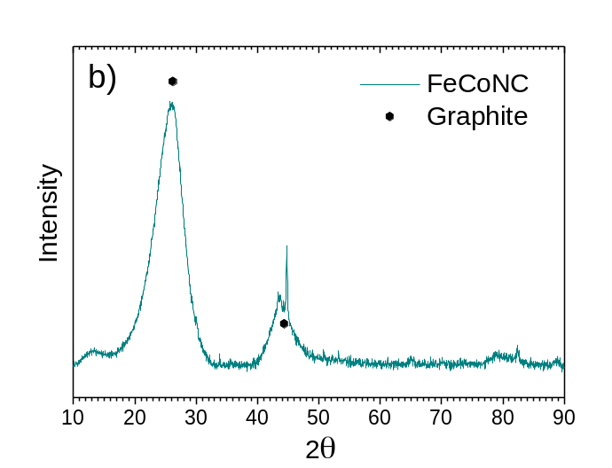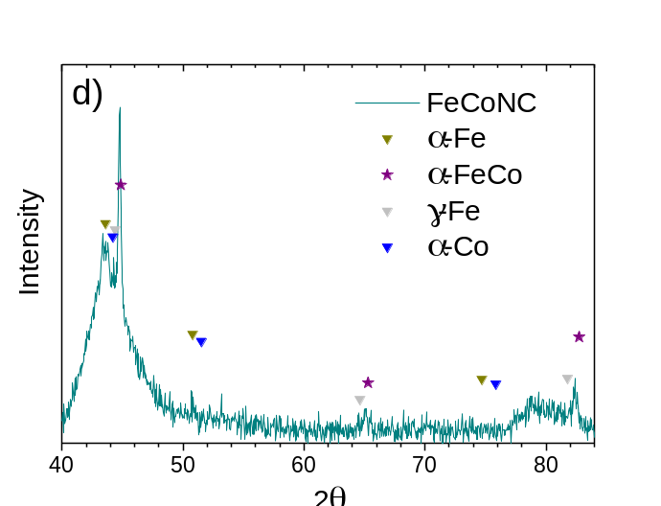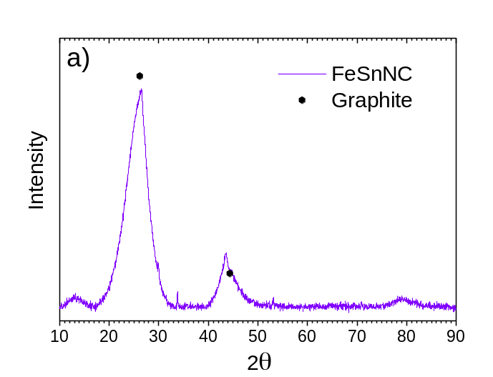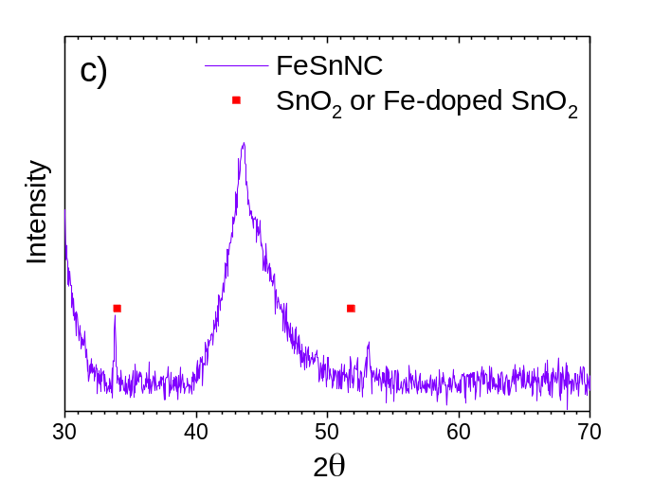

Supplementary Fig. 2. XRD patterns of a) FeSnNC and b) FeCoNC catalysts. The expected positions for the (002) and (101) reflections for graphite are indicated. c) and d) show the XRD patterns in the high-angle region for FeSnNC and FeCoNC, respectively, and the expected position and relative intensity of the main diffraction lines for SnO₂, α-Fe (JCPDS card number 96-900-8470), γ-Fe (96-901-3476), metallic Co (96-901-2950) and α-FeCo alloy (00-049-1568).

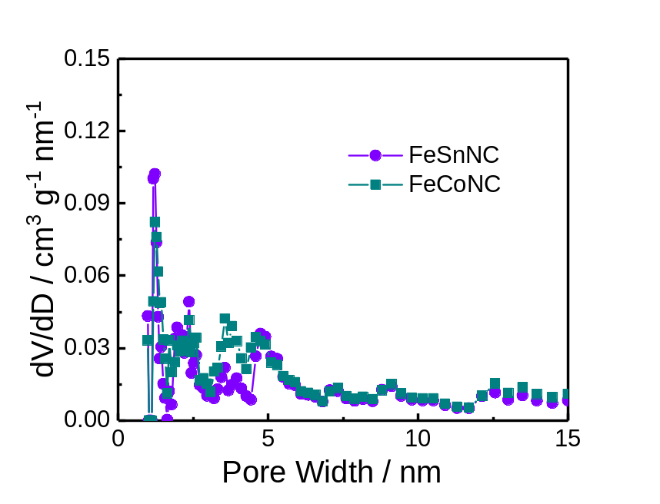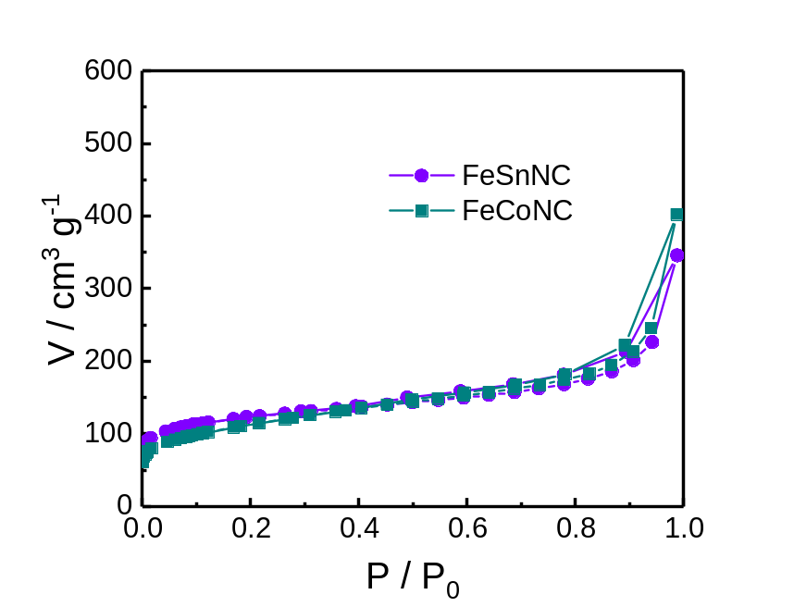
a)
b)

Supplementary Fig. 3. (a) N₂ adsorption and desorption isotherms and (b) pore size distribution of FeSnNC and FeCoNC.

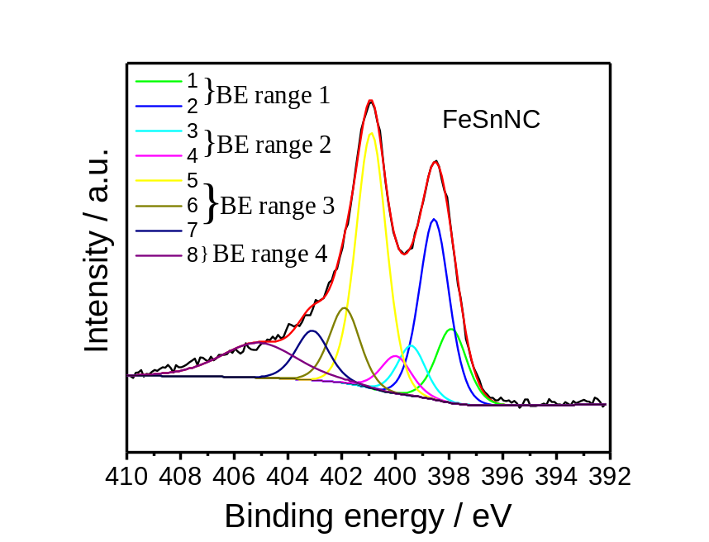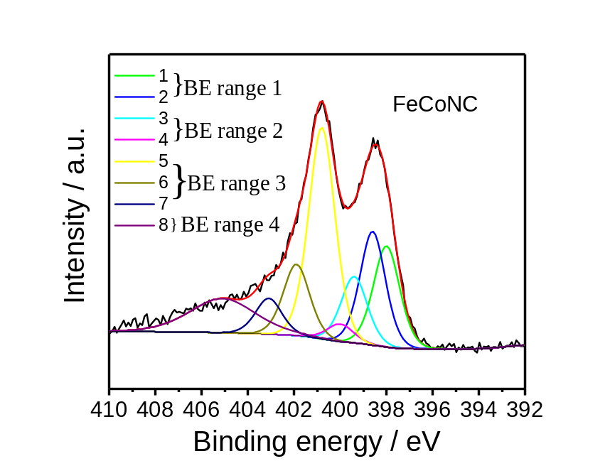
a)
b)

Supplementary Fig. 4. High-resolution XPS N 1S spectra. The narrow scans for (a) FeSnNC and (b) FeCoNC. The eight components used for the fitting were clustered into 4 BE-ranges. BE-range 1 includes Peak 1 (398.1 eV) and Peak 2 (398.7 eV) covering N atom bonded to two sp2-hybridized carbons and -C=N-C double bond motifs (e.g. imine N, pyridinic N or triazinic N). BE-range 2 includes Peak 3 (399.3 eV) and Peak 4 (399.8 eV) covering sp2 hybridized N atom in Metal-N coordination, OC-NH-C partial double bonds, or multiple graphitic N motifs in a single aromatic ring (e.g. M – Nx, amides). BE-range 3 includes Peak 5 (400.7 eV), Peak 6 (401.8 eV), and Peak 7 (403 eV) covering N atoms bonded with 1 H (in-plane hydrogenated N), isolated graphitic N, out-of-plane hydrogenated/protonated N and hydrogenated graphitic N (e.g. pyrrolic or protonated pyridinic, protonated graphitic N). BE-range 4 includes only Peak 8 (405 eV), corresponding to oxidized N (e.g. C=N-O or other oxidized N)¹²⁻¹⁸. The positions of the binding energies were chosen from previous DFT and experimental-DFT combinatorial studies on MNC and NC materials performed by Artyushkova et al ^{12-13, 18-24}.

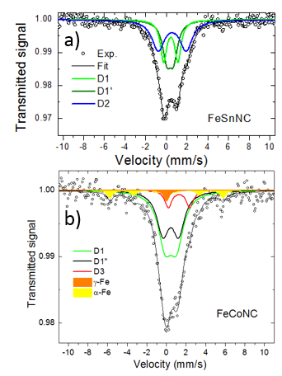
Supplementary Fig. 5. Structural characterization of iron species from ⁵⁷Fe Mössbauer spectra measured at room temperature for (a) FeSnNC, (b) FeCoNC.

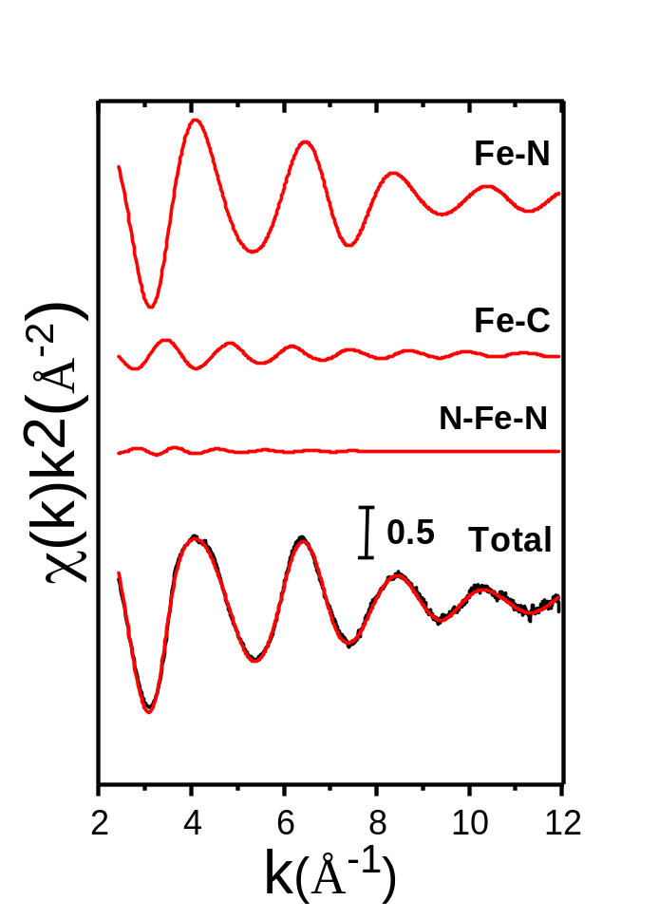

Supplementary Fig. 6. Fe K-edge EXAFS analysis of FeSnNC. Curves from top to bottom: Fe-N, and Fe-C γ⁽²⁾ two-body signals, the N-Fe-N γ⁽³⁾ three-body signal included in the fit, the total signal (red curve) superimposed to the experimental one (black curve).

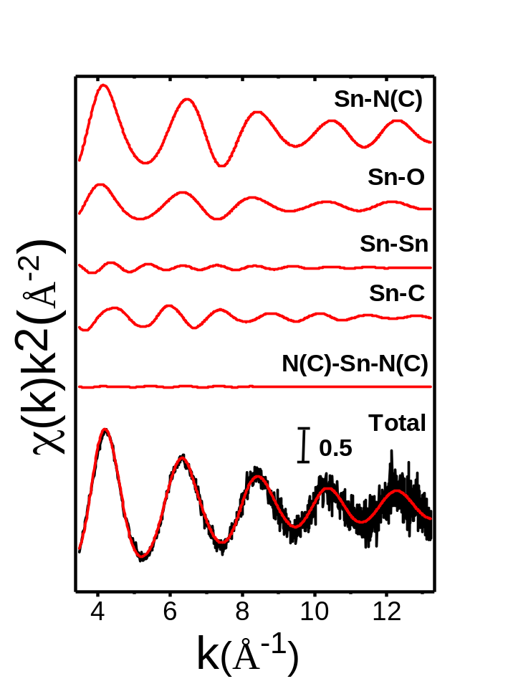
Supplementary Fig. 7. Sn K-edge EXAFS analysis of SnNC. Curves from top to bottom: Sn-N(C), Sn-O, Sn-C, Sn-Sn two-body signals, the N(C)-Sn-N(C) three body signal included in the fit, the total signal (red curve) superimposed to the experimental one (black curve).

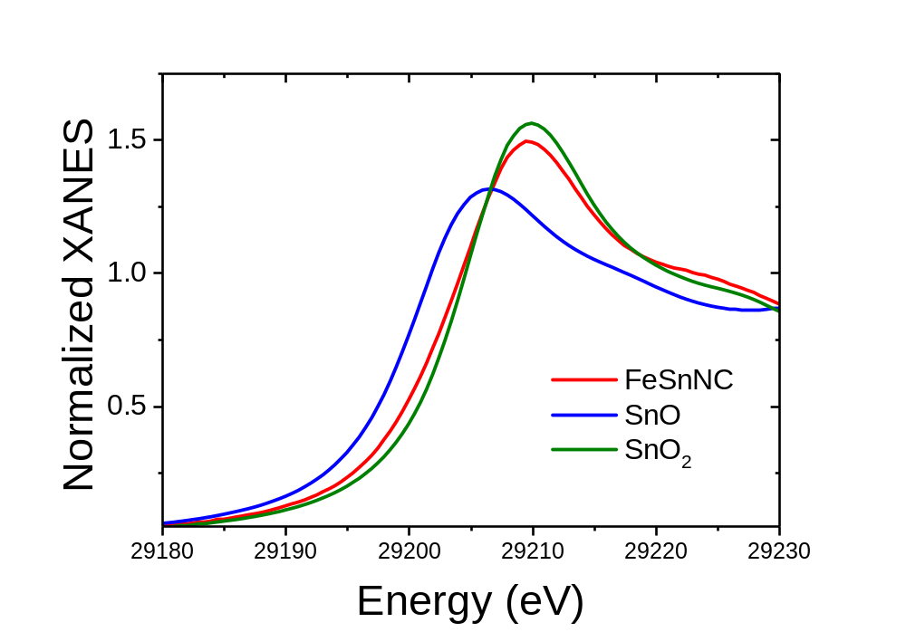
Supplementary Fig. 8. Sn K-edge XANES spectrum of FeSnNC. The measured spectrum (red curve) and its comparison to the XANES of SnO (blue curve) and SnO₂ (dark green curve).

a)
b)
c)
d)
e)
f)
g)
h)

Supplementary Fig. 9. ADF- and BF-STEM image of FeSnNC catalyst. Carbon sheets consisted of randomly oriented, intertwined, turbostratic graphitic grains/domains as shown in (a), (b), (e), (f). The bright atoms in (c), (d), (g), (h) are Fe (green arrows) and Sn atoms (red arrows) homogeneously distributed in graphitic or less-ordered carbon sheets.

a)
b)
c)
d)
e)
f)
g)
h)

Supplementary Fig. 10. ADF- and BF-STEM images of FeCoNC catalyst. Carbon sheet consisted of randomly oriented, intertwined, turbostratic graphitic grains/domains as shown in (a), (b), (e), (f), (g). The bright atoms in (c), (d), (h) are Fe and Co atoms homogeneously distributed in graphitic or less-ordered carbon sheet. It is difficult to distinguish the Co and Fe atoms based on contrast due to the similar size of their atomic nuclei (atomic number). The identity of these atoms can only be distinguished with EELS.

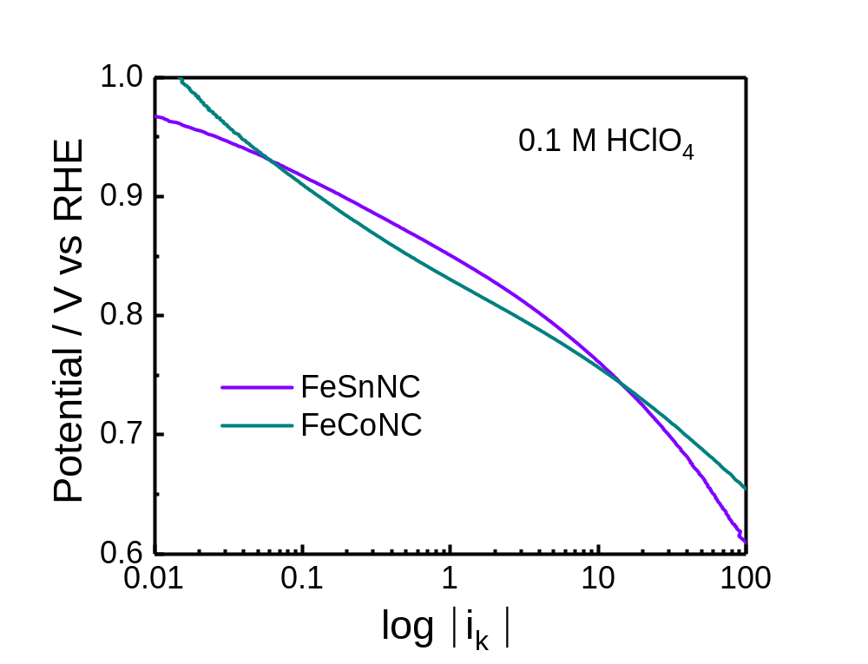
Supplementary Fig. 11. Representative Tafel plots for the bimetallic catalysts. The data is derived from RRDE experiments performed at 1600 rpm, in O₂-saturated 0.1 M HClO₄, 25 °C, with a geometric catalyst loading of 0.8 mg_{MNC} cm⁻².

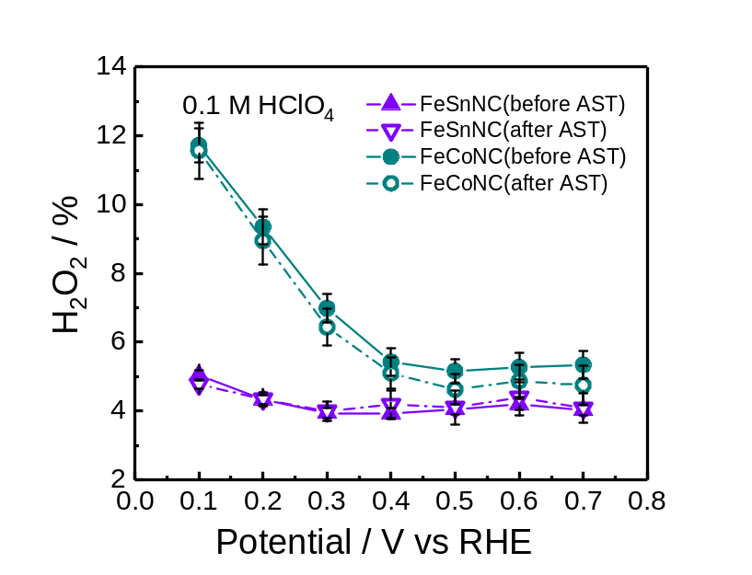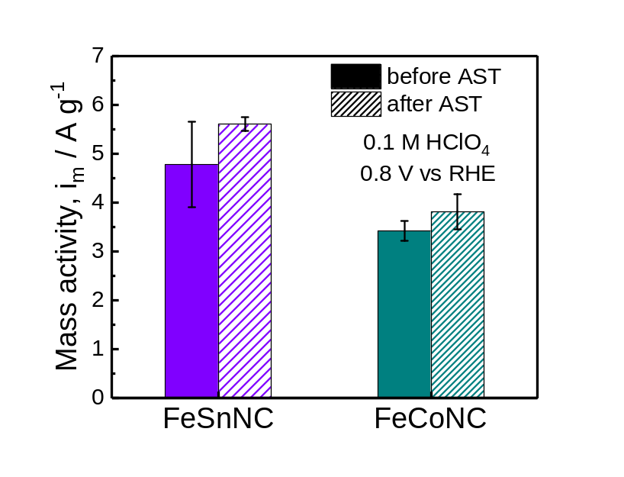
a)
b)

Supplementary Fig. 12. Activity and selectivity of Accelerated Stress Testing (AST). (a) Kinetic mass activity (A g⁻¹) at 0.8 V vs. RHE in 0.1 M HClO₄ for the ORR of FeSnNC and FeCoNC catalysts before and after AST. (b) H₂O₂ yield of FeSnNC and FeCoNC before and after AST. The AST involved 10,000 rectangular-wave potential cycles at 0.6 and 1.0 V vs. RHE in N₂-saturated 0.1 M HClO₄ with 30-second hold at each potential. For (a) and (b), error bars were calculated from multiple RRDE experiments.

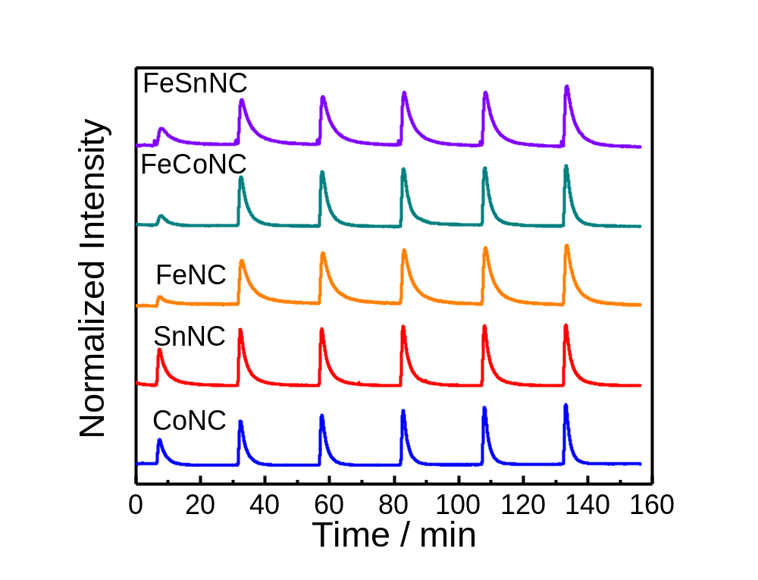
Supplementary Fig. 13. Carbon monoxide pulse chemisorption profiles. The profiles for FeNC, SnNC and CoNC were reproduced from Figure 2b in Reference.³ The quantity of CO adsorbed on a given mass of catalyst is obtained from CO pulse chemisorption, whereby a defined volume of carbon monoxide in a Helium carrier gas is passed over a catalyst via consecutive pulses. The quantification of the lower CO signal during the first pulses as compared to the signal after the saturation of the catalytic surface by CO (typically observed after six pulses) allows us to calculate the quantity of CO adsorbed by the MNC materials during the first five pulses.

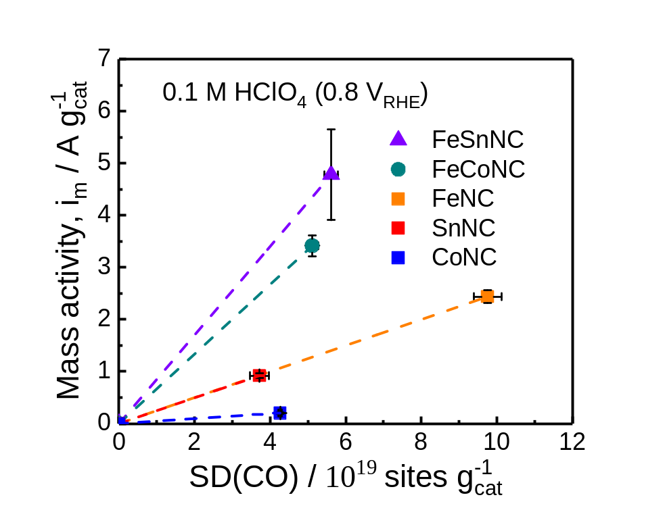
Supplementary Fig. 14. ORR mass activity at 0.8 V versus RHE as a function of the site density per gram of catalyst, measured by CO cryo-sorption, the plots for FeNC, SnNC and CoNC were reproduced from Figure 2d in Reference³.

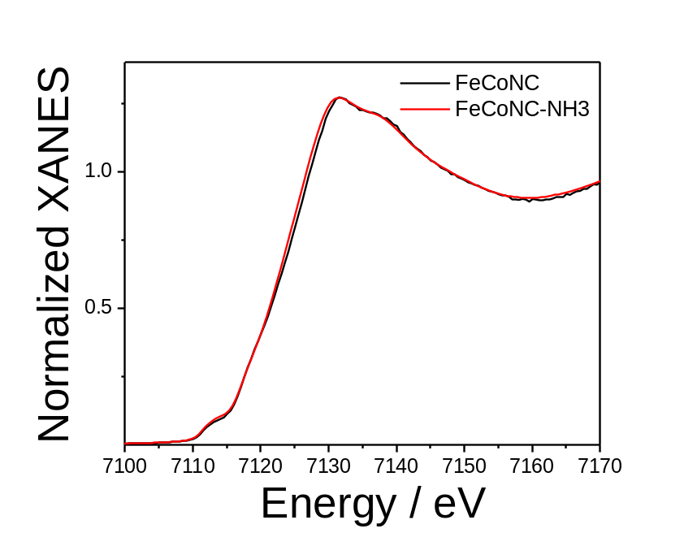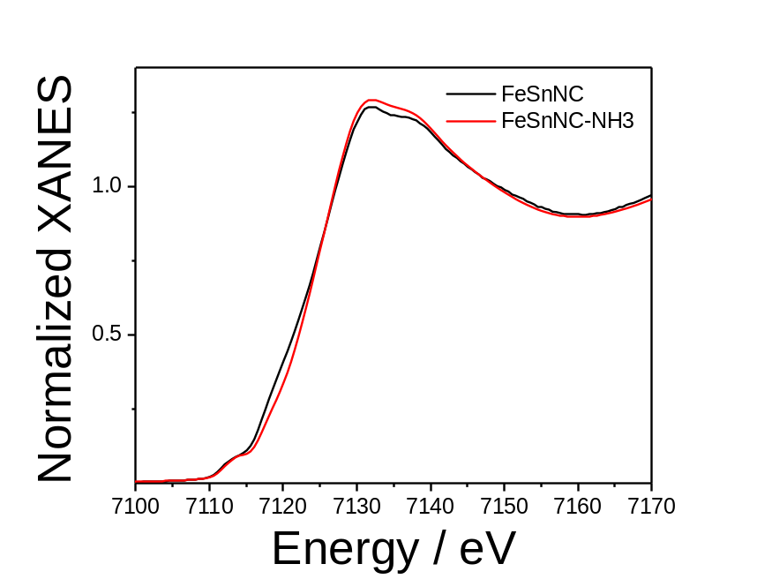
b)
a)
Supplementary Fig. 15. Comparison between the ex situ Fe K-edge XANES spectra of: (a) FeSnNC (black curve) and FeSnNC-NH₃ (red curve) , and (b) FeCoNC (black curve) and FeCoNC-NH₃ (red curve).

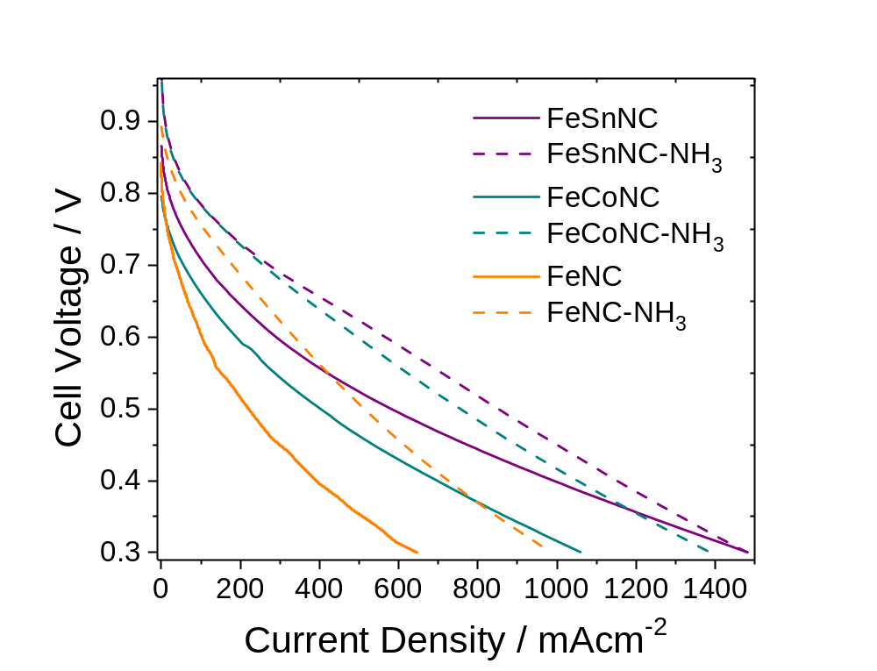

Supplementary Fig. 16. Comparison of PEMFC results for bimetallic catalysts with the FeNC catalyst prepared otherwise identically. The cathode loadings were 4 mg·cm⁻² with anode loadings of 2.0 mg_{Pt}·cm⁻². The cell was at 80°C, pure H₂ and O₂ at 100% relative humidity, at 2 bar absolute pressure. Polarization curves were acquired using linear scan voltammetry with a scan rate of 1 mV·s⁻¹. The data for FeNC and FeNC-NH₃ was reported previously by us and taken from Figure S15 in Reference³.

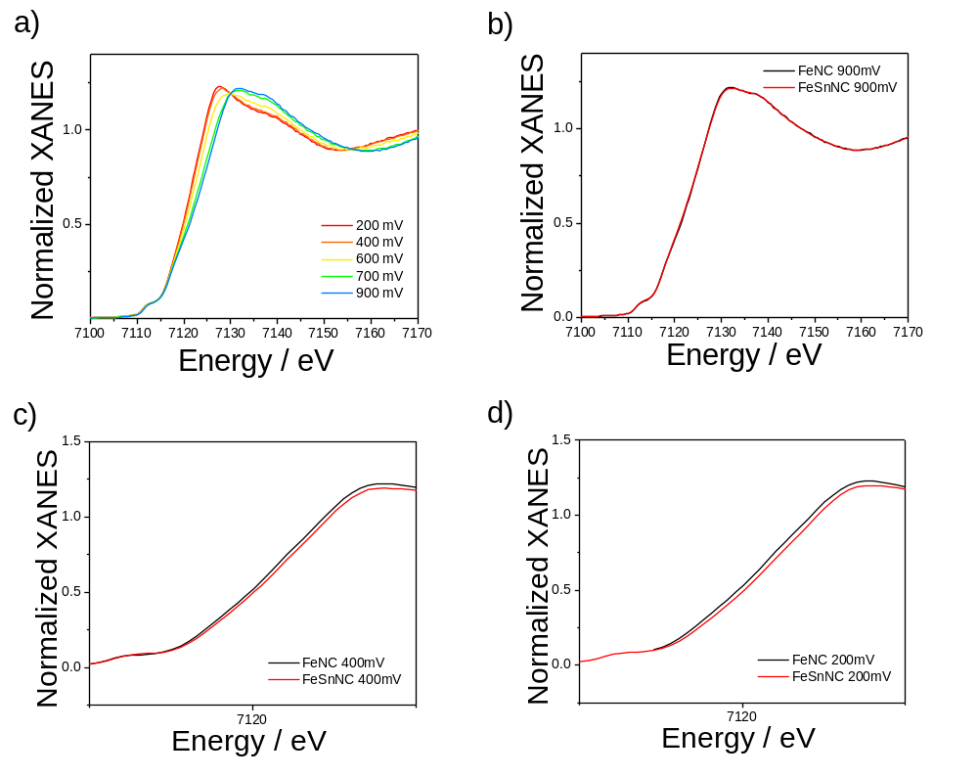

Supplementary Fig. 17. (a) Operando Fe K-edge XANES spectra of FeNC as a function of the electrochemical potential, and comparison between the Fe K-edge XANES spectra of FeNC (black curve) and FeSnNC (red curve) at (b) 900 mV vs. RHE, (c) 400 mV vs. RHE and (d) 200 mV vs. RHE. The operando analysis indicates that single iron atoms in FeSnNC are in a higher average oxidation state than those in FeNC, at all potentials.

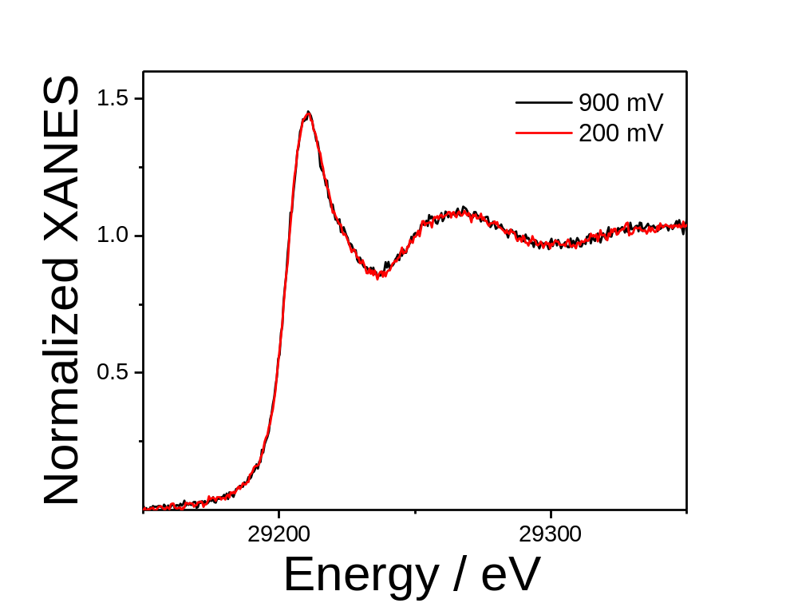
Supplementary Fig. 18. Sn K-edge XANES spectra of SnNC at 900 mV (black curve) and 200 mV (red curve).

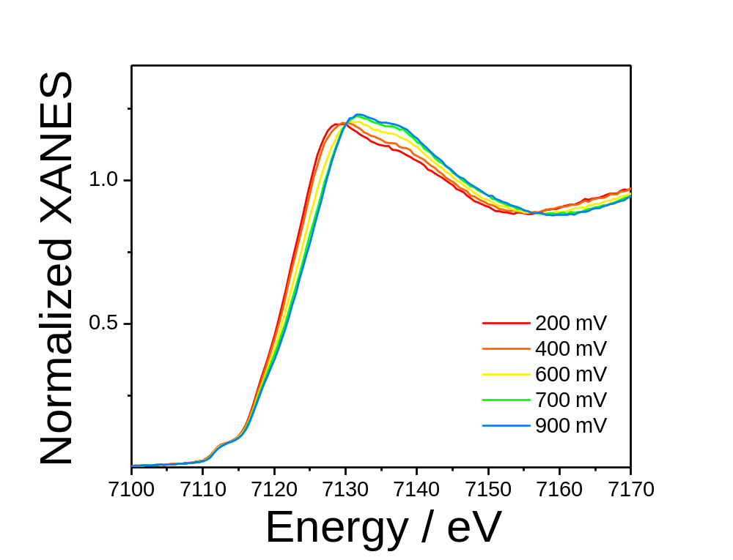
Supplementary Fig. 19. Fe K-edge XANES spectra of FeSnNC-NH₃ as a function of the electrochemical potential.

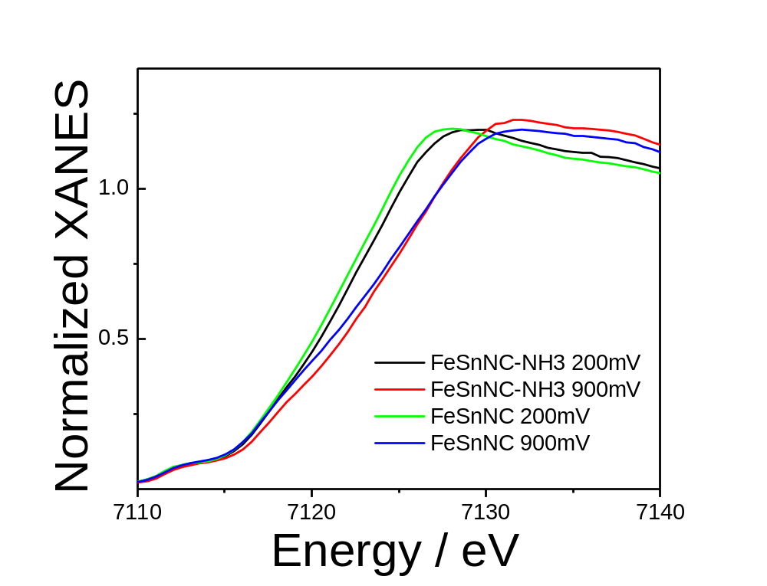

Supplementary Fig. 20. Comparison between the Fe K-edge XANES spectra of FeSnNC and FeSnNC-NH₃ at 0.2 V vs. RHE and 0.9 V vs. RHE.

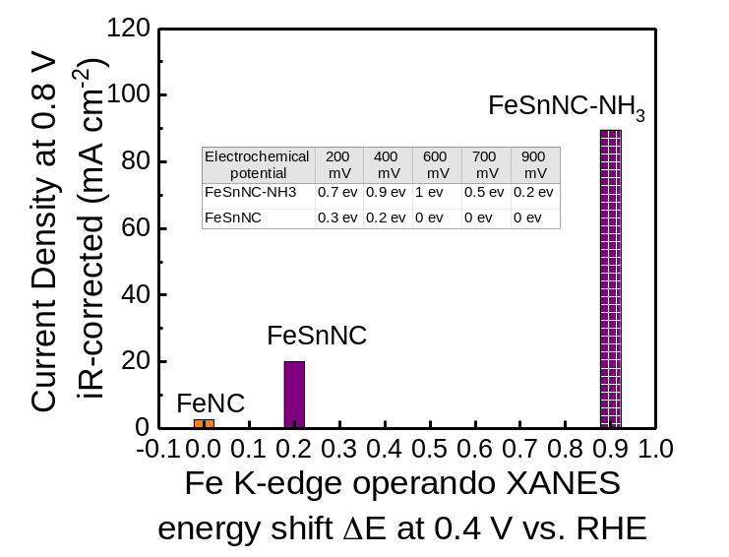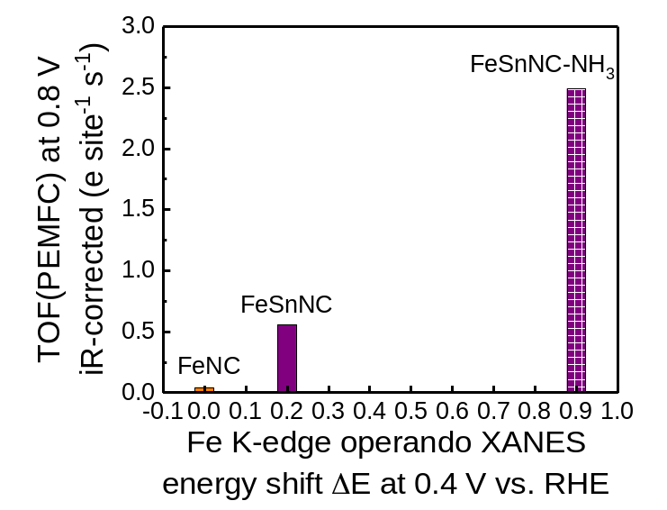
a)
b)
Supplementary Fig. 21. The correlation between (a) the ORR activity or (b) the TOF value measured in PEMFC at 0.8 V vs. the threshold energy shift $∆E$ measured at 0.4 V_{RHE} in the Fe K-edge XANES spectra. The ORR activity is represented by the current density measured in PEMFC at 0.8 V iR-corrected cell voltage, and the TOF was derived from the former value and the SD_{mass} measured by CO chemisorption (Suppl. Equation 7). The relative energy shift $∆E$ was obtained from operando Fe K-edge XANES spectra measured at 0.4 V vs. RHE;
${∆E}/{ev}={E \left[Fe K-edge threshold XANES\right]}/{ev}-{E \left[Fe k-edge threshold XANES of FeNC \right]}/{ev}$
The operando XANES data is shown in Figure 5a for FeSnNC, Supplementary Figure 19 for FeSnNC-NH₃ and previously reported in Figure 5b of Ref³ for FeNC (all measured at the same beamline). The table inside Supplementary Fig. 21a shows the $∆E$ values at other electrochemical potentials, reflecting same trends as observed at 0.4 V vs RHE, i.e. FeSnNC-NH₃ leading to a higher energy shift than FeSnNC, at all these potentials.

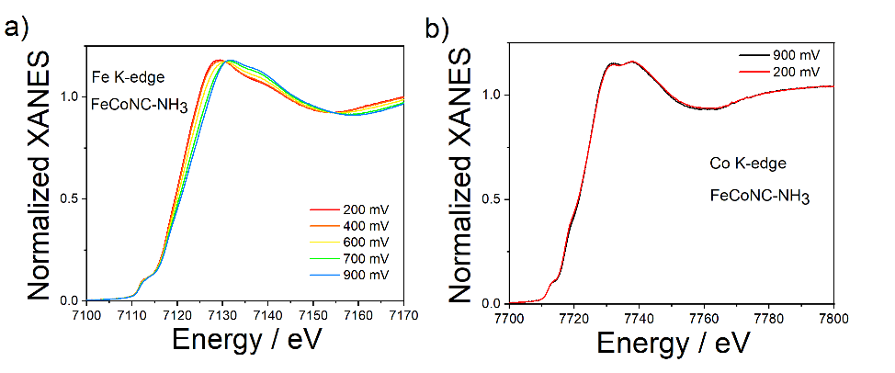
Supplementary Fig. 22. (a) Operando Fe K-edge XANES spectra of FeCoNC-NH₃ as a function of the electrochemical potential, and (b) comparison between the Co K-edge XANES spectra of FeCoNC -NH₃ at 900 mV (black curve) and 200 mV (red curve).

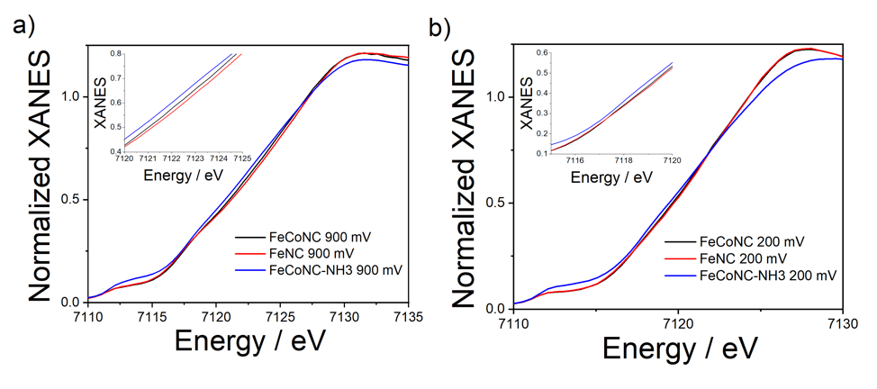
Supplementary Fig. 23. Comparison between the Fe K-edge XANES spectra of FeCoNC, FeNC, and FeCoNC-NH₃ at (a) 0.9 V vs. RHE, and (b) 0.2 V vs. RHE. The insets show a magnification of the XANES threshold.

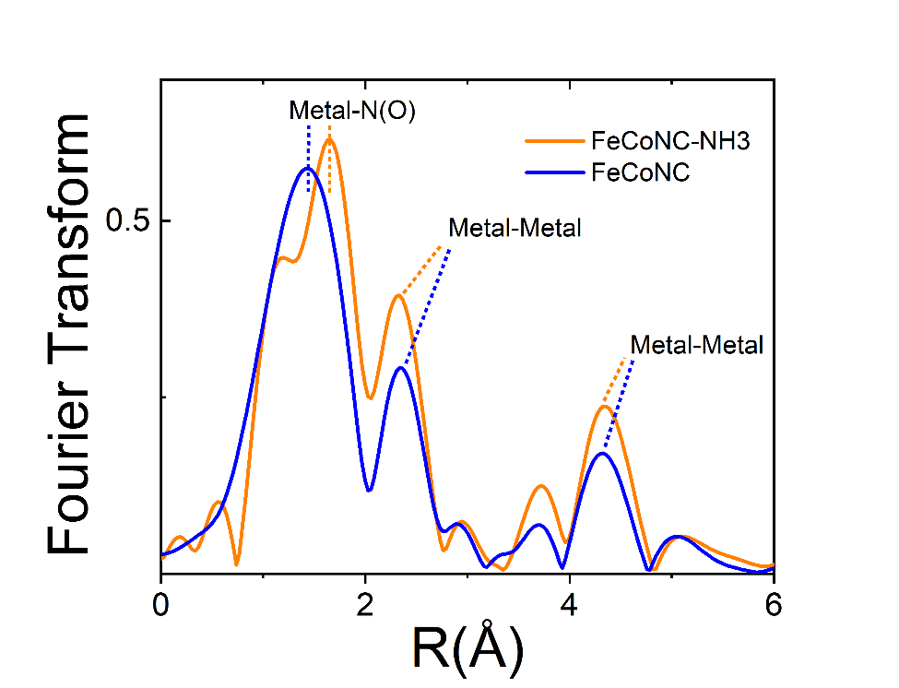
Supplementary Fig. 24. Fourier transforms of the experimental XAS spectra of FeCoNC-NH₃ and FeCoNC at the Fe K-edge.

Supplementary Tables

Supplementary Table 1. Porous structure and elemental bulk characterization of FeSnNC and FeCoNC.
 | Micro-porosity  / cm³ g⁻¹ | Meso-porosity  / cm³ g⁻¹ | Micropore Surface Area / m²g⁻¹ | BET Surface Area / m²g⁻¹ | Metal Content (ICP) / wt % | Nitrogen Content (EA) / wt % | Carbon Content (EA) / wt % | Sulfur Content (EA)/ wt%
FeSnNC | 0.13 | 0.32 | 342 | 391 | 3.11 (Fe)  0.14 (Sn) | 6.3 | 76.3 | 1.7
FeCoNC | 0.09 | 0.33 | 242 | 381 | 2.39 (Fe)  0.96 (Co) | 6.2 | 76.9 | 1.9

Supplementary Table 2. XPS-derived elemental composition of FeSnNC and FeCoNC.
 | C (at%) | N (at%) | Fe (at%) | Co or Sn (at%) | S (at%) | O (at%)
FeSnNC | 88.96 | 6.54 | 0.63 | 0.01 (Sn) | 0.84 | 3.02
FeCoNC | 88.46 | 5.45 | 0.57 | 0.29 (Co) | 0.90 | 4.33

Supplementary Table 3. The relative amount (in relative % of the total signal for N 1s) of four groups of nitrogen species in FeSnNC and FeCoNC.

 | BE- range 1  N bonded to two sp² carbons, NC double bonds, -C=N-C (e.g. imine, pyridinic N, tri-azinic N)  [398-399 eV] |  | BE- range 2  sp² N, N-Metal coordination, OC-NH-C, multiple graphitic N in a single aromatic ring  (e.g. M – N_{x}, amide)  [399 – 400 eV] |  | BE- range 3  in–plane hydrogenated N, isolated graphitic N, out-of-plane hydrogenated-N/protonated N, hydrogenated graphitic N (e.g. pyrrolic, protonated pyridinic)  [400 – 403 eV] |  |  | BE- range 4  oxidized N  (e.g. C=N-O)  [~405 eV]
BE (eV) | ~398.1 | ~398.7 | ~399.3 | ~399.8 | ~400.7 | ~401.8 | ~403 | ~405
FeSnNC | 9.2 | 21.9 | 5.7 | 4.7 | 31.6 | 9.4 | 6.3 | 10.9
FeCoNC | 14.4 | 15.7 | 9.5 | 2.5 | 30.3 | 10.2 | 5.1 | 12.2

Supplementary Table 4. Mössbauer parameters for the iron sites in FeSnNC and FeCoNC and for the tin sites in FeSnNC. The relative area (RA), isomer shift (IS), quadrupole splitting (QS), linewidth (LW) and hyperfine field (H) of each component are reported.

Supplementary Table 4a. Parameters of the spectral components obtained from the fitting of the ⁵⁷Fe Mössbauer spectrum for FeSnNC at 5 K or 300 K, and from the fitting of the ¹¹⁹Sn Mössbauer spectrum for FeSnNC at 300 K. The ⁵⁷Fe spectrum was measured at 5 K or 300 K, and IS values are referred to α-Fe at room temperature. The ¹¹⁹Sn spectrum was measured at 300 K, and IS values are referred to BaSnO₃, with absorber and source at 300 K.
 | Comp. | RA  % | IS  mm·s⁻¹ | QS  mm·s⁻¹ | LW  mm·s⁻¹ | H  Tesla | Assignment
⁵⁷Fe  (5 K) | D1 | 37 | 0.53 | 1.26 | 1.40 | - | HS O-Fe³⁺N₄ or LS Fe²⁺-N₄
⁵⁷Fe  (5 K) | D2 | 14 | 0.66 | 3.01 | 1.46 | - | LS or MS Fe²⁺-N₄
⁵⁷Fe  (5 K) | Sextet 1 | 40 | 0.66 | - | 5.80 | 40.2 | Fe(III) (hydr)oxide
⁵⁷Fe  (5 K) | Sextet 2 | 9 | 0.52 | - | 1.33 | 45.5 | Fe(III) (hydr)oxide
⁵⁷Fe  (300 K) | D1 | 28 | 0.43 | 1.39 | 0.74 | - | HS O-Fe³⁺N₄ or LS Fe²⁺-N₄
⁵⁷Fe  (300 K) | D2 | 40 | 0.56 | 2.70 | 1.44 | - | LS or MS Fe²⁺-N₄
⁵⁷Fe  (300 K) | D1’ | 32 | 0.36 | 0.65 | 0.97 | - | Superparam. ferric oxide
¹¹⁹Sn  (300 K) | D1 | 27 | 0.34 | 1.32 | 1.09 | - | Sn(IV)-a
¹¹⁹Sn  (300 K) | Singlet | 56 | 0.14 | - | 1.30 | - | Sn(IV)-b
¹¹⁹Sn  (300 K) | D2 | 17 | 3.01 | 2.41 | 1.23 | - | Sn(II)

Supplementary Table 4b. Parameters of the spectral components obtained from the fitting of the ⁵⁷Fe Mössbauer spectrum for FeCoNC. The spectrum was measured at 5 K and 300 K, and IS values are referred to α-Fe at room temperature.
 | Comp. | RA  % | IS  mm·s⁻¹ | QS  mm·s⁻¹ | LW  mm·s⁻¹ | H  Tesla | Assignment
5 K | D1 | 40.1 | 0.55 | 1.44 | 1.46 | - | HS O-Fe³⁺N₄ or LS Fe²⁺-N₄
5 K | D3 | 26.0 | 0.98 | 2.73 | 2.37 | - | HS FeCl₂·4H₂O
5 K | Sextet 1 | 4.8 | 0.16 | - | 0.57 | 37.90 | α-Fe or α-FeCo
5 K | Sextet 2 | 27.6 | 0.54 | - | 4.68 | 40.35 | FeCoO_{x}
5 K | Singlet | 1.5 | 0.07 | - | 0.57 | - | γ-Fe
300 K | D1 | 48.0 | 0.45 | 1.19 | 1.68 | - | HS O-Fe³⁺N₄ or LS Fe²⁺-N₄
300 K | D3 | 8.7 | 1.28 | 2.19 | 0.87 | - | HS FeCl₂·4H₂O or HS Fe²⁺N₄
300 K | Sextet 1 | 5.8 | 0.01 | - | 0.64 | 35.79 | α-Fe or α-FeCo
300 K | D1’’ | 35.4 | 0.44 | 1.60 | 1.48 | - | FeCoO_{x}
 | Singlet | 2.0 | 0.01 | - | 0.64 | - | γ-Fe

Supplementary Table 5. Best-fit parameters obtained from the Fe K-edge EXAFS analysis of FeSnNC.
R is the interatomic distance, σ² represents the Debye-Waller factor, and CN is the coordination number. Errors are given in parentheses, e.g. 2.01(1) means 2.00-2.02.
 | R (Å) | σ² (10⁻³ Å²) | CN
Fe-N | 2.01(1) | 9.0(2) | 3.85(5)
Fe-C | 3.04(2) | 19(2) | 1.0(3)

Supplementary Table 6. Best-fit parameters obtained from the Sn K-edge EXAFS analysis of FeSnNC.
R is the interatomic distance, σ² represents the Debye-Waller factor, and CN is the coordination number. Errors are given in parentheses, e.g. 2.03(1) means 2.02-2.04.
 | R (Å) | σ² (10⁻³ Å²) | CN
Sn-N(O) | 2.03(1) | 4.8(4) | 4.0(4)
Sn-O | 2.07(2) | 8(2) | 2.0(3)
Sn-C | 2.70(1) | 6(2) | 4(1)
Sn-Sn | 3.33(2) | 17(4) | 1.6(3)

Supplementary Table 7. Site density (SD) and Turn over Frequency (TOF) values at 0.8 V vs. RHE in pH 1 electrolyte for the MNC catalysts. For the bimetallic catalysts, the SD is the sum of Fe-N_{x} and Sn-N_{x}, or Fe-N_{x} and Co-N_{x} sites and the TOF is the average on all M-N_{x} sites that are accessible by CO gas. The overall utilization factor is defined as the ratio of the number of M-N_{x} sites that are CO-accessible to the sum of the metal atoms present in the material. For the bimetallic materials, the number of metal atoms was derived from the bulk metal content measured by ICP-MS for each metal species and from the atomic mass of each metal species, and the mathematical sum was then calculated.

Supplementary Table7a. Mass activity, TOF, SD data for catalysts of the present work.
Catalyst | FeSnNC | FeCoNC | FeNC | SnNC | CoNC
Mass activity / A g⁻¹ | 4.78 | 3.42 | 2.44 | 0.92 | 0.20
TOF/ electrons site⁻¹ s⁻¹ | 0.53 | 0.42 | 0.16 | 0.16 | 0.03
SD/ 10¹⁹ site g⁻¹ | 5.61 | 5.11 | 9.75 | 3.72 | 4.28
Bulk metal content / 10²⁰ atoms g⁻¹ | 3.42 (Fe + Sn) | 3.56 (Fe + Co) | 4.23 | 1.92 | 1.02
Utilization factor / - | 0.16 | 0.14 | 0.23 | 0.19 | 0.42

Supplementary Table7b. Mass activity, TOF and SD data for other catalysts.
Catalyst | TOF/ electron site⁻¹ s⁻¹ | SD/ 10¹⁹ site g⁻¹
FeNC-CNRS²⁵ | 0.2 | 5.80
FeNC-ICL²⁵ | 0.36 | 2.20
FeNC-PAJ²⁵ | 0.71 | 2.02
FeNC-UNM²⁵ | 0.47 | 3.12
Fe_{0.5}NC⁶ | 0.18 | 3.84
Fe_{0.5}NC-600⁶ | 0.18 | 3.80
Fe_{0.5}NC-800⁶ | 0.45 | 3.99
ZIF-Fe²⁶ | 0.49 | 4.37
ZIF-Co²⁶ | 0.05 | 4.11
FeNi-NC²⁷ | 0.05 | 3.2

Measurements conditions of RRDE for catalysts FeNC-CNRS, FeNC-ICL, FeNC-PAJ, FeNC-UNM: 0.5 M H₂SO₄, 5 mV s⁻¹, 0.8 mg cm⁻², 1600rpm, 25°C (ref²⁵); For other ZIF-derived FeNC and CoNC, and FeNi-NC: 0.1 M HClO₄, 5 mV s⁻¹, 0.8 mg cm⁻², 1600 rpm, room temperature (refs^{6, 26-27}).

References

1. Das, S.; Sudhagar, P.; Ito, E.; Lee, D.-y.; Nagarajan, S.; Lee, S. Y.; Kang, Y. S.; Choi, W., Effect of HNO3 functionalization on large scale graphene for enhanced tri-iodide reduction in dye-sensitized solar cells. Journal of Materials Chemistry 2012, 22 (38), 20490-20497.
2. Zhang, G.; Sun, S.; Yang, D.; Dodelet, J.-P.; Sacher, E., The surface analytical characterization of carbon fibers functionalized by H2SO4/HNO3 treatment. Carbon 2008, 46 (2), 196-205.
3. Luo, F.; Roy, A.; Silvioli, L.; Cullen, D. A.; Zitolo, A.; Sougrati, M. T.; Oguz, I. C.; Mineva, T.; Teschner, D.; Wagner, S.; Wen, J.; Dionigi, F.; Kramm, U. I.; Rossmeisl, J.; Jaouen, F.; Strasser, P., P-block single-metal-site tin/nitrogen-doped carbon fuel cell cathode catalyst for oxygen reduction reaction. Nature materials 2020, 19 (11), 1215-1223.
4. Filipponi, A.; Di Cicco, A.; Natoli, C. R., X-ray-absorption spectroscopy and n-body distribution functions in condensed matter. I. Theory. Physical Review B 1995, 52 (21), 15122-15134.
5. Filipponi, A.; Di Cicco, A., X-ray-absorption spectroscopy and n-body distribution functions in condensed matter. II. Data analysis and applications. Physical Review B 1995, 52 (21), 15135-15149.
6. Luo, F.; Choi, C. H.; Primbs, M. J. M.; Ju, W.; Li, S.; Leonard, N. D.; Thomas, A.; Jaouen, F.; Strasser, P., Accurate Evaluation of Active-Site Density (SD) and Turnover Frequency (TOF) of PGM-Free Metal–Nitrogen-Doped Carbon (MNC) Electrocatalysts using CO Cryo Adsorption. ACS Catalysis 2019, 4841-4852.
7. Zitolo, A.; Ranjbar-Sahraie, N.; Mineva, T.; Li, J.; Jia, Q.; Stamatin, S.; Harrington, G. F.; Lyth, S. M.; Krtil, P.; Mukerjee, S.; Fonda, E.; Jaouen, F., Identification of catalytic sites in cobalt-nitrogen-carbon materials for the oxygen reduction reaction. Nature Communications 2017, 8 (1), 957.
8. Jiao, L.; Li, J.; Richard, L. L.; Sun, Q.; Stracensky, T.; Liu, E.; Sougrati, M. T.; Zhao, Z.; Yang, F.; Zhong, S.; Xu, H.; Mukerjee, S.; Huang, Y.; Cullen, D. A.; Park, J. H.; Ferrandon, M.; Myers, D. J.; Jaouen, F.; Jia, Q., Chemical vapour deposition of Fe–N–C oxygen reduction catalysts with full utilization of dense Fe–N4 sites. Nature materials 2021, 20 (10), 1385-1391.
9. Concas, G.; Congiu, F.; Ennas, G.; Piccaluga, G.; Spano, G., Investigation of cobalt–iron alloy nanoparticles in silica matrix by X-ray diffraction and Mössbauer spectroscopy. Journal of Non-Crystalline Solids 2003, 330 (1), 234-241.
10. Le Trong, H.; Presmanes, L.; De Grave, E.; Barnabé, A.; Bonningue, C.; Tailhades, P., Mössbauer characterisations and magnetic properties of iron cobaltites CoxFe3−xO4 (1≤x≤2.46) before and after spinodal decomposition. Journal of Magnetism and Magnetic Materials 2013, 334, 66-73.
11. Takahashi, M.; Fine, M. E., Magnetic behavior of quenched and aged CoFe2O4–Co3O4 alloys. Journal of Applied Physics 1972, 43 (10), 4205-4216.
12. Artyushkova, K.; Kiefer, B.; Halevi, B.; Knop-Gericke, A.; Schlogl, R.; Atanassov, P., Density functional theory calculations of XPS binding energy shift for nitrogen-containing graphene-like structures. Chem Commun (Camb) 2013, 49 (25), 2539-41.
13. Artyushkova, K.; Serov, A.; Rojas-Carbonell, S.; Atanassov, P., Chemistry of Multitudinous Active Sites for Oxygen Reduction Reaction in Transition Metal–Nitrogen–Carbon Electrocatalysts. The Journal of Physical Chemistry C 2015, 119 (46), 25917-25928.
14. Kattel, S.; Atanassov, P.; Kiefer, B., Density Functional Theory Study of Ni–Nx/C Electrocatalyst for Oxygen Reduction in Alkaline and Acidic Media. The Journal of Physical Chemistry C 2012, 116 (33), 17378-17383.
15. Kattel, S.; Atanassov, P.; Kiefer, B., Catalytic activity of Co-N(x)/C electrocatalysts for oxygen reduction reaction: a density functional theory study. Physical chemistry chemical physics : PCCP 2013, 15 (1), 148-53.
16. Kattel, S.; Atanassov, P.; Kiefer, B., A density functional theory study of oxygen reduction reaction on non-PGM Fe-Nx-C electrocatalysts. Physical chemistry chemical physics : PCCP 2014, 16 (27), 13800-6.
17. Qian, Y.; Du, P.; Wu, P.; Cai, C.; Gervasio, D. F., Chemical Nature of Catalytic Active Sites for the Oxygen Reduction Reaction on Nitrogen-Doped Carbon-Supported Non-Noble Metal Catalysts. The Journal of Physical Chemistry C 2016, 120 (18), 9884-9896.
18. Artyushkova, K., Misconceptions in interpretation of nitrogen chemistry from x-ray photoelectron spectra. Journal of Vacuum Science & Technology A 2020, 38 (3), 031002.
19. Guo, D.; Shibuya, R.; Akiba, C.; Saji, S.; Kondo, T.; Nakamura, J., Active sites of nitrogen-doped carbon materials for oxygen reduction reaction clarified using model catalysts. Science 2016, 351 (6271), 361-365.
20. Herranz, J.; Jaouen, F.; Lefèvre, M.; Kramm, U. I.; Proietti, E.; Dodelet, J.-P.; Bogdanoff, P.; Fiechter, S.; Abs-Wurmbach, I.; Bertrand, P.; Arruda, T. M.; Mukerjee, S., Unveiling N-Protonation and Anion-Binding Effects on Fe/N/C Catalysts for O2 Reduction in Proton-Exchange-Membrane Fuel Cells. The Journal of Physical Chemistry C 2011, 115 (32), 16087-16097.
21. Sahraie, N. R.; Kramm, U. I.; Steinberg, J.; Zhang, Y.; Thomas, A.; Reier, T.; Paraknowitsch, J. P.; Strasser, P., Quantifying the density and utilization of active sites in non-precious metal oxygen electroreduction catalysts. Nat Commun 2015, 6, 8618.
22. Vayner, E.; Anderson, A. B., Theoretical Predictions Concerning Oxygen Reduction on Nitrided Graphite Edges and a Cobalt Center Bonded to Them. The Journal of Physical Chemistry C 2007, 111 (26), 9330-9336.
23. Masa, J.; Xia, W.; Muhler, M.; Schuhmann, W., On the Role of Metals in Nitrogen-Doped Carbon Electrocatalysts for Oxygen Reduction. Angewandte Chemie 2015, 54 (35), 10102-20.
24. Calle-Vallejo, F.; Martínez, J. I.; Rossmeisl, J., Density functional studies of functionalized graphitic materials with late transition metals for oxygen reduction reactions. Physical Chemistry Chemical Physics 2011, 13 (34), 15639-15643.
25. Primbs, M.; Sun, Y.; Roy, A.; Malko, D.; Mehmood, A.; Sougrati, M.-T.; Blanchard, P.-Y.; Granozzi, G.; Kosmala, T.; Daniel, G.; Atanassov, P.; Sharman, J.; Durante, C.; Kucernak, A.; Jones, D.; Jaouen, F.; Strasser, P., Establishing reactivity descriptors for platinum group metal (PGM)-free Fe–N–C catalysts for PEM fuel cells. Energy & Environmental Science 2020, 13 (8), 2480-2500.
26. Luo, F.; Wagner, S.; Ju, W.; Primbs, M.; Li, S.; Wang, H.; Kramm, U. I.; Strasser, P., Kinetic Diagnostics and Synthetic Design of Platinum Group Metal-Free Electrocatalysts for the Oxygen Reduction Reaction Using Reactivity Maps and Site Utilization Descriptors. Journal of the American Chemical Society 2022.
27. Luo, F.; Wagner, S.; Onishi, I.; Selve, S.; Li, S.; Ju, W.; Wang, H.; Steinberg, J.; Thomas, A.; Kramm, U. I.; Strasser, P., Surface site density and utilization of platinum group metal (PGM)-free Fe–NC and FeNi–NC electrocatalysts for the oxygen reduction reaction. Chemical Science 2021, 12, 384-396.

