All the reagents used in this study were listed in Supplementary Table 1
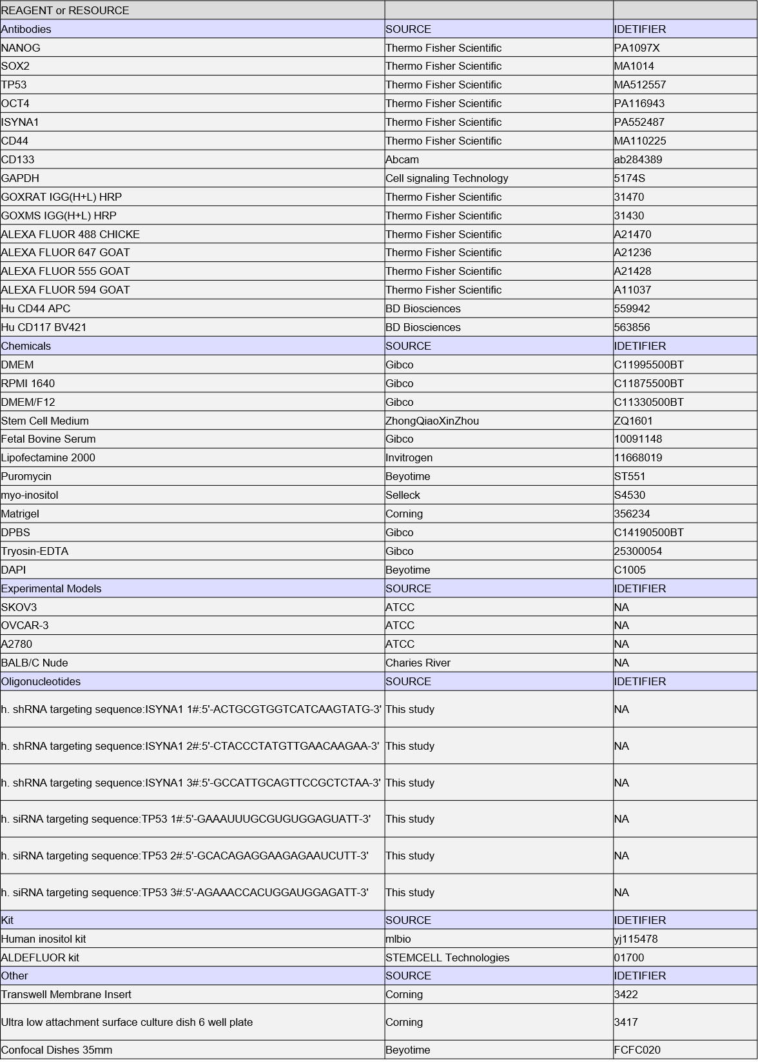
Supplementary Table 1

