Distinct behavioural deficits characterise cognitive impairment and negative symptoms in treatment resistant schizophrenia

Supplementary Material

Abbreviations table

Supplementary Methods

Supplementary Results

Abbreviations table

Abbreviation | Meaning
ACE-III/ACE_Total | Addenbrooke’s cognitive examination version III /Total score
PANS_Positive | Positive sub score of positive and negative syndrome scale for schizophrenia.
BACS_Total | Total score for Brief Assessment of Cognition in Schizophrenia scale
Cloz_level | Serum Clozapine level
CDS_Total | Total score for Calgary depression scale
Strauss_MAP | Motivation and pleasure factor of BNSS questionnaire using factor weightings from Strauss et al
STRAUSS_EXP | Blunted expression factor of BNSS questionnaire using factor weightings from Strauss et al

Supplementary methods

Ethics
This study was approved by the local ethics committee (18/EE/0178; IRAS 237532). Informed written consent was obtained from all subjects and all testing was conducted in accordance with the declaration of Helsinki.

Participants

Inclusion criteria:
- Aged between 18-65
- Formally diagnosed with schizophrenia
- Clinically stable on medication and an unchanged medication regime for at least 8 weeks
Exclusion criteria:
- Participants who were unable to understand and engage with the behavioural testing protocol.
- Physical disability preventing participants squeezing a hand-held device in response to visual stimuli.
- Evidence of history suggestive of any concomitant neurodegenerative or neuroinflammatory disease such as Alzheimer’s disease or vascular dementia.

Logistic regression with mixed effects

This was completed in MATLAB using the fitglme function. Trials with reaction times less than 0.4s or greater than 10 seconds were deemed accidental and discarded. The first two models included a full factorial model exploring the effects of reward, effort and grouping on choice. Model two used a squared effort parameter. This variation was included as several studies have suggested that there is a quadratic relationship between force requirements and effort costs(4,5). A third model investigated the effect of cognitive function across all 80 participants on these groupwise differences. Finally a fourth model removed fixed factors (group, and cognitive function), and used an agnostic model that included per subject parameters of intercept, reward, effort and reward:effort. These parameters were used to predict behaviour, as well as in outcome variables in multiple regressions. The latter were conducted to associate behavioural measures with clinical variables within the schizophrenia patient group.

Supplementary Table 1. Model comparison of choice behaviour between schizophrenia and controls.

Model | Model specification | Random effects | AIC**
1 | 'Choice ~ Reward*Effort*Group’ | (Reward + Effort | Subject) | +69
2 | 'Choice ~ Reward*Effort²*Group’ | (Reward + Effort² | Subject) | +71.6
3 | 'Choice ~ Reward*Effort*Group + Reward*Effort*Cognitive_fx | (Reward + Effort | Subject) | 0
4 | 'Choice ~ Reward*Effort’ | (Reward + Effort | Subject) | -

** AIC reported in relation to the winning model, scaled at 0.

Drift Diffusion Model

Decisions to “accept” or “reject” offers on our effort-based decision making paradigm can be viewed as a two alternative forced choice task (2AFC) (6). Well validated modelling approaches such as drift diffusion modelling (DDM) can be used to analyse these types of data (6–9), and this approach has previously been used successfully to model choices with and without apathy in cerebrovascular small vessel disease (6). Here we used similar methods to investigate behavioural changes schizophrenia which are described below.

DDM frames the decision making process as a noisy accumulation of evidence towards one of two decision boundaries, beyond which a decision is made (i.e. accept or reject). The model can be encapsulated in four broad parameters: i) bias, z, which determines the a priori starting point of evidence accumulation in relation to a perfectly unbiased starting point (whose value = 0.5); ii) threshold, a, which represents the distance between the two decision boundaries and the amount of evidence required to reach a decision; iii) non decision time, t, which accounts for biological processes not actively contributing to the decision making process (e.g. sensory perception, motor execution); iv) drift rate, v, which speaks to the rate of evidence accumulation.

As our task structure systematically varied reward and effort, we altered the drift rate in relation to the amount of reward and effort on offer. This gave rise to four sub-components of the parameter v per-subject:
i) baseline, or average, drift rate across all trials, v₀
ii) effect of reward on drift rate, v_{r}
iii) effect of effort on v, or v_{e}
iv) effect of the reward x effort interaction on v, or v_{r,e}.
These components were used to compute an actual drift rate, V_{r,e}, per subject within each segment of the decision making space. In line with previous work using this approach (6,7), we assumed this to be a linear combination of reward, effort and their interaction as portrayed below:

$$V_{r,e}=v_{0}+v_{r}+v_{e}+v_{r*e}$$

Overall group acceptance rates (AR) and decision times (DT) were subsequently predicted using the following two equations (Bogacz et al., 2006) which were also used in (Saleh et al., 2021):
$$AR=\frac{1}{1+e^{-2V_{r,e} a/c^{2}}} \left(1\right)$$

$DT=\left|\frac{a}{V_{r,e}} \tanh\left(\frac{V_{r,e}*a}{c^{2}}\right)\right|$ (2)

The noise parameter c was set to 1 by default. Population analysis was conducted with “subject” included as a hierarchical factor, followed by separate fits of each subject (6). Posterior distributions for z, a, t, and V (including its subcomponents) were generated. Between-group effects across DDM parameters were compared using Bayesian inference, and reported using posterior probabilities (P_{P|D}). For Bayesian hypothesis testing, statistical significance was be inferred if the probability of a hypothesis being true was > 0.95. Within-group associations between DDM parameters and clinical measures in the schizophrenia group were conducted by averaging per-subject posterior distributions into a single point estimate. These were subsequently regressed against clinical measures of interest using robust multiple regressions. Statistical significance was set at p < 0.05.

Data was fit to a DDM using a well validated toolbox (10)(for further details: http://ski.clps.brown.edu/hddm_docs/; version 0.8.0; Python 3.6). Informative group mean priors used in the original toolbox were retained, as they constrain parameter estimates within a plausible range in accordance with previous literature (10,11). Samples from the joint posterior distributions for all parameters were generated using Markov chain Monte Carlo methods (MCMC). Ten thousand samples were performed per MCMC chain, with the first 1000 samples discarded as ‘burn-ins’. Five percent of the data was assumed to contain outliers and subsequently excluded.

DDM model evaluation

Our DDM models

Supplementary Table 2: Gelman Ruben statistic (R-hat) across fice MCMC chains. Appropriate model convergence in our model as demonstrated by R-hat values < 1.1 across all seven model parameters.

DDM Parameters | R-Hat M1 (SCZ) | R-Hat M2 (CTRL)
Drift rate (V) | ﻿0.9999 | ﻿1.0004
V:Reward | ﻿1.0000 | ﻿1.0000
V:Effort | ﻿1.0001 | ﻿1.0001
V:Reward*Effort | ﻿1.0000 | ﻿1.0000
Threshold (a) | ﻿1.0005 | ﻿1.0019
Non-decision time (t) | ﻿1.0000 | ﻿1.0000
Bias (z) | ﻿1.0006 | ﻿1.0006

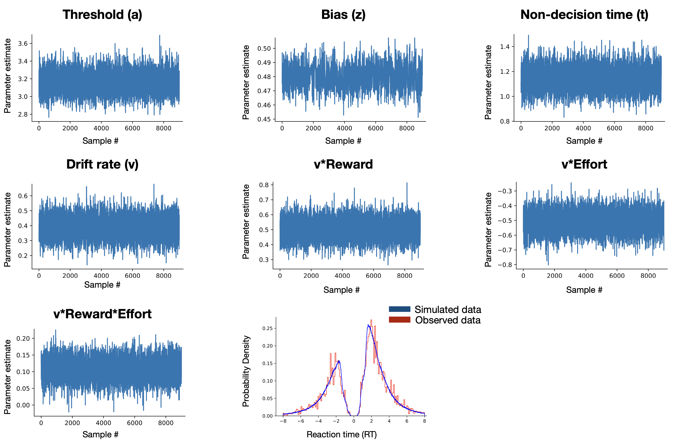
Supplementary figure 1: Model convergence and posterior predictive plots M1. All seven model parameters appropriately converged after 10,000 Markov chain Monte Carlo samples. The first 1,000 samples have been discarded as burn-in and are not shown here. Posterior predictive plot for all patients. Probability density plot for all subjects’ raw reaction time (RT) data (Red) in comparison to our model’s predictions (blue). The two peaks represent the accepted trials’ RT (positive x-axis values) and rejected trials’ RT (negative values). Similar analysis can be seen below for M2.

Supplementary figure 2: Model convergence and posterior predictive plots M2 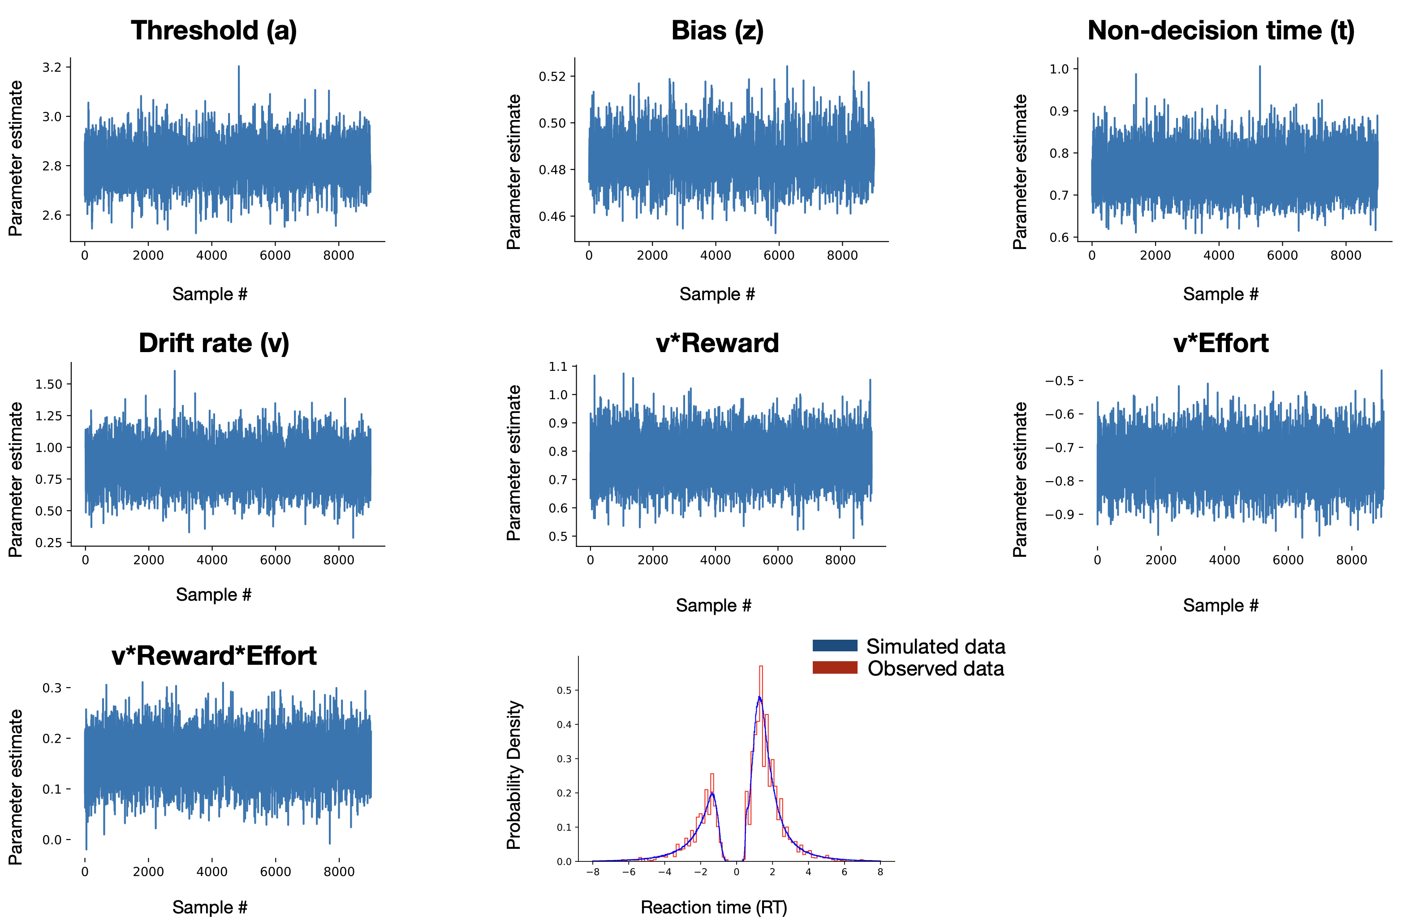

Supplementary Results

Questionnaire correlations:

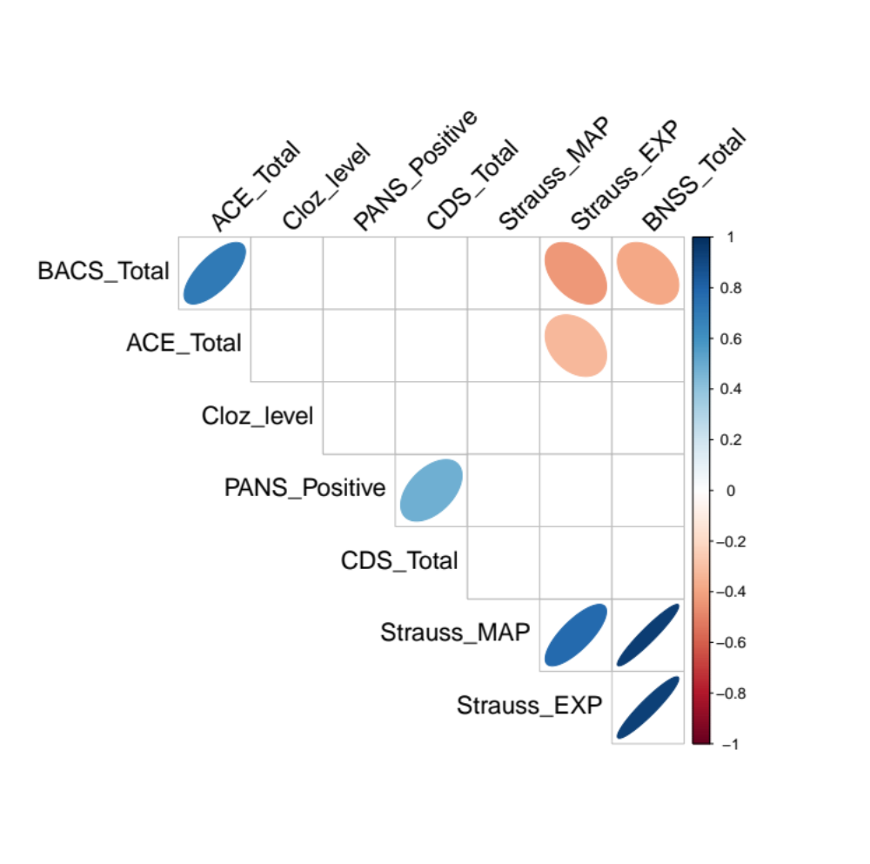
Supplementary Figure 3. Clinical associations within schizophrenia patients.
A visualisation of significant associations within a pairwise comparison using the corrplot function in R. Colour indicates the direction of associations so that blue and red represent positive and negative associations respectively. Only significant correlations (i.e. p < 0.05) are shown. Correlation strength, as measured by Pearson’s r, is represented by the width of the ellipses so that stronger correlations produce thinner the ellipses. Correlations are ordered along the first principle component to visually cluster associations.

Cognitive variables:

Both ACE-III and BACS total scores were independently positively associated with reward sensitivity (respectively, [F(1,4852)=13.39, P=0.0002] and [F(1,4852)=4.481, P=0.035]). Including both scores in a logistic multiple regression with mixed effects retained the association between reward sensitivity and ACE-III but not BACS (respectively, [F(1,4352)=5.6, P=0.018] and [F(1,4352)=0.004, P=0.94]). Hence the ACE-III was deemed a more sensitive measure when correlating cognitive function and behavioural markers using our paradigm. Post-Hoc analyses can be seen below.

Supplementary Table 3: Association of ACE-III subdomains with reward sensitivity

Subdomain | DF | F-statistic | uncorrected P value | Corrected p-value
Attention | 1,4852 | 12.29 | 0.00046 | 0.0023**
Fluency | 1,4852 | 3.29 | 0.069 | 0.34
Language | 1,4852 | 9.72 | 0.0018 | 0.009**
Visuo-Spatial | 1,4852 | 7.02 | 0.008 | 0.04*
Memory | 1,4852 | 6.76 | 0.0094 | 0.047*

Correlating behavioural parameters and clinical measures.

Below are multiple regressions of behavioural parameters extracted from the two analytic approaches. First the generalised models which used only the choice data. Second the DDM models which combined choice data and reaction times.

Generalised linear mixed effects model parameters

Supplementary Table 4: Association between choice parameters and clinical measures

DF(1,31) | Intercept | Reward sensitivity | Effort sensitivity | Reward*Effort
Cognition (ACE-III) | β = 0.24  t = 0.83  p = 0.41 | β = 0.87  t = 3.32  p = 0.002  p(corr) = 0.014 | β = 0.03  t = 0.15  p = 0.88 | β = 0.25  t = 2.07  p = 0.046  p(corr) = 0.28
Depression (CDS) | β = - 0.1  t = -0.33  p = 0.74 | β = -0.1  t = -0.36  p = 0.72 | β = 0.28  t = 1.00  p = 0.32 | β = -0.08  t = -0.64  p = 0.52
Clozapine level | β = -0.44  t = -1.6  p = 0.11 | β = 0.16  t = 0.67  p = 0.51 | β = -0.60  t = -2.56  p = 0.015*  p(corr) = 0.09 | β = 0.014  t = 0.12  p = 0.90
Positive Sx (PANS positive) | β = -0.27  t = -0.88  p = 0.38 | β = -0.21  t = -0.75  p = 0.46 | β = -0.096  t = -0.35  p = 0.72 | β = -0.092  t = -0.70  p = 0.49
EXP | β = 0.1  t = 0.98  p = 0.33 | β = 0.077  t = 0.77  p = 0.45 | β = 0.28  t = 2.94  p = 0.006  p(corr) = 0.036 | β = 0.10  t = 2.20  p = 0.035  p(corr) = 0.21
MAP | β = -0.14  t = -1.37  p = 0.18 | β = -0.06  t = -0.63  p = 0.53 | β = -0.18  t = -2.00  p = 0.054 | β = -0.04  t = -0.96  p = 0.34

Drift Diffusion model parameters

Supplementary Table 5: Association drift diffusion model parameters and clinical measures

DF(1,31) | Threshold (a) | Decision time (t) | Bias (z) | Drift rate | Drift * Reward | Drift *Effort | Drift*Rew*Eff
Cognition (ACE-III) | β = -0.076  t = -0.69  p = 0.49 | β = 0.16  t = 1.97  p = 0.058 | β = -0.00012  t = -0.14  p = 0.89 | β = 0.006  t = 0.12  p = 0.90 | β = 0.15  t = 3.25  p = 0.0027  p(corr) = 0.016 | β = 0.036  t = 0.72  p = 0.47 | β = 0.015  t = 0.87  p = 0.39
Depression (CDS) | β = -0.05  t = -0.455  p = 0.65 | β = -0.15  t = -1.7  p = 0.098 | β = -0.00001  t = -0.013  p = 0.98 | β = -0.036  t = -0.58  p = 0.56 | β = 0.019  t = 0.38  p = 0.71 | β = 0.051  t = 0.94  p = 0.35 | β = -0.0020  t = -0.14  p = 0.89
Clozapine level | β = -0.49  t = -0.48  p = 0.63 | β = -0.0022  t = -0.029  p = 0.97 | β = -0.0004  t = -0.49  p = 0.63 | β = -0.051  t = -0.97  p = 0.34 | β = -0.01  t = -0.23  p = 0.81 | β = -0.085  t = -1.83  p = 0.07 | β = -0.020  t = -0.123  p = 0.23
Positive Sx (PANS positive) | β = -0.17  t = -1.4  p = 0.17 | β = 0.06  t = 0.74  p = 0.46 | β = -0.0007  t = 0.82  p = 0.41 | β = -0.05  t = -0.85  p = 0.40 | β = 0.02  t = 0.42  p = 0.68 | β = -0.042  t = -0.77  p = 0.44 | β = -0.0026  t = -0.14  p = 0.89
EXP | β = -0.0066  t = -0.15  p = 0.88 | β = -0.039  t = -1.27  p = 0.21 | β = -0.0002  t = -0.58  p = 0.56 | β = 0.017  t = 0.82  p = 0.42 | β = 0.025  t = 1.43  p = 0.16 | β = 0.048  t = 2.58  p = 0.015  p(corr) = 0.09 | β = 0.0009  t = 1.48  p = 0.14
MAP | β = -0.045  t = 1.13  p = 0.26 | β = 0.07  t = 2.44  p = 0.02  p(corr) = 0.12 | β = -0.0002  t = -0.67  p = 0.50 | β = -0.033  t = -1.6  p =0.11 | β = -0.023  t = -1.37  p = 0.18 | β = 0.13  t = -1.56  p = 0.12 | β = -0.0005  t = -0.81  p = 0.43

