Supporting Information

Linking Molecular Structure and Lubrication Mechanisms in Tetraalkylammonium Orthoborate Ionic Liquids

Jieming Yan^{1,2}, Hsu-Ming Lien^{1,2}, Filippo Mangolini^{1,3,*}

- Texas Materials Institute, The University of Texas at Austin, Austin, TX 78712, USA
- Materials Science and Engineering Program, The University of Texas at Austin, Austin, TX 78712, USA
- Walker Department of Mechanical Engineering, The University of Texas at Austin, Austin, TX 78712, USA

*Corresponding Author: filippo.mangolini@austin.utexas.edu

Characterization of Tetraalkylammonium Orthoborate ILs
The characterization of the as-synthesized, dried ILs by nuclear magnetic resonance (NMR) spectroscopy (Bruker Avance 400 spectrometer) confirmed the molecular structure of both anions and cations. The characteristic ¹H, ¹³C, and ¹¹B are reported below for the three ILs prepared in this study. Notably, the ¹¹B NMR spectrum always exhibited a single, strong signal that could be assigned to orthoborate anions, with minimal residual boric acid.

- Trimethyloctylammonium bis(oxalato)borate ([N₁₁₁₈][BOB]):
¹H NMR (400 MHz, Acetone-d₆): 3.61 – 3.52 (m, 2H), 3.36 (s, 9H), 2.01 – 1.88 (m, 2H), 1.41 (dq, J = 6.6, 3.7, 2.9 Hz, 4H), 1.33 – 1.24 (m, 6H), 0.88 (t, J = 6.7 Hz, 3H).
¹³C NMR (101 MHz, Acetone-d₆): 158.41, 66.72, 52.82 (t, J = 0.4 Hz), 31.52, 26.03 (t, J = 0.1 Hz), 22.65, 22.33, 13.43.
¹¹B NMR (128 MHz, Acetone-d₆): 7.51.

- Triethylhexylammonium bis(oxalato)borate ([N₂₂₂₆][BOB]):
¹H NMR (400 MHz, Acetone-d₆): 3.38 (q, J = 7.3 Hz, 3H), 3.28 – 3.18 (m, 1H), 1.69 (dq, J = 12.0, 8.2, 7.6 Hz, 1H), 1.29 – 1.23 (m, 5H), 0.75 (t, J = 7.0 Hz, 1H).
¹³C NMR (126 MHz, Acetone-d₆): 205.31, 158.35, 57.12 – 56.65 (m), 52.79 (t, J = 4.1 Hz), 31.00, 25.80 (d, J = 2.0 Hz), 22.14, 21.36, 13.22, 6.85.
¹¹B NMR (128 MHz, Acetone-d₆): 7.51.

- Trimethyloctylammonium bis(salicylato)borate ([N₁₁₁₈][BscB]):
¹H NMR (400 MHz, Acetone-d₆): 7.70 (dd, J = 7.8, 1.8 Hz, 1H), 7.25 (ddd, J = 8.6, 7.3, 1.9 Hz, 1H), 6.75 – 6.64 (m, 2H), 3.33 – 3.23 (m, 1H), 3.07 (s, 4H), 1.63 (dq, J = 14.0, 5.8, 5.0 Hz, 1H), 1.17 – 1.03 (m, 5H), 0.71 (t, J = 6.9 Hz, 1H).
¹³C NMR (126 MHz, Acetone-d₆): 164.18, 159.91, 134.07, 129.44, 118.24, 118.09, 116.22, 66.65, 52.77, 52.74, 52.70, 31.52, 28.83, 26.02, 22.64, 22.33, 13.42.
¹¹B NMR (160 MHz, Acetone-d₆): 3.86.

The temperature-dependent viscosity of the three ILs is displayed in Figure S.2. Compared to the ILs with [BOB] anions, a significant increase in viscosity was observed in the case of the IL with [BScB] anion at all temperatures. The viscosity of the [N₁₁₁₈][BOB], [N₂₂₂₆][BOB], and [N₁₁₁₈][BScB] at 353 K (i.e., at the temperature at which tribological tests were performed) was 95±2 mPa s, 47±2 mPa s, and 635±17 mPa s, respectively.
KF titration measurements indicated high levels of water in all ILs, even after drying (e.g., 4.83% and 4.78% for [N₁₁₁₈][BOB] and [N₂₂₂₆][BOB], respectively). This can be attributed to the release of water from the direct reaction of orthoborate anions with methanol during KF titration as previously reported in Ref. [1]. The stoichiometric decomposition of [N₁₁₁₈][BOB] and [N₂₂₂₆][BOB] with methanol yields a water content of 5.02 wt.% and 4.83 wt.%, respectively, which is close to the values obtained with KF titration. In lieu of coulometric measurements, ¹H NMR spectroscopy was used to estimate the water content of the as-synthesized orthoborate ILs, which was found to be 6732±335 ppm, 7988±395 ppm, and 504±25 ppm for [N₁₁₁₈][BOB], [N₂₂₂₆][BOB], and [N₁₁₁₈][BScB], respectively. The water uptake resulting from the exposure of the ILs to air for 1 hour at 353 K indicated a minimal (<10%) change in water content.

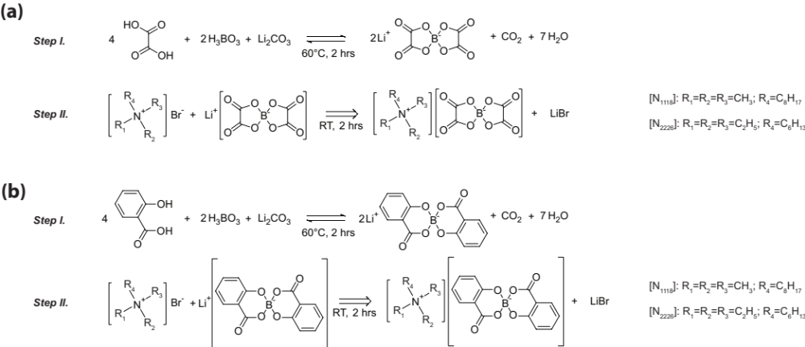
Figure 1. Schematic of the synthetic approach to prepare tetraalkylammonium orthoborate ionic liquids.

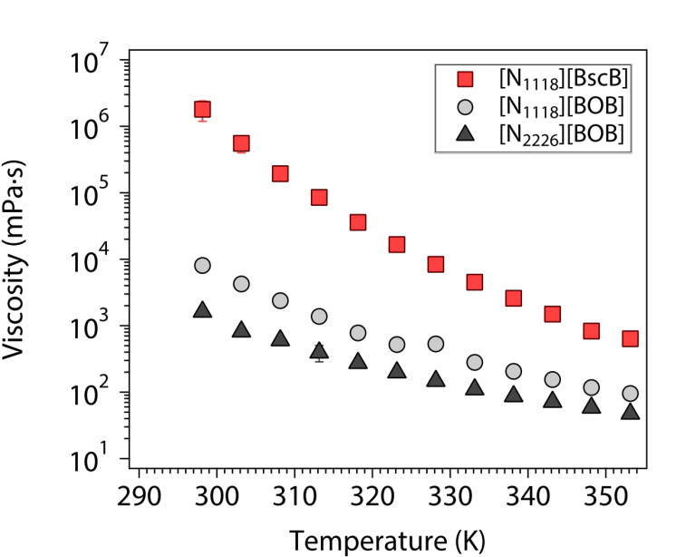
Figure 2. Viscosity as a function of temperature for tetraalkylammonium orthoborate ILs.

References
[1] W. Larsson, J.C. Panitz, A. Cedergren, Interference-free coulometric titration of water in lithium bis(oxalato)borate using Karl Fischer reagents based on N-methylformamide, Talanta. 69 (2006) 276–280. https://doi.org/10.1016/J.TALANTA.2005.10.004.

